3GPP TSG SA WG4 #134 S4-251648
Dallas, November 17-21, 2025

Title: [FS_ULBC] 3GPP NB-IoT NTN system and design parameters

Source: Qualcomm Incorporated, Thales, Xiaomi, Huawei, Aalyria, Viasat
Agenda item: 7.9 FS_ULBC

Document for: Agreement

1 Reasons for change
The current PD does not have a separate clause to introduce the NB-IoT NTN system as defined in the 3GPP specifications or the design parameters. This needs to be addressed for clarity.
Proposal:
- Adopt the proposed changes
- If the proposed changes are agreed, move clauses 5.1 and 5.2 from the PD to the TR.

2 Proposed changes

Add a new subclause in clause 5 to introduce the NB-IoT NTN system together with the design parameters.

First Change

2 References
[1] SP-250378, "SID on Ultra Low Bitrate Speech Codec", China Mobile Com. Corporation, vivo, Fraunhofer IIS, Qualcomm Incorporated, Spreadtrum, Dolby Laboratories Inc., Xiaomi, Huawei, 2025.
[26132] 3GPP TS 26.132: “Speech and video telephony terminal acoustic test specification”.
[38811] 3GPP TR 38.811, “Study on New Radio (NR) to support non-terrestrial networks”.
[38821] 3GPP TR 38.821, “Solutions for NR to Non-Terrestrial Networks (NTN)”
[36321] TR 36.321, "Evolved Universal Terrestrial Radio Access (E-UTRA); Medium Access Control (MAC) protocol specification"
[36300] TS 36.300, “Evolved Universal Terrestrial Radio Access (E-UTRA) and Evolved Universal Terrestrial Radio Access Network (E-UTRAN); Overall description”
[36211] TS 36.211, “Evolved Universal Terrestrial Radio Access (E-UTRA); Physical channels and modulation”
[36212] TS 36.212, “Evolved Universal Terrestrial Radio Access (E-UTRA); Multiplexing and channel coding”
[36213] TS 36.213, “Evolved Universal Terrestrial Radio Access (E-UTRA); Physical layer procedures”
[36763] 3GPP TR 36.763, “Study on Narrow-Band Internet of Things (NB-IoT) / enhanced Machine Type Communication (eMTC) support for Non-Terrestrial Networks (NTN)”.
[23203] 3GPP TS 23.203, “Policy and charging control architecture.”
[2] 3GPP TR 38.811: Study on New Radio (NR) to support non-terrestrial networks
[3] Tdoc S4-251390: [FS_ULBC] On ULBC bit rate spacing
[4] Tdoc S4aA250058: Simulation results for FS_ULBC, Beijing Xiaomi Mobile Software

Second Change

5.1 Architectural components and interfaces

5.1.1 Scenario 1: IMS Voice Call over GEO

5.1.X Scenario X:TBD

5.1.Y NB-IoT NTN system in 3GPP and design parameters

5.1.Y.1 System architecture
The NB-IoT NTN RAN is shown in Figure 5.1.Y.1-1 [36300]
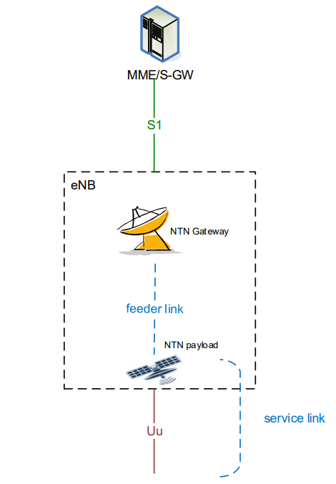
Figure 5.1.Y.1-1 System architecture of an NTN

The service link is between the UE and the NTN payload. The feeder link is between the NTN payload and the NTN Gateway.
NOTE: typically, multiple UEs are scheduled.

5.1.Y.2 RAN parameters
Channel coding
The uplink data channel NPUSCH Format 1 uses Turbo code, and the downlink data channel NPDSCH uses TBCC [36212].
MCS and resource allocation
NB-IoT supports pi/2 BPSK, pi/4 QPSK, QPSK, and 16QAM [36213].
Resource allocation is specified in [36213].
For NPUSCH Format 1, two subcarrier spacings are supported: 3.75kHz and 15kHz. The minimum time-domain resource allocation is the duration of a resource unit (RU). The frequency-domain resource allocation is determined by the number of allocated subcarriers associated with different RU durations, and the RU duration depends on the subcarrier spacing and the number of tones, as shown in Table 5.1.Y.2-1 (Table 10.1.2.3-1 of [36211]), where NPUSCH format 1 is relevant to the NB-IoT system with GEO because it is for data while NPUSCH format 2 is for ACK/NACK. For 3.75kHz SCS the a slot is 2ms, and for 15kHz SCS a slot is 0.5ms.
Table 5.1.Y.2-1: Supported combinations of , , and for frame structure type 1.
NPUSCH format
1 | 3.75 kHz | 1 | 16 | 7
1 | 15 kHz | 1 | 16 | 7
1 | 15 kHz | 3 | 8 | 7
1 | 15 kHz | 6 | 4 | 7
1 | 15 kHz | 12 | 2 | 7
2 | 3.75 kHz | 1 | 4 | 7
2 | 15 kHz | 1 | 4 | 7

The number of allowed RUs per repetition is defined in Table 16.5.1.1-2 and the number of allowed repetitions is defined in Table 16.5.1.1-3 of [36213].
For NPDSCH Format 1, there is only one subcarrier spacing supported – 15kHz – and the frequency-domain resource allocation is always 180kHz. The number of allowed subframes per repetition is defined in Table 16.4.1.3-1 and the number of allowed repetitions is defined in Table 16.4.1.3-2 of [36213].
TBS values
[36213] specifies the allowed TBS values.
For NPUSCH, the allowed TBS values depend on the MCS and the number of RUs per repetition and are specified in Table 16.5.1.2-2 of [36213]. For NPUSCH Format 1 single-tone, the allowed TBS values depend on Table 16.5.1.2-1 of [TS 36.213]
For NPDSCH, the allowed TBS values depend on the MCS and the number of NPDSCH subframes per repetition and are specified in Table 16.4.1.5.1-1of [36213].
It is expected that the same TBS value will be used in UL and DL.
UL/DL timing
The NB-IoT device operates using semi-persistent scheduling (SPS) for NB-IoT NTN. An example frame structure is shown in Figure 5.1.Y.2-2 with timing at the UE. The NPDSCH now can be anywhere in the first 15ms (considering that a minimum gap of 1 ms to the NPUSCH needs to be maintained).

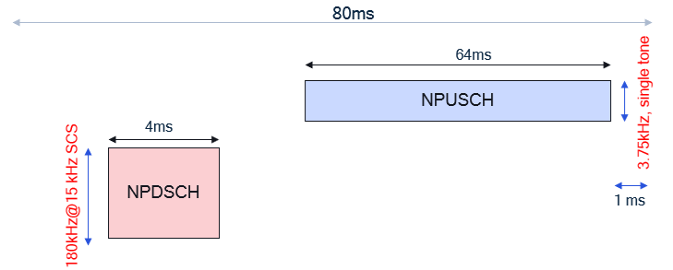
Figure 5.1.Y.2-2 An example frame structure for 80ms bundling period and SPS
Another example of a semi-persistent (SPS) scheme for NB-IoT NTN is shown in Figure 5.1.Y.2.-3, which does not depend on the “TA report UE capability”.

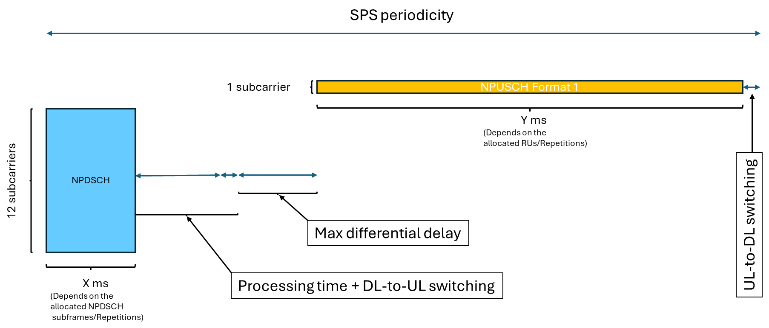
Figure 5.1.Y.2-3 SPS scheme based on “Cell_specific_Koffset” approach, which does not depend on the “TA report UE capability”.

Notes: The gap between DL and UL can consist of:
- A “Processing time + DL-to-UL switching”: It can be discussed whether the time for decoding the DL transport block needs to be considered or not, but at least the time that a “half-duplex device” requires for switching from DL-to-UL shall be considered which is 1 ms.
- The “Max differential delay” shall be considered for the network to handle the different delays of different UEs in the NTN cell. The value of “Max differential delay” will vary and will typically range between [close to 0 and 10.3 ms].
Editor’s note: The range of the “Max differential delay” is TBC.
Note: RAN1 reply LS stated:
- “Although the example Figure 5.2.2.3-1 is supportable by RAN1 specifications in most scenarios, it may not be supportable in the case where the cell is very large (e.g. >3000km), when the UE does not support TA report and the network does not support UE-specific K-offset. The example Figure 5.2.2.3-1 itself also requires the UE to be configured with two HARQ processes and with HARQ feedback disabled.”
- RAN1/2 have not yet started the work on designing SPS. Therefore, RAN1 currently cannot confirm whether the example frame structure for SPS (related to Figure 5.2.2.3-2 and associated text) will be supported.

5.1.Y.3 QoS characteristics
The QoS is done through QCI [23203]. A QCI is associated with the resource type (GBR or Non-GBR), priority level, packet delay budget (PDB) and packet error loss rate (PELR). See Table 6.1.7-A: Standardized QCI characteristics of [23203] for a list of QCI.
A QCI applies to both UL and DL, and specifically [23203] states “For a certain QCI the value of the PELR is the same in uplink and downlink.” With the background of the half-duplex FDD NB-IoT channel, this suggests that UL and DL time-domain transmission resources need to be balanced to allow for the same PELR on both links.

5.1.Y.4 Multi-user consideration
The selected configurations for UL and DL results in using only a subset of the total resources. Scheduling may assign resources to multiple users. Scheduling resources may be done through dynamically, or statically if SPS is specified for NB-IoT. Any configuration implies a number of supported UEs in the system assuming every UE uses the same configuration and maximizing this number is an important optimization criterion when identifying suitable configurations.

5.2 Channel characteristics
Editor’s Note:
- Study bitrates and loss/delay/jitter profiles.

5.2.1 Scenario 1: IMS Voice Call over GEO

5.2.1.1 Introduction
This clause introduces the methodology of obtaining channel characteristics and results for developing design constraints and performance requirements for a codec supporting the main scenario as documented in Clause 4.2.1: IMS Voice Call over GEO.

5.2.1.2 Delay error profiles
The delay-error profile is a model used to describe the network impairments—particularly delay and packet loss—that can impact real-time conversational services such as IMS voice call. Such profile typically reveals the GEO satellite channel characteristics and will be used to evaluate codec robustness, guide jitter buffer design and ensure a fair and comparable testing.

5.2.1.3 End to end simulation model to derive delay error profiles
The intention of this methodology is to reuse the simulation model defined in Annex E of TS 26.132 [26132] to produce the delay error profile.
This Annex E reference LTE access scenario is illustrated in Figure 5.2.1.3-1. Building on the main scenario defined in Clause 4.2.1, the corresponding end-to-end GEO access scenario is shown in Figure 5.2.1.3-2 and Figure 5.2.1.3-2a. The primary distinction between the reference LTE scenario and the GEO voice main scenario lies in the introduction of the “new GEO channel” and the potential inclusion of the Non-IP Data Delivery option in the protocol stack as illustrated in Figure 5.2.1.3-2a.
Fig.5.2.1.3-1: End-to-end channel of VoLTE using LTE access
Fig.5.2.1.3-2: End-to-end channel of main scenario for IMS voice call using NB-IoT (GEO) satellite access
Fig.5.2.1.3-2a: End-to-end channel of main scenario for IMS voice call using NB-IoT (GEO) satellite access with Non-IP Data Delivery
Based on the functional description in Table E.1 of TS 26.132, the following input parameters are required to implement the simulation model:

BLER_tx / BLER_rx:
These parameters are required to simulate block error rates in both uplink and downlink.
NOTE: the resulted error trace based on Clause 5.2.2 will be used to serve as the BLER_tx/BLER_rx.
[max_tx / max_rx:
These define the maximum number of HARQ retransmissions for uplink and downlink respectively, which fall under RAN2 scope. In current specifications, NB-IoT supports at most two HARQ processes, which face constraints in high-latency GEO satellite scenarios. For IMS voice over GEO, HARQ feedback is suggested to be disabled per the standard of Release 18 [5].]
drx_cycle_length:
This parameter represents the duration of the DRX (Discontinuous Reception) cycle in milliseconds. It determines how frequently the device wakes up to monitoring possible scheduling grant. This parameter affects packet scheduling and transmission timing in the simulation context Annex E of TS 26.132. In addition, the values for LTE are 20-40ms, whether these values are suitable for GEO scenarios should be confirmed with RAN2.
mis_eNB1_eNB2:
This parameter represents the scheduling time mis-align between the two eNBs. In GEO scenarios, it indicates how long packets wait in the buffer before the next transmission opportunity. This should be determined primarily by RAN2 (responsible for dynamic scheduling or Semi-Persistent Scheduling) with possible input from RAN1 about physical layer timing relationship aspects.
[max_net_delay / min_net_delay:
These represent the delay range between eNB1 and eNB2. For GEO voice, they are considered similar to the LTE scenario, and legacy parameter values can be reused.]
Editor’s NOTE: whether the model for the delay between eNB1 and eNB2 for LTE scenarios well reflects the delay in deployment is FFS.
nFrames:
This refers to the number of frames for the simulation. In the reference LTE scenario, one IP packet corresponds to 20 ms of speech. In contrast, the GEO voice scenario introduces additional considerations shown as follows due to the propagation delay from GEO satellite altitude.
- Speech sequence (frame length): For GEO, a longer frame length may be used. The maximum frame length of 80 ms, as defined by 3GPP, is assumed in this simulation. Final confirmation is expected from SA4.
- Voice packet size: This depends on the protocol overhead as illustrated in Figure 5.2.1.3-3 for the reference LTE access scenario and Figure 5.2.1.3-4 for the GEO voice main scenario. The exact overhead depends on the transport path of the voice packets, user plane or control plane, via IP or via Non-IP (NIDD)—and must be confirmed by RAN2 and SA2.The RTP layer in Figure 5.2.1.3-4 may use a simplified RTP header. The feasibility of such a simplified header may be specified by SA4.

Fig. 5.2.1.3-3: VoIP RTP packet in reference LTE access scenario
Fig.5.2.1.3-4: Example of RTP packet in GEO voice main scenario
- RTP Payload Size: This is computed as the product of frame length and codec bit rate.
Editor’s Note: whether the size of RTP payload affects the delay-error profile is FFS.
Once the parameters regarding GEO channel are confirmed, the simulation methodology as described in Table E.1 will be updated with these new parameters and used to produce the required delay-error profiles.

5.2.2 Simulation Model to generate error traces and derive codec bitrates
The NTN link consists of a service link (between the UE and the satellite) and a feeder link (between the satellite and the ground station). At the NB-IoT NTN RAN, the bottleneck is the service link due to the limited TX power and small antenna at the UE. The feeder link is typically characterized by large capacity and high reliability and can be abstracted as an ideal link in the end-to-end simulation. The RAN simulation addresses the service link only.
The candidate values for the RAN parameters in 5.1.Y.2 are down selected for the simulation, based on the number of supported UEs in the system and the GEO channel characteristics.
The objective is to generate multiple loss traces for relevant combinations of RAN parameters including frame loss rate (target BLER), raw bitrate (TBS), voice bundling period and Doppler spread, while maintaining channel consistency among different combinations required for comparability.
The multiple loss traces are the result of using multiple random seeds, and the number is 10. For each combination, all 10 seeds are used in generating the error traces.
NOTE: 10 seeds will finally be confirmed after the demonstration of the feasibility of reasonable simulation workload
Each trace represents a duration of 400 seconds (or 6.67 minutes). Therefore, for 80ms bundling, there are 5000 TBs, and for 160ms bundling there are 2500 TBs.

5.2.2.1 Link budget analysis
TR36.763 [36763] performed link budget analysis for 3GPP Set 1 GEO and 23dBm UE. The following CNR values are adopted as the baseline:
- UL CNR = 2.6dB, 0dBi UE antenna gain, 3.75kHz SCS, 1 tone, UE maximum TX power 23dBm
- DL CNR=-3.3dB, 0dBi UE antenna gain, 15kHz SCS, 12 tones, 1 UE receive antenna, UE maximum TX power 23dBm.
5.2.2.2 Uplink simulation parameters
The following parameters are for the uplink of the service link.
- Channel model: NTN-TDL-C [38811]
- Modulation: QPSK, pi/2 BPSK [36213]
- Subcarrier Spacing (SCS): 3.75kHz, 15kHz [36213]
- Number of tones: 1 for 3.75kHz SCS and 15kHz SCS [36213]
- Number of repetitions: companies will report the number of repetitions for each simulation
- Voice bundling period: 80ms, 160ms, 320ms
NOTE: the 40ms bundling is not considered because for SCS 3.75kHz the minimum time-domain allocation is 32ms and it leaves insufficient time for downlink data (NPDSCH) and control (NPDCCH) transmissions in the same 40ms time interval.
- Doppler spread: 1Hz, 5 Hz
- Target BLER: 1%, 2%, 6%, 10%
Editor’s Note: whether a fixed target BLER will be used is FFS.
- Maximum Achievable SNR values: (3GPP SET-1 UL SNR) – 10*log₁₀(B/3.75) + (P - 23dBm) + G + [X] dB, where
  - 3GPP SET-1 UL SNR (=2.6dB) is the UL SNR for a single tone at 3.75kHz, 23dBm UE power, 0dBi UE antenna gain, as considered in TR36.763 [36763].
  - B is the bandwidth, taking values 3.75kHz, 15kHz
  - P is the maximum UE transmission power, taking value 23 dBm, 26 dBm, 31 dBm,
  - G is the difference between the UE antenna gain and that assumed in TR36.763 [36763], and it is from 0 up to -5.5dBi,
  - X is TBD (to be reported by companies) to account for lower loss (e.g., lower scintillation loss), and/or better performance of commercial satellites.
- TBS values and PHY bitrates: The TBS values are selected from table 16.5.1.2-2 for NB-IoT for NPUSCH in TS36.213 and the corresponding PHY bitrates and codec bitrate (assuming 7 bytes of packet header) are calculated for each bundling period, as shown in Table 5.2.2.1-1, 5.2.2.1-2, and 5.2.2.1-3.
NOTE 1: The final size of packet header depends on the conclusions reached by SA2 and RAN, including whether 1-byte MAC header is feasible.
NOTE 2: The packet header is only counted once, regardless of how many voice frames are bundled together.
NOTE 3: The precise relationship between the voice frame duration and the bundling time depends on the RTP payload design. In the case of multiple voice frames bundled together, the loss of a single Transport Block (TB) means the loss of multiple consecutive voice frames.
Table 5.2.2.1-1 TBS and PHY bitrate for 80ms bundling
TBS (bits) | 144 | 256 | 328 | 424
PHY bitrate (kbps) | 1.8 | 3.2 | 4.1 | 5.3
Codec bitrate (kbps) | 1.1 | 2.5 | 3.4 | 4.6

Table 5.2.2.1-2 TBS and PHY bitrate for 160ms bundling
TBS (bits) | 208 | 424 | 600 | 808
PHY bitrate (kbps) | 1.30 | 2.65 | 3.75 | 5.05
Codec bitrate (kbps) | 0.95 | 2.30 | 3.40 | 4.70

Table 5.2.2.1-3 TBS and PHY bitrate for 320ms bundling
TBS (bits) | 328 | 776 | 1096 | 1544
PHY bitrate (kbps) | 1.025 | 2.425 | 3.425 | 4.825
Codec bitrate (kbps) | 0.850 | 2.250 | 3.250 | 4.650

Editor’s NOTE: The need of 320ms bundling option should be revisited after the channel simulation results are available.
Editor’s NOTE: Company can report candidate values of TBS.
Channel consistency: The same set of channel realizations are used across all combinations.

5.2.2.3 Downlink simulation parameters
Only the parameters that are different from the uplink are listed here.
- SCS: 15kHz [36213]
- Number of tones: 12 [36213]
- Achievable SNR: (3GPP SET-1 DL SNR) + G + [Y] dB, where
  - 3GPP SET-1 DL SNR (=-3.3 dB) is the DL SNR for 12 tones at 15kHz subcarrier spacing and 1 UE receive antenna as considered in TR36.763 [36763],
  - G is the difference between the UE antenna gain and that assumed in TR36.763 [36763], and it is from 0 up to -5.5dBi,
  - [Y] is TBD (to be reported by companies) to account for more UE receive antennas (2 receive antennas instead of 1, providing an increase up to 3dB), lower loss (e.g., lower scintillation loss), better G/T values and/or better performance of commercial satellites.
Editor’s NOTE:
Four companies [S4-251272,R1-2506170,R1-2505366,R1-2505941] reported Y=3 due to G/T from field measurements, -28.6dB/K, NF = 4dB, being 3dB better than the 3GPP assumed value -31.6dB/K.However, no consensus has been reached in RAN1 at this stage.
- TBS values and PHY bitrates: The TBS values are selected from table 16.4.1.5.1-1 for NB-IoT for NPDSCH in TS36.213 and the corresponding PHY bitrates and codec bitrate (assuming 7 bytes of packet header) are calculated for each bundling period, and they are identical as those in clause 5.2.2.2.

5.2.2.3 Frame structure
For dynamic scheduling, an example frame structure for Half-duplex FDD for the 80ms bundling period is shown in Figure 5.1.Y.2-1.
For SPS scheduling, an example is shown in Figure 5.1.Y.2-2.

