3GPP TSG SA WG4#135 S4-260155
Goa, India, 9 – 13 February 2026

Source: vivo Mobile Communication Co., Xiaomi Technology, Spreadtrum, Bytedance
Title: [FS_ULBC] Analysis of AI Codec Real-Time Performance (RTF) and Complexity Scaling
Spec: 3GPP TR 26.940 v0.4.0
Agenda item: 7.8
Document for: Discussion/Agreement

1. Introduction
As part of the study on the new Ultra Low Bitrate Speech Codec (ULBC) [1], it is necessary to establish complexity constraints that reflect real-world device capabilities. Previous contributions have analyzed theoretical complexity using static metrics such as FLOPs and WMOPS [2] [5]. However, static metrics often fail to capture system-level bottlenecks, such as memory bandwidth pressure and thermal constraints on mobile System-on-Chips (SoCs).
This contribution presents a comprehensive performance analysis of a neural audio codec (based on the Descript Audio Codec architecture) running on a representative mid-range mobile platform. By sweeping across model sizes (1M to 74M parameters) and sample rates (8, 16, 32 kHz), we evaluate the correlation between theoretical complexity and the Real-Time Factor (RTF).

2. Experimental Setup
To ensure the results are representative of consumer hardware, we utilized a standard Android mobile device and a rigorous frequency-locking methodology to eliminate dynamic frequency scaling noise.

2.1 Model Configuration
To assess the scalability of the proposed solution, eight distinct model variants (designated " enc8dec144" to " enc64dec1536") were evaluated. The codec architecture is based on a fully convolutional encoder-decoder structure employing Residual Vector Quantization (RVQ) [3]. All variants operate with a frame length of 40ms, and all variants have the same total up/down-sampling factor (2 * 4 * 5 * 8 = 8 * 5 * 4 * 2 = 320). The evaluation covers three input sampling rates: 8 kHz (corresponding to 320 samples), 16 kHz (640 samples), and 32 kHz (1280 samples). For the purpose of this analysis, the models were exported to ONNX format using Float32 precision.
Table 1: Model Variants & Complexity Analysis
Variant | Params (M) | Size (MB) | GFLOP  counts (8k) | GFLOP  counts (16k) | GFLOP  counts (32k) | MFlops/s (8k) | MFlops/s (16k) | MFlops/s (32k)
enc8dec144 | 1.09 | 4.3 | 0.01 | 0.02 | 0.04 | 218.5 | 439.2 | 880.6
enc12dec288 | 2.89 | 11.1 | 0.03 | 0.06 | 0.11 | 698.8 | 1406.2 | 2821.0
enc16dec384 | 4.94 | 18.9 | 0.05 | 0.10 | 0.20 | 1241.0 | 2497.2 | 5009.7
enc19dec456 | 6.85 | 26.1 | 0.07 | 0.14 | 0.28 | 1743.3 | 3508.0 | 7037.3
enc24dec576 | 10.76 | 41.0 | 0.11 | 0.22 | 0.45 | 2789.2 | 5612.6 | 11259.6
enc32dec768 | 18.90 | 71.9 | 0.20 | 0.40 | 0.80 | 4955.9 | 9972.6 | 20006.1
enc40dec960 | 29.34 | 111.7 | 0.31 | 0.62 | 1.25 | 7741.0 | 15577.1 | 31249.4
enc64dec1536 | 74.50 | 283.6 | 0.79 | 1.59 | 3.20 | 19807.3 | 39857.9 | 79959.3

2.2 Device Under Test (DUT) Environment
The experimental evaluation was conducted on a device under test (DUT) featuring the MediaTek Dimensity 1200 system-on-chip (SoC). This 6nm chipset was selected to represent a typical mid-range consumer performance profile. The inference engine employed was ONNX Runtime v1.14+, configured to use the CPU execution provider in single-threaded mode. To characterize the heterogeneous processing capabilities of the SoC, test execution was explicitly pinned to specific CPU clusters: the Efficiency cluster (Cortex-A55), the Performance cluster (Cortex-A78), and the Prime core (Cortex-A78+)
To ensure reproducibility, thermal services and power HALs were disabled, and CPU frequencies were clamped via /proc/ppm and sysfs to fixed operating points. RTF was calculated as:
$$RTF=\frac{\text{ Inference Time }(\text{ Encoder }+\text{ Quantizer }+\text{ Decoder })}{\text{ Audio Duration }(40 ms)}$$

3. Results and Analysis

3.1 Complexity Scaling vs. Bandwidth
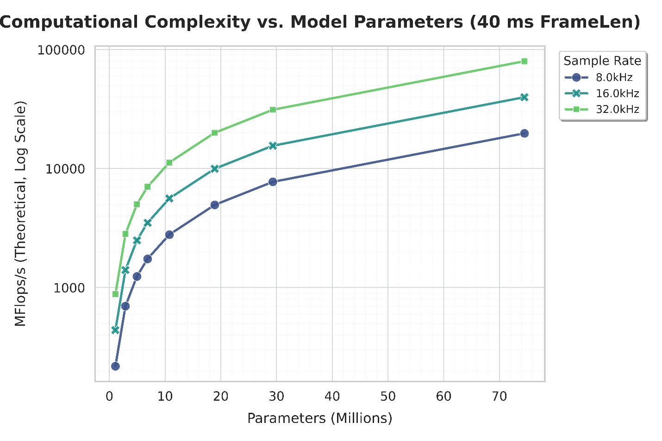
Figure 1: Complexity Scaling vs Model Parameters

Figure 1 illustrates the relationship between model complexity and parameters. An analysis of the operating points at 8 kHz, 16 kHz, and 32 kHz reveals a significant trend. Although the parameter count is invariant for a specific model configuration (e.g., enc32dec768 utilizes 18.9M parameters across all rates), the complexity at 32 kHz is notably higher.
The complexity metrics for the enc32dec768 variant are summarized as follows:
8kHz: ~0.20 GFLOP counts, corresponding to 4955.9 MFlops/s
16kHz: ~0.40 GFLOP counts, corresponding to 9972.6 MFlops/s
32kHz: ~0.80 GFLOP counts, corresponding to 20006.1 MFlops/s
For a given model variant, the computational complexity at 32 kHz is observed to be approximately double that of 16 kHz and four times that of 8 kHz. This confirms that higher sampling rates incur a proportional computational penalty.

3.2 Real-Time Factor (RTF) Analysis
The real-time performance of the codec was evaluated across three distinct frequency tiers (Low, Mid, and High), corresponding to the rows of the 3x3 analysis grid depicted in Figure 2. The low tier (Tier 1) represents an energy-conserving state with the Cortex-A55 cores clocked at 750 MHz, the Cortex-A78 at 902 MHz, and the Prime A78+ at 1.108 GHz. The mid tier (Tier 2) reflects a typical sustained workload, increasing frequencies to 1.0 GHz for the A55, 1.162 GHz for the A78, and 1.137 GHz for the Prime core. Finally, the high tier (Tier 3) simulates a high-performance state approaching sustained limits, with the A55 running at 1.725 GHz, the A78 at 1.451 GHz, and the Prime core at 1.632 GHz.
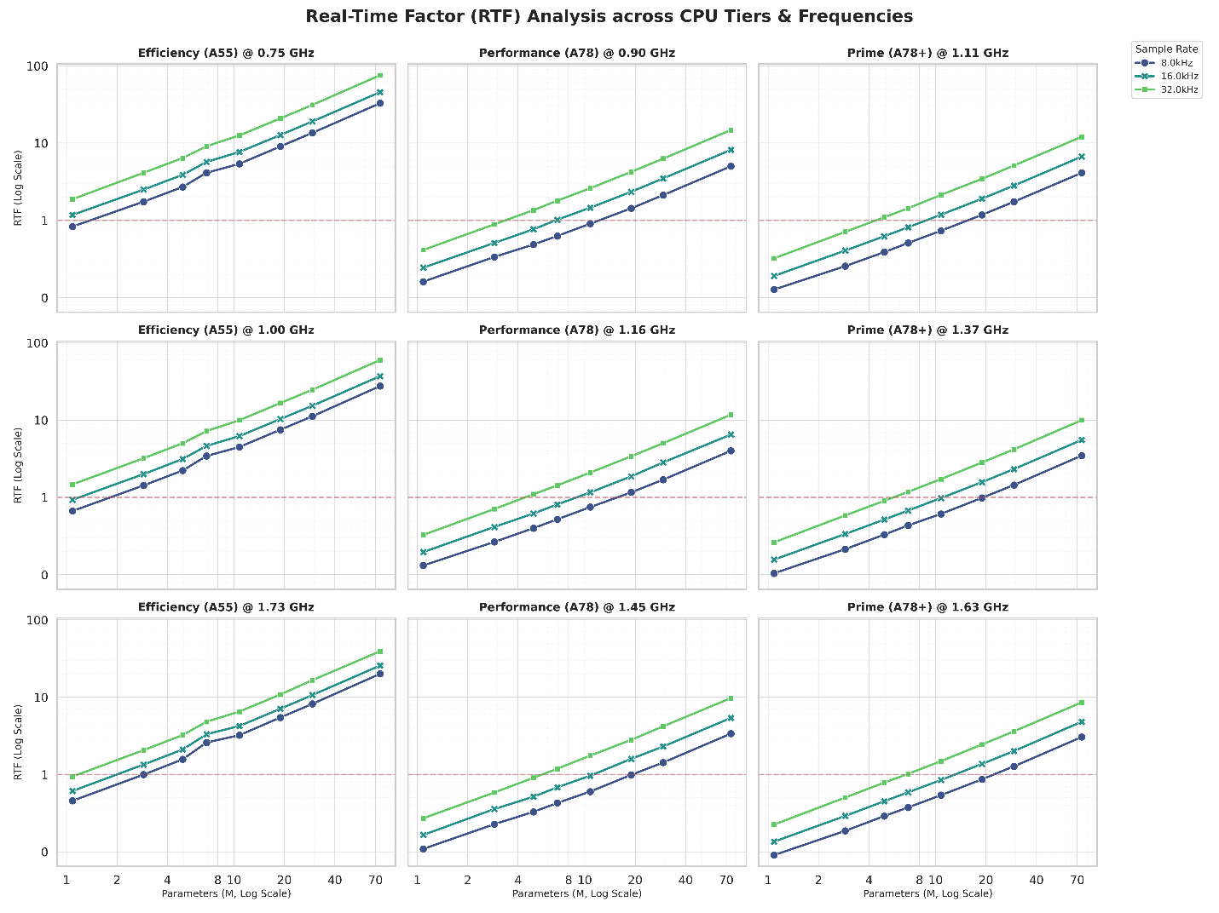Figure 2: RTF Analysis across CPU Tiers and Frequency

3.2.1 Tier 1: Low Frequency (A55@750M, A78@902M, A78+@1.1G)
At this energy-conserving operating point, computational resources are significantly constrained. On the efficiency cluster (Cortex-A55 @ 750 MHz), performance is severely limited; even at an 8 kHz sampling rate, only the most compact models (e.g., enc8dec144) maintain real-time operation. At 16 kHz and 32 kHz, the RTF rapidly exceeds 1.0, rendering high-fidelity audio processing unfeasible.
The performance cluster (Cortex-A78 @ 902 MHz) exhibits rapid saturation at 32 kHz, limiting feasibility to very small models with fewer than 3 million parameters. At 16 kHz, low-complexity models are supported, though performance limits are reached around 8 million parameters. Conversely, 8 kHz operation offers reasonable headroom, supporting models up to approximately 10 million parameters.
The prime core (Cortex-A78+ @ 1.108 GHz) demonstrates trends similar to the Performance cluster but benefits from the increased clock speed, extending the feasible limit for 16 kHz operation closer to the 10 million parameter threshold.

3.2.2 Tier 2: Mid Frequency (A55@1.0G, A78@1.16G, A78+@1.37G)
This tier represents a typical "sustained" workload state.
On the efficiency cluster (Cortex-A55 @ 1.0 GHz), performance shows improvement for 8 kHz inputs, supporting models up to approximately 2 million parameters. However, 16 kHz and 32 kHz operation remain largely out of reach for any model larger than enc8dec144 or enc12dec288.
For the performance cluster (Cortex-A78 @ 1.162 GHz), 32 kHz operation is still constrained, with a feasible limit around 5 million parameters. At 16 kHz, feasibility extends to approximately 10 million parameters, effectively covering the "Low Complexity" profile. The 8 kHz operating point demonstrates robust performance for models up to 20 million parameters.
Interestingly, the prime core (Cortex-A78+ @ 1.37 GHz) operates at a slightly lower frequency than the performance core in this tier. This results in performance parity or a slight regression compared to the A78 cluster, confirming that clock speed is the primary differentiator in this specific configuration.

3.2.3 Tier 3: High Frequency (A55@1.73G, A78@1.45G, A78+@1.63G)
This tier reflects high-performance states, approaching the sustained limits of the device.
On the efficiency cluster (Cortex-A55 @ 1.73 GHz), the increased frequency provides tangible benefits. At 8 kHz, the core can now support models up to approximately 3 million parameters. Support at 16 kHz extends to roughly 2 million parameters, while at 32 kHz, feasibility is limited to models around 1 million parameters.
The performance cluster (Cortex-A78 @ 1.451 GHz) demonstrates significant scaling. At 32 kHz, the feasible limit reaches approximately 7 million parameters. Reducing the sample rate to 16 kHz extends this limit to 10 million parameters, while at 8 kHz, the core can support models up to 20 million parameters. This scaling behavior reinforces the inverse relationship between sample rate and model size capacity.
The prime core (Cortex-A78+ @ 1.632 GHz) offers the highest performance headroom in this configuration. It can safely execute 8 million parameter models at 32 kHz. At 16 kHz, support extends comfortably to 10 million parameters, and at 8 kHz, the limit reaches approximately 20 million parameters, mirroring the Performance cluster's ceiling for lower sample rates.

3.3 Maximum Performance Envelope
To establish the absolute upper bound of real-time feasibility on the DUT, we analyzed the performance of both the efficiency and performance cores at their maximum locked frequencies, as illustrated in Figure 3.
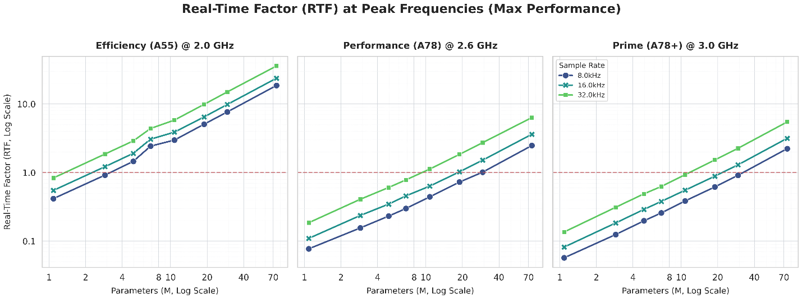Figure 3: RTF Analysis at Peak Frequency per CPU Tiers

3.3.1 Efficiency Core (Target: Cortex-A55 @ 2.0 GHz)
Even at peak frequency, the efficiency core remains highly constrained by model size. Models exceeding approximately 5 million parameters, such as enc16dec384, begin to fail real-time constraints (RTF > 1.0) at sampling rates of 8 kHz and above. The observed latency on the A55 cluster suggests it is unsuitable for models with large weight matrices.

3.3.2 Performance Core (Target: Cortex-A78 @ 2.6 GHz)
Focusing on the Cortex-A78 (performance core) provides the most relevant benchmark for ULBC, as it represents the sustained compute capability of modern mobile devices. The experimental data reveals a precise "Complexity vs. Bandwidth" trade-off, where the feasible parameter count is inversely proportional to the sampling rate.
At a 32 kHz sampling rate, the RTF curve crosses the 1.0 threshold near the 10 million parameter mark, approximately corresponding to the enc24dec576 variant. At this high sample rate, models larger than enc24dec576 saturate the core, making 10 million parameters the practical hard limit for High-Fidelity ULBC candidates.
Reducing the bandwidth to a 16 kHz sampling rate allows the feasible model size to effectively double. The limit is observed around 20 million parameters, specifically near the enc32dec768 variant. While enc32dec768 runs near the limit, the larger enc40dec960 model fails to meet real-time constraints. This indicates a linear relationship between bandwidth reduction and parameter capacity.
Further halving the bandwidth to an 8 kHz sampling rate extends the feasible envelope to approximately 39 million parameters. At this operating point, enc40dec960 (29M parameters) is safe, but the trend line suggests failure before reaching the enc64dec1536 variant.

Prime Core (Target: Cortex-A78+ @ 3.0 GHz)
The Prime core offers the highest performance on the SoC. The results generally mirror the trends observed on the standard performance (A78) core but with slight improvements in headroom due to the higher clock frequency. The feasible limits at each operating point are consistent with the A78 findings (e.g., the 32 kHz limit remains near the 10M-15M parameter range).
While the prime core processes individual frames faster, the bandwidth bottleneck remains the dominant factor. The higher clock speed provides a slightly larger safety margin for models that are borderline on the A78, such as enc24dec576 at 32 kHz, but it does not fundamentally shift the feasible model size category.

4. Proposal
It is proposed to include the findings of this RTF analysis in PDoc to inform the selection of complexity constraint for the ULBC candidate.

References
[1] SP-250378, "New SID on Ultra Low Bitrate Speech Codec".
[2] S4aA250264, "[FS_ULBC] Considerations on measuring ULBC complexity ".
[3] Descript, Inc., "Descript Audio Codec (DAC)," Version 0.0.1, Feb. 2023. [Online]. Available: https://github.com/descriptinc/descript-audio-codec
[4] Lyken, "pytorch-OpCounter." GitHub, 2018. [Online]. Available: https://github.com/Lyken17/pytorch-OpCounter.
[5] S4aA25023, "On complexity measurement for ULBC"

