3GPP TSG-SA3 Meeting #126 draft_S3-260948-r1

Goa, India, February 09-13 2026

Source: ZTE
Title: Remove the ENs
Document for: Approval
Agenda item: 5.2.4
Spec: 3GPP TR 33.758
Version: 0.1.0
Work Item: FS_PLMNNPN_Ph2

Comments
This contribution proposes to remove the ENs in TR 33.758.

Proposed Changes
* * * First Change * * * *

4 Architecture
TR 33.757[3] has studied two scenarios of PLMN hosting a NPN, where the interface between PLMN operational domain and PNI-NPN domain is N4 or SBA interface.
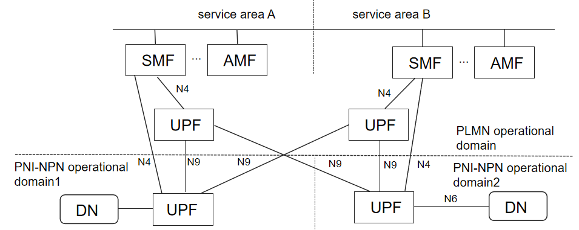
Figure 4-1 N9 interface across PLMN operational domain and PNI-NPN operational domain
In addition to the scenarios in TR 33.757[3], the interfaces between PLMN operational domain and PNI-NPN domain can include N9. Considering the scenario depicted in Figure 4-1, the dedicated UPF in PNI-NPN operational domain2 is controlled by SMF in service area B, and customers can access the DN through the UPF in service area A or the UPF in service area B depending on customers’ location. The situation is similar for the dedicated UPF in PNI-NPN operational domain1.
This architecture in Figure 4-1 is used to show the impact on different domain when TEID attack happen.
Editor’s Note: More clarification on the architecture is FFS.

In TR 33.757[3], the CP functions deployed in the PNI-NPN operational domain only consider AMF and SMF. However, more CP functions (except AMF, SMF, UDM) defined in TS 23.501 [4] are likely to be deployed in the PNI-NPN operational domain.

5 Security assumptions

The security assumption in TR 33.757[3] clause 5 apply.

6 Evaluation for SBA interface protection

The 5G System architecture consists of the network functions is list in TS 23.501[4] clause 4.2.2, while the service-based interface is list in TS 23.501[4] clause 4.2.6.
The following NFs specified in TS 23.501[4] clause 4.2.2 with service-based interface specified in TS 23.501[4] clause 4.2.6 may be considered not to be deployed in the PNI-NPN operator domain:
- Authentication Server Function (AUSF).
- Unified Data Management (UDM).
- Unified Data Repository (UDR).
- Unstructured Data Storage Function (UDSF).
- 5G-Equipment Identity Register (5G-EIR).
- CHarging Function (CHF).
Except the NFs list above, the NFs specified in TS 23.501[4] clause 4.2.2 with service-based interface specified in TS 23.501[4] clause 4.2.6 may be considered to be deployed in the PNI-NPN operator domain.
The security recommendations given in TS 33.501[2] annex AB apply to the NF which is considered to be deployed in the PNI-NPN operator domain.
* * * End of Changes * * * *

