3GPP TSG-SA3 Meeting #126 draft_S3-260913-r1

Goa, India, 9 – 13 February 2026

Source: Nokia
Title: Pseudo-CR on Evaluation on the hybrid SUCI
Document for: Approval
Agenda item: 5.2.1
Spec: TR 33.703
Version: 0.3.0
Work Item: FS_CryptoPQC

Comments
This document is for the evaluation of the hybrid SUCI calculation.

* * * First Change * * * *

7.2.1.12 Solution #12 to SUCI calculation: Hybrid SUCI calculation

7.2.1.12.1 Introduction
This solution addresses the key issue#1.

7.2.1.12.2 Solution details
EN#1: The details of the Combiner Function (3>) is FFS.

SUPI and SUCI type
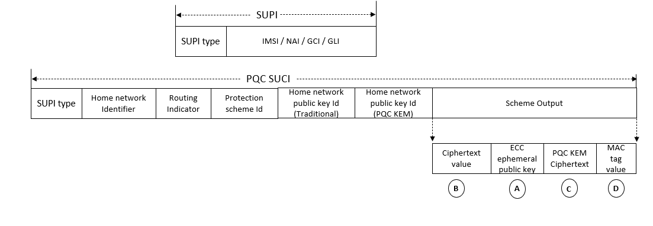
The SUPI is a globally unique 5G Subscription Permanent Identifier allocated to each subscriber in the 5G System. It is defined in clause 5.9.2 of 3GPP TS 23.501 [85].
The SUPI is defined as:
- a SUPI type: in this release of the specification, it may indicate an IMSI, a Network Specific Identifier (NSI), a Global Line Identifier (GLI) or a Global Cable Identifier (GCI); and
- dependent on the value of the SUPI type:
- an IMSI as defined in clause 2.1 of TS 23.003 [74];
- a Network Specific Identifier (NSI), taking the form of a Network Access Identifier (NAI) as defined in clause 28.7.2 of TS 23.003 [74];
- a Global Cable Identifier (GCI) taking the form of a NAI as defined in clause 28.15.2 of TS 23.003 [74];
- a Global Line Identifier (GLI) taking the form of an NAI as defined in clause 28.16.2 of TS 23.003 [74].
NOTE: Depending on the protocol used to convey the SUPI, the SUPI type can take different formats.

The SUCI is a privacy preserving identifier containing the concealed SUPI. It is defined in clause 6.12.2 of 3GPP TS 33.501 [4].
The SUCI is composed of the following parts:
1) SUPI Type, consisting in a value in the range 0 to 7. It identifies the type of the SUPI concealed in the SUCI. The following values are defined:
- 0: IMSI
- 1: Network Specific Identifier (NSI)
- 2: Global Line Identifier (GLI)
- 3: Global Cable Identifier (GCI)
- 4 to 7: spare values for future use.
2) Home Network Identifier, identifying the home network of the subscriber.
When the SUPI Type is an IMSI, the Home Network Identifier is composed of two parts:
- Mobile Country Code (MCC), consisting of three decimal digits. The MCC identifies uniquely the country of domicile of the mobile subscription.
- Mobile Network Code (MNC), consisting of two or three decimal digits. The MNC identifies the home PLMN or SNPN of the mobile subscription.
When the SUPI type is a Network Specific Identifier (NSI), a GLI or a GCI, the Home Network Identifier consists of a string of characters with a variable length representing a domain name as specified in clause 2.2 of IETF RFC 7542. For a GLI or a GCI, the domain name shall correspond to the realm part specified in the NAI format for SUPI in clauses 28.15.2 and 28.16.2.
3) Routing Indicator, consisting of 1 to 4 decimal digits assigned by the home network operator and provisioned in the USIM, that allow together with the Home Network Identifier to route network signalling with SUCI to AUSF and UDM instances capable to serve the subscriber.
Each decimal digit present in the Routing Indicator shall be regarded as meaningful (e.g., value "012" is not the same as value "12"). If no Routing Indicator is configured on the USIM, this data field shall be set to the value 0 (i.e., only consist of one decimal digit of "0").
4) Protection Scheme Identifier, consisting in a value in the range of 0 to 15 (see Annex C.1 of 3GPP TS 33.501 [4]). It represents the null scheme, or a non-null scheme specified in Annex C of 3GPP TS 33.501 [4], or a protection scheme specified by the HPLMN; the null scheme shall be used if the SUPI type is a GLI or GCI.
5) Home Network Public Key Identifier (traditional), consisting in a value in the range 0 to 255. It represents a public key provisioned by the HPLMN or SNPN and it is used to identify the key used for SUPI protection. This data field shall be set to the value 0 if and only if null protection scheme is used.
6) Home Network Public Key Identifier (PQC KEM), consisting in a value in the range 0 to 255. It represents a public key provisioned by the HPLMN or SNPN and it is used to identify the key used for SUPI protection apart from traditional HN public key. Example of the PQC KEM Public key is ML-KEM [21] (selected by NIST standards).
Note: If the above 6 needs to be avoided, then it could be merged with 5 and sent as a bitmap, where the bits are set for those traditional and PQC identifiers (known at USIM and UDM). Example: 01 for traditional alone, 10 for PQC alone and 11 for both traditional and PQC.
So, the bitmap and public keys ID (traditional& PQC) needs to fit into 5).
Moreover this 6) is optional and present only when hybrid key exchange is available.
7) Scheme Output, consisting of a string of characters with a variable length or hexadecimal digits, dependent on the used protection scheme, as defined below. It represents the output of a public key protection scheme specified in Annex C of 3GPP TS 33.501 [4] or the output of a protection scheme specified by the HPLMN.
PQC KEM ciphertext: Post Quantum Cryptography Key encapsulation mechanism uses the PQC KEM public key of Home Network to generate the ciphertext.

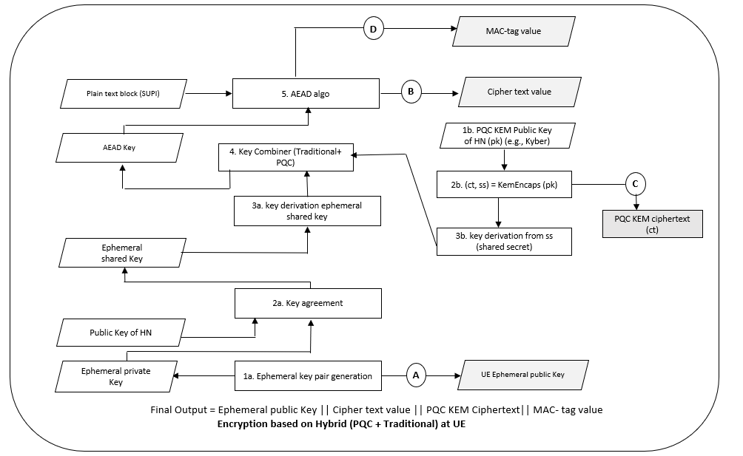
At UE, generate key pair (Ephemeral public key and private key) using key pair generation primitive. Based on the Diffie-Hellman primitive, a shared secret key element is derived (from public key of HN and generated ephemeral private key). PQC KEM ciphertext(ct) is generated using the Key encapsulation mechanism (asymmetric cryptographic scheme) where PK is PQC KEM public key of HN (PQC KEM public key is identified by PQC KEM public key ID and UDM/USIM has list of PQC KEM public keys). A PQC shared secret (ss) is also generated which is used as an input to a Key Derivation Function (KDF) to derive the final PQC shared secret.
Followed by that, key combiner function is used to combine the traditional shared key and newly generated final PQC shared secret (from the KDF function) to generate AEAD key K. With the derived key, symmetric encryption (AEAD) is performed to encrypt the plaintext block (SUPI) to generate the ciphered text and the MAC key.
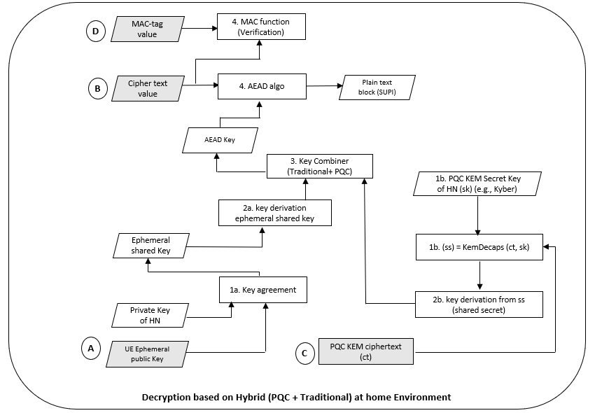
This hybrid PQC solution is making use of two separate HN identifiers, one for the classic (traditional) and yet another for the hybrid PQC. Consequently, at SIDF, the received UE ephemeral public key and stored private key of home network (Traditional HN public key ID is used to fetch the corresponding HN private key) is used to generate the ephemeral shared key. PQC KEM ciphertext(ct) is used along with the PQC KEM secret key of HN– SK (PQC Public key ID received from UE is used to fetch the Secret Key SK in HN), in Key decapsulation mechanism (asymmetric cryptographic scheme) to generate the shared secret. The newly generated shared secret is used along with the traditional ephemeral shared key as inputs to the key combiner function functions to generate AEAD Key. The generated AEAD Key is used to de-cipher the cipher text using symmetric decryption (AEAD). The expected MAC is compared against the received MAC, and with this comparison the integrity of the SUCI is verified.

7.2.1.12.3 Evaluation

This hybrid solution is considering the classic/traditional cryptographic algorithms as well as the quantum safe cryptographic algorithms. The classic/traditional procedure is making reuse of the existing in 5G, while for the post-quantum a standard key-encapsulation method will be used.
The combiner function is taking the classic/traditional and the quantum safe key as input and is computing a single secure key, that could be used further for encryption and integrity protection of the SUPI.
The specialty of this solution is that an algorithm with combined mode support could be used, such as the AEAD, and with that one key is used for cipher and integrity protection and the ciphertext and authentication tag will be provided at once, i.e., by using a single procedure call.
This solution satisfies IND-CPA security (i.e., security against passive eavesdropping attacks) but not IND-CCA2 security (i.e., security against active attacks) as per clause 4.6.3 of SP 800-227 [73].
Editor’s Note: Whether IND-CCA2 security is considered is FFS.
Editor’s Note: Evaluation on impact of initial access due to increased length of SUCI is ffs.
Editor’s Note: Evaluation on computing overhead of SUCI calculation on both UE and network side is ffs.
Editor’s Note: Whether the solution work for case that user does not update USIM card is ffs.
Editor’s Note: Further evaluation is FFS.

* * * End of Changes * * * *

