3GPP TSG-SA3 Meeting #126 S3-260844-r1 merger of 0390 and 0521

Goa, India, 09 – 13 February 2026

Source: Huawei, HiSilicon, Samsung
Title: EN addressing and evaluation for solution#4
Document for: Approval
Agenda item: 5.2.1
Spec: 3GPP TR 33.703
Version: 0.3.0
Work Item: FS_CryptoPQC

Comments
This contribution proposes some updates to solution #4 to address the Editor Notes:
Editor’s Note: it is ffs that RAND without binding to any UE specific key or encryption or MAC value will result in the attacker is just sending and RAND number blocking the genuine UE.
Editor’s Note: it is ffs that just the RAND can’t be used for routing of the information.
Editor’s Note: How does pre-configured pseudonym prevent traceability is FFS.
For the first EN, the solution is updated to use H (K, RAND) as the pseudonym. For the routing issue, routing indicator is added. For the traceability issue, COUNT is added forthe calculation of pseudonym is listed.
In addition, in the last meeting, the following comments/new ENs were raised by companies (but not treated). They are also addressed in this contribution.
Editor’s Note: resynchronization of desynchronized pseudonyms is FFS.
Editor’s Note: Further evaluation is FFS.
Editor’s Note: Whether hash extension attacks need to be considered in this solution is FFS.
Editor’s Note: Whether use of a RAND value in a scheme for which it is not intended presents a security risk is FFS.
For the resynchronization of desynchronized pseudonyms, a COUNT value is added to address the traceability issue.
For the hash extension attack, the hash function is set to HMAC, i.e. HMAC (K, RAND).
For the last EN, the RAND value is used only once in the primary authentication and does not seems to be any security risk. Otherwise, it could be re-generated.
* * * First Change * * * *

7.2.1.4 Solution #4 to SUCI calculation: SUPI Pseudonym

7.2.1.4.1 Introduction
This contribution proposes SUPI concealment using pseudonym instead of asymmetric encryption for SUPI.

7.2.1.4.2 Solution details
The Figure 7.2.1.4.2-1 illustrates the procedure:

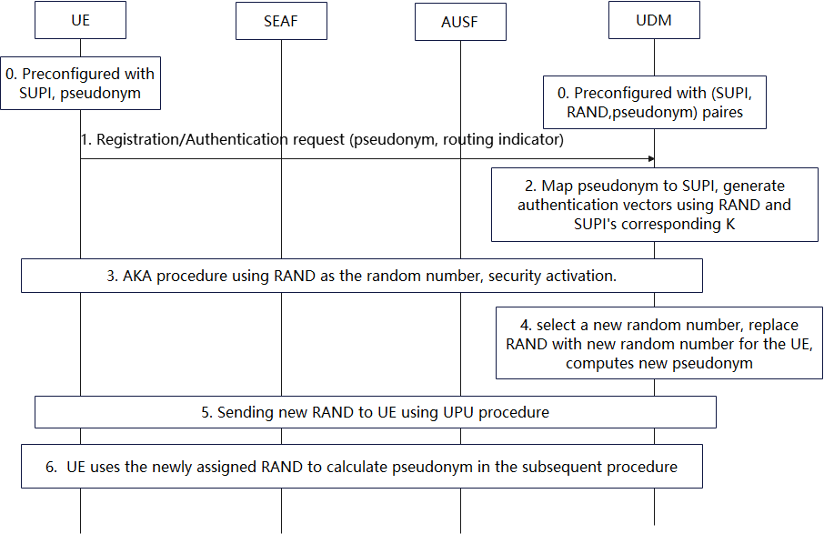
Figure 7.2.1.4.2-1 procedure of using random number to do SUPI concealment
0. The UE is pre-configured with the UE’s SUPI, a random value RAND generated by the network and a routing indicator binding to the UDM instance storing the UE’s subscription data. The UDM instance is pre-configured with the UE’s SUPI, the random value RAND and a pseudonym=H (K, RAND), the UDM can also pre-compute several pseudonyms H (K, RAND, COUNT) using different COUNT values (e.g. 0,1,2, etc.), where K is UE’s long-term key and “H” refers to HMAC, a quantum-resistant hash-based message authentication code.
1. During registration, the UE calculates pseudonym=H (K, RAND) using the pre-configured RAND, and sends pseudonym and the routing indicator as the UE's SUCI over the air interface.
2-3. The network routes the message to the corresponding UDM instance according to the routing indicator, UDM maps the pseudonym to SUPI and complete the authentication using the SUPI. The RAND can also be reused as the random value used in the primary authentication.
4-5. After authentication, the UDM instance assigns a new RAND for the UE, update the pseudonyms with H (K, RAND), H (K, RAND, COUNT) using different COUNT values (e.g. 0,1,2, etc.) and sends the new RAND to the UE. UE responses to network after receiving the new RAND value. If network did not receive the response from the UE, UDM will also keep the pseudonyms calculated using the previous RAND value.
6. The UE uses the newly assigned RAND to calculate the pseudonym and the SUCI at UE in the subsequent procedure.
After sending the pseudonym, the UE may receive a rejection message or may not receive any response after a timeout. The UE will re-calculate the value of pseudonym. i.e. H (K, RAND, COUNT) with the COUNT value is incremented by one each time a duplicate RAND value is used.
In order to address the traceability issue, a COUNT with initial values setting to 0 is introduced in the computation of pseudonym. Specifically, the UE and network compute H (K, RAND, COUNT) as the pseudonym. If the authentication is failed, the value of COUNT will increase from UE side. The UDM can pre-compute several pseudonyms using different COUNT values (e.g. 0,1,2, etc.) and compare the value to the receiving pseudonym in order to resolve SUPI.

7.2.1.4.3 Evaluation

This solution addresses the key issue about PQC migration for SUCI calculation.
This solution relies on a one-time pseudonym RAND that will serve as the SUCI value. This pseudonym is known to the UDM that can then identify the corresponding UE. After each authentication, a new pseudonym RAND’ is generated by the UDM and transmitted to the UE. This requires synchronisation between the UE and the UDM. In case a UE is desynchronized, the UE uses a COUNT value to re-calculate the pseudonym (as in the steps 1 and 6) to address the trackability issue.
Recovery procedure of pseudonym using COUNT may add additional complexity.

Editor’s Note: Further evaluation is FFS.

* * * End of Changes * * * *

