3GPP TSG-SA3 Meeting #126 draft S3-260835-r1

Goa, India, 09 – 13 February 2026

Source: Huawei, HiSilicon
Title: Address ENs in Sol#6 of TR 33.700-30
Document for: Approval
Agenda item: 5.2.9
Spec: TR 33.700-30
Version: 0.2.0
Work Item: FS_5GSAT_Ph4_SEC

Comments
This proposal is to address ENs in Sol#6.

* * * First Change * * * *

6.6 Solution #6: Secure NAS messages via using different NAS keys in multiple satellites

6.6.1 Introduction
This solution addresses “Key issue #1: Authenticated UE to exchange NAS messages with multiple satellites in split-MME architecture”.
This solution is based on split MME architecture. S&F Satellite operation may involve multiple satellites allocated by an S&F Monitoring List. In order to prevent reusing key stream, one possible approach is to use different NAS keys when UE interacts with different satellites. This solution can improve the data exchange efficiency of the entire system.

6.6.2 Solution details
Based on the existing authentication procedures, this solution proposes to use different NAS keys when UE exchanges data with multiple satellites.

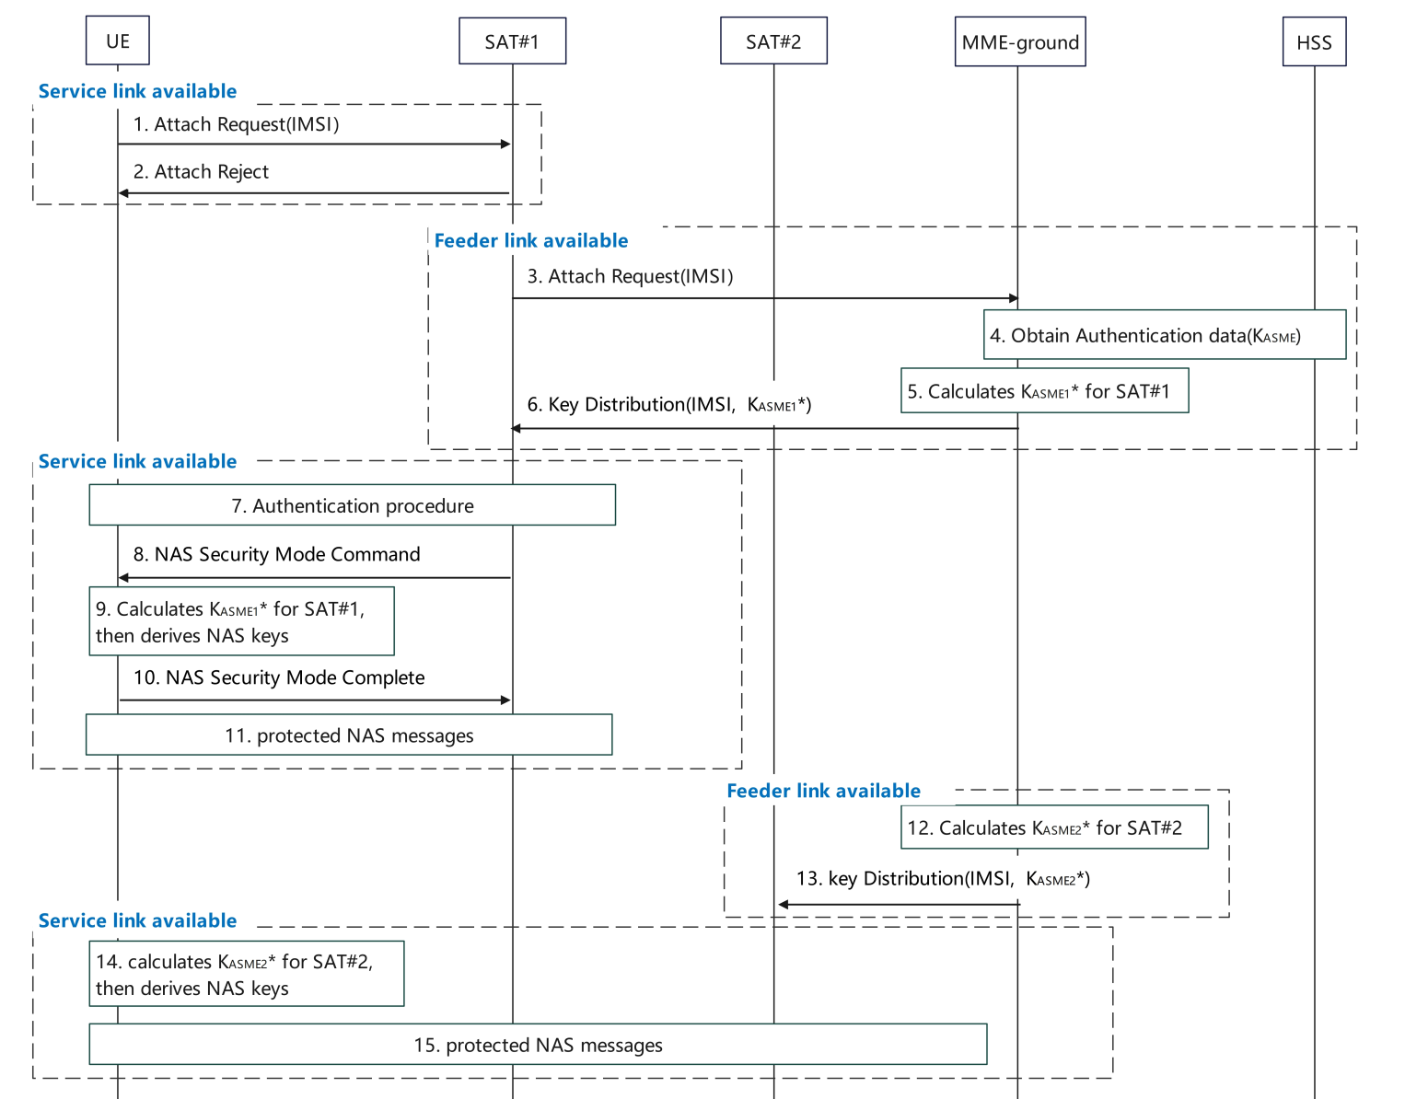
Figure 6.6.2-1 Enhanced NAS security for multiple satellites in S&F mode
SAT#1 has available Service Link.
- The UE sends the Attach Request to SAT#1.
- If SAT#1 does not have context to authenticate the UE, then sends the Attach Reject.

SAT#1 has available Feeder Link.
- SAT#1 sends the Attach Request to the MME-ground.
- The MME-ground obtains authentication data including K_{ASME}, as defined in TS 33.401 [3].
- The MME-ground determines to use SAT#1 to serve UE, then the MME-ground calculates K_{ASME1}* by using K_{ASME} and SAT Id of SAT#1.
- The MME-ground distributes K_{ASME1}* for SAT#1 during the transmission of AV.

SAT#1 has available Service Link.
- The authentication procedure is completed, as defined in TS 33.401 [3].
- SAT#1 derives NAS keys based on the K_{ASME1}* using existing mechanism as defined in TS 33.401[3] and sends the NAS security mode command integrity protected.
- The UE calculates K_{ASME1}* using the same method as the MME-ground in step5, and further derives the NAS keys using existing mechanism as defined in TS 33.401[3], then the UE verifies the NAS security mode command.
- If successfully verified, the UE sends the NAS security mode complete to SAT#1.
- After the NAS SMC procedure, the UE and SAT#1 send protected NAS messages.

SAT#2 has available Feeder Link.
- The MME-ground determines to use SAT#2 to serve the UE, the MME-ground calculates K_{ASME2}* by using K_{ASME} and SAT Id of SAT#2.
- The MME-ground distributes K_{ASME2}* for SAT#2. Then SAT#2 derives the NAS keys by using K_{ASME2}*.

SAT#2 has available Service Link.
- The UE establishes RRC connection with SAT#2 and calculates K_{ASME2}* using the method as the MME-ground in step12, and further derives the NAS keys by using K_{ASME2}*.
NOTE 1: The UE obtains the SAT Id of SAT#2 broadcast by the satellite SAT#2 to derive KASME2*.
The UE sends a protected initial NAS message to SAT#2. The successful processing of the initial NAS message by the satellite SAT#2 activates the NAS key between the UE and the satellite SAT#2. The UE and SAT#2 exchange protected NAS messages.
NOTE 2: As described in TS 23.401[2], the MME-ground together with the associated MME-onboard(s) behave jointly as a single MME entity. For multiple satellites, assume MME-onboards have the same list of ordered NAS security algorithms. After NAS SMC, the selected NAS security algorithms could be synchronized for MME-onboards. Each satellite/UE pair maintains independent COUNTs.
NOTE 3: As Store-and-Forward satellite operations involve sparse, infrequent transmissions, spread across multiple satellites, COUNT wrap-around can only occur over a substantial amount of time. It is left to network policy to determine when the MME ground re-authenticates the UE to avoid COUNT wrap around.
NOTE 4: To secure NAS messages using different NAS keys during handover-like processes in Store-and-Forward satellite operations, the UE handles satellite changes as cell reselection events and performs a protected tracking area update procedure using NAS keys.

NOTE 5: Following successful NAS security activation, AS security is established between the UE and the serving satellite by deriving the AS integrity and encryption keys from the satellite-specific KASME using the existing AS key derivation procedures, and performing the standard AS security setup, ensuring that AS security contexts are unique per satellite and aligned with the corresponding NAS security context.

6.6.3 Evaluation
This solution addresses the Key Issue #1, and it applies for S&F operations with multiple satellites. In this solution, the UE can exchange data with multiple satellites efficiently without security risk.
The solution has the following impacts:

This solution requires the MME-ground and the UE to derive new keys (i.e. K_{ASME}* derivation based on K_{ASME}) for different satellites and the UE needs to maintain multiple NAS COUNTs. This solution requires the key transfer from MME-ground to MME-onboard.
If the UE interacts with a new satellite, it computes a new K_{ASME}* and derives new NAS keys based on the same NAS security algorithms.
The same UE context cannot be re-used across satellites because new NAS keys need to be generated by the UE.
Each MME on-board needs to maintain a separate pair of NAS COUNTs.

To secure NAS messages using different NAS keys during handover-like processes in Store-and-Forward satellite operations, the UE handles satellite changes as cell reselection events and performs a protected tracking area update using NAS keys derived from the base KASME and the target satellite’s SAT ID, ensuring secure continuity without requiring real-time context synchronization between satellites.
The use of the Satellite ID when deriving the K_ASME* per satellite is a new capability that requires new means for support indication and activation.
The solution requires the UE to derive a satellite specific key for each satellite the UE establishes a NAS connection with.

* * * End of Changes * * * *

