3GPP TSG-SA3 Meeting #126 draft_S3-260832-r1
Goa, India, 9 - 13 February, 2026

Source: Huawei, HiSilicon
Title: New Solution for KI#1 securing NAS messages via one pair of COUNTs
Document for: Approval
Agenda item: 5.2.9
Spec: 3GPP TR 33.700-30
Version: 0.2.0
Work Item: FS_5GSAT_Ph4_SEC

Comments
This solution is to addresses Key issue #1. It proposes that UE provides the latest NAS COUNTs to MME-onboard.
* * * First Change * * * *

6.Y Solution #Y: Secure NAS messages via one pair of COUNTs

6.Y.1 Introduction
This solution addresses “Key issue #1: Authenticated UE to exchange NAS messages with multiple satellites in split-MME architecture”.
For MME-split architecture in S&F mode, UE could interact with more than one satellites. The NAS COUNTs are not synchronized across multiple satellites. However, the UE has the latest NAS COUNTs. This solution proposes that the UE provides the latest NAS COUNTs to MME-onboard, which can realize NAS COUNTs synchronization.

6.Y.2 Solution details
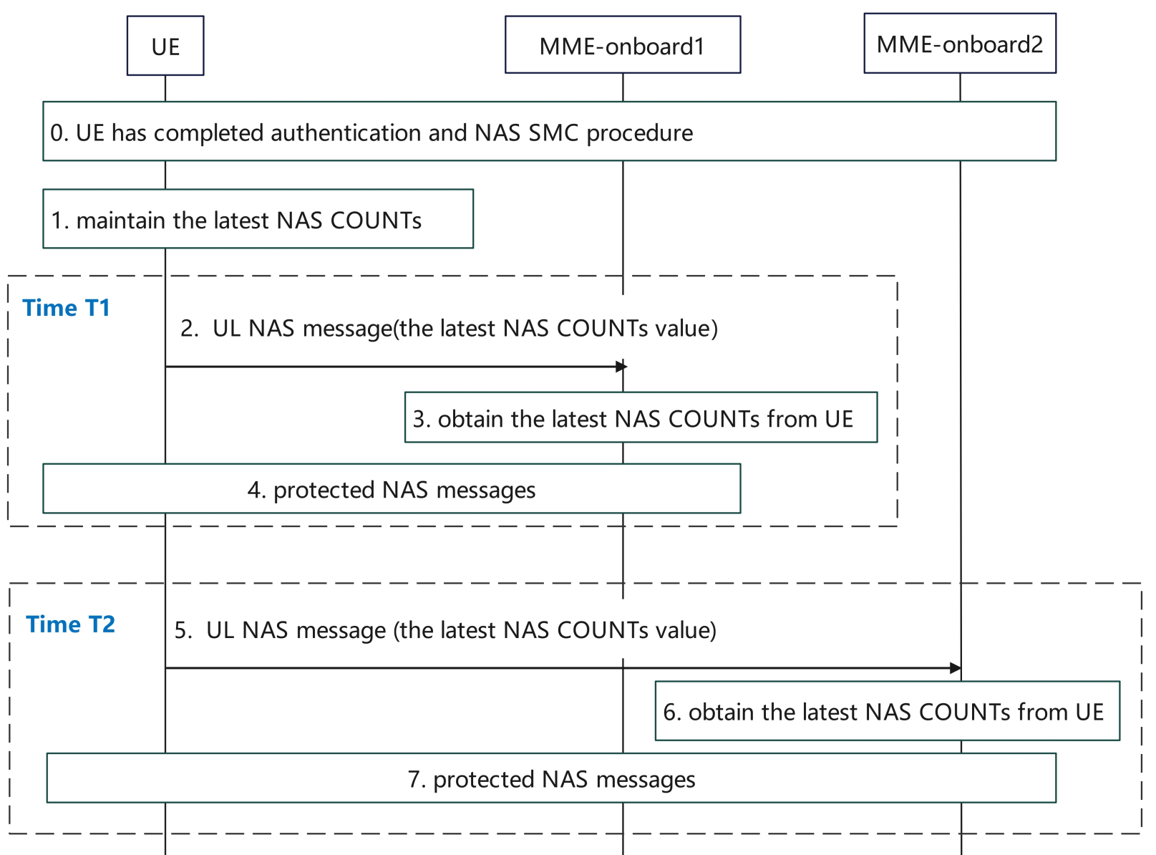
Figure 6.Y.2 Secure NAS messages via one pair of COUNTs
- The UE has completed authentication and NAS SMC procedure with an MME-onboard.
- The UE maintains the latest NAS COUNTs, including the UL NAS COUNT and DL NAS COUNT. NAS COUNT is constructed by NAS OVERFLOW and NAS SQN.
- At Time T1, the UE starts to communicate with MME-onboard1. The first UL NAS message includes the latest value of UL NAS COUNT and the latest value of DL NAS COUNT. The latest values of NAS COUNTs are integrity protected. To prevent replay attack, satellite ID is used as an input to integrity protect the NAS message.
- MME-onboard1 could obtain latest NAS COUNTs from UE. With the latest value of UL NAS COUNT, the MME-onboard1 verifies the integrity of NAS message received from step2. If verified successful, the MME-onboard1 obtains the latest value of UL NAS COUNT and the latest value of DL NAS COUNT.
Editor’s Note: How DL NAS COUNT is used when DL NAS COUNT on MME is higher than the one from UE.
- The UE and MME-onboard1 interact with protected NAS messages based on the latest NAS COUNT values.
5-7. At Time T2, the UE starts to communicate with MME-onboard2. These steps are similar with steps 2-4.

6.Y.3 Evaluation
This solution addresses the Key Issue #1, and it applies for S&F operations with multiple satellites.
This solution introduces extra overhead for UE to send additional parameter to MME.
* * * End of Changes * * * *

