3GPP TSG-SA3 Meeting #126 draft_S3-260774-r2

Goa, India, 9 – 13 February 2026 merger of S3-260257, S3-260474, S3-260738, S3-260480, S3-260259, S3-260400, S3-260481, S3-260573, S3-260211

Source: vivo
Title: Clean up for TR 33.785
Document for: Approval
Agenda item: 5.2.6
Spec: 3GPP TR 33.785
Version: 0.3.0
Work Item: FS_AIML_CN_Ph2_SEC

Comments
This contribution cleans the editor’s notes in TR 33.785.

* * * First Change * * * *

2 References
The following documents contain provisions which, through reference in this text, constitute provisions of the present document.
- References are either specific (identified by date of publication, edition number, version number, etc.) or non-specific.
- For a specific reference, subsequent revisions do not apply.
- For a non-specific reference, the latest version applies. In the case of a reference to a 3GPP document (including a GSM document), a non-specific reference implicitly refers to the latest version of that document in the same Release as the present document.
[1] 3GPP TR 21.905: "Vocabulary for 3GPP Specifications".
[2] 3GPP TR 23.700-04: "Study on Core Network Enhanced Support for Artificial Intelligence (AI)/Machine Learning (ML)".
[3] 3GPP TS 33.501: "Security architecture and procedures for 5G system".
[4] 3GPP TS 33.535: "Authentication and Key Management for Applications (AKMA) based on 3GPP credentials in the 5G System (5GS)".
[5] 3GPP TS 33.210: "Network Domain Security (NDS); IP network layer security".
[6] IETF RFC 4279: "Pre-Shared Key Ciphersuites for Transport Layer Security (TLS)".
[7] IETF RFC 8446: "The Transport Layer Security (TLS) Protocol Version 1.3".
[xx] 3GPP TR 23.700-42: "Study on Application user consent”.
* * * Next Change * * * *

5 Key issues

5.1 Key Issue #1: Security of UE connection setup with Data Collection NF

5.1.1 Key issue details
The architecture requirement in clause 4.2 of TR 23.700-04 [2] is that MNO has full controllability and visibility for standardized data and a UP path is used between the UE and a data collection network function for transferring standardized collected data from the UE using PDU connectivity service provided by a PDU session as described in clause 7.1.1 of TR 23.700-04 [2]. That means the training data between UE and the 5G core will be standardized and it is visible to 5G core and MNO will be data controller.
The key issue aims to address the security issues, such as authentication and authorization for the UE during the connection setup with the data collection network function (Naming and role of data collection function is subject to progress of TR 23.700-04 [2]). This will ensure only legit and authorized UE are able to share its data towards the Data collection NF.
Another aspect is to address the security issues, ensuring integrity and confidentiality of the UE related data between UE towards the 5GC Data collection NF as studied in KI#1 of TR 23.700-04 [2] to meet requirements for AI/ML for NR air interface operation with UE-side model training.
So, the focus is to identify the means to authenticate and authorize the UP connection setup between UE and NF before the data transmission take place and to study security of the UP communication between UE and data collection NF during data transmission.

5.1.2 Security threats
Lack of authentication and authorization may lead to unauthorized access to network services.
Lack of confidentiality, integrity protection in collecting UE related data can lead to disclosure and tampering of UE related information.
Tampering of UE related data in transit can also impact the quality of training data towards 5GC data collection NF and subsequently to external OTT servers.
Lack of user consent may lead to inadvertent UE data disclosure.

5.1.3 Potential security requirements
The 5GS should support authentication and authorization between UE and data collection NF before data transmission takes place.

NOTE 1: Authentication and authorization between UE and data collection NF is not addressed in the present document.
The 5GS should support confidentiality, integrity and replay protection for data in transit between UE and data collection NF.
The 5GS should support user consent mechanism for data collection by the network depending on the local regulations and operator policies.

NOTE 2: Whether user consent is applicable or not is not addressed in the present document.

5.2 Key Issue #2: Security and Authorization for Exposure of UE Data towards OTT Servers

5.2.1 Key issue details
As studied in TR 23.700-04 [2], training data for AI/ML-based NR air interface operation with UE-side model training may be transferred via the 5G Core (5GC) and then exposed to external OTT servers. The exposure of such UE-related data outside the 3GPP domain introduces security risks that need to be addressed at the exposure interface (e.g., via NEF).
The exposure interface requires mechanisms to:
- Authenticate OTT servers before any data exposure.
- Authorize and apply access control to restrict exposed data to what is necessary for the OTT server.
- Provide confidentiality, integrity, and replay protection of the exposed data during transport.
- Ensure that exposure of UE-related data complies with user consent.

5.2.2 Security threats
Unauthenticated or impersonating OTT servers could obtain sensitive UE-related data.
Without authorization, OTT servers can abuse UE-related data exposure services.
Leakage, tampering, or replay of UE-related data at the NEF and OTT/AF interface could compromise integrity, confidentiality.
Exposure of UE information without proper consent may violate regulations and create liabilities for the MNO.

5.2.3 Potential security requirements
The 5GS shall support mutual authentication between the NEF and OTT/AF servers handling UE-related data.
The 5GS shall support authorization mechanisms for services related to exposure of UE-related data to the OTT server.
The 5GS shall support confidentiality, integrity, and replay protection for UE-related data during transfer between NEF and OTT/AF.

6 Solutions

6.1 Mapping of solutions to key issues

Table 6.1-1: Mapping of solutions to key issues
 | Key Issues
Solutions | #1 | #2
#1 | X
#2 | X
#3 | X
#4 | X
#5 | X
#6 |  | X
#7 |  | X
#8 |  | X
#9 |  | X
#10 |  | X
#11 | X

6.2 Solution #1: Security of UE connection setup with Data Collection NF

6.2.1 Introduction
This solution addresses requirements of key issue #1.
For authorization and user consent check between UE and data collection NF, it proposes that the entity who selects UE for data collection is deemed as enforcement point. Especially for user consent check, the existing mechanism can be reused.
For authentication and communication protection, it proposes that 3GPP network sends security parameters (e.g. PSK) to the UE in protected RRC/NAS message and the UE uses the security parameters to establish secure connection (e.g. TLS) with the DCF for UP data transferring.

6.2.2 Solution details
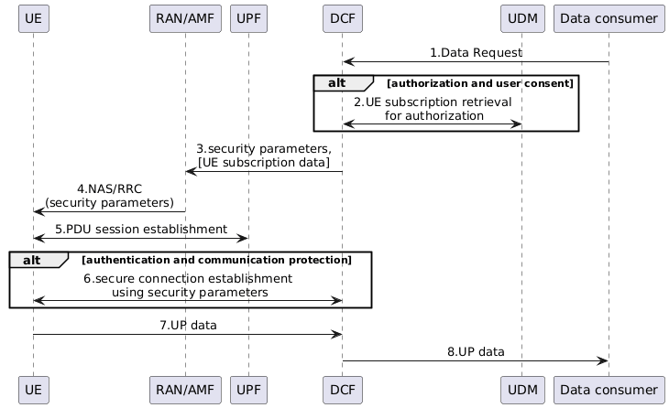
Figure 6.2.2-1: Security of UE connection setup with Data Collection NF
1. Data consumer (e.g. UE model training entity server) requests UE data collection to DCF.
2. DCF retrieves UE subscription data from UDM. The subscription data includes:
a) User consent data: existing user consent parameters can be reused.
b) Authorization profile: whether UE is allowed for exposing specific data to specific data consumer.
The DCF can be enforcement point for authorization and user consent check if it decides that DCF is used for UE selection for data collection.
3. The DCF sends security parameters (e.g. PSK) to the RAN/AMF. The DCF may also send UE subscription data to the RAN/AMF to enforce the authorization and user consent check if it decides that RAN/AMF is used for UE selection for data collection.
4. The RAN/AMF sends security parameters to the UE. The security parameters are protected by RRC/NAS mechanism.
5. The UE establishes a PDU session as depicted in clause 7.1.1 of TR 23.700-04 [2].
6. The UE establishes a secure connection using the security parameters to the DCF, e.g. the UE uses PSK to establish a secure TLS connection with the DCF.
7. The UE reports UP data in the secure connection to the DCF.
8. The DCF reports UP data to the Data consumer.
One alternative of PSK generation is that
- UE and Network (AUSF or AMF) derive the PSK independently via the root key (K_{AUSF} or K_{AMF}). For this network sends the random value as a salt to UE; and UE and Network uses the same salt to drive the same PSK.
- Rest of the details of the key derivation is not defined in this solution.

NOTE 1: Aspect related to user consent its application and enforcement in any form for UE data collection is not addressed.

NOTE 2: Applicability and distribution of related security parameter (i.e. PSK) for the purpose of secure channel establishment or applicability of UE subscription data and its distribution to AMF/RAN in any form is not addressed.

NOTE 3: The need for UE authentication is not addressed.

NOTE 4: How the network sends the random value as salt to UE and how it is used for PSK generation is not addressed.

6.2.3 Evaluation
None.

6.3 Solution #2: Security for Data Collection using a DCF

6.3.1 Introduction
This solution addresses Key Issue #1.
This solution builds on TR 23.700-04 (for the standardized transfer of standardized data over UP for UE-side data collection) and introduces security enhancements in the 5GS for secure UE connection setup and data transfer with a Data Collection Function (DCF).

6.3.2 Solution details
Architecture scope and roles
- DCF in the MNO domain manages Data Collection Profiles (DCPs) and orchestrates UE data collection and transfer,
Security functions
1) Authentication and session protection between UE and DCF
- The UE establishes a secure association with the DCF using shared key derived from network credentials. Transport security (e.g., TLS) is bound to the shared key. Options for shared key derivation are:
- Option #1: AKMA-based keys (TS 33.535 [4]). DCF acts as a trusted AF, and obtains KAF from the AAnF over SBI.

NOTE 1: The role of DCF acting as AF is not addressed in the present document.
- Option #2: K_{AMF} derived shared key. DCF obtains the shared key from AMF over SBI.
UE sends its 5G-GUTI to the DCF in the ClientHello message. DCF requests a PSK for the UE from the AMF, providing 5G-GUTI. UE and AMF derive PSK using K_{AMF} as input KEY, and parameters including SUPI, FQDN/IP address of DCF.

NOTE 2: Whether TLS implementations allow exporting 5G-GUTI in the ClientHello to the SBA layer is not addressed in the present document.
2) UE authorization and policy enforcement
- The DCF authorizes a UE to participate per DCP, using subscription, consent, and operator policy.

NOTE 3: Whether and how DCP is applicable is not addressed in the present document.
3) Consent enforcement inside the Core Network
- The DCF acts as the consent enforcement point for data collection from the UE, i.e., checks consent from UDM/UDR for permissions, as per TS 33.501 [3], Annex V.

NOTE 4: Whether and how user consent exposure applies is not addressed in the present document].

6.3.3 Evaluation
None.

NOTE 1: The need for UE authentication is not addressed in the present document.

6.4 Solution #3: Security of connection between UE and Data Collection NF

6.4.1 Introduction
This solution address KI#1 Security of UE connection setup with Data Collection NF by reusing the existing TLS based mechanism.

6.4.2 Solution details
The UE establishes the user plane connection to the Data Collection NF, to protect the interface, the TLS based mechanism is supported. AKMA specified in TS 33.535 [x] or GBA specified in TS 33.220[y] could be reused to secure the end-to-end connection between the UE and the Data collection NF. The Data collection NF takes the role of AF in case AKMA is used, or NAF in case GBA is used.

NOTE 1: How to perform AKMA is not addressed in the present document.

NOTE 2: DCF acting as an AF and its role is not addressed in the present document.

6.4.3 Evaluation

None.

6.5 Solution #4: New solution for Security of UE connection setup with Data collection NF

6.5.1 Introduction
This solution addresses requirements of key issue #1: "Security of UE connection setup with Data collection NF", particularly by hop-by-hop security. For authorization and user consent check between UE and data collection NF, it proposes detailed authorization checks against UE subscription data and operator policies at the data collection NF (DCF).

6.5.2 Solution details
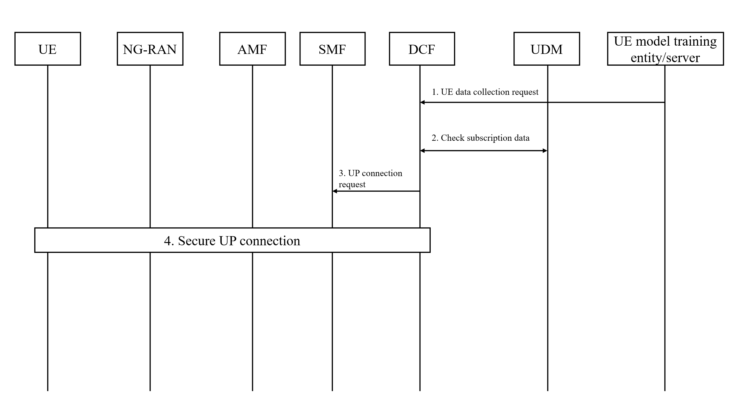
Figure 6.5.2-1: Security of UE connection setup with Data Collection NF
1. The UE model training entity/server sends a request to the DCF to collect UE data for UE side model training.
2. The DCF checks subscription data for UE data collection and transfer from the UDM.
3. After successful authorization and user consent check, UE and UPF, DCF sends a request to SMF to establish a secure UP connection.
4. The procedure of secure UP connection shall reuse existing UP security mechanisms from TS 33.501 [3] between UE and gNB, reuse exiting NDS/IP specified in TS 33.210 [5] between gNB and DCF.

NOTE 1: The authentication between UE and data collection NF is not addressed in the present document.

NOTE 2: Aspect related to user consent its application and enforcement in any form for UE data collection is not addressed in the present document.

NOTE 3: How the solution covers all the requirements of KI#1 is not addressed in the present document.

NOTE 4: How the UE perform data collection is not addressed in the present document.

6.5.3 Evaluation

None.

6.6 Solution #5: Secure communication between UE and the data collection function

6.6.1 Introduction
This solution addresses part of KI#1, i.e. secure communication and mutual authentication between UE and the data collection function.
Secure connection is required between the UE and the data collection function, the connection between the UE and the data collection function can be secured by the TLS or NDS/IP and UP security in this solution.
The generation of shared key depends on other solutions in this document.
According to RFC 4279 [6], to enable data collection function to identify the shared key, UE needs to send the PSK identity to the data collection function via ClientKeyExchange message.
According to RFC 8446 [7], to enable the data collection function to identify the shared key, UE needs to send the PSK identity to the data collection function via pre_shared_key extension.
In this solution, the PSK identity is set as SUCI to enable the data collection function to identify the correct shared key.

6.6.2 Solution details
For connection between UE and the data collection function located in home network, the TLS connection between the UE and the data collection function can be used for protecting the UE data. The TLS can be established based on key shared between the UE and the data collection function.
The shared key is generated based on mechanisms defined in other solutions in this document (e.g., data collection function generates the shared key, the AKMA based mechanism).
Since the PSK identity is delivered in an insecure environment (i.e., the TLS tunnel between UE and the data collection function is not established yet), the PSK identity is set as the SUCI of the UE when the AKMA/GBA based mechanism is not used.
After receiving the PSK identity (i.e., the SUCI), the data collection function interacts with the UDM/UDR/ADRF to retrieve the SUPI and uses the SUPI to identify the shared key.

NOTE 1: Whether TLS implementations support exporting PSK identity for retrieving PSK is not addressed in the present document.

NOTE 2: How the shared key is generated is not addressed in the present document.

NOTE 3: How SUCI and other user identifiers are used to identify PSK and how and if those are utilized for key derivation are not addressed in the present document.
For connection between UE and the data collection function located in home network, the connection between the UE and base station, the connection between base station and the UPF, the connection between the UPF and the data collection function will be secured. Then the following mechanisms can be reused.
- The connection between UE and base station can be secured based on user plane related security algorithms defined in clause 6.6 of TS 33.501[3].
- The connection between base station and UPF can be secured based on existing NDS/IP as specified in clause 9.3 of TS 33.501 [3].
- The connection between UPF and the data collection function can be secured based on existing NDS/IP as specified in clause 9.3 of TS 33.501 [3].

6.6.3 Evaluation

None.

NOTE 1: How the UE perform data collection is not addressed in the present document.

6.7 Solution #6: UE-side Data Collection Exposure

6.7.1 Introduction
This solution addresses Key Issue #2.
This solution builds on TR 23.700-04 [2] (for the standardized transfer of standardized data over UP for UE-side data collection) for the secure, authorized, and privacy-preserving exposure of UE-related data towards OTT servers via the 5GC exposure function (e.g., NEF).

6.7.2 Solution details
Architecture scope and roles
- DCF in the MNO domain manages Data Collection Profiles (DCPs) and orchestrates UE data collection and transfer towards the OTT server via NEF. The NEF exposes authorized subsets of collected data with any applicable post-processing done by DCF prior to being forwarded to OTT servers.
Security functions
1) OTT server authentication and authorization and policy enforcement
- The NEF authenticates and authorizes the OTT server using existing mechanisms, to transfer data collected from the UE based on subscription information and operator policy.
2) Data access control
- DCF enforces access control and visibility of collected data and UE information before exposure outside the MNO domain, with the following:
- DCF applies per parameter access control (e.g., filtering) based on DCP visibility configuration. For example, DCF may replace or filter identifiers not authorized for external exposure.

NOTE: Aspects related to DCP, post processing, enforcement of access control and visibility is not addressed in the present document.
3) Data exposure toward OTT servers (NEF-facing)
- Exposure is constrained to authorized datasets as provided by DCF.

6.7.3 Evaluation
None.

6.8 Solution #7: Security and Authorization for Exposure of UE Data towards OTT Servers

6.8.1 Introduction
This clause outlines the security considerations for AF authentication, communication security between NEF and AF and authorization for data collection procedure between both AFs and DCF utilizing NRF token-based approach. General mechanism to utilise the token-based authorization is specified in clause 13.4.1 of TS 33.501 [3].
As specified in clause 12.2 of TS 33.501 [3] for authentication between NEF and an AF that resides outside the 3GPP operator domain, mutual authentication based on client and server certificates shall be performed between the NEF and AF using TLS.
As specified in clause 12.3 of TS 33.501 [3] TLS shall be used to provide integrity protection, replay protection and confidentiality protection for the interface between the NEF and the AF to secure the communication data.

6.8.2 Solution details

NOTE 1: Whether the DCF is a new NF or the existing one is not addressed in the present document.
Figure 6.8.2-1: Authorization for Exposure of UE Data towards OTT Servers
1a. In case of untrusted AF OTT server, the NEF registers its NF profile at the NRF with AF’s related parameters that includes AF ID, data context ID(s), and Filter info (e.g. AoI(s)).
1b. DCF registers its NF profile at the NRF that consists of allowed list which contains AF ID, data context ID(s), Filter info (e.g. AoI(s)) that indicates whether the specific AF is allowed to access specific set of UE.

NOTE 2: What constitutes the allowed list during the DCF profile registration how this is implemented is not addressed in the present document.
2. The OTT server sends Service Request towards NEF. The Service request shall contain the AF ID, and data context ID(s), Filter info (e.g. AoI(s)).
3. The NEF requests an access token from the NRF. The access token request shall contain AF ID, data context ID(s), Filter info (e.g. AoI(s)).

NOTE 3: Which input parameters are mandatory is not addressed in the present document.
4. The NRF checks whether NEF on behalf of OTT Server is authorized to access DCF services by comparing the allowed list parameters that contains AF ID, data context ID(s) and Filter info (e.g. AoI(s)) received in step 1b and the one received in step 3.
5. If the NEF is authorized, the NRF will issue an access token(s) in response. The token claim shall include parameters as part of the allowed list i.e. AF ID, data context ID(s) and Filter info (e.g. AoI(s)).

NOTE 4: What constitute the access token claims is not addressed in the present document.
6. The NEF sends service request with parameters as received in step 2 and the access token claims received in step 5 to DCF.
7. The DCF verifies the received access token as specified in clause 13.4.1 and checks for the token claims. The DCF extracts the allowed list parameters i.e. AF ID, data context ID(s) and Filter info (e.g. AoI(s)), and checks whether it matches the one received in step 6.
8. In case of successful access token verification, the DCF returns the requested data collected to the NEF and that is subsequently returned to the OTT server.

NOTE 5: Utilizing specific authorization parameters and overall solution alignment with TR 23.700-04 [2] (e.g. data collection procedure) is not addressed in the present document.

NOTE 6: NRF based OTT server authorization is not addressed in the present document.

6.8.3 Evaluation

None.

6.9 Solution #8: Authorization for Exposure of UE Data towards OTT Servers

6.9.1 Introduction
As studied in TR 23.700-04 [2], the CN may exposure the data to the OTT Servers. These data are collected by the CN from various UEs which may belong to different Vendors or TACs. And some vendors or chipsets vendors may have concern to exposure the data of its product (e.g., UE or chipset) to other vendors. The CN needs to consider the concerns of equipment vendors when exposure data to the OTT Servers by verify the vendor ID of AF is in the allowed vendors of vendors for the request data.

6.9.2 Solution details
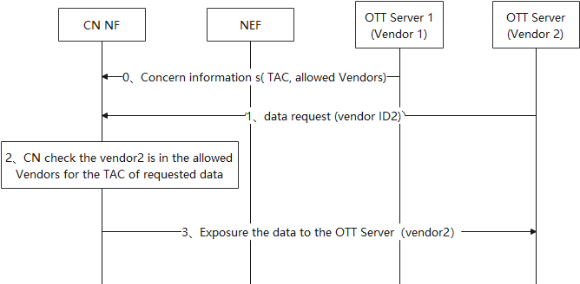
Figure 6.9.2-1: Authorization for Exposure of UE Data towards OTT Servers
0. The OTT servers register the data exposure concerns to the CN. The data exposure concerns include: UE information (e.g., Vendor ID, TAC) and its allowed vendor list. The OTT server agree to exposure the data collected from the UE in the UE information to the vendor in the allowed vendors.
1. OTT server as the data consumer send data request to the CN, including Vendor ID of the OTT server.
2. The CN determines the data and checks whether the vendor ID of the data consumer is in the allowed vendor list corresponding to the UE information for the data.
3. The CN return the requested data to the OTT server.

NOTE 1: The overall solution alignment with TR 23.700-04 [2] is not addressed in the present document.

NOTE 2: How the CN NF determines the UE vendor ID of the UE that provided the data is not addressed in the present document.

NOTE 3: How the CN NF verifies the vendor ID of the OTT server is not addressed in the present document.

NOTE 4: Whether the use case of delegation of authorization among OTTs is not addressed in the present document.

6.9.3 Evaluation

None.

6.10 Solution #9: Secure mechanism for NEF and OTT/AF interaction

6.10.1 Introduction
This solution addresses KI#2.
Specifically, existing mechanisms defined in TS 33.501 [3] are reused to address the issue.

6.10.2 Solution details
TLS based mechanism defined in clause 12.2 of TS 33.501 [3] is reused for mutual authentication between the NEF and the OTT/AF servers handling UE-related data.
Authorization mechanism defined in clause 12.4 or 12.5 of TS 33.501 [3] is reused for authorizing services related to exposure of UE-related data to the OTT server.

NOTE: Authorization part is not addressed in the present document.
TLS based mechanism defined in clause 12.3 of TS 33.501[3] is reused for protecting UE-related data transferred between the NEF and the OTT/AF servers handling UE-related data.

6.10.3 Evaluation
Existing TLS based mechanism defined in clause 12 of TS 33.501 [3] can be reused for mutual authentication and communication protection between NEF and the OTT/AF servers handling UE-related data.

NOTE: Evaluation is not completed.

6.11 Solution #10: Granular authorization for OTT/AF

6.11.1 Introduction
This solution addresses requirements of key issue #2.

6.11.2 Solution details
When AF or OTT requests UE-side model training data from DCF via NEF, the exposure of such UE data outside the 3GPP domain introduces security risks requiring control at the exposure interface, particularly for authorization.
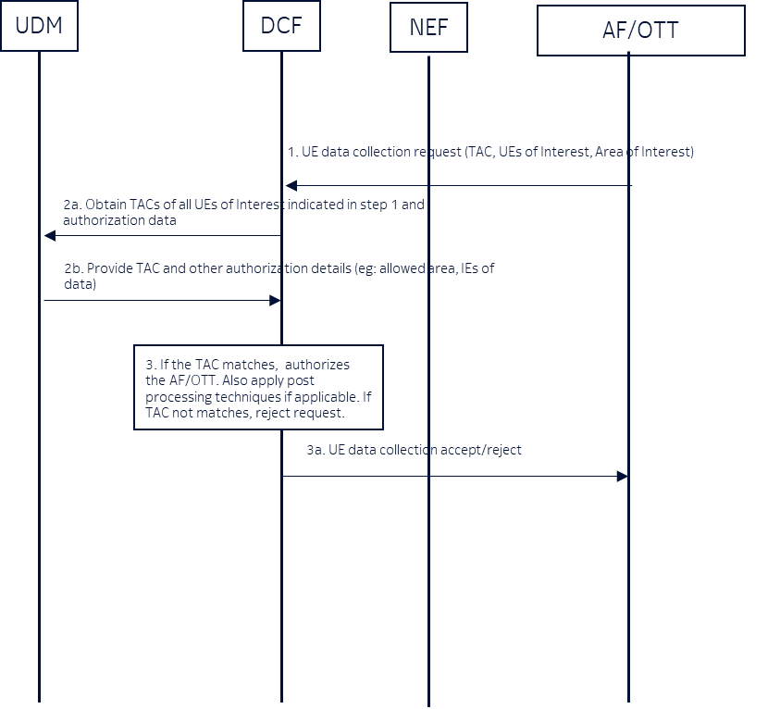
Figure 6.11.2-1: Granular authorization for OTT/AF
1: An AF/OTT server requests UE-side model training data from the DCF via the NEF, including the Type Allocation Code (TAC). This request optionally includes UEs of interest, and/or areas of interest from which UE data needs to be collected.
NEF authenticate and authorize the AF/OTT via mTLS and authorization procedure defined in TS 33.501 [3], section 12. NEF and AF/OTT data exchange is integrity, confidentiality and replay protected via existing means.
Note 1: AF/OTT server can access data from UEs primarily when the UE's TAC matches the TAC specified by the AF/OTT, or from other TACs if permitted by operator policy/configuration in UDM.
Note 2: The Type Allocation Code (TAC) is the first 8 digits of the 15-digit International Mobile Equipment Identity (IMEI) number. It uniquely identifies the make and model of a mobile device.
2: The DCF queries the UDM to obtain UE’s TAC and optionally retrieves authorization data from the UDM. This authorization data includes
- allowed geographical area for data collection, (e.g. UE1 is allowed to collect data at certain location)
- allowed IEs for UE-side model training data
- applicable post processing on IEs before exposure
This authorization data can also be configured locally.
3: Based the information received from the UDM (or locally configured), the DCF authorizes the AF/OTT for data collection for selected UEs. E.g., If TAC does not match, then DCF rejects the request. If UE area does not fall into allowed geographical area, then reject the request. DCF also uses this information from the UDM to select the authorized list of UEs.
If there is a policy to apply post processing on the IE before the exposure, e.g. anonymization, the DCF shall apply the same.

NOTE 1: Whether UDM is the right NF to store this granular information is not addressed in the present document.

NOTE 2: Aspect related to allowed IEs for UE side model training data and applicable post processing on IEs before exposure is not addressed in the present document.

6.11.3 Evaluation

None.

6.12 Solution #11: Security of UE connection setup with Data Collection NF using TLS

6.12.1 Introduction
This solution addresses Key Issue #1 "Security of UE connection setup with Data Collection NF".

6.12.2 Solution details
This solution proposes that the security between the UE and the Data Collection NF is based on TLS. TLS is a well-established security protocol at the transport layer and provides authentication, confidentiality, integrity and replay protection.
Authentication of the Data Collection NF towards the UE can be based on server-side certificates. This requires the provisioning of the root certificate at the UE by the operator of the network where the Data Collection NF is located.

NOTE 1: Whether server side only authentication is sufficient is not addressed in the present document.

NOTE 2: Client cert provisioning is not addressed in the present document.
For authentication of the UE towards the Data Collection NF there are several options. The operator of the network where the Data Collection NF could provision client-side certificates to the UE. It is also possible to use AKMA or to decide that only server-side authentication is required. This decision needs to be done by the operator of the network where the Data Collection NF is located.

NOTE 3: AKMA solution details are not addressed in the present document.
The TLS protocol profiles for secure support and usage of TLS in 3GPP TS 33.210 [5], clause 6.2, need to be followed. This implies that TLS 1.1 and earlier versions of TLS are not to be supported.
This solution also proposes that authorization at UE and Data Collection NF is based on local policy.

NOTE 4: Authorization details are not addressed in the present document.
If the underlying transport protocol is datagram-based, e.g. UDP, instead of TLS the DTLS or QUIC protocol could be used.

6.12.3 Evaluation
None.

* * * End of Changes * * * *

