3GPP TSG-SA3 Meeting #126 draft S3-260767-r1

Goa, India, 09 – 13 February 2026

Source: Huawei, HiSilicon
Title: Resolving the ENs on Solution #2
Document for: Approval
Agenda item: 5.2.3
Spec: TR 33.786
Version: 0.0.0
Work Item: FS_AIMLE_SEC

Comments
This contribution proposes to resolve Editor’s Notes.

* * * First Change * * *

6.2 Solution #2: Authorization of AIMLE clients acting as FL members for access to AIMLE Service Security

6.2.1 Introduction
This solution proposes the authorization of AIMLE clients in support of federated learning (FL). It ensures that only authorized clients (FL members) are selected, and that secure token-based verification is performed using authorization server. Tokens include only the minimum required claims such as ML model ID / Application Data Analytics Enablement (ADAE) analytics ID and ML model interoperability information to maintain security while ensuring interoperability.

6.2.2 Solution details

6.2.2.1 The procedure for AIMLE clients’ authorization
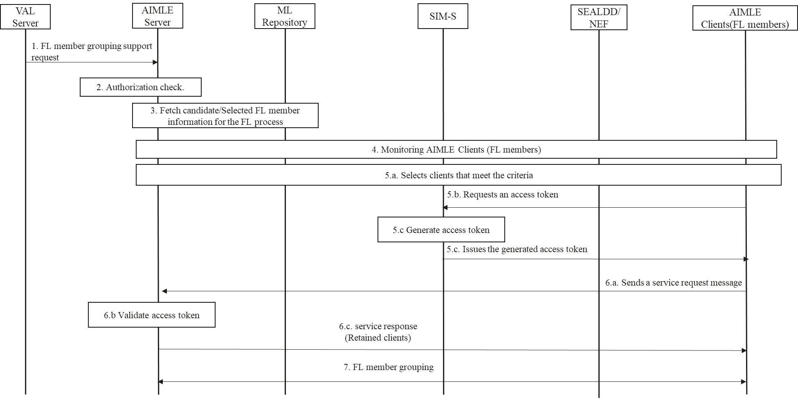
Figure 6.2.2.1-1 Authorization’s procedure of AIMLE clients acting as FL members
1. The VAL server sends a FL member grouping support request to the AIMLE server. The request includes the requestor ID, security credentials, and FL grouping criteria (e.g., grouping method, member selection criteria). The initial request is to create the FL member grouping support as described in Step 1 of clause 8.17.2 of TS 23.482 [3]. The security credentials authenticate the VAL server's identity and authorize the grouping request, with validation by the AIMLE server.
2. Upon receiving the request, the AIMLE server validates whether the requestor is authorized to make it.
3. If authorized, the AIMLE server performs an FL member registration fetch with the ML repository based on the FL grouping criteria (see Step 3 of clause 8.17.2 in TS 23.482[3]).
4. The AIMLE server monitors AIMLE clients (FL members) to check whether they meet the selection criteria from step 1 as described in Step 4 of clause 8.13.2.2 of TS 23.482 [3]. AIMLE server interacts with NEF and/or SEAL services (including SEALDD) to set up monitoring. For location-based criteria, it uses SEAL-LMS (3GPP TS 23.434 [5] clauses 9.3.11/9.3.12) or 5GC services (e.g., NEF) to detect UEs entering or present in the target area.
5.a. Using monitoring results, the AIMLE server selects clients that meet the criteria and removes those that do not (e.g., due to location changes). The selected clients are forwarded to the SIM-S, which issues the corresponding access tokens.
NOTE 1: The frequency at which monitoring results are provided is left to the implementation.
5.b. Each selected AIMLE client requests an access token from the SIM-S,. The access token request sent to the SIM-S, includes the following parameters: ML model ID / ADAE analytics ID and ML model interoperability information.
5.c. Upon receiving the request, the SIM-S, issues the generated access token to the client.
6.a. If AIMLE client obtains the access token, the AIMLE client sends a service request message to AIMLE server, requesting the AIMLE server to join FL group. The message contains the ML model ID / ADAE analytics ID and ML model interoperability information, and access token.
6.b. The AIMLE server performs token verification. The AIMLE server obtains the ML model ID / ADAE analytics ID and ML model interoperability information contained in the access token and verifies whether they match the corresponding values in step 6.a.
6.c. In case of successful access token verification, AIMLE server retains the client by sending the service response to the retained clients.
7. The AIMLE server performs the FL member grouping, notifies selected AIMLE clients of their group membership, collects acknowledgements, and returns a FL member grouping support response to the VAL server that includes success/failure status, grouping details, and an optional expiration time for the grouping.

6.2.3 Evaluation

This solution addresses authorization in AIMLE client-related service procedures in TS 23.482 (e.g., client selection, participation, and FL member grouping in clauses 8.8-8.10, 8.13, 8.17) by requiring VAL servers to provide authenticated credentials for requests, enabling AIMLE servers to monitor and select clients while AIMLE clients obtain access tokens from SIM-S (as authorization server per TS 33.434 clause 5.2), with tokens including ML model ID/ADAE analytics ID and interoperability info; clients then request to join FL groups, where AIMLE servers (as resource servers) verify tokens to retain only authorized clients, preventing unauthorized access during monitoring and grouping.

This solution requires each AIMLE client selected through AIMLE-server monitoring and selection to request an access token from the SIM-S and subsequently send an FL participation request to the AIMLE server, where AIMLE servers verify tokens to retain only authorized AIMLE clients.

* * * End of Changes * * * *

