3GPP TSG-SA3 Meeting #126 S3-260181

Goa, India, 9 – 13 February 2026

Source: Nokia
Title: Pseudo-CR on Introduction of user scenarios for 256-bit support
Document for: Approval
Agenda item: 5.3.2
Spec: 3GPP TR 33.771
Version: 0.2.0
Work Item: FS_AEAD

Comments
This pCR is introducing user scenarios for the 256-bit support, with the aim to identify which user scenario fits best for which 256-bit mode. In this context the definition of terms will be provided.

* * * First Change * * * *

3.3 Abbreviations
For the purposes of the present document, the abbreviations given in TR 21.905 [1] and the following apply. An abbreviation defined in the present document takes precedence over the definition of the same abbreviation, if any, in TR 21.905 [1].

AEAD Authenticated Encryption with Associated Data
AKA Authentication and Key Agreement
AMF Access and Mobility Management
AS SMC Access Stratum Security Mode Command
EtM Encrypt-then-MAC
MtE MAC-then-Encrypt
NAS SMC Non-Access Stratum Security Mode Command
RAN Radio Access Network
TMSI Temporary Mobile Subscriber Identity
UE User Equipment
USIM Universal Subscriber Identity Module

* * * Next Change * * * *

6.Y Solution Y: Introduction to Use Cases

6.Y.1 Introduction

This solution addresses the Key Issue #1.
The definition of user scenarios can be useful for selecting the algorithm.

6.Y.2 Solution details

The 256-bit support is intended for the Air-Link interface and is thus applicable to all use cases (flows) that are to be handled via this interface.
A use case (or use flow) could be protected through encryption alone, integrity alone, or through both encryption and integrity protection. Since not all use cases require the same protection/security level, as a very first step, it may be useful to provide an overview of the use cases and the corresponding required protection scheme.
The following Table 6.y-1 provides an overview of use cases and corresponding protection scheme.

Table 6.y-1: use cases and protection scheme overview
Flow | Heading Use Case | Encryption Protection | Integrity Protection
A | NAS/AS messages | - | Yes
B | NAS/AS (RRC) messages | Yes | Yes
C | User plane (unauthenticated encryption) | Yes | -
D | User plane unauthenticated encryption (on receive side AEAD-mode support) | Yes | -
E | User plane (authenticated encryption) | Yes | Yes
F | User plane (UP IP) | - | Yes

The following are applicable:
- Flow (A): These messages refer to the initial messages, which cannot be encrypted, therefore will be integrity protected. NAS/AS security mode command not completed.
- Flow (B): These messages refer to normal operation, i.e., NAS/AS (RRC) messages are passing over the air-link and therefore must be encrypted and integrity protected. NAS/AS security mode command completed successfully.
- Flow (C): This use case refers to unauthenticated encryption protection of the user data, i.e., the PDCP frame does not have included a MAC-tag. The sending side is encrypting the data and the receiving is performing the decryption of the data.
- Flow (D): This use case refers to unauthenticated encryption protection of the user data whereas the receiving side has implemented the combined mode and might be able to perform decryption and integrity verification.
- Flow (E): This user scenario is requesting the encryption and integrity protection of the user data.
- Flow (F): This user scenario is requesting the integrity protection of the user data.

Assessment and Conclusions:
If we consider the above listed Flows (A)…(F) as being typical user scenarios, then there exist flows that require standalone mode support, which can be either encryption only (see (C) and (D)) or integrity only (see (A) and (F)). Some other flows require both, i.e., the encryption and integrity protection of data (see (B) and (E).
Encryption and integrity alone should be implemented by using/selecting standalone mode. The usage of the combined mode is an option but comes along with special treatment of the combined mode, e.g., computing the MAC-tag and discarding it.
If both are required, i.e., encryption and integrity protection, then implementation should use the combined mode, because of performance gain due to the processing of the encryption and integrity protection in a single procedure call. On the other hand, the implementation is standalone mode is losing the performance gain but is reusing the legacy PDCP architecture (see Figure 6.y-2).

If we would assume that the PDCP architecture is remaining unchanged in 6G, then the following extensions might be required for the support of the combined mode.

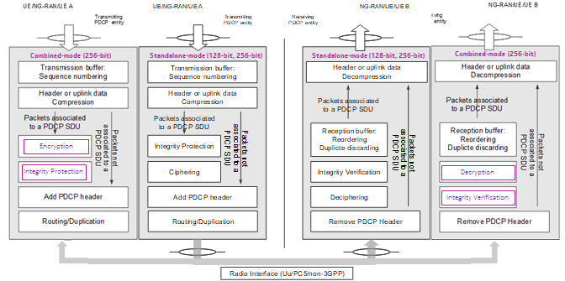
Figure 6.y-2: Extended PDCP architecture for 256-bit support (example illustration)

The following is applicable:
- For 6G, the current 128-bit algorithms would need to be continued to enable interworking between 5G and 6G.
- For the 256-bit standalone mode, the 5G-PDCP architecture can be used further, and thus also the order of the algorithms, i.e., first calculate the MAC tag and then the ciphertext, which refers to MAC-then-Encrypt (MtE).
- For the AEAD mode with 256-bit, the PDCP architecture must be extended because the order of the algorithms is reversed, i.e., encryption is calculated first and then the MAC tag, which refers to Encrypt-then-MAC (EtM).
- The AEAD mode with 256-bit would need to adjust its order to EtM to ensure interworking with the combined mode when used.

6.Y.3 Evaluation
Editor’s Note: Place holder for an evaluation if necessary.

* * * End of Changes * * * *

