3GPP TSG-WG SA2 Meeting #173 S2-260xxxx
Goa, IN, 9th Feb – 13th Feb, 2026 (revision of S2-260xxxx)

Source: Huawei, HiSilicon
Title: [KI1, Conclusion] Topology 2 Conclusion Update
Document for: Approval
Agenda Item: 20.5.1
Work Item / Release: FS_AmbientIoT_Ph2_ARC / Rel-20
Abstract: Update to KI1 conclusions to address remaining ENs.

1. Introduction

1.1 Endorsed way forward updates
The following was endorsed at SA2#172 in S2-2511016:
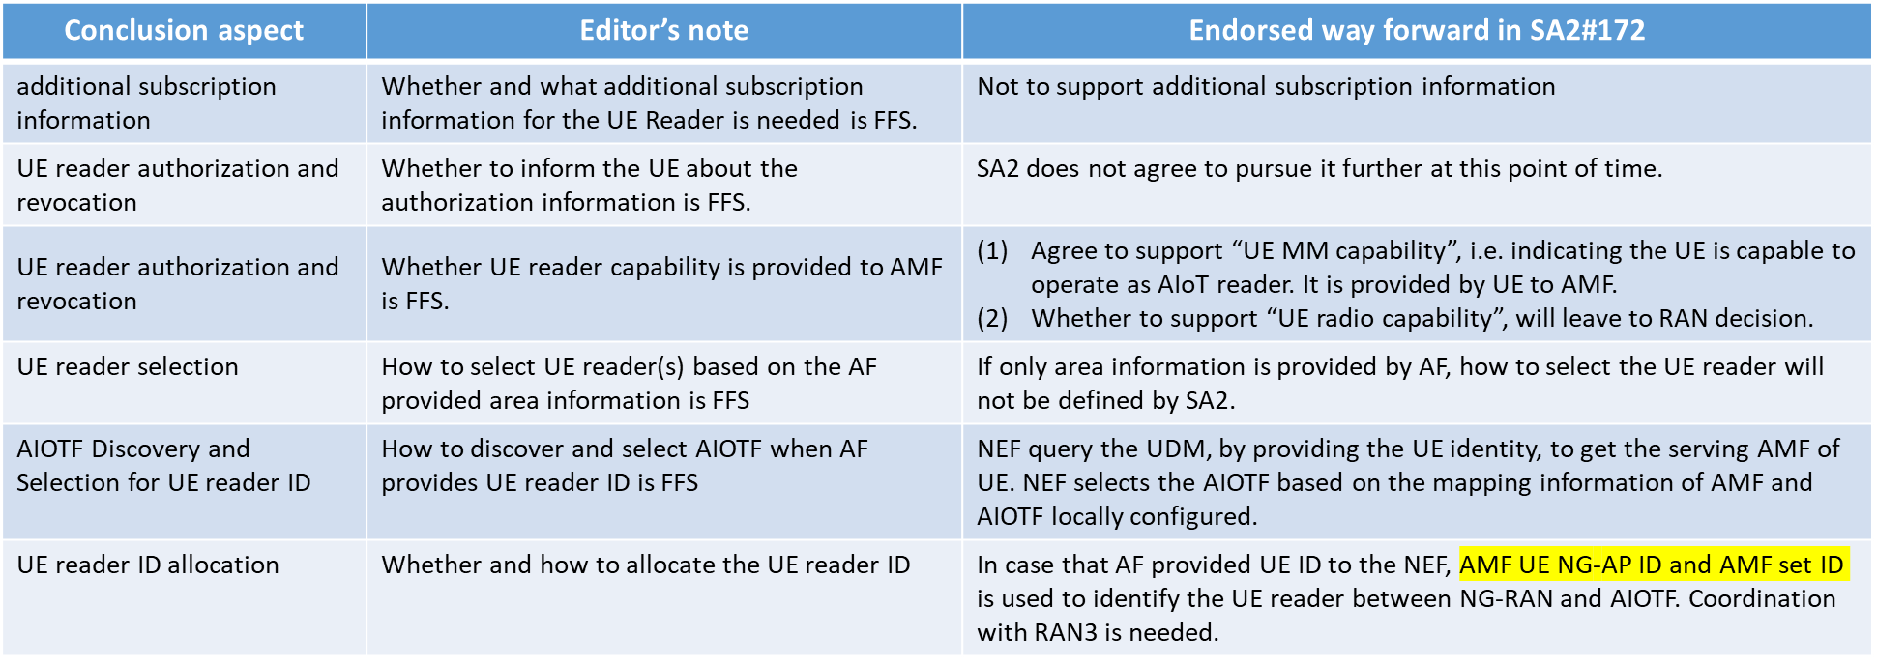
Additional subscription information
The following EN can be deleted:
Editor's note: Whether and what additional subscription information for the UE Reader is needed is FFS.

UE reader authorization and revocation
The following ENs can be deleted:
Editor's note: Whether to inform the UE about the authorization information is FFS.
Editor's note: Whether UE reader capability is provided to AMF is FFS.
Clarification is added to the conclusion for the UE to provide an indicating of support for operating as a UE Reader as part of UE 5GMM Core Network Capability is added. The AMF should additionally take this indication into account when providing authorisation to the RAN the UE can operate as a UE Reader.
UE reader selection
It has been determined that SA2 will not define how to perform UE reader selection if only an area is provided. Therefore the EN can be deleted and text saying the existing procedures are used:
Editor's note: How to select UE reader(s) based on the AF provided area information is FFS.

AIOTF Discovery and Selection for UE reader ID
The following EN can be deleted and the endorsed way forward added to the conclusion.
Editor's note: How to discover and select AIOTF when AF provides UE reader ID is FFS.

UE reader ID allocation
Currently the endorsed way forward states that an AMF UE NG-AP IF and AMF set ID are used to identify the UE reader between the NG-RAN and the AIOTF.
It is clear that NG-RAN needs to be informed which UE(s) to send a request to when the AF provides a UE Reader ID. Examination of NGAP leads to the conclusion that when an NGAP message targets a single UE it includes both “AMF UE NGAP ID” and “RAN UE NGAP ID” to allow NG-RAN to determine which UE to send a request to. While it is true that the AMF UE NGAP ID can be used, it is not allocated by NG-RAN so it is not the natural primary identifier to locate a UE and the same operations can be used on the network side to determine RAN UE NGAP ID at the same time as AMF UE NGAP ID.
In order for the AIOTF to determine the AMF UE NGAP ID and RAN UE NGAP ID to place inside the “NGAP AIoT Information” that the AMF forwards to RAN it needs to request the current values from the serving AMF. The overall flow is shown in the following example:
In step 1, the AF provides the UE IDs and use NEF determines from the UDM the SUPI and serving AMF in steps 2 and 3. The NEF selects an AMF and forwards the request to it, including the serving AMF and SUPI, in step 4.
In step 5 and 6, the AIOTF request from the serving AMF the NGAP ID(s) (i.e., AMF UE NGAP ID and RAN UE NGAP ID), along with the service NG-RAN node ID for the UE. The NGAP IDs are included in the “NGAP AIoT Information” to allow NG-RAN to request the UE Reader to perform the operation (steps 7 to 11) and provide the response back to the AIOTF.
The NG-RAN needs to include AMF UE NGAP ID and RAN UE NGAP ID in the responses so the AIOTF can determine which UE Reader a response is from, in the case there was multiple UE Readers in the NGAP AIoT Information send towards NG-RAN.
The conclusion for the case a UE Reader ID is provided is updated, and the following can be removed from the conclusion:
UE reader ID allocation:
Editor's note: Whether and how to allocate the UE reader ID is FFS.

1.2 Remaining Editor’s Notes
After the updates and clarifications based on the endorsed way forward, the remains the following EN in the conclusion:
Editor's note: Whether and how UE Reader subscription information is provided to AIOTF is FFS.

The only aspect related to AIoT that remains in the subscription after the way forward is whether the UE is authorised to be a UE Reader.
The authorisation is not enough by itself to determine whether a UE is a UE Reader, as in addition to the authorisation, the UE also indicated whether is supports UE Reader operation as part of the UE 5GMM Core Network Capability, which is stored in the UE Context in the AMF, and not the subscription data in the UDM.
Whether a UE operates as a UE Reader depends ultimately on both the subscription data and the UE 5GMM Core Network Capability – and this combination is used to determine whether it is authorised.
If an AMF gets a request for an AIoT operation it can check whether it is authorised and if not, reject any requests.
The conclusion is updated with this, and the Editor’s note removed.

2. Text Proposal
It is proposed to capture the following changes vs. TR 23.700-19.

* * * * First change * * * *

7.1.1 Agreed Principles for KI#1
'Figure 7.1.1-1 depicts the AIoT System Architecture for Topology 2.
Figure 7.1.1-1: AIoT System Architecture for Topology 2
Figure 7.1.1-2 depicts the AIoT system architecture, using the reference point representation.
Figure 7.1.1-2: AIoT System Architecture for Topology 2 in reference point representation
NOTE: Whether the interface between AIOTF and UDM is needed will be checked in later phase.
Message and protocol stack
- Messages between the UE Reader and the AIOTF are delivered using RRC between UE and NG-RAN and NGAP between NG-RAN and AMF and using an SBI interface between AMF and AIOTF. The related protocol stack is shown in Figure 7.1.1-3.
Figure 7.1.1-3: Protocol Stack for the RRC option
UE reader authorization and revocation part:
- Subscription aspects:
- The UE subscription in the UDM will be extended with UE Reader subscription information, which consists of the following:
- information indicating whether the UE is allowed to operate as a UE Reader.

- UE Reader subscription information is available to AMF.
- The UE provides, as part of the UE 5GMM Core Network Capability in Registration Request, whether it supports operating as a UE Reader.
- If AMF receives as part of the subscription information the indication that the UE is authorized to operate as a UE Reader and the UE has indicated support of operating as a UE Reader, AMF informs NG-RAN that the UE is authorized to operate as a UE Reader.

- If the subscription information has been revoked, the indication that the UE is not authorized to operate as a UE Reader from the UDM, then the AMF informs NG-RAN that the UE is not authorized to operate as a UE Reader.

- Radio resource management for UE Reader operation:
- If the gNB has received the indication that a UE is authorized to operate as a UE Reader, then the gNB may assign radio resources to the UE for UE Reader operation.
AIOTF Discovery and Selection for UE reader ID:
The NEF determines which AIOTF to handle the request based on implementation, e.g., taking the serving AMF into account the NEF obtained from the UDM using the Nudm_UECM_Get service operation.

UE reader selection part:
Two scenarios will be supported for UE reader selection, AF providing UE reader ID case and AF providing Area case for all types of UE reader.
- For AF providing UE reader ID case:
- If UE Reader ID(s) is provided by the AF via the NEF for the operation, then that is used as the selected Reader(s) if authorized as UE reader. The AIOTF provides the selected UE Reader(s) to the NG-RAN.
- The UE Reader ID is provided is a UE ID that is used by the NEF in the Nudm_UECM_Get service operation, as defined in clause 5.2.3.2.3 of TS 23.502 [x], to determine the UEs SUPI(s) and serving AMF(s), and the SUPI(s) and serving AMF(s) are included in the AIOTF service operation request.
- The AIOTF requests the AMF UE NGAP ID, RAN UE NGAP ID and NG-RAN ID for a UE Reader identified by its SUPI from the serving AMF provided in the request towards the AIOTF.
- The AIOTF includes the AMF UE NGAP ID and RAN UE NGAP ID in the NGAP AIoT information (i.e., the area information is not included) and uses the procedures defined in clause 6.2.4 of TS 23.369 [x]. The response NGAP AIoT information from NG-RAN also includes AMF UE NGAP ID and RAN UE NGAP ID which the AIOTF uses to identify a specific UE Reader in the case there were multiple UE Readers in the request towards NG-RAN.
- If the AMF receives an AIoT request for a UE that is not authorised, it rejects the request.
- For AF providing Area case:
- The core network does not perform UE Reader selection and the existing procedures for NG-RAN Node selection, as defined in clause 5.3.3 of TS 23.369 [x] is used to determine which NG-RAN nodes to use for an operation. The NG-RAN selects which readers to use and can including both RAN Readers and UE Readers.
- For AF provided an Area and UE Reader ID(s):
- Any request that includes both an Area and UE Reader ID(s) is rejected.

* * * * End of changes * * * *

