SA WG2 Meeting #173 S2-26xxxxx
Goa, India, 09 - 13 Feb 2026
Source: Google
Title: Conclusion for KI#2 (Support of SMS delivery to ERC via NAS)
Document for: Approval
Agenda Item: 20.8.1
Work Item / Release: FS_SMS2EC_ARC/Rel-20
Abstract of the contribution: This paper proposes a conclusion for KI#2.

1. Discussion
In the US, the delivery of SMS to ERC (PSAP) is governed by a joint ATIS/TIA specification for SMS Text-to-9-1-1 (see ATIS J-STD-110 [10]). Figure 1.1 illustrates the high-level functional architecture for the SMS Text to 9-1-1 service, as defined by the ATIS/TIA specification [10]. In particular, the architecture includes the Text Control Center (TCC), a functional entity that outside of 3GPP domain, that acts as the logical entity interfacing between the SMSC and the PSAPs.
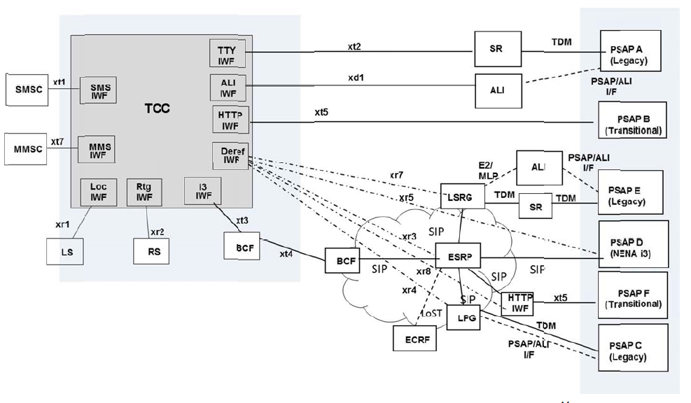
Figure 1-1: SMS Text to 9-1-1 High level Functional Architecture
Unfortunately, the TCC does not support roaming users, whether international or national. For national roamers (i.e., those moving between US carriers), the architecture mandates that the TCC to generate a "bounce-back" message, advising the UE to use voice communication instead of text for emergency communications. Further details regarding this behaviour can be found in Appendix C of the ATIS/TIA specification (reproduced below).
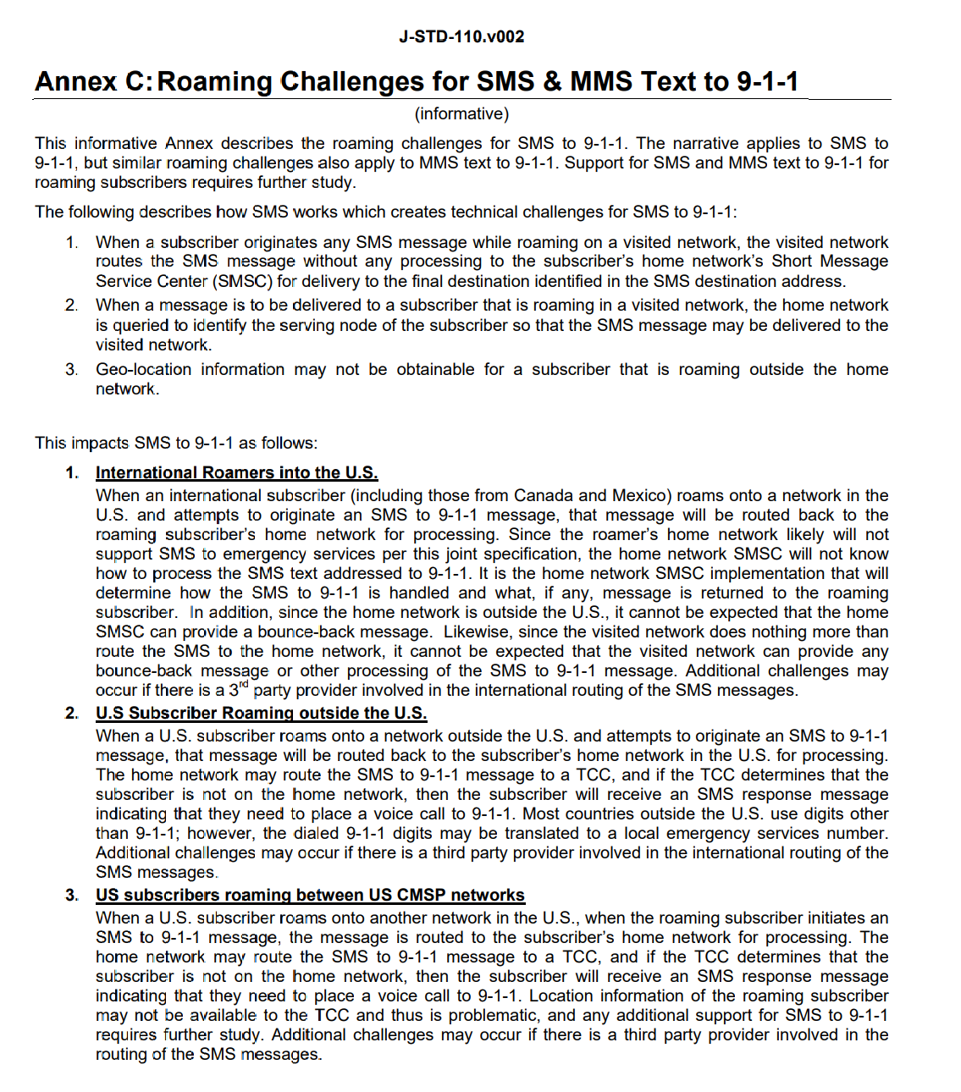

All the solutions proposed so far under KI#2 for roaming UEs perform “local breakout” to ensure that the MO SMS reached the V-SMSC before subsequently being routed to the ERC. Since the TCC connected to the V-SMSC will interpret this SMS as coming from a roaming UE, it will likely generate a “bounce-back” message and the SMS will not reach the ERC.
Observation: The solutions proposed so far in TR 23.700-65 will not work, at least in the US, for roaming users because the TCC does not support roaming functionality.
In order to resolve the issue of roaming UEs in (at least) the US, we suggest adopting the mechanism detailed in solution XX [S2-26xxxxx].
It is also proposed to agree the following changes to 3GPP TR23.700-65.
* * * * First Change * * * *

8.2 Interim conclusions for KI#2
The following interim conclusions for Key Issue #2 Support of SMS delivery to ERC via NAS are made:
1. To ensure delivery to the local ERC, SMS to ERC messages from roaming users are sent over NAS utilizing a local breakout mechanism.

* * * * End of Changes * * * *

