3GPP TSG-WG SA2#173 S2-2601156

Goa, India, 9 – 13 February, 2026

Source: ZTE, Apple (Pen-holder(s))
Title: KI#11: Solution variants
Document for: Approval
Agenda item: 20.6.11
Work Item: FS_6G_ARC
Abstract of the contribution: <This contribution is the merged solutions for Key issue#11, support of non-3GPP access to 6G.

Guidance: Pen-holder tasks after submission deadline:
1. Analyse the input papers and identify which "topics" each contribution addresses (a topic may e.g. correspond to bullet#y of KI#X).
NOTE: A contribution may contain a solution proposal for a single topic within a KI, multiple topics within a KI, or multiple topics in different KIs.
2. For a given "topic", identify commonalities and differences between the solutions proposed. List the different "solution variants". Pen-holders are encouraged to identify solution variants per "topic", i.e. not combine solutions for multiple unrelated topics.
3. Draft a pCR proposing solution description(s) in clause 6 of the TR, with one solution per solution variant identified in step 2 (i.e. a single pCR is used to capture all solution variants). Each solution variant in the pCR should clearly describe what topic(s) it addresses (e.g. KI#, bullet#) as well a description of the solution and open issues if any. Please see further guidance below.
4. Upload the pCR to INBOX using the new tdoc number assigned. Deadline for upload is provided in the slides. (Remove blue guidance text from the pCR before submission).

1. Discussion
Guidance – include in this clause:
- a description of what topics are addressed (first bullet below). The bullet could be for the KI in total or repeated e.g. per KI "topic"
- and how many solution variants are included (second bullet below)
- additional discussion material that penholders think may be useful for the group to understand the pCR

This pCR proposes to capture
- <N> solutions variants based on selected input solutions for KI#X (<KI title>)
- list of the submitted input solutions in Annex X
< additional discussion material if needed>

Table: List of submitted solutions and high level principles for this KI not considered in this paper
Company | Tdoc | High level principles | Comments to the listed principles
NEC | S2-2600085 | - This solution aims to optimize the untrusted non-3GPP access to 6G for IMS voice by reducing 2 IPSec tunnels to 1 IPSec tunnel from UE perspective.  - It suggests studying the removal of the IPSec tunnel between the UE and the untrusted non-3GPP Gateway, or the removal of the IPSec tunnel between the UE and P-CSCF. | This is a topic for SA3 to study.

2. Text proposal
It is proposed to agree the following changes vs. TR 23.801-01:

* * * First Change * * * *

6.11 Solutions to KI#11

6.11.1 Solution variant #11.1: NAS-enabled UE

6.11.1.0 Topics addressed and High-level Solution Principles
Guidance – include in this clause:
- description of which topic the solution addresses. A topic could be a whole KI, a sub-set of a KI (e.g. a bullet of a KI), multiple KIs, or subsets of multiple KIs
- description of which solution proposals this solution variant is based on, e.g. "This solution variant addresses KI#4, bullet 3, and is extracted from Solutions #1, #2, #3, #4 and #28 of Annex X."
- description of the high level principles of the solution, e.g. in bullet form, describing the key architectural points that are proposed by the solution.
This solution addresses the following bullet of KI#11:
For non-3GPP access:
1. Study how to support untrusted non-3GPP access in 6G System architecture.
For Non/Seamless WLAN Offload:
4. How to support UE policy necessary for Non-Seamless WLAN Offload (NSWO).
This solution merges the technical essence of solutions #3, #4, #5, #6, #7, and #8 of Annex X.11. The followings are high-level solution principles:
- NAS Support in UE: The UE shall support the 6G NAS protocol stack to maintain consistency between 3GPP and non-3GPP access regarding registration, mobility management, session management.
- In a solution variant (solution #7), the 6G-N3IWF performs the NAS Registration procedure on behalf of the 6G UE.
- Introduce a gateway similar to N3IWF: The 6G Non-3GPP Gateway (6G-N3IWF) acts as a transparent relay for NAS signaling and EAP authentication, ensuring the core network remains access-agnostic. The 6G-N3IWF is similar to the N3IWF in 5G.
NOTE 1: The exact abbreviation for 6G-N3IWF will be determined later.
- Common Security Framework: Mutual authentication is performed using EAP-AKA' or 5G-AKA relayed to the 6G AUSF/UDM over a secure transport layer.

6.11.1.1 Description
The architecture in Figure 6.11.1.1-1 shows how to support the untrusted non-3GPP access in 6G system. The specific NFs are defined in solutions for other KIs, e.g., in KI#1, KI#2, KI#4, KI#18. Therefore, the 6G CN is simply illustrated by grouping the NFs into Control Plane functions (6G CP) and User Plane functions (6G UP).
Figure 6.11.1.1-1: Architecture for non-3GPP access
The interfaces related to the untrusted non-3GPP access in 6G architecture are defined as below:
Y1' Reference point between the UE and the untrusted non-3GPP access (e.g. WLAN). This depends on the non-3GPP access technology and is outside the scope of 3GPP.
Y2' Reference point between the untrusted non-3GPP access and the 6G-N3IWF for the transport of NWu traffic.
NWu' Reference point between the UE and 6G-N3IWF for establishing secure tunnel(s) between the UE and 6G-N3IWF so that control-plane and user-plane exchanged between the UE and the 6G CN is transferred securely over untrusted non-3GPP access.
6G N1 Reference point between the UE and CP NFs for 6G NAS signalling exchange. The 6G NAS signalling exchange over 6G N1 interface is securely transmitted over the untrusted non-3GPP access.
6G N2 In addition to the functionality defined in the overall architecture, the 6G N2 is used to transport signalling between 6G UE and CP NFs for 6G UE authentication to enable the CP NFs to perform 6G-N3IWF configuration.
6G N3 The functionality defined in the overall architecture is reused.
Editor’s Note: The roaming architecture for untrusted non-3GPP access is FFS.
The key properties of the architecture are the following:
- A unified 6G CN for both 3GPP and non-3GPP access includes the 6G CP and 6G UP. The UE and the 6G CP NFs maintain the UE context independently for each access. The UE and the 6G CP NFs perform the NAS procedures independently for each access.
- A new NF 6G-N3IWF is introduced, which is similar to the N3IWF in 5G. The 6G-N3IWF connects to the 6G CP via 6G-N2 interface and connects to the 6G UP via 6G-N3 interface.
- The 6G UE discovers the 6G-N3IWF by enhancing the ePDG/N3IWF discovery procedures.
The key properties of the signalling protocol between UE and 6G-N3IWF are the following:
- Most of solutions (solutions #4, #5, #6, #7, #8) use IKEv2/IPsec between UE and 6G-N3IWF.
- When IKEv2 is applied, the first child SA, i.e. the "signaling IPsec SA", is used for the secure transport of 6G NAS messages (solutions #4, #8).
- A solution variant (solution #3) use NAS over QUIC instead of NAS over IKEv2/IPsec between UE and 6G-N3IWF/N3GW to improve performance and firewall traversal. The 6G-N3IWF acts as a transparent forwarder for NAS messages between the UE and the CP Functions during the initial phase.
For UE registration and authentication procedures, there are different approaches proposed:
- Decoupled Authentication and Registration (solutions #4, #8). The secure transport tunnel is fully established before the initiation of the 6G NAS registration procedures. There are two phases:
- In phase 1, establishment of IKEv2 signalling and authentication. The UE selects the 6G-N3IWF to establish the IPSec tunnel. The UE source IP address is allocated by 6G-N3IWF. The EAP authentication payload is encapsulated in the IKEv2 message, similar as the EAP authentication over IKEv2 between the UE and ePDG. The UE is authenticated by the 6GC based on the EAP procedures.
- In phase 2, the NAS messages are transported between the UE and the CN over the IPSec tunnel established in phase 1.
- Coupled Authentication and Registration (solution #5). Initial NAS PDUs (e.g., Registration Request) are encapsulated within the initial transport handshake (e.g., IKE_AUTH) to reduce connection establishment latency.
- Proxy-Initial Registration (solution #7). Upon receiving the initial IKEv2 signalling (e.g. IKE-AUTH Req) from the 6G UE, the 6G-N3IWF initiates the Registration request towards the 6G CN on behalf of the 6G UE. The Registration Request contains information extracted from the initial IKEv2 signalling. After registration, a secure connection (i.e. IPSec tunnel) is established between 6G UE and 6G-N3IWF via which 6G NAS signalling can be exchanged between 6G UE and the CP NFs.
- NAS over QUIC, Two-Phase Bootstrapping (solution #3). Phase 1 establishes an initial certificate-based QUIC connection to perform NAS authentication and derive a session key. Phase 2 establishes a final, fully encrypted QUIC tunnel using that key as a TLS-PSK.
The key properties of the Protocol and User Plane Mapping and Traffic Differentiation are the following:
- Two-Level User Plane: to enhance transmission efficiency, the protocol stack is optimized to two IP layers, eliminating the 5G "Inner IP" layer (solution #8).
- The signalling IPsec SA is used to exchange the NAS message. All PDU sessions share the same IKE SA, i.e. use the different child SA (IPsec SA) for different PDU session (solutions #7, #8). It is also possible to establish a new IKE SA for PDU session (solution #8).
- SPI-based Mapping: The gateway identifies user-plane tunnels using the Security Parameter Index (SPI) in the ESP header, allowing direct mapping to 6G-N3 tunnels (solution #8)
The control plane and user plane protocol stacks are represented on the following figures (based on solution #8):

- IPSec protocol stack in phase 1
(b) NAS protocol stack in phase 2
Figure 6.11.1.1-2: Control plane protocol stack between UE and CN

Figure 6.11.1.1-3: User plane protocol stack between UE and CN
Editor's note: It is FFS if the GRE layer is needed, depending on whether the QoS related information needs to be transported between the UE and Gateway.

6.11.X.2 Procedures
Guidance:
- include in this clause: description of the procedures and information flows for the solution.
- this clause is not a priority in the February meeting and can be added in a later meeting, but the penholders can make a judgement whether it can be proposed already in February (e.g. if it is straightforward and aligned in this solution variant)

6.11.X.3 Services, Entities and Interfaces
Guidance:
- include in this clause: description of the Services, Entities and Interfaces assumed by the solution. If existing Services, Entities and/or Interfaces are impacted (e.g. 5G), describe the impacts.
- this clause is not a priority in the February meeting and can be added in a later meeting, but the penholders can make a judgement whether it can be proposed already in February (e.g. if it is straightforward and aligned in this solution variant)

6.11.X.4 Issues
Guidance:
- include in this clause: description of the open issues related to the solution variants. Open issues may e.g be due to a solution variant based on individual solution proposals that have large commonalities but differ in specific aspects, or due to aspects brought up during the discussion of solutions. The description of the open issues can e.g. consist of a set of Editor’s Notes with FFS statements.

* * * Next Change * * * *

6.11.2 Solution variant #11.2: UE without NAS support

6.11.2.0 Topics addressed and High-level Solution Principles
This solution addresses the following bullet of KI#11:
1. Study how to support untrusted non-3GPP access in 6G System architecture.
This solution merges the technical essence of solutions #1, #2, #9, #10, #11, #12, #13, #14 and #15 of Annex X.11. The high-level solution principles are the following:
- No NAS support in UE: The UE does not need to support the 6G NAS protocol stack over non-3GPP access.
- Introduce a gateway similar to ePDG: The Non-3GPP access Gateway Function (N3GF, or 6G-NGW, N3F, CNGWF or 6G-N3IWF as called in the various solutions) is similar to the ePDG in the EPC. It does not support NAS signalling between the 6G CN and the UE.
- In a solution variant (solution #13), the N3GF performs registration, session management on behalf of the UE.
NOTE: The exact abbreviation for N3GF will be determined later.
- Common Security Framework: Mutual authentication is performed using EAP-AKA' or 5G-AKA relayed to the 6G AUSF/UDM over a secure transport layer. The architecture eliminates legacy Diameter-based interfaces.

6.11.2.1 Description
The architecture shown in Figure 6.11.2.1-1 shows how to the support of untrusted non-3GPP access in 6G system. The specific NFs are defined in solutions for other KIs, e.g., in KI#1, KI#2, KI#4, KI#18. Therefore, the 6G CN is simply illustrated by grouping the NFs into Control Plane functions (6G CP) and User Plane functions (6G UP).
Figure 6.11.2.1-1: Architecture for non-3GPP access
Figure 6.11.2.1-2: Reference point Architecture for non-3GPP access
Sx1: derived from SWu: to communicate with the UE over untrusted Wi-Fi. It is based on IKEv2/IPsec for tunnel establishment and encryption (see TS 33.402).
Sx2: derived from SWn: to communicate with the untrusted Non-3GPP access (e.g., Wi-Fi Access Point).

Another architecture variant for non-3GPP access:
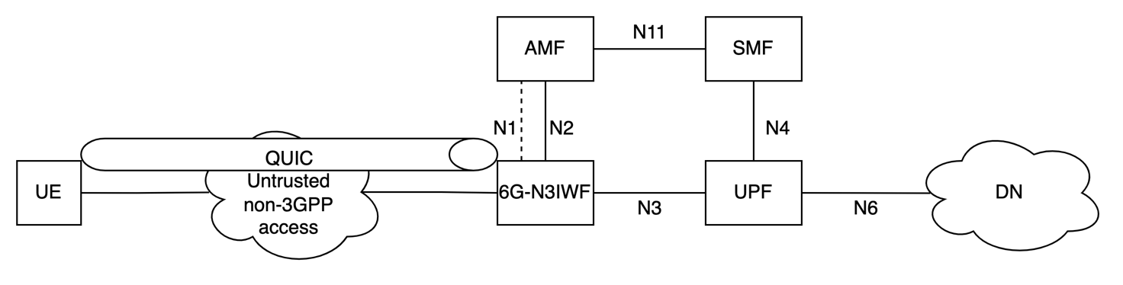 Figure 6.11.2.1-3: Architecture variant based on QUIC for non-3GPP access
The key properties of the architecture are the following:
- No NAS support in UE: The UE does not need to support the 6G NAS protocol stack over non-3GPP access.
- The N3GF has signalling interfaces with multiple NFs in 6G CP and connects to the 6G UP via 6G-N3 interface.
- The N3GF terminates secure transport from the UE. The N3F does not support NAS signalling between the 6G CN and the UE.
- In a solution variant (solution #13), the N3GF performs registration, session management on behalf of the UE.
- The 6G UE discovers the N3GF by enhancing the ePDG/N3IWF discovery procedures.
The N3GF interfaces with the 6G CN through two distinct strategies:
- Variant A: SBI-interface (solutions #1, #2, #9, #10, #11, #12, #14, #15): The N3GF translates access-specific transport signaling (IKEv2 or QUIC) directly into Service-Based Interface (SBI) operations. It can interact with UDM, AUSF, NRF, SMF directly.
- In solution #15, the N3GF has the S2b-C interface with SMF and S2b-U interface with UPF.
- Variant B: QUIC-Proxy (solution #13): The N3GF acts as a QUIC proxy on behalf of UE. The N3GF binds the QUIC connection to the UE NAS context. The N3GF maintains a local NAS state machine for the UE and interfaces with the AMF using N1 (NAS) and N2 reference points. The N3GF generates NAS registration and session management requests on behalf of the UE.
The key properties of the signalling protocol between UE and N3GF are the following:
While the UE operates without a NAS stack, the solution supports two primary transport options:
- IKEv2/IPsec variant (solutions #1, #2, #9, #11, #12, #15): similar with 4G and 5G, the UE uses standard IKEv2/IPsec to establish a secure tunnel and uses it for authentication. It reuses the ePDG-style secure tunnel where connectivity parameters are carried in IKEv2 payloads (e.g., IDr or Configuration payloads) instead of NAS containers.
- QUIC variant (solutions #2, #10, #13, #14): The UE uses QUIC to establish a secure tunnel with N3GF. In order to transfer the signalling, there are two options:
1) HTTP/3-based control plane protocol over QUIC (solution #10, #14).
2) MASQUE over HTTP/3 over QUIC (solution #13).
For both options, the N3GF extracts parameters from transport-layer handshakes (IKEv2 or QUIC) and maps them directly to 6GC service operations (solutions #1, #2, #9, #10, #11, #12, #14, #15) or NAS (solution #13).
For UE authentication procedures, there are different approaches proposed:
- Variant A (solutions #1, #2, #9): SBI-based mutual authentication is executed between the UE and 6G AUSF/UDM (e.g., Nx1, Ny), e.g. utilizing EAP-AKA'. In solution #12, SBI interface is used to connect N3GF with 6G AAA.
- Variant B (solution #13).: QUIC-Proxy. The N3GF acts as a QUIC proxy, generating and terminating NAS registration procedure to the 6G CN on behalf of the UE.
- Temporary ID Management (solution #14): The UDM de-conceals the UE's concealed identity (SUCI) and generates a Temporary ID linked to the UE's permanent identifier, which the N3GF stores and uses it for subsequent session management.
The key properties of the Protocol and User Plane Mapping and Traffic Differentiation are the following:
IKEv2/IPsec variant:
- Two-Level User Plane: To enhance transmission efficiency, the protocol stack is optimized to two IP layers, eliminating the 5G "Inner IP" layer (solutions #2, #9, #12).
- For each UE, there is only one IKEv2 SA between UE and N3GF. All the PDU session are carried in the IPsec Child SAs within a single IKEv2 SA. Similarly to 4G, there is one IKEv2 SA between UE and N3GF for each PDU session. All the QoS flows of this PDU session are carried in the IPsec Child SAs within the IKEv2 SA.
In the QUIC variant, the PDU is conveyed over the stream between the UE and N3GF. Each stream is associated with a specific QoS flow.
The control plane and user plane protocol stacks for the IKEv2 variant are represented on the following figures (based on solution #2):
Figure 6.11.2.1-4. Control and User Plane Protocols for N3GF based non-3GPP access

QUIC-based variant (based on solution #13):
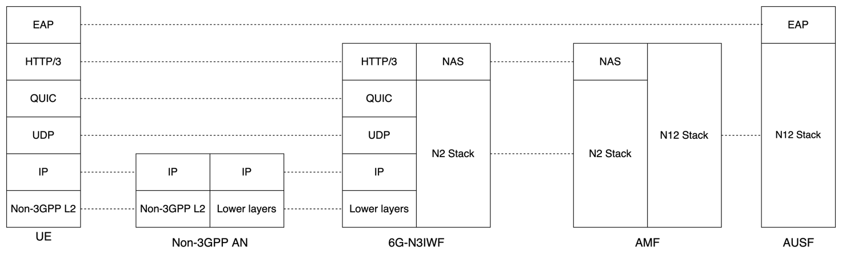
Figure 6.11.2.1-5 Control Plane via 6G-N3IWF (QUIC NAS-proxy)
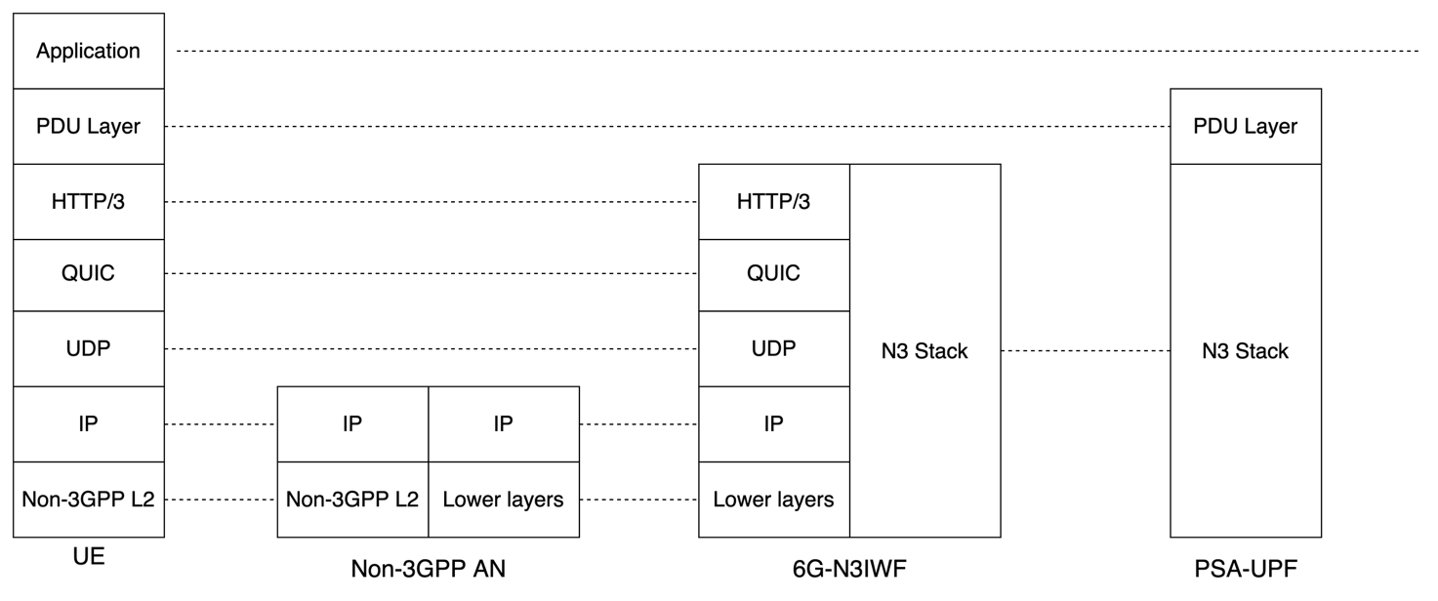
Figure 6.11.2.1-6 Control Plane via 6G-N3IWF (QUIC NAS-proxy)

6.11.2.2 Procedures
Guidance:
- include in this clause: description of the procedures and information flows for the solution.
- this clause is not a priority in the February meeting and can be added in a later meeting, but the penholders can make a judgement whether it can be proposed already in February (e.g. if it is straightforward and aligned in this solution variant)

6.11.2.3 Services, Entities and Interfaces
Guidance:
- include in this clause: description of the Services, Entities and Interfaces assumed by the solution. If existing Services, Entities and/or Interfaces are impacted (e.g. 5G), describe the impacts.
- this clause is not a priority in the February meeting and can be added in a later meeting, but the penholders can make a judgement whether it can be proposed already in February (e.g. if it is straightforward and aligned in this solution variant)

6.11.2.4 Issues
Guidance:
- include in this clause: description of the open issues related to the solution variants. Open issues may e.g be due to a solution variant based on individual solution proposals that have large commonalities but differ in specific aspects, or due to aspects brought up during the discussion of solutions. The description of the open issues can e.g. consist of a set of Editor’s Notes with FFS statements.

* * * Next Change * * * *

6.11.3 Solution variant #11.3: Cross-Access Data Session Establishment

6.11.3.0 Topics addressed and High-level Solution Principles
Solution#16 addresses the following aspects of Key Issue #11:
1. Study how to support untrusted non-3GPP access in 6G System architecture.
The high-level solution principles of this solution are as follows:
- Elimination of N3IWF: The solution removes the N3IWF from the data path. The UE establishes a direct connection to the User plane function over the non-3GPP access network.
- Cross-Access data session establishment via 3GPP Access: The UE requests a special type of data session over 3GPP access, referred to as "cross-access" data session. The characteristic of this type of data session is that it uses 3GPP access for control-plane signaling but non-3GPP access for user-plane communication.
- QUIC-based Tunneling: The user plane utilizes QUIC and HTTP/3 (e.g., RFC 9484 for IP Proxying) instead of IPsec/GRE. The QUIC connection between the UE and UPF is secured using a Pre-Shared Key (PSK) in the TLS handshake. This key is securely derived during the cross-access data session establishment.

6.11.3.1 Description
The solution leverages connectivity to 3GPP for securely bootstrapping a user-plane context (i.e., pre-shared key, user plane resources, etc.) that allows the UE to subsequently establish a user-plane connection directly with a user-plane function over non-3GPP networks.
Architectural Model:
- UE: Supports a modified NAS signaling to request a "Cross-Access" data session over 3GPP access and a client-side QUIC stack capable of PSK authentication and proxying IP or Ethernet traffic using HTTP/3.
- Control Plane Functions: The 6G CN control plane functions handle registration via 3GPP access, session management, security, etc. They derive a session-specific key (called "UP Session" key) using a Key Derivation Function (KDF) based on an existing common key (e.g. derived during 3GPP registration) and Nonce. They select a user plane function and provisions it with the key and UE Identity.
- User plane function (QUIC proxy): Acts as the termination point for the non-3GPP user plane path. It authenticates incoming QUIC connections from the UE using the provisioned PSK ("UP Session" key) and tunnels IP or Ethernet traffic using HTTP/3 Datagrams.
This model removes the need for Public Key Infrastructure (PKI) or certificates for non-3GPP access, as trust between UE and the user plane function is derived from 3GPP credentials.

6.11.3.2 Procedures
Guidance:
- include in this clause: description of the procedures and information flows for the solution.
- this clause is not a priority in the February meeting and can be added in a later meeting, but the penholders can make a judgement whether it can be proposed already in February (e.g. if it is straightforward and aligned in this solution variant)

6.11.3.3 Services, Entities and Interfaces
Guidance:
- include in this clause: description of the Services, Entities and Interfaces assumed by the solution. If existing Services, Entities and/or Interfaces are impacted (e.g. 5G), describe the impacts.
- this clause is not a priority in the February meeting and can be added in a later meeting, but the penholders can make a judgement whether it can be proposed already in February (e.g. if it is straightforward and aligned in this solution variant)

6.11.3.4 Issues
Guidance:
- include in this clause: description of the open issues related to the solution variants. Open issues may e.g be due to a solution variant based on individual solution proposals that have large commonalities but differ in specific aspects, or due to aspects brought up during the discussion of solutions. The description of the open issues can e.g. consist of a set of Editor’s Notes with FFS statements.

6.11.4 Solution variant #11.4: Service continuity and 5GS interworking

6.11.4.0 Topics addressed and High-level Solution Principles
This solution addresses the following bullet of KI#11:
2. Study how to support service continuity between 3GPP access and non-3GPP access in the above bullet(s).
3. Study how to support Interworking aspects between 5GS and 6GS related to non-3GPP access.
This solution merges the technical essence of solutions #2, #5, #6, #9, #10 and #13 of Annex X.11. The high-level solution principles are the following:
- Unified Core Anchoring: Service continuity and 5GS interworking are achieved by anchoring the PDU Session in a combined UPF. By maintaining the same anchor point in the CN, the network ensures UE IP address preservation when the UE moves between 3GPP and non-3GPP access paths, or between 5G and 6G.
- The UE in the target CN re-establishes the PDU session with "existing PDU session" flag.
NOTE: The architecture for 5GS interworking aspects between 5GS and 6GS related to non-3GPP access depend on the output of KI#17. In this solution, it assumes that the 6G UDM and 5G UDM are co-located, the 6G SMF and 5G SMF are co-located, and the 6G UPF and 5G UPF are co-located.

6.11.4.1 Description
The architecture shown in Figure 6.11.4.1-1 shows how to the support of service continuity between 6G 3GPP access and 6G non-3GPP access. The architecture shown in Figure 6.11.4.1-2 shows how to the support Interworking aspects between 5GS and 6GS related to non-3GPP access.

Figure 6.11.4.1-1. Service Continuity between 3GPP access and non-3GPP access

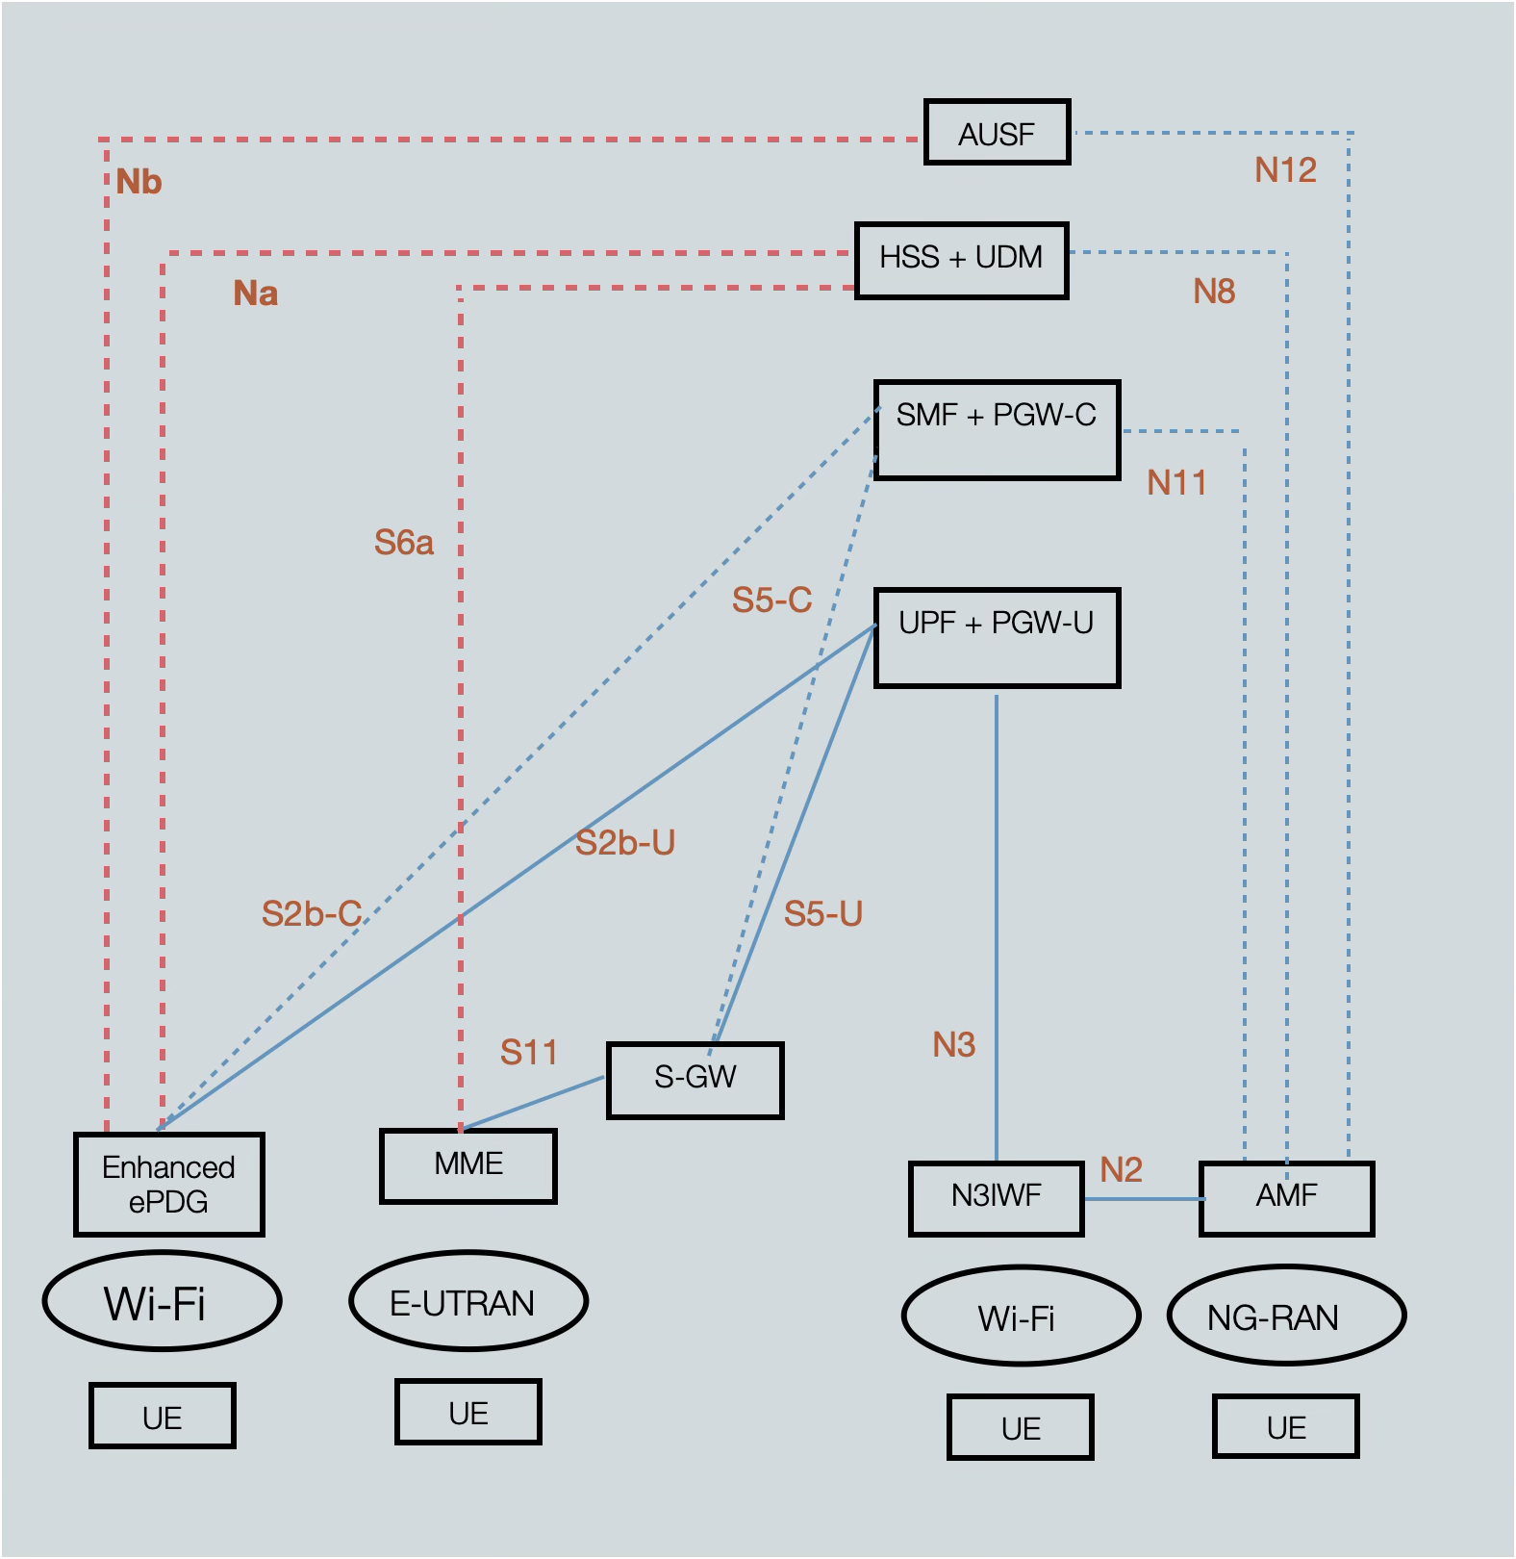
Figure 6.11.4.1-2. Interworking aspects between 5GS and 6GS related to non-3GPP access
For service continuity, all the solutions follow the similar principle in service continuity between 3GPP access and non-3GPP access in 5G. For 5GS interworking, all the solutions follow the similar principle in interworking between 4G and 5G related to non-3GPP access.
To support the interworking aspects between 5GS and 6GS related to non-3GPP access, the PDU session is anchored in the combo-node (e.g. 5G SMF+6G SMF, 5G UPF+6G UPF, etc). The 5G UDM and 6G UDM are also co-located.
Centralized Context: To facilitate handovers, the PDU sessions information are stored in the UDM (e.g. as specified in the 5GS by SMF).
In the target access, if the UE uses NAS (e.g. 3GPP access, or UE support NAS over non-3GPP access), the UE sends PDU session establishment requests with specific indicators, such as "Handover" or "Existing PDU Session" flags. These flags inform the core network to transfer the existing session context rather than creating a new one.
In the target access, if the UE does not use NAS (e.g. UE with no NAS support in non-3GPP access), the gateway (e.g N3GF) contacts with SMF to establish the signalling path with SMF for PDU session
Target access function (e.g., 6G AMF in UE NAS approach or N3GF in UE NAS-free approach) retrieves the existing session context (including the anchor SMF identity and PDU Session ID) from UDM. This allows the target access function to reconnect to the correct SMF.
In Proxy-Based approach: In this variant where the UE does not support NAS over non-3GPP access, the 6G-N3IWF acts as a Proxy-N1 entity. The 6G-N3IWF sends PDU session establishment requests to 6G AMF with "Existing PDU Session" flag on behalf of the UE.

6.11.4.2 Procedures
Guidance:
- include in this clause: description of the procedures and information flows for the solution.
- this clause is not a priority in the February meeting and can be added in a later meeting, but the penholders can make a judgement whether it can be proposed already in February (e.g. if it is straightforward and aligned in this solution variant)

6.11.4.3 Services, Entities and Interfaces
Guidance:
- include in this clause: description of the Services, Entities and Interfaces assumed by the solution. If existing Services, Entities and/or Interfaces are impacted (e.g. 5G), describe the impacts.
- this clause is not a priority in the February meeting and can be added in a later meeting, but the penholders can make a judgement whether it can be proposed already in February (e.g. if it is straightforward and aligned in this solution variant)

6.11.4.4 Issues
Guidance:
- include in this clause: description of the open issues related to the solution variants. Open issues may e.g be due to a solution variant based on individual solution proposals that have large commonalities but differ in specific aspects, or due to aspects brought up during the discussion of solutions. The description of the open issues can e.g. consist of a set of Editor’s Notes with FFS statements.

* * * Next Change * * * *

Annex X: Submitted solutions

X.11 List of submitted solutions for KI#11
Guidance – include in this clause:
- a table containing references to the individual solution proposals that lead to the solution variants in this pCR.
- The “Solution#” column is used to cross-reference between the solution variant description (clause 6.X.Y.0) and the input papers in this Table. Use sequential numbering (1,2,3,…). The rapporteurs will adjust the numbering when implementing the TR.

Table X.11: List of submitted solutions
Meeting | Solution# | Company | TDoc | Subject/Comment
SA2#173 | 1 | Qualcomm | S2-2600227 | [KI#11] Solution based on Non-3GPP access gateway Function (N3F)
SA2#173 | 2 | Ericsson | S2-2600253 | [KI#11, bullets #1 and #2] Non-3GPP access connectivity over N3GW for 6G CN
SA2#173 | 3 | Lenovo | S2-2600256 | [KI#11, bullet#1] QUIC-based Non-3GPP Access with 6G-N3IWF
SA2#173 | 4 | LG Electronics | S2-2600279 | [KI#11, bullet #1]  Decoupling NAS and IKE signalling over untrusted non-3GPP access
SA2#173 | 5 | MediaTek Inc. | S2-2600282 | [KI#11, bullet #1-3]: Support of non-3GPP access in 6G
SA2#173 | 6 | Samsung | S2-2600313 | [KI#11, bullet 1,2,4] Method for supporting Non-3GPP
SA2#173 | 7 | Xiaomi | S2-2600329 | [KI#11, bullet#1] Solution on supporting of non-3GPP access
SA2#173 | 8 | Huawei, HiSilicon | S2-2600335 | [KI#11, bullet#1] Solution for bullet#1 of KI#11: Architecture and procedures for N3G access
SA2#173 | 9 | ZTE | S2-2600339 | [KI#11] A N3PDG based solution to support non-3GPP access
SA2#173 | 10 | ZTE | S2-2600340 | [KI#11] QUIC-based protocol for access to core network via non-3GPP access in 6G
SA2#173 | 11 | China Telecom | S2-2600354 | [KI#11, bullet #1] Solution for untrusted Non-3GPP access in 6G
SA2#173 | 12 | OPPO | S2-2600395 | KI#11: New solution on un-trusted non-3GPP access support
SA2#173 | 13 | CableLabs, Comcast, Rogers | S2-2600554 | [KI#11, bullet #1, #2] Untrusted non-3GPP using NAS-terminated IWF
SA2#173 | 14 | Charter, CableLabs, Comcast, Rogers | S2-2600558 | [KI#11, bullet #1] 6G non-3GPP Architecture leveraging QUIC
SA2#173 | 15 | Apple | S2-2600606 | [KI#11, bullet #1] Support of Untrusted Non-3GPP Access in 6G via enhanced ePDG architecture
SA2#173 | 16 | Lenovo | S2-2600257 | [KI#11, bullet #1] Cross-Access Data Session Establishment for Simplified Non-3GPP Access.

* * * End of Changes * * * *

