3GPP TSG-SA WG2 Meeting #173 S2-260xxxx

February 9-13, 2026 Goa, India

Source: Skylo Technologies
Title: Non-IP mechanism negotiation for IP PDN
Agenda item: 20.1.1
Document for: Discussion
Work Item / Release: FS_5GSAT_Ph4_ARC /Rel-20
Abstract of the contribution: This paper discusses non-IP mechanism negotiation for IP PDN

1. Discussion
The interim conclusion for KI#1, agreed upon in SA2#172, support non-IP mechanism within an IP PDN connection for the transport of voice packets. This contribution analyses the feasibility of negotiating IP and non-IP capabilities between the UE and the network.
In Figure 1, the PDN Connection is established with PDN Type IP, ensuring that the Control Plane (NAS) remains 'IP-aware' for the purposes of context establishment, IP address allocation, and QoS negotiation. However, to minimize overhead over the bandwidth-constrained GEO satellite link, a ‘header removal/restoration’ capability is negotiated during the connection setup. This enables the User Plane to transport Raw Payloads (by stripping IP/UDP headers) while maintaining traffic differentiation via standard EPS Bearers:
- Signalling (Binary-encoded): Mapped to the Default Bearer via the default route.
- Voice Media: Mapped to a Dedicated Bearer. Standard Traffic Flow Templates (TFTs) are used at the ingress to bind the application flow to the specific bearer prior to header removal. And a simplified RTP header maybe used.
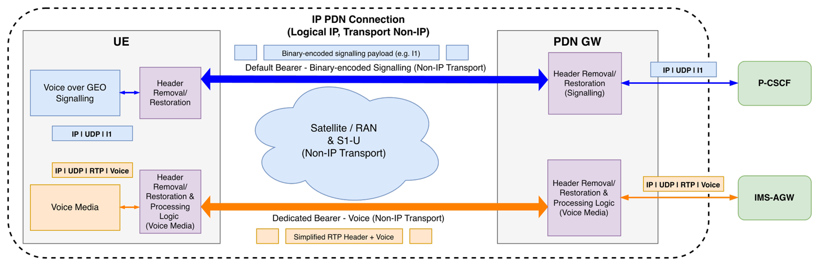
Figure 1: Non-IP Mechanism within IP PDN Connection

1.1 Signalling bearer establishment
During PDN establishment, UE sends Attach Request or PDN Connectivity Request with PDN Type = IP, which includes a new Protocol Configuration Option (PCO) flag to indicate the capability of header removal/restoration and processing logic.

IP mode

For the PDN GW (PGW) that does not recognize the new PCO flag, the PGW allocates a standard IP address and sets up the Default Bearer for signalling. The existing default bearer context activation procedure to establish a default EPS bearer context between the UE and the EPC will be followed, with the response PCO containing standard parameters.

In the uplink, the UE sends signalling packets with full standard IP/UDP headers.

In the downlink, the UE expects to receive packets with full standard IP/UDP headers.

The UE may attempt to negotiate standard RoHC (Robust Header Compression) with the eNB.

Non-IP mode

A PGW with Voice over GEO support recognizes the PCO flag and accepts the request. It stores the "Signaling Context" (e.g. P-CSCF IP and Port number) associated with the Default Bearer. It responds with a proper flag in the PCO to confirm the support of non-IP mechanism within the IP PDN connection.

In the downlink, the PGW receives binary-encoded signaling messages (e.g. I1) destined for the UE. It matches the traffic to the Default Bearer. The PGW removes the IP/UDP headers and maps the raw payload (e.g., binary-encoded I1) to the Default Bearer. The UE receives raw data on the Default Bearer. It identifies "Default Bearer = Signaling", and restores the IP/UDP headers, and delivers the message to the signalling stack.

In the uplink, when the UE generates a binary-encoded signaling message (e.g. I1 message), it identifies the flow as belonging to the Default Bearer. The UE removes the IP/UDP headers. When the PGW receives raw data on the Default Bearer, it restores the IP/UDP headers (Source = UE, Dest = P-CSCF) and forwards the standard packet to the Core Network.

1.2 Voice Bearer Establishment
Initiated by the IMS Session Setup (e.g., SIP INVITE or I1 INVITE), the PCRF triggers the PGW to allocate resources for the voice media flow.

1.2.1 IP Mode

For the PDN GW (PGW) that does not recognize or store the header removal/restoration and processing capability during the Signaling Bearer setup, it defaults to standard IP behaviour.

In this case, the PGW initiates the Dedicated Bearer activation by sending a Create Bearer Request (GTP-C) towards MME. The MME translates this into the NAS message ACTIVATE DEDICATED EPS BEARER CONTEXT REQUEST sent to the UE. The message includes standard IP-based Traffic Flow Templates (TFTs) filtering on the negotiated UDP ports.
The PGW establishes a standard GTP-U tunnel without any header manipulation logic. In uplink, UE sends voice packets with full standard IP/UDP/RTP headers. In downlink, UE receives voice packets with full standard IP/UDP/RTP headers.
The UE may attempt to negotiate standard RoHC with the eNB in the RAN.

1.2.2 Non-IP Mode
A PGW with Voice over GEO support checks the PDN Context. It identifies that header removal/restoration and processing capability was successfully negotiated during the Signaling Bearer setup and determines that this bearer should operate in non-IP mode within the IP PDN connection.
The PGW initiates the Dedicated Bearer activation by sending a Create Bearer Request (GTP-C) towards MME. The MME translates this into the NAS message ACTIVATE DEDICATED EPS BEARER CONTEXT REQUEST sent to the UE.
The PGW still includes standard IP Packet Filters (e.g., UDP Destination Port) in the signalling message. The UE receives the TFT and creates an internal binding to map the UDP destination port to Dedicated Bearer ID X.
In Downlink, the PGW receives RTP voice packets from the IMS-AGW. It matches the packet to the Voice TFT and identifies the target is Dedicated Bearer. It removes the IP/UDP headers and optionally compresses the RTP header (e.g., keeping only the Sequence Number), and maps the payload to the Dedicated Bearer X.

The UE receives raw data on the Dedicated Bearer X. Using the internal binding (Bearer X = Voice), it restores the full RTP/UDP/IP headers and delivers the media to the Voice Stack.

In Uplink, when the UE generates a voice packet, it identifies that the application matches Bearer X. It removes the IP/UDP headers and compresses the RTP header, sending only the stripped payload on Bearer X.

The PGW receives raw data on Bearer X. Using the stored context for that bearer, it restores the IP/UDP headers (Dest = IMS-AGW) and regenerates the full RTP header before forwarding to the IMS AGW.

2. Proposal
It is proposed to agree the CR nnmm to TS 23.401 in S2-260xxxx.

