3GPP TSG-SA WG1 Meeting #112 S1-254210r2
Dallas, USA, 17th - 21st November, 2025 (revision of S1-254210r1)

Title: Use case on AI-enabled satellite-UAV collaborative emergency service
Agenda Item: 8.1.3-Artifcial Intelligence
Source: BUPT, Pengcheng Laboratory, CMCC, China Telecom, ZGC Institute of Ubiquitous-X Innovation and Application, OPPO, Huawei
Contact: Xiaodong Xu (xuxiaodong@bupt.edu.cn), Mengying Sun (smy_bupt@bupt.edu.cn), Nan Ma (manan@bupt.edu.cn), Sheng Jiang (shengjiang@bupt.edu.cn), Jinghong Huang (huangjh@bupt.edu.cn), Zhe Zheng (zhengzh02@pcl.ac.cn), Lifeng Xie (xielf@pcl.ac.cn),
Xu Xia (xiaxu@chinatelecom.cn)

Abstract: Use case on AI-enabled satellite-UAV collaborative emergency service.

* * * First Change* * * *

2 References
The following documents contain provisions which, through reference in this text, constitute provisions of the present document.
- References are either specific (identified by date of publication, edition number, version number, etc.) or non-specific.
- For a specific reference, subsequent revisions do not apply.
- For a non-specific reference, the latest version applies. In the case of a reference to a 3GPP document (including a GSM document), a non-specific reference implicitly refers to the latest version of that document in the same Release as the present document.
- 3GPP TS 22.261: "Service requirements for the 5G system".
- 3GPP TR 38.821: "Solutions for NR to support Non-Terrestrial Networks".
- 3GPP TR 22.822: "Study on using Satellite Access in 5G".
- Gao H, Cao R, Xu W, et al. Space-air-ground integrated networks with task-driven connected intelligence[J]. IEEE Wireless Communications, 2024.
- Meng S, Wu S, Zhang J, et al. Semantics-empowered space-air-ground-sea integrated network: New paradigm, frameworks, and challenges[J]. IEEE Communications Surveys & Tutorials, 2024, 27(1): 140-183.
* * * Next Change (all the text is new)* * * *

6.x Use case on AI-enabled satellite-UAV collaborative emergency service

6.x.1 Description
Against the backdrop of intensifying global climate change, sudden natural disasters are imposing higher demands on emergency response capabilities. When disasters such as floods occur, traditional on-site reconnaissance methods struggle to meet the need for rapid and accurate decision-making due to their inefficiency and high risks. In the future, 6G technology will empower drone-based emergency rescue services by capturing high-definition images and videos to provide critical information sources for disaster assessment. In case ground-based 6G networks are impacted by disaster, the data captured by drones can be alternatively transmitted with satellite access to the 6G network. However, satellite access has its inherent disadvantage of transmission challenges such as limited bandwidth and high dynamics/disturbances, necessitating more efficient data transmission solutions. For example, the AI method of token communications can achieve a 5‰ data compression rate while ensuring reliable information recovery.
To address this, AI models deployed on UAVs (being an application on UE) can convert raw images/videos into key semantic features, such as submerged areas and damaged buildings, and convert them into token sequences. This achieves a fundamental shift from “transmitting bit-level data” to “transmitting semantic information.” These semantic features captured by token are transmitted to emergency centers via satellite access of 6G networks, where decoding models reconstruct the on-site scenario in real time or generate situational reports. This technology effectively overcomes the transmission bottleneck caused by limited link resources of satellite access, ensures near-real-time presentation of disaster situations at the emergency centers, provides intelligent support for rescue decision-making, and comprehensively enhances emergency response efficiency.
We conducted simulation verification using token communications for image transmission as an example, and now provide the related findings.
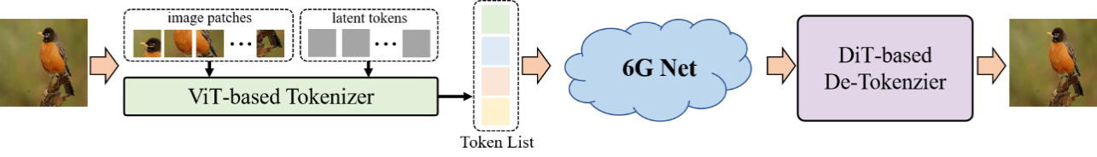
Figure 6.x.3-1: Token communication framework for image transmission
As shown in Figure 6.x.3-21, a brief description of the Token Communication Framework for Image Transmission is as follows.
Transmitter: The original input image is first divided into a series of image patches. Then, using a ViT (Vision Transformer)-based tokenizer, the image patches are transformed into compact token representations. The resulting token list is input into a fully connected layer-based channel encoder to make it suitable for transmission over a noisy channel.
Receiver: The received data is passed through a fully connected layer-based channel decoder to obtain the restored token sequence. The sequence is then fed into a DiT (Diffusion Transformer)-based de-tokenizer to reconstruct the output image.
Test Set: The ImageNet 100 dataset, with 50 images randomly selected.
Simulation Setup: The test images are resized to (3, 256, 256), and the token sequence length is 256. It is assumed that erroneous tokens can be identified and discarded at the receiver.
Channel Conditions: Training is conducted at an SNR of 10dB in an AWGN channel, followed by testing.
Simulation Scenarios:
- Case 1: No importance ranking applied to the token sequence.
- Case 2: Importance ranking applied to the token sequence.
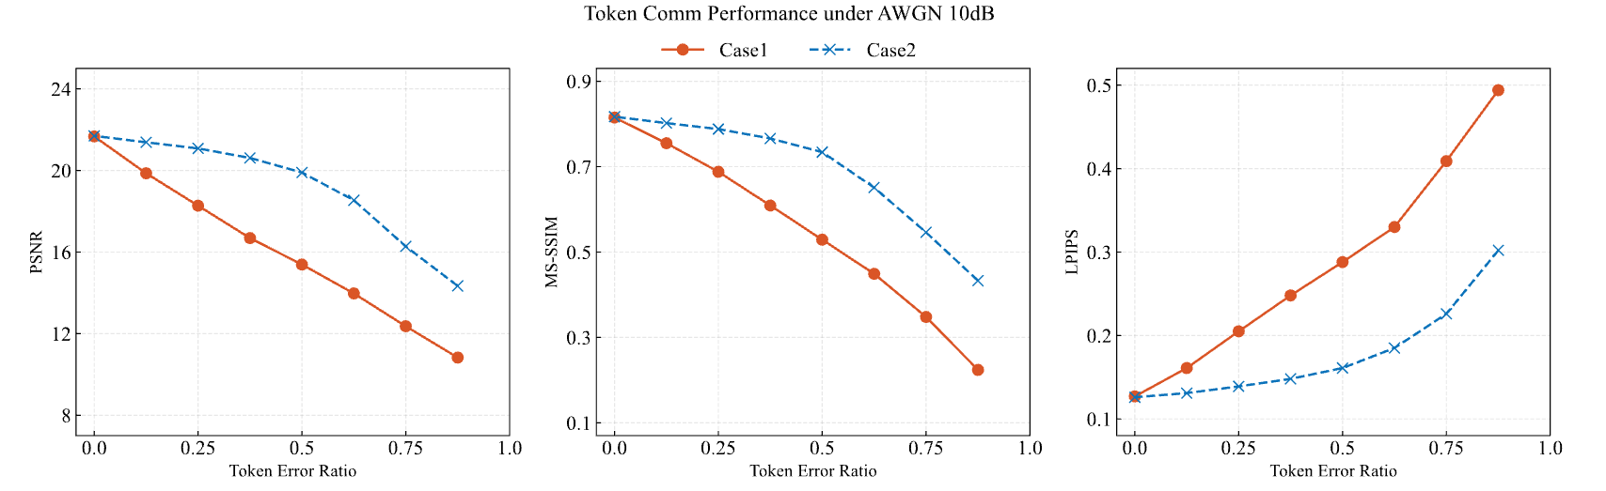
Figure 6.x.3-2: PSNR, MS-SSIM, and LPIPS vs. token error ratio under case 1 and case 2
As shown in Figure 6.x.3-2, the image recovery quality decreases as the token error rate increases, while the image recovery performance based on token importance ranking outperforms that of images without token importance ranking.
Based on the simulation results, the importance of tokens is crucial for the quality of information recovery. Therefore, when carrying token data in a 6G network, differentiated protection and transmission are required.

6.x.2 Pre-conditions
The 6G network with satellite access has been fully deployed and is capable of covering target areas prone to natural disasters (such as certain remote regions, coastlines, etc.), and the UEs support new information extraction and enhancement modules (including signal processing, information analysis, etc.). The components integrated into user terminals (satellite phones, shipborne communication terminals, UAV, etc.) can extract, identify, and efficiently encode source data, as well as accurately decode received information, interacting seamlessly with the 3GPP communication network.
AI in the UAV inspection processes the multimodal data on the UAV itself to extract meaningful insights. Token communications, a semantic communication paradigm, employ an AI-based tokenizer model to convert raw data into compact token sequences that capture essential meanings, thereby achieving high data compression and enabling interpretable, task-oriented transmission.
UAVs first upload the captured images to 6G network and if necessary via satellite access, which then relay the data to ground networks that subsequently forward the information to the emergency center.

6.x.3 Service Flows
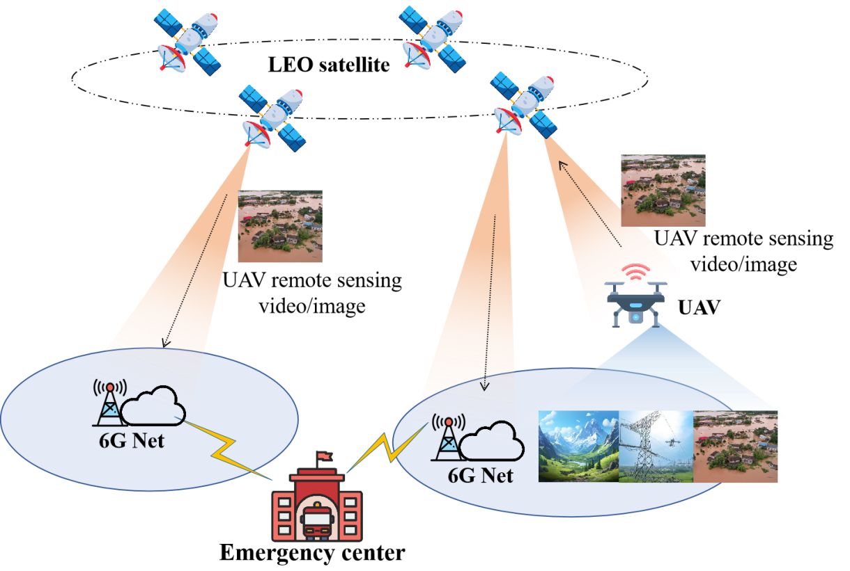
Figure 6.x.3-3: Token communication for UAV emergency scenario supported by 6G network with satellite access.
As shown in Figure 6.x.3-3, the service flow is described as follows.
- A sudden flood struck a region, severely damaging local mobile communication infrastructure. The emergency center received distress calls from residents and activated rescue response measures.
- The emergency center dispatches UAVs to capture images of the disaster area. Hovering over the affected regions, the UAVs collect high-resolution ground images to identify damaged zones, blocked roads, and potential signs of life. However, due to local network disruptions, these images cannot be directly transmitted to the emergency center through the terrestrial 6G network.
- The UAVs and the emergency center have deployed AI models (e.g., tokenizers). The UAV uses the AI model to convert captured images or videos into semantic feature data (e.g., token), which are transmitted via satellite access to the 6G network and then forwarded to the emergency center.
- As the 3rd party / application on the UAV exposed to 6G network the token (semantic feature data) traffic patterns such as multimodalities of the token traffic, relative importance of priority among the tokens. The 6G network accordingly performs differentiated protection and priority scheduling based on the importance of token, ensuring the accurate and reliable transmission of critical information.
- The emergency center reconstructs corresponding images and videos from the received semantic feature data (e.g., token) using matched AI models, thereby enabling real-time visualization of the disaster scene.

6.x.4 Post-conditions
The emergency center receives AI traffic through 6G networks with satellite access enabling token communication (e.g. differentiated scheduling of token traffic), maintaining real-time transmission of disaster-site image/video even though the satellite access’s bandwidth is limited. 6G network with satellite access demonstrates the merit of supporting such scenarios by dynamically prioritizing data transmission for AI token traffic for scarce network resources to be efficiently utilized.

6.x.5 Existing features partly or fully covering the use case functionality
Existing satellite systems provide wide-area coverage, enabling emergency support in remote or disconnected regions. But for AI traffic preserving semantic information in tokens, the current data transfer mechanisms are not efficient, particularly for bandwidth-restricted satellite access.

6.x.6 Potential New Requirements needed to support the use case
[PR 6.x.6.1] Subject to applicable regulation and operator policy, the 6G network shall support the exchange of AI traffic (e.g., token data, semantic data) with error tolerance, while ensuring QoS.
[PR 6.x.6.2] Subject to applicable regulation and operator policy, the 6G network shall provide suitable means for AI traffic (e.g., token data, semantic data) exchange between the third party applications.

