Hello all,

This is an invitation to RAN4#118 Webinar sessions on 09– 13 Feb 2026. This invitation covers three sessions in 3 separate rooms: Main (Yang Session), RRM_Demod_OTA (Shan Session), RF,NTN,A-IOT (Gene Session).

GoToWebinar (GTW) conference calls will be set in each session. And 1-way remote participants can be supported.

Please remember that consistent registration format is important for session chairing and hence use the following format when you register: BriefCompanyName - Firstname, Lastname. An example is shown below

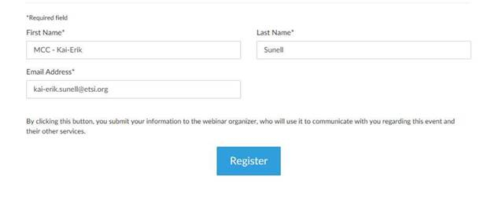
where BriefCompanyName is ‘MCC’, Firstname is ‘Kai-Erik’ and Lastname is ‘Sunell’.

Your email address for Webinar registration needs to be the same as for your 3GPP meeting registration.

Registration links are found below and they are session specific. You may register to all sessions, e.g. if you plan to switch between sessions or if you are able to listen to all sessions at the same time. Once you have registered for a session your registration is valid for the whole week.

The starting time for all sessions on 09 Feb is 09:00 local time 19:30 local time (GMT+1)

The starting time for all sessions on 10-12 Feb is 08:30 local time 19:30 local time (GMT+1)

The starting time for all sessions on 13 Feb is 08:00 local time 17:00 local time (GMT+1)

RAN4#118 Main Webinar Session (09- 13 Feb)
Mon, Feb 9, 2026 9:00 AM - 7:30 PM CET

RAN4#118 Main Webinar Session (09- 13 Feb)
Join us for a webinar beginning on Feb 09, 2026 at 9:00 AM CET.
Register now!

After registering, you will receive a confirmation email containing information about joining the webinar.
View System Requirements

RAN4#118 RRM_Demod_OTA (Shan Session) Webinar Session (09- 13 Feb)
Mon, Feb 9, 2026 9:00 AM - 7:30 PM CET

RAN4#118 RRM_Demod_OTA (Shan Session) Webinar Session (09- 13 Feb)
Join us for a webinar beginning on Feb 09, 2026 at 9:00 AM CET.
Register now!

After registering, you will receive a confirmation email containing information about joining the webinar.
View System Requirements

RAN4#118 RF,NTN,A-IOT (Gene Session) (09 - 13 Feb)
Mon, Feb 9, 2026 9:00 AM - 7:30 PM CET

RAN4#118 RF,NTN,A-IOT (Gene Session) (09 - 13 Feb)
Join us for a webinar beginning on Feb 09, 2026 at 9:00 AM CET.
Register now!

After registering, you will receive a confirmation email containing information about joining the webinar.
View System Requirements

Regards,
Jin Lian

