3GPP TSG-RAN WG4 Meeting # 118 R4-xxx
Gothenburg, Sweden, 9-13 February 2026

Title: WF on 6MHz CBW
Agenda Item: 7.1.1
Source: Apple
Document for: Approval

UE RF

NS_15 - PC3
The A-MPR contributions from moderator summary were taking into account to create a harmonized table for PC3. The Table 1 captures the combined inputs for PC3 and is proposed as a starting point for further discussion.
Table 1: A-MPR regions for NS_15 (Power Class 3)
Channel BW | Carrier Frequency, Fc, MHz | RB_{end}*12*SCS (MHz) | L_{CRB}*12*SCS (MHz) | A-MPR
6MHz | 842.0 < Fc ≤ 846 | ≥ 4.32 | > 0 | A7
 |  | ≥ 2.16, < 4.32 | ≥ 1.8 | A2
 |  | ≤ 1.44 | ≤ 0.36 | A8
 | 837 < Fc ≤ 842.0 | > 0 | ≥ 3.42 | A10

Graphical layout for PC3 RB regions:
PC3 | 842.0 < Fc ≤ 846 | 837 < Fc ≤ 842.0
6MHz | 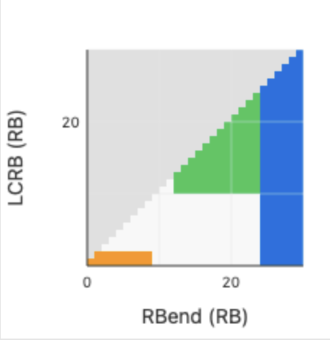 | 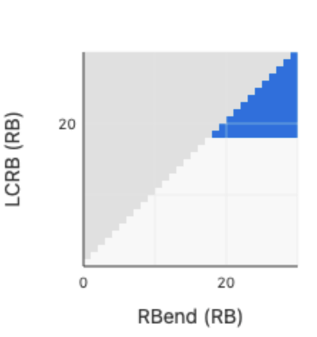

NS_15 - PC2
For creating the PC2 table the PC3 regions are used as a basis and additional regions are added as required. The Table 2 captures the combined inputs for PC2 and is proposed as a starting point for further discussion.

Table 2: A-MPR regions for NS_15 (Power Class 2)
Channel BW | Carrier Frequency, Fc MHz | RB_{end}*12*SCS (MHz) | L_{CRB}*12*SCS (MHz) | A-MPR
6MHz | 842.0 < Fc ≤ 846 | ≥ 4.32 | > 0 | A8
 |  | ≥ 2.16 < 4.32 | ≥ 1.8 | A9
 |  | ≥ 2.16, < 4.32 | ≥ 1.08, < 1.8 | A10
 |  | ≤ 1.44 | ≤ 0.36 | A11
 | 837 < Fc ≤ 842.0 | ≥ 0 | ≥ 3.42 | A12
 |  | ≥ 5.04 | <3.42 | A13

Graphical layout for PC2 RB regions:
PC2 | 842.0 < Fc ≤ 846 | 837 < Fc ≤ 842.0
6MHz | 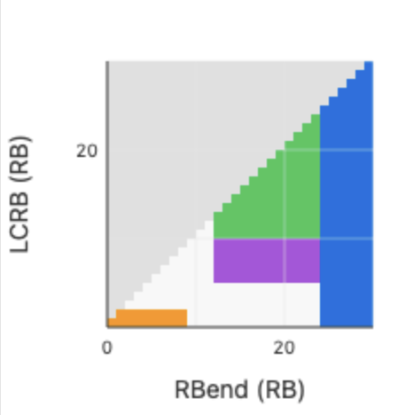 | 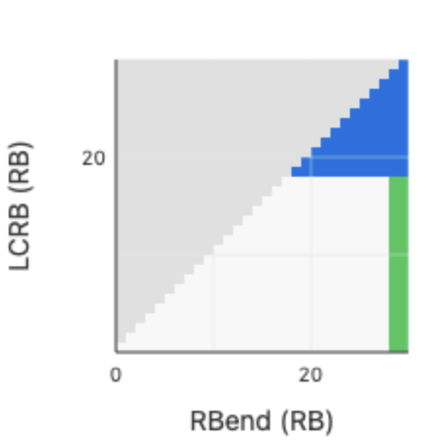

Json representation:
The json structure below is a representation of the Table 1 and Table 2 allowing to quickly import the RB regions to simulations tools. The schema files is described in R4-2600637.
{
"powerClassList": [
{
"powerClass": "PC3",
"numOfTx": 1,
"channelList": [
{
"channelBandwidth": 6,
"channelFcList": [
{
"channelFc": [
">842",
"<=846"
],
"amprRegionList": [
{
"rbEnd": [
">=4.32"
],
"amprIndex": 7
},
{
"rbEnd": [
">=2.16",
"<4.32"
],
"lcrb": [
">=1.8"
],
"amprIndex": 2
},
{
"rbEnd": [
"<=1.44"
],
"lcrb": [
"<=0.36"
],
"amprIndex": 8
}
]
},
{
"channelFc": [
">837",
"<=842"
],
"amprRegionList": [
{
"lcrb": [
">=3.42"
],
"amprIndex": 10
}
]
}
]
}
]
},
{
"powerClass": "PC2",
"numOfTx": 1,
"channelList": [
{
"channelBandwidth": 6,
"channelFcList": [
{
"channelFc": [
">842",
"<=846"
],
"amprRegionList": [
{
"rbEnd": [
">=4.32"
],
"amprIndex": 8
},
{
"rbEnd": [
">=2.16",
"<4.32"
],
"lcrb": [
">=1.8"
],
"amprIndex": 9
},
{
"rbEnd": [
"<=1.44"
],
"lcrb": [
"<=0.36"
],
"amprIndex": 10
},
{
"rbEnd": [
">=2.16",
"<4.32"
],
"lcrb": [
">=1.08",
"<=1.8"
],
"amprIndex": 11
}
]
},
{
"channelFc": [
">837",
"<=842"
],
"amprRegionList": [
{
"lcrb": [
">=3.42"
],
"amprIndex": 12
},
{
"rbEnd": [
">=5.04"
],
"lcrb": [
"<3.42",
">0"
],
"amprIndex": 13
}
]
}
]
}
]
}
]
}

<Way forward>: Discuss whether Tables 1 and 2 for 6MHz A-MPR are acceptable

