3GPP TSG-RAN4 Meeting #118 R4-2602100
Gothenburg, Sweden, February 9th – 13rd, 2026

Agenda item: 4.1.3
Source: Moderator (CMCC)
Title: Topic summary for [118][326] A-IoT_Maintenance
Document for: Information

Introduction
This thread focuses on maintenance part of Rel-19 Ambient IoT in NR and corresponds to agenda 4.20.1.

Topic #1: RF requirements for A-IoT device

Companies’ contributions summary
T-doc number | Company | Proposals / Observations
R4-2600671 | vivo | Observation 1: Performance loss is not observed for same D2R transmission bandwidth when different filter is applied under different R value.  Proposal 1: No need to introduce additional description of filter for D2R.
R4-2601870 | Ericsson | draftCR for 38.191:Maintenance CR -test configuration  Table for test configuration in annex A is missing, accorind to our anaysis in R4-2521995
R4-2601981 | Huawei, HiSilicon | The test configuration for D2R measurement is missing. As defined in clause 6.1.1, the backscatter power is defined as mean filtered power measured over the duration of the D2R signal, excluding the power at the carrier frequency.  Due to modulation imperfection, sidebands at the harmonic frequencies will appear in the D2R signal backscattered from the device. Hence, to measure the useful part of the D2R signal, the measurement fitler should only pass the two sidebands around the carrier frequency and attenuate the rest.  Some margin needs to be included to account for the SFO of the device. Refer to R4-2522138 for more details.

Open issues summary
Most of draft CRs have been endorsed during last meeting.

Sub-topic 1-1 Test configuration for A-IoT device
Issue 1-1: backscatter power
- Proposals:
  - Option 1: No need to introduce additional description of filter for D2R. (vivo)
  - Option 2: Use the test configuration in Table 2 for D2R measur ement. (Huawei)
- Table 2: Test configuration for D2R measurement
Measurement parameter | Value
CW frequency (F_{CW}) | According to TS 38.192
Filter passband range for D2R upper sideband | $F_{CW}+\frac{R_{SFS}-1}{T_{b}}*0.9$ to $F_{CW}+\frac{R_{SFS}+1}{T_{b}}*1.1$
Filter passband range for D2R lower sideband | $F_{CW}-\frac{R_{SFS}+1}{T_{b}}*1.1$ to $F_{CW}-\frac{R_{SFS}-1}{T_{b}}*0.9$
Note 1: The power at the carrier frequency is excluded from the D2R power.

  - Option 3: Apply a filter bandwidth of 1/Tc in positive frequency or 2/Tc including both positive and negative frequency, and apply the test parameter in RF domain so to avoid the test equipment implementation discussion.
The test configuration in Table A.1-1 is defined to be used for testing the backscattering loss requirement defined in section 6.1.1, the filter position is illustrated in Figure A.1-1 and Figure A.1-2.
- Table A.1-1: Test configuraton
Test parameter | value
filter bandwidth (kHz) | 2/Tc* 1.1
CW frequency (MHz) | According to TS 38.194
Filter center frequency | Fcw

- Figure A.1-1: illustration of measurement filter configuration (R>1)
- Figure A.1-2: illustration of measurement filter configuration (R=1)
- Recommended WF
  - FFS.

Sub-topic 1-3 recommendation for these formal CR and draft CR provided in this meeting
Consider merging the following draft CRs into one.
T-doc number | Company | Proposals / Observations | recommendation
R4-2601870 | Ericsson | draftCR for 38.191:Maintenance CR -test configuration | Wait for the agreements of Issue 1-1
R4-2601981 | Huawei, HiSilicon | Add test configuration table for D2R measurement in Annex A. | Wait for the agreements of Issue 1-1

Topic #2: RF requirements for A-IoT BS and CW

Companies’ contributions summary
T-doc number | Company | Proposals / Observations
R4-2600209 | CATT | (Ambient_IoT_Solutions-Core)CR for 38.194, on framework simplification for co-location/co-existence requirement  The agreed CR R4-2523018 proposes to simplify framework for co-location/co-existence requirement in TS 38.104 with new tables, it is reasonable to simplify framework for co-location/co-existence requirement for A-IoT BS in TS 38.194.
R4-2600340 | CATT | CR for TS 38.194, Correction on A-IoT BS Tx requirements  To supplement the Maximum offset of OBUE outside the downlink operating band table for unwanted emissions requirements. This correction will align the OBUE offset with the context in TS 38.195 and other network devices.
R4-2601010 | Huawei, HiSilicon | Proposal 1: To ensure intermodulation products fall directly on the wanted signal, adjust the interfering signal location of narrowband intermodulation as follows:  For 200 kHz D2R CBW:  Change the interfering RB center frequency offset (from the lower/upper BS RF bandwidth edge) from ±880 kHz to ±780 kHz.  For 3520 kHz D2R CBW:  Change the interfering RB center frequency offset (from the lower/upper BS RF bandwidth edge) from ±780 kHz to ±2300 kHz.  Table 7.6.2-1: Narrowband intermodulation performance requirement for A-IoT Medium Range BS  Observation 1: Of the different baseband filter options, Option 1 provides the greatest advantages and offers a practical design that reduces complexity compared to Options 2 and 3.  Proposal 2: When baseband filter Option 1 is used, there is no theoretical difference between the demodulation thresholds for R=1 and R>1with the same D2R transmission bandwidth.  Proposal 3: Since R=1 represents the worst case for reference sensitivity, there is no need to define separate reference sensitivity requirements for R>1.  Proposal 4: The baseband filter is an implementation trade-off and should not be included as a declared feature.  Proposal 5: Keep the current D2R channel bandwidth definition unchanged; introducing a scaling factor for R>1 is unnecessary.
  Channel bandwidth of the lowest/highest carrier received [kHz] | Wanted signal mean power [dBm] | Interfering signal mean power [dBm] | Interfering RB centre frequency offset from the lower/upper Base Station RF Bandwidth edg [kHz] | Type of interfering signal
  200 | P_{REFSENS} + 6dB (Note 1) | -53 | ±340 | CW
  200 | P_{REFSENS} + 6dB (Note 1) | -53 | ±780 | 5 MHz NRsignal, 1 RB (Note 2)
  3520 | P_{REFSENS} + 6dB (Note 1) | -53 | ±270 | CW
  3520 | P_{REFSENS} + 6dB (Note 1) | -53 | ±2300 | 5 MHz NR signal, 1 RB (Note 2)
  NOTE 1: P_{REFSENS} depends on the sub-carrier spacing as specified in Table 7.2.2-1.
  NOTE 2: Interfering signal consisting of one resource block positioned at the stated offset, the channel bandwidth of the interfering signal is located adjacently to the lower/upper Base Station RF Bandwidth edge.
R4-2601011 | Huawei, HiSilicon | CR for TS 38194 on A-IoT BS RF requirements  This is resubmission with some minor update of R4-2523216  1) Interfering signals for ACS, in-band blocking and narrowband intermodulation are 3 MHz E-UTRA/NR. Given that 3 MHz NR is not widely deployed, use a 5 MHz NR signal as the interfering source can be better align with real-world network scenarios.  2) The current narrow-band intermodulation requirements of A-IoT BS are problematic because the intermodulation products do not fall directly on the wanted signa. These requirements need to be revised.  3) FRC for R2D Tx requirements is missing
R4-2601447 | CATT | CR for TS 38.194, Correction on A-IoT BS Rx requirements  To correct the description of A-IoT BS channel bandwidth of ACS/general blocking/narrowband intermodulation requirement for A-IoT BS, the description should be consistent with other descriptions of channel bandwidth in the spec.
R4-2601854 | ZTE Corporation, Sanechips | Maintenance CR for TS 38.194  The additional spurious emission requirement and co-location requirement is not simplified compared with other BS specification.  BS type 1-H is not supported for A-IoT BS, it should be removed from the specification.
R4-2601871 | Ericsson | draftCR for 38.194: Maintenance CR-D2R bandwidth  Adding manufacture declaration factor on the D2R bandwidth definition;  Correcting some definition of the test metric definition for Tx modulartion siganl quality

Open issues summary

Sub-topic 2-1 A-IoT BS
Issue 2-1: ACS
- Proposals:
  - Option 1: (Huawei)
    - Update the interfering signal for ACS, in-band blocking, and narrowband intermodulation from 3 MHz E-UTRA/NR to 5 MHz NR.
    - For 200kHz D2R CBW, the ACS interfering signal center frequency offset to the lower/upper Base Station RF Bandwidth need to correct from +/-100kHz to +/-340kHz.
    - For 3.52M D2R CBW, correct the ACS interfering signal center frequency offset to the lower/upper Base Station RF Bandwidth from +/-100kHz to +/-2500kHz.
- Table 7.3.1.2-1: Base station ACS requirement
A-IoT  channel bandwidth of the lowest/highest carrier received [kHz] | Wanted signal mean power [dBm] | Interfering signal mean power [dBm] | Interfering signal centre frequency offset to the lower/upper Base Station RF Bandwidth edge [kHz] | Type of interfering signal
200 | P_{REFSENS} + 6dB (Note) | -53 | ±340 | 5 MHz DFT-s-OFDM NR signal, 15 kHz SCS, 1 RB，closest to wanted signal
3520 | P_{REFSENS} + 6dB (Note) | -53 | ±2500 | 5 MHz DFT-s-OFDM NR signal
Note: P_{REFSENS} depends on the sub-carrier spacing as specified in Table 7.2.2-1

- Table 7.3.1.2-2: Base Station ACS interferer frequency offset values
BS channel bandwidth of the lowest/highest carrier received (kHz) | Interfering signal centre frequency offset from the lower/upper Base Station RF Bandwidth edge (kHz) | Type of interfering signal
200 | ±340 | 5 MHz DFT-s-OFDM NR signal, 15 kHz SCS, 1 RB，closest to wanted signal
3520 | ±2500 | 5 MHz DFT-s-OFDM NR signal

  - Option 2: Others
- Recommended WF
  - FFS.
Issue 2-2: In-band blocking
- Proposals:
  - Option 1: (Huawei)
    - For 200kHz D2R CBW, the type of general blocking interfering signal change from 3M NR signal to 5M NR signal.
    - For 3.52M D2R CBW, the type of general blocking interfering signal change from 3M NR signal to 5M NR signal. Change the interfering signal center frequency offset to the lower/upper Base Station RF Bandwidth from +/-4.5MHz to +/-7.5MHz.
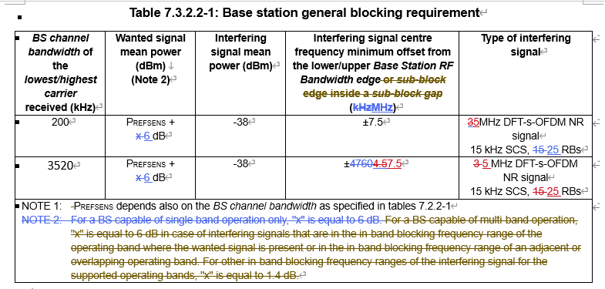
  - Option 2: Others
- Recommended WF
  - FFS.
Issue 2-3: Narrowband intermodulation
- Proposals:
  - Option 1: To ensure intermodulation products fall directly on the wanted signal, adjust the interfering signal location of narrowband intermodulation as follows(Huawei):
    - For 200 kHz D2R CBW:
    - Change the interfering RB center frequency offset (from the lower/upper BS RF bandwidth edge) from ±880 kHz to ±780 kHz.
    - For 3520 kHz D2R CBW:
    - Change the interfering RB center frequency offset (from the lower/upper BS RF bandwidth edge) from ±780 kHz to ±2300 kHz.
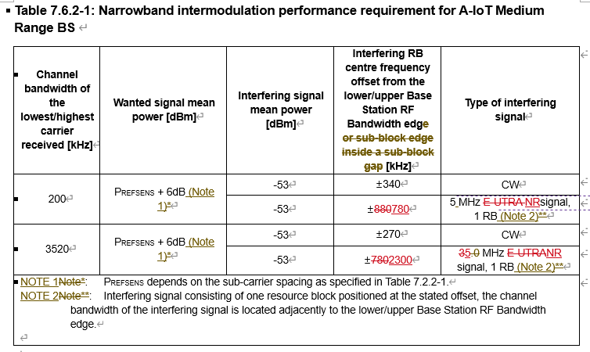
  - Option 2: Others
- Recommended WF
  - FFS.
Issue 2-4: FRC for R2D
- Proposals:
  - Option 1: Add the missing FRC for R2D (Huawei).

B.2 Fixed Reference Channels for R2D Tx requirements
Component | Parameter | Unit | Value
Component | Parameter | Unit | A-FR1-B1-1 | A-FR1-B1-2 | A-FR1-B1-3 | A-FR1-B1-4
General | PRB | RBs | 1 | 2 | 3 | 4
General | SCS | kHz | 15 | 15 | 15 | 15
SIP | Bit length | Bits | 8 | 8 | 8 | 8
SIP | Mapping to OFDM | Chips/Symbol | 4 | 4 | 4 | 4
CAP | Bit length | Bits | 4 | 4 | 4 | 4
CAP | M | Chips/Symbol | 6 | 12 | 24 | 24
PRDCH | TBS | Bits | 96 | 96 | 96 | 96
PRDCH | CRC | Bits | 16 | 16 | 16 | 16
PRDCH | M | Chips/Symbol | 6 | 12 | 24 | 24
Postamble | Bit length | Bits | 4 | 4 | 4 | 4
Postamble | M | Chips/Symbol | 6 | 12 | 24 | 24
Padding | Padding for last OFDM symbol | Chips | 2 | 8 | 8 | 8

  - Option 2: Others
- Recommended WF
  - FFS.

Issue 2-5: D2R bandwidth
- Proposals:
  - Option 1: BS Manufacture declare the scaling factor for the D2R bandwidth to improve the D2R coverage. (Eri)
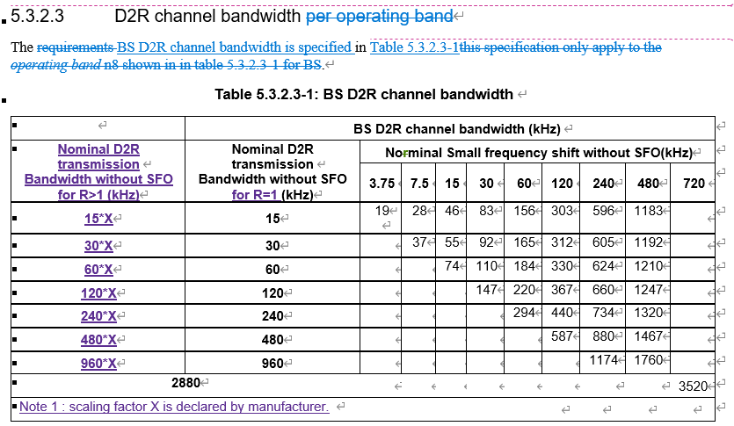
  - Option 2: Keep the current D2R channel bandwidth definition unchanged; introducing a scaling factor for R>1 is unnecessary.(Huawei)
- Recommended WF
  - FFS.

Sub-topic 2-3 recommendation for the draft CR provided in this meeting
T-doc number | Company | Proposals / Observations | recommendation
R4-2600209 | CATT | 1) Add reference for 3GPP TS 25.104. TS 36.104 and TS 38.104.  2) Replace co-existence spurious requirement in Table 6.5.5.2.2-1 with new format table.  3) Replace co-location spurious requirement in Table 6.5.5.2.3-1 with new format table. | Can be merged with ZTE’s CR
R4-2600340 | CATT | To supplement the Maximum offset of OBUE outside the downlink operating band table for unwanted emissions requirements. This correction will align the OBUE offset with the context in TS 38.195 and other network devices. | Further check. Some modifications are associated with Huawei's CRs.
R4-2601011 | Huawei, HiSilicon | 1) Change the interfering signal for ACS, in-band blocking, and narrowband intermodulation from 3 MHz E-UTRA/NR to 5 MHz NR.  2) For 200kHz D2R CBW, change the ACS interfering signal center frequency offset to the lower/upper Base Station RF Bandwidth from +/-100kHz to +/-340kHz.  3) For 3.52M D2R CBW, change the ACS interfering signal center frequency offset to the lower/upper Base Station RF Bandwidth from +/-100kHz to +/-2500kHz.  4) To ensure intermodulation products fall directly on the wanted signal, adjust the interfering signal location of narrowband intermodulation as follows:  For 200 kHz D2R CBW:  Change the interfering RB center frequency offset (from the lower/upper BS RF bandwidth edge) from ±880 kHz to ±780 kHz.  For 3520 kHz D2R CBW:  Change the interfering RB center frequency offset (from the lower/upper BS RF bandwidth edge) from ±780 kHz to ±2300 kHz.  5) Add the missing FRC for R2D | Wait for the agreements of Issue 2-1~2.4
R4-2601447 | CATT | To correct the description of A-IoT BS channel bandwidth of ACS/general blocking/narrowband intermodulation requirement for A-IoT BS, the description should be consistent with other descriptions of channel bandwidth in the spec. | Further check. Some modifications (e.g., Clause 5.3) are associated with Ericsson's CRs.
R4-2601854 | ZTE Corporation, Sanechips | 1) To simplify the additional spurious emission requirement and co-location requirement;  2) To remove the BS type 1-H from the specification | Further check
R4-2601871 | Ericsson | Adding manufacture declaration factor on the D2R bandwidth definition;  Correcting some definition of the test metric definition for Tx modulartion siganl quality | Wait for the agreements of Issue 2-5

