3GPP TSG-RAN4 Meeting #118 R4-2602079

Gothenburgh, Sweden, 9th Nov 2025 – 13th Feb 2026

Agenda item: 4.1.3
Source: Moderator (Eutelsat Group)
Title: [118][303] Ku_band_Maintenance
Document for: Information

Introduction
This is the topic summary for Ku Band maintenance.
:
    - Introduction of Ku Band for NR NTN [NR_NTN_Ku_bands-Core]
      - System parameters [NR_NTN_Ku_bands-Core]
      - UE RF requirements [NR_NTN_Ku_bands-Core]
      - SAN RF core requirements
      - RRM core requirements
.

Topic #1: System parameters (agenda 4.2.7.1)

Companies’ contributions summary
All Tdocs related to the following topics (agenda 4.2.7.1) are listed here:

Tdoc | Company | Proposals / Observations
R4-2600042 | Eutelsat Group | Observation 1: Considering a typical use of circular polarization for initial NR NTN use cases, signalling one of rhcp, lhcp and linear values by the satellite network to the UE was deemed sufficient to properly support NR NTN transmission in Rel-17 with FR1-NTN UE and Rel-18 including Ka band VSAT.  Observation 2: A VSAT UE served by a linearly polarized satellite access node will need to distinguish between two orthogonal linear polarizations for both downlink reception and uplink transmission, independently.  Observation 3: The introduction of new NR NTN operating bands - such as the Ku band in Rel-19 - is unlocking the support by 3GPP of new scenarios requiring the signalling of additional information for linear polarization, more specifically whether the linear polarization used at the satellite for transmission and reception for any UL/DL frequency pair is co-polar or cross-polar.  Observation 4: A GSO can use orthogonal polarizations on the downlink to transmit different signals. It is therefore necessary, in order to avoid interference with another user, that the absolute orientation (nominally H or V) needs to be signalled in the downlink. And for simplicity of design, the absolute orientation (nominally H or V) could also be signalled for the uplink rather than just a co-polar / cross polar indication.  Proposal 1: Send a reply LS to RAN2 expressing that:  - the indication of orthogonal linear polarisation is essential to the UE in satellite systems where the detected downlink linear polarization might be orthogonal to the expected uplink linear polarization,  - RAN4 suggest adding linear polarisation orientation (nominally X or Y) as an optional information element whenever linear polarization is signalled according to the Rel-17 RRC specification for the serving and neighbour cells/satellites in both uplink and downlink directions.
R4-2600043 | Eutelsat Group | To RAN WG2  ACTION: RAN WG4 asks RAN WG2 to add linear polarisation orientation (nominally X or Y) as an optional information element whenever linear polarization is signalled according to the Rel-17 RRC specification for the serving and neighbour cells/satellites in both uplink and downlink directions
R4-2601154  Moved from 4.7.1 | Samsung | Observation 1: In NR FR2 TN, polarization diversity is assumed at both NW and UE sides and they can both correctly receive any random polarized signal, which makes the linear polarization orientation signalling not necessary  Proposal 1: Proponents to clarify whether the reception at both NTN SAN and NTN UE sides is based on polarization diversity.  Proposal 2: RAN4 to discuss the uplink beam selection procedure for NTN and in such context if SAN’s linear polarization orientation signalling could provide additional usage.
R4-2601352  Moved from 4.7.1 | Ericsson | Observation1: From NTN RF perspective, the signaling of the linear polarization orientation by the network to the UE doesn’t seem necessary.  Observation2: From NTN UE demodulation perspective, the signaling of the linear polarization orientation by the network to the UE doesn’t seem necessary.  Observation3: From RRM perspective, the signaling of the linear polarization orientation by the network to the UE doesn’t seem necessary.  Proposal: Respond to RAN2 indicating that RAN4 does not identify any need for the network to signal the linear polarization orientation to the UE for NR NTN.
R4-2601932 | Nokia | Observation 1: From RAN4 perspective, there is no specification impacted or UE performance improvement associated to the signalling of the polarization.  Proposal 1: Reply to RAN2 that, at this late stage of Rel-19, there is no measurable gain, from RAN4 perspective to provide such signalling.  Observation 2: If real and measurable gains are provided, RAN4 might revise this position.
R4-2601687  Moved from 11.2 | SKY Perfect JSAT, CHTTL | Proposal 1: RAN4 should provide feedback to RAN2 that it is necessary for NR NTN networks operating in the Ku band to provide the linear polarization orientation (horizontal/vertical) information to the UE, in order to ensure uplink and downlink performance and to avoid interference.  Observation 1: When the satellite polarizations are not aligned square with the equatorial plane, the linear polarization (H/V) information alone is not sufficient. In such cases, the satellite skew angle information is necessary for the UE to perform polarization alignment.  Observation 2: In current GSO satellite systems, different satellite skews exist for different frequency bands on a satellite, while in the case of SDS (Software-Defined Satellite), some systems allow the satellite skew to be adjusted on a per-channel basis, enabling dynamic modification of the skew.  Proposal 2: RAN4 to provide additional feedback to RAN2 that the satellite skew information is also necessary together with the linear polarization orientation (horizontal/vertical) information.  - The satellite skew should be defined as the angle measured clockwise when looking at the satellite from the Earth, with an angular resolution of at least one decimal place, and within the range of −90 to +90 degrees.  Proposal 3: RAN4 to agree the LS in R4-2601483.
R4-2601483  Moved from 11.2 | CHTTL, SKY Perfect JSAT | Draft LS reply to RAN2  RAN4 agreed that it is necessary for NR NTN networks operating in the Ku bands to provide the linear polarization orientation (horizontal/vertical) information to the UE in order to ensure uplink and downlink performance and to avoid interference. It is noted that the uplink and downlink may use different polarization orientations.  Furthermore, RAN4 has identified that the linear polarization (H/V) information alone is not sufficient in cases where the satellite skew are not aligned square with the equatorial plane. In such cases, the satellite skew information shall be provided together with the linear polarization (H/V) information. In current GSO satellite systems, different satellite skews exist for different frequency bands on a satellite, while in the case of SDS (Software-Defined Satellite), some systems allow the satellite skew to be adjusted on a per-channel basis, enabling dynamic modification of the skew.  It is suggested that the satellite skew be defined as the angle

Open issues summary

Sub-topic 1-1: Requirement to signal linear polarization H or V
- Proposals:`
- Proposal 1 in R4-2600042 from Eutelsat
Send a reply LS to RAN2 expressing that:
- the indication of orthogonal linear polarisation is essential to the UE in satellite systems where the detected downlink linear polarization might be orthogonal to the expected uplink linear polarization,
- RAN4 suggest adding linear polarisation orientation (nominally X or Y) as an optional information element whenever linear polarization is signalled according to the Rel-17 RRC specification for the serving and neighbour cells/satellites in both uplink and downlink directions.
- Draft LS reply in R4-2600043 from Eutelsat
To RAN WG2
ACTION: RAN WG4 asks RAN WG2 to add linear polarisation orientation (nominally X or Y) as an optional information element whenever linear polarization is signalled according to the Rel-17 RRC specification for the serving and neighbour cells/satellites in both uplink and downlink directions
- Proposal 1 in R4-2601352 from Samsung
Proponents to clarify whether the reception at both NTN SAN and NTN UE sides is based on polarization diversity.
- Proposal 2 in R4-2601352 from Samsung
RAN4 to discuss the uplink beam selection procedure for NTN and in such context if SAN’s linear polarization orientation signalling could provide additional usage.
- Proposal in R4-2601352 from Ericsson
Respond to RAN2 indicating that RAN4 does not identify any need for the network to signal the linear polarization orientation to the UE for NR NTN
- Proposal 1 in R4-2601932 from Nokia
Reply to RAN2 that, at this late stage of Rel-19, there is no measurable gain, from RAN4 perspective to provide such signalling.

The Eutelsat analysis in R4-2600042 provides the technical basis for the request from RAN2. This relates to the use of polarization diversity in both downlink and uplink. The VSAT can detect the downlink polarization, but without signalling, cannot determine which polarization to use on the uplink as this may be co-polar or cross-polar to the downlink. This is the technical justification to send the draft LS in R4-2600043 indicating that the requested signaling is an essential correction in Rel-19 for normal operation.
- Moderator Recommendation:
- Discussion required

Sub-topic 1-2: Requirement to signal linear polarization skew
- Proposals:`
- Proposals in R4-2601687 from SKY Perfect JSAT, CHTTL
Proposal 1: RAN4 should provide feedback to RAN2 that it is necessary for NR NTN networks operating in the Ku band to provide the linear polarization orientation (horizontal/vertical) information to the UE, in order to ensure uplink and downlink performance and to avoid interference.

Proposal 2: RAN4 to provide additional feedback to RAN2 that the satellite skew information is also necessary together with the linear polarization orientation (horizontal/vertical) information. The satellite skew should be defined as the angle measured clockwise when looking at the satellite from the Earth, with an angular resolution of at least one decimal place, and within the range of −90 to +90 degrees.

- Draft LS reply in R4-2601483 from CHTTL, SKY Perfect JSAT
RAN4 agreed that it is necessary for NR NTN networks operating in the Ku bands to provide the linear polarization orientation (horizontal/vertical) information to the UE in order to ensure uplink and downlink performance and to avoid interference. It is noted that the uplink and downlink may use different polarization orientations.
Furthermore, RAN4 has identified that the linear polarization (H/V) information alone is not sufficient in cases where the satellite skew are not aligned square with the equatorial plane. In such cases, the satellite skew information shall be provided together with the linear polarization (H/V) information. In current GSO satellite systems, different satellite skews exist for different frequency bands on a satellite, while in the case of SDS (Software-Defined Satellite), some systems allow the satellite skew to be adjusted on a per-channel basis, enabling dynamic modification of the skew.
It is suggested that the satellite skew be defined as the angle
- Moderator Recommendation:
- The motivation and consequences for signalling linear polarization skew are different to the motivation and consequences for signalling orthogonal linear polarization in sub-topic 1-1.
- The RAN2 LS was limited to the usefulness of signalling two orthogonal linear polarizations. The more advanced proposals to signal linear polarization skew may need to be treated separately for the purposes of the reply LS.
- Discussion required.

Topic #2: UE RF requirements (agenda 4.2.7.2)

Companies’ contributions summary
All Tdocs related to the following topics (agenda 4.2.7.2) are listed here:

T-doc | Company | Proposals / Observations
R4-2600777 | MediaTek (Chengdu) Inc. | Observation 1:When the VSAT transmit signal bandwidth is greater than or equal to 4.32 MHz (SCS = 15 kHz, 24 RBs), the A‑MPR is 0 dB, and when the VSAT transmit signal bandwidth is smaller than 4.32 MHz (SCS = 15 kHz, 24 RBs), A MPR is needed to reduce the EIRP PSD level to meet the off-axis EIRP requirements.  Proposal 1: The A-MPR values can be calculated based on the formula Max( 0, -10log₁₀(N_{RB} × SCS × 12 / factor)), where the factor is 24 RBs × 15 kHz SCS × 12, i.e., 4.32 MHz.  Observation 2: When the VSAT transmit signal bandwidth is greater than or equal to 1.08 MHz (SCS = 15 kHz, 6 RBs), the A‑MPR is 0 dB, and when the VSAT transmit signal bandwidth is smaller than 1.08 MHz (SCS = 15 kHz, 6 RBs), A‑MPR is needed to reduce the EIRP PSD level to meet the off‑axis EIRP requirements.  Proposal 2: The A-MPR values can be calculated based on the formula Max( 0, -10log₁₀(N_{RB} × SCS × 12 / factor)), where the factor is 6 RBs × 15 kHz SCS × 12, i.e., 1.08 MHz.  Observation 3: When the VSAT transmit signal bandwidth is greater than or equal to 9.36 MHz (SCS = 15 kHz, 52 RBs), the A MPR is 0 dB, and when the VSAT transmit signal bandwidth is smaller than 9.36MHz (SCS = 15 kHz, 52RBs), A MPR is needed to reduce the EIRP PSD level to meet the off axis EIRP requirements.  Proposal 3: The A-MPR values can be calculated based on the formula Max( 0, -10log₁₀(N_{RB} × SCS × 12 / factor)), where the factor is 52 RBs × 15 kHz SCS × 12, i.e. 9.36 MHz.  Observation 4: No A-MPR is needed for the mechanically steered VSAT  Proposal 4: RAN4 to consider adding A‑MPR requirements for Ku‑band electrically steered VSATs in 38.101‑5 when communicating with GSO satellites, as shown in the following table.  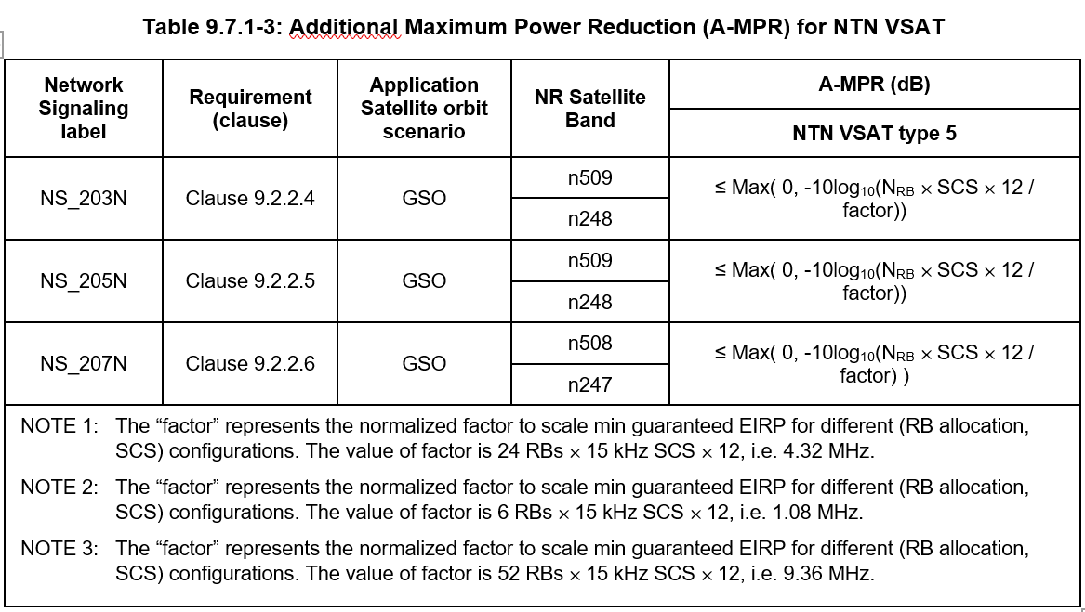
R4-2601748 | MediaTek Inc. | 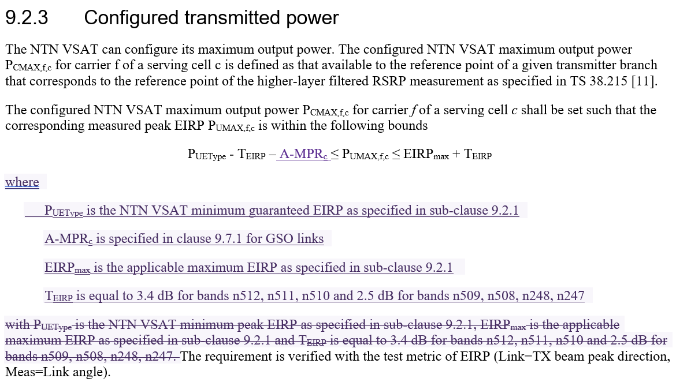  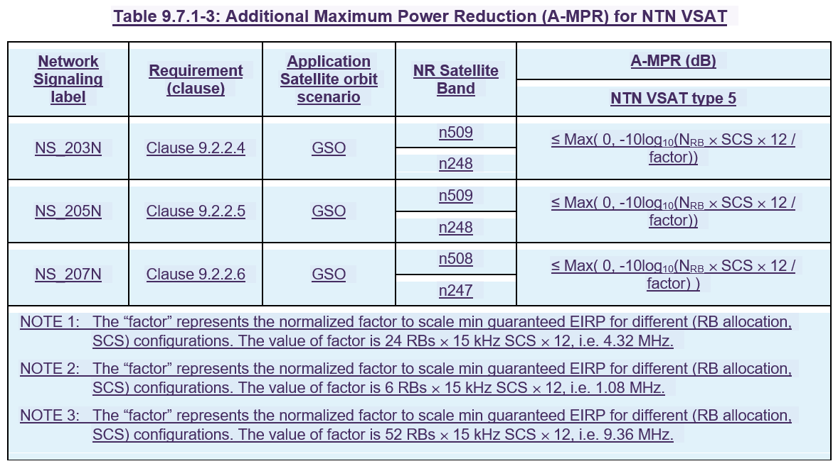
R4-2601061 | ZTE Corporation, Sanechips | 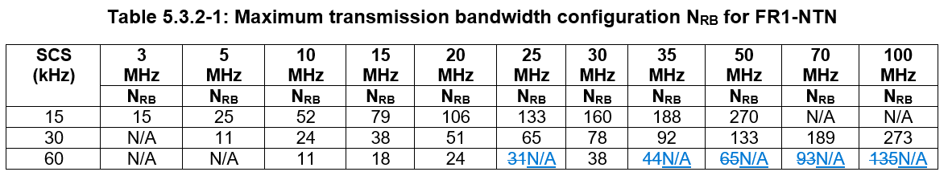  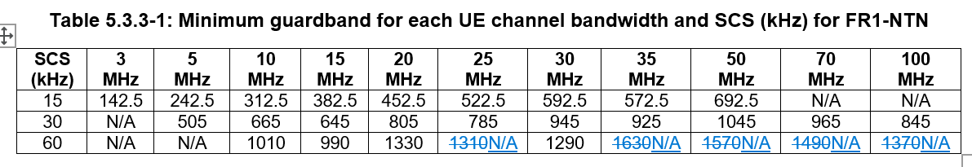
R4-2601750 | MediaTek (Chengdu) Inc. | Unavailable

Open issues summary

Sub-topic 2-1: Addition of VSAT AMPR
- Proposals:
- Proposal from MediaTek (Chengdu) Inc. in R4-2600777
- CR from MediaTek Inc. in R4-2601748
- Moderator Recommendation:
- Discussion required

Sub-topic 2-2: Removal of redundant 60 KHz SCS channel bandwidths
- Proposals:
- CR from ZTE Corporation, Sanechips in R4-2601061
- Moderator Recommendation:
- If this is currently redundant information, is it essential to remove it?
- Discussion required

Topic #3: SAN RF requirements (agenda 4.2.7.3)

Companies’ contributions summary
All Tdocs related to the following topics (agenda 4.2.7.3) are listed here:

T-doc | Company | Proposals / Observations
R4-2600208 | CATT | 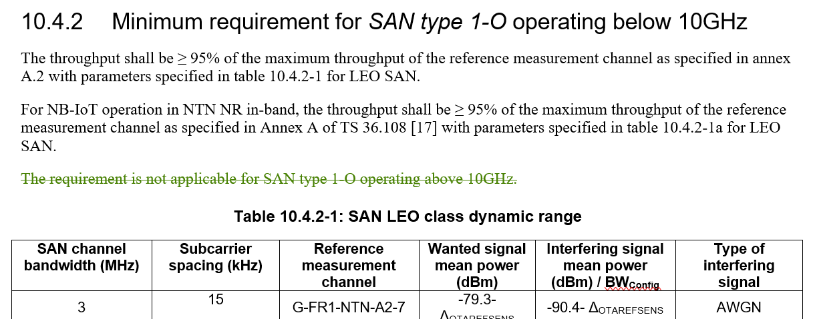  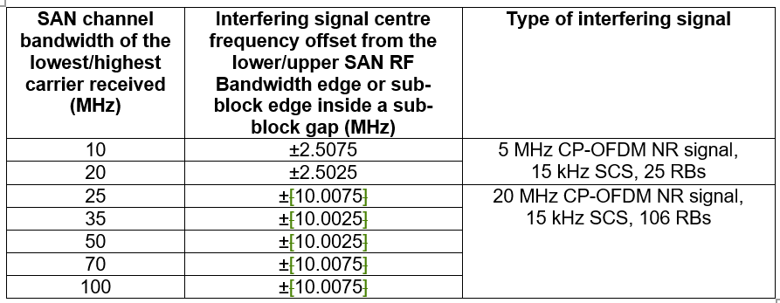
R4-2601062 | ZTE Corporation, Sanechips | 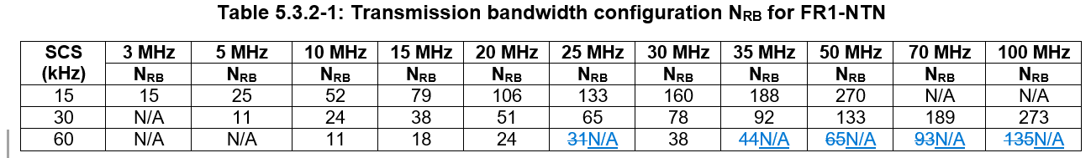  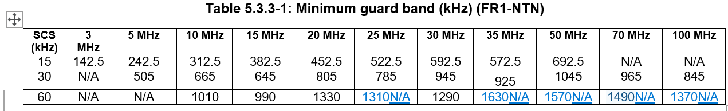

Open issues summary

Sub-topic 3-1: Corrections for SAN type 1-O operating below 10 GHz
- Proposals:
- CR from CATT in R4-2600208
- Remove redundant statement:
- Moderator Recommendation:
- Approve the first change in CR R4-2600208

Sub-topic 3-2: Correction for OTA ACS interferer frequency offset for SAN type 1-O operating above 10 GHz
- Proposals:
- CR from CATT in R4-2600208
- Remove redundant square brackets:
- Moderator Recommendation:
- Approve the second change in CR R4-2600208

Sub-topic 3-3: Removal of redundant 60 KHz SCS channel bandwidths
- Proposals:
- CR from ZTE Corporation, Sanechips in R4-2601062
- Moderator Recommendation:
- This is the same as sub-topic 2-2 for the UE.
- If this is currently redundant information, is it essential to remove it?
- Discussion required

Topic #4: RRM requirements (agenda 4.2.7.4)

Companies’ contributions summary
All Tdocs related to the following topics (agenda 4.2.7.4) are listed here:

T-doc | Company | Proposals / Observations
R4-2600657 | MediaTek inc. | Relax the scheduling restriction during a soft satellite switch when 'deriveSSB-IndexFromCell' is not enabled.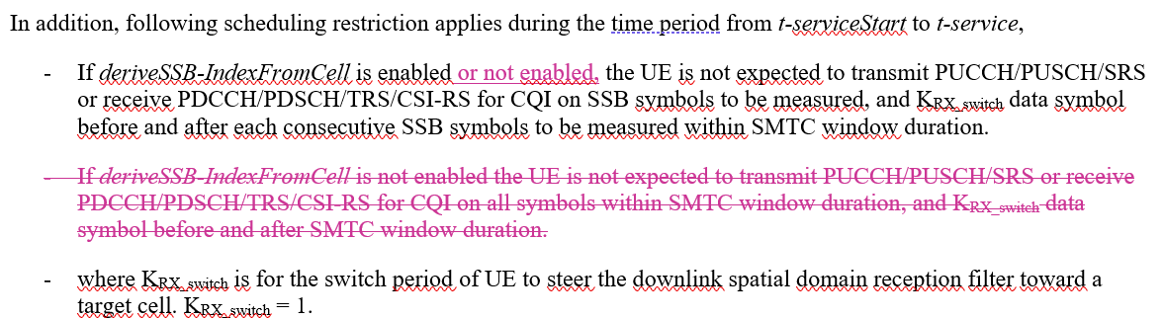
R4-2601359 | ZTE Corporation, Sanechips | Proposal 1: The re-defined scheduling restriction shall be considered as below:  In addition, following scheduling restriction applies during the time period from t-serviceStart to t-service,  - The UE is not expected to transmit PUCCH/PUSCH/SRS or receive PDCCH/PDSCH/TRS/CSI-RS for CQI on SSB symbols to be measured decided by source SSB configuration and ssb-TimeOffset , and KRX_switch data symbol before and after each consecutive SSB symbols to be measured.  - where KRX_switch is for the switch period of UE to steer the downlink spatial domain reception filter toward a target satellite. KRX_switch=1.
R4-2601374 | ZTE Corporation, Sanechips | 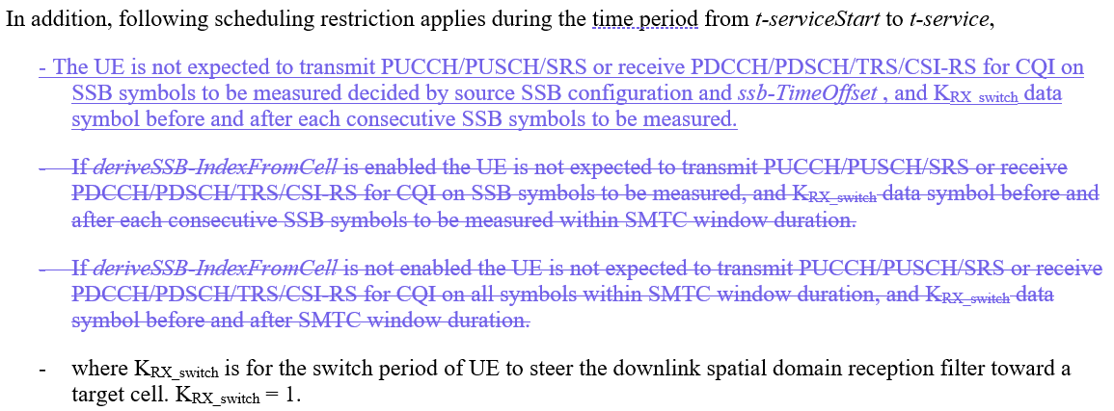
R4-2601537 | Huawei, HiSilicon | Proposal 1: Define scheduling restriction for soft satellite switch as  UE is not expected to transmit PUCCH/PUSCH/SRS or receive PDCCH/PDSCH/TRS/CSI-RS for CQI on SSB symbols of the target satellite, and K data symbol before and after each consecutive SSB symbols of the target satellite, where K=1.
R4-2601538 | Huawei, HiSilicon | 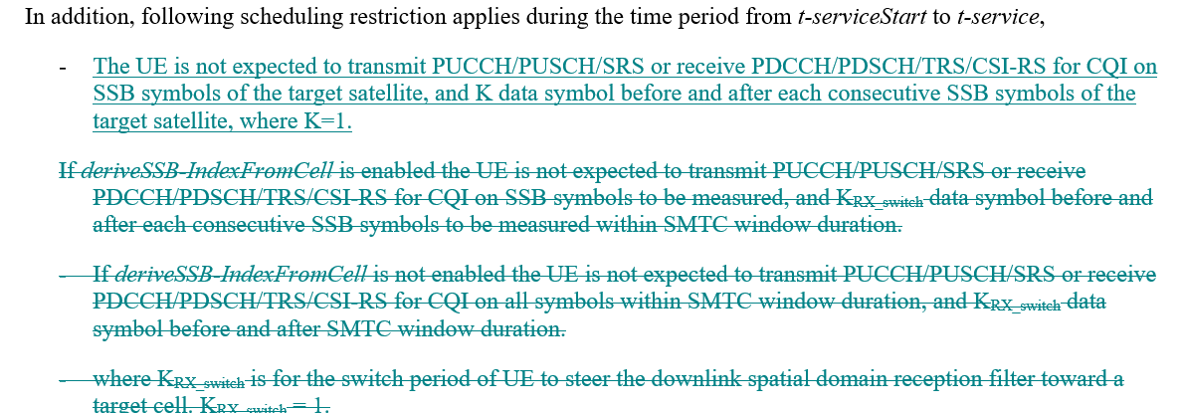

Open issues summary

Sub-topic 4-1: Scheduling restriction for NR SAN Satellite switching with re-synchronization
- Proposals:
- CR from MediaTek Inc. in R4-2600657
Relax the scheduling restriction during a soft satellite switch when 'deriveSSB-IndexFromCell' is not enabled.
- Proposal 1 from ZTE Corporation, Sanechips in R4-2601359
The re-defined scheduling restriction shall be considered as below:
In addition, following scheduling restriction applies during the time period from t-serviceStart to t-service,
- The UE is not expected to transmit PUCCH/PUSCH/SRS or receive PDCCH/PDSCH/TRS/CSI-RS for CQI on SSB symbols to be measured decided by source SSB configuration and ssb-TimeOffset , and KRX_switch data symbol before and after each consecutive SSB symbols to be measured.
- where KRX_switch is for the switch period of UE to steer the downlink spatial domain reception filter toward a target satellite. KRX_switch=1.
- CR from ZTE Corporation, Sanechips in R4-2601374
- Proposal 1 from Huawei, HiSilicon in R4-2601537
Proposal 1: Define scheduling restriction for soft satellite switch as
UE is not expected to transmit PUCCH/PUSCH/SRS or receive PDCCH/PDSCH/TRS/CSI-RS for CQI on SSB symbols of the target satellite, and K data symbol before and after each consecutive SSB symbols of the target satellite, where K=1.
- CR from Huawei, HiSilicon in R4-2601538
- Moderator Recommendation:
- The three proposals to 6.1C.3.3.3 do not align, discussion required.

