3GPP TSG-RAN4 Meeting #118 R4-2602079

Gothenburgh, Sweden, 9th Nov 2025 – 13th Feb 2026

Agenda item: 4.1.3
Source: Moderator (Eutelsat Group)
Title: [118][303] Ku_band_Maintenance
Document for: Information

Introduction
This is the topic summary for Ku Band maintenance.
:
    - Introduction of Ku Band for NR NTN [NR_NTN_Ku_bands-Core]
      - System parameters [NR_NTN_Ku_bands-Core]
      - UE RF requirements [NR_NTN_Ku_bands-Core]
      - SAN RF core requirements
      - RRM core requirements
.

Topic #1: System parameters (agenda 4.2.7.1)

Companies’ contributions summary
All Tdocs related to the following topics (agenda 4.2.7.1) are listed here:

Tdoc | Company | Proposals / Observations
Moved to 11.2 [324]

Topic #2: UE RF requirements (agenda 4.2.7.2)

Companies’ contributions summary
All Tdocs related to the following topics (agenda 4.2.7.2) are listed here:

T-doc | Company | Proposals / Observations
R4-2600777 | MediaTek (Chengdu) Inc. | Observation 1:When the VSAT transmit signal bandwidth is greater than or equal to 4.32 MHz (SCS = 15 kHz, 24 RBs), the A‑MPR is 0 dB, and when the VSAT transmit signal bandwidth is smaller than 4.32 MHz (SCS = 15 kHz, 24 RBs), A MPR is needed to reduce the EIRP PSD level to meet the off-axis EIRP requirements.  Proposal 1: The A-MPR values can be calculated based on the formula Max( 0, -10log₁₀(N_{RB} × SCS × 12 / factor)), where the factor is 24 RBs × 15 kHz SCS × 12, i.e., 4.32 MHz.  Observation 2: When the VSAT transmit signal bandwidth is greater than or equal to 1.08 MHz (SCS = 15 kHz, 6 RBs), the A‑MPR is 0 dB, and when the VSAT transmit signal bandwidth is smaller than 1.08 MHz (SCS = 15 kHz, 6 RBs), A‑MPR is needed to reduce the EIRP PSD level to meet the off‑axis EIRP requirements.  Proposal 2: The A-MPR values can be calculated based on the formula Max( 0, -10log₁₀(N_{RB} × SCS × 12 / factor)), where the factor is 6 RBs × 15 kHz SCS × 12, i.e., 1.08 MHz.  Observation 3: When the VSAT transmit signal bandwidth is greater than or equal to 9.36 MHz (SCS = 15 kHz, 52 RBs), the A MPR is 0 dB, and when the VSAT transmit signal bandwidth is smaller than 9.36MHz (SCS = 15 kHz, 52RBs), A MPR is needed to reduce the EIRP PSD level to meet the off axis EIRP requirements.  Proposal 3: The A-MPR values can be calculated based on the formula Max( 0, -10log₁₀(N_{RB} × SCS × 12 / factor)), where the factor is 52 RBs × 15 kHz SCS × 12, i.e. 9.36 MHz.  Observation 4: No A-MPR is needed for the mechanically steered VSAT  Proposal 4: RAN4 to consider adding A‑MPR requirements for Ku‑band electrically steered VSATs in 38.101‑5 when communicating with GSO satellites, as shown in the following table.  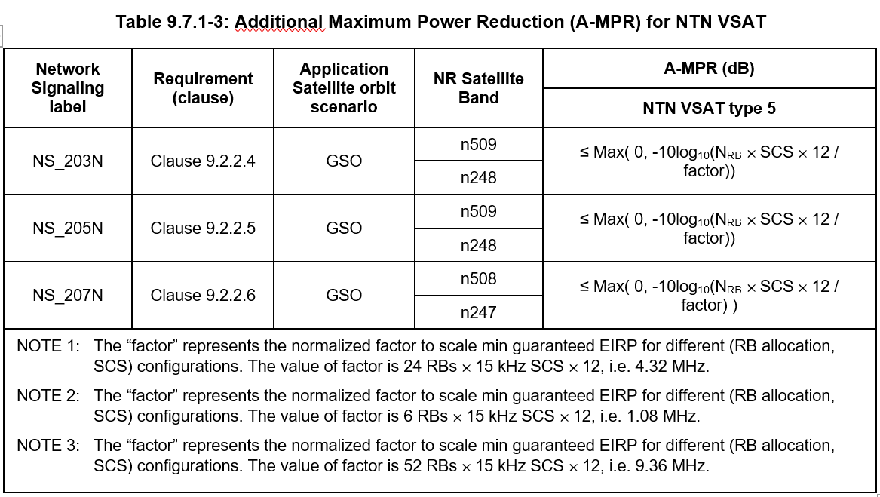
R4-2601748 | MediaTek Inc. | 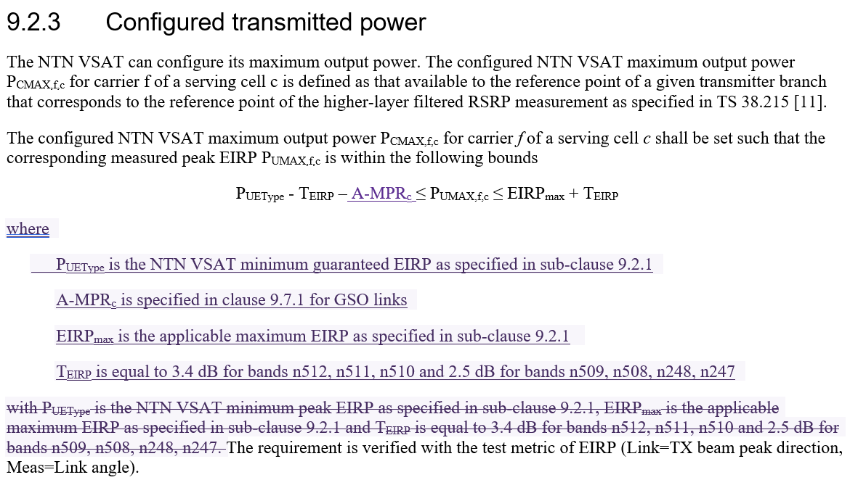  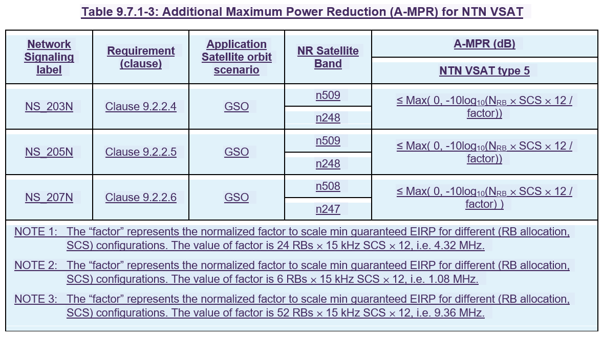
R4-2601061 | ZTE Corporation, Sanechips | 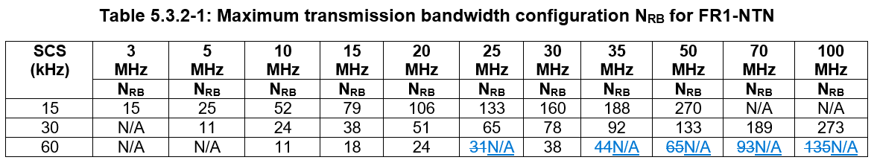  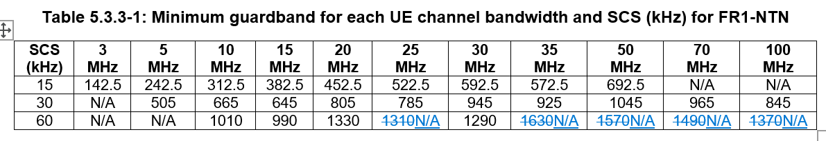
R4-2601750 | MediaTek (Chengdu) Inc. | Unavailable

Open issues summary

Sub-topic 2-1: Addition of VSAT AMPR
- Proposals:
- Proposal from MediaTek (Chengdu) Inc. in R4-2600777
- CR from MediaTek Inc. in R4-2601748
- Moderator Recommendation:
- What is the applicability of the 3 notes in Tale 9.7.1-3?
- 1.08 MHz is not possible in bands 609/508
- Discussion required

Sub-topic 2-2: Removal of redundant 60 KHz SCS channel bandwidths
- Proposals:
- CR from ZTE Corporation, Sanechips in R4-2601061
- Moderator Recommendation:
- If this is currently redundant information, is it essential to remove it?
- Discussion required

Topic #3: SAN RF requirements (agenda 4.2.7.3)

Companies’ contributions summary
All Tdocs related to the following topics (agenda 4.2.7.3) are listed here:

T-doc | Company | Proposals / Observations
R4-2600208 | CATT | 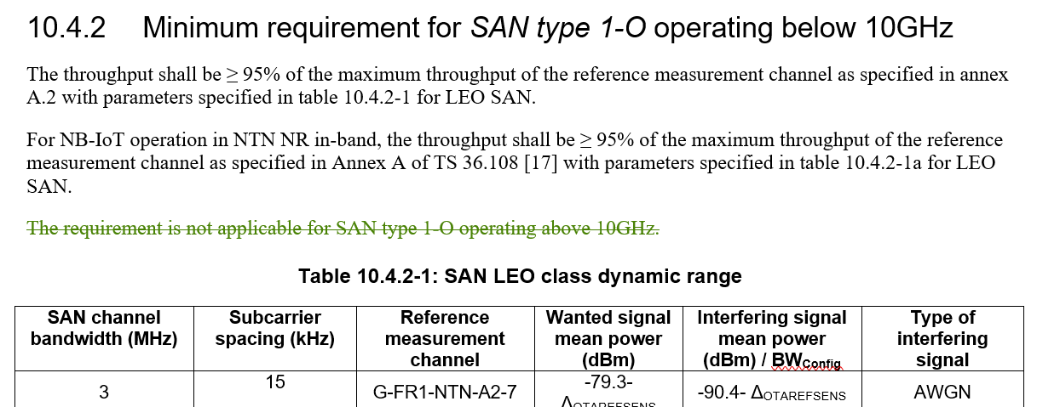  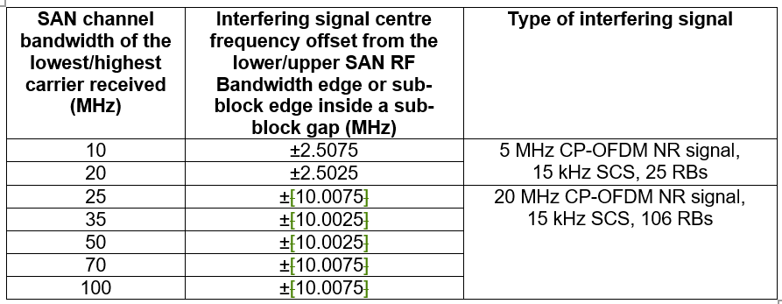
R4-2601062 | ZTE Corporation, Sanechips | 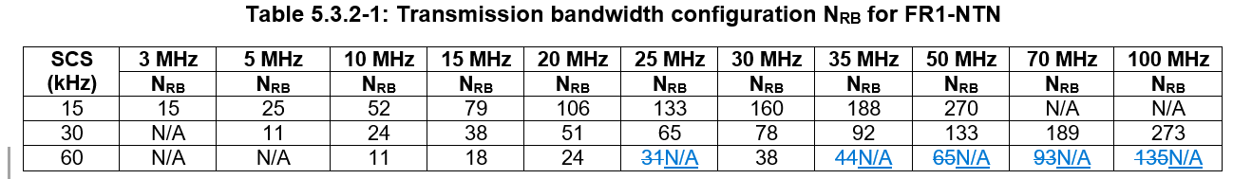  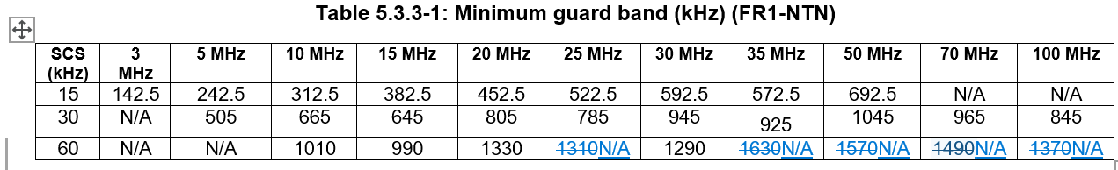

Open issues summary

Sub-topic 3-1: Corrections for SAN type 1-O operating below 10 GHz
- Proposals:
- CR from CATT in R4-2600208
- Remove redundant statement:
- Moderator Recommendation:
- Approve the first change in CR R4-2600208

Sub-topic 3-2: Correction for OTA ACS interferer frequency offset for SAN type 1-O operating above 10 GHz
- Proposals:
- CR from CATT in R4-2600208
- Remove redundant square brackets:
- Moderator Recommendation:
- Approve the second change in CR R4-2600208

Sub-topic 3-3: Removal of redundant 60 KHz SCS channel bandwidths
- Proposals:
- CR from ZTE Corporation, Sanechips in R4-2601062
- Moderator Recommendation:
- This is the same as sub-topic 2-2 for the UE.
- If this is currently redundant information, is it essential to remove it?
- Discussion required

Topic #4: RRM requirements (agenda 4.2.7.4)

Companies’ contributions summary
All Tdocs related to the following topics (agenda 4.2.7.4) are listed here:

T-doc | Company | Proposals / Observations
R4-2600657 | MediaTek inc. | Relax the scheduling restriction during a soft satellite switch when 'deriveSSB-IndexFromCell' is not enabled.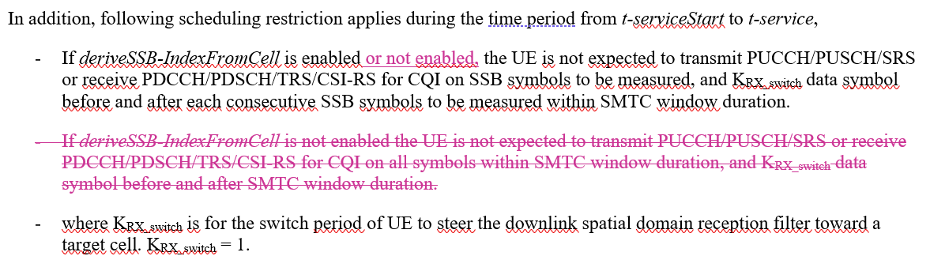
R4-2601359 | ZTE Corporation, Sanechips | Proposal 1: The re-defined scheduling restriction shall be considered as below:  In addition, following scheduling restriction applies during the time period from t-serviceStart to t-service,  - The UE is not expected to transmit PUCCH/PUSCH/SRS or receive PDCCH/PDSCH/TRS/CSI-RS for CQI on SSB symbols to be measured decided by source SSB configuration and ssb-TimeOffset , and KRX_switch data symbol before and after each consecutive SSB symbols to be measured.  - where KRX_switch is for the switch period of UE to steer the downlink spatial domain reception filter toward a target satellite. KRX_switch=1.
R4-2601374 | ZTE Corporation, Sanechips | 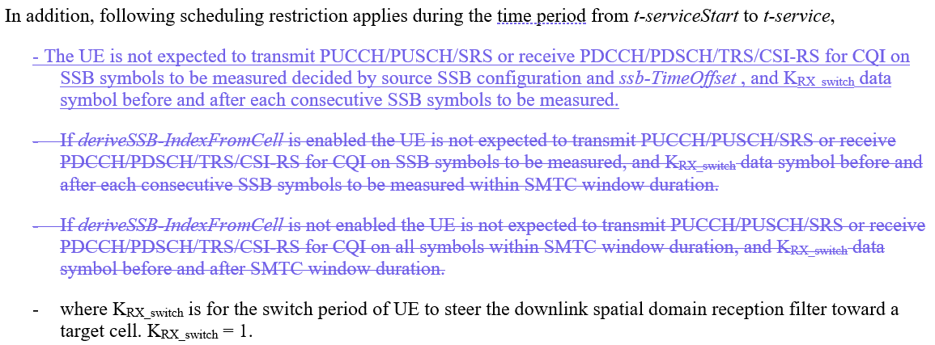
R4-2601537 | Huawei, HiSilicon | Proposal 1: Define scheduling restriction for soft satellite switch as  UE is not expected to transmit PUCCH/PUSCH/SRS or receive PDCCH/PDSCH/TRS/CSI-RS for CQI on SSB symbols of the target satellite, and K data symbol before and after each consecutive SSB symbols of the target satellite, where K=1.
R4-2601538 | Huawei, HiSilicon | 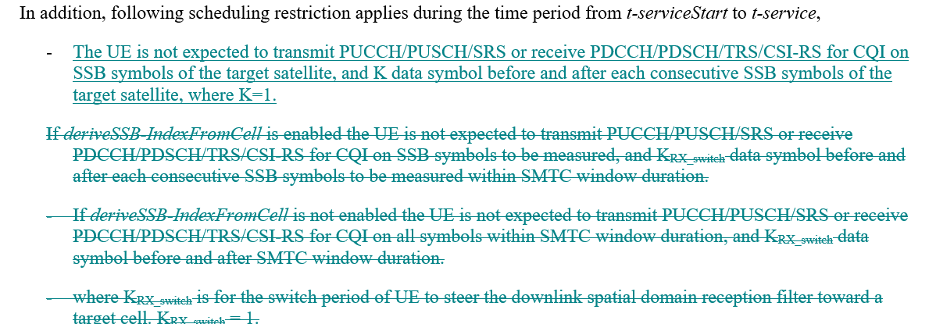

Open issues summary

Sub-topic 4-1: Scheduling restriction for NR SAN Satellite switching with re-synchronization
- Proposals:
- CR from MediaTek Inc. in R4-2600657
Relax the scheduling restriction during a soft satellite switch when 'deriveSSB-IndexFromCell' is not enabled.
- Proposal 1 from ZTE Corporation, Sanechips in R4-2601359
The re-defined scheduling restriction shall be considered as below:
In addition, following scheduling restriction applies during the time period from t-serviceStart to t-service,
- The UE is not expected to transmit PUCCH/PUSCH/SRS or receive PDCCH/PDSCH/TRS/CSI-RS for CQI on SSB symbols to be measured decided by source SSB configuration and ssb-TimeOffset , and KRX_switch data symbol before and after each consecutive SSB symbols to be measured.
- where KRX_switch is for the switch period of UE to steer the downlink spatial domain reception filter toward a target satellite. KRX_switch=1.
- CR from ZTE Corporation, Sanechips in R4-2601374
- Proposal 1 from Huawei, HiSilicon in R4-2601537
Proposal 1: Define scheduling restriction for soft satellite switch as
UE is not expected to transmit PUCCH/PUSCH/SRS or receive PDCCH/PDSCH/TRS/CSI-RS for CQI on SSB symbols of the target satellite, and K data symbol before and after each consecutive SSB symbols of the target satellite, where K=1.
- CR from Huawei, HiSilicon in R4-2601538
- Moderator Recommendation:
- The three proposals to 6.1C.3.3.3 do not align, discussion required.

