TSG-RAN Working Group 4 (Radio) meeting #118 R4-2602952
Gothenburg, Sweden, 9-13 February 2026

Agenda item: 4.3.1
Source: Ericsson
Title: Way forward for maintenance work to remove RDN for OTA BS
Document for: Approval

Way Forward

The following proposals are to be further considered:
- Proposal 1:
- Modify the RDN definition, by deleting the “linear and passive”:
radio distribution network: linear passive network which distributes the RF power generated by the transceiver unit array to the antenna array, and/or distributes the radio signals collected by the antenna array to the transceiver unit array
- Specify that RDN shall be linear and passive only in case of Hybrid AAS BS and BS Type 1-H ( in the core specs and xx.xxx-1 specs)

- Proposal 2:
- delete the “RDN”, “AA” and “Composite antenna” from the OTA BS architecture figures
- Delete the statement about “composite antenna” from the TS 37.145-2 and TS 38.141-2
- Modify the statement about composite antenna so that it only applies for hybrid AAS BS and BS Type 1-H.
See example below:
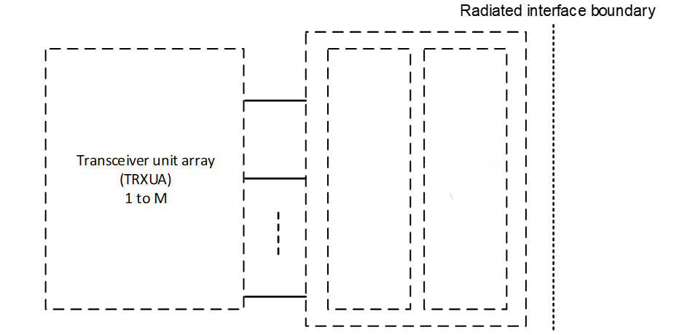

- Proposal 3: keep the existing specification unchanged.

- Other proposals are not precluded.

