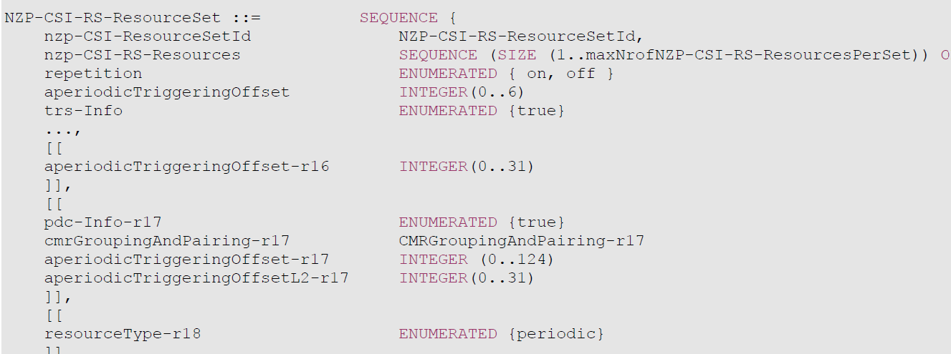
aperiodicTriggeringOffset, aperiodicTriggeringOffset-r16, aperiodicTriggeringOffset-r17
Offset X between the slot containing the DCI that triggers a set of aperiodic NZP CSI-RS resources and the slot in which the CSI-RS resource set is transmitted. For aperiodicTriggeringOffset, the value 0 corresponds to 0 slots, value 1 corresponds to 1 slot, value 2 corresponds to 2 slots, value 3 corresponds to 3 slots, value 4 corresponds to 4 slots, value 5 corresponds to 16 slots, value 6 corresponds to 24 slots. For aperiodicTriggeringOffset-r16 and aperiodicTriggeringOffset-r17, the value indicates the number of slots. aperiodicTriggeringOffset-r17 is applicable to SCS 480 kHz and 960 kHz, and only the values of integer multiples of 4 are valid, i.e. 0, 4, 8, and so on. The network configures only one of the fields. When neither field is included, the UE applies the value 0. This field is not present in case NZP-CSI-RS-ResourcesSet is received as part of an LTM-Candidate IE

