Phase margin and throughput
The CSI-RS period is 20ms and phase shifting will be calculated as follows:
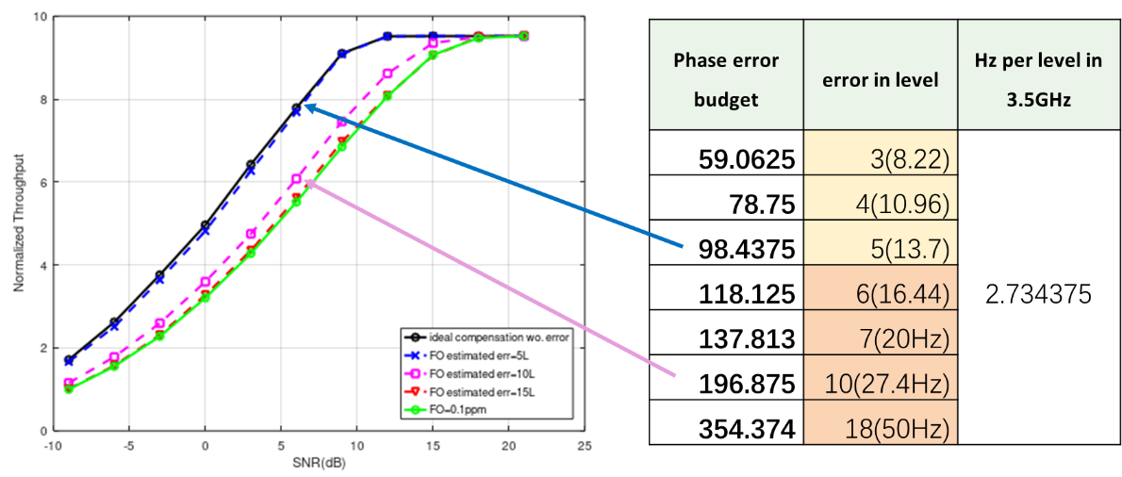

Align views from network side:
To ensure the CJT works well the phase difference between two TRPs should remain within 90°. Consequently, the UE is required to report FO estimations with less than 5 levels error.

