3GPP TSG-RAN WG4 Meeting #118 R4-2600934

Gothenburg, Sweden, Feb. 09-13, 2026
CR-Form-v12.3
CHANGE REQUEST
 | 38.133 | CR | draftCR | rev | - | Current version: | 19.3.0
For HELP on using this form: comprehensive instructions can be found at
http://www.3gpp.org/Change-Requests.

Proposed change affects: | UICC apps |  | ME | x | Radio Access Network |  | Core Network

Title: | DraftCR on TC8 RLM requirement for PCell
Source to WG: | OPPO
Source to TSG: | R4
Work item code: | NR_LBCA_Sw-Perf |  |  |  |  |  | Date: |  |  | 2026-01-30
Category: | B |  |  |  |  |  | Release: |  |  | Rel-19
 | Use one of the following categories:  F (correction)  A (mirror corresponding to a change in an earlier release)  B (addition of feature),  C (functional modification of feature)  D (editorial modification)  Detailed explanations of the above categories can  be found in 3GPP TR 21.900. |  |  |  |  |  |  |  | Use one of the following releases:  Rel-8 (Release 8)  Rel-9 (Release 9)  Rel-10 (Release 10)  Rel-11 (Release 11)  …  Rel-17 (Release 17)  Rel-18 (Release 18)  Rel-19 (Release 19)  Rel-20 (Release 20)
Reason for change: |  | Based on WF for Rel-19 LBCA (R4-2514870), the test cases for RLM requirements for FDD PCell based on SSB resource need to be introduced.
Summary of change: |  | Introduce the test case for RLM requirements for FDD PCell.
Consequences if not approved: |  | The test configuration and procedure will be imcompleted.
Clauses affected: |  | (new)A.6.5.1.X1 A.6.5.1.X2
 |  | Y | N
Other specs |  |  | x | Other core specifications |  |  |  | TS/TR ... CR ...
affected: |  | x |  | Test specifications |  |  |  | TS 38.533
(show related CRs) |  |  | x | O&M Specifications |  |  |  | TS/TR ... CR ...
Other comments:
This CR's revision history:

------------ START OF CHANGE 1--------------

A.6.5.1.X1 Radio Link Monitoring Out-of-sync Test for FR1 PCell with LowBandCA-Switching-r19 configured with SSB-based RLM RS in non-DRX mode

A.6.5.1.X1.1 Test Purpose and Environment
The purpose of this test is to verify that the UE supporting featureSetCombinationLowBandSwitching-r19 properly detects the out of sync and in sync for the purpose of monitoring downlink radio link quality of the PCell. This test will partly verify the FR1 radio link monitoring requirements in clause 8.1.
In the test, UE is configured to perform RLM on SSB, with detectionResource included in RadioLinkMonitoringRS set to SSB#0, and purpose set to ‘rlf’. Supported test configurations are shown in table A.6.5.1.X1.1-1. The test parameters are given in tables A.6.5.1.X1.1-2 and A.6.5.1.X1.1-3 below. There are two cells, Cell 1 is the FDD PCell and Cell 2 is the SDL SCell, in the test. The PCell and SCell are co-located deployed and synchronized with 3us MRTD. The frequencies of PCell and SCell are lower than 1GHz. The test consists of three successive time periods, with time duration of T1, T2 and T3 respectively. Figure A.6.5.1.X1.1-1 shows the variation of the downlink SNR in the active cell to emulate out-of-sync and in-sync states. Prior to the start of the time duration T1, the UE shall be fully synchronized to Cell 1. The UE shall be configured for periodic CSI reporting with a reporting periodicity of 5 ms.
Table A.6.5.1.X1.1-1: Supported test configurations for FR1 PCell and SCell
Configuration | Description
1 | FDD for PCell, SSB SCS 15 kHz, data SCS 15 kHz, BW 10 MHz  SDL for SCell, SSB SCS 15 kHz, data SCS 15 kHz, BW 10 MHz
Table A.6.5.1.X1.1-2: General test parameters for FR1 out-of-sync testing in non-DRX mode
Parameter |  |  | Unit | Value
 |  |  |  | Test 1
BW_{channel} |  | Config 1 | MHz | 10: N_{PRB,c} = 52
DL initial BWP configuration |  | Config 1 |  | DLBWP.0.1
DL dedicated BWP configuration |  | Config 1 |  | DLBWP.1.1
TDD Configuration |  | Config 1 |  | Not Applicable
RMSI CORESET Reference Channel |  | Config 1 |  | CR.1.1 FDD
Dedicated CORESET Reference Channel |  | Config 1 |  | CCR.1.3 FDD
SSB Configuration |  | Config 1 |  | SSB.14 FR1
SMTC Configuration |  | Config 1 |  | SMTC.13
PDSCH/PDCCH subcarrier spacing |  | Config 1 |  | 15 kHz
OCNG parameters |  |  |  | OP.1
CP length |  |  |  | Normal
Correlation Matrix and Antenna Configuration |  |  |  | 2x2 Low
Out of sync transmission parameters | DCI format |  |  | 1-0
 | Number of Control OFDM symbols |  |  | 2
 | Aggregation level |  | CCE | 8
 | Ratio of hypothetical PDCCH RE energy to average SSS RE energy |  | dB | 4
 | Ratio of hypothetical PDCCH DMRS energy to average SSS RE energy |  | dB | 4
 | DMRS precoder granularity |  |  | REG bundle size
 | REG bundle size |  |  | 6
DRX |  |  |  | OFF
Time offset between Cell 1 and Cell 2 |  |  | us | 3us
Switching pattern |  |  |  | 00000000000000000111  11111110000000000000
gapDurationPCelltoSCell |  |  |  | 3
gapDurationSCelltoPCell |  |  |  | 4
Layer 3 filtering |  |  |  | Enabled
T310 timer |  |  | ms | 0
T311 timer |  |  | ms | 1000
N310 |  |  |  | 1
N311 |  |  |  | 1
CSI-RS configuration for CSI reporting |  | Config 1 |  | CSI-RS.1.1 FDD
CSI-RS for tracking |  | Config 1 |  | TRS.1.1 FDD
T1 |  |  | s | 0.2
T2 |  |  | s | 0.48
T3 |  |  | s | 0.48
D1 |  |  | s | 0.44
NOTE 1: All configurations are assigned to the UE prior to the start of time period T1.
NOTE 2: UE-specific PDCCH is not transmitted after T1 starts.

Table A.6.5.1.X1.1-3: Cell specific test parameters for FR1 (Cell 1 and Cell 2) for out-of-sync radio link monitoring tests in non-DRX mode
Parameter | Unit | Cell 1 |  |  | Cell 2
 |  | T1 | T2 | T3 | T1 | T2 | T3
RF Channel Number |  | 1 |  |  | 2
Duplex mode |  | FDD |  |  | SDL
UL initial BWP configuration |  | ULBWP.0.1 |  |  | N/A
UL dedicated BWP configuration |  | ULBWP.1.1 |  |  | N/A
PRACH Configuration |  | Table A.3.8.2.1-1 |  |  | N/A
SSB index assigned as RLM RS |  | 0 |  |  | N/A
EPRE ratio of PDCCH DMRS to SSS | dB | 4 |  |  | 4
EPRE ratio of PDCCH to PDCCH DMRS | dB | 0 |  |  | 0
EPRE ratio of PBCH DMRS to SSS | dB | 0 |  |  | 0
EPRE ratio of PBCH to PBCH DMRS | dB
EPRE ratio of PSS to SSS | dB
EPRE ratio of PDSCH DMRS to SSS | dB
EPRE ratio of PDSCH to PDSCH DMRS | dB
EPRE ratio of OCNG DMRS to SSS | dB
EPRE ratio of OCNG to OCNG DMRS | dB
SNR on RLM-RS | dB | 1 | -7 | -15 | N/A
 | dBm/15kHz | -98 |  |  | -98
 | dBm/SCS | -98 |  |  | -98
Propagation condition |  | TDL-C 300 ns 100 Hz |  |  | TDL-C 300 ns 100 Hz
NOTE 1: OCNG shall be used such that the resources in Cell 1 are fully allocated and a constant total transmitted power spectral density is achieved for all OFDM symbols.
NOTE 2: The signal contains PDCCH for UEs other than the device under test as part of OCNG.
NOTE 3: SNR levels correspond to the signal to noise ratio over the SSS REs.
NOTE 4: The SNR in time periods T1, T2 and T3 is denoted as SNR1, SNR2 and SNR3 respectively in Figure A.6.5.1.X1.1-1.
NOTE 5: The SNR values are specified for testing a UE which supports 2RX on at least one band. For testing of a UE which supports 4RX on all bands, the SNR during T3 is A.3.6.

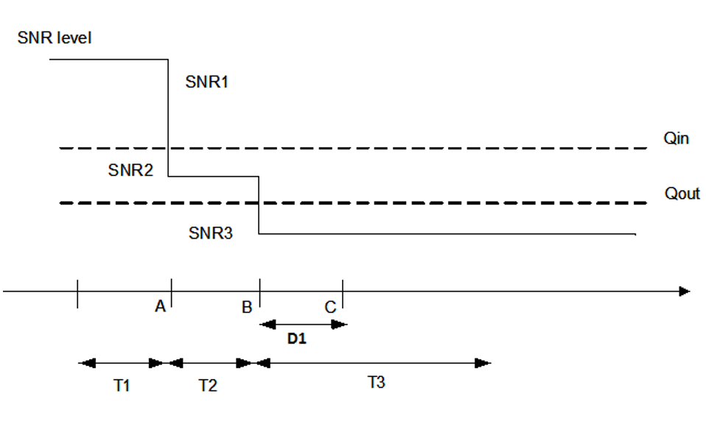
Figure A.6.5.1.X1.1-1: SNR variation for out-of-sync testing

A.6.5.1.X1.2 Test Requirements
The UE behaviour in each test during time durations T1, T2 and T3 shall be as follows:
During the period from time point A to time point B the UE shall transmit uplink signal at least in all uplink slots configured for CSI transmission according to the configured periodic CSI reporting and overlapped with FDD PCell ON duration corresponding to the LB CA switching pattern.
The UE shall stop transmitting uplink signal no later than time point C (D1 second after the start of the time duration T3).
The rate of correct events observed during repeated tests shall be at least 90 %.

A.6.5.1.X2 Radio Link Monitoring In-sync Test for FR1 PCell with LowBandCA-Switching-r19 configured with SSB-based RLM RS in non-DRX mode

A.6.5.1.X2.1 Test Purpose and Environment
The purpose of this test is to verify that the UE supporting featureSetCombinationLowBandSwitching-r19 properly detects the out of sync and in sync for the purpose of monitoring downlink radio link quality of the PCell. This test will partly verify the FR1 radio link monitoring requirements in clause 8.1.
In the test, UE is configured to perform RLM on SSB, with detectionResource included in RadioLinkMonitoringRS set to SSB#0, and purpose set to ‘rlf’. Supported test configurations are shown in table A.6.5.1.X2.1-1. The test parameters are given in tables A.6.5.1.X2.1-2, and A.6.5.1.X2.1-3 below. There are two cells, Cell 1 is the FDD PCell and Cell 2 is the SDL SCell, in the test. The PCell and SCell are co-located deployed and synchronized with 3us MRTD. The frequencies of PCell and SCell are lower than 1GHz. The test consists of five successive time periods, with time duration of T1, T2, T3, T4 and T5 respectively. Figure A.6.5.1.X2.1-1 shows the variation of the downlink SNR in the active cell to emulate out-of-sync and in-sync states. Prior to the start of the time duration T1, the UE shall be fully synchronized to Cell 1. The UE shall be configured for periodic CSI reporting with a reporting periodicity of 5 ms.
Table A.6.5.1.X2.1-1: Supported test configurations for FR1 PCell
Configuration | Description
1 | FDD for PCell, SSB SCS 15 kHz, data SCS 15 kHz, BW 10 MHz  SDL for SCell, SSB SCS 15 kHz, data SCS 15 kHz, BW 10 MHz

Table A.6.5.1.X2.1-2: General test parameters for FR1 in-sync testing in non-DRX mode
Parameter |  |  | Unit | Value
 |  |  |  | Test 1
BW_{channel} |  | Config 1 | MHz | 10: N_{PRB,c} = 52
DL initial BWP configuration |  | Config 1 |  | DLBWP.0.1
DL dedicated BWP configuration |  | Config 1 |  | DLBWP.1.1
TDD Configuration |  | Config 1 |  | Not Applicable
RMSI CORESET Reference Channel |  | Config 1 |  | CR.1.1 FDD
Dedicated CORESET Reference Channel |  | Config 1 |  | CCR.1.1 FDD
SSB Configuration |  | Config 1 |  | SSB.14 FR1
SMTC Configuration |  | Config 1 |  | SMTC.13
PDSCH/PDCCH subcarrier spacing |  | Config 1 |  | 15 kHz
OCNG parameters |  |  |  | OP.1
CP length |  |  |  | Normal
Correlation Matrix and Antenna Configuration |  |  |  | 2x2 Low
In sync transmission parameters | DCI format |  |  | 1-0
 | Number of Control OFDM symbols |  |  | 2
 | Aggregation level |  | CCE | 4
 | Ratio of hypothetical PDCCH RE energy to average SSS RE energy |  | dB | 0
 | Ratio of hypothetical PDCCH DMRS energy to average SSS RE energy |  | dB | 0
 | DMRS precoder granularity |  |  | REG bundle size
 | REG bundle size |  |  | 6
Out of sync transmission parameters | DCI format |  |  | 1-0
 | Number of Control OFDM symbols |  |  | 2
 | Aggregation level |  | CCE | 8
 | Ratio of hypothetical PDCCH RE energy to average SSS RE energy |  | dB | 4
 | Ratio of hypothetical PDCCH DMRS energy to average SSS RE energy |  | dB | 4
 | DMRS precoder granularity |  |  | REG bundle size
 | REG bundle size |  |  | 6
DRX |  |  |  | OFF
Time offset between Cell 1 and Cell 2 |  |  | us | 3us
Switching pattern |  |  |  | 00000000000000000111  11111110000000000000
gapDurationPCelltoSCell |  |  |  | 3
gapDurationSCelltoPCell |  |  |  | 4
Layer 3 filtering |  |  |  | Enabled
T310 timer |  |  | ms | 1000
T311 timer |  |  | ms | 1000
N310 |  |  |  | 1
N311 |  |  |  | 1
CSI-RS configuration for CSI reporting | Config 1 |  |  | CSI-RS.1.1 FDD
CSI-RS for tracking | Config 1 |  |  | TRS.1.1 FDD
T1 |  |  | s | 0.2
T2 |  |  | s | 0.2
T3 |  |  | s | 0.24
T4 |  |  | s | 0.2
T5 |  |  | s | 0.88
D1 |  |  | s | 0.84
NOTE 1: All configurations are assigned to the UE prior to the start of time period T1.
NOTE 2: UE-specific PDCCH is not transmitted after T1 starts.

Table A.6.5.1.X2.1-3: Cell specific test parameters for FR1 (Cell 1 and Cell 2) for in-sync radio link monitoring tests in non-DRX mode
Parameter |  | Unit | Cell 1 |  |  |  |  | Cell 2
 |  |  | T1 | T2 | T3 | T4 | T5 | T1 – T5
RF Channel Number |  |  | 1 |  |  |  |  | 2
Duplex mode |  |  | FDD |  |  |  |  | SDL
UL initial BWP configuration |  |  | ULBWP.0.1 |  |  |  |  | N/A
UL dedicated BWP configuration |  |  | ULBWP.1.1 |  |  |  |  | N/A
PRACH Configuration |  |  | Table A.3.8.2.1-1 |  |  |  |  | N/A
SSB index assigned as RLM RS |  |  | 0 |  |  |  |  | N/A
EPRE ratio of PDCCH DMRS to SSS |  | dB | 0 |  |  |  |  | 0
EPRE ratio of PDCCH to PDCCH DMRS |  | dB | 0 |  |  |  |  | 0
EPRE ratio of PBCH DMRS to SSS |  | dB | 0 |  |  |  |  | 0
EPRE ratio of PBCH to PBCH DMRS |  | dB
EPRE ratio of PSS to SSS |  | dB
EPRE ratio of PDSCH DMRS to SSS |  | dB
EPRE ratio of PDSCH to PDSCH DMRS |  | dB
EPRE ratio of OCNG DMRS to SSS |  | dB
EPRE ratio of OCNG to OCNG DMRS |  | dB
SNR on RLM-RS | Config 1 | dB | 1 | -7 | -15 | -4.5 | 1 | N/A
 | Config 1 | dBm/15 kHz | -98 |  |  |  |  | -98
 | Config 1 | dBm/SCS | -98 |  |  |  |  | -98
Propagation condition |  |  | TDL-C 300 ns 100 Hz |  |  |  |  | TDL-C 300 ns 100 Hz
NOTE 1: OCNG shall be used such that the resources in Cell 1 are fully allocated and a constant total transmitted power spectral density is achieved for all OFDM symbols.
NOTE 2: The signal contains PDCCH for UEs other than the device under test as part of OCNG.
NOTE 3: SNR levels correspond to the signal to noise ratio over the SSS REs.
NOTE 4: The SNR in time periods T1, T2, T3, T4 and T5 is denoted as SNR1, SNR2, SNR3, SNR4 and SNR5 respectively in Figure A.6.5.1.X2.1-1.
NOTE 5: The SNR values are specified for testing a UE which supports 2RX on at least one band. For testing of a UE which supports 4RX on all bands, the SNR during T3 and T4 is modified as specified in clause A.3.6.

Table A.6.5.1.X2.1-4: Void
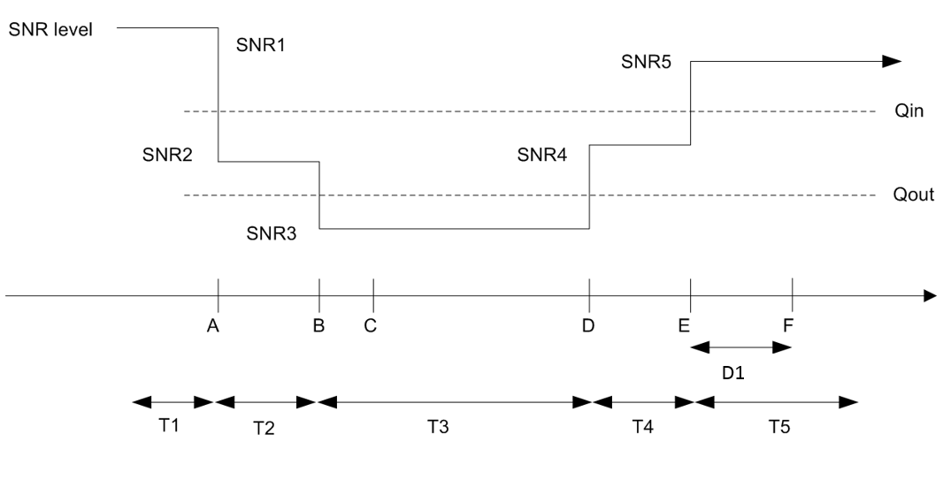
Figure A.6.5.1.X2.1-1: SNR variation for in-sync testing

A.6.5.1.X2.2 Test Requirements
The UE behaviour in each test during time durations T1, T2, T3, T4 and T5 shall be as follows:
During the period from time point A to time point F (D1 second after the start of time duration T5) the UE shall transmit uplink signal at least in all uplink slots configured for CSI transmission according to the configured periodic CSI reporting and overlapped with FDD PCell ON duration corresponding to the LB CA switching pattern.
The rate of correct events observed during repeated tests shall be at least 90 %.
------------ END OF CHANGE 1--------------

