3GPP TSG-RAN WG4 Meeting #118 R4-2601589
Gothenburg, Sweden, 9th February – 13th February 2026

Agenda item: 5.7.9
Source: Ericsson, Nokia
Title: TP for PRD 01 v0.6.0 updating the procedures for including new band combinations
Document for: Approval

Introduction
This is a TP updating the procedure for including new band combinations.

Background
As stated in the new Rel-20 WID’s RP-253842 New WID for DC_xBLTE_yBNR_R20 and RP-253849 New WID NR_CADC_SUL_R20_v5 it is now mandated to include a JSON Data File for new band combinations and changes to existing band combinations.
This TP for PRD 01 include changes to the procedures for introducing new band combinations as well some explanations on JSON data files.
Below are the agreements made in the WF R4-2522407 at RAN4 #117:
- RAN4 shall mandate the inclusion of JSON files for all new or modified band combinations starting from Rel-20.
  - In the submitted draft CRs, the word document shall have no clause 5 content.
  - In the submitted TPs, the word document shall have clause 5 content.
  - For draft CR’s with only JSON files, still a cover sheet is needed to inform about what is included.
  - Irrespective of draftCR or TP, there shall be a JSON file for each combination while submitting the contribution.
  - After the RAN4 meeting, the Co-Rapporteurs will collect all the agreed JSON files in draft CR’s,
  - Then the Main-Rapporteur will create a BigCR, and submit this for post-meeting approval,
  - When the batch of JSON files is approved, these are either directly by the Main-Rapporteur or via MCC committed to the ETSI Forge (GIT repository).
  - In addition, the specification ZIP package shall contain additional file which is a representation of JSON file content in tabular format

Proposed changes to PRD 01 version 0.6.0
---Start of changes---

4.2.1 Band combination workflow

4.2.1.1 The workflow on introduction of band combinations for block approval
To ensure the efficiency of RAN4’s work, it’s necessary to have a clear workflow for the introduction of band combinations for block approval. The workflow for the introduction of band combinations for block approval is shown as figure 5.1A.1.1-1 as a typical example for one RAN4 meeting in one quarter. The specific steps are listed as below.
#1 Band combinations should be requested by contact person using request template. And the request spread sheet should be shared in the reflector 3GPP_TSG_RAN_WG4_NR_BANDS for NR CA, MR DC and SUL band combinations or 3GPP_TSG_RAN_WG4_CA for LTE CA band combinations before RAN4#(X-1) meeting.
#2 Band combinations should be captured into the draft revised WIDs during RAN4#(X-1) meeting by rapporteurs.
#3 The official revised basket WIDs can be approved together with requested band combinations during RAN#(Y-1) meeting.
#4 Proponents should prepare and submit the corresponding contributions, e.g. a JSON combined with a draft CR, or a JSON combined with a TP before RAN4#X meeting. A TP is used when a technical analysis is needed, and a draft CR is used if no technical analysis is needed. If a draft CR or TP is depending on approval of lower order fallbacks submitted at the same meeting, this need to be clearly mentioned in the cover sheet of the draft CR or in the heading of the TP. The coverpage for a draft CR need to include both information about the DL configuration as well as the UL configuration for all the combinations added. When HPUE is added for combinations (less than 3DL) the clause 5 information is provided in JSON files and the mandatory clause 6 information is added in a draft CR. The JSON file shall be provided and included in the Tdoc Zip file, which includes either the new or modified JSON container for the configuration or single band channel bandwidth support.
#5 The Block/Approval procedure is applicable to the band combinations in one week before formal RAN4#X meeting, if there are no general issues observed.
#6 The contributions will be discussed during RAN4#X meeting. If there are no technical concerns and if all the needed fallbacks are completed, the band combinations can be approved. And the final decision will be made by chairman.
#7 If the contributions are approved or endorsed, the corresponding band combinations should be captured into the objective draft big CRs and/or TRs for each objective by responsible rapporteurs and multiple objective draft big CRs are then merged into one formal big CR by the main Rapporteur. Note: The objective draft big CR and formal big CR are official CRs and the formal big CR is used to capture all the corrections for one specification by the main rapporteur.
#8 Email approval can be used for the objective draft big CRs, formal big CRs and/or TRs in one week after formal RAN4#X meeting. Note: No updates for objective draft big CRs. The Main-Rapporteur will also collect all the agreed JSON files and together with the BigCR submit this for post-meeting approval.
#9 The status of band combinations is expected to be shared by contact person after formal RAN4#X meeting.
#10 The status of band combinations should be captured into the WID and/or SR by rapporteurs.
#11 RAN #Y will approve the formal big CRs and revised WIDs.
#12 The agreed band combinations will be introduced into the specification in next version. When the batch of JSON files is approved, these are either directly by the Main-Rapporteur or via MCC committed to the ETSI Forge (GIT repository)
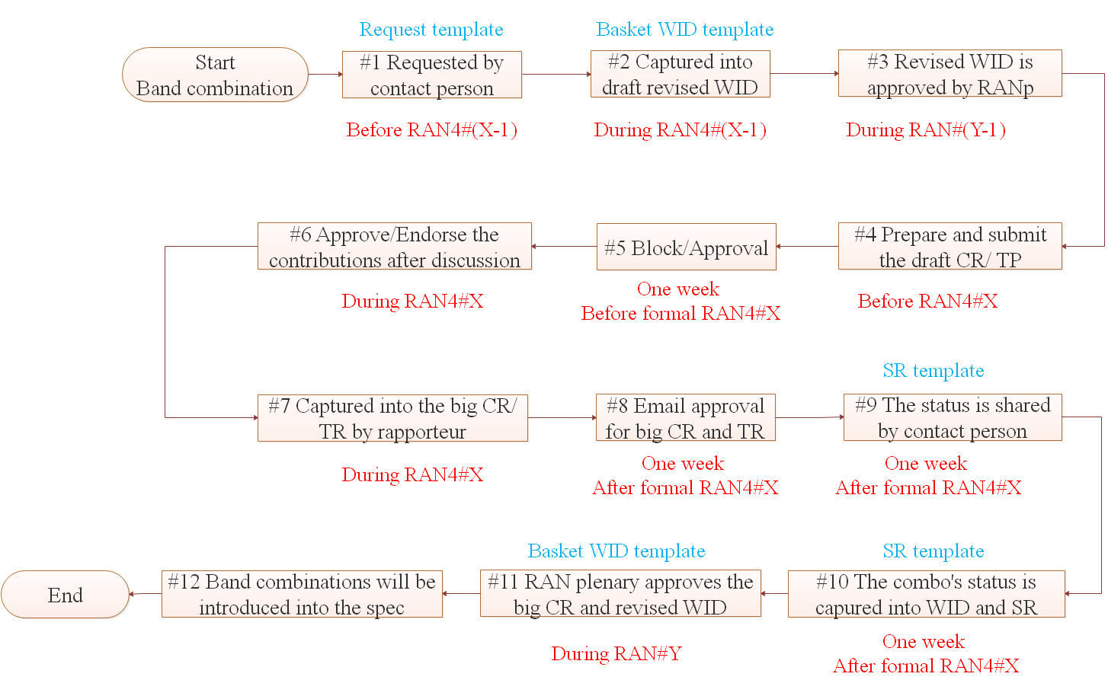
Figure 4.2.1.1-1 The workflow on the introduction of band combinations for block approval
---Text omitted---

4.4 Submitting technical contributions (Tdoc) for specifying band combinations

4.4.1 JSON Data File together with a Text Proposal (TP) or a Draft Change Request (draft CR)
When providing technical contributions for the inclusion of a band combination there are two possible approaches.
1) JSON Data File together with a Text Proposal (TP) to a Technical Report (TR) for the specific basket Work Item (WI).
2) JSON Data File together with a Draft Change Request (draft CR) to the Technical Specification (TS)
RAN4 have agreed that if there is a need for any technical study/analysis as UE coexistence studies potentially resulting in relaxations needed defined this needs to be provided via a TP to a TR such that this study/analysis is captured in the TR. For new band combinations which do not require any technical study/analysis RAN4 has agreed to introduce these via draft CR directly to the TS. It shall be noted that not all the basket WIs have a TR indicating for which technical study/analysis may be needed and for which there is no need.

4.4.2 Specific for Text Proposal (TP)
TPs shall be drafted using the latest version of the corresponding TR as baseline and if included to the TR the provided template in the TR. All additions intended to be captured to the TR shall be marked with change-marks.
Sourcing company/companies are encouraged to combine all related band combinations to a single Tdoc for the TR containing one or more TPs with the needed technical analysis.
The drafted TP shall be submitted together with a JSON file corresponding to the band combination captured in the TP.

4.4.3 Specific for Draft Change Request (draft CR)
Draft CRs shall be drafted using the latest version of the corresponding TS as baseline. All additions intended to be captured to the TR shall be marked with change-marks.
Sourcing company/companies shall provide a single draft CR per basket WI corresponding to an individual agenda item at the RAN4 meetings. Noting that if a company is working with multiple other companies for providing technical input (draft CRs) for the same type of combinations (i.e. basket WI) each different group of sourcing companies shall be allowed to submit individual Tdocs. It shall also be noted that if different types of draftCRs are needed (e.g. Cat.B and Cat.F) a single draftCR per type is allowed.
The draft CR shall be submitted together with JSON file(s) corresponding to the change(s). This means that a separate JSON file per changed band combination is needed. The coversheet of the draft CR shall list all changes and JSON file containing that change.

4.4.4 Which agenda to submit the Tdoc for
The TP or draft CR shall be submitted to the agenda corresponding to the basket WI for which the specific band combination belongs (i.e.is included in the WID). Attention shall be made to which type of combinations it is under the basket if there are different sub-agendas for e.g. with or without FR2 parts of the combination.
---Text omitted---

5.8.3 Guidelines on grouping for DC configurations
In order to reduce the EN-DC, NE-DC and NR-DC configuration table size, the following guidelines should be applied to the grouping of the configurations.
- Grouping of DC configurations is based on common band combination.
- Common band combination is considered as the configuration having the same band sequence, such as DC_x-y-y_nz and DC_x-x-y_nz are not common band combination, while all configurations with DC_x-y_nz(*) having non-contiguous parts in band nz are considered as common band combination.
- In case E-UTRA or/and NR has non-contiguous CA, it will be in a separate row compared to cases when DC configuration has only single carrier or contiguous CA operation.
- If multiple UL DC configurations are indicated with multiple DL DC configurations, only UL DC configurations with the same or a lower number of carriers in the same fallback group are valid UL configurations.

5.9 The Band Combination Database

5.9.1 The ETSI Forge
The Band Combination Database is accessible via the ETSI Git(lab) instance also known as the ETSI Forge. All 3GPP members can gain access to the Band Combination Database via:
https://forge.3gpp.org/rep/ran4/specifications
using their EOL account. Thereby all have access to the folder/repository containing JSON data files, channel bandwidths per NR band, as well as the corresponding schema files.
Currently only work related to the Band Combination Database is stored in the ETSI Forge repository for RAN4. The structure of band combination data is shown in 5.9.1-1. It can be noted that the Band Combination Database structure is now under a folder for “RAN4”/”Specifications”. Within this is a sub-folder for “38.101” with a sub-folder for “-1”, “-2” and “-3” specifications as well as a “common” folder. With this it is possible to have versions of the repository for each specification tagged in alignment to the specification release.
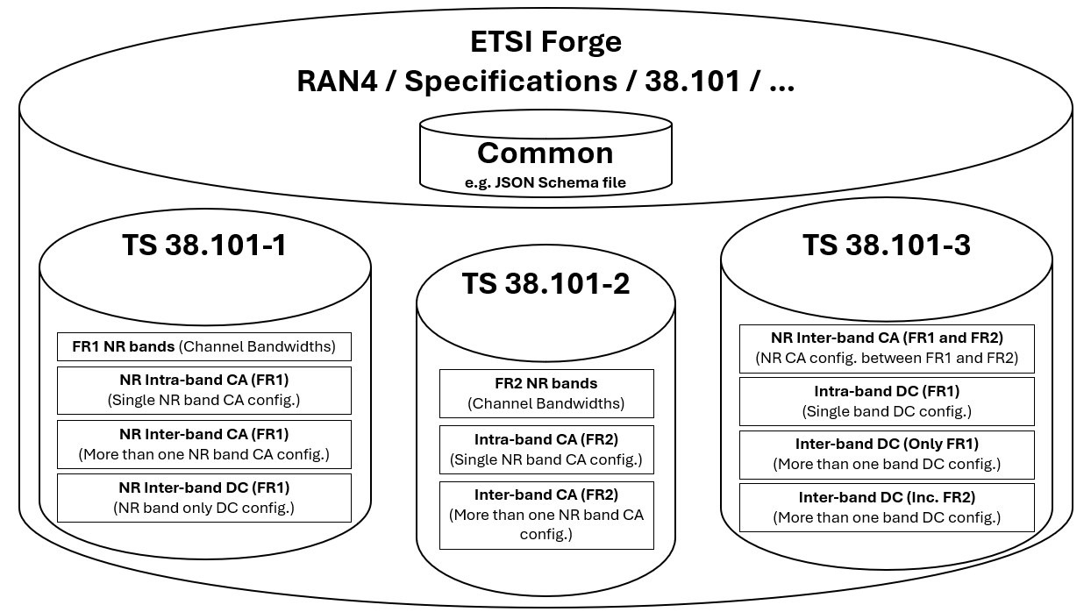
Figure 5.9.1-1 Endorsed new repository structure
The ETSI Forge inherently incorporates version control of the data stored, as it uses the underlying GIT framework. It is possible to align the versions of the JSON data and schema files to the versions of the specification, meaning that one similar to now can extract and view a specific version of supported band combinations.

5.9.2 The ETSI Web-App
The content of the Band Combination Database can be visualised via a web app. This can be accessed via:
https://tnm.etsi.org/ca/
Via the Web-App, it is possible to download all the content of the repository for the Band Combination Database using the EOL account login information. Via the Web-App it is also possible to access a tool developed by ETSI which facilitate the creation and visualization/verification of a created JSON data file. The tool is intended as a simple assistant to companies, as companies for more advanced use, use as running batch generation of JSON data files, are expected to have their own tools.
The ETSI tool can be accessed via:
https://tnm.etsi.org/ca/editor

5.10 Guidelines for JSON Files
A JSON data files represent a specific downlink CA or DC configuration with all its attributes. Meaning that one can envision each row of the Rel-19 DOCX band combination tables as a representation of what is included in a JSON data file.
This means that instead of adding new rows to the band combination tables in the DOCX-based specifications, as we did in Rel-19 and before, we will instead add a new JSON data file to the database.
Similar to an agreed table format in the current DOCX-based specifications, the JSON data also needs to follow a specified structure to make sure it can be represented correctly. Therefore, RAN4 have agreed on a JSON schema files which can be envisioned as an empty DOCX-based tables with columns, rows and cells ready to represent the content of the JSON data files. Hence, the JSON schema file defines the structure of the corresponding JSON data files.
In conclusion, there are two different JSON file formats that it is important to distinguish:
- JSON Data Files
- JSON Schema Files
These two are further explained in the following.

5.10.1 JSON Data Files
There are currently three different JSON data files stored in the ETSI forge. One is for the individual bands, and the others are for the CA and DC band combinations. These JSON data files follow the structure given by the JSON schema files stored in the Common repository.
The content of the FR1_NR_bands or FR2_NR_bands JSON data files representing all supported channel bandwidths of the individual bands is to be aligned to what is listed in TS 38.101-1/2 Table 5.3.5-1. The reason they are needed included to the band combination database without removing the information also from the DOCX tables in the specification is that the information is only used as reference for supported channel bandwidth of band combinations. Hence, instead of having the input this every time a band combination is generated it can be referenced from the JSON data files.
The other repositories contains all the JSON data files representing the band combination configurations now included to the Band Combination Database. This means that band combinations can be sorted by type as also possible with the DOCX table based Rel-19 specifications.

5.10.2 JSON Schema Files
JSON schema files are templates which define the structure of corresponding JSON data files. JSON editors can use the schema files to assist by auto-completion when writing or editing new data files and to highlight syntax errors when a data file does not comply with the schema.
The different schema files give the structure for the channel bandwidths supported per band in the and the individual band combinations. This means that a modification of a schema file corresponds to a change in Rel-19 DOCX table layout (adding/removing columns; using different content in existing cells; …). If there is a need to modify a schema, RAN4 should review those changes with great care to ensure that existing data files are still compatible with the updated schema.
When schema files are modified, there will typically be a need to modify the Web-App, too. This is to ensure that all necessary data is also displayed in the Web-App as needed.
Finally, a modification of a JSON schema will typically also require updating tools that are used to validate consistency of the tables or to extract information, e.g. for use in product development.

5.10.3 Additional attributes of Band Combinations
In the Rel-19 DOCX version of TS 38.101, the note numbering and sometimes the wording for bands and band combinations were not aligned across tables and files. The same footnote numbers had different meanings in different tables and vice versa. Furthermore, definitions of those footnotes tended to deviate slightly in wording among tables, even though they were meant to be the same.
In the Band Combination Database, each band and each band combination is defined in a separate JSON data file. To ensure consistency among those files and to simplify creating and utilising those files, notes are now defined in the JSON schema files and associated with a short but descriptive identifier.
The JSON schema file includes the possible additional attributes of band combinations, as we are now capturing via notes in the DOCX-based specifications. This includes, e.g. HPUE UL support and/or DL channel bandwidth restrictions.
A clear advantage with this approach is that there will inherently need to be alignment/agreement on wording for these notes, defining additional attributes of band combinations. Further, as an extension to ensure unambiguous representation of the JSON data, the JSON schema file templates that the JSON editors (i.e proponents of a new or modified band combination) can use the schema files to assist by auto-completion when writing or editing new data files and to highlight syntax errors when a data file does not comply with the schema
By having the “master” JSON schema file as a starting point for all new band combinations, now including all the attributes (including notes), the task for those proposing a new combination will then become only to specify the required attributes. With this approach, each JSON file becomes independently readable and as lean as possible.
The use of the JSON schema files as a basis for adding notes to the JSON files is further described in [8].

5.10.4 Examples of creation/modification of JSON data files
To facilitate the adaptation of the Band Combination Database by RAN4, further an introduction to it and some guidance on how to use it have been added in this section of this contribution.
There are two different recommended approaches to either introduce a new band combination or modify/amend an existing band combination within the Band Combination Database.
Note that the below is aligned to the Phase 1 procedure.
- Edit an existing JSON data file:
  - Navigate to the JSON data file located in the ETSI Forge repository (e.g. /38.101-1/) of the band combination which is to be modified/amended.
  - Download the JSON data file and save it as a local copy
    - It is suggested to append the Tdoc number of the contribution in front of the file name to associate the modified JSON data file.
  - Open the JSON data file in your preferred code editor (e.g. Notepad++ or VS Code).
  - Perform the needed additions or modifications to the JSON data file and save it
  - Add the modified JSON data file to the Zip folder together with other content, i.e. draftCR or TP.
  - Submit as a contribution for RAN4

- Add a JSON data file:
  - Copy an existing JSON data file as a template, or create a new file with a .json extension.
  - Save the new JSON data files as a local copy using the naming convention of the included bands
    - It is suggested to append the Tdoc number of the contribution in front of the file name to associate the new JSON data file.
  - Open the JSON data file in your preferred code editor (e.g. Notepad++ or VS Code).
    - If using a code editor as VS Code, one can use the autocompletion features provided by the JSON schema file to fill in required fields according to the schema.
  - Perform the needed additions or modifications to the JSON data file and save it
  - Add the modified JSON data file to the Zip folder together with other content, i.e. draftCR or TP.
  - Submit as a contribution for RAN4

When submitting the JSON files together with the Tdocs then need to be included to the zib files as explained in the following:

  - JSON files are saved including the TDoc number prefixed the file name:
or
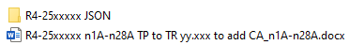
  - JSON files are saved within the zip file in a sub-folder named “JSON”:
  - If multiple JSON files these are all in the same JSON folder (Note this is not zipped):
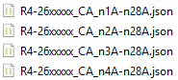

---End of changes---

