3GPP TSG-RAN WG4 Meeting #118 R4-260xxxx

Gothenburg, Sweden, Feb. 09-13, 2026
CR-Form-v12.5
CHANGE REQUEST
 | 38.768 | CR | 0007 | rev | 1 | Current version: | 19.1.0
For HELP on using this form: comprehensive instructions can be found at
https://www.3gpp.org/Change-Requests.

Proposed change affects: | UICC apps |  | ME | X | Radio Access Network |  | Core Network

Title: | CR for 38.768 to align the IE name with TS 38.306 and 38.331 for low band carrier aggregation via switching
Source to WG: | OPPO, CATT, ZTE Corporation, Sanechips
Source to TSG: | R4
Work item code: | NR_LBCA_Sw-Core |  |  |  |  |  | Date: |  |  | 2025-1-25
Category: | F |  |  |  |  |  | Release: |  |  | Rel-19
 | Use one of the following categories:  F (correction)  A (mirror corresponding to a change in an earlier release)  B (addition of feature),  C (functional modification of feature)  D (editorial modification)  Detailed explanations of the above categories can  be found in 3GPP TR 21.900. |  |  |  |  |  |  |  | Use one of the following releases:  Rel-8 (Release 8)  Rel-9 (Release 9)  Rel-10 (Release 10)  Rel-11 (Release 11)  …  Rel-18 (Release 18)  Rel-19 (Release 19)  Rel-20 (Release 20)  Rel-21 (Release 21)
Reason for change: |  | The IE name for low band carrier aggregation via switching did not align with TS 38.306 and TS 38.331
Summary of change: |  | - Change the UE capability IE supportedLowBandSwitching-r19 to IE featureSetCombinationLowBandSwitching-r19 and switchingPeriodForFDD-SDL-r19.  - Change the NW configuration signalling LBCA-SwitchingGap-Duration-SCelltoPCell and LBCA-SwitchingGap-Duration-PCelltoSCell to gapDurationSCelltoPCell-r19 and gapDurationPCelltoSCell-r19
Consequences if not approved: |  | The IEs are confusion in current spec
Clauses affected: |  | 5.2, 5.4, 5.5, 5.6, 5.7, 6.3.3
 |  | Y | N
Other specs |  |  | N | Other core specifications |  |  |  | TS/TR ... CR ...
affected: |  | Y |  | Test specifications |  |  |  | TS 38.521-1
(show related CRs) |  |  | N | O&M Specifications |  |  |  | TS/TR ... CR ...
Other comments:
This CR's revision history:

==============First change==============

5.2 Switching period location

5.2.1 General
For what follows we consider switching between an FDD and SDL band for the CA-n5A-29A configuration in Table 4-1 but without loss of generality: one UL is configured in a paired FDD band with the DL SCell configured in an SDL band and both bands belong to Sub-1GHz bands.
The switching period, defined in units of 𝜇s according to UE capability, is located within a switching gap located within the switched-from carrier. Switching gaps, expressed in units of 15kHz SCS symbol, are accommodated by the network according to the physical layer design of the feature.
The timing reference for the switching pattern and switching gap at the UE is the DL timing of the Pcell (in the FDD band). The uplink radio frame transmission on the Pcell takes place T_{TA} = (N_{TA} + N_{TA,offset})T_{c} (as defined in the clause 4.3.1 of TS 38.211) before the reception of the first detected path (as defined in TS 38.133) in time on the corresponding DL radio frame. This means that the timing advance must be considered at switching events.
The duration of the switching gap is RRC configured. The network ensures that the switching gap is large enough to cover the switching period (35𝜇s, 70𝜇s, and 140𝜇s according to the UE capability), transient periods and the TA, if needed, in both switch directions.

5.2.2 FDD (case 1) to SDL (case 2) switch
For the FDD to SDL switch the gNB configures a gap long enough to accommodate timing advance such that no collisions should occur. Figure 5.2.2-1 shows the case with T_{TA} > 0 µs. The figure illustrates the applicable transient periods, switching period T_{switch} (35𝜇s, 70𝜇s, and 140𝜇s according to UE capability switchingPeriodForFDD-SDL-r19 and switchingPeriodForFDD-SDL-r19), and the applicability of ON and OFF power requirements.
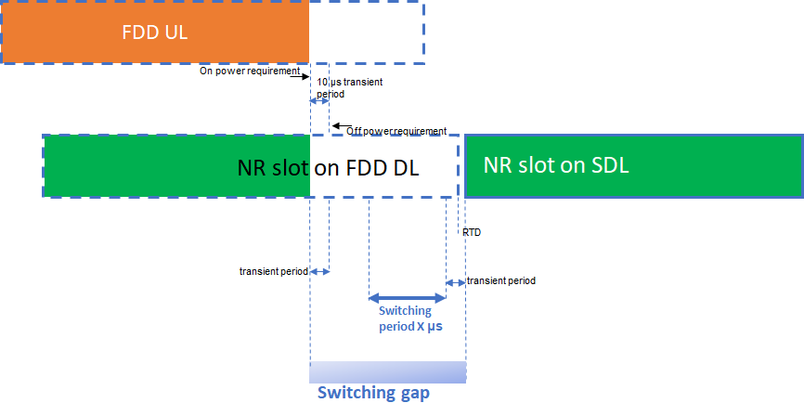
Figure 5.2.2-1: FDD to SDL switch with the switching gap on the switched-from carrier.
The UL slot will always end before the DL slot, neglecting any timing errors in case T_{TA} = 0 µs. The worst case in terms of switching is that in which T_{TA} = 0 µs, the DL and UL timing are the same (again neglecting the errors that are of the order of 1 µs) and the SDL starts RTD µs before the Pcell DL slot timing. Switching period is always after UL transient period. The switching gap with respect to the end of the last FDD DL symbol must therefore be at least
when FDD UL trailing end transient period - T_{TA} * 10⁶≤0:
actual switching gap length ≥ ceil[(T_{switch} + RTD_{P2S} + SDL leading transient period)/(1/14*10³)]
when FDD UL trailing end transient period - T_{TA} * 10⁶ > 0:
actual switching gap length ≥ ceil[ (T_{switch} + RTD_{P2S} + FDD UL trailing end transient period- T_{TA} * 10⁶ + SDL leading transient period)/(1/14*10³)]
where the RTD_{P2S} is the receiving timing difference among the closest DL slot timing boundaries between PCell and SCell, with the range of negative MRTD to positive MRTD. And the MRTD = 3us assuming that the FDD and SDL carriers are colocated. UL transient period is assumed as 10us.

5.2.3 SDL (case 2) to FDD (case 1) switch
For the SDL to FDD switch, the switching gap ends at end of slot on “switch from” carrier (SDL). The timing advance must also be accounted for; Figure 5.2.3-1 illustrates this for all applicable switching periods T_{switch} (35μs, 70μs, and 140𝜇s according to UE capability switchingPeriodForFDD-SDL-r19 and switchingPeriodForFDD-SDL-r19), by placing the switching period X. The applicability of ON and OFF power requirements is also shown.
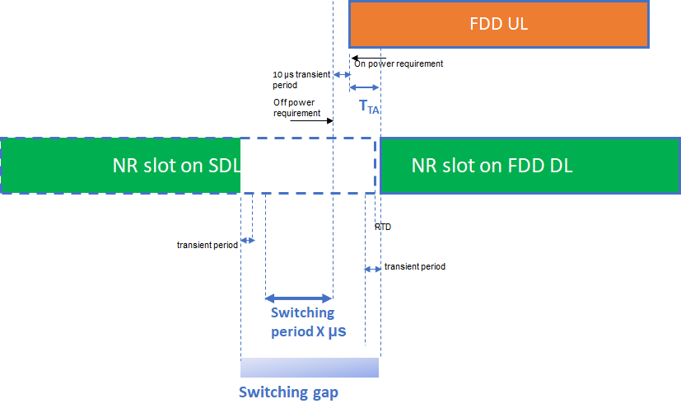
Figure 5.2.3-1: SDL to FDD switch with the switch occurring before the start of the UL slot.
The time mask could be devised such that the switching period occurs before the first symbol of the UL slot of the switched-to FDD carrier, this to avoid dropping symbols on the UL that starts T_{TA} before the first symbol of the FDD DL slot. Notwithstanding, the switching gap on the SDL carrier must be at least
Actual switching gap length ≥ ceil[ ( T_{switch} + T_{TA} * 10⁶+ RTD_{S2P} + FDD UL leading transient period ) / (1/14*10³) ]

Where RTD_{S2P} is the receiving timing difference among the closest DL slot timing boundaries between SCell and PCell, with the range of negative MRTD to positive MRTD. And MRTD = 3us assuming that the FDD and SDL carriers are colocated. In addition, RTD_{S2P} = - RTD_{P2S}. UL transient period is assumed as 10us.
In the live network operation, timing advance for a UE in a cell is variable. It is the network task to adjust the length of the switching gap by gapDurationSCelltoPCell considering maximum cell coverage of PCell without the knowledge of accurate N_{TA} for each UE, so that the UL transient period is not overlapping with switching period X.
==============Next change==============

5.4 Applicability of simultaneous Rx/Tx requirements
The following statement in section 5.2A.2 of TS38.101-1 captures the applicability of simultaneous Rx/Tx requirements when the UE supports the low NR band carrier aggregation via switching: “Concurrent operation between these bands is not applicable to UEs indicating support of low NR band aggregation via switching [supportedLowBandSwitching-r19] for this band combination.”

5.5 CA configurations
Low NR band inter-band CA configurations in which the UE is allowed to indicate support of the configuration via switching featureSetCombinationLowBandSwitching-r19 and switchingPeriodForFDD-SDL-r19 are indicated with the corresponding note in the configuration tables in sub-clause 5.5A.3.1 of TS38.101-1.
The following notes to be added in Table 5.5A.3.1-1d of TS38.101-1 next to the band combinations that support low NR band aggregation via switching: “The UEs is allowed to indicate support of low NR band carrier aggregation via switching featureSetCombinationLowBandSwitching-r19 and switchingPeriodForFDD-SDL-r19 for this NR CA configuration”.
The following notes to be added in Table 5.5A.3.1-1f of TS38.101-1 next to the band combinations that support low NR band aggregation via switching: “Applicable only for UEs which indicate support of low NR band carrier aggregation via switching featureSetCombinationLowBandSwitching-r19 and switchingPeriodForFDD-SDL-r19 for this NR CA configuration.”

5.6 MSD requirements
The following note to be added in Table 7.3A.6-1 and Table 7.3A.6-1a-1 of TS38.101-1 to indicate that the specified MSD is not applicable to UEs indicating support of low NR band carrier aggregation via switching :.”Not applicable to UEs indicating support of low NR band aggregation via switching featureSetCombinationLowBandSwitching-r19 and switchingPeriodForFDD-SDL-r19 for this band combination.”

5.7 ΔR_{IB,c} requirements
The following note to be added in Table 7.3A.3.2.1-1 of TS38.101-1 to indicate that the specified ΔR_{IB,c} is not applicable to UEs indicating support of low NR band carrier aggregation via switching: “Not applicable to UEs indicating support of low NR band aggregation only via switching featureSetCombinationLowBandSwitching-r19 and switchingPeriodForFDD-SDL-r19 for this band combination.”
NOTE: When introducing higher order CA with the LB CA switching as one of fallback configuration and/or different device type of LB CA switching (e.g., con-current DL CA, or FDD+FDD CA switching with concurrent DL CA) RAN4 should discuss ΔR_{IB,c} requirements. This discussion is out of scope of the current release.

==============Next change==============

6.3.3 Deactivated SDL SCell L3 measurement requirement
RAN4 #115 agreed to define the requirement for deactivated SDL SCell L3 measurement. The legacy deactivated SCell measurement delay requirements are applied for UE to perform deactivated SDL SCell measurement.
RAN4#116 agreed to define the interruption requirement as follows:
- For R19 LB CA via switching, interruption length on PCC due to measurements on deactivated SDL is (tuning time in slot level + T_{SMTC_duation} + retuning time in slot level),
- Tuning time from PCell to SCell is equal to the RRC configured switching gap from PCell to Scell, i.e., gapDurationPCelltoSCell-r19 and switchingPeriodForFDD-SDL-r19
- Returning time from SCell to PCell is equal to the RRC configured switching gap from SCell to PCell, i.e., gapDurationSCelltoPCell-r19 and switchingPeriodForFDD-SDL-r19
- Missed ACK/NACK rate
- For R19 LB CA via switching, missed ACK/NACK rate due to measurements on deactivated SDL are allowed with up to X=$\frac{Y}{measCycleSCell}$, where Y=2* interruption length.

==============End of change==============

