3GPP TSG-RAN WG4 Meeting#118 R4-25xxxxx
Gothenburg, Sweden, Feb 09th – 13st, 2026
Agenda item: 8.1
Source: Moderator (ZTE)
Title: Topic summary for [118][109] 6G sensing
Document for: Information

1 Introduction
Based on the latest approved RAN working group level SID on 6G Radio [RP-252912], RAN4 study on sensing including RF, coexistence, testability, with the detailed objective provided as:
- Sensing – Studies to be based on use cases and associated requirements, as defined in [TR38.914]
- PHY functions and procedures for sensing technology (e.g., waveform. reference signals, measurement feedback, etc…) [RAN1, RAN4]
- Evaluate sensing performance and if necessary, extend channel modelling, for the selected use cases [RAN1]
- Aspects of integration with communication services [RAN1]
- higher layer procedures and protocol aspects [RAN2]
- RAN4 aspects of sensing including RF, coexistence, and testability in coordination with other WGs [RAN4]
Note: RAN1 identify detailed requirements, if triggered by TSG RAN

In the last RAN4#116bis meeting, based on the initial discussions on 6G sensing, we reached the following consensus:

Key agreements

General scope and timeline
Before April 2026, the agenda for sensing will be kept. RAN4 discussion will primarily focus on the following aspect
- Sensing related regulatory status and requirement survey
- Potential architecture consideration based on the RAN plenary use case study
- views sharing on the potential RAN4 scope based on the identified use cases out of RAN plenary study
- Identify less RAN1 design dependent RAN4 aspects if any

In the running summary [R4-2521752], we also captured the agreement reached for sensing in RAN/RAN1/RAN2 to provide the background information to facilitate RAN4’s sensing discussion. In this thread, we summarized the contribution submitted under the agenda 8.10 for the discussion.

2 Topic: 6G sensing

Open issues summary
Issue 1-1: General principle
- Proposal 1: RAN4 should active work closely with RAN1 on design of sensing signal from system performance impacts and coexistence perspective. [CATT]
- Proposal 2: To facilitate RAN4 studies, it is proposed to abstract from specific applications and use cases and focus instead on the types of: [Ericsson]
    - sensing tasks (e.g., detection, characterization, localization, tracking, velocity estimation, etc.),
    - sensing measurements,
    - sensing modes,
    - sensing targets*, and
    - environments*.
    - NOTE (*): based on the studies, it can be decided later how generic the RAN4 requirements will be, e.g., whether the requirements will depend on the type of environment or sensing target.
- Recommended WF:
  - For proposal 1, it is common understanding and no need for further discussion.
  - For proposal 2, propose to discuss the use case, sensing mode and other measurement metrics and further discuss the proposal 2 how to conduct the abstraction from specific applications and use cases.

Issue 1-2: Use case
- Proposal 1: for RAN4 study, it is proposed to consider use cases of detection and/or tracking of passive objects, at least including UAVs, human, vehicles and AGVs. [CMCC]
- Proposal 2: RAN4 to start with the use cases of detection and/or tracking of passive objects, at least including UAVs, humans, vehicles and AGVs. UAVs as passive objects can be considered to leverage the NR ISAC study for the 6G sensing study. [Nokia]
- Proposal 3: Propose RAN4 to follow the sensing use case agreed by RAN and RAN1. [ZTE]
- Proposal 4: RAN4 can start to do warm-up discussion on 6G ISAC assuming UAV case and BS [/UE] mono-static as an example initially before next April. [CATT]
- Proposal 5: For 6G ISAC use cases, in addition to detection and/or tracking of passive objects, physical world digital twin should be considered. [Huawei]
- Proposal 6: The 6G sensing study in RAN4 should focused the agreed use cases in RAN-P, i.e., Detection and/or tracking of passive objects including UAVs, human, vehicles and AGVs. [Vivo]
- Proposal 7: For supporting better sensing performance, RAN4 consider more device types other than smartphone, e.g. robots, FWA, with different assumption of UE capability (Tx/Rx). [Vivo]
- Proposal 8: RAN4 can prioritize for its studies sensing targets which are passive objects (neither a transmitter nor a receiver of sensing radio signals). [Ericsson]
- Proposal 9: RAN4 can discuss what is the definition of the exact location of bigger passive objects, taking into account that the location in this case cannot be associated with any antenna which passive objects do not have. [Ericsson]
- Recommended WF:
  - To follow RAN guidance:
    - at least including UAVs, human, vehicles and AGVs. Other use case is up to RAN’s decision.
  - In RAN4 sensing study:
    - Propose to discuss whether RAN4 can prioritize any use cases before RAN/RAN1/RAN2 draw the conclusion (e.g. UAV etc).
    - If no consensus can be reached in RAN4 in RAN4#118 meeting, propose to postpone the discussion until RAN1/RAN2 reach the agreement on the 6G sensing use cases.

Issue 1-3: Sensing mode
- Proposal 1: RAN4 can start ISAC discussion from the typical sensing modes (e.g. TRP-TRP mono static sensing and TRP-UE bi-static sensing). [Xiaomi]
- Proposal 2: In initial stage, RAN4 shall focus on the study on reference architecture and RF feasibility of interference handling on receiver side from gNB side (TRP-TRP mono static sensing) [Xiaomi]
- Proposal 4: RAN4 consider prioritizing UE-related bistatic sensing mode to facilitate the RF requirements and testability discussion. [Vivo]
- Proposal 5: RAN4 considers TRP monostatic sensing mode, TRP-to-TRP bistatic sensing mode, TRP-to-UE sensing mode, and UE-to-TRP sensing mode in ISAC technology study at first. [Samsung]
- Proposal 6: RAN4 may select one possible sensing mode as the warm-up option to push forward the in-depth technical discussions, then align the topic with RAN1 after RAN1 6G ISAC study begins. [Samsung]
- Proposal 7:RAN4 to consider the six sensing modes (i.e., TRP monostatic, UE monostatic, TRP-TRP bistatic, TRP-UE bistatic, UE-TRP bistatic, and UE-UE bistatic) at the start of the 6G study. Further updates on the considered sensing modes can be made based on input from RAN1. [Nokia]
- Proposal 8: Propose RAN4 to following the sensing mode as agreed by RAN and RAN1 and discuss further work arrangement for different sensing mode. [ZTE]
- Proposal 9: For 6G sensing mode, gNB-based mono-static sensing can be the starting point. [Huawei]
- Proposal 10: [Signals/resources to be used for BS and UE monostatic sensing modes] RAN4 to discuss the applicability of DL/UL sensing reference signals for different 6G candidate sensing modes, e.g.: [Ericsson]
  - whether DL sensing reference signals (and DL resources) should be assumed for BS monostatic and BS-to-BS bi-/multi-static sensing;
  - whether UL sensing reference signals (and UL resources) should be assumed for UE monostatic and UE-to-UE bi-/multi-static sensing.
- Recommended WF:
  - The following sensing modes are not precluded from RAN4 perspective:
    - TRP monostatic, UE monostatic, TRP-TRP bistatic, TRP-UE bistatic, UE-TRP bistatic, and UE-UE bistatic and multistatic
    - Discuss the prioritized sensing mode if possible without RAN1/RAN2 conclusion. If this is not agreeable in RAN4#118, then propose to postpone the discussion until RAN1/RAN2 reach the agreement on the 6G sensing mode.
  - Discuss the relevant signals/resources for monostatic sensing modes.
Issue 1-4: Regulatory requirement for sensing
- Proposal 1:RAN4 is encouraged to discuss how to structure the 6G sensing regulatory survey. This paper provides a potential direction with a simplified visualization of the related ITU allocations. [Apple]
- Proposal 2: RAN4 could adopt the existing requirements in regulations as starting point or reference for 6GR ISAC discussions. [Samsung]
- Recommended WF:
  - Encourage the regulatory inputs from different regions;
  - If no explicit regulatory requirement for sensing are defined as far, propose to use the Samsung and Nokia’s regulatory information as starting point.
  - Discuss how to capture and structure the regulatory information for sensing.

Issue 1-5: Operating frequency and bandwidth for sensing
- Proposal 1: RAN4 could study the characteristics and regulations of different frequency band, then discuss which frequency band/bands should be adopted for the 6GR ISAC system. [Samsung]
- Proposal 2: RAN4 to discuss whether frequency bands in this study will be prioritized or open to all of availability. [Samsung]
- Proposal 3: For 6G ISAC study, consider FR1 TDD with available spectrum wider than 100MHz at least, FR2-1 bands and FFS for 7-24GHz; [ZTE]
- Proposal 4: For UAV case, RAN4 can start to do warm-up discussion on 6G ISAC assuming 3.5GHz/4.9GHz/7GHz as exemplary centre frequency initially before next April. [CATT]
- Proposal 6: RAN4 should discuss if the 5m range resolution and above can meet the requirements or not for UAV use case. [CATT]
- Recommended WF:
  - For 6G sensing, at least FR1 and FR2-1 is not precluded in RAN4.
  - Propose to follow the same handling approach as use case and sensing mode in Issue 1-2 and Issue 1-3.

Issue 1-6: The assumption for sensing signal in RAN4
- Proposal 1: the characteristics above for Pulse Wave (PW) Radar and Continuous Wave (CW) Radar can be considered as the part of RAN4 6G ISAC study. [CATT]
 | Pulse Wave (PW) Radar | Continuous Wave (CW) Radar
Time Domain characteristic | 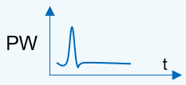  Or 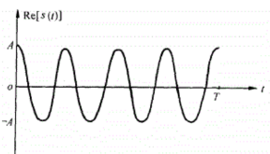 | 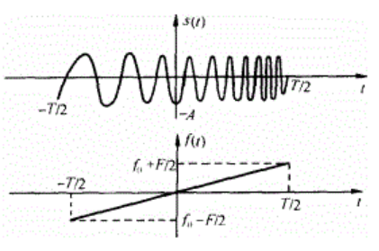
Frequency Domain  Characteristic | 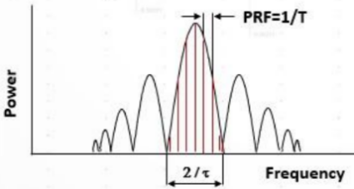 | 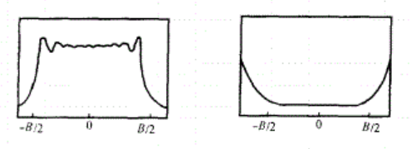
Time-Bandwidth Product (TBP) | $$τ×B=1$$ | $$τ×B>1$$
Operating State of the transmitter PA | Saturation State for larger output power | Saturation State or linear State due to large TBP
Duplex Mode | The operation of transmission and receiving is in the Time Division Duplex (TDD). | The operation of transmission and receiving is in the Full Duplex at the same time and frequency (bandwidth).
Self-interference | As TDD is used for transmission and receiving, there is no self-interference issue. | There is a strong receiving self-interference coupled from transmitter. Generally, the methods of moving target detection technology should be used to eliminate the self-interference, e.g. self-heterodyne, Pulse-Doppler Method.
Range Blind Zone | cτ/2 | If Full Duplex Operation between transmission and receiving is used, there is no Range Blind Zone for CW Radar.
Pulse Compression | Not supported | Supported. For example, matched filter is used to complete the Pulse Compression for LMF signal, but the side lobe of strong Object may interfere the detection of the small Object.

- Recommended WF:
  - Discuss the sensing signal as proposed above in RAN4.

Issue 1-7: Evaluation metric
- Proposal 1: It is proposed to take Table 1 as stating point for metric discussion for sensing. [CMCC]
Table 1 Metrics for sensing
Metric | Definition
Miss detection probability | Miss detection probability is the probability that a true target is not associated with a detected target.  From the aspect of evaluation, it is defined as  $$P_{md}={\sum_{n=0}^{N-1}{\frac{D_{n}}{M_{n}}}}/N$$  Where,  - $D_{n}$ is the number of missed targets in the drop n, i.e., the true target not associated with any detected object  - $M_{n}$ is the number of true targets in the drop n.  - $N$ is total number of drops with at least one target per drop
False alarm probability | Definition Type 1 (no target dropped in simulation area): False alarm probability is defined as the probability that an object is detected when there is no target present in simulation area is considered a false alarm.  From the aspect of evaluation, it is defined as  $$P_{f1}=\frac{\sum_{n=0}^{N-1}{Q_{n}}}{N}$$  Where,  - $Q_{n}$ equal to 1 if at least one object is detected when there is no target dropped in the simulation area in the drop n, otherwise $Q_{n}$ equal to 0.  - $N$ is the total number of drops without targets in the simulation area.  Definition Type 2 (targets dropped in simulation area): False alarm probability is defined as the probability that an object is detected but not associated with any true targets in the simulation area is considered as a false alarm.  From the aspect of evaluation, it is defined as  $$P_{f2}={\sum_{\begin{aligned}0≤n<N \\ M_{n}^{'}≠0\end{aligned}}{\frac{D_{n}^{'}}{M_{n}^{'}}}}/K$$  Where,  - $D_{n}^{'}$ is the number of detected objects but not associated with any true targets in the drop n.  - $M_{n}^{'}$ is the total number of detected objects in the drop n.  - $K$ is number of drops (N)
Horizontal/Vertical Positioning Accuracy | Horizontal/vertical positioning accuracy is defined as the 95th percentile point of the cumulative distribution function (CDF) of the horizontal/vertical position estimation error.  From the aspect of evaluation, the horizontal/vertical position estimation error is the norm of the difference between the estimated horizontal/vertical position and the corresponding true position of a sensing target.
Velocity Accuracy | Velocity accuracy is defined as the 95th percentile point of the cumulative distribution function (CDF) of the velocity estimation error.  From the aspect of evaluation, the velocity estimation error is the norm of the difference between the estimated velocity and the corresponding true velocity of a sensing target.
Sensing Capacity  Note 1 | Sensing capacity is defined as the maximum number of the targets per sector when sensing results of all targets in observation zone fulfil QoS requirements with 95% probability. The QoS requirements are defined by other KPIs (except sensing capacity itself) on sensing.
Max sensing service latency | Max sensing service latency is the time elapsed between the event triggering the determination of the sensing result and the availability of the sensing result at the sensing system interface.
Refreshing rate | Refreshing rate is the rate at which the sensing result is generated by the sensing system. It is the inverse of the time elapsed between two successive sensing results.
Note 1: An intuitive evaluation methodology for sensing capacity can be found in Annex A.

- Proposal 2: For the UAV use case of 6G ISAC study at least, propose to consider the distance, angle estimation and velocity estimation as the basic metric for the study in RAN4. [ZTE]
- Proposal 3: For the UAV use case of 6G ISAC study at least, propose to consider the distance accuracy impacts, angle estimation accuracy impacts and velocity estimation accuracy impacts to quantify the performance impacts from both co-channel and adjacent channel. [ZTE]
- Proposal 4: for the 6G ISAC coexistence study in RAN4, for 6GR performance metric, propose to use the legacy throughput loss as basic metric. [ZTE]
- Proposal 5: The performance requirements for UE side and TRP side should be formulated separately. [OPPO]
- Proposal 6: Based on 6G sensing-related requirements, RAN4 should further study the RF impact and start to work on potential new metric and test methodologies to quantify the Detection Probability and FAP. [Vivo]

- Proposal 8: The performance metrics and acceptable degradation for ISAC need to be defined. For IMT MBB network SINR and/or throughput loss can be used. Besides evaluation of performance degradation due to the presence of ACI from another network deployment, also in-band blocking should be studied, since certain sensing modes, when ISAC is the victim, may see the BS sensing receiver blocked by the DL of an adjacent operator. [Ericsson]
- Recommended WF:
  - Discuss the evaluation metric for different use case in Issue 1-2 in case by case manner;

Issue 1-8: KPI for sensing
- Proposal 1: It is proposed to take Table 2 as stating point to discuss KPI on sensing. [CMCC]
Table 2 KPIs on sensing
Use case | Positioning Accuracy |  | Velocity Accuracy  [m/s] | Max sensing service latency  [ms] | Refreshing rate  [Hz] | Sensing Capacity  [per sector] | Missed detection  [%] | False alarm  [%]
Use case | Horizontal  [m] | Vertical  [m]
UAV detection | 10 | 10 | 1 | 1000 | 1-10 | 100 | 1 | 1
UAV tracking | 1 | 1 | 1 | 100-1000 | 1-10 | 100 | 0.1-1 | 1
Automotive detection and tracking | 1 | N/A | 1 | 1000-5000 | 10 | 100 | 1 | 3
Human detection | 1 | N/A | N/A | 1000 -5000 | 10 | 100 | 5 | 2
Note 1: Metrics for tracking can be different with detection. And metrics for tracking should be evaluated independently.

- Recommended WF:
  - Postpone the KPI relevant discussion since this is up to RAN/RAN1 discussion

Issue 1-9: General issue for coexistence study for sensing and RF
- Proposal 1: it’s RAN4’s scope for self-interference cancellation/spatial isolation analysis and the adjacent carrier co-existence simulation for following scenarios [CMCC]
  - Between 5G legacy network and 6G sensing network
  - Between 6G normal network and 6G sensing network based on detailed interference avoidance scheme.
- Proposal 2: RAN4 should waits the agreements from RAN1 to decide whether the coexistence study is necessary. [Xiaomi]
- Proposal3: RAN4 should discuss the necessity of the coexistence study for the scenario of ISAC-UAVs to other base stations. [Xiaomi]
- Proposal 4: RAN4 could discuss the potential types of the adjacent channel coexistence problem for the ISAC system and decide which type of the coexistence problem to be prioritize. [Samsung]
- Proposal 5: for the 6G ISAC BS, the coexistence studies between ISAC system(s) and the legacy system need to be conducted to figure out the appropriate RF requirements. [ZTE]
- Proposal 6: for the different use case of ISAC deployment, propose to consider differentiating the deployment to make the evaluation more realistic and closer to the deployment. [ZTE]
- Proposal 7:: For co-existence scenario, gNB-based mono-static for 6G ISAC and NR system can be viewed as the starting point [Huawei]
- Proposal 8:

- Recommended WF:
  - Further discuss whether the following adjacent channel coexistence case should be considered
    - Between 5G legacy network and 6G sensing network
    - Between 6G normal network and 6G sensing network

Issue 1-10: Assumptions for TRP based mono-static sensing mode, UAV use case
- Proposal 1: RAN4 to identify the antenna configuration for monostatic sensing mode before further performance discussions. [Samsung]
- Proposal 2: For TRP monostatic sensing, RAN4 should prioritize TDM and FDM method, while deprioritizing SDM due to its processing complexity and restrictions on precoding selection. [Samsung]
- Proposal 3: for the simulation assumption for UAV sensing evaluation in RAN4, propose to follow the agreement of simulation assumption reached in RAN1. [ZTE]
- Proposal 4: for the simulation assumption for TN BS, propose to follow the simulation assumption as captured in TR 38.858 for TDD network. [ZTE]
- Proposal 5: for the RCS of sensing target, propose to consider the RCS model as captured in clause 7.9.2.1 of TR 38.901 and simplify the RCS in the large scale pathloss model if necessary. [ZTE]
- Proposal 6: For the 6G ISAC study, consider TDM based sensing operation and full duplex based sensing operation. [ZTE]
- Proposal 7: For the 6G ISAC BS with option 1 TDM operation, consider the RF feasibility evaluation from the receiver’s in-channel linearity and also out of carrier blocking performance. [ZTE]
- Proposal 8: For the 6G ISAC BS with option 2 FDM operation, consider the RF feasibility including fully overlapping transmission/reception between DL and UL. [ZTE]
- Proposal 9: RAN4 should discuss if the summarized azimuth / elevation angular resolution above can meet the requirements or not for UAV use case. [CATT]
- Proposal 10: RAN4 should discuss how to detect the UAV objectives in the Blind Spot if we reuse the existing performance of vertical antenna array and element. Alternatively, RAN4 can discuss whether the configurations of vertical antenna array and element can be adjusted for ISAC BS. [CATT]
- Proposal 11: RAN4 should discuss how the BS antenna arrays are used for BS supporting ISAC. [CATT]
  - P3-1: discuss whether the existing TDD BS antenna arrays for communications can be directly reused for BS to support ISAC.
  - (P3-1) Possible Answer: the purpose for BS supporting ISAC is to reuse the existing TDD BS hardware / antenna arrays as much as possible.
  - P3-2: If BS has to support BS monostatic ISAC for UAV use case, it’s unclear whether additional BS antenna array need to be implemented, e.g. additional Rx antenna array which is separated from Tx antenna array.
  - (P3-2) Possible Answer: it depends on whether Pulse Wave or Continues Wave is used as the ISAC waveform.
  - For Pulse Wave ISAC BS, the existing shared antenna array between Tx and Rx can be reused since the operation of transmission and receiving for Pulse Wave ISAC BS is in the Time Division Duplex (TDD).
  - For Continues Wave ISAC BS, additional Rx antenna array is needed to provide better isolation between BS transmitter and receiver. Thus, for this case, the BS antenna arrays supporting SBFD can be reused for Continues Wave ISAC BS.
  - P3-3: Apart from Tx and Rx antenna array, it’s unclear whether the antenna elements and the vertical spacing $d_{V}$ should be adjusted, for example: more elements/BB chain is needed, and/or adjust $d_{V}$ from 0.7/2.1λ to 0.5λ.
  - (P3-3) Possible Answer: it depends on the targeted scenarios and the performance of azimuth/elevation angular resolution.

- Proposal 12: Consider existing network deployment aspects like aligned TDD operation between operators, macro-BS power, antenna configuration, etc. This should be prioritized in the first studies with ISAC. [Ericsson]
- Proposal 13: For the 3 to 4 GHz and 6 to 8 GHz frequency ranges different AAS BS array antenna configurations and simulation assumptions should be considered in the studies. RAN4 should adopt the parameters, assumptions and attributes discussed in Table 3-1. [Ericsson]
- Recommended WF:
  - For TRP monostatic sensing mode for UAV use case, postpone the discussion on TDM/FDM/SDM before RAN1 reaches the agreement for the sensing mode.
  - For the simulation assumption for UAV sensing evaluation in RAN4 if agreeable, propose to follow the agreement of simulation assumption reached in RAN1 as starting point.
  - For the simulation assumption for TN BS, propose to follow the simulation assumption as captured in TR 38.858 for TDD network as starting point.
  - FFS on the Blind Spot according to simulation assumption;
  - FFS on azimuth / elevation angular resolution of proposed antenna array can meet the requirements or not for UAV use case.

Issue 1-11: RF requirements
- Proposal 1: RAN4 to assess UE RF impacts once RAN1 reaches sufficient agreements. [Nokia]
- Proposal 2: RAN4 to study the RAN4 impact on BS RF requirements once RAN1 makes sufficient agreements. [Nokia]

- Proposal 4: Based on 6G sensing-related requirements, RAN4 should further study the RF impact and start to work on potential new metric and test methodologies to quantify the Detection Probability and FAP. [Vivo]
- Recommended WF:
  - FFS on RF requirements for sensing node e.g. BS or UE.

Issue 1-12: the architecture for sensing in RAN4
- Proposal 1: For the architecture study for 6G sensing in RAN4, propose to focus on the RF architecture of sensing node for different use case. [ZTE]
- Proposal 2: In initial stage, RAN4 shall focus on the study on reference architecture and RF feasibility of interference handling on receiver side from gNB side (TRP-TRP mono static sensing) [Xiaomi]
- Recommended WF:
  - For architecture discussion for sensing in RAN4, focus on RF architecture for sensing system;

Issue 1-13: RRM
- Proposal 1: it is proposed to study the impact on UE measurement for the sensing modes involving UE. [CMCC]
- Proposal 2: Which types of RRM requirements shall be studied in 6G SI can wait for the other WGs’ progress. [Xiaomi]
- Proposal 3: RAN4 can consider the several common measurements requirements below for sensing purpose: [Xiaomi]
  - Power strength, timing delay, Doppler, angle in sensing RX
  - Power strength, timing delay, Doppler, angle per path in the sensing RX
  - Accuracy for the measurements which used for the final positioning/velocity estimation
- Proposal 4: RAN4 can take the KPIs of 5G sensing as a start point to discuss the necessary measurement requirement. E.g. [Xiaomi]
  - the delay of a successful measurement report
  - the confidence level for a successful detection
  - the minimum accuracy report granularity
- Proposal 5: From RAN4 perspective, the measurement gap pattern for sensing especially for the Doppler shift estimation can be reconsidered. [Xiaomi]
- Proposal 6: for the 6G ISAC RRM requirement, propose to postpone the discussion until there are sufficient progress made in RAN1/RAN2/RAN3 [ZTE]
- Proposal 7: RAN4 considers the following in its RRM discussions for ISAC: [Ericsson]
  - Not all ISAC deployment scenarios will have the same RAN4 specification impact;
  - Some ISAC measurement and accuracy requirements may need to be specified by RAN4, since new sensing-specific measurements may be introduced;
  - RAN4 needs to discuss not only the requirements for RRM sensing measurements but also the requirements ensuring the general RRM performance for the UE performing sensing measurements and/or transmitting radio signals for sensing;
  - The reflected signals in ISAC may have lower SINRs than usually considered for other RRM measurements;
  - Interference in UL resources at a UE needs to be considered for UE monostatic sensing;
  - The sensing continuity consideration may potentially also impact the RAN4 assumptions, requirements, and the measurement procedure for sensing.
- Recommended WF:
  - For RRM for sensing, propose to postpone the discussion until there are sufficient progress made in RAN/RAN1/RAN2;

Issue 1-14: Testability
- Proposal 1: RAN4 need to study test method for ISAC considering movement of sensing targets, new sensing requirement metric and ISAC channel model. [Xiaomi]
- Proposal 2: RAN4 should consider developing a dedicated sensing channel model to simulate the channel conditions required for different use cases, enabling accurate verification of the corresponding KPIs. [Vivo]
- Proposal 3: RAN4 could begin the testability related topics study for 6GR ISAC once there is any decision on the sensing modes. [Samsung]
- Proposal 4: It is proposed to take OTA-based test setup as 6G sensing test methodology to evaluate the sensing performance. [OPPO]
- Proposal 5: Several new issues of 6G sensing conformance and performance test with OTA-based test setup, that differ from previous OTA testing method, should be considered. [OPPO]
  - Can monostatic sensing and bistatic sensing share the same test setup?
  - Can base station and UE share the same test setup?
  - How to address target moving scenario in OTA chamber?
  - How to facilitate the test case of distance detection in a limited size of OTA chamber?
- Proposal 6: RAN4 to start the study by focusing on testability aspects with priority given to test cases that involve UE participation. [Nokia]
- Proposal 7: for the 6G ISAC conformance testing, propose to discuss the OTA test setup for conformance testing of moving sensing target. [ZTE]
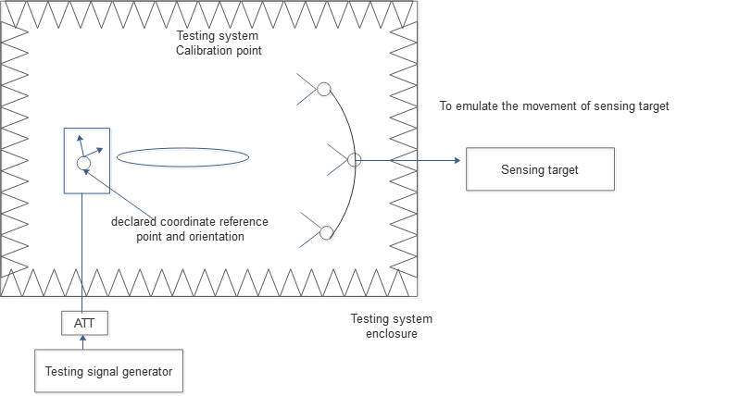
Figure 2.8-1.Illustration of OTA conformance testing for ISAC BS
- Recommended WF:
  - For different ISAC use case, propose to discuss the test setup case by case;
  - For TRP mono-static sensing mode for UAV use case, discuss how to build object emulator in the testing chamber.
  - FFS for other sensing mode and use case;
  - FFS on the channel modelling for sensing;

Issue 1-15: Other
- Proposal 1: RAN4 to further discuss the possibility of introduce more OTA requirements for 1-H. On the other side, OTA requirements numbers are limited to reduce testing workload. [CMCC]
- Recommended WF:
  - Postpone the discussion for above proposal until the set of RF requirement for sensing BS is stable.

Issue 1-16: General guidance on simulation studies (RRM and co-existence)
- Proposal 1: RAN4 ISAC studies and requirements must be based on the assumptions, which are relevant for general radio communications network deployment scenarios and an acceptable trade-off level between resources needed for radio communications services and resources needed to support sensing. [Ericsson]
- Proposal 2: For RAN4 simulations, RAN4 needs to consider that the legacy (6G) simulation setups and test cases can be more difficult to reuse as such for ISAC, e.g., because: (i) a sensing target can be neither a transmitter nor a receiver of a radio signal(s) for sensing, (ii) more entities are to be modelled in ISAC simulations and test cases (e.g., at least one transmitter, one receiver, and one passive object can be envisioned). Hence, it is important to identify the scenarios and the simulations needed earlier on. [Ericsson]
- Recommended WF:
  - Discuss the proposals.

Issue 1-17: Feasible/acceptable (from RAN4 point of view) sensing signal strength and quality levels
- Proposal 1: RAN4 needs to discuss and agree on the targeted levels for sensing reference signal received strength and quality, taking into account signals reflected from sensing targets. [Ericsson]
- Recommended WF:
  - Discuss the proposal.
Issue 1-18: Synchronization requirements
- Proposal 1: RAN4 to conduct further studies on mechanisms to improve synchronization accuracy between UE and TRP, between TRPs, and between UEs to enable bistatic sensing. [Nokia]
- Recommended WF:
  - For the bi-static sensing mode, the sync performance between different nodes (TRP vs UE and TRP vs TRP) should be carefully considered.

Companies’ contributions summary
T-doc number | Company | Proposals / Observations
R4-2600269 | CATT | Observation 1: the use cases of detection and/or tracking of passive objects, at least including UAVs, human, vehicles and AGVs, are supported by 6GR and 6G RAN architecture referring to the latest TR 38.914.  Observation 2-1: For positioning, the positioning accuracy is considered as the KPI, which include Horizontal positioning accuracy in the horizontal plane (i.e., x/y axis, or latitude/longitude) and [Vertical positioning accuracy in the vertical direction (i.e., z-axis, or altitude)].  Observation 2-2: For Sensing, Detection Probability, False Alarm Probability, Horizontal/Vertical Localization Accuracy and Velocity Accuracy are considered as the KPI.  Proposal 1: RAN4 can start to do warm-up discussion on 6G ISAC assuming UAV case and BS [/UE] mono-static as an example initially before next April.  2.2 Targeted Frequency  Observation 3: For the agreed use cases of 6GR sensing , i.e. UAVs, human, vehicles and AGV, all of them can meet the RCS requirements of Optical Region for the centre frequency equal to or larger than 2GHz.  Proposal 2: For UAV case, RAN4 can start to do warm-up discussion on 6G ISAC assuming 3.5GHz/4.9GHz/7GHz as exemplary centre frequency initially before next April.  2.3 BS antenna configuration for BS monostatic mode and UAV case  Observation 4: RAN1 assumed the two separate Tx and Rx antenna arrays for BS supporting ISAC in R20 5G-A ISAC, but RAN4 only assumed one shared antenna array for both Tx and Rx in TR 38.922 supporting communication function only.  Proposal 3: RAN4 should discuss how the BS antenna arrays are used for BS supporting ISAC.  P3-1: discuss whether the existing TDD BS antenna arrays for communications can be directly reused for BS to support ISAC.  (P3-1) Possible Answer: the purpose for BS supporting ISAC is to reuse the existing TDD BS hardware / antenna arrays as much as possible.  P3-2: If BS has to support BS monostatic ISAC for UAV use case, it’s unclear whether additional BS antenna array need to be implemented, e.g. additional Rx antenna array which is separated from Tx antenna array.  (P3-2) Possible Answer: it depends on whether Pulse Wave or Continues Wave is used as the ISAC waveform.  For Pulse Wave ISAC BS, the existing shared antenna array between Tx and Rx can be reused since the operation of transmission and receiving for Pulse Wave ISAC BS is in the Time Division Duplex (TDD).  For Continues Wave ISAC BS, additional Rx antenna array is needed to provide better isolation between BS transmitter and receiver. Thus, for this case, the BS antenna arrays supporting SBFD can be reused for Continues Wave ISAC BS.  P3-3: Apart from Tx and Rx antenna array, it’s unclear whether the antenna elements and the vertical spacing $d_{V}$ should be adjusted, for example: more elements/BB chain is needed, and/or adjust $d_{V}$ from 0.7/2.1λ to 0.5λ.  (P3-3) Possible Answer: it depends on the targeted scenarios and the performance of azimuth/elevation angular resolution.  Observation 5: the candidate azimuth angular resolution and elevation angular resolution are summarised below for different assumptions BS antenna configurations  Proposal 4: RAN4 should discuss if the summarized azimuth / elevation angular resolution above can meet the requirements or not for UAV use case.  Observation 6:  For UAV scenarios from horizontal profile, current range of horizontal electronic scan is $-60{≤φ}_{escan}≤60$ deg, which can meet the necessity.  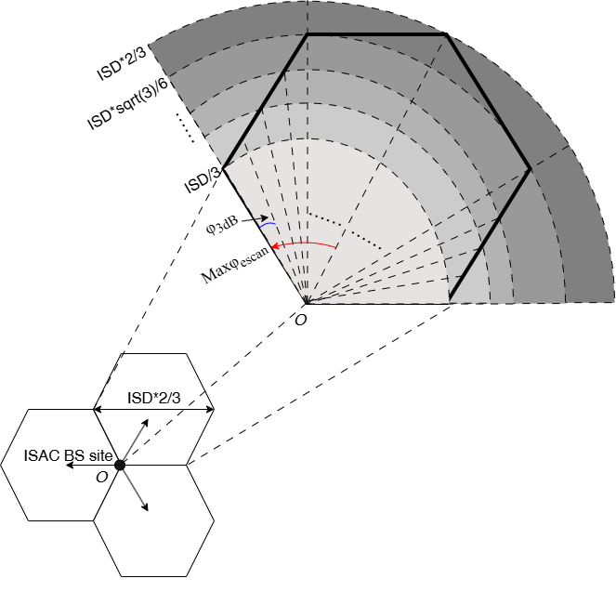  For UAV scenarios from vertical profile, current range of vertical electronic scan is $90{≤θ}_{escan}≤100$ deg referring to TR 38.922, which will result in some Blind Spot. In addition, θ_{3dB} of antenna element is 65 deg, which will also result in some Blind Spot.  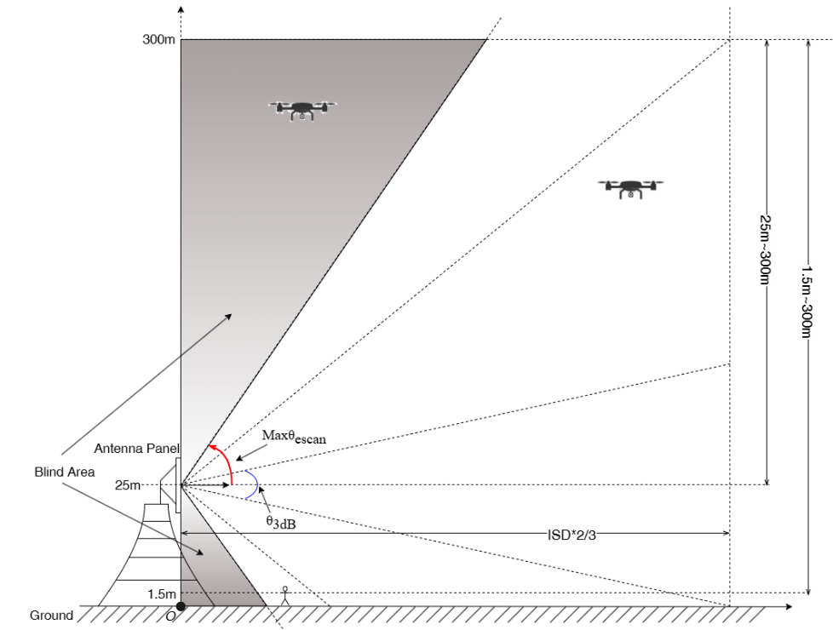  Proposal 5: RAN4 should discuss how to detect the UAV objectives in the Blind Spot if we reuse the existing performance of vertical antenna array and element. Alternatively, RAN4 can discuss whether the configurations of vertical antenna array and element can be adjusted for ISAC BS.  2.4 Bandwidth of Sensing signal  Observation 7: No matter what kind of Radar system we choose, the bandwidth of sensing signal will determine the range resolution of sensing signal.  Proposal 6: RAN4 should discuss if the 5m range resolution and above can meet the requirements or not for UAV use case.  2.5 sensing signal: Continuous Wave (CW) / Pulse Wave (PW)  Proposal 7: the characteristics above for Pulse Wave (PW) Radar and Continuous Wave (CW) Radar can be considered as the part of RAN4 6G ISAC study.  Proposal 8: RAN4 should active work closely with RAN1 on design of sensing signal from system performance impacts and coexistence perspective.
  azimuth angular resolution | elevation angular resolution
  case 1: (N=16, $\frac{d_{H}}{λ}=0.5$)  0.12rad = 6.8º  case 2: (N=8, $\frac{d_{H}}{λ}=0.5$)  0.25rad = 14.5º | case 0-1: (M=8)  (2.1λ ) 0.06rad = 3.5º  case 0-2: (M=4)  (2.1λ ) 0.14rad = 8.1º | case 1: (M=16)  (0.8λ ) 0.07rad = 4.2º  (0.5λ ) 0.12rad = 6.8º  case 2: (M=12)  (0.8λ ) 0.10rad = 5.8º  (0.5λ ) 0.16rad = 9.3º  Option 3: (M=8)  (0.8λ ) 0.16rad = 9.1º  (0.5λ ) 0.25rad = 14.6º
   | Pulse Wave (PW) Radar | Continuous Wave (CW) Radar
  Time Domain characteristic | Or
  Frequency Domain
  characteristic
  Time-Bandwidth Product (TBP) | $$τ×B=1$$ | $$τ×B>1$$
  Operating State of the transmitter PA | Saturation State for larger output power | Saturation State or linear State due to large TBP
  Duplex Mode | The operation of transmission and receiving is in the Time Division Duplex (TDD). | The operation of transmission and receiving is in the Full Duplex at the same time and frequency (bandwidth).
  Self-interference | As TDD is used for transmission and receiving, there is no self-interference issue. | There is a strong receiving self-interference coupled from transmitter. Generally, the methods of moving target detection technology should be used to eliminate the self-interference, e.g. self-heterodyne, Pulse-Doppler Method.
  Range Blind Zone | cτ/2 | If Full Duplex Operation between transmission and receiving is used, there is no Range Blind Zone for CW Radar.
  Pulse Compression | Not supported | Supported. For example, matched filter is used to complete the Pulse Compression for LMF signal, but the side lobe of strong Object may interfere the detection of the small Object.
R4-2600463 | Xiaomi | Observation 1-2: In 6GR, target use cases, sensing modes (e.g., mono-static, bi-static) and deployment scenarios are subject to RAN/SA and RAN1’s discussion and decision.  Observation 1-3: With sufficient progress from other WGs, it’s hard to have efficient discussion in RAN4 for ISAC  Proposal 1-1: RAN4 can start ISAC discussion from the typical sensing modes (e.g. TRP-TRP mono static sensing and TRP-UE bi-static sensing).  Coexistence study:  Observation 2-1: For FDM ISAC, adjacent channel interference to the FDD receiver should be considered.  Observation 2-2: For TDM ISAC, the ACLR and ACS can be reused.  Proposal 2-1: RAN4 should waits the agreements from RAN1 to decide whether the coexistence study is necessary.  Observation 2-3: The aggressor base stations work in ISAC-UAVs scenario will generate higher interference to other base stations.  Proposal 2-2: RAN4 should discuss the necessity of the coexistence study for the scenario of ISAC-UAVs to other base stations.  RF impact  Observation 3-1: The detailed RF impact is pending other WGs’ design.  Proposal 3-2: In initial stage, RAN4 shall focus on the study on reference architecture and RF feasibility of interference handling on receiver side from gNB side (TRP-TRP mono static sensing)  RRM study:  Proposal 4-1: Which types of RRM requirements shall be studied in 6G SI can wait for the other WGs’ progress.  Proposal 4-2: RAN4 can consider the several common measurements requirements below for sensing purpose:  - Power strength, timing delay, Doppler, angle in sensing RX  - Power strength, timing delay, Doppler, angle per path in the sensing RX  - Accuracy for the measurements which used for the final positioning/velocity estimation  Proposal 4-3: RAN4 can take the KPIs of 5G sensing as a start point to discuss the necessary measurement requirement. E.g.  - the delay of a successful measurement report  - the confidence level for a successful detection  - the minimum accuracy report granularity  Observation 4-1: From RAN4 perspective, if UE needs to receive the more than one sensing signals from the different cells/carriers as the serving cell, the gap window like the measurement gap in NR will be specified in RAN4 spec.  Observation 4-2: In order to support the more precise and contiguous Doppler shift estimation over a measurement sample, the measurement duration of one occasion shall be not less than 40ms.  Proposal 4-4: From RAN4 perspective, the measurement gap pattern for sensing especially for the Doppler shift estimation can be reconsidered.  Test  Proposal 5-1: RAN4 need to study test method for ISAC considering movement of sensing targets, new sensing requirement metric and ISAC channel model.
R4-2600633 | Apple | Observation 1: A cursory examination of visualizations shows that there are some frequency ranges in which both mobile (primary and/or secondary) and radiolocation (primary and/or secondary) are identified allocations by the ITU.  Observation 2: A closer investigation of the notes accompanying the ITU frequency allocation tables is needed to ensure RAN4 performs a thorough survey.  Proposal 1: RAN4 is encouraged to discuss how to structure the 6G sensing regulatory survey. This paper provides a potential direction with a simplified visualization of the related ITU allocations.
R4-2600688 | vivo | Proposal 1: The 6G sensing study in RAN4 should focused the agreed use cases in RAN-P, i.e., Detection and/or tracking of passive objects including UAVs, human, vehicles and AGVs.  Proposal 2: Based on 6G sensing-related requirements, RAN4 should further study the RF impact and start to work on potential new metric and test methodologies to quantify the Detection Probability and FAP.  Proposal 3: For supporting better sensing performance, RAN4 consider more device types other than smartphone, e.g. robots, FWA, with different assumption of UE capability (Tx/Rx).  Proposal 4: RAN4 consider prioritizing UE-related bistatic sensing mode to facilitate the RF requirements and testability discussion.  Proposal 5: RAN4 should consider developing a dedicated sensing channel model to simulate the channel conditions required for different use cases, enabling accurate verification of the corresponding KPIs.
R4-2600723 | Samsung | - Currently, ISAC is a still relatively new technology area, and there have not been any established regulations or RF requirements on this technology yet.  - RAN4 could adopt the existing requirements in regulations as starting point or reference for 6GR ISAC discussions.  - RAN4 considers TRP monostatic sensing mode, TRP-to-TRP bistatic sensing mode, TRP-to-UE sensing mode, and UE-to-TRP sensing mode in ISAC technology study at first.  - RAN4 may select one possible sensing mode as the warm-up option to push forward the in-depth technical discussions, then align the topic with RAN1 after RAN1 6G ISAC study begins.  - The architecture of an ISAC system depends on the sensing mode of the corresponding system. The discussion of potential ISAC architecture may require RAN4 identify the sensing modes to be studied.  - In monostatic sensing mode, Tx and Rx antennas could exist at the same location. The monostatic sensing would typically employ full-duplex methods unless a distance to the target become excessively large, necessitating consideration of antenna panel separations designed to mitigate self-interference.  - Different antenna configurations affect antenna gains in channel impulse response.  - RAN4 to identify the antenna configuration for monostatic sensing mode before further performance discussions.  - For TDM, dedicated time resources (with full exploitation of the entire allocated bandwidth) are beneficial for range estimation, and the switching time between communication and sensing needs to be considered.  - For FDM, the multiplex method can be classified to two scenarios: 1) multiplexing in a sub-band level, which divides the whole channel bandwidth into two mutually exclusive frequency ranges and 2) multiplexing in a subcarrier-level while occupying the same entire channel bandwidth. The clarification is able to be made based on RAN1’s further investigations.  - For TRP monostatic sensing, RAN4 should prioritize TDM and FDM method, while deprioritizing SDM due to its processing complexity and restrictions on precoding selection.  - RAN4 could study the characteristics and regulations of different frequency band, then discuss which frequency band/bands should be adopted for the 6GR ISAC system.  - RAN4 to discuss whether frequency bands in this study will be prioritized or open to all of availability.  - RAN4 could discuss the potential types of the adjacent channel coexistence problem for the ISAC system and decide which type of the coexistence problem to be prioritize.
R4-2600809 | CMCC | Proposal 1: for RAN4 study, it is proposed to consider use cases of detection and/or tracking of passive objects, at least including UAVs, human, vehicles and AGVs.  Proposal 2: It is proposed to take Table 1 as stating point for metric discussion for sensing.  Proposal 3: It is proposed to take Table 2 as stating point to discuss KPI on sensing.  Proposal 4: it’s RAN4’s scope for self-interference cancellation/spatial isolation analysis and the adjacent carrier co-existence simulation for following scenarios  - Between 5G legacy network and 6G sensing network  - Between 6G normal network and 6G sensing network based on detailed interference avoidance scheme.  Proposal 5: RAN4 to further discuss the possibility of introduce more OTA requirements for 1-H. On the other side, OTA requirements numbers are limited to reduce testing workload.  Proposal 6: it is proposed to study the impact on UE measurement for the sensing modes involving UE.
R4-2600908 | Huawei, HiSilicon | Proposal 1: For 6G ISAC use cases, in addition to detection and/or tracking of passive objects, physical world digital twin should be considered.  Proposal 2: For 6G sensing mode, gNB-based mono-static sensing can be the starting point.  Proposal 3: For co-existence scenario, gNB-based mono-static for 6G ISAC and NR system can be viewed as the starting point
R4-2601453 | OPPO | - The performance that UE-based sensing can achieve on the sensing metrics, e.g. miss detection probability, false alarm probability, horizontal/vertical positioning accuracy, velocity accuracy and distance accuracy, will be significantly different from those of TRP-based sensing.  - The performance requirements for UE side and TRP side should be formulated separately.  - It is proposed to take OTA-based test setup as 6G sensing test methodology to evaluate the sensing performance.  - Several new issues of 6G sensing conformance and performance test with OTA-based test setup, that differ from previous OTA testing method, should be considered.  - Can monostatic sensing and bistatic sensing share the same test setup?  - Can base station and UE share the same test setup?  - How to address target moving scenario in OTA chamber?  - How to facilitate the test case of distance detection in a limited size of OTA chamber?
R4-2601746 | Nokia | - RAN4 to start with the use cases of detection and/or tracking of passive objects, at least including UAVs, humans, vehicles and AGVs. UAVs as passive objects can be considered to leverage the NR ISAC study for the 6G sensing study.  - RAN4 to consider the six sensing modes (i.e., TRP monostatic, UE monostatic, TRP-TRP bistatic, TRP-UE bistatic, UE-TRP bistatic, and UE-UE bistatic) at the start of the 6G study. Further updates on the considered sensing modes can be made based on input from RAN1.  - For US, FCC considers key technical aspects such as frequency band allocation, power limits, spectral density, and duty cycle to ensure safe and effective operation of short-range radar systems. Frequency ranges considered for radar operation are the 76-81 GHz band and the 60 GHz band.  Regulatory aspects in Europe for the various envisaged use cases of integrated sensing and communication are being considered in EU funded projects such as Hexa-X-II and in pre-standard research such as ETSI ISG ISAC. Frequency ranges for sensing consider 0.5 GHz up to 170 GHz frequency range, both for OFDM based signals and radar.  For China, it is expected RF requirements will comply with regional spectrum regulations, including designated frequency usage and technical compliance. Frequency ranges considered for radar operation are the 76-79 GHz band and the 24.05-24.25 GHz band.  IMT-2030 recommendation REC-M.2160 considers frequency bands above 92 GHz as feasible for sensing applications.  - RAN4 to assess UE RF impacts once RAN1 reaches sufficient agreements.  - RAN4 to study the RAN4 impact on BS RF requirements once RAN1 makes sufficient agreements.  More accurate synchronization, in the order of nanoseconds to microseconds, between transmitter and receiver sides, is required for TRP-TRP bistatic, UE-UE bistatic, TRP-UE bistatic and UE-TRP bistatic sensing modes to accurately estimate the distance of objects from the receiver.  Use of GPS/GNSS reference clock at the transmitter and receiver to generate a time stamp for transmitted and received sensing waveform may be needed to improve accuracy.  - RAN4 to conduct further studies on mechanisms to improve synchronization accuracy between UE and TRP, between TRPs, and between UEs to enable bistatic sensing.  The RRM impact is different for each of the six sensing modes considered in 6G. It will further depend on UE and TRP RF impacts and the sensing reference signal design decided by RAN1.  A testing framework is essential for validating 6G sensing performance, and its development in RAN4 depends on foundational definitions from RAN1.  The sensing test metrics may vary depending on the considered use cases and sensing modes.  Test cases involving UE provide a clearer basis for defining DUT behavior and evaluating sensing performance. TRP-UE bistatic provides a practical and direct starting point for initiating the sensing testability study.  - RAN4 to start the study by focusing on testability aspects with priority given to test cases that involve UE participation.
R4-2601827 | Ericsson | - To facilitate RAN4 studies, it is proposed to abstract from specific applications and use cases and focus instead on the types of:  - sensing tasks (e.g., detection, characterization, localization, tracking, velocity estimation, etc.),  - sensing measurements,  - sensing modes,  - sensing targets*, and  - environments*.  NOTE (*): based on the studies, it can be decided later how generic the RAN4 requirements will be, e.g., whether the requirements will depend on the type of environment or sensing target.  - RAN4 ISAC studies and requirements must be based on the assumptions, which are relevant for general radio communications network deployment scenarios and an acceptable trade-off level between resources needed for radio communications services and resources needed to support sensing.  - RAN4 to discuss the applicability of DL/UL sensing reference signals for different 6G candidate sensing modes, e.g.:  - whether DL sensing reference signals should be assumed for BS monostatic and BS-to-BS bi-/multi-static sensing;  - whether UL sensing reference signals should be assumed for UE monostatic and UE-to-UE bi-/multi-static sensing.  - RAN4 needs to discuss and agree on the targeted levels for sensing reference signal received strength and quality, taking into account signals reflected from sensing targets.  - RAN4 can prioritize for its studies sensing targets which are passive objects (neither a transmitter nor a receiver of sensing radio signals).  - RAN4 can discuss what is the definition of the exact location of bigger passive objects, taking into account that the location in this case cannot be associated with any antenna which passive objects do not have.  - RAN4 considers the following in its RRM discussions for ISAC:  - Not all ISAC deployment scenarios will have the same RAN4 specification impact;  - Some ISAC measurement and accuracy requirements may need to be specified by RAN4, since new sensing-specific measurements may be introduced;  - RAN4 needs to discuss not only the requirements for RRM sensing measurements but also the requirements ensuring the general RRM performance for the UE performing sensing measurements and/or transmitting radio signals for sensing;  - The reflected signals in ISAC may have lower SINRs than usually considered for other RRM measurements;  - Interference in UL resources at a UE needs to be considered for UE monostatic sensing;  - The sensing continuity consideration may potentially also impact the RAN4 assumptions, requirements, and the measurement procedure for sensing.  - For RAN4 simulations, RAN4 needs to consider that the legacy (6G) simulation setups and test cases can be more difficult to reuse as such for ISAC, e.g., because: (i) a sensing target can be neither a transmitter nor a receiver of a radio signal(s) for sensing, (ii) more entities are to be modelled in ISAC simulations and test cases (e.g., at least one transmitter, one receiver, and one passive object can be envisioned). Hence, it is important to identify the scenarios and the simulations needed earlier on.  - Consider existing network deployment aspects like aligned TDD operation between operators, macro-BS power, antenna configuration, etc. This should be prioritized in the first studies with ISAC.  - The performance metrics and acceptable degradation for ISAC need to be defined. For IMT MBB network SINR and/or throughput loss can be used. Besides evaluation of performance degradation due to the presence of ACI from another network deployment, also in-band blocking should be studied, since certain sensing modes, when ISAC is the victim, may see the BS sensing receiver blocked by the DL of an adjacent operator.  - For the 3 to 4 GHz and 6 to 8 GHz frequency ranges different AAS BS array antenna configurations and simulation assumptions should be considered in the studies. RAN4 should adopt the parameters, assumptions and attributes discussed in Table 3-1.  Table 3-1: Attributes for urban macro from TR 38.914, “Study on 6G Scenarios and Requirements” in Reference [6] with RAN4 ISAC specific values.  NOTE1: The options noted here are for evaluation purpose, and do not mandate the deployment of these options or preclude the study of other spectrum options. A range of bands from 450 MHz – 960 MHz identified for WRC-15 are currently being considered and around 700MHz is chosen as a proxy for this range. A range of bands from 1427 – 2690 MHz identified for WRC-15 are currently being considered and around 2 GHz is chosen as a proxy for this range. A range of bands from 3300 – 4990 MHz identified for WRC-15 are currently being considered and around 4 GHz is chosen as a proxy for this range. A range of bands from 6425-7125 MHz identified for WRC-23 are currently being considered and around 7 GHz is chosen as a proxy for this range.  NOTE2: The aggregated system bandwidth is the total bandwidth typically assumed to derive the values for some KPIs such as area traffic capacity and user experienced data rate. It is not allowed to simulate a smaller bandwidth than the aggregated system bandwidth and transform the results to a larger bandwidth.  NOTE3: Aggregated system bandwidth assumes availability of three FDD carriers each of 10/20 MHz channel bandwidth in different spectrum band in the Around 700 MHz/Around 2 GHz spectrum regions, respectively. Aggregation of the spectrum into one band in each of the bandwidth regions is allowed for simulation purposes. Consider larger aggregated system bandwidth if 20 MHz cannot meet requirement.  NOTE4: 10 users per TRxP is the baseline with full buffer traffic. For evaluation of UL user experienced data rate, the number of users per TRxP can be reduced to 2  NOTE5: 3GPP needs to strive to meet the target with typical antenna configurations. The specific typical antenna configurations may be different for different device types/characteristics and need further study.  NOTE6: For non-full-buffer traffic with QoS requirement, use XR traffic models in TR 38.838 for XR composite requirement evaluation, use FTP-3 with packet delay budget requirement for energy efficiency evaluation, and use AI/ML traffic models for AI/ML related capability evaluation.  Table 3-2 Potential deployments areas for different indoor/outdoor ISAC scenarios  Table 3-3 Potential coexistence scenarios for evaluation  Table 3-4 Potential sensing modes for coexistence evaluation  Table 3-5 ISAC sensing targets  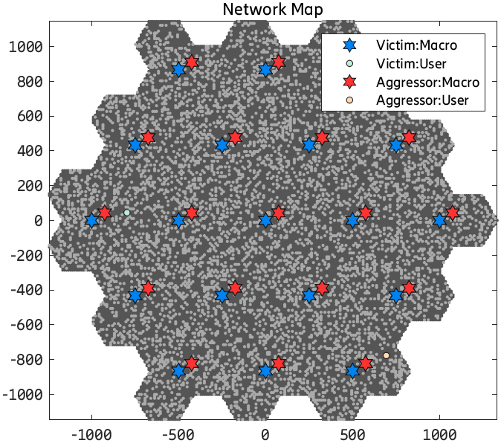  Figure 3-1: Interferer to victim scenario BS-to-BS scenario (hex-grids).
  Attributes | Values or assumptions
  Carrier Frequency  NOTE1 | Macro layer:  Around 4 GHz (covering the 3 - 4 GHz range)  Around 7 GHz (covering the 6 – 8 GHz range)
  [  From Reference [6]:  Aggregated system bandwidth  NOTE2, NOTE3  ]  System bandwidth | Around 4 GHz: Up to 200 MHz (DL+UL)  Around 7 GHz: Up to 200 MHz (DL+UL)
  Layout | From Reference [6]:  Two layers:  - Macro layer: Hex. Grid  ---------------------------------------  Shifting the interferer BS from minimum victim BS - to - interferer BS distance to the cell edge of victim BS (xy% to 100% grid shift), Figure 3-1
  ISD | Around 4 GHz: Table 4.2.1.1-1 in Reference [9]  Around 7 GHz: Table 4.2.1.1-1 in Reference [9]  0.45 km (urban) and 0.9 km (suburban)
  BS antenna elements  NOTE5 | Around 4 GHz: Table 4.4.1.2-1 in Reference [8]  Around 7 GHz: Table 5.4.1.2-1 in Reference [8]
  UE antenna elements  NOTE5 | [  From Reference [6]:  For the purpose of further study in RAN and RAN WGs for frequency up to 7GHz, evaluate the following UE RX/TX antennas:  Up to 4 Tx and Rx antenna elements  Up to 8 Tx and Rx antenna elements  Up to 16 Rx antenna elements (intended only for FWA)  ]  [  In Reference [8] for 4 and 7 GHz assumes isotropic radiation pattern antenna and without beamforming. For UE sensing capability this needs to be further defined  ]
  User distribution and UE speed | [  From Reference [6]:  Two layers: Uniform/macro TRxP + Clustered/micro TRxP  UE number per TRxP is [10, 30, 50]  Opt1: 80% indoor (3 km/h); 20% outdoor (30 km/h)  Opt2: 40% indoor (3 km/h); 40% outdoor (3 km/h); 20% outdoor (30 km/h)  ]  [  IMT MBB usual UE distribution  Sensing scenario and sensing target needs to be defined.  Stationary UEs for sensing mode  ]
  Service profile  NOTE6 | [  From Reference [6]:  NOTE: Whether to use full buffer traffic or non-full-buffer traffic with/without QoS requirement depends on the evaluation methodology adopted for each KPI. For certain KPIs, full buffer traffic is desirable to enable comparison with IMT-2020 values.  ]  Consider also pseudo realistic generic models for use case and traffic
  RAN4 sensing specific | - Deployment areas, Table 3-2  - Coexistence scenarios, Table 3-3  - Sensing modes, Table 3-4  - Sensing target, Table 3-5  - Scenario layout, Figure 3-1  - BS mechanical antenna tilts:  - 6 degrees for macro urban [14]  - ...  - Performance degradation metric for ISAC and IMT MBB: (Needs to be defined)  - Pathloss model: from TR 38.901. For propagation model for sensing, Rel 19 extensions for ISAC from TR 38.901 can be considered, focusing on large scale parameters. Also for RCS of the sensing target, the model captured in clause 7.9.2.1 of TR 38.901 can be considered, On the other hand, for the interference again the TR 38.901 can be considered, but for the BS-to-BS interference, the model should modify the Line of Sight (LoS) probability to e.g. 100%, or FSPL can be considered.  - …
  Scenario | FR | Aggressor | Victim | Priority
  1 | FR1 4GHz | Urban Macro | Urban Macro | First priority
  2 | FR1 4GHz | Indoor factory | Indoor factory | Second priority
  3 | FR2-1 26GHz | Urban Macro | Urban Macro | Second priority
  4 | FR2-1 26GHz | Indoor factory | Indoor factory | First Priority
  5 | Around 7GHz | Urban Macro | Urban Macro | First Priority
  6 | Around 7GHz | Indoor factory | Indoor factory | Second priority
  Coex | Aggressor | Victim | Priority
  1 | ISAC | Legacy TDD | First priority
  2 | Legacy TDD | ISAC | First priority
  3 | ISAC | ISAC | Second priority
  Mode | Sensing modes | Priority
  1 | BS-to-BS bi-static | First priority
  2 | BS mono-static | First priority
  3 | BS-to-UE bi-static | Second priority
  4 | UE-to-BS bi-static | Second Priority
  Target | Sensing targets
  1 | UAVs
  2 | Humans
  3 | Vehicles
  4 | AGV including collision avoidance for indoor/outdoor
  5 | …
  6 | …
R4-2601848 | ZTE Corporation, Sanechips | Proposal 1: Propose RAN4 to follow the sensing use case agreed by RAN and RAN1.  Proposal 2: Propose RAN4 to following the sensing mode as agreed by RAN and RAN1 and discuss further work arrangement for different sensing mode.  Observation 1: In order to meet the RAN Sensing KPI for IMT-2030, the measurement bandwidth for sensing signal should be at least larger than 100MHz;  Observation 2: In order to meet more than 100MHz sensing signal bandwidth, FR1 high TDD bands and FR2-1 bands are more suitable for ISAC deployment;  Proposal 3: For 6G ISAC study, consider FR1 TDD with available spectrum wider than 100MHz at least, FR2-1 bands and FFS for 7-24GHz;  Proposal 4: For the 6G ISAC study, consider TDM based sensing operation and full duplex based sensing operation.  Proposal 5: For the architecture study for 6G sensing in RAN4, propose to focus on the RF architecture of sensing node for different use case.  Proposal 6: For the 6G ISAC BS with option 1 TDM operation, consider the RF feasibility evaluation from the receiver’s in-channel linearity and also out of carrier blocking performance.  Proposal 7: For the 6G ISAC BS with option 2 FDM operation, consider the RF feasibility including fully overlapping transmission/reception between DL and UL.  Proposal 8: for the 6G ISAC BS, the coexistence studies between ISAC system(s) and the legacy system need to be conducted to figure out the appropriate RF requirements.  Proposal 9: for the different use case of ISAC deployment, propose to consider differentiating the deployment to make the evaluation more realistic and closer to the deployment.  Proposal 10: for the simulation assumption for UAV sensing evaluation in RAN4, propose to follow the agreement of simulation assumption reached in RAN1.  Proposal 11: for the simulation assumption for TN BS, propose to follow the simulation assumption as captured in TR 38.858 for TDD network.  Proposal 12: for the RCS of sensing target, propose to consider the RCS model as captured in clause 7.9.2.1 of TR 38.901 and simplify the RCS in the large scale pathloss model if necessary.  Proposal 13: For the UAV use case of 6G ISAC study at least, propose to consider the distance, angle estimation and velocity estimation as the basic metric for the study in RAN4.  Proposal 14: For the UAV use case of 6G ISAC study at least, propose to consider the distance accuracy impacts, angle estimation accuracy impacts and velocity estimation accuracy impacts to quantify the performance impacts from both co-channel and adjacent channel.  Proposal 15: for the 6G ISAC coexistence study in RAN4, for 6GR performance metric, propose to use the legacy throughput loss as basic metric.  Proposal 16: for the 6G ISAC RRM requirement, propose to postpone the discussion until there are sufficient progress made in RAN1/RAN2/RAN3.  Proposal 17: for the 6G ISAC conformance testing, propose to discuss the OTA test setup for conformance testing of moving sensing target.

