SSB periodicity assessment
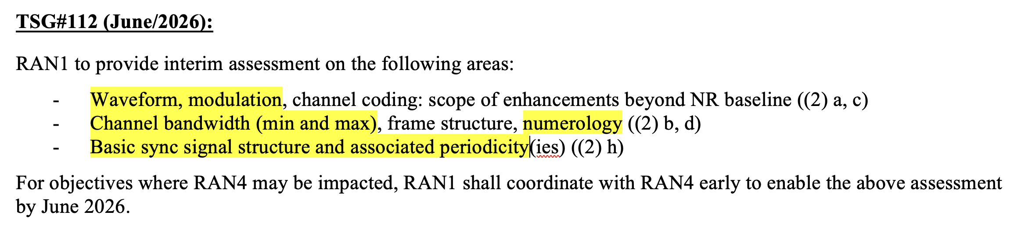

[From Chairman]Task RRM group to discuss interim assessment: SSB and periodicity from RRM perspective in this meeting.

In Tuesday online discussion, following was agreed in the note:
Agreement:
In Q2 2026, SSB (or different name of synchronization signal in 6G) related RRM study in RAN4 will focus on the interim assessment defined in 6G SID, which is related to synchronization signal periodicity, including the minimum periodicity of the synchronization signal.
- RAN4 will closely monitor the progress of the related discussion in RAN1
- RAN4 will not discuss and introduce new synchronization signal design, which is different from RAN1

Draft LS discussion:
1. Overall Description:

RAN4 initiated scope discussion for 6G RRM from the RAN4#116bis meeting, and identified that most of the 6G RRM work will depend on the design of synchronization signal and associated periodicity, including but not limited to,
- Mobility related delay/interruption, including HO and cell-reselection
- Cell identification/measurement/evaluation delay
- UE Tx Timing
- Measurement gap pattern design
- SCell activation delay
- RLM/CBD/BFD (if 6G has)
- Beam measurement
- and etc.
In order to meet the interim assessment timeline set by the 6G Radio SI, it would be appreciated if RAN1 could provide conclusion/options about the synchronization signal and associated periodicity as early as possible. RAN4 plans to start the synchronization signal periodicity related RRM study from Q2, 2026.

2. Actions:

To RAN1
ACTION: RAN4 would like to respectfully request RAN1’s early feedback for the conclusion/options about the synchronization signal and associated periodicity.

