3GPP TSG RAN4 Meeting #118 DRAFT R4-26xxxxx
Gothenburg, Sweden, 9th – 13th February, 2026
Agenda item: 8.1
Source: Feature lead (Nokia)
Title: WF for [118][104-A] 6G spectrum (part I)
Document for: Agreement

Introduction
In the current Study on 6G Radio (RP-250858) the following topics are listed under (5) 6GR core and performance requirements.
- UE RF requirement aspects including band and band combination [RAN4]
    - UE RF requirement framework aiming at improvements and/or simplification compared to 5G NR
    - Study how to improve 6G UE RF specification(s), including structure, drafting principles, and database for band combination
    - Study UE RF capabilities considering different device types and implementations
- Other aspects [RAN4]
    - Handling channel bandwidths which are not multiple of 5MHz
    - Definition of ‘frequency range(s)’
Furthermore, at RAN4#116 a plan for the 6G study in RAN4 was presented by the RAN4 chair as captured in [2]. One of the topics was “Spectrum” with a scope listed as:
- Band/band combination definition and simplification
- Definition of frequency ranges
- Spectrum related regulatory survey
The progress on these topics has been captured in the Running Summary of 6G Spectrum with the latest in R4-2601664.
At this meeting the discussion is broken into two different parts:
Part 1: definition of frequency range, band and band combination definition and simplification
Part 2: band group concept study, spectrum related regulatory survey
This WF is for part 1.

Topic #1: Definition of frequency ranges and bands
Under this topic RAN4 will discuss how to define frequency ranges and bands for 6G.

Companies’ contributions summary
See R4-2602144 for company contributions and summary of these

Open issues summary
The spectrum in focus is stated in the current Study on 6G Radio (RP-250858) description:
From a technology perspective, the study will address frequency ranges up to 52.6GHz, including at least the full range of FR1 (up to 7.125GHz), the range between FR1 and FR2-1 (including around ~7GHz), and FR2-1 (24.25 GHz – 52.6GHz).
NOTE: The following TRs will be taken into account:
TR 38.921 - Study on International Mobile Telecommunications (IMT) parameters for 6.425 - 7.025 GHz, 7.025 - 7.125 GHz and 10.0 - 10.5 GHz
TR 38.922 - Study on International Mobile Telecommunications (IMT) parameters for 4400 - 4800 MHz, 7125 - 8400 MHz and 14800 - 15350 MHz
NOTE: Frequency ranges beyond 52.6 GHz are not in scope of the work.
During the RAN#109 meeting, there were initial discussions on the potential 6G frequency ranges, which were summarised in the following document (RP-252963). However, no conclusion was reached since this is for further RAN WG4 discussions. According to the moderator’s summary report, the following options were proposed by companies:
- extend FR1 to 8.4 GHz and define a separate mid-high band (8.4–24.25 GHz) with its own single numerology.
- extend FR1 to 8.4 GHz and merge 8.4–24.25 GHz into FR2, creating a unified FR2 family.
- define separate FR for 7.125 – 24.25 GHz.
At this RAN4 meeting, even more options have been brought forward, which all is further discussed during the RAN4 meeting.

Sub-topic 1-1: Frequency Range framework
At previous RAN4 meeting, even more options have been brought forward, which all have been and will be further discussed. A common denominator seems, as captured also by the FL at RAN4#117, that FR1 can be extended up to 8.4GHz. However, since the exact frequency point is dependent on discussion outside of RAN4 this is left open as following the RAN guidance of using “around 7GHz” as the term.
Following was agreed in Online session:
- Agreement:
  - For TN frequency range:
  - FR1 is extended up to cover the band around 7GHz. The exact definition of “around 7GHz” can be further discussed and decided in RAN.
    - Further extension of FR1 beyond around 7GHz is subject to further discussion and not precluded.
    - If technical issue is identified as sufficient necessity, it is not precluded to sub-divide FR1 to differentiate around 7GHz and the rest of FR1
  - FR2-1 definition in 5G is taken as the baseline FR2 definition in 6G including the upper/lower bounds.
    - Further extension downward of FR2 is subject to further discussion and not precluded.

Following online discussion, the WF below is derived:
- WF:
  - Use the following frequency range split as baseline for further discussion:
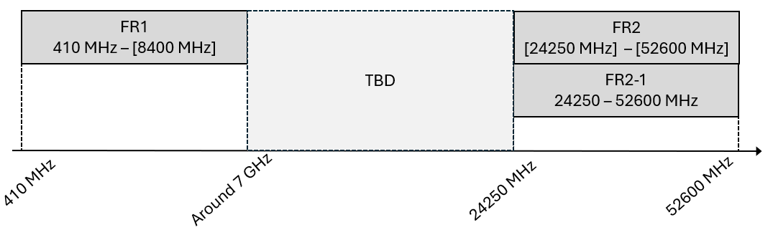

Topic #2: Definition of 6G bands
Under this topic RAN4 will discuss how to define bands for 6G.

Open issues summary

Sub-topic 2-1: Band migration/refarming from 5G to 6G
Multiple companies point out that there at some point will be a refarming of LTE/NR bands to 6GR bands as well of the inclusion of completely new bands. At RAN4#117 it was agreed (R4-2601664) to denote the 6G band with a pre-fix “s” but still how to define these are up to discussion in RAN4. Additionally, at RAN4#117 it was agreed that no band would automatically be migrated/refarming from 5G to 6G but would be dependent on operator request.
During online discission the following proposals were discussed:
- Proposals
  - Option 1: RAN4 shall continue to utilize both band number/name and NS for defining band specific requirements
  - Option 2: RAN4 shall reevaluate the concept for defining band specific requirements for 6G bands,
    - a) RAN4 will strive to only use band number/name i.e. reduce/remove the need for NSs
    - b) RAN4 shall expand the use of NS and remove/reduce the number of overlapped 6G bands as compared to NR.
It was clarified that the intention of the three options above can be summarised as:
  - Option 1: RAN4 will continue the way we defined bands in NR also in 6G. Meaning a mix of bands and NSs to capture regional differences for the band as frequency ranges and regulatory aspects
  - Option 2: RAN4 will for 6G bands,
    - a) rely more on different bands defined on the basis of regional/regulatory differences meaning more bands defined but less or no NSs needed per band.
    - b) rely more on NSs defined on the basis of regional/regulatory differences for bands meaning less bands defined and not or less need for overlapping bands.

At the online session an attempt for an agreement was drafted which is used as basis the proposed WF which are for further discussion at the ad-hoc:
- WF:
  - For defining 6G bands the 5G approach is taken as the baseline to utilize both band number/name and NS for defining band specific requirements
    - FFS how to handle the cases where bands are updated based on regulatory changes as frequency range or other requirements.
    - FFS whether it is possible to reduce the number of refarmed overlapped bands in 6G as compared to NR. Companies are encouraged to provide suggestions for using wider/overlapping bands for bands which is covered/overlapped by them.

Topic #3: Band combination definition and simplification
Under this topic, RAN4 will discuss how to define band combinations and simplify these in 6G

Sub-topic 3-2: Bandwidth Combinations Sets (BCS) in 6G
To allow the addition of supported channel bandwidths to already defined bands, the concept of BCSs was introduced to the specification. However, lately in NR, only the so-called BCS 4 and 5 method, meaning all supported channel bandwidths are utilized. Therefore, some are proposing to abandon the BCs concept in 6G.
During previous discission the following proposals were presented:

- Proposals
  - Option 1: RAN4 shall not use Bandwidth Combinations Sets (BCS) in 6G (ZTE, Samsung, Nokia, Ericsson, Apple, Oppo, MediaTek)
  - Option 2a: RAN4 shall further investigate the need for Bandwidth Combinations Sets (BCS) in 6G (QC)
  - Option 2b:RAN4 shall further investigate the possibility for not using Bandwidth Combinations Sets (BCS) in 6G (CATT, LGE)
  - Option 3: RAN4 shall introduce Bandwidth Combinations Sets (BCS) in 6G

At the ad-hoc session an attempt for an agreement was drafted which is used as basis the proposed WF:
- WF:
  - RAN4 will continue to discuss whether there is a need for Bandwidth Combinations Sets (BCS) in 6G.

