3GPP TSG RAN4 Meeting #118 DRAFT R4-2602144
Gothenburg, Sweden, 9th – 13th February, 2026
Agenda item: 8.1
Source: Feature lead (Nokia)
Title: Topic Summary for [118][104-A] 6G spectrum (part I)
Document for: Information

Introduction
In the current Study on 6G Radio (RP-250858) the following topics are listed under (5) 6GR core and performance requirements.
- UE RF requirement aspects including band and band combination [RAN4]
    - UE RF requirement framework aiming at improvements and/or simplification compared to 5G NR
    - Study how to improve 6G UE RF specification(s), including structure, drafting principles, and database for band combination
    - Study UE RF capabilities considering different device types and implementations
- Other aspects [RAN4]
    - Handling channel bandwidths which are not multiple of 5MHz
    - Definition of ‘frequency range(s)’
Furthermore, at RAN4#116 a plan for the 6G study in RAN4 was presented by the RAN4 chair as captured in [2]. One of the topics was “Spectrum” with a scope listed as:
- Band/band combination definition and simplification
- Definition of frequency ranges
- Spectrum related regulatory survey
The progress on these topics has been captured in the Running Summary of 6G Spectrum with the latest in R4-2601664.
At this meeting the discussion is broken into two different parts:
Part 1: definition of frequency range, band and band combination definition and simplification
Part 2: band group concept study, spectrum related regulatory survey
This summary is for part 1.

Companies’ contributions summary
The list of company contributions submitted under agenda item 8.5, 8.5.1 and 8.5.2 for RAN4#118 with relevance for the topics treated in this summary .
TDoc Number | TDoc Title | Source | Agenda
R4-2601956 | Proposal of Candidate NR Refarming Bands in Canada for 6GR | Rogers, CableLabs | 8.5
R4-2602019 | Refarming band n48 from 5G to 6G | Charter Communications, CableLabs | 8.5
R4-2600150 | Views on 6G frequency ranges | Apple | 8.5.1
R4-2600191 | Discussion on 6G definition of frequency ranges | China Telecom | 8.5.1
R4-2600296 | Discussion on 6G frequency ranges | CATT | 8.5.1
R4-2600368 | 6G spectrum_Definition of frequency ranges | Samsung | 8.5.1
R4-2600466 | View on 6GR FR and regulation | Xiaomi | 8.5.1
R4-2600655 | 6G Frequency range definition and updated 6G regulatory survey | MediaTek Korea Inc. | 8.5.1
R4-2600669 | Discussion on definition of frequency ranges and spectrum related regulatory survey for 6G | vivo | 8.5.1
R4-2600797 | Views on 6G frequency ranges | Spreadtrum,UNISOC | 8.5.1
R4-2600804 | Definition of frequency range | CMCC | 8.5.1
R4-2601005 | Discussion on frequency range framework | LG Electronics Inc. | 8.5.1
R4-2601183 | Views on 6GR definition of frequency ranges | ZTE Corporation,Sanechips | 8.5.1
R4-2601344 | 6G Spectrum - Frequency range | Ericsson | 8.5.1
R4-2601424 | Discussion on 6GR frequency range | OPPO | 8.5.1
R4-2601665 | 6GR Considerations on frequency ranges and spectrum related regulatory survey | Nokia | 8.5.1
R4-2601724 | Qualcomm views on Definition of frequency ranges and spectrum related regulatory survey | Qualcomm Incorporated | 8.5.1
R4-2600151 | Views on 6G bands | Apple | 8.5.2
R4-2600192 | Discussion on new 6G band | China Telecom | 8.5.2
R4-2600270 | Discussion on 6G spectrum | KDDI Corporation | 8.5.2
R4-2600297 | Discussion on 6G band definition | CATT | 8.5.2
R4-2600369 | 6G spectrum_Band and band combination definition and simplification | Samsung | 8.5.2
R4-2600465 | View on 6GR band definiton | Xiaomi | 8.5.2
R4-2600656 | 6G Band & Band combination definition and simplification | MediaTek Korea Inc. | 8.5.2
R4-2600798 | Views on 6G band and band combination definition and simplification | Spreadtrum,UNISOC | 8.5.2
R4-2600802 | band and band combination definition and simplification | CMCC | 8.5.2
R4-2601006 | Discussion on Band and Band Combination Introduction/Simplification | LG Electronics Inc. | 8.5.2
R4-2601184 | Views on 6GR Band and band combination definition and simplification | ZTE Corporation,Sanechips | 8.5.2
R4-2601409 | Views on band and band combination definition and simplification | NTT DOCOMO, INC. | 8.5.2
R4-2601425 | Discussion on the definition and simplification of band and band combination | OPPO | 8.5.2
R4-2601592 | Band combination definition and simplification in 6G | Ericsson | 8.5.2
R4-2601666 | 6GR Considerations on band and band combination definition and simplification | Nokia | 8.5.2
R4-2601725 | Qualcomm views on Band and band combination definition and simplification | Qualcomm Incorporated | 8.5.2
R4-2602025 | Input on 6G Spectrum | T-Mobile USA | 8.5.2

The proposals from the listed contributions have been included under the relevant Topic(s) in the following .

Topic #1: Definition of 6G frequency ranges
Under this topic RAN4 will discuss how to define frequency ranges for 6G. The following observations and proposals have been made.

Companies’ contributions summary
T-doc number | Company | Proposals / Observations
R4-2600150 | Apple | Proposal 1a: Since it is impossible to predict the outcome of the regulatory discussions, 6G SI can focus on ensuring that the relevant frequency range(s) will be supported.  Proposal 1b: Existing 5G mobile terrestrial and satellite bands can be re-farmed to 6G (subject for further checking and potential band optimisations).  Proposal 1c: New bands can be defined once they become available based on the outcome of the corresponding regulatory decisions.  Proposal 2a: As a starting point, existing FR1 and FR2 frequency ranges can be also considered for 6G.  Proposal 2b: FR1 frequency range can cover existing frequencies up to 7.1GHz and can be extended, if needed, to higher frequencies subject for further decisions in the regulatory domain.  Proposal 2c: FR2 frequency range can cover existing frequencies at 24.2-52.6GHz.  Proposal 3a: Introduction of a new frequency (sub-)range should be well justified by considering various factors including UE RF architecture, physical layer design and performance requirements verification.  Proposal 3b: UE RF architecture is one of the key factors to decide whether a new frequency range is needed or not.  Proposal 3c: Other factors, such as system parameters, can be taken into account to decide whether we need sub-ranges as 3GPP did in the past for FR2-1 and FR2-2.
R4-2600191 | China Telecom | Proposal 1: Option 3 that extend FR1, define a new frequency range and keep FR2-1 definitions is our preference, and keep to find the boundary when doing extension to minimize the impact to existing FR1 bands around 6GHz.
R4-2600296 | CATT | Proposal 1: RAN4 should continue to use the terminology “Frequency Range (FR)” in 6G.  Proposal 2: RAN4 should extend FR1 and FR2 to “close the gap” from 7.125 – 24.25 GHz.  Proposal 3: RAN4 should consider the frequency range definitions presented in Table 1.  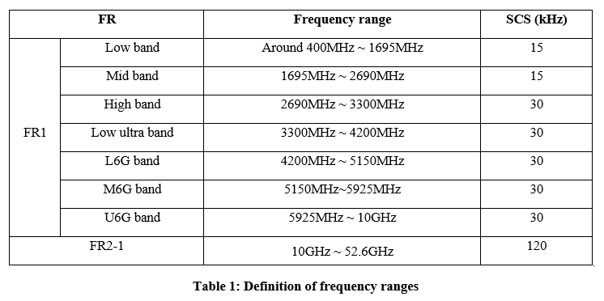  Proposal 4: RAN4 could prioritize defining the frequency ranges before discussing FR3.
R4-2600368 | Samsung | Proposal 1: For frequency range definition/separation, following new options (i.e., Option 9a/b) are proposed, by considering single-SCS principle and UE RF front-end architecture.  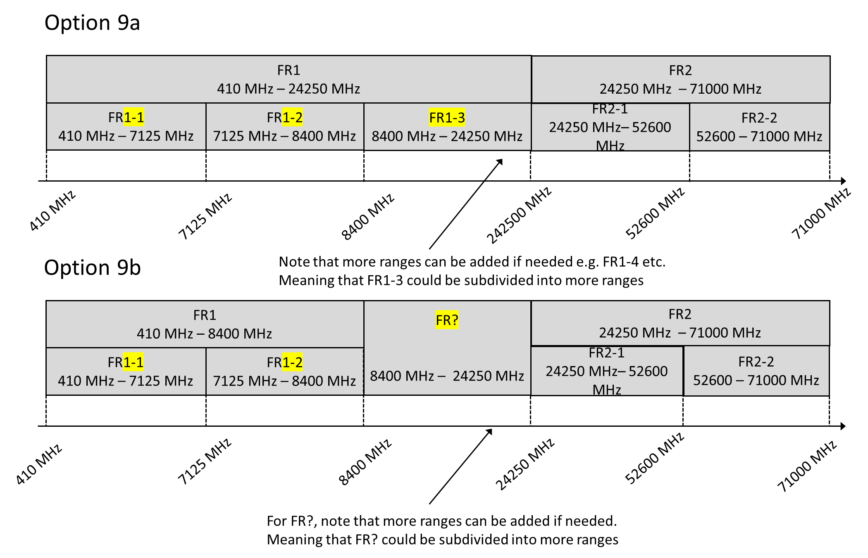
R4-2600466 | Xiaomi | Observation 2-1: NR divided frequency range majorly based on applicable numerologies sets and UE RF front-end architecture (conductive vs radiated requirements)  • FR1 with antenna connector (omnidirectional antenna) ->Conductive Requirements + SISO/MIMO OTA requirements  • FR2 integrated RF front-end (directional antenna) -> Radiated requirements only  Proposal 2-1: RAN4 consider UE RF front-end architecture (e.g., whether requirements can be verified conducted or not) as major principle for FR definition.  Observation 2-2: On 7-24 GHz, depending on frequency with initial survey on UE RF front-end architecture:  • For below10GHz, FR1 like is feasible with antenna connector  • For above 15GHz, FR2 like is most likely with integrated RF front end  • 10GHz ~ 15GHz, unclear mixed UE architectures probably exist for same frequency  Observation 2-3: on conductive and radiated requirement applicable rule, RAN4 can further discuss following different UE requirement types:  • UE type C: only digital BF with omnidirectional antenna performance and antenna connector  • UE type H: Hybrid, conductive requirements can be applied on RIB and OTA requirements plus  • UE type O: OTA requirements only with analog BF, FR2 like requirements  Proposal 2-2: two alternative approaches can be considered for frequency range definition and extension:   Alt 1: Extend FR1 and FR2 to cover 7-24GHz with overlapping range   Alt 2: Introduce dedicated FR3 frequency with hybrid requirements pending on device type  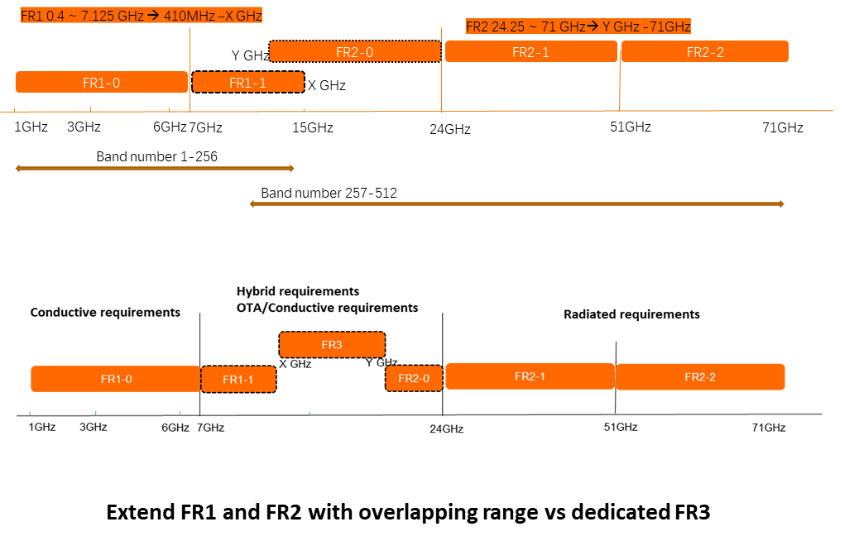  Proposal 2-3: At least FR1 can be further extended to 8.4GHz, dedicated sub-frequency range can be introduced for 7.125~8.4GHz i.e., “FR1-1”.  Proposal 3-4: Other frequency between 7-24GHz can be kept open until regulation on spectrum arrangement is clear.
R4-2600655 | MediaTek Korea Inc. | Observation 1: In NTN specification, there are two NTN operating bands according to different numerology in Ku-band by operator demand/preference. Same way can be considered in 6G for 6G TN and NTN harmonized frequency range definition between FR1 and FR2.  Proposal 1: The regulatory framework for 6G candidate spectrum usage, UE RF front-end architecture and test methodology shall be highly considered to separate 6G frequency range definition as criteria.  Proposal 2: Based on our preference of the criteria on the frequency range definition, we support option 3 as baseline in 6GR. The candidate X frequency can be considered with 8.4GHz, but the detail frequency X will be decided in WI phase based on WRC27 conclusion.  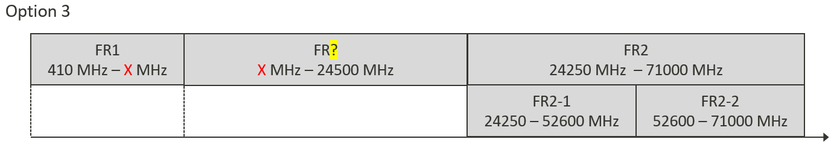
R4-2600669 | vivo | Proposal 1: Do not further subdivide the existing FR1, i.e., avoid defining frequency ranges such as FR1-1 and FR1-2.  Proposal 3: Avoid introducing overlapping frequency bands between FR1 and FR2 to ensure clear and unambiguous definitions of the frequency ranges.  Proposal 4: Option 1-a, 3, and 7 are preferred. Considering that WRC-27 has not yet begun, temporarily selecting option 6 is also acceptable.
R4-2600797 | Spreadtrum,UNISOC | Observation 1: For 13-15GHz, it is difficult for hand-held UE to put FR2-like panels due to the array size might constrain the dimensions.  Proposal 1: Proposed Frequency ranges in Fiugre3 (option1) and Figure4 (option2) in 6GR can be a starting point, the boundary between FR2 and FR1 can be 16GHz or 18GHz.  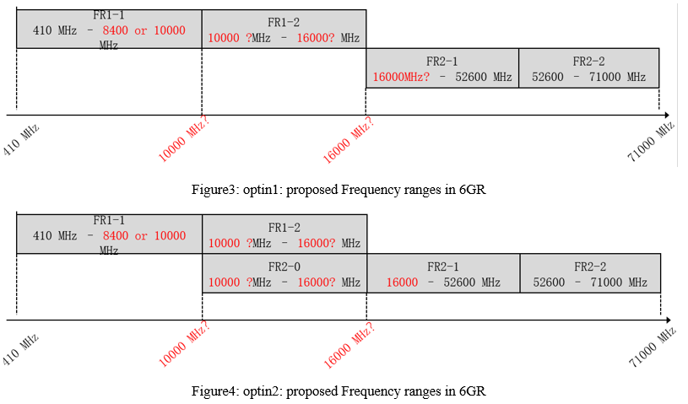
R4-2600804 | CMCC | Observation 2: with larger antenna element number at gNB side, the UL coverage of 8.4GHz is almost comparable with 3.5GHz at least for O2O scenario.  Proposal 1: if WRC-27 finally doesn’t identify 14.8-15.35GHz for IMT, RAN4 can extend FR1, keep FR2-1 definitions, not to define a new frequency range.
R4-2601005 | LG Electronics Inc. | Proposal 1: Define 10 – 15 GHz as an "Overlapping Frequency Range" with Conditional Testing Interfaces. Instead of a fixed frequency cutoff, the testing interface in this overlapping range (where FR1 and FR2 definitions coexist) must be determined by the UE’s hardware architecture.  • Default Rule (Conducted / FR1-like): UEs that do not employ phase shifter-based beam sweeping.  • Condition for FR2 Application (OTA / FR2-like): UEs equipped with antenna arrays and utilizing Phase Shifters for Beam Sweeping.  Proposal 2: Redefine FR1 up to 15 GHz for Non-Beam Sweeping Devices. Based on the principle established in Proposal 1, we propose extending the FR1 upper boundary to 15 GHz for devices utilizing the conducted interface.  • The Conducted Reference Condition should be the default baseline for handheld devices operating up to 15 GHz, provided they utilize transceiver architectures without phase shifter-based beam sweeping.  Proposal 3: Extend the FR2 Lower Boundary down to 10GHz or 15 GHz for Beam Sweeping Devices. To accommodate devices utilizing phase shifter-based beam sweeping, the lower boundary of FR2 (OTA testing interface) should be extended down to 10 GHz(for large form factors) and 15 GHz (for handhelds). This extension is justified by the following implementation feasibilities:  • For Handheld Devices (e.g., Smartphones): While full AiP (Antenna-in-Package) solutions are typically limited to frequencies above 24 GHz due to size constraints, Semi-AiP technology may enables the implementation of beam sweeping arrays in handheld form factors down to 15 GHz.  • For Large Form Factor Devices (e.g., CPEs, FWA): Larger devices can accommodate antenna arrays at even lower frequencies, necessitating OTA testing down to 10 GHz.  Proposal 4: Subdivide the extended FR1 into FR1-1 and FR1-2. To address the physical characteristics of the extended FR1 range (up to 15 GHz), it should be categorized as follows:  • FR1-1 (< 7/8 GHz band): Maintains legacy characteristics.  • FR1-2 (7/8 GHz band – 15 GHz band): While maintaining the conducted interface, this sub-range requires revised RF requirements (e.g., relaxed budgets for insertion loss and linearity) to compensate for the increased path loss. Furthermore, special implementation techniques should be permitted to offset this loss. For instance, architectures utilizing power splitters (as shown in Figure 1d) to drive multiple antenna elements for enhanced directivity should be considered within this conducted framework.  Proposal 5: Based on Proposals 1 through 4, we present the following options for frequency range definitions. [Insert Table or Figure illustrating the options here]
R4-2601183 | ZTE Corporation,Sanechips | Observation 1. There are some proposals for the spectrum in WRC-23 conference, i.e. 4.4-4.8GHz, 7.125-8.4 GHz and 14.8-15.35 GHz. However the final decisions for the IMT-2030/6G spectrum will be made in the WRC-27 conference.  Observation 2. The frequency range 10G-10.5GHz is the only spectrum confirmed in WRC-23.  Proposal 1. It would be premature to discuss the frequency range with detailed frequencies in RAN4.  Proposal 2. RAN4 should avoid to define the overlap frequency range for TN.  Proposal 3. It is proposed to extend the existing NR FR1 and FR2 to cover 7.124-24GHz in the following:  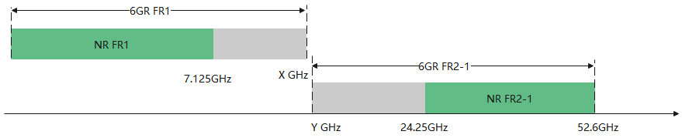  where 7.125GHz<X≤Y<24.25GHz  Proposal 4. RAN4 avoid to use ‘FR3’ name for 7.124-24GHz, instead to use“around 7GHz” “around 10GHz”, or ‘around 15GHz’ for technical discussion.
R4-2601344 | Ericsson | Proposal 1: Consider extending the FR1 frequency range upper limit at least up to 10.5 GHz provided there is no impact on RRM when considering BS hybrid beamforming.  Proposal 2: RRM FR1 requirements should be re-evaluated considering the BS hybrid beamforming type of architecture.  Proposal 3: Should RAN4 determine that an overlap between the FR1 and FR2 frequency ranges is necessary, it is recommended that RAN4 establish a new frequency range, FR3, to represent this overlapping segment.  Observation: In light of the preceding observations and proposals, the following definitions for frequency ranges may be taken into consideration:  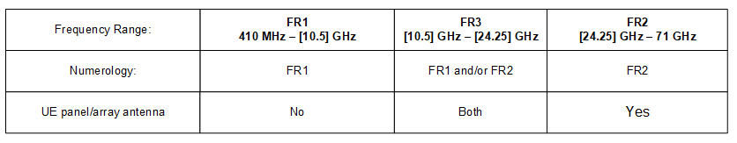  Proposal4: If RAN4 concludes on harmonizing TN and NTN frequency ranges definition, agree on the below frequency ranges definition:  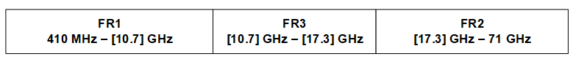  Proposal5: RAN4 should still assess the impact on NTN specifications by introducing the new frequency range FR3 replacing the overlapping FR1-NTN/FR2-NTN frequency ranges
R4-2601424 | OPPO | Observation 1: Both of SAR and MPE are tested through OTA, SAR/MPE shouldn’t be the limit factors of frequency range definition.  Observation 2: NR FR2-1 are defined based on radiated characteristics rather than the same as FR1 which is based on conducted characteristics is mainly because of UE/BS RF front-end architecture.  Proposal 1: The key criteria for frequency range definition are whether the conducted connector can be obtained.  Proposal 2: For 6G TN frequency range, extend FR1 up to 15300MHz, keep FR2-1 of 24250 to 52600 MHz.
R4-2601665 | Nokia | Observation 1: FR2 is separated into two sub-ranges FR2-1 and FR2-2, where FR2-2 currently is only for unlicensed deployment of NR.  Proposal 1: RAN4 shall excluded the FR2-2 range from the discussions in alignment with the SID.  Observation 2: NR currently has multiple frequency range definitions dependent on not only frequency range but also deployment type. The frequency ranges defined for TN deployments are not aligned to those defined for NTN deployments.  Observation 3: Other WGs are already using sub-ranges of the current frequency ranges for discussion.  Proposal 2: RAN4 shall conclude that a band around 7 GHz can be included into FR1  Proposal 3: RAN4 shall conclude that bands up to at least to 8400MHz can be included into FR1  Proposal 4: RAN4 shall consider the proposal of extending FR1 upwards and FR2 downwards to cover the frequency range between FR1 and FR2 as the basis for a 6G frequency range framework. This does not preclude the option of defining sub-ranges under FR1 and FR2.  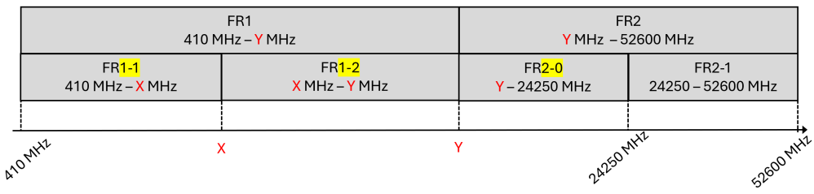  Proposal 5: RAN4 shall consider pairing frequency sub-ranges to specified assumptions and requirements in 6GR.  Proposal 6: RAN4 shall discuss a split into multiple frequency sub-ranges spanning from around 400MHz to around 52GHz in 6GR.
R4-2601724 | Qualcomm Incorporated | Observation 1: There is no rush due to technical aspects to lock down at least the extension of FR1 yet  Proposal 1: If RAN4 chooses to make agreements on frequency ranges, extend FR1 at least up to 8.4GHz and reserve possibility to extend beyond 8.4GHz later

Open issues summary
The spectrum in focus is stated in the current Study on 6G Radio (RP-250858) description:
From a technology perspective, the study will address frequency ranges up to 52.6GHz, including at least the full range of FR1 (up to 7.125GHz), the range between FR1 and FR2-1 (including around ~7GHz), and FR2-1 (24.25 GHz – 52.6GHz).
NOTE: The following TRs will be taken into account:
TR 38.921 - Study on International Mobile Telecommunications (IMT) parameters for 6.425 - 7.025 GHz, 7.025 - 7.125 GHz and 10.0 - 10.5 GHz
TR 38.922 - Study on International Mobile Telecommunications (IMT) parameters for 4400 - 4800 MHz, 7125 - 8400 MHz and 14800 - 15350 MHz
NOTE: Frequency ranges beyond 52.6 GHz are not in scope of the work.
During the RAN#109 meeting, there were initial discussions on the potential 6G frequency ranges, which were summarised in the following document (RP-252963). However, no conclusion was reached since this is for further RAN WG4 discussions. According to the moderator’s summary report, the following options were proposed by companies:
- extend FR1 to 8.4 GHz and define a separate mid-high band (8.4–24.25 GHz) with its own single numerology.
- extend FR1 to 8.4 GHz and merge 8.4–24.25 GHz into FR2, creating a unified FR2 family.
- define separate FR for 7.125 – 24.25 GHz.

Sub-topic 1-1: Extension of FR1 to 8.4 GHz
At previous RAN4 meeting, even more options have been brought forward, which all have been and will be further discussed. A common denominator seems, as captured also by the FL at RAN4#117, that FR1 can be extended up to 8.4GHz.
Issue 1-1-1: Extension of FR1 to 8.4 GHz
- Proposals
  - Option 1: RAN4 shall agree that FR1 can be extended up to 8.4 GHz
    - FFS whether the extension shall be denoted differently than current FR1, e.g. FR1-1.
    - Note. FR1 can, based on further RAN4 discussions, potentially be extended further
  - Option 2: RAN4 shall further discuss whether FR1 can be extended up to 8.4 GHz
- Recommended WF
  - Option 1 – Since this seems to be a common view this could be a good starting point.

Sub-topic 1-2: Frequency Range framework
Some make the point that since we are now starting a new generation, there may not be a need to adopt the frequency ranges used by NR for 6GR. Others point out that due to co-existence would need to be alignment. An important point is that the unresolved regulatory framework for the 7-24 GHz frequency range, with critical decisions from WRC-27 scheduled post-6G study conclusion, should not hinder the progress of the design and standardization of 6G radio access technology
As a result, this topic addresses the definition and categorisation of frequency ranges for 6G, including the introduction of new frequency ranges, and the extension of existing ranges like FR1 and FR2. It discusses the harmonization of frequency definitions between terrestrial networks (TN) and non-terrestrial networks (NTN), the challenges of multiple numerologies, and the need for regulatory alignment. The importance of considering UE implementation impacts, RF requirements, and the potential for new spectrum based on WRC decisions is also highlighted.
Issue 1-2-1: Basis of frequency range definitions
- Proposals
  - Option 1: Extend FR1 and FR2 to “close the gap” from 7.125 – 24.25 GHz
    - Option 1a: Extended existing NR FR1 and FR2 without overlapping frequency
    - No new frequency range designation between extended FR1 and FR2
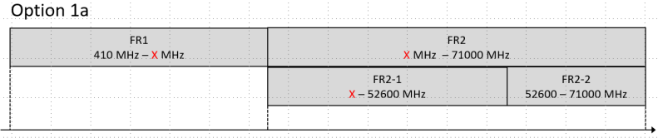
    - Option 1b: Extended existing NR FR1 and FR2 with overlapping frequency
      - No new frequency range designation for 7.125-24.25GHz
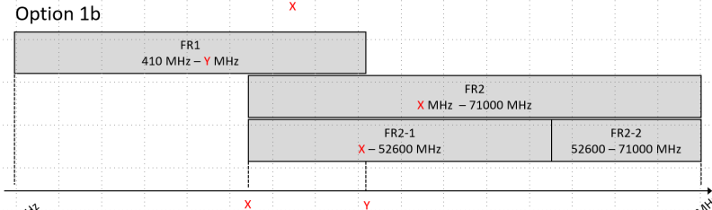
    - Option 1b-Modified: Extended existing NR FR1 and FR2 with overlapping frequency
      - No new frequency range designation for 7.125-24.25GHz
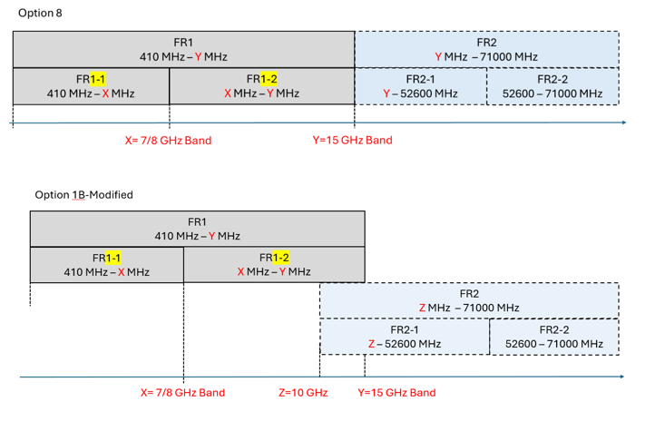

  - Option 2: Define a new frequency range for the 7.125 – 24.25 GHz and keep the current FR1 and FR2-1 definitions
  - Option 3: Extend FR1, define a new frequency range and keep FR2-1 definitions.
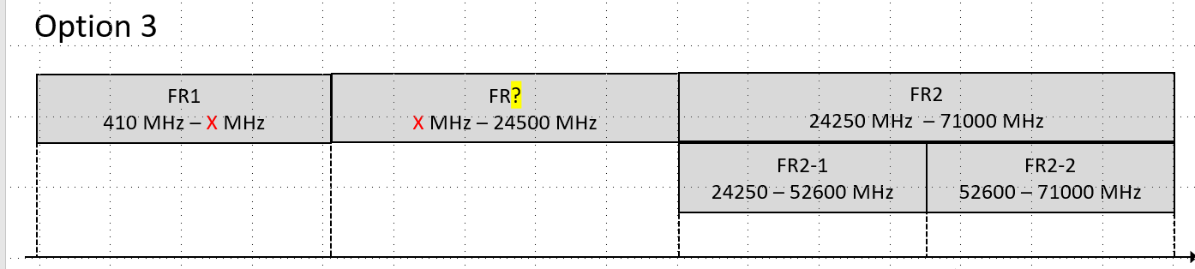
  - Option 4: Sub-divide FR1, define new frequency ranges and keep FR2-1 definitions.
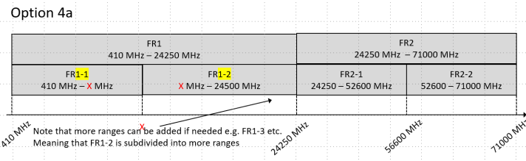
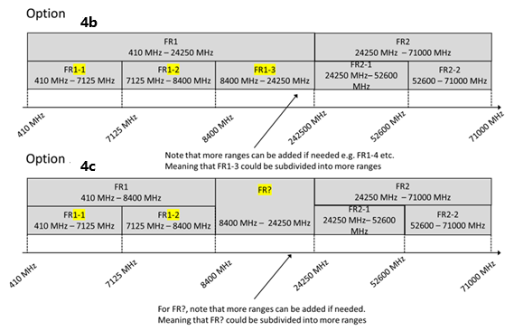
  - Option 5: Clean slate and define new frequency ranges from around 400MHz to 52.6GHz
  - Option 6: Postpone the discussion on FR1 extension
  - Option 7: Extend existing NR FR1 and FR2 to cover partial part of 7.124-24GHz
    - New frequency range designation for remaining part between extended FR1 and FR2
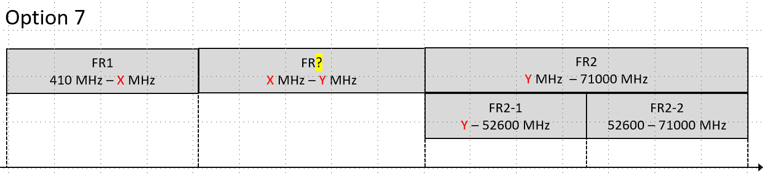
  - Option 7a: Extend option 7 with proposed numbers
  - Option 8: Extend existing NR FR1 and FR2 to cover partial part of 7.124-24GHz
    - Sub-divide FR1, define new frequency ranges
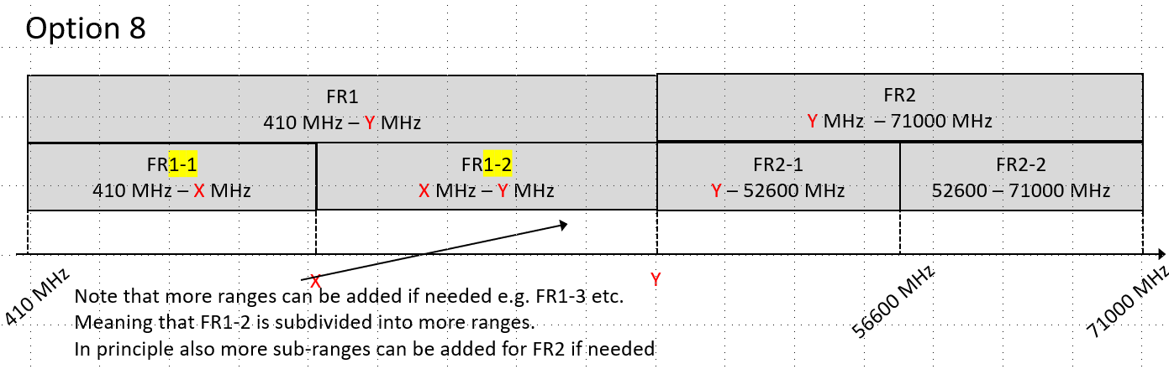
  - Option 9a: Extension of option 4a with concrete numbers
  - Option 9b: Extension of option 4b with concrete numbers
  - Option 10: Extension of option 1b/8 with concrete numbers

- Recommended WF
  - Focus on “compromise” proposal in Issue 1-2-2 and then further discuss the options listed here.
Given the many and for some very similar proposals the FL have tried to combine as many proposals as possible.
Issue 1-2-2: FL proposals for basis of frequency range definitions
- Proposal
  - Extend FR1 to 8.4 GHz, keep 8.4 to 24.250 GHz TBD and limit FR2 based on the SI to 56.600 GHz
  - 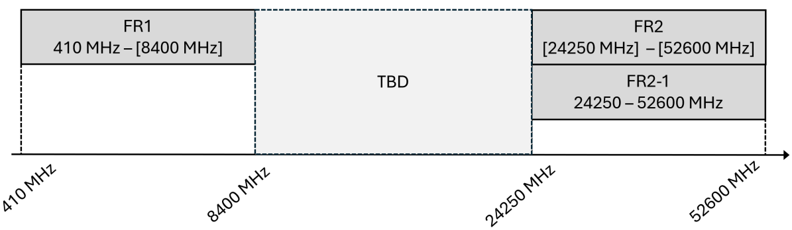
    - Note 1: FR1 and FR2 can be further extended based on further RAN4 agreements
    - Note 2: Frequency range designation between extended FR1 and FR2 is TBD. This is not precluding a new range designation or extending FR1 and FR2 to close the gap.
- Recommended WF
  - Agree the proposal with the understanding that this is the basis for further discussions.

The intention with the proposal above is to use this as basis for further discussion.

Sub-topic 1-3: TN and NTN Frequency Range harmonization
As pointed out in several contributions, the Terrestrial Networks (TN) and Non-Terrestrial Networks (NTN) NR Frequency Range definition is not aligned with each other. The lack of consensus on defining frequency ranges for 6G, particularly for the mid-band spectrum between 7 GHz and 24 GHz, leads to fragmentation in TN and NTN, complicating UE and network RF design, numerology selection, and spectrum management, which ultimately hinders efficient implementation and performance optimization.
Previously RAN4 have agreed to focus first on TN frequency ranges but as any alignment will have impact it is needed to again discuss this point.
Issue 1-3-1: TN and NTN Frequency Range Harmonization
- Proposals
  - Option 1: RAN4 shall like for NR define separate frequency ranges for NR and NTN for 6G
  - Option 2: RAN4 shall define the same frequency ranges for NR and NTN for 6G
- Recommended WF
  - TBA

Topic #2: Definition of 6G bands
Under this topic RAN4 will discuss how to define bands for 6G. The following observations and proposals have been made.

Companies’ contributions summary
T-doc number | Company | Proposals / Observations
R4-2601956 | Rogers, CableLabs | Proposal 1: Rogers proposes the following frequency bands as candidate spectrum for 6GR consideration: s5, s7, s12, s25, s38, s66, s71, s77, s258, s260, and s261. The corresponding frequency ranges and duplex modes are listed in Table 1 for FR1 bands and Table 2 for FR2 bands.  Proposal 2: The detailed technical parameters for the proposed bands are subject to future study, including but not limited to: supported channel bandwidths, subcarrier spacings (SCS), and band combinations.
R4-2602019 | Charter Communications, CableLabs | Proposal 1: RAN4 defines 6GR band s48 (3550-3700 MHz) as a 6G band, refarming from 5G NR band n48.  Proposal 2: RAN4 initiates a study item on requirements for mid-band spectrum (3-4 GHz) support in 6G, including s48.  Proposal 3: Band s48 should comply with USA regulation rules defined in FCC Part 96.41.
R4-2600151 | Apple | Proposal 1: Migrate existing 5G bands to the 6G bands striving for reduced total number of bands.  Proposal 2: Harmonize existing overlapping and nested bands.  Proposal 3: Put on hold bands, which were not commercially deployed in 5G (subject for further revisions).  Proposal 4: Put on hold bands, which are associated with certain features, e.g. NR-U or V2X (subject for further revisions once the corresponding features are introduced).
R4-2600192 | China Telecom | Proposal 1: Introduce frequency range of (6425 MHz - 7125 MHz) as 6G spectrum.  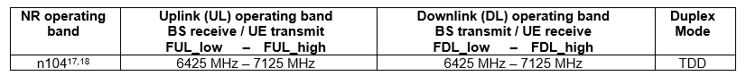
R4-2600270 | KDDI Corporation | Observation 1: Some regions/countries are proactively discussing to allocate Upper 6 GHz to IMT.  Proposal 1: Study several candidates as 6G bands for 6.425-7.125GHz identified in WRC-23 and 4.4-4.8, 7.125-8.4 and 14.8-15.35 GHz being discussed toward WRC-27 considering the regulatory discussions are still ongoing.  Proposal 2: Study whether some existing 5G bands can be optimized and re-defined in 6G.  Proposal 3: Study the frequency ranges considering frequencies used first time in 6G and the progress/outcomes of the ongoing regulatory discussions.
R4-2600297 | CATT | Proposal 1: It is proposed that RAN4 consider a new frequency band definition, which is a continuous spectrum segment configurable to support uplink, downlink, or both, without the requirement for paired UL and DL operating bands.  Proposal 2: The UE could report its pairing capability and required bandwidth to the network. The network could configure the corresponding parameters based on the UE's reported capabilities.  Proposal 3: UE could support multiple UL and DL pairings. Therefore, one cell can contain multiple TRPs operating in different frequency bands, with each TRP handling the UL and DL carriers that it supports.  Proposal 4: RAN4 should explore a categorization approach for the band numbers of 6G, grouping bands within the same broader frequency range.
R4-2600369 | Samsung | Proposal 1: RAN4 shall strive to define global bands for sake of economies of scale while retaining the possibility of introducing partially or fully overlapped bands if justified.  - For instance, in cases where a wider frequency range proves infeasible from a UE implementation perspective, a narrower band can be introduced
R4-2600465 | Xiaomi | Observation 1: Following pain points observed for 5G band definition:   In 5G beginning, RAN4 introduced both 4G migrated bands and new bands for above 3GHz and FR2. These cumulative bands brought lots of work and number of bands for 5G in initial stage and many of them not deployed/commercialized in 5G day1.   NTN and TN bands are specified separately with different band numbers even the spectrum is partially overlapped or partially overlapped.  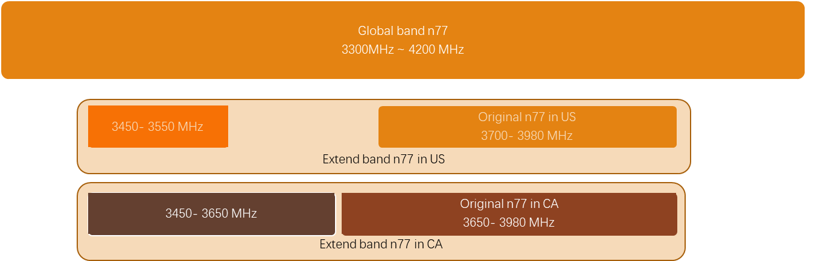  Proposal 1: RAN4 shall further evaluate how to efficient manage NR refarming bands into 6GR as case-by-case manner  Proposal 2: RAN4 needs to further study how to handle 4G/5G migration spectrum/bands to 6G with potential research area   Harmonize spectrum/band definition with partial overlapping or fully overlapped operating frequency considering regulation difference (NS-value can be used to discriminate regulation difference)   RAN4 needs to further study how to generate generic solution to resolve regional frequency ranges on large global bands (taking TR 38.893 as basis for further study)  Proposal 3: RAN4 needs to consider both 5G NTN refarming bands and potential new dedicated spectrum for NTN operation under 6GR.   RAN4 also needs study how to harmonize existing 5G NTN bands which have partial overlapping or full overlapping frequency  Proposal 4: RAN4 also needs to study how to handle band definition for NTN operation using TN spectrum if regulation/3GPP rule allow such operation.
R4-2600798 | Spreadtrum,UNISOC | Proposal 1: The definition of several bands which are partly overlapping and subset can be kept if it is reasonable and necessary.
R4-2601184 | ZTE Corporation,Sanechips | Observation 1. Not all partly overlapping and subset bands can share a same band number. In the other words, separated band numbers should still be used for some bands partly overlapping and subset bands.  Proposal 1. It may be feasible to enhance the band numbers for some 6GR bands over 5G NR to harmonize bands which are partly overlapping and subset, but operator’s feedback is important.
R4-2601409 | NTT DOCOMO, INC. | Observation 1: It is difficult at this stage to determine which bands and band combinations should be migrated from 5G to 6G, and it is preferable to introduce them progressively based on operator requirements.  Observation 2: Reducing the specification workload and minimizing or grouping performance differences among overlapping bands and band combinations may help prevent excessive bands and band combinations specifications.  Proposal 1: Consider redefining and optimizing existing 5G bands to help avoid fragmentation in 6G band introduction.
R4-2601425 | OPPO | Observation 1: 6425-7125 MHz is totally overlapping with NR band n104.  Observation 2: 10-10.5 GHz with very restrict limitation, no operator will support it in 6G clearly.  Observation 3: Candidate 6G Spectrum in WRC-27 includes 6 425-7 125 MHz, 4400-4800 MHz, 7125-8400 MHz, and 14.8-15.35 GHz which also need to be studied in RAN4.  Observation 4: New spectrum range of 4400-4800 MHz has been covered by NR band n79, furthermore, band n79 will also be considered for re-farming into 6G.  Observation 5: For the candidate spectrum 7125-8400 MHz, NS value could be used to solve specific requirements.  Observation 6: In 5G NR, many overlapping bands have adopted same RF front-end in real UE implementation which makes defining separate bands is not meaningful.  Proposal 1: RAN4 should first study whether the n104 can be re-employed for 6G to cover the new 6G spectrum 6425-7125 MHz.  Proposal 2: RAN4 should first study whether the n79 can be re-employed for 6G to cover the new 6G spectrum 4400-4800MHz.  Proposal 3: RAN4 should strive to define global bands for 7125-8400 MHz and for 6G.  Proposal 4: 14.8-15.35 GHz can be further discussion based on ITU’s progress.  Proposal 5: Consider to merge overlapping bands as much as possible when re-farming FR1 bands.
R4-2601666 | Nokia | Observation 1: NR concept for band numbering has proven successful and very usable. This concept means that 3G, 4G, and 5G had used same band number if frequency arrangement is same. LTE uses Arabic numeral, WCDMA uses Roman numeral and NR has prefix on “n” in front of Roman numeral.  Observation 2: RAN4 has agreed to use prefix “s” for 6G bands.  Observation 3: RAN4 will keep using numbering space 1-512 for new bands using the division shown in Table 2.2.1-1 as a starting point.  Observation 9: No 5G/NR bands or band combinations will be automatically transferred to 6G/6GR
R4-2601725 | Qualcomm Incorporated | Proposal 1: Band numbers for the overlapping bands, when specified, should be re-used from 5G  Observation 1: Given overlapping bands have unique band-specific characteristics and associations to certain regions, reducing the number of overlapping bands compared to 5G may be challenging  Observation 2: In 5G, the approach of adding new NS-values for existing bands on case-by-case basis has been used instead of adding new band numbers to indicate new county/region specific applicable frequencies  Proposal 2: Have separate discussion on how/if to harmonize overlapping bands and how to define/add applicable country/region-specific frequency ranges
R4-2602025 | T-Mobile USA | Proposal: RAN4 should study merging the 6G equivalent of bands n5 and n26, n2 and n25 and n12 and n85.

Open issues summary

Sub-topic 2-1: Band migration/refarming from 5G to 6G
Multiple companies point out that there at some point will be a refarming of LTE/NR bands to 6GR bands as well of the inclusion of completely new bands. At RAN4#117 it was agreed (R4-2601664) to denote the 6G band with a pre-fix “s” but still how to define these are up to discussion in RAN4. Additionally, at RAN4#117 it was agreed that no band would automatically be migrated/refarming from 5G to 6G but would be dependent on operator request.
Issue 2-1-1: 6G Bands migration/refarming basis
- Proposals
  - Option 1: RAN4 shall continue to utilize both band number/name and NS for defining band specific requirements
  - Option 2: RAN4 shall reevaluate the concept for defining band specific requirements for 6G bands,
    - a) RAN4 will strive to only use band number/name i.e. reduce/remove the need for NSs
    - b) RAN4 shall expand the use of NS and remove/reduce the number of overlapped 6G bands as compared to NR.
- Recommended WF
  - TBA
Issue 2-1-2: Refarmed 6G Bands numbering/naming
- Proposals
  - Option 1: RAN4 shall strive to reuse NR band numbers for bands with overlapped frequency range for requested 6G bands. This even if there are differences between frequency range of the NR band and the proposed 6G band.
  - Option 2: RAN4 shall only reuse NR band numbers for bands which frequency range is equivalent to the proposed 6G band.
- Recommended WF
  - TBA

Sub-topic 2-2: Example band for 6G studies
Multiple companies have on the basis of the agreement at last RAN4#117 it was agreed (R4-2601664) stating that no band would automatically be migrated/refarming from 5G to 6G but would be dependent on operator request requested/proposed bands at this meeting.
Issue 2-2-1: Proposed 6G Example Band
- Proposals
  - Option 1: RAN4 shall select only a single example band for 6G.
    - 1a) Refarmed n104 to s104, i.e. 6425-7125 MHz
    - 1b) New 6G candidate spectrum 7125-8400 MHz
    - 1c) Refarmed n79 to s79, i.e. 4400-5000 MHz
    - 1d) Refarmed n48 to s48. i.e. 3550-3700 MHz
  - Option 2: RAN4 shall define multiple example bands for 6G.
    - 2a) All of the WRC-27 identified bands 4400-4800 MHz, 6 425-7 125 MHz, 7125-8400 MHz, and 14.8-15.35 GHz
    - 2b) All of the NR bands refarmed to equivalent band s5, s7, s12, s25, s38, s66, s71, s77, s258, s260, and s261.
- Recommended WF
  - TBA

Sub-topic 2-3: Enhancements to 6G bands
Some companies have suggested that with the band numbering/naming there shall be a way to identify e.g. whether there is mandated UL/DL paring.
Issue 2-3-1: Enhancements to 6G band naming
- Proposals
  - Option 1: RAN4 shall not change the band numbering/naming.
    - Note this does not preclude that special band number ranges can be used for bands with special attributes.
  - Option 2: RAN4 shall consider to add to the 6G band numbering/naming to identify special band attributes etc.
    - Note the intention is to add more than e.g. “s123” for a band so e.g. adding a suffix like s123U for a UL band only or s123D for a DL band only.
- Recommended WF
  - TBA

Topic #3: Band combination definition and simplification
Under this topic, RAN4 will discuss how to define band combinations and simplify these in 6G. The following observations and proposals have been made.

Companies’ contributions summary
T-doc number | Company | Proposals / Observations
R4-2600369 | Samsung | Observation 1: The procedure for requesting and porting 5G band combinations and their associated requirements to 6G heavily depends on whether the 5G requirements would be reused or not.  Proposal 2: Regarding the procedure for requesting and porting the first-batch 5G band combinations(i.e., the combos identified before the first 6G spec made available) and their associate requirements to 6G,  - In case the 5G requirements are reused, a fast-porting approach could be considered.  - In case the 5G requirements are not re-used, a 5G-like request procedure is needed, and requirements should be studied case-by-case as needed.  - The request template and procedure could be simplified compared to 5G.  Note: The agreements made could be re-visited once sufficient conclusions are reached in 6G UE RF session.  Proposal 3: For the refreshed 6G combos (which are not re-farmed from 5G), a 5G-like request procedure is considered, and requirements should be studied case-by-case as needed.  - The request template and procedure could be simplified compared to 5G.  Observation 2: Regarding procedure to introduce band combination, the high-level ideas have been presented in clause 2.1.2, we recommend agreeing the high-level principles first(ideally in this meeting) and discussing the detailed possibilities in future meetings.  Observation 3: The procedure for introducing band combination is not urgent, and it can be deferred until the conclusion of UE RF made, if necessary.  Proposal 4: It must be firstly determined, in the UE RF thread, whether the ∆TIB and ∆RIB requirements will be removed from CA requirements or kept, before discussing any kind of simplification in this thread.  Proposal 5: It is proposed to discuss the removal of BCS concept for band combination.  - This means that one band within a band combination is supposed to support all CBWs that a single band supports, unless otherwise indicated  - If certain channel bandwidths, such as the maximum channel bandwidth, cannot be supported due to interference concerns to other bands or carriers, this can be indicated additionally
R4-2600656 | MediaTek Korea Inc. | Proposal 1: Based on the following criteria, RAN4 can introduce the 6G band combinations as the refarming band combination first with several WIs in Rel-21 or later release.  - Baseline UE RF requirements for either of PC3/PC2 UE for single carrier has been finished.  - An example band combination’s general UE RF requirements shall be finished based on the band grouping concepts.  - To request the 6G band combinations as refarming band combinations from 5G, the 5G BCs shall be deployed at real field except new 6G spectrum.  Proposal 2: RAN4 need to study reusing the NR BCS4/5 exercise as 6G day-1 baseline. FFS further design requirements from other topics such as band-grouping, MCSC and others.  Proposal 3: RAN4 can consider the band combination simplification by band group concepts (i.e., Super call, MCSC etc.,) to reduce the capability signalling overload and introduce fewer band combination compared to 5G NR.
R4-2600798 | Spreadtrum,UNISOC | Proposal 2: Based on the current market and operators’ request to introduce the band combinations transfer from 5G to 6G case by case for re-framing bands.  Proposal 3: Strive to a simple approach to address the requesting and status report updates.  Proposal 4: BCS concept should be kept in 6GR (e.g., BCS5). The number of BCS can be considered to be one in 6GR. The number of MIMO layers factor can be considered when reporting BCS or aggregated bandwidth.  Proposal 5: The approach to derive the ∆TIB and ∆RIB can be improved and simpler in 6GR (e.g., two levels of value: low level: 0.5dB; high level: 0.8 or 1dB).
R4-2600802 | CMCC | Observation 1: RAN5 using operators’ interest as input to identify the priority of band combination conformance testing. Now only 1/8 band combinations defined in RAN4 have been completely in RAN5 because most band combinations are in pending status due to no operators have interests.  Proposal 1: One candidate method to reduce BC workload is to cap the maximum number of ongoing band combinations (BCs) per operator. An operator may only submit new BC request when its count of ongoing BCs is below the threshold of N. Specifically, if an operator has urgent deployment demands, it may suspend existing ongoing BCs to reallocate RAN4 workload resources to such urgent demands.  Proposal 2: the “high speed band combination request procedure” as proposed in R4-2521453 is suggested for further study  • Operator request one band combination and provide TR/draft CR at the same RAN4 meeting;  • RAN4 endorse this TP/draft CR in that meeting;  • In the following RAN plenary, operator bring this endorsed TP/CR to RAN plenary for approval directly together with the WID revision.
R4-2601006 | LG Electronics Inc. | Proposal 1: RAN4 should transition from the legacy "per-combination" RF requirement definition to a "Rule-Based" framework to ensure a lean specification.  Proposal 2: The Rule-Based framework is recommended to consider the "Band Group" concept, where RF requirements (e.g., ΔTIBΔTIB, ΔRIBΔRIB, MSD) are derived from the relationship between Band Groups rather than individual bands. Note: Details of the Band Group definition and the derivation framework are discussed in 8.5.3 contribution].  Proposal 3: To simplify UE conformance testing, RAN4 should endorse the principle of "Representative Testing" for band combinations that share identical Band Group relationships and RF requirements.
R4-2601184 | ZTE Corporation,Sanechips | Observation 2. ‘high speed request procedure’ has benefits for some urgent combinations, but RAN4 has no metric to judge whether it is urgent or not.  Observation 3. For the urgent combinations, companies should request it in advance, rather than using ‘high speed request procedure’ since no one can guarantee the urgent band combination can be approved in short time.  Proposal 2. To improve/simplify the ΔTIB/ΔRIB requirements based on PRD guidance.  Proposal 3. RAN4 should discuss a rule that for those band combination who has larger than XdB MSD is not valid for CA operation.  Proposal 4: In 6GR, RAN4 should focus on the band configurations for real deployment and RAN4 should discuss the criteria on how to judge it.  Proposal 5. Discuss the necessity of BCS for inter-band NR CA in 6GR.  Proposal 6. Do not use ‘high speed request procedure’ if it cannot well be justified.  Proposal 7. Discuss if it is feasible to use database approach for the status reports updates work.  Proposal 8. Discuss if it is feasible for the band configuration errors self-checking in the database/JSON file.
R4-2601425 | OPPO | Observation 7: It takes at least two RAN4 meetings and two RAN meetings to complete one band combination from request to introduce into the spec.  Observation 8: BCS4 is introduced in NR in Release 17. It can be supported in 6G day one.  Observation 9: In NR, there are many intra-bands congruous CA with smaller aggregated bandwidth, which will not be a typical application.  Proposal 6: Consider introduce “high speed band combination request procedure”:  • Operator request one band combination and provide TR/draft CR at the same RAN4 meeting;  • RAN4 endorse this TP/draft CR in that meeting;  • In the following RAN plenary, operator bring this endorsed TP/CR to RAN plenary for approval directly together with the WID revision.  Proposal 7: To avoid overload RAN4:  • This special procedure is limited to at most N times with M band combinations requested per operator each time;  • The urgency should be well justified at the very beginning of RAN4 discussion;  • The newly requested band combinations should not exceed the TU limits for basket WI.  Proposal 8: RAN4 should first focus on 2 bands combination in 6G. Then consider more than 2 bands combination, once the impact and requirements of two bands combination are clear.  Proposal 9: In 6G, band combination should limit up to 5 bands for DL and 2 bands for UL.  Proposal 10: Consider remove BCS definition for band combination.  Proposal 11: In 6G, strive to avoid using multiple small contiguous CCs aggregation to derive the large CBW, and use one CC with large CBW as much as possible.
R4-2601592 | Ericsson | Observation 1: Block approval of band combinations contributions is recommended to be continued.  Proposal 1: Study how to improve and simplify selection of MSD values based on a proposed band group concept of lower low bands (600-800), upper low bands (800-1000), lower mid bands (1400-1700), mid bands (1700-2200), upper mid bands (2200-2700), lower high bands (3300-4200) and upper high bands (4400-7200)  Proposal 2: Don’t specify BCS’s and specific channel BW’s per band for 6G Intra-band and Inter-band combinations. Introduce a maximum channel BW value for intra-band combinations.  Proposal 3: Study how existing NR CA band combinations can be transferred into a 6G specification baseline  Proposal 4: JSON database is to be used instead of configuration tables for all 6G band combinations.  Proposal 5: Check the relevance of continuing to define the ΔTIB and ΔRIB insertion loss values.
R4-2601666 | Nokia | Observation 4: The underscore seems not to have a clearly unified defined purpose in current band combinations.  Observation 5: The band prefix already can be used to identify DC combinations.  Observation 6: There is no need to declare the type, but use only CA, when more carriers are combined.  Proposal 1: RAN4 shall not to use RAT or device type indications for band combinations in 6GR.  Observation 7: Removing special band combination declarations would allow simplification of band combination notation.  Proposal 2: In 6GR the band combination syntax shall consists of a single type (“CA”), underscore separators for Type, DL and UL, one or more downlink bands separated by dash and one or more uplink bands separated by dash.  Observation 8: In NR UL and DL switching schemes means that the CA notation is no longer enough to identify a radio state configuration.  Proposal 3: RAN4 shall consider how CA attributes as DL/UL switching can be clearly identifiable for 6GR band combinations  Observation 9: No 5G/NR bands or band combinations will be automatically transferred to 6G/6GR  Observation 10: Operators will have to decide whether they would like band combinations transferred to 6GR including NR based requirements or new studies has to be done based on 6GR
R4-2601725 | Qualcomm Incorporated | Observation 3: It’s likely that eventually operators want to achieve similar CA functionality in 5G as in 6G  Observation 4: It is very important to ensure that operators have all meaningful combinations specified from the beginning of 6G  Observation 5: It would be possible to significantly reduce the number of combinations if Intra-band contiguous/non-contiguous CA were not needed to be explicitly captured in Inter-band combinations  Proposal 3: RAN4 to study ways how to reduce the line items (explicit band combinations) in 6G compared to 5G, yet keeping the same CA functionality as captured in current 5G specifications  Proposal 4: RAN4 to study if there are certain types of band combinations which never got deployed/which likely are not going to get deployed in current 5G specifications. This information could possibly be used to reduce the number of combinations in 6G  Observation 6: How to handle operator requests to transfer 5G combinations into 6G certainly needs a process to be created during the 6G SI so that the process is ready to be used in 6G WI, which can be done when the concept of how 6G CA combinations are generally specified is in more mature shape  Proposal 5: RAN4 to study the framework how 6G CA band combinations are specified in RAN4 specifications to establish a process to smoothly transfer operators desired band combinations specified in 5G into 6G for day 1
R4-2602025 | T-Mobile USA | Proposal 2: Based on requests from operators, we should re-use 5G band combinations from 6G to avoid the CA technology sawtooth for operators and their customers.  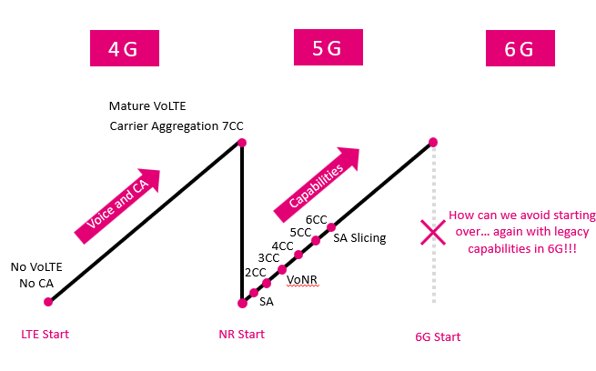

Open issues summary
This topic addresses the simplification of band definitions and combinations in 6G, focusing on the challenges posed by numerous frequency bands and carrier aggregation (CA) combinations. It includes discussions on the band group concept, the optimization of band combinations, and the need for unified requirements for carrier aggregation. The proposal emphasises the importance of reducing complexity in RF front-end design and ensuring backward compatibility with legacy systems.
The aspects here have also been partly addressed during the NR timeframe:
During Rel-18 timeframe RAN4 has conducted a SI on Study on simplification of band combination specification as captured in TR 38.846 which party resulted in the first RAN 4 Permanent Reference Document (PRD01)
RAN4 needs to continue to explore options to reduce the workload related to band combinations and RF front-end complexity in 6G. The challenges faced in 5G regarding the specification of numerous bands and ongoing work on how to improve this should also be taken into account.
Since the topic of spectrum aggregation methods is discussed under agenda 8.3, some of the proposals related to this may not be fully incorporated in the following sub-topics, and companies are encouraged to bring their discussion under the relevant agenda for the next meeting.

Sub-topic 3-1: Band combination introduction
Some companies propose to speed up the adaptation of 6G and reduce the workload to transfer current NR band combinations to 6G. It is, however, not clear which requirement shall apply. Other companies want to define band combinations based only on explicit operator demand. At last, RAN4#117 meeting it was agreed (R4-2601664) that no band combination would automatically be migrated from 5G to 6G but would be dependent on operator request. The mechanism for requesting new or migrated band combination was left FFS.
Issue 3-1-1: Band combination introduction
- Proposals
  - Option 1: RAN4 shall, based on operator request, consider transferring existing NR band combinations including up to 6 CCs to be applicable also for 6G.
    - a) Applicable requirements are FFS
    - b) Applicable requirements are also transferred from NR
  - Option 2: RAN4 shall define 6G band combinations, based on operator request, in a step-by-step approach starting with 2 CCs and building on that only when completed.
- Recommended WF
  - TBA

Sub-topic 3-2: Bandwidth Combinations Sets (BCS) in 6G
To allow the addition of supported channel bandwidths to already defined bands, the concept of BCSs was introduced to the specification. However, lately in NR, only the so-called BCS 4&5 method, meaning all supported channel bandwidths are utilized. Therefore, some are proposing to abandon the BCs concept in 6G.
Issue 3-2-1: Bandwidth Combinations Sets (BCS) in 6G
- Proposals
  - Option 1: RAN4 shall not use Bandwidth Combinations Sets (BCS) in 6G
  - Option 2: RAN4 shall further investigate the need for Bandwidth Combinations Sets (BCS) in 6G
  - Option 3: RAN4 shall introduce Bandwidth Combinations Sets (BCS) in 6G
- Recommended WF
  - TBA

Sub-topic 3-3: ∆TIB and ∆RIB in 6G
The ∆TIB and ∆RIB defined per specific band combination roots in the first introduction of CA in LTE times. Therefore, some companies are now questioning whether there is really still a need for these in 6G. Additionally, there have been multiple attempts to align and clarify the rules for defining the ∆TIB and ∆RIB values, but there is still no unified way specified. This is wanted to be addressed by other companies.
Issue 3-3-1: ∆TIB in 6G
- Proposals
  - Option 1: RAN4 shall not consider ∆TIB for 6G
  - Option 2: RAN4 shall study if ∆TIB is needed, defined for 6G
  - Option 3: RAN4 shall continue to define ∆TIB for 6G but unify and specify how a value is determined.
- Recommended WF
  - TBA

Issue 3-3-2: ∆RIB in 6G
- Proposals
  - Option 1: RAN4 shall not consider ∆RIB for 6G
  - Option 2: RAN4 shall study if ∆RIB is needed, defined for 6G
  - Option 3: RAN4 shall continue to define ∆RIB for 6G but unify and specify how a value is determined.
- Recommended WF
  - TBA

Sub-topic 2-4: Working procedures and Database for band combinations
One company is proposing changing the working procedure for band combination work. Multiple companies want to utilize the ongoing NR work related to the band combination database with JSON files also for 6G.
Issue 3-4-1: Database adaptation
- Proposals
  - Option 1: RAN4 shall study further development of the use of the Band Combination Database (JSON files) for 6G
  - Option 2: RAN4 shall wait for the outcome of the NR work on the Band Combination Database before starting the study on further developments
- Recommended WF
  - TBA

