3GPP TSG-RAN WG4 Meeting #118 R4-2602285
Gothenburg, Sweden, Feb. 09-13, 2026

Agenda item: 8.1
Source: Feature lead (OPPO)
Title: Adhoc2 minutes for [118][101-B] 6G system parameter (part II)
Document for: Information

Introduction
This document provides feature lead summary for 6GR system parameters including:
- Modulation
  - NR modulations
  - UL 1024QAM
  - DL 4096QAM
  - Constellation shaping
- Channel arrangement
  - Channel raster
  - Channel spacing
- Device types
  - Smallest max CBW

Topic #1: Modulation

Open issues summary
Background: WF in previous RAN4 meetings.
Agreement
- RAN4 evaluation work focus on the feasibility study and RF requirements impact
- To establish the foundational evaluation framework in RAN4 firstly when no solid progress and inputs from RAN1
  - Identify the main affected requirements for modulation evaluations
    - The existing 5G NR requirements will serve as the baseline, which are subject to future updates based on RAN4’s 6G UE RF discussions.
  - Align on the evaluation assumptions.
  - Study on how to align on the transmitter chain model, including PA model, for consistent evaluations on the modulation.
  - RF evaluation could be done firstly for 5G supported modulations with new assumptions for 6G study, such as assumed new spectrum, CBW, new PA models, etc. Co-ordination with 6G UE RF study is needed.
  - Both link-level and system-level simulations should be performed as usual for high-order modulations study done by RAN4 in prior releases, pending on the progress of RAN1.
- Model and evaluate the performance and the implementation complexity of higher-order modulations, e.g. 1024QAM on the UL and/or new constellations
  - For high order QAM with uniform constellation, e.g. 1024QAM on the UL, RAN4 can work concurrently with RAN1 studies.
  - For new non-uniform constellation, the evaluation in RAN4 should depend on RAN1 progress and request.

Recommendation from FL in RAN4#117
- Evaluation Cases:
  - Case 1 (Baseline): Existing NR modulations (BPSK to 256QAM) with new 6G PA model(s).
  - Case 2 (Higher-order modulation):
    - UL 1024QAM: Primarily focusing on FWA UE implementation feasibility.
      - Already agreed to start parallel study in last RAN4 meeting
    - DL 4096QAM: Focusing on both BS and UE implementation feasibility.
      - Whether and when to consider it as an optional feature for study, pending on further RAN4 discussion and decision
  - Case 3 (Constellation shaping): Defer detailed evaluation until RAN1 conclusions are stable.
- Evaluation assumptions:
  - PA Model: Depends on the discussion progress on 6G PA model. This is a foundational assumption for all modulation studies.
  - EVM budget: Define a clear EVM budget for higher order modulation (UL 1024QAM, DL 4096QAM), considering all impairment sources (PA non-linearity, I/Q imbalance, phase noise, CFR, etc.).
  - Scenarios and frequencies: Focus evaluations on agreed scenarios (TBD, like Urban Macro and indoor hotspot), across agreed frequencies (TBD, like ~700 MHz, 2 GHz, and 7 GHz).
  - Bandwidth: Consider wider channel bandwidths (TBD, e.g., 200 MHz)

Sub-topic 1-1: General
Issue 1-1-2 R1/R4 work split
- Xiaomi R4-2600458:
- Proposal 1: RAN4 work closely with RAN1 to avoid duplicated evaluation work across different WGs with clarification of responsibility of each WG
    - RAN4 focused on evaluation on Transmitter side for achievable Tx EVM and MPR reduction
    - RAN1 evaluation focused on the throughput gain/SNR gain in receiver side by taking RAN4 input into account including achievable Tx EVM, Rx EVM and MPR
    - The simulation assumption between RAN1 and RAN4 shall be well aligned e.g., BS/UE antenna modelling, fading channel profile, MIMO configuration, and operating frequency, CHBW.
- Proposal 2: RAN4 evaluation focus on MPR and Tx EVM aspects by considering performance benefits and implementation feasibility.
- Proposal 3: Postpone modulation order evaluation until sufficient progress reached in RAN1/RAN4 e.g., start from Q2’ 26

- CMCC R4-2600813
- Proposal 3: it’s suggested to further study the workload split between RAN1 and RAN4 is listed as below:
    - For the uniform higher order modulation without shaping, RAN4 can evaluate the MPR/A-MPR and EVM as RAN4 has done previously
    - For the constellation shaping case, RAN4 can be involved to provide more RF impairment analysis.

Feature Lead note:
- In previous RAN4 evaluations on high modulation, RAN4 has done the EVM budget analysis, applicable SINR in LLS, and SINR distribution in SLS.
- Now in 6G, the parallel discussion happens in both R4 and R1. Some co-ordination would be useful especially in the LLS and SLS configurations. However, it is observed that the EVM requirement is key factor in supporting high modulations. The feasibility finally needs to be confirmed in RAN4.

Agreement:
- RAN4 works on EVM budget evaluation, power backoff and LLS/SLS as usual to complete the feasibility study and define applicable EVM requirements.
    - RAN4 strives to align with R1 on the LLS/SLS configurations if possible.
    - RAN4 target to stabilize the EVM budget range and the LLS assumption in RAN4#118bis.

Sub-topic 1-2: NR modulations
Issue 1-2-1 Supported modulations
- Nokia R4-2600386
- For 6GR DL, 5G NR uniform QPSK, 16QAM, 64QAM, 256QAM and 1024QAM are supported for data channel
- For 6GR UL, 5G NR uniform QPSK, 16QAM, 64QAM, and 256QAM are supported for CP-OFDM for data channel
- For 6GR UL, 5G NR pi/2 BPSK, uniform QPSK, 16QAM, 64QAM, and 256QAM are supported for DFT-s-OFDM for data channel
- FFS: Enhancements and other modulation schemes

- Xiaomi R4-2600458:
- Proposal 5: Taking NR uniform modulation orders as basis for 6GR
    - For 6GR DL, 5G NR uniform QPSK, 16QAM, 64QAM, 256QAM and 1024QAM are supported as basis for data channel
    - For 6GR UL, 5G NR uniform QPSK, 16QAM, 64QAM, and 256QAM are supported as basis for CP-OFDM for data channel
    - For 6GR UL, 5G NR pi/2 BPSK, uniform QPSK, 16QAM, 64QAM, and 256QAM are supported as basis for DFT-s-OFDM for data channel.

- Apple R4-2600575:
- Proposal 1: It is proposed to consider the following modulation schemes as a starting point for 6G:
    - UL: up to 256 QAM
    - DL: up to 1024QAM

Feature Lead note:
- RAN1 agreement is as below. It seems there is no much difference in “supported as basis” or “is supported” among companies. All the 5G modulations need to be supported.

Agreement
- For 6GR DL, 5G NR uniform QPSK, 16QAM, 64QAM, 256QAM and 1024QAM are supported as basis for study for data channel
  - FFS: Enhancements and other modulation schemes
- For 6GR UL, 5G NR uniform QPSK, 16QAM, 64QAM, and 256QAM are supported as basis for study for CP-OFDM for data channel
  - FFS: Enhancements and other modulation schemes
- For 6GR UL, 5G NR pi/2 BPSK, uniform QPSK, 16QAM, 64QAM, and 256QAM are supported as basis for study for DFT-s-OFDM for data channel
  - FFS: Enhancements and other modulation schemes

Recommended WF:
- From RAN4 perspective, for FR1 and around 7GHz NR modulations up to 256QAM can be supported for 6GR in UL and up to 1024QAM can be supported in DL, subject to further requirement evaluation.
  - FFS support on per band basis.

Issue 1-2-2 EVM for the NR modulations
- OPPO R4-2601419
- Proposal 1: The EVM values in 6G for the modulation (BPSK to 256QAM) can keep the same with the EVM values in NR.

Agreement:
- Discuss in UE RF thread.

Sub-topic 1-3: UL 1024QAM
Issue 1-3-1 Support UL 1024QAM
- R4-2600386 Nokia
- Proposal 2: Support uniform 1024QAM in Uplink.

- Spreadtrum R4-2601053
- Proposal 3: For above 4.2GHz especially around 7GHz, support UL 256QAM as the baseline. For below 4.2GHz, UL 1024QAM can be further discussed.

- Samsung R4-2601123
- Proposal 3: For uplink, in order to increase efficiency spectral in indoor and high‑SNR regions, it is proposed to support 1024K‑QAM and initiating study to define EVM requirements in RAN4.

Agreement:
- Postpone until the evaluations results are clear.

Issue 1-3-3 LLS assumptions
- Huawei R4-2600886
- Proposal 6: For uplink 1024QAM, the evaluation should focus on the implementation feasibility and performance gain, evaluated through both link-level and system-level simulations.

- NTT DoCoMo R4-2601466
- Proposal 1: For modulation evaluation with 200MHz channel bandwidth, RAN4 verifies the model's validity by comparing the performance trends (e.g., ACLR and EVM degradation) between 100MHz and 200MHz

- CMCC R4-2600813
- For link level, the metric should be the marginal performance loss at a relative throughput range (e.g. 70% -90%) compared to the performance with 0% EVM.

- MediaTek R4-2600909
- Proposal 1: RAN4 should set up a simulation campaign to check the feasibility of UL 1024QAM.

- OPPO R4-2601419
- Proposal 4: The phase noise model doesn’t need to introduce in 6G FR1 link-level simulation.
- Proposal 7: RAN4 could first evaluate higher-order modulation using RAN1 agreed BS modelling for 700MHz, 2GHz, and 7GHz.
- Proposal 5: The link-level simulation can focus on MCS 23 and MCS 24 for UL 1024QAM with Tx EVM between 2.5% and 3%.
- Proposal 6: The link-level simulation can use the link-level simulation assumption in Table 4 as the starting point.
Table 4 Link level simulation assumptions
Parameter | Value
Carrier frequency | 700 MHz, 2 GHz,7GHz
CBW/SCS | Around 700 MHz: 20MHz with 15kHz SCS  Around 2 GHz: 100MHz with 30kHz SCS  Around 7 GHz: 200MHz with 30kHz SCS
Allocated RBs | Full allocation
Propagation | TDL-A 10ns delay spread, 5Hz Doppler frequency  TDL-D 10ns delay spread, 5Hz Doppler frequency  Static (AWGN)
MCS | Based on 5G MCS for 1024QAM PDSCH in Table 5.1.3.1-4 of TS 38.214:  CP-OFDM: MCS 23, 24 other MCSs are not precluded
Symbol type | CP-OFDM
HARQ | 4, None
Antenna configuration | Fading channel: 2x2 for Rank1 and Rank2, Low correlation  Static channel: 1x2 for Rank1, 2x2 for Rank2 (using the diagonal matrix)
Channel estimation | Practical
Receiver type | MMSE
PUSCH configuration | Type A mapping, Start symbol 0, Duration 14
DMRS configuration | Type 1, Single symbol, 1 additional DMRS
txEVM + rxEVM | txEVM = rxEVM: 2.5%+2.5%, 3%+3%  txEVM > rxEVM: 3%+2%, 3%+2.5%

Feature Lead note:
- The purpose of the LLS is to find out the SINR boundary that the UL 1024QAM is better than UL 256QAM under specific Tx and Rx EVM conditions. An example from papers in this meeting is as below.
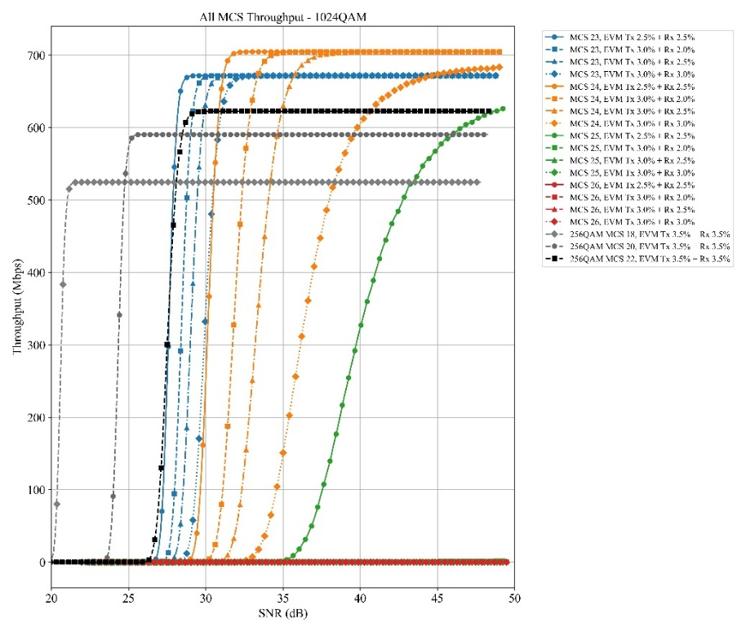
- MCS in RAN1 high modulation LLS configuration: R1 LLS configuration:
- UL 1KQAM: MCS 25, 26
- UL 256QAM: MCS 21, 22
- RAN1 MCS table:
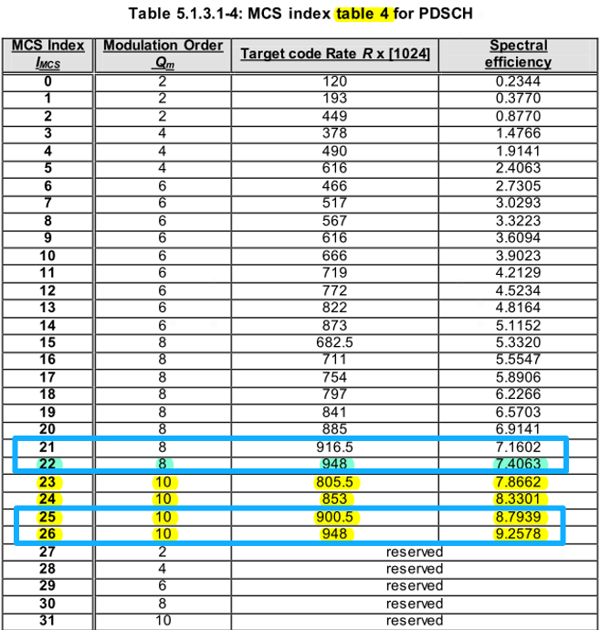

Agreement:
- The metric for LLS is the SINR vs Throughput, and purpose is to find out the SINR boundary at which the 1024QAM shows performance gain than UL 256QAM under the Tx and Rx EVM assumptions.
  - Other metrics can be considered based on company inputs.

For information:
- Below table is considered as starting point for UL 1KQAM LLS SINR evaluation.
- Companies are encouraged to check the configurations.

Parameter | Value
Carrier frequency | 7GHz
CBW/SCS | 200MHz with 30kHz SCS
Waveform | CP-OFDM
Allocated RBs | Full allocation
Propagation | TDL-A 10ns delay spread, 5Hz Doppler frequency  TDL-D 10ns delay spread, 5Hz Doppler frequency  AWGN
MCS | Based on NR MCS in Table 5.1.3.1-4 of TS 38.214:  - UL 1KQAM: MCS 23, 24  - UL 256QAM: MCS 22
HARQ | 4, None
Antenna configuration | Fading channel: 2x2 for Rank1 and Rank2, Low correlation  Static channel: 1x2 for Rank1, 2x2 for Rank2 (using the diagonal matrix)
Channel estimation | Practical
Receiver type | MMSE
PUSCH configuration | Type A mapping, Start symbol 0, Duration 14
DMRS configuration | Type 1, Single symbol, 1 additional DMRS
txEVM + rxEVM | Example:  - txEVM = rxEVM: 2.5%+2.5%, 3%+3%  - txEVM > rxEVM: 3%+2%, 3%+2.5%

Issue 1-3-4 SLS assumptions
- CMCC R4-2600813
- Proposal 1: For system level, the metric should be 5% throughput loss across all MCS

- CableLabs, Charter, Rogers R4-2601955
- Proposal 2: We encourage other companies to perform similar system-level simulations to evaluate the achievability of UL 1024-QAM in 6GR FWA scenarios.
- UMa scenario for FWA.
- Network topology: 19 sites topology, 3 sectors per site, see Figure 1.
- Both co-channel network and adjacent-channel network use TDD assuming they are TDD synced, with a grid shift of 100%, see Figure 1.
- Frequency: around 4 GHz and around 7 GHz.
- Inter-site distance (ISD) is 500 m around 4 GHz [6] and around 7 GHz [5].
- Channel bandwidth: 100 MHz [6] and [7].
- Max BS EIRP:
  - Around 4 GHz: 72 dBm around 4 GHz [6] (this value is conservative, the actual EIRP density limit in band n77 in the USA is 62 dBm/MHz, which is 10 dB higher than in a 100 MHz channel, so that the actual DL 4096-QAM achievability could be higher).
  - Around 7 GHz: 78.3 dBm [7] and [8].
- BS antenna:
  - Around 4 GHz: 8×8 array, 6.4 dBi gain per element, and 24.5 dBi max gain for the array [6].
  - Around 7 GHz: 8×16 sub-arrays, 3×1 elements per sub-array 6.4 dBi gain per element, and 32.2 dBi max gain for the array [5]. Note that the RAN agreed BS antenna array size is 2304 [5], which provides much larger BS antenna gain.
- BS antenna height: 25 m above ground.
- BS noise figure: 5 dB at 4 GHz and 6 dB at 7 GHz [7].
- Max CPE EIRP: 31 dBm, UL power control disabled.
- CPE antenna: 2×4 array, 6.4 dBi gain per element, and 15.4 dBi max gain for the array [7] and [5].
- CPE location: indoor (applying outdoor-to-indoor, O2I, loss based on TR 38.901) vs. outdoor (0 dB O2I loss).
- CPE height: 4 m for outdoor CPE, 1.5 m for indoor CPE.
- CPE distribution: uniformly distributed in a cell [6].
- CPE noise figure: 7 dB at 4 GHz and 9 dB at 7 GHz [9].
- Network load: 50% in DL and 50% in UL.
- 30 dB SINR threshold is selected for 1024-QAM in UL, and 38 dB SINR threshold is chosen for 4096-QAM in DL.

- OPPO R4-2601419
- Proposal 3: For higher-order modulation, RAN4 can focus on the scenarios of Urban Macro and Indoor using the parameters in Table 2 as starting point:
Table 2 The frequency parameters and scenarios for modulation evaluation
 | Urban Macro | Indoor Hotspot
Carrier frequency | Around 700 MHz  Around 2 GHz  Around 7 GHz | Around 2 GHz  Around 7 GHz
Simulation BW | Around 700 MHz: 20MHz with 15kHz SCS  Around 2 GHz: 100MHz with 30kHz SCS  Around 7 GHz: 200MHz with 30kHz SCS

- Proposal 8: System-level simulation can start using the system-level simulation assumption in Table 5
Table 5 System level simulation assumptions
Parameters |  | Urban macro | Indoor
Network layout |  | hexagonal grid, 19 macro sites, 3 sectors per site with wrap around | 50m x 120m, 12BSs
Inter-site distance |  | 500m | 20m
BS antenna height |  | 25 m | 3 m
UE location | Outdoor/indoor | Outdoor and indoor | Indoor
UE location | Indoor UE ratio | 20%
UE location | Low/high Penetration loss ratio | 50% low loss, 50% high loss
UE location | LOS/NLOS | LOS and NLOS | LOS and NLOS
UE location | UE antenna height | Same as 3D-Uma in TR 36.873 | 1.5 m
UE distribution (horizontal) |  | Uniform
Minimum BS – UE distance (2D) |  | 35 m | 0 m
Shadowing correlation |  | Between cells: 1.0  Between sites: 0.5
Pathloss |  | 3D-Uma LOS and NLOS in Table 7.2-1 of 36.873 | 3D-InH LOS and NLOS in Table 7.2-1 of 36.873
Carrier frequency |  | 700MHz, 2GHz, 7GHz
BS antenna configuration |  | - 700MHz:  (M,N,P,Mg,Ng; Mp, Np)= (8, 2, 2, 1, 1; 1, 2)  (dH, dv) = (0.5λ, 0.5λ)  GE,max = 8 dBi  - 2GHz  (M,N,P,Mg,Ng; Mp, Np)= (12, 8, 2, 1, 1; 4, 8)  (dH, dv) = (0.5λ, 0.5λ)  GE,max = 8 dBi  - 7GHz  (M,N,P,Mg,Ng; Mp, Np)= (64, 16, 2, 1, 1; 16, 16)  (dH, dv) = (0.5λ, 0.5λ)  GE,max = 8 dBi | - 2GHz  (M,N,P,Mg,Ng; Mp, Np)= (4, 4, 2, 1, 1; 1, 4)  (dH, dv) = (0.5λ, 0.5λ)  GE,max = 5 dBi  - 7GHz  (M,N,P,Mg,Ng; Mp, Np)= (16, 16, 2, 1, 1; 8, 8)  (dH, dv) = (0.5λ, 0.5λ)  GE,max = 5 dBi
UE antenna configuration |  | FFS
System bandwidth |  | Around 700 MHz: 20MHz with 15kHz SCS  Around 2 GHz: 100MHz with 30kHz SCS  Around 7 GHz: 200MHz with 30kHz SCS
Target SNR at BS side |  | Get from link-level simulation
UE max output power |  | Around 700 MHz: PC3 23dBm  Around 2 GHz: FDD 23dBm, TDD 26dBm  Around 7 GHz: PC2: 26 dBm
Power control |  | Power control parameters set to achieve the target SNR at BS side.

Feature Lead note:
- The purpose of the SLS is to find out the probability of targeting SINR that can be achieved in the NW.
- The SLS assumptions are derived from TR38.921 and taking R1 6G evaluation assumptions into account.
- BS ant configuration in RAN4 TR38921
- Uma: (16, 8, 2)
- Inh: (4, 4, 2)
- BS ant configuration in RAN1:
- for outdoor combination 1 (i.e., 768AE/128TXRU), update the (M,N,P,Mg,Ng; Mp,Np) to be (24, 16, 2, 1, 1; 4, 16).
for outdoor combination 3 (i.e., 1536AE/256TXRU), update the (M,N,P,Mg,Ng; Mp,Np) to be (48, 16 ,2, 1, 1; 8, 16).
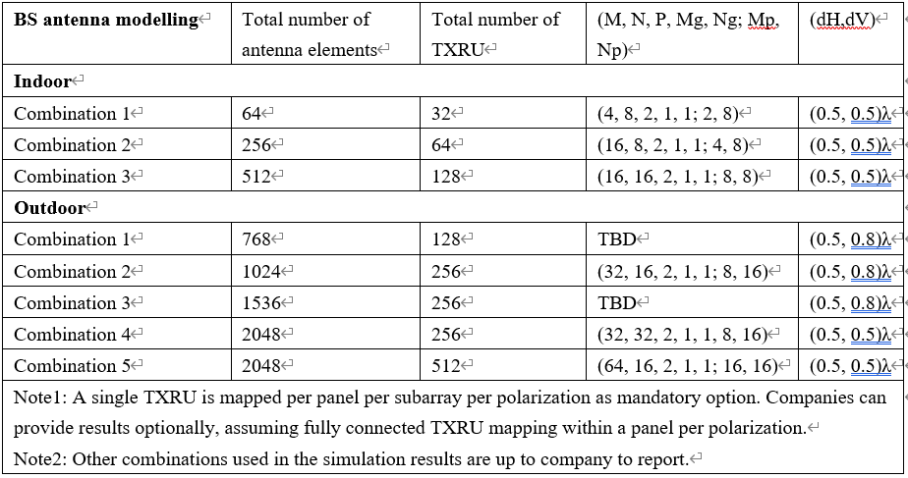

Agreement:
- The metric for SLS is the SINR CDF in NW, and purpose is to find out the probability of targeting SINR that can be achieved.
  - Other metrics can be considered based on company inputs.

For information:
- Below table is considered as starting point for UL 1KQAM SLS SINR evaluation.
        - FFS on UE antenna configurations
        - FFS on BS antenna configurations
        - Companies are encouraged to check the configurations.

Parameters |  | Urban macro | Indoor
Frequency band |  | 7GHz
System bandwidth |  | 200MHz with 30kHz SCS
UE max output power |  | PC2: 26 dBm
UE antenna configuration |  | CPE antenna: 2×4 array, 6.4 dBi gain per element, and 15.4 dBi max gain
Network layout |  | 19 macro sites, 3 sectors per site with wrap around | 50m x 120m, 12BSs
Inter-site distance |  | 500m | 20m
BS antenna height |  | 25 m | 3 m
UE location | Outdoor/indoor | Outdoor and indoor | Indoor
UE location | Indoor UE ratio | 20%
UE location | Low/high Penetration loss ratio | 50% low loss, 50% high loss
UE location | LOS/NLOS | LOS and NLOS | LOS and NLOS
UE location | UE antenna height | Same as 3D-Uma in TR 36.873 | 1.5 m
UE distribution (horizontal) |  | Uniform
Minimum BS – UE distance (2D) |  | 35 m | 0 m
Channel model |  | TR 38.901 v19.1.0 Indoor-Office | TR 38.901 v19.1.0 UMa
Shadowing correlation |  | Between cells: 1.0  Between sites: 0.5
Handover margin (dB) |  | 3
Pathloss |  | 3D-Uma LOS and NLOS in Table 7.2-1 of 36.873 | 3D-InH LOS and NLOS in Table 7.2-1 of 36.873
BS antenna configuration  (Align with R1 assumptions) |  | (M,N,P,Mg,Ng; Mp, Np)= (24, 16, 2, 1, 1; 4, 16)  (dH, dv) = (0.5λ, 0.8λ)  GE,max = 8 dBi | (M,N,P,Mg,Ng; Mp, Np)= (4, 8, 2, 1, 1; 2, 8)  (dH, dv) = (0.5λ, 0.5λ)  GE,max = 5 dBi
Mechanic tilt |  | 10° | Boresight direction is perpendicular to the ceiling
BS noise figure |  | Around 7GHz: [5@R1, 6]dB | Around 7GHz: [5@R1, 14]dB
Target SNR at BS side |  | Get from link-level simulation
UE noise figure |  | [7@R1, 9]dB
Power control |  | TPC model specified in clause 9.1 TR 36.942 is applied with following parameters.  - CL_{x-ile} = 88 + 10*log10(200/X) + 11 – Y, where X is UL transmission BW (MHz) and Y is the BS noise figure  - γ = 1

Issue 1-3-5 Impacts to RF requirements
- LGE R4-2600698
- Proposal 3: Study how to update a general in-band emission for 1024QAM.
- Proposal 4: Study how to update IQ image for 1024QAM.
- Proposal 5: Study how to update carrier leakage for 1024QAM.

- Spreadtrum R4-2601053
- Proposal 1: For uplink modulation evaluation, the affected RF requirements should include EVM and MPR/AMPR.
- Proposal 2: Define the EVM budget and PA model/PA calibration point to evaluate assumptions to simulate MPR/AMPR.

- ZTE R4-2601177
- Proposal 2: If LP-WUS signal is supported in 6G day1, it is proposed to further discuss the impacts on potential EVM degradation of 6GR other modulation orders due to the simultaneous LP-WUS signal transmission.

Recommended WF:
- The RF requirement impacts of UL 1024QAM can be discussed in UE RF thread.

Sub-topic 1-4: DL 4096QAM
Issue 1-4-1 Supporting DL 4096QAM
- Skyworks R4-2600737
- DL1024QAM is considered as baseline for 6G:
    - Assuming a link target of <2.5% and a contribution of the BS of 1.5%, a UE contribution of <2% EVM is achievable with the same LO phase noise and IQ impairment than in the UL.
- DL4096QAM is studied as an optional modulation for 6G:
    - Most contributors need to improve significantly (at least 2x versus 1024QAM) and, assuming that the most critical is the UE LO phase noise especially at higher RF frequencies, Sub 1% EVM will be needed from the BS Tx and most contributors. Based on this an EVM link budget <1.5% is achievable.

- Spreadtrum R4-2601053
- Proposal 4: Don’t consider DL 4096QAM and Keep DL 1024QAM in 6G day1.

- Samsung R4-2601123
- Proposal 2: For downlink, in order to increase spectral efficiency in indoor and high‑SNR regions, it is proposed to support 4096-QAM and initiating study to define EVM requirements in RAN4.

Agreement:
- Postpone until the evaluations results are clear.

Issue 1-4-2 EVM budget table
- Samsung R4-2601123
- For initial link-level anchoring under AWGN, RAN4 uses 1.52% (4096-QAM) as reference target values for feasibility comparisons across companies and simulations.
- RAN4 then evaluates how much additional EVM margin is required when RF impairments are included, and records the main drivers (e.g., phase noise, I/Q imbalance, PA nonlinearity, clipping/CFR if applied), without forcing a requirement change until there is consistent evidence.

Recommended WF:
- More input is needed based on below table.
EVM contributor @ 7GHz |  | EVM (%) | SNR (dB)
BS Tx EVM | PA
BS Tx EVM | Transmitter
BS Tx EVM | LO Phase noise
BS Tx EVM | IQ imbalance
BS Tx EVM | Total Tx EVM
UE Rx EVM budget
Total Tx+ Rx EVM

Issue 1-4-3 LLS assumptions
- MediaTek R4-2600909
- Proposal 3: RAN4 should set up a simulation campaign to check the feasibility of DL 4096QAM together with the target BS Tx EVM.

Recommended WF:
- More input is needed.

Issue 1-4-4 SLS assumptions
- CableLabs, Charter, Rogers R4-2601955
- Proposal 2: We encourage other companies to perform similar system-level simulations to evaluate the achievability of 4096-QAM in 6GR FWA scenarios.

- Apple R4-2600575:
- Proposal 4: It is proposed to understand the potential gain of supporting 4096QAM in real field.

Recommended WF:
- More input is needed.

Issue 1-4-5 Impacts to RF requirements
- Spreadtrum R4-2601053
- Proposal 1: For downlink modulation evaluation, from BS perspective, which should include EVM.

Agreement:
- BS RF impact can be discussed in BS RF thread.

Sub-topic 1-5: Constellation shaping
Issue 1-5-1 Impacts to RF requirements
- vivo R4-2600668
- Proposal 1: RAN4 needs to study the impact of GS and PS schemes on RF performance metrics, such as changes in the ideal constellation and possible adjustments to calculation rules for EVM calculation.

- MediaTek R4-2600909
- Proposal 4: RAN4 may need to check whether a different EVM requirement is needed for probabilistic shaping (pending on RAN1 discussion progress).

- Huawei R4-2600886
- Proposal 5: For existing NR modulations that may adopt non-uniform constellations, the evaluation should focus on determining whether new EVM requirements should be considered.

Agreement:
- Hold on the discussion until sufficient progress are made in RAN1.

Topic #2: Channel arrangement

Open issues summary
Before Meeting, Feature Leads shall summarize list of open issues, candidate options and possible WF (if applicable) based on companies’ contributions.
Background: WF in previous RAN4 meetings.
Agreement
- Study 5G-6GR co-existence impact on channel raster with legacy NR refarmed bands
  - Note that NR bands could have 100kHz channel raster, 10kHz enhanced channel raster or SCS based channel raster
- Investigate the interaction between the channel raster and the synchronization raster
- Investigate the necessity of channel raster or alternative ways for the channel configuration
  - If channel raster needs to be specified, further investigate granularity including SCS based raster, and enhanced channel raster
  - Investigate the possibility of migrating to SCS based raster if legacy rasters are still to be supported
- Study the listed main proposals especially for the migration and co-existence approaches
  - Other options not presented in this meeting are not precluded
- Provide early feedback to RAN1 with RAN4's analysis on the RF coexistence performance and potential implementation complexity associated with the various proposed channel raster options (5 kHz, 10 kHz, SCS-based).

Recommendation from FL in RAN4#117
- For the sub-3GHz bands, adopt smaller channel raster instead of 100kHz channel raster for 6GR
  - Further compare 5kHz vs. 10kHz channel raster for different scenarios.
    - E.g., evaluate the implementation and coexistence complexity for operators if 6G uses a different channel raster (e.g., 5kHz) in a band where 5G uses 100kHz/10kHz.
- Further study the proposals on simplification and future migration

Sub-topic 2-1: Channel raster

Issue 2-1-2 Relation b/w UE dedicated CBW and Channel raster
- CMCC R4-2600814
- Proposal 1: RAN4 is suggested to study whether the carrier bandwidth in UE dedicated CBW must be aligned with channel raster, i.e., whether to reflect them into RAN2 spec.

Feature Lead note:
- This topic was discussed in NR for a long time with no conclusion. If this is essential, some clear conclusion is needed at the beginning of 6G channel raster design.

Agreement:
- channel bandwidth in UE dedicated CBW must be aligned with channel raster, whether to reflect them into RAN2 spec is up to RAN2.

Sub-topic 2-3: Channel spacing
Issue 2-3-1 Channel spacing for CA and non-CA
- CATT R4-2600315
- Proposal 4: RAN4 to re-examine channel-spacing definitions for both single- and multiple-carrier operations by considering wider channel bandwidth, new operating frequencies and shared spectrum scenarios, and defer the discussion until the other core parameters have become more stable.

- Xiaomi R4-2600460
- Proposal 6: Simplify Channel spacing definition without consideration of mixed numerology case in 6GR.
- Proposal 7: Further study “normal channel spacing” definition and the relation-ship between intra-band contiguous CA and NC CA.
  - Observation 8: “Normal channel spacing” concept was introduced for RAN4 requirements and conformance test. There is no restriction on real network deployment.

- MediaTek R4-2601004
- Proposal 8: Simplify channel spacing definition in 6G without considering mixed numerology scenarios.

- ZTE R4-2601070
- Proposal 5: It’s better to simplify the definition of nominal channel spacing without considering mixed numerologies.
- Proposal 6: It is critical to avoid such a misalignment between spec and practical deployment that spec supports 300kHz nominal channel spacing but this configuration cannot be used in practical deployment scenarios.

- LG Electronics R4-2600701
- Proposal 6: Consider 6G nominal channel spacing as follows.
  - Below 3GHz (assuming channel raster (∆F_{Raster}) = 5kHz)
    - Nominal Channel spacing = (BW_{Channel(1)} + BW_{Channel(2)})/2
  - For above 3GHz, Normal Channel spacing can be rewriten as follows.
    - Nominal Channel spacing = (BW_{Channel(1)} + BW_{Channel(2)})/2+{- (∆F_{Raster} /3) kHz, 0 kHz, (∆F_{Raster} /3) kHz}

Agreement:
- For FR1 and around 7GHz, mixed numerology scenarios are not considered in channel spacing definition for intra-band CA and non-CA
- FFS on the nominal channel spacing for CA and non-CA with single numerology

Topic #3: Device types

Open issues summary
Feature Lead note: RAN#110 agreements in RP-253856.
Proposal 1:
- 6GR supports the operation (but not required to be optimized for performance) in a minimum spectrum allocation of 3MHz with a 15kHz SCS
Note: the following agreement made in RAN1#123 still holds, with the clarification that the bandwidth in Opt 1 below is assumed to be at least 5MHz with a 15kHz SCS.
Agreement
If the minimum spectrum allocation is 3MHz with 15kHz SCS for 6GR,
- Opt1: Design of the common signals/channels (at least for SSB) for initial access by assuming bandwidth larger than 3MHz, which is applicable to any spectrum allocations with adjustment, if applicable
- Opt2: A single design of the common signals/channels (at least for SSB) for initial access by assuming minimum spectrum allocation as target bandwidth 3MHz, which is applicable to any spectrum allocations
- Regarding the smallest maximum UE bandwidth as discussed in the following RAN1 agreement, Opt 1 is excluded. Aim to conclude by RAN plenary no later than RAN#112 (June 2026).
  - RAN1 and RAN4 is tasked to continue providing more analysis accordingly.
  - Companies are encouraged to provide more analysis at RAN plenary particularly regarding the use cases, requirements, economy of scale, etc.

Agreement
- Study the following smallest maximum supported RF and BB UE BW without spectrum aggregation for at least one low-tier device type supported by 6GR framework from physical layer perspective, subject to further discussion and confirmation in RAN
  - Opt1: 3MHz
  - Opt2: 5MHz
  - Opt3: 10MHz
  - Opt4: 20MHz
  - FFS: the UL bandwidth may be different to the DL bandwidth
  - FFS: the bandwidth value may be different for different SCS, duplex modes, and bands.
  - FFS: whether RF and BB UE BW are same or different
Proposal 2:
- Diverse device types as in 6G SIDs are expected to include supporting at least MBB (as highest priority), FWA, and Massive IoT services
- Companies are encouraged to further contribute at RAN plenary regarding the analysis of necessary aspects to help progress RAN WG technical design and evaluations.
- The detailed discussion for device types (how many, parameters, whether or not to define device types, whether or not to introduce minimum mandatory set of features, etc.) is on hold in RAN plenary and to resume from RAN#113 (September 2026). Discussions on device types are not to be discussed in WGs until further update from RAN plenary.

Proposal 3: Capture the following aspects related to diverse device types into the TR:
- Scalable and forward compatible design
- Limited set of device types (based on the agreement in RAN#109)
Detailed wording is to be drafted in RAN#111, along with possibly other aspects (e.g., scalability, differentiated services, etc.).

Sub-topic 3-1: Smallest max UE bandwidth

Issue 3-1-2: How to enable SAW-Less design
- Nordic R4-2600054
- Proposal-1: Capture in RAN4 6G TR: If 6G maximum smallest DL/UL RF BW is 10 or 20MHz, RAN4 defines band-specific frequency regions where UL scheduling restrictions within 10 or 20MHz BWP apply after MSG4 for HD-FDD 6G IoT UE with reduced number of band-specific RF filter.
  - Note, it is assumed that initial access UL BB BW remains naturally limited to [4-5] MHz in UL as in NR in FR1.
  - FFS UL scheduling restrictions within 10 or 20Mhz UL BWP, UL <=5MHz, including dependency on transmit power/PSD and/or location from band edge.
  - FFS relaxation of spurious emission requirement(s).
- Proposal-2: Relax duplexing gap 2x compared to 5G to enable single PLL implementation of HD-FDD.
- Proposal-3: Study how a 5MHz RF UE could operate within configured 10 or 20MHz UL BWP.

- Sony R4-2601399
- Proposal 4: RAN4 further study additional approaches to enable a fully SAW-less implementation for a few extremely challenged scenario (e.g., band to band separation below 12MHz) with 5MHz uplink BW for the low tier device in 6GR.
- Proposal 6: RAN4 further study the following additional solutions to enable a fully SAW-less implementation for the low tier device of 6GR:
  - Limit location of UL RBs
  - limited number/length of allocated UL RBs,
  - allowed power backoff for certain bands and/or certain UL RB allocations restrictions
  - possible relaxed band to band spurious emission level

- AT&T R4-2600631
- Proposal: RAN4 is requested to study the proposed approaches that enable SAW-less RF implementations for massive IoT devices in the 6G era

- MediaTek R4-2600501
- Proposal 4: study further the impact of partial or fully SAW-less designs in UE Tx side, with analysis on the following mitigation approaches:
  - Relaxation of the spurious emission requirement for UE cross-band coexistence.
  - Restricting the operated UL bandwidth by the UE or UL RB allocation in certain strict coexistence scenarios when the UE is located close to the band edge.
  - A-MPR for device in certain frequency locations that operates a wider CBW/RB allocation.
- Proposal 5: RAN4 to consider further Rx blocking and associated impacts to enabling fully or partially SAW-less Rx designs for the lowest tier 6GR device.

- vivo R4-2600674
- Proposal 2: RAN4 can further study whether and how to support SAW-less device based on 20MHz maximum channel bandwidth

- Ericsson R4-2601880
- Proposal-1: Study the RF impact of SAW-less design with the smallest maximum bandwidth with below two bandwidth options:
  - Limit the maximum configurable UL bandwidth, with same RF and BB bandwidth
  - Limit the maximum contiguous RB allocation (BB bandwidth) within a wider configurable UL bandwidth (RF bandwidth), with different RF and BB bandwidth
- Proposal-2: Revisit the coexisting requirement in 6G if necessary.
- Proposal-3: Limiting BB bandwidth may bring network benefit more than limiting RF bandwidth, other aspect could be discussed other than RF impact for SAW-less design, e.g., LO retuning time.

Feature Lead note:
- Several solutions have been proposed to enable SAW-less design
- Some company think the SAW-less design is not dependent on the smallest max CBW decision.

Agreement:
- For 6G lowest tier device, study how to support the SAW-less design for HD-FDD/TDD, below solutions can be considered as starting point pertaining to different smallest max CBW:
  - Option 1: Restricting the operated UL bandwidth by the UE or UL RB allocation in certain strict coexistence scenarios when the UE is located close to the band edge.
  - Option 2: MPR/AMPR for certain bands
  - Option 3: Relaxation of the spurious emission requirement for UE cross-band coexistence.
  - Other options are not precluded

- FFS on the applicable bands.
- The agreement here doesn’t impact the 6GR smallest max CBW also min CBW discussion.
- FFS on the requirement impacts with the SAW-less design, e.g., Tx emission requirement, Rx blocking requirements.

Sub-topic 3-2: Device types
Feature Lead note: According to the agenda of this meeting, the discussion will focus on the smallest max CBW and no device type discussion.
Issue 3-2-1: Device type related proposals
- Nokia R4-2600388
- Proposal 1: Consider four receivers as mandatory baseline for bands re-farmed from 5G for eMBB UE for RAN4 requirement work.
- Proposal 2: Consider six receivers as mandatory baseline for new 6GR bands for eMBB UE for RAN4 requirement work.
- Proposal 3: Consider eight receivers as mandatory baseline for new 6GR bands for FWA UE for RAN4 requirement work.
- Proposal 4: Consider eMBB UE and FWA UE devices support two TX chains as mandatory baseline for RAN4 requirement work.
- Proposal 5: RAN4 to study how Maximum Output Power needs to differentiate for 6G eMBB, FWA, Wearable and massive IoT devices by candidate 6G frequency ranges.
- Proposal 7: RAN4 to study realistic feasibility boundaries for Modulation Order for 6G eMBB, FWA, Wearable and massive IoT devices in UL and DL.
- Proposal 8: RAN4 does not differentiate device types by duplex mode, since duplex operation follows automatically from supported bands.

- Xiaomi R4-2600457
- Proposal 1: RAN4 focus on the evaulation of the mandatory RF/BB capabilities with different device assumption considering implementation feasibility and constraints
  - Target to identify fundemental parameters/factors related to 6GR common system design and coverage (Tight cooperation with RAN1)
  - Provice necessary input to RAN-P to assist the discussion on device type defintion
  - Urgent to be concluded in intial stage on identified fundemental parameters for overall system design
- Proposal 2: RAN4 also can further discuss UE RF/BB capability sets and dynamic UE capability
  - This work have RAN-P and RAN2 dependency
  - No urgency to discuss in intial stage
- Proposal 3: RAN4 also needs to study how to handle and discriminate different device assumption/form factors from RAN4 RF/BB requirements perspective
  - Target to have scalable RF/RRM/Demod requirement framework to support diverse device assumption especailly on form factor dependency requirements
  - Not necessary treated as device types/capabilities
  - Majorly RAN4 internal study, less cross WG dependency
  - Discuss under UE RF, RRM and demod agenda separately

- LGE R4-2600700
- Proposal 1: Consider RF/BB implementation feasibility and constraints in Table 2-2 for IoT, Wearable, Smartphone, and FWA.
- Proposal 2: Consider baseline and maximum values per device type in Table2-3 as starting point

- CMCC R4-2600812
- Proposal 1: for device type, it’s suggested to take above aspects into consideration.
- Proposal 2: it’s suggested to further discuss device types with above table as example.

- CATT R4-2600316
- Proposal 1: RAN4 to progress studies related to device types by focusing on identifying distinct RF requirement and implementation feasibility implications, while remaining independent of and not constraining device type categorization at the RAN level.
- Proposal 2: RAN4 to consider a scalable RF requirement framework, in which RF requirements are parameterized along key technical dimensions, and to further consider realistic baseline and maximum values for these parameters to represent widely deployable and energy-efficient implementations, as well as optional high-end capabilities respectively.

Recommended WF:
- Hold on the discussion of device type according to RAN plenary agreement until September 2026.

