3GPP TSG-RAN WG4 Meeting #118 revision of R4- 2601446
Gothenburg, Sweden, 9th – 13th Feb, 2026
Agenda Item: 8.2.1
Source: MediaTek Inc.
Title: Views on 6G PA model
Document for: Discussion

1 Introduction
Following the 6G SI [1] approved in RAN#108, the first 6G discussion started from RAN4#116bis meeting. During RAN4#117, a WF for 6GR system parameter [2] was agreed, classifying topics and directions for further study. In this paper, we provide our views on the PA model.

2 PA model

In RAN1#122bis meeting, a RAN1 LS [3] was agreed to request a PA model from RAN4 to facilitate the waveform evaluation in RAN1. Before providing RAN1 the PA model, we believe that there are some high-level principles that needs to be discussed first.
Agreements in RAN4#117:
  - Staged development of the PA model used for waveform evaluation.
    - For RAN1: Provide a model for timely waveform comparison.
      - Targeted for RAN4#118 meeting
    - For RAN4: Continue internal development of PA models, if needed, with more realistic considerations for RF requirements evaluation.
  - Prioritize PA model(s) for 7 GHz, PC2/PC3 for waveform evaluation.
    - Consider models like the Generalized Memory Polynomial (GMP)
    - Other options not precluded
  - Develop PA models covering different frequency ranges, power classes if single PA model is not accurate enough for all evaluation scenarios.
  - Agree on calibration conditions and applicable requirements for the PA model (e.g., achieved ACLR for a reference waveform at a specific MPR) to ensure fair comparisons.
The evaluation assumption and PA calibration conditions had also been agreed in the same meeting:
Table 1: Waveform evaluation assumptions for RAN1/RAN4
Parameter/Requirements |  | Assumptions/Value | Note
PA model |  | TBD | Memory effect should be considered for ~7GHz with larger channel bandwidth
Band under evaluation |  | around 7GHz, other bands are not precluded | n104 could be assumed for ~7GHz
Channel Bandwidth (CBW) |  | At least 100MHz, 200MHz  Other CBW based on inputs for PA models | Same SU assumed for 200MHz as 100MHz
Power class |  | PC2 (26dBm), PC3 (23dBm)
Complied requirements | SEM | TS 38.101-1 §6.5.2.2 | Subject to further adjustment pending on progress of UE RF, co-existence study
Complied requirements | ACLR | TS 38.101-1 §6.5.2.4
Complied requirements | EVM | TS 38.101-1 §6.4.2.1 | Considered for high modulation order/inner RB allocation, pending on RAN1 discussion
Complied requirements | IBE | TS 38.101-1 §6.4.2.3
Tx impairments | Carrier Leakage | -28dBc | Subject to further adjustment pending on progress of UE RF study
Tx impairments | IQ image | -28dBc
Tx impairments | CIM3 | -60dB
PA calibration conditions | CBW | 100MHz full RB allocation | Other options are not precluded, pending on the further study in RAN4
PA calibration conditions | SCS | 30kHz
PA calibration conditions | Waveform | DFT-s-OFDM
PA calibration conditions | Modulation | QPSK
PA calibration conditions | Power class | PC2/PC3
PA calibration conditions | Power backoff to meet ACLR | 1dB
RAN4 still target on unified PA model and hopefully in this contribution, we can get some progress on the target.
To understand the need for memory polynomial, we compare a 200MHz bandwidth waveform measurement and simulation results using memoryless polynomial and same waveform using 13th-order, 5-taps memory polynomial model where the carrier frequency is at 6.8GHz. The result is shown in Figure 1. We can see memory polynomial model can provide better accuracy on the PA output spectrum simulation.
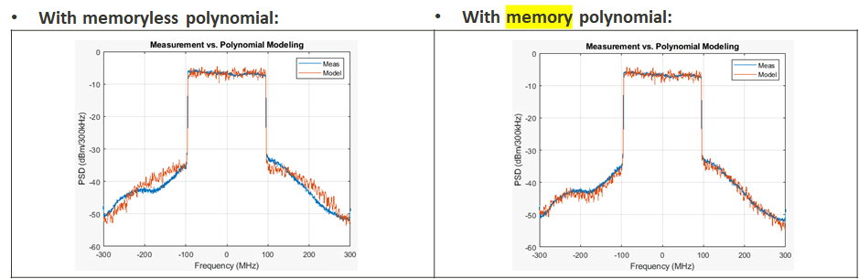
Figure 1. Comparison between memoryless polynomial and memory polynomial
Observation 1: Memoryless polynomial is not proper for the case channel bandwidth >=100MHz
Proposal 1: Memory polynomial shall be considered for wider channel bandwidth PA model
We further try 400MHz bandwidth waveform using memory polynomial model see if we can get good correlation between simulated output spectrum and measured output spectrum. However, we see some inconsistency that simulated results is a bit far away from measured spectrum on ACLR-R region even using 17th-order, 9-taps memory polynomial model. It would still need to spend more time to figure out the root cause.
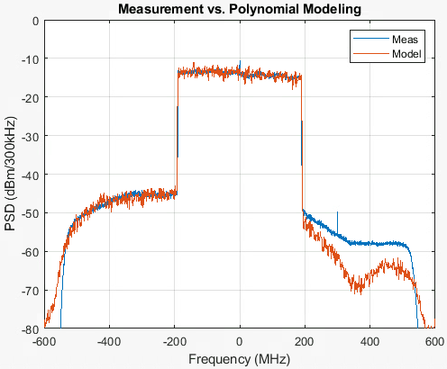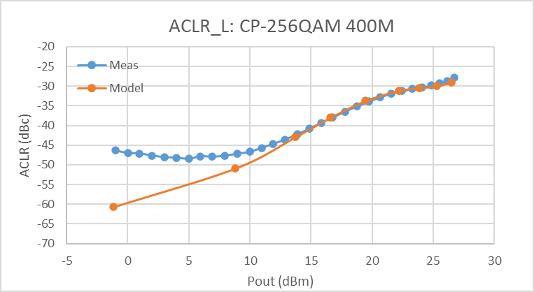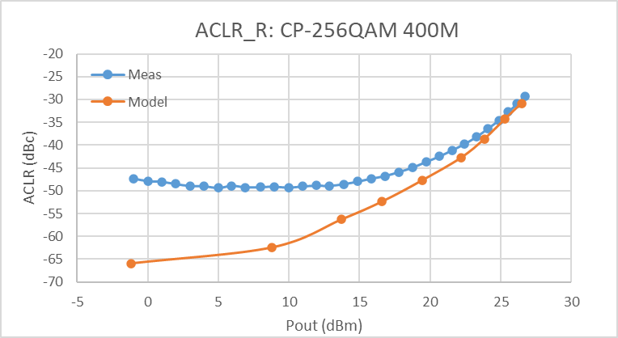
Figure 2. 17th-order, 9taps PA model coefficient curve fitting for 400MHz CBW using 400MHz waveform, fc=6.8GHz
Observation 2: We’ve tried from 9th-order, 5taps to 17th-order, 9taps for 400MHz, CP-OFDM-256QAM. Simulated with the modelled coefficient sets still not well fit the measured performance
There are different techniques that can improve PA power efficiency such as Average Power Tracking(APT_, Digital Pre-Distortion(DPD), Envelope Tracking (ET)…etc. The side effect is these techniques may more or less worse out of channel or out of band emissions. On the other hand, these power efficiency improvement techniques are very UE implementation dependent, thus we don’t think it is proper to include them in the PA modelling.
We decide to extract memory polynomial model from 200MHz, CP-OFDM 256QAM measured waveform at Pout=25dBm. The PC2 PA calibration follows RAN4 agreement and fixed-bias PA without APT or DPD/ET techniques. The simulated results and measurement comparison plots are shown in Figure 3 and Figure 4. We can see the model can be applicable for CBW less or equal to 200MHz. The applicable output power level range of the model is about 10~12dB. The 13th-order, 5-taps memory polynomial model can be provided to RAN1 for new waveform evaluation to accommodate PA memory effect up to 200MHz.
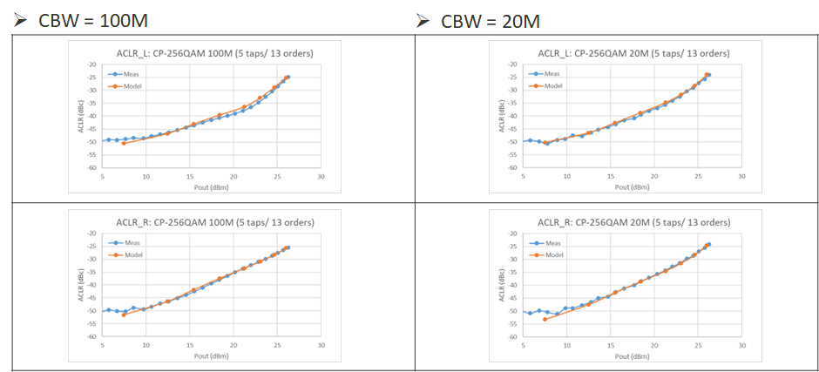
Figure 3. Model coefficient curve fitting for 20/100MHz CBW using 200MHz CP-OFDM 256QAM measured waveform, fixed biased PA, fc=6.8GHz
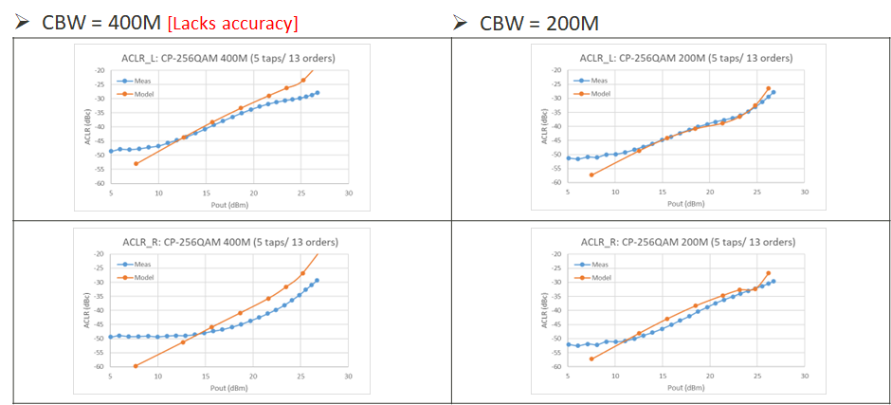
Figure 4. Model coefficient curve fitting for 200/400MHz CBW using 200MHz CP-OFDM 256QAM measured waveform, fc=6.8GHz

Proposal 2: Adop 13th-order, 5-taps memory polynomial model (including the model coefficients listed below) for UE CBW up to 200MHz for around 7GHz PA model:
Order | a | b | c | d | e
1st | 34.5740 - 30.4430i | -73.8674 + 60.7998i | 83.3917 + 64.6447i | -1.0110e+02 - 1.1335e+02i | 56.4092 + 42.0192i
3rd | -2.1020e+01 + 1.6457e+02i | 2.3961e+00 - 2.9547e+02i | -2.5102e+02 - 5.2031e+02i | 3.6879e+02 + 1.2987e+03i | -1.6143e+02 - 6.5106e+02i
5th | 3.2327e+02 - 5.4457e+02i | 3.9517e+02 + 2.4179e+03i | -1.1425e+03 - 4.2744e+03i | 1.0211e+03 + 3.5902e+03i | -1.6374e+02 - 1.3977e+03i
7th | -1.9519e+02 + 3.1487e+03i | -3.0089e+03 - 1.4757e+04i | 5.9442e+03 + 2.6497e+04i | -4.8623e+03 - 2.2651e+04i | 7.5488e+02 + 8.5670e+03i
9th | -1.1596e+03 - 5.9812e+03i | 6.6253e+03 + 3.0041e+04i | -8.4557e+03 - 5.4828e+04i | 4.6526e+03 + 4.7036e+04i | 5.9613e+02 - 1.7654e+04i
11th | 1.8405e+03 + 4.8550e+03i | -5.8466e+03 - 2.6831e+04i | 4.3521e+03 + 5.0627e+04i | 1.3994e+02 - 4.4149e+04i | -2.3675e+03 + 1.6650e+04i
13th | -8.1103e+02 - 1.4225e+03i | 1.8653e+03 + 8.8912e+03i | -3.9780e+02 - 1.7500e+04i | -1.4314e+03 + 1.5603e+04i | 1.3971e+03 - 5.9424e+03i
Memory polynomials[4]:

3 Summary
In this paper, we provide our views on 6G system parameters with the following observations and proposals for the PA modelling:
Observation 1: Memoryless polynomial is not proper for the case channel bandwidth >=100MHz
Proposal 1: Memory polynomial shall be considered for wider channel bandwidth PA model
Observation 2: We’ve tried from 9th-order, 5taps to 17th-order, 9taps for 400MHz, CP-OFDM-256QAM. Simulated with the modelled coefficient sets still not well fit the measured performance
Proposal 2: Adop 13th-order, 5-taps memory polynomial model (including the model coefficients listed below) for UE CBW up to 200MHz for around 7GHz PA model:
Order | a | b | c | d | e
1st | 34.5740 - 30.4430i | -73.8674 + 60.7998i | 83.3917 + 64.6447i | -1.0110e+02 - 1.1335e+02i | 56.4092 + 42.0192i
3rd | -2.1020e+01 + 1.6457e+02i | 2.3961e+00 - 2.9547e+02i | -2.5102e+02 - 5.2031e+02i | 3.6879e+02 + 1.2987e+03i | -1.6143e+02 - 6.5106e+02i
5th | 3.2327e+02 - 5.4457e+02i | 3.9517e+02 + 2.4179e+03i | -1.1425e+03 - 4.2744e+03i | 1.0211e+03 + 3.5902e+03i | -1.6374e+02 - 1.3977e+03i
7th | -1.9519e+02 + 3.1487e+03i | -3.0089e+03 - 1.4757e+04i | 5.9442e+03 + 2.6497e+04i | -4.8623e+03 - 2.2651e+04i | 7.5488e+02 + 8.5670e+03i
9th | -1.1596e+03 - 5.9812e+03i | 6.6253e+03 + 3.0041e+04i | -8.4557e+03 - 5.4828e+04i | 4.6526e+03 + 4.7036e+04i | 5.9613e+02 - 1.7654e+04i
11th | 1.8405e+03 + 4.8550e+03i | -5.8466e+03 - 2.6831e+04i | 4.3521e+03 + 5.0627e+04i | 1.3994e+02 - 4.4149e+04i | -2.3675e+03 + 1.6650e+04i
13th | -8.1103e+02 - 1.4225e+03i | 1.8653e+03 + 8.8912e+03i | -3.9780e+02 - 1.7500e+04i | -1.4314e+03 + 1.5603e+04i | 1.3971e+03 - 5.9424e+03i

Memory polynomials[4]:

4 References
[1] RP-251881, Study on 6G Radio, NTT DOCOMO (Moderator)
[2] R4-2522450, WF for 6GR system parameter, Feature lead (Huawei, HiSilicon)
[3] R1-2508069, LS on PA models in 6GR waveform evaluations, RAN WG1
[4] TR38.803, Study on new radio access technology:Radio Frequency (RF) and co-existence aspects, Annex A

