3GPP TSG-RAN4 Meeting #117 R4-2522212
Dallas, USA, 17th – 21st, November, 2025

Agenda item: 4.1.3
Source: Moderator (CMCC)
Title: Topic summary for [116bis][326] A-IoT_Maintenance
Document for: Information

Introduction
This thread focuses on maintenance part of Rel-19 Ambient IoT in NR and corresponds to agenda 4.20.1, 4.20.3.

Topic #1: RF requirements for A-IoT device

Companies’ contributions summary
T-doc number | Company | Proposals / Observations
R4-2520165 | CATT | Observation 1: For A-IoT Device spec TS 38.191, the clauses numbering from Clause 6 onwards may require reordering.  Observation 2: For A-IoT Device spec TS 38.191, the applicable D2R CBW of the Output RF spectrum emissions requirements is not clear.
R4-2520169 | CATT | CR for TS 38.191, Correction on A-IoT Device Symbol  The symbols in the A-IoT device specifications are reused from the network device spec, while AIOT devices will be considered as UE, the UE spec approach should be used.
R4-2520170 | CATT | CR for TS 38.191, Correction on A-IoT Device Output RF spectrum emissions.  To clarify the spectrum emission mask requirements apply to all D2R CBW  To correct the sub-clause number for Output RF spectrum emissions
R4-2520306 | China Mobile Com. Corporation | CR on 38.191 for A-loT device testing  For sub-clause 8.4.3, 1)Delete brackets in clause 8.4.3. 2)add missing value of the CW incident power at the device antenna, i.e.10dB higher than the receiver sensitivity requirement.  For sub-clause 8.4.2, RF core requirement reference clause for backscatter power measurement is updated as clause 6.
R4-2520871 | China Telecom | CR for TS 38.191 on including n5 for A-IoT.
R4-2521995 | Ericsson | Proposal-1:Apply a filter bandwidth of 1/Tc in positive frequency or 2/Tc including both positive and negative frequency.  Proposal-2:Apply the test parameter in RF domain so to avoid the test equipment implementation discussion.
R4-2521997 | Ericsson | draftCR for 38.191:Maintenance CR  adding missing table in annex A
R4-2522138 | Huawei, HiSilicon | Proposal 1: Use the test configuration in Table 2 for D2R measurement.  Table 2: Test configuration for D2R measurement  Proposal 2: The same D2R RMC used for testing SEM and spurious emission requirements can also be used to test backscatter power requirements. Additional RMCs can be added in the future if the need is identified.
  Measurement parameter | Value
  CW frequency (F_{CW}) | According to TS 38.192
  Filter passband range for D2R upper sideband | $F_{CW}+\frac{R_{SFS}-1}{T_{b}}*0.9$ to $F_{CW}+\frac{R_{SFS}+1}{T_{b}}*1.1$
  Filter passband range for D2R lower sideband | $F_{CW}-\frac{R_{SFS}+1}{T_{b}}*1.1$ to $F_{CW}-\frac{R_{SFS}-1}{T_{b}}*0.9$
  Note 1: The power at the carrier frequency is excluded from the D2R power.
R4-2522139 | Huawei, HiSilicon, [CMCC, VIVO, ZTE, Ericsson] | Corrections for device RF requirements  The test configuration and FRC for D2R measurement are missing. There’re errors in the R2D FRC as well as the requirements for D2R channel bandwdith. “The general part” for clause 6 is missing.  The requirement applicablity for bandwidth is not clearly stated in the spec, e.g., backscatter loss, reference sensitivity

Open issues summary
Most of draft CRs have been endorsed during last meeting.

Sub-topic 1-1 Test configuration for A-IoT device
Issue 1-1-1: backscatter power
- Proposals:
  - Option 1: Use the test configuration in Table 2 for D2R measurement.(Huawei)
- Table 2: Test configuration for D2R measurement
Measurement parameter | Value
CW frequency (F_{CW}) | According to TS 38.192
Filter passband range for D2R upper sideband | $F_{CW}+\frac{R_{SFS}-1}{T_{b}}*0.9$ to $F_{CW}+\frac{R_{SFS}+1}{T_{b}}*1.1$
Filter passband range for D2R lower sideband | $F_{CW}-\frac{R_{SFS}+1}{T_{b}}*1.1$ to $F_{CW}-\frac{R_{SFS}-1}{T_{b}}*0.9$
Note 1: The power at the carrier frequency is excluded from the D2R power.

  - Option 2: Apply a filter bandwidth of 1/Tc in positive frequency or 2/Tc including both positive and negative frequency, and apply the test parameter in RF domain so to avoid the test equipment implementation discussion.
The test configuration in Table A.1-1 is defined to be used for testing the backscattering loss requirement defined in section 6.1.1, the filter position is illustrated in Figure A.1-1 and Figure A.1-2.
- Table A.1-1: Test configuraton
Test parameter | value
filter bandwidth (kHz) | 2/Tc* 1.1
CW frequency (MHz) | According to TS 38.194
Filter center frequency | Fcw

- Figure A.1-1: illustration of measurement filter configuration (R>1)
- Figure A.1-2: illustration of measurement filter configuration (R=1)

- Recommended WF
  - FFS.
Issue 1-1-2 : RMC for D2R
During last meeting, we have the following agreement.
- Use the D2R RMC in Table 6 to test spurious emission requirement.
  - FFS Parameters for backscatter power.
Table 6: FRC for [backscatter power,] SEM and spurious emissions
Parameter | Unit | Value
Transmission BW | kHz | 15
TBS | Bits | Depending on the length of AIoT device ID
CRC | Bits | 16
FEC code rate |  | 1/3
Block repetition number |  | 1
Preamble length | Bits | 31
Midamble length | Bits | 31
Interval for midamble insersion | Bits | 48
Additional midamble insertion |  | No
Small frequency shift | kHz | 480
Modulation |  | BPSK/OOK (NOTE1)
NOTE 1: The modulation scheme used is up to device implementation.

- Proposals:
  - Option 1: The same D2R RMC used for testing SEM and spurious emission requirements can also be used to test backscatter power requirements. Additional RMCs can be added in the future if the need is identified. (Huawei)
  - Option 2: Others
- Recommended WF
  - FFS.

Sub-topic 1-2 Operation band for A-IoT
Issue 1-2-1: Operation band for A-IoT
- Proposals:
  - Option 1: Band n5 can be directly incorporated into the A-IoT band list without additional analysis, and add band n5 into the A-IoT operation band list. (China Telecom)
  - Option 2: Others.
- Recommended WF
  - o FFS.

Sub-topic 1-3 recommendation for these formal CR and draft CR provided in this meeting
Consider merging the following draft CRs into one.
T-doc number | Company | Proposals / Observations | recommendation
R4-2520169 | CATT | The symbols in the A-IoT device specifications are reused from the network device spec, while AIOT devices will be considered as UE, the UE spec approach should be used. | Further check
R4-2520170 | CATT | To clarify the spectrum emission mask requirements apply to all D2R CBW  To correct the sub-clause number for Output RF spectrum emissions | Further check
R4-2520871 | China Telecom | CR for TS 38.191 on including n5 for A-IoT. | Wait for the agreements of Issue 1-2-1
R4-2521997 | Ericsson | Adding missing table in annex A | Wait for the agreements of Issue 1-1-1
R4-2522139 | Huawei, HiSilicon, [CMCC, VIVO, ZTE, Ericsson] | Corrections for device RF requirements  The test configuration and FRC for D2R measurement are missing. There’re errors in the R2D FRC as well as the requirements for D2R channel bandwdith. “The general part” for clause 6 is missing.  The requirement applicablity for bandwidth is not clearly stated in the spec, e.g., backscatter loss, reference sensitivity | Wait for the agreements of Issue 1-1-1 and 1-1-2

Topic #2: RF requirements for A-IoT BS and CW

Companies’ contributions summary
T-doc number | Company | Proposals / Observations
R4-2520098 | CATT | CR to TS 38.194 on A-IoT  Some descritions in current TS will cause misunderstanding as:  1. For D2R and R2D, diffenrent CBW are defined, there are some confusions in current spec;  2. Receiver requirements defined for 200kHz which is not a BS D2R bandwidth.  3. Transmission BW and Transmission BW configuration are mixed used.  4. Interfering offset for RX requirements has error.
R4-2520163 | CATT | CR for TS 38.194, Correction on A-IoT BS Annex  To correct Annex of characteristics of the interfering signal for A-IoT BS
R4-2520164 | CATT | CR for TS 38.194, Correction on A-IoT BS Rx requirements  To correct the A-IoT BS channel bandwidth of ACS/general blocking/narrowband intermodulation requirement for A-IoT BS.
R4-2520166 | CATT | Observation 1: The A-IoT BS spec TS 38.194 lacks an annex which specifies the characteristics of the interfering signal.  Observation 2: The A-IoT BS spec TS 38.194 lacks the SCS and number of RB for the type of the interfering signal of the ACS requirements.  Observation 3: For A-IoT BS spec TS 38.194, the descriptions of the BS D2R channel bandwidth for some Rx requirements are not aligned.
R4-2520409 | Huawei, HiSilicon | Proposal 1: For A-IoT operation, A-IoT requirements for receiver shall apply with a frequency offset F_{offset} as defined in Table 3 below where CBW is defined in 5.3.1 and 5.3.2 of TS38.194.  Table 3 F_{offset} for A-IoT operation  Proposal 2: Update the interfering signal for ACS, in-band blocking, and narrowband intermodulation from 3 MHz E-UTRA/NR to 5 MHz NR.  Proposal 3: For 200kHz D2R CBW, the ACS interfering signal center frequency offset to the lower/upper Base Station RF Bandwidth need to correct from +/-100kHz to +/-340kHz.  Proposal 4: For 3.52M D2R CBW, correct the ACS interfering signal center frequency offset to the lower/upper Base Station RF Bandwidth from +/-100kHz to +/-2500kHz.  - Table 7.3.1.2-1: Base station ACS requirement  - Table 7.3.1.2-2: Base Station ACS interferer frequency offset values  Proposal 5: For 200kHz D2R CBW, the type of general blocking interfering signal change from 3M NR signal to 5M NR signal.  Proposal 6: For 3.52M D2R CBW, the type of general blocking interfering signal change from 3M NR signal to 5M NR signal. Change the interfering signal center frequency offset to the lower/upper Base Station RF Bandwidth from +/-4.5MHz to +/-7.5MHz.  Table 7.3.2.2-1: Base station general blocking requirement  Proposal 7: For narrowband intermodulation, change the type of interfering signal from LTE signal to 5M NR signal.  Table 7.6.2-1: Narrowband intermodulation performance requirement for A-IoT Medium Range BS
  Carrier | F_{offset}
  Ambient IoT | 100 kHz+CBW/2
  A-IoT  channel bandwidth of the lowest/highest carrier received [kHz] | Wanted signal mean power [dBm] | Interfering signal mean power [dBm] | Interfering signal centre frequency offset to the lower/upper Base Station RF Bandwidth edge [kHz] | Type of interfering signal
  200 | P_{REFSENS} + 6dB (Note) | -53 | ±100 | 5 MHz DFT-s-OFDM NR signal, 15 kHz SCS, 1 RB，closest to wanted signal
  3520 | P_{REFSENS} + 6dB (Note) | -53 | ±2500 | 5 MHz DFT-s-OFDM NR signal
  Note: P_{REFSENS} depends on the sub-carrier spacing as specified in Table 7.2.2-1
  BS channel bandwidth of the lowest/highest carrier received (kHz) | Interfering signal centre frequency offset from the lower/upper Base Station RF Bandwidth edge (kHz) | Type of interfering signal
  200 | ±100 | 5 MHz DFT-s-OFDM NR signal, 15 kHz SCS, 1 RB，closest to wanted signal
  3520 | ±2500 | 5 MHz DFT-s-OFDM NR signal
  BS channel bandwidth of the lowest/highest carrier received (kHz) | Wanted signal mean power (dBm)  (Note 2) | Interfering signal mean power (dBm) | Interfering signal centre frequency minimum offset from the lower/upper Base Station RF Bandwidth edge (MHz) | Type of interfering signal
  200 | P_{REFSENS} + 6 dB | -38 | ±7.5 | 5MHz DFT-s-OFDM NR signal  15 kHz SCS, 15 RBs
  3520 | P_{REFSENS} + 6 dB | -38 | ±7.5 | 5 MHz DFT-s-OFDM NR signal  15 kHz SCS, 25 RBs
  NOTE 1: P_{REFSENS} depends also on the BS channel bandwidth as specified in tables 7.2.2-1
  Channel bandwidth of the lowest/highest carrier received [kHz] | Wanted signal mean power [dBm] | Interfering signal mean power [dBm] | Interfering RB centre frequency offset from the lower/upper Base Station RF Bandwidth edg [kHz] | Type of interfering signal
  200 | P_{REFSENS} + 6dB (Note 1) | -53 | ±340 | CW
  200 | P_{REFSENS} + 6dB (Note 1) | -53 | ±880 | 5 MHz NR signal, 1 RB (Note 2)
  3520 | P_{REFSENS} + 6dB (Note 1) | -53 | ±270 | CW
  3520 | P_{REFSENS} + 6dB (Note 1) | -53 | ±780 | 5MHz NR signal, 1 RB (Note 2)
  NOTE 1: P_{REFSENS} depends on the sub-carrier spacing as specified in Table 7.2.2-1.
  NOTE 2: Interfering signal consisting of one resource block positioned at the stated offset, the channel bandwidth of the interfering signal is located adjacently to the lower/upper Base Station RF Bandwidth edge.
R4-2520410 | Huawei, HiSilicon | CR for TS 38194 on A-IoT BS RF requirements  There is F_{offset} for transmitter requirements, but no F_{offset} for receiver requirements;  Interfering signals for ACS, in-band blocking and narrowband intermodulation are 3 MHz E-UTRA/NR. Given that 3 MHz NR is not widely deployed, use a 5 MHz NR signal as the interfering source can be better align with real-world network scenarios.
R4-2520872 | China Telecom | CR for TS 38.194 on including n5 for A-IoT  Add band n5 into the A-IoT operation band list.
R4-2521996 | Ericsson | Observation 1 PSD of the Rel-19 A-IoT BPSK and OOK is similar  Observation 2 For waveform with R>1, the transmission bandwidth centred at R/Tb is the same as transmission bandwidth of R=1.  Observation 3 The SNR of D2R for BS REFSENS is derived assuming R=1.  Observation 4 The same SNR is assumed for R>1 in current A-IoT BS specification lacking the technical evidence.  Observation 5 Increasing the receiver filter bandwidth with scaling factor >1 reduce the ISI and improve the Eb/N0.  Proposal-1: BS Manufacture declare the scaling factor for the D2R bandwidth to improve the D2R coverage.
R4-2521998 | Ericsson | draftCR for 38.194: Maintenance CR  Adding manufacture declaration factor on the D2R bandwidth definition;  Correcting some definition of the test metric definition for Tx modulartion siganl quality

Open issues summary

Sub-topic 2-1 A-IoT BS
Issue 2-1: F_{offset} for A-IoT operation
- Proposals:
  - Option 1: For A-IoT operation, A-IoT requirements for receiver shall apply with a frequency offset Foffset as defined in Table 3 below where CBW is defined in 5.3.1 and 5.3.2 of TS38.194.. (Huawei)
- Table 3 F_{offset} for A-IoT operation
Carrier | F_{offset}
Ambient IoT | 100 kHz+CBW/2

  - Option 2: Others
- Recommended WF
  - FFS.
Issue 2-2: ACS
- Proposals:
  - Option 1: (Huawei)
    - Update the interfering signal for ACS, in-band blocking, and narrowband intermodulation from 3 MHz E-UTRA/NR to 5 MHz NR.
    - For 200kHz D2R CBW, the ACS interfering signal center frequency offset to the lower/upper Base Station RF Bandwidth need to correct from +/-100kHz to +/-340kHz.
    - For 3.52M D2R CBW, correct the ACS interfering signal center frequency offset to the lower/upper Base Station RF Bandwidth from +/-100kHz to +/-2500kHz.
- Table 7.3.1.2-1: Base station ACS requirement
A-IoT  channel bandwidth of the lowest/highest carrier received [kHz] | Wanted signal mean power [dBm] | Interfering signal mean power [dBm] | Interfering signal centre frequency offset to the lower/upper Base Station RF Bandwidth edge [kHz] | Type of interfering signal
200 | P_{REFSENS} + 6dB (Note) | -53 | ±340 | 5 MHz DFT-s-OFDM NR signal, 15 kHz SCS, 1 RB，closest to wanted signal
3520 | P_{REFSENS} + 6dB (Note) | -53 | ±2500 | 5 MHz DFT-s-OFDM NR signal
Note: P_{REFSENS} depends on the sub-carrier spacing as specified in Table 7.2.2-1

- Table 7.3.1.2-2: Base Station ACS interferer frequency offset values
BS channel bandwidth of the lowest/highest carrier received (kHz) | Interfering signal centre frequency offset from the lower/upper Base Station RF Bandwidth edge (kHz) | Type of interfering signal
200 | ±340 | 5 MHz DFT-s-OFDM NR signal, 15 kHz SCS, 1 RB，closest to wanted signal
3520 | ±2500 | 5 MHz DFT-s-OFDM NR signal

  - Option 2: Others
- Recommended WF
  - FFS.
Issue 2-3: In-band blocking
- Proposals:
  - Option 1: (Huawei)
    - For 200kHz D2R CBW, the type of general blocking interfering signal change from 3M NR signal to 5M NR signal.
    - For 3.52M D2R CBW, the type of general blocking interfering signal change from 3M NR signal to 5M NR signal. Change the interfering signal center frequency offset to the lower/upper Base Station RF Bandwidth from +/-4.5MHz to +/-7.5MHz.
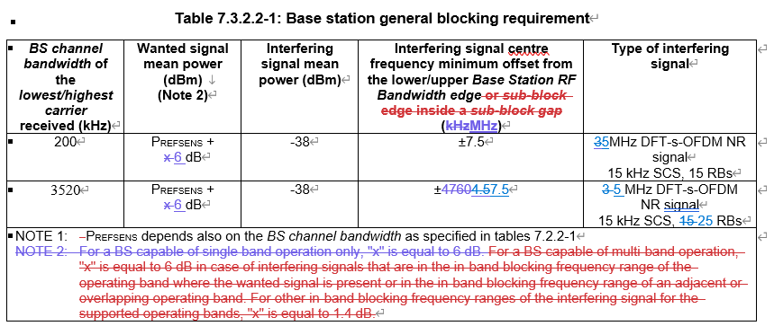
  - Option 2: Others
- Recommended WF
  - FFS.
Issue 2-4: Narrowband intermodulation
- Proposals:
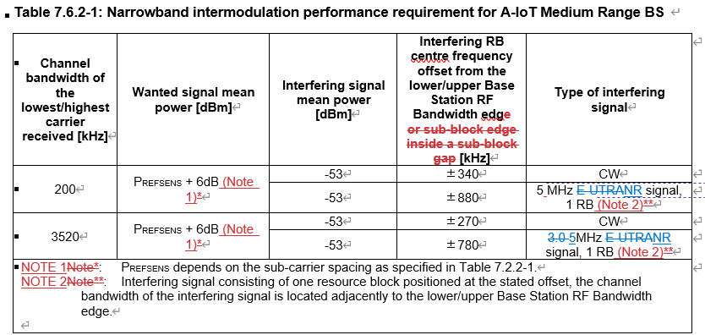
  - Option 1: Proposal 7: For narrowband intermodulation , change the type of interfering signal from LTE signal to 5M NR signal. (Huawei)
  - Option 2: Others
- Recommended WF
  - FFS.
Issue 2-5: D2R bandwidth
- Proposals:
  - Option 1: BS Manufacture declare the scaling factor for the D2R bandwidth to improve the D2R coverage. (Eri)
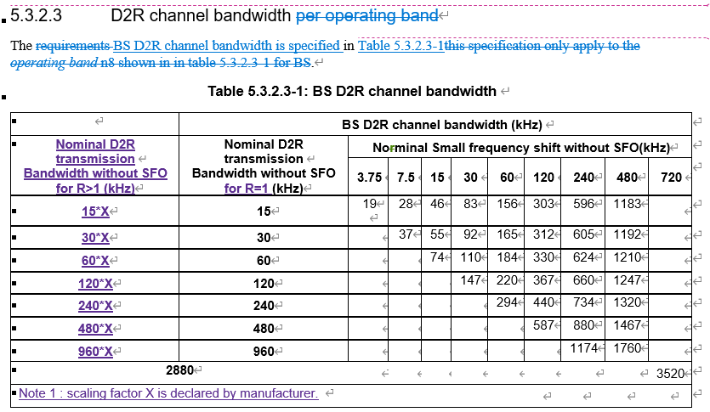
  - Option 2: Others
- Recommended WF
  - FFS.

Sub-topic 2-3 recommendation for the draft CR provided in this meeting
T-doc number | Company | Proposals / Observations | recommendation
R4-2520098 | CATT | 1. Clarify the BW with “D2R” or “R2D”;  2. Define a new definiton of “BS D2R channel bandwidth for RX requirements definition” to capture 200kHz;  3. Align the usage of transmission BW configuration.  4. Correct the interfering offset for RX requirements. | Can be merged
R4-2520163 | CATT | To supplement missing Annex of characteristics of the interfering signal for A-IoT BS | Further check
R4-2520164 | CATT | To correct the description of A-IoT BS channel bandwidth of ACS/general blocking/narrowband intermodulation requirement for A-IoT BS, the description should be consistent with other descriptions of channel bandwidth in the spec.  To correct the type of interfering signal of ACS requirement for A-IoT BS | Revised to R4-2522325
R4-2522325 | CATT | 1. Clarify the BW with “D2R” or “R2D”;  2. Define a new definiton of “BS D2R channel bandwidth for RX requirements definition” to capture 200kHz;  3. To correct the description of A-IoT BS channel bandwidth of ACS/general blocking/narrowband intermodulation requirement for A-IoT BS, the description should be consistent with other descriptions of channel bandwidth in the spec.  4. To correct the type of interfering signal of ACS requirement for A-IoT BS  5. Correct the interfering offset for RX requirements. | Further check
R4-2520410 | Huawei, HiSilicon | 1) A-IoT receiver requirements apply with a frequency offset Foffset;  2) Change the interfering signal for ACS, in-band blocking, and narrowband intermodulation from 3 MHz E-UTRA/NR to 5 MHz NR.  3) For 200kHz D2R CBW, change the ACS interfering signal center frequency offset to the lower/upper Base Station RF Bandwidth from +/-100kHz to +/-340kHz.  4) For 3.52M D2R CBW, change the ACS interfering signal center frequency offset to the lower/upper Base Station RF Bandwidth from +/-100kHz to +/-2500kHz. | Wait for the agreements of above issues
R4-2520872 | China Telecom | CR for TS 38.194 on including n5 for A-IoT. | Wait for the agreements of Issue 1-2-1
R4-2521998 | Ericsson | Adding manufacture declaration factor on the D2R bandwidth definition;  Correcting some definition of the test metric definition for Tx modulartion siganl quality | Wait for the agreements of Issue 1-5

Topic #3: OTA test method for A-IoT device 1

Companies’ contributions summary
T-doc number | Company | Proposals / Observations
R4-2520306 | China Mobile Com. Corporation | This is the formal CR version of draft CR R4-2515144 which has been endorsed in RAN4 #116bis meeting.  For sub-clause 8.4.3, 1)Delete brackets in clause 8.4.3. 2)add missing value of the CW incident power at the device antenna, i.e.10dB higher than the receiver sensitivity requirement.  For sub-clause 8.4.2, RF core requirement reference clause for backscatter power measurement is updated as clause 6.

