3GPP TSG-RAN4 Meeting #117 R4-2522210

Dallas, USA, 17th Nov 2025 – 21st Nov 2025

Agenda item: 4.1.3
Source: Moderator (Eutelsat Group)
Title: Topic summary for [117][303] Ku_band_Maintenance
Document for: Information

Introduction
This is the topic summary for Ku Band maintenance.
:
    - Introduction of Ku Band for NR NTN [NR_NTN_Ku_bands-Core]
      - System parameters [NR_NTN_Ku_bands-Core]
      - UE RF requirements [NR_NTN_Ku_bands-Core]
      - SAN RF core requirements
      - RRM core requirements
.

Topic #1: System parameters (agenda 4.2.7.1)

Companies’ contributions summary
All Tdocs related to the following topics (agenda 4.2.7.1) are listed here:

Tdoc | Company | Proposals / Observations
R4-2520056 | CATT | Proposal 1: Add “unless otherwise stated” to NOTE 1 for FR1-NTN to follow the treatment in Note 2 for FR2-NTN.  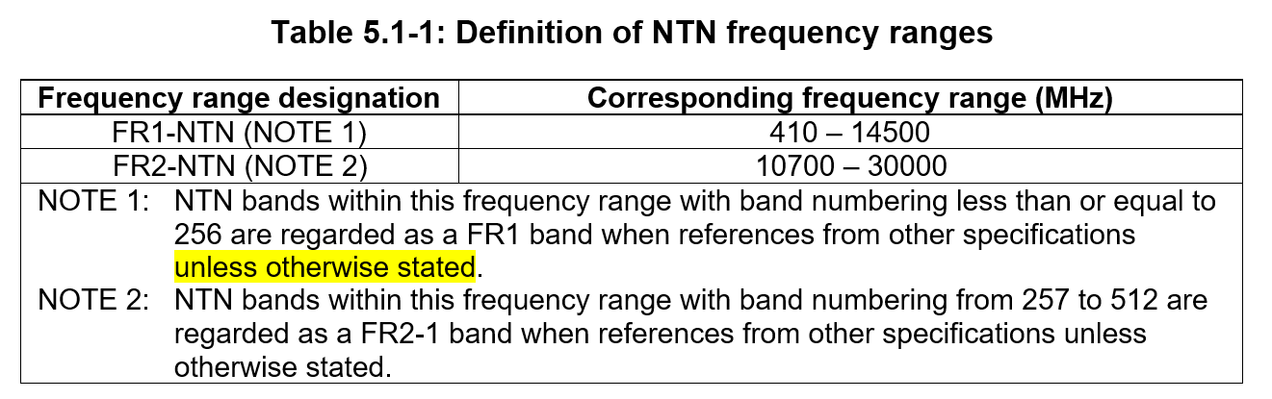
R4-2520057 | CATT | CR for 38.101-5, On FR1-NTN frequency range for NR NTN Ku band  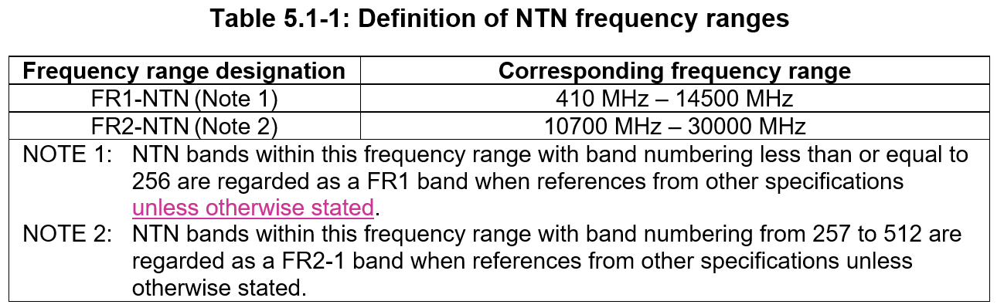
R4-2520058 | CATT | CR for 38.108, On FR1-NTN frequency range for NR NTN Ku band  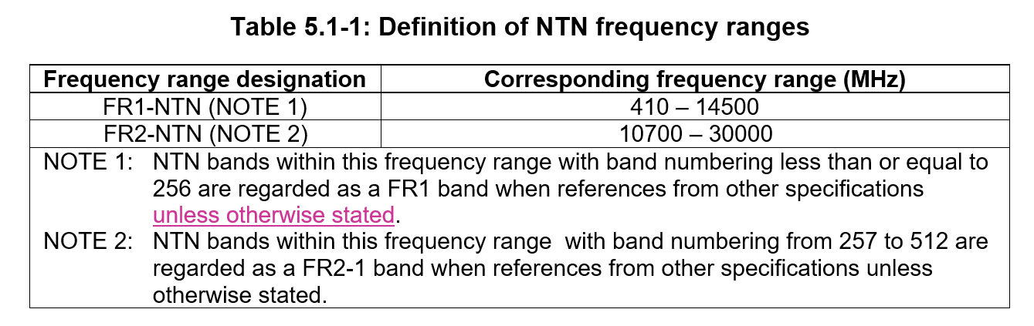
R4-2520501 | Xiaomi | CR on NTN frequency range definition (38.108)  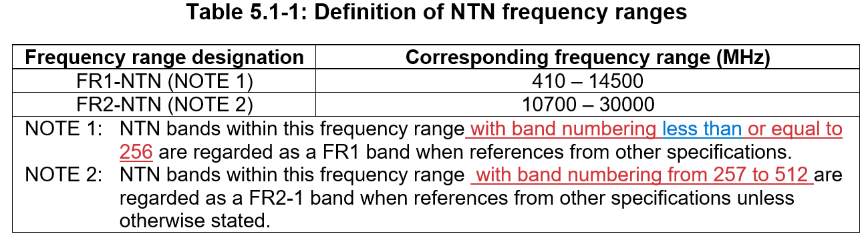
R4-2520502 | Xiaomi | CR on NTN frequency range definition (38101-5)  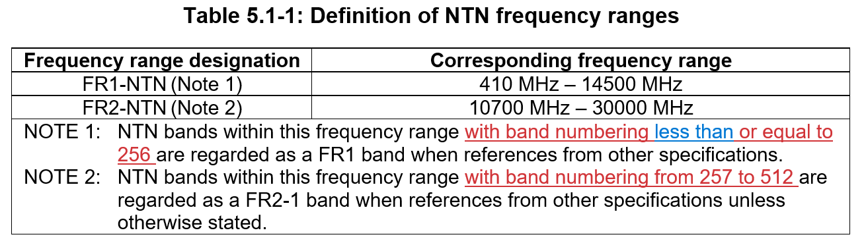
R4-2521427 | Ericsson | CR to TR 38.863 - Regulatory context for the NTN Ku-bands
R4-2522034 | Keysight Technologies UK Ltd | Corrections based on NR_UE_OTA_Enh Testability Discussions  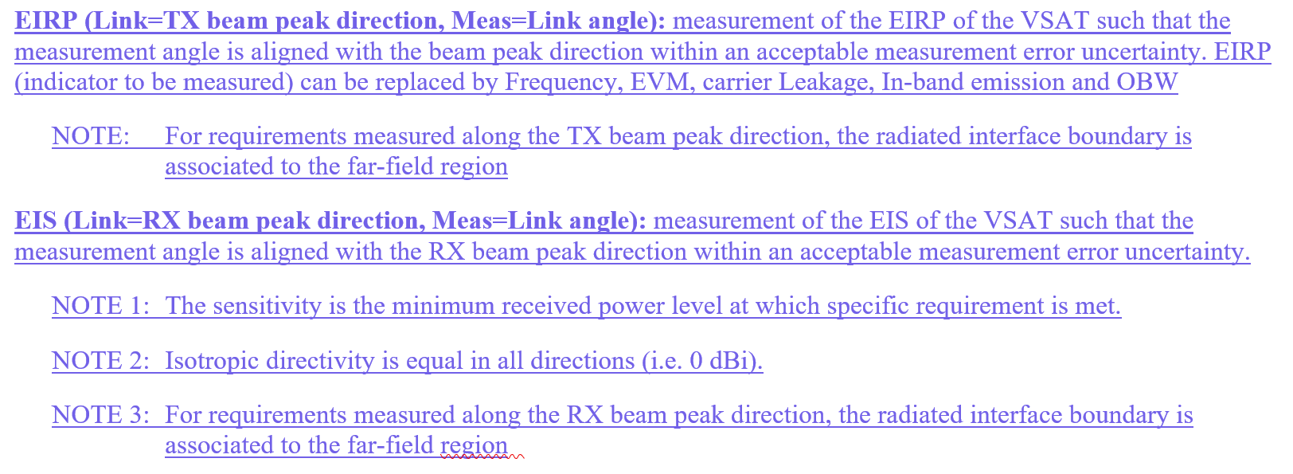  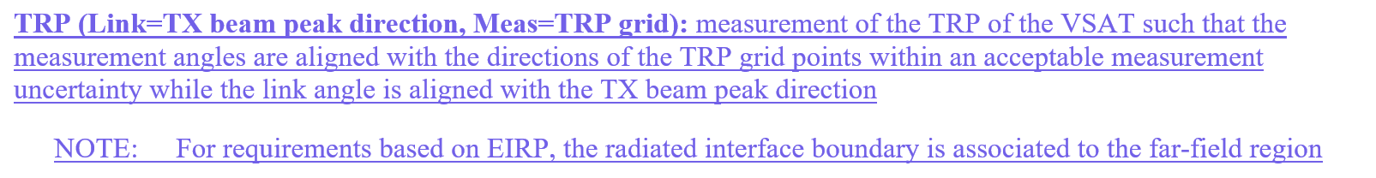  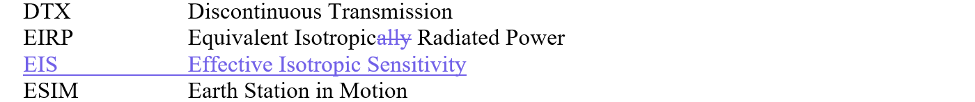  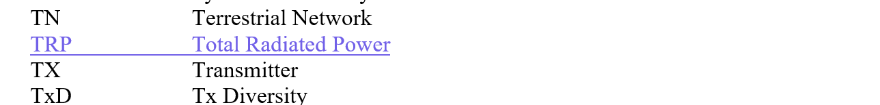  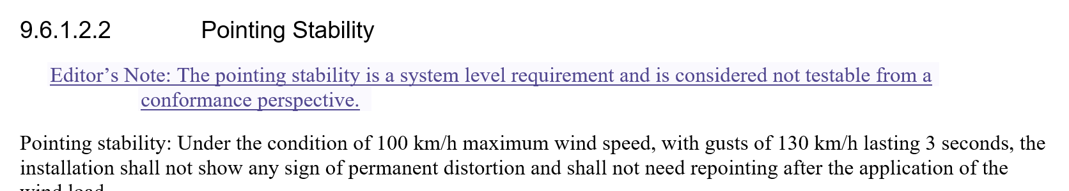  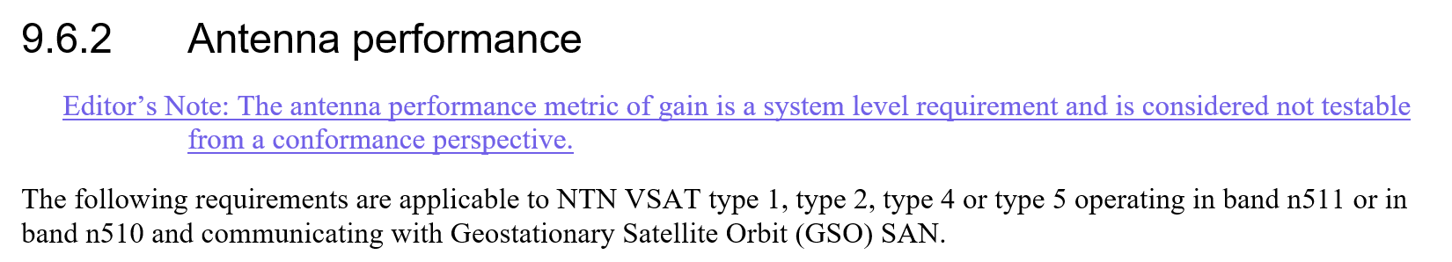

Open issues summary

Sub-topic 1-1: Clarification of NTN frequency ranges
- Proposals: CRs from CATT in R4-2520057 and R4-2520058 and CRs from Xiaomi in R4-2520502 fand R4-2520501
CR to 38.101-5

CR to 38.108
CR on NTN frequency range definition (38101-5)

CR on NTN frequency range definition (38.108)

- Moderator Recommendation:
- Based on the endorsed draft CRs at RAN4 #116bis in R4-2515135 and R4-2515136 the CRs in R4-2520057 and R4-2520058 should be approved.
- Based the discussion document R4-2520056 the principle in the CRs of in R4-2520057 and R4-2520058 is agreeable, however, the CRs are based on an assumption that the draft CRs in R4-2515135 and R4-2515136 were already implemented, rather than the current version of 38.101-5 and 38.108 which do not yet include these changes. There fore the CRs in R4-2520057 and R4-2520058 need to be revied to reflect the current version of 38.101-5 and 48.108. The two sets of CRs do not overlap, so can each reflect specific changes, and the spec rapporteur can merge them.
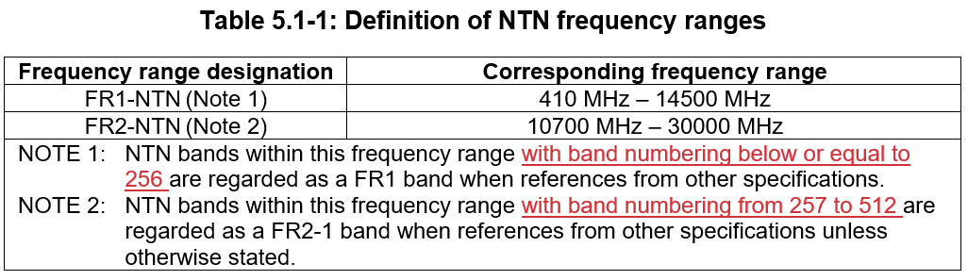

- Moderator Recommendation:
- Endorse the draft CRs in R4-2513449 and R4-2513450

Sub-topic 1-2: Regulatory updates
- Proposals: CR from Ericsson in R4-2521427
- Moderator Recommendation:
- The CR is a re-presentation of the endorsed draft CR at RAN4 #116bis in R4-2513831. Approve the CR in R4-2521427.

Sub-topic 1-3: Corrections to 38.101-5 related to NR_UE_OTA_Enh Testability

- Moderator Recommendation:
- Approve the CR rom Keysight in R4-2522034

Topic #2: UE RF requirements (agenda 4.2.7.2)

Companies’ contributions summary
All Tdocs related to the following topics (agenda 4.2.7.2) are listed here:

 | T-doc | Company | Proposals / Observations
 | R4-2520059 | CATT | CR to 38.101-5 to align SCS for SSB and data channel  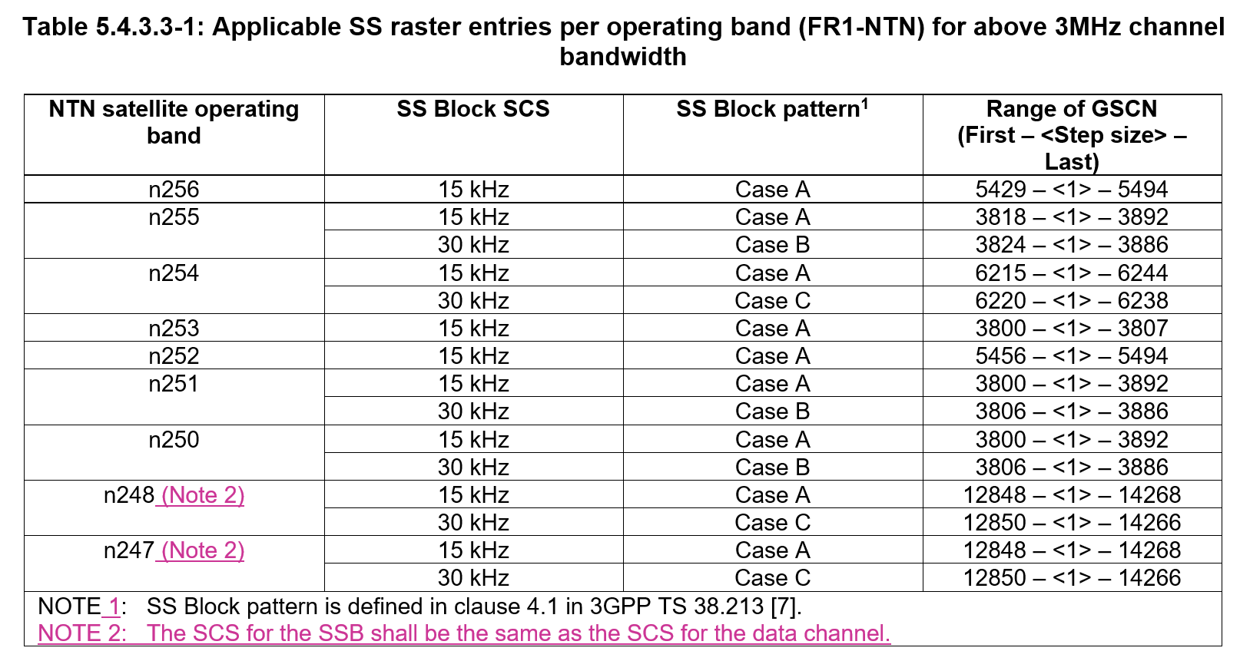
 | R4-2520528 | LG Electronics, Thales | Max Peak EIRP value for NTN UE in Ku-band  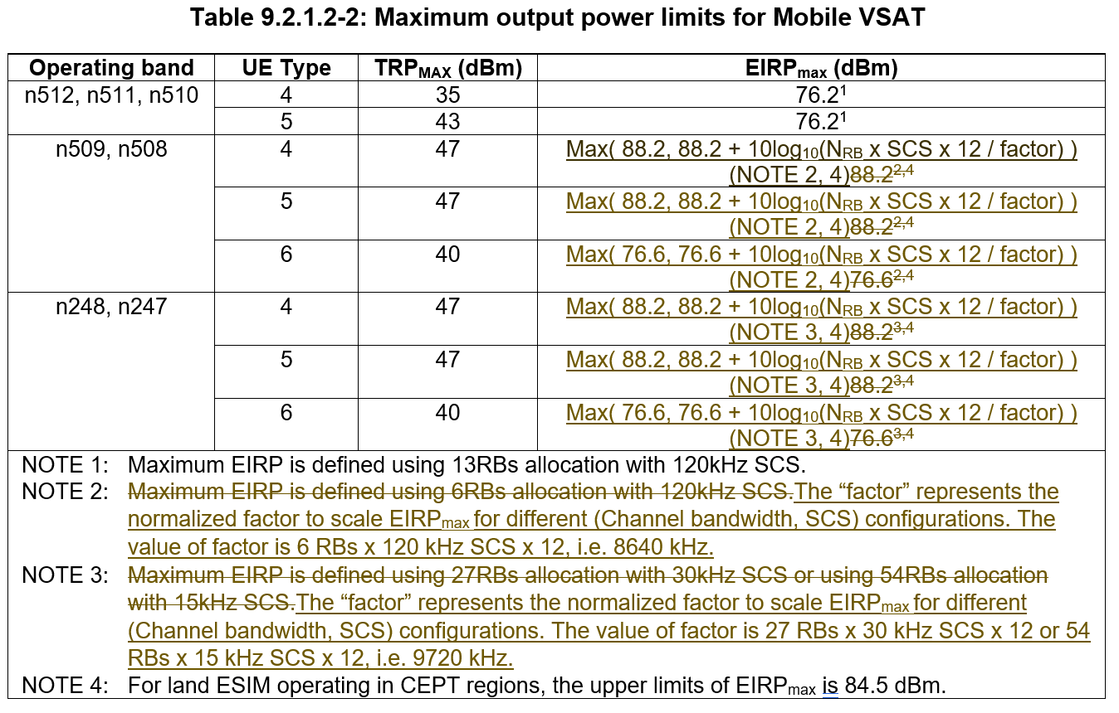
 | R4-2520529 | LG Electronics, Thales | Min Peak EIRP value for NTN UE in Ku-band  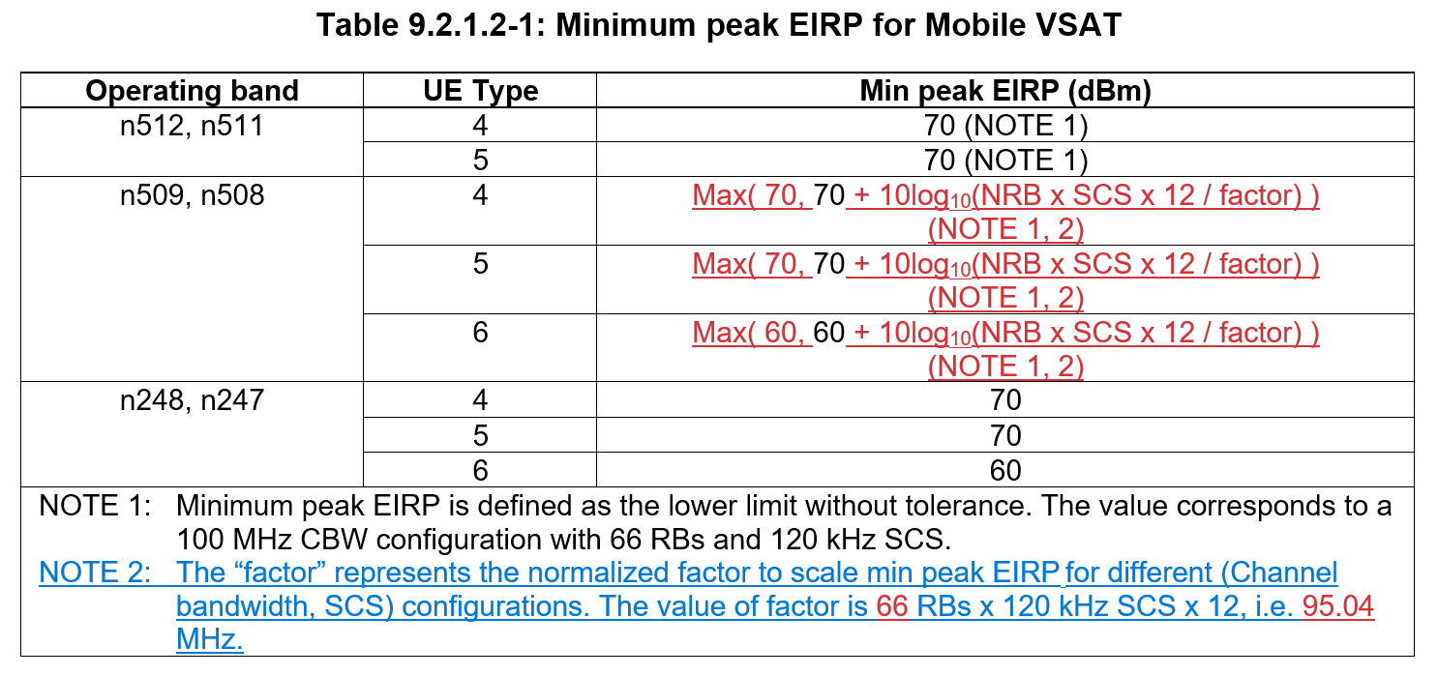
 | R4-2520962 | CHTTL, LG Electronics, ZTE Corporation, SGS Wireless | Correction of NTN Ku band VSAT requirements for section 10.3, 10.5 and 10.6  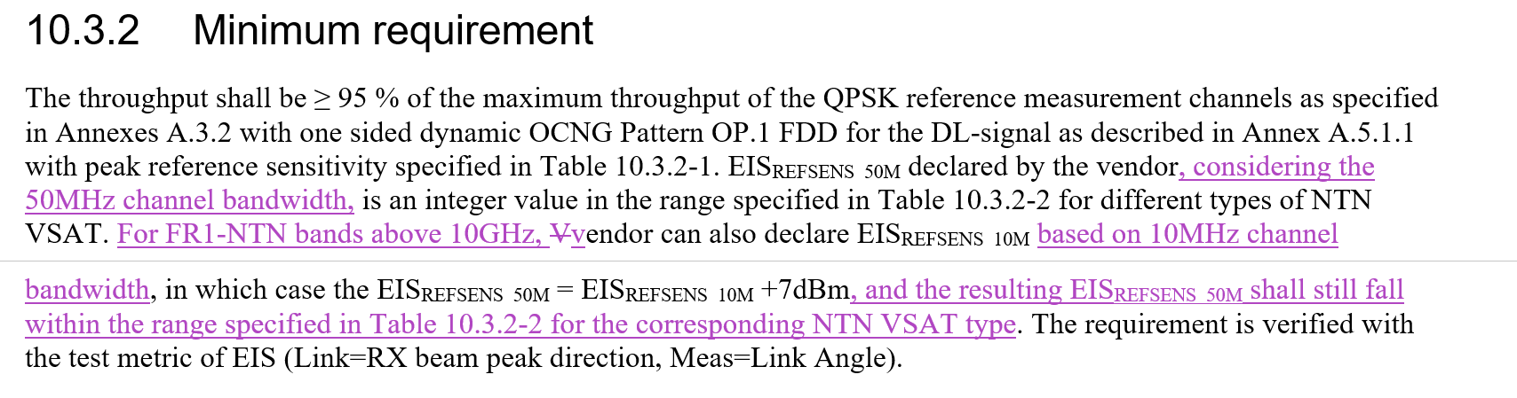  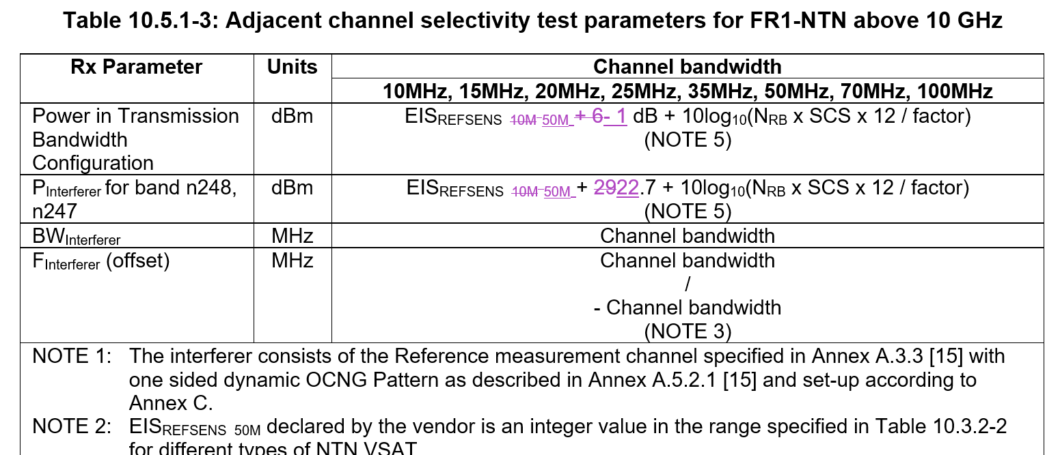  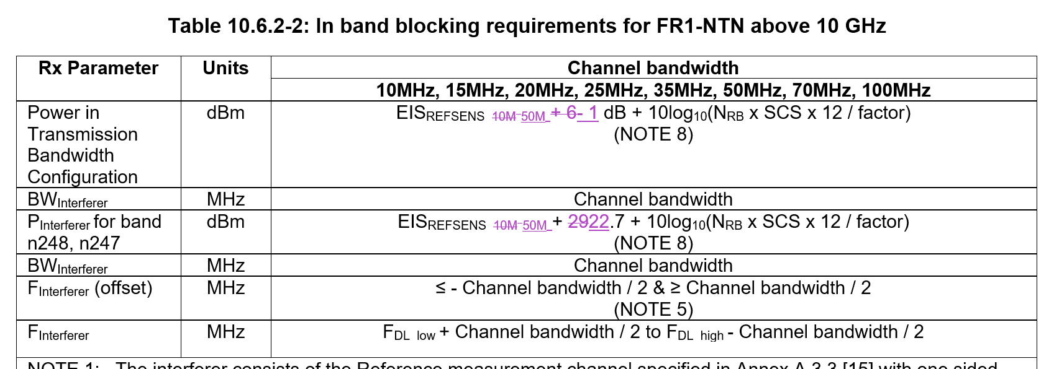
R4-2521054 |  | ZTE Corporation, Sanechips | Configured transmitted power  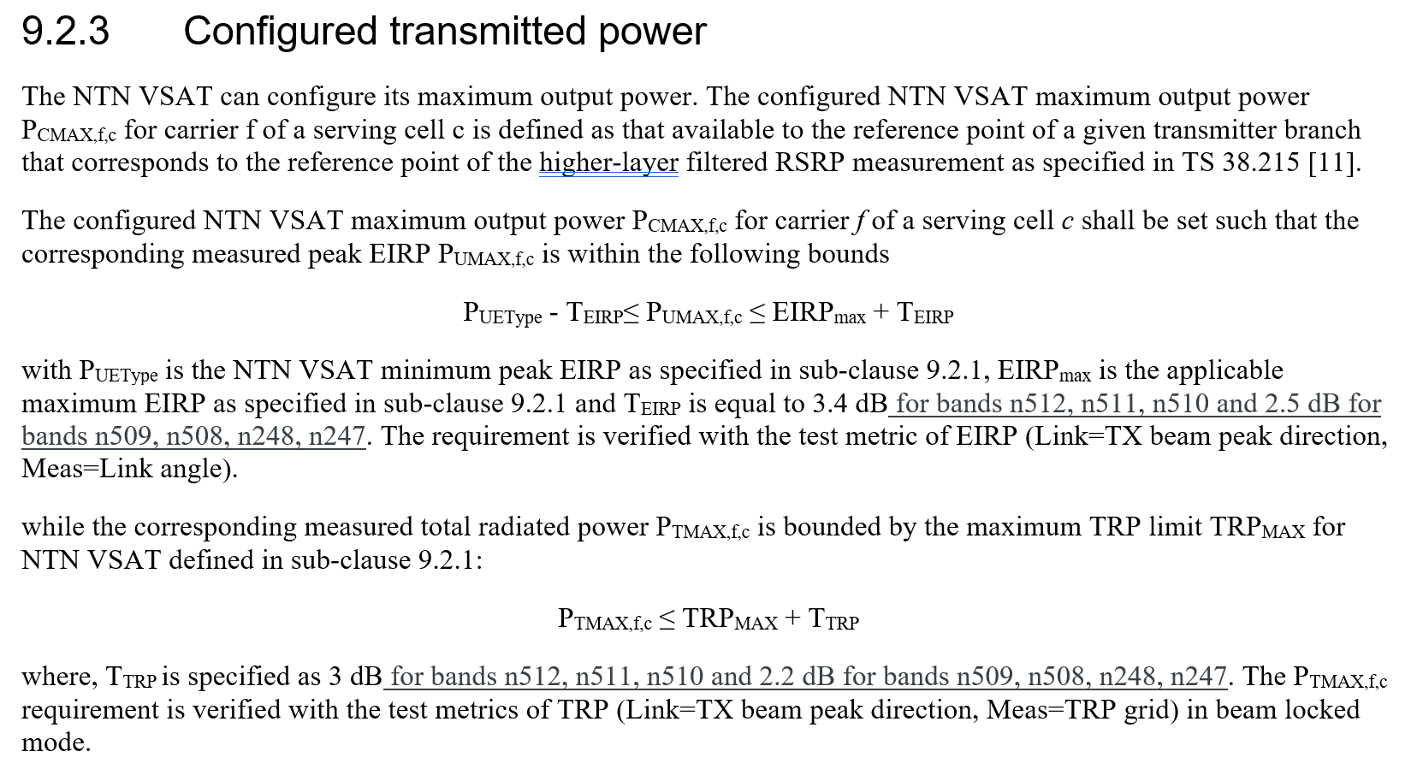
 | R4-2521055 | ZTE Corporation, Sanechips | Receiver antenna off-axis performance should apply to “NS_206N”, but currently it is not applicable  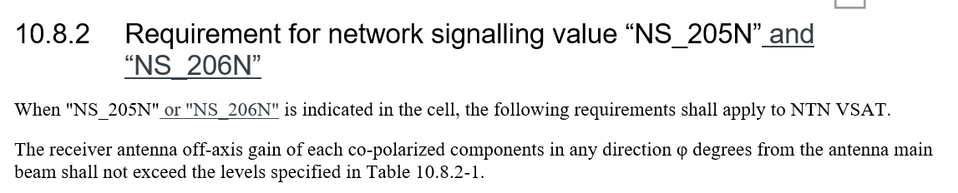  Clause numbers in Table 9.7.1-1 have some mistakes  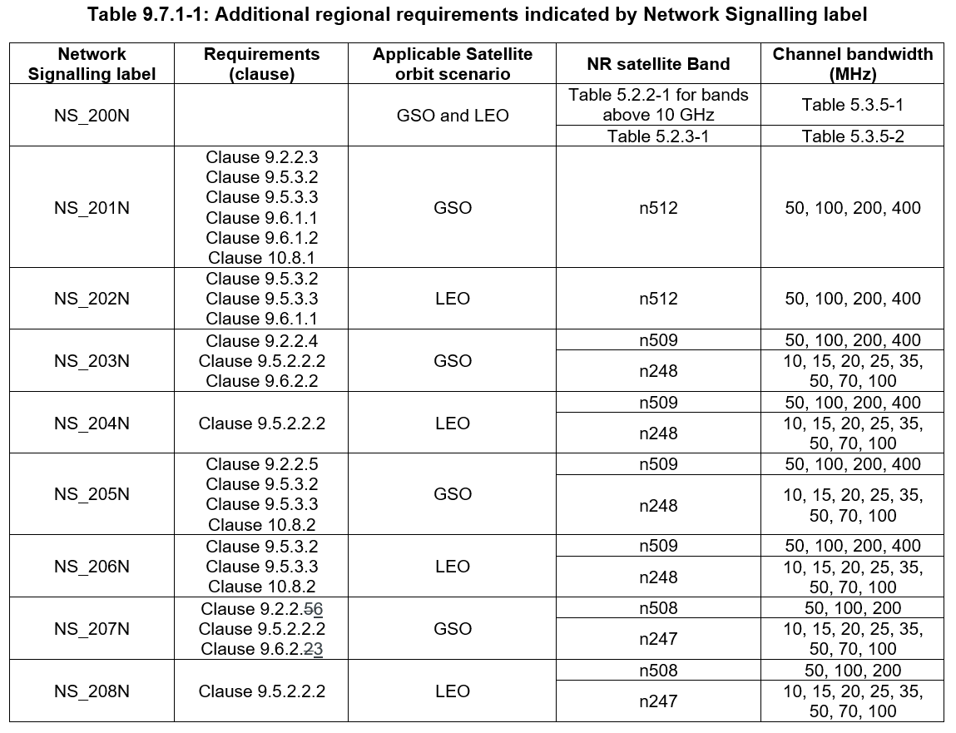
 | R4-2521426 | Ericsson, Thales | CR to introduce PFD limits
 | R4-2521448 | MediaTek Inc. | Clarification and corrections related to minimum EIRP and maximum EIRP
 | R4-2521605 | MediaTek (Wuhan) Inc. | Addition of NS_206 for off axis receiver performance  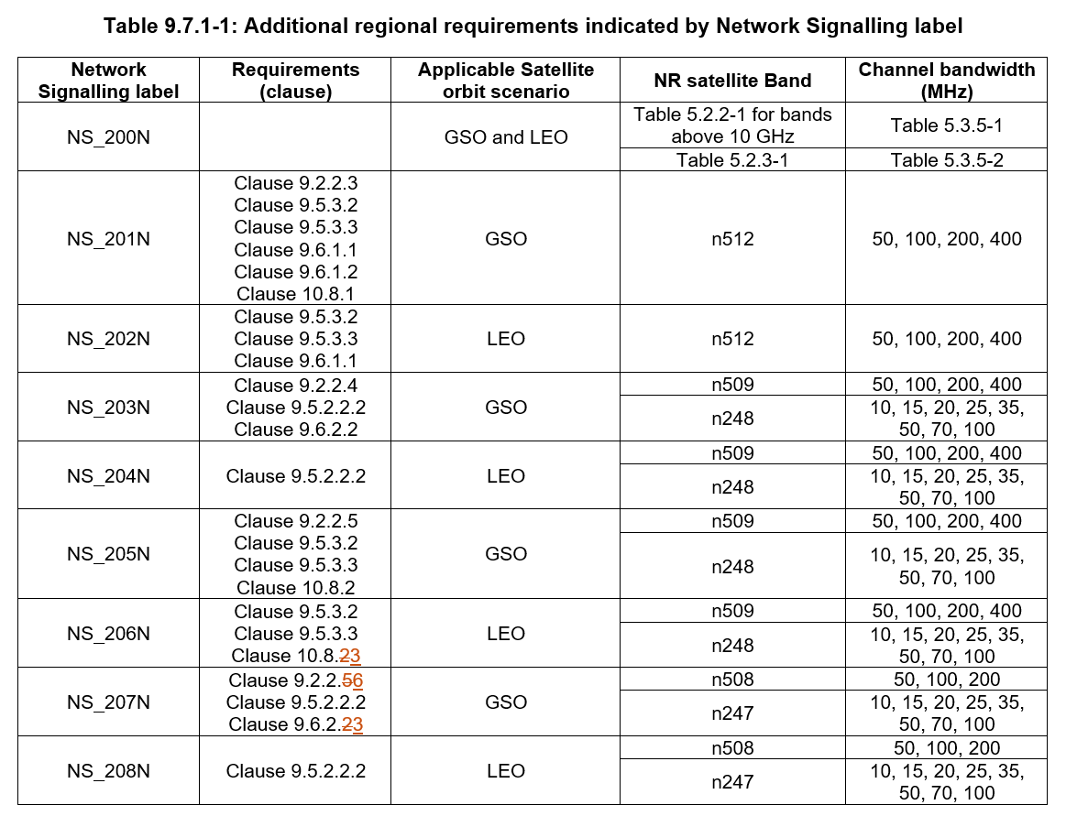  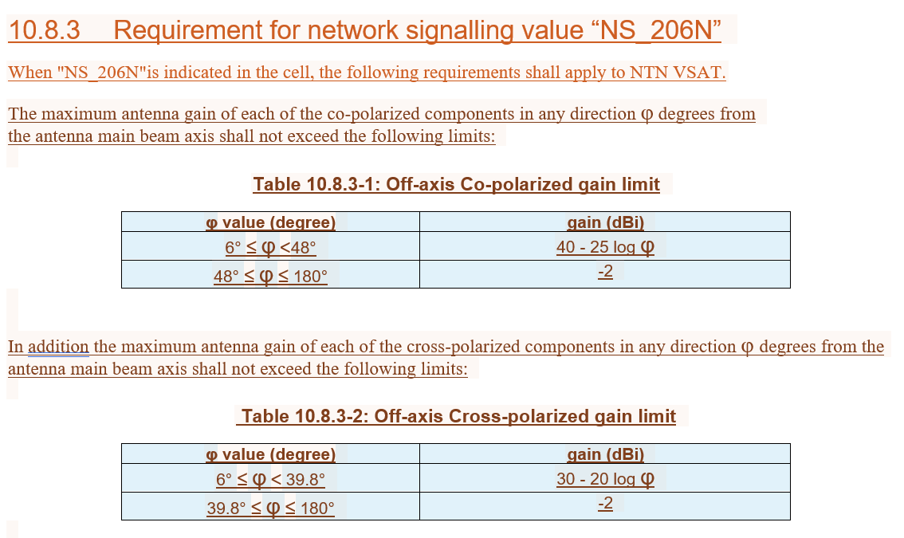

Open issues summary

Sub-topic 2-1: Alignment of SSB and Sync raster SCS
- Proposals:
- CR from CATT in R4-2520059
- Moderator Recommendation:
- Based on the endorse CR at RAN4 #116bis in R4-2513150, approve the CR in R4-2520059

Sub-topic 2-2: Max Peak EIRP value for NTN UE in Ku-band
- Proposals:
- CR from LGE in R4-2520528
- Moderator Recommendation:
- Discussion required

Sub-topic 2-3: Min Peak EIRP value for NTN UE in Ku-band
- Proposals:
- CR from LGE in R4-2520529
- Moderator Recommendation:
- Discussion required

Sub-topic 2-4: Correction of NTN Ku band VSAT requirements for section 10.3, 10.5 and 10.6
- Proposals:
- CR from CHTTL, LG Electronics, ZTE Corporation, SGS Wireless in R4-2520962

- Moderator Recommendation:
- The changes above are consistent with the endorsed CR at RAN4 #116bis in R4-2515138. The exception is the addition of the definition of EIS_{REFSENS_10M} in 3.2.
- Approve the CR in R4-2520962

Sub-topic 2-5: Configured transmitted power
- Proposals:
- CR from ZTE Corporation, Sanechips in R4-2521054
- Moderator Recommendation:
- This CR is a resubmission of the endorsed draft CR at RAN4 116bis in R4-2515138.
- Approved the daft CR in R4-2521054

Sub-topic 2-6: Applicability of antenna off-axis performance to “NS_206N
- Proposals:
- CR from ZTE Corporation Sanechips in R4-2521055
Editorial corrections
- Moderator Recommendation:
- This CR is a resubmission of one of the changes in the draft CR at RAN4 116bis in R4-2514023. The CR cover sheet incorrectly states it is a resubmission of the endorsed draft CR in R4-2515138 which is a different topic.
- Revise the cover sheet to correct the history. The content is agreeable.

Sub-topic 2-7: PFD limits
- Proposals:
- CR from Ericsson in R4-2521426
- Moderator Recommendation:
- This CR is based on the endorsed principle at RAN4 #116bis in R4-2513828.
- Clarification on what EIRP assumptions were used for the selected limits would be useful
- Discussion required

Sub-topic 2-8: Clarification and corrections related to minimum EIRP and maximum EIRP
- Proposals:
- CR from MediaTek Inc. in R4-2521448
- Moderator Recommendation:
- Does this impact Rel-18? Discussion required

Sub-topic 2-9: Corrections for NS_206 and NS_207
- Proposals:
- CR from MediaTek (Wuhan) Inc. in R4-2521605

- Moderator Recommendation:
- CR title is too generic, a more specific title would help for the spec change history
- Discussion required.

Topic #3: SAN RF requirements (agenda 4.2.7.3)

Companies’ contributions summary
All Tdocs related to the following topics (agenda 4.2.7.3) are listed here:

T-doc | Company | Proposals / Observations
R4-2520060 | CATT | CR to 38.108 to align SCS for SSB and data channel  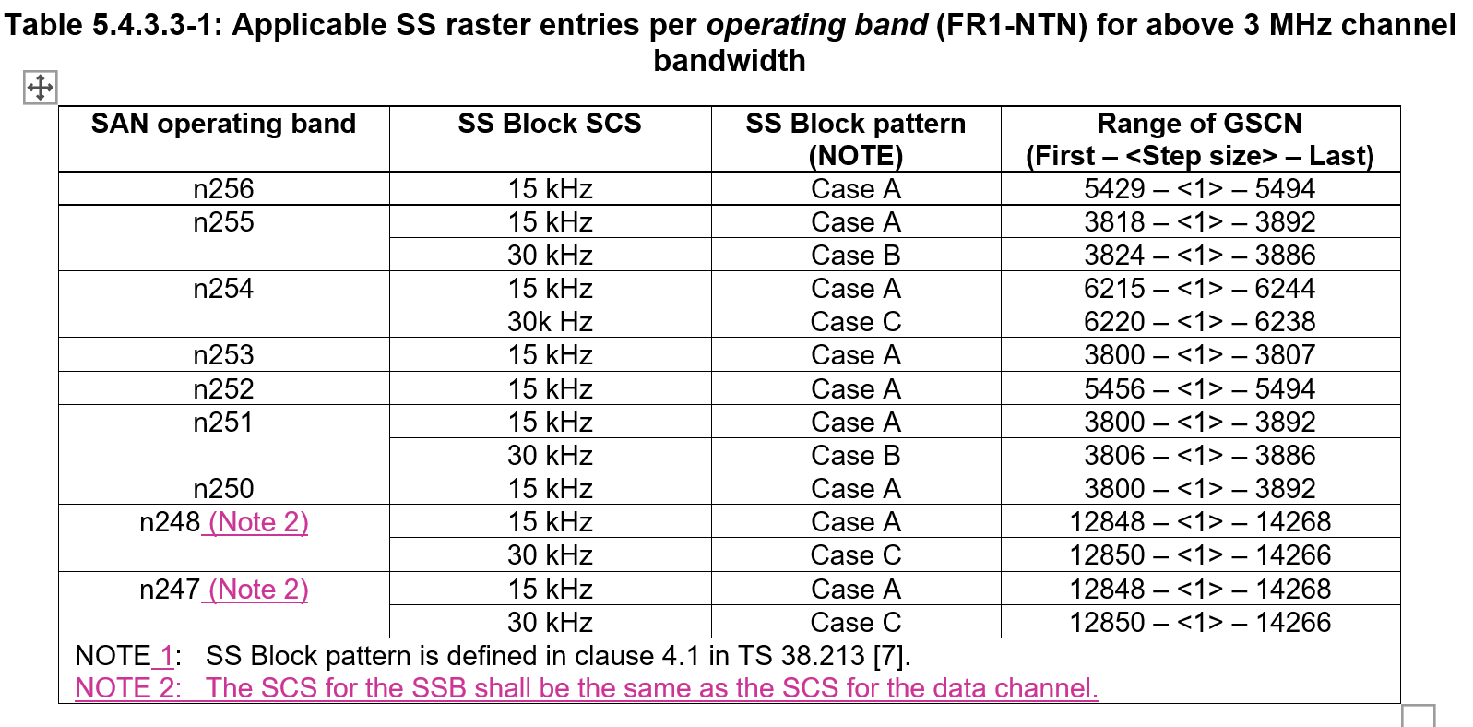
R4-2520171 | CATT | CR to correct the SAN channel bandwidth of ACLR for SAN operating under Ku band  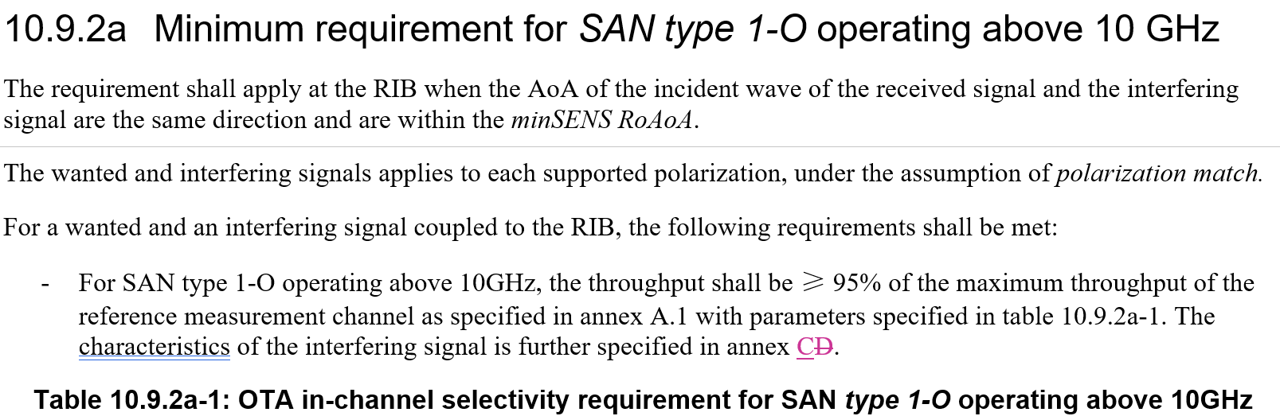
R4-2520999 | CHTTL, Ericsson, ZTE Corporation, SGS Wireless | CR for 38.108 for correction of NTN Ku band SAN requirements for section 9.4, 9.6, 10.3, 10.4 and 10  The big CR for 38.108 for Re.19 NTN Ku band was agreed during last RAN4 meeting. The group agree to introduce the FR1-NTN Ku band SAN requirement by separating the subclause of SAN type 1-O to operating below 10GHz and above 10GHz. However, as some section are expected to be no impact in the beginning, this cause misalignment between different sections. This draft CR is proposed to correct this issue. In addition, few corrections are made after further review.  This draft CR provides the following corrections:  - Aligning the clause title as “SAN type 1-O operating below 10GHz”, and “SAN type 1-O above operating 10GHz” for section 9.4.2.2, 9.4.4, 9.6.1.2, 9.6.1.2a (new), 9.6.2.2, 9.6.2.2a (new), 10.4.2.  - Add note 2 to Table 10.3.2a-1 to align with Table 10.3.3-1.
R4-2521056 | ZTE Corporation, CHTTL | Addition of EVM window length  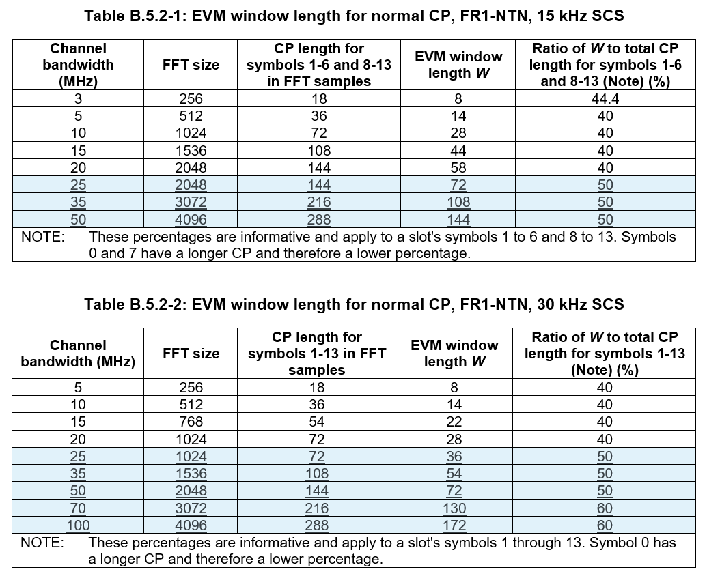
R4-2521057 | ZTE Corporation, CHTTL | EIRP and TRP tolerance, OTA transmitter emissions requirement for Ku bands are wrong.  1. Revise EIRP and TRP tolerance for FR2-NTN Ku bands  2. Revise OTA transmitter spurious emissions for FR1-NTN and FR2-NTN Ku bands.  3. Change SAN type 1-O and SAN type 2-O to italics.  4. Change some words to non-italic such as “operating below 10 GHz”.  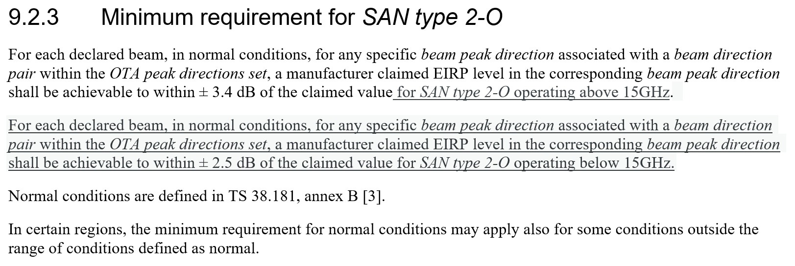  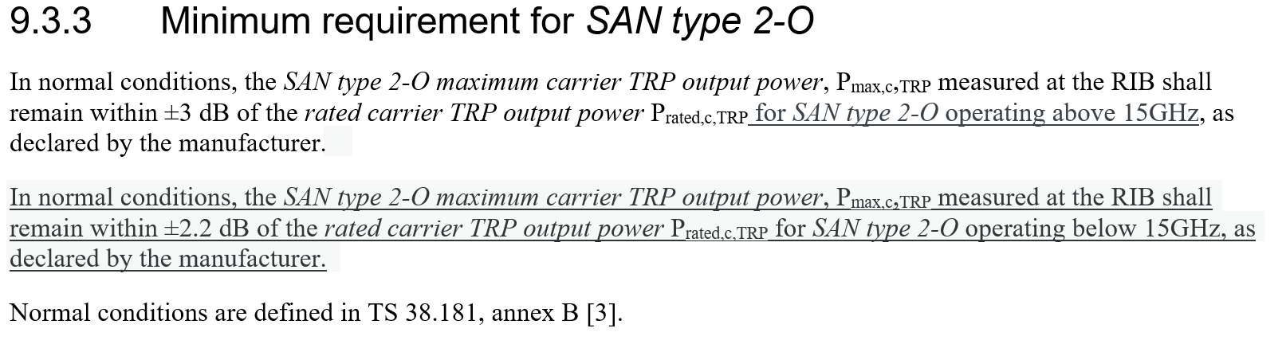  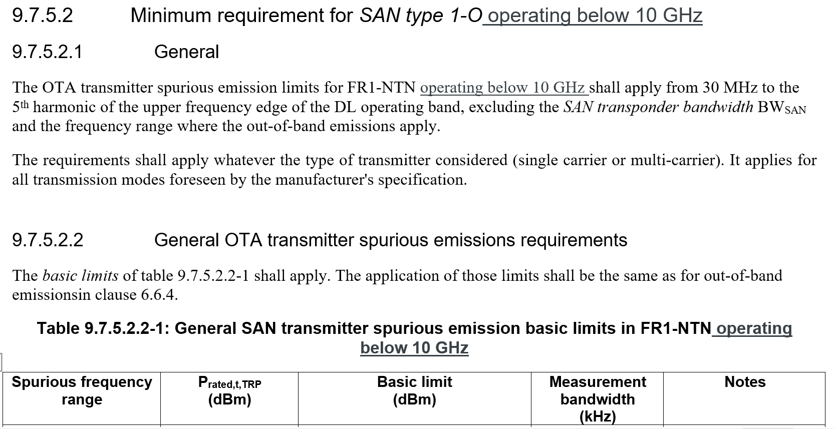  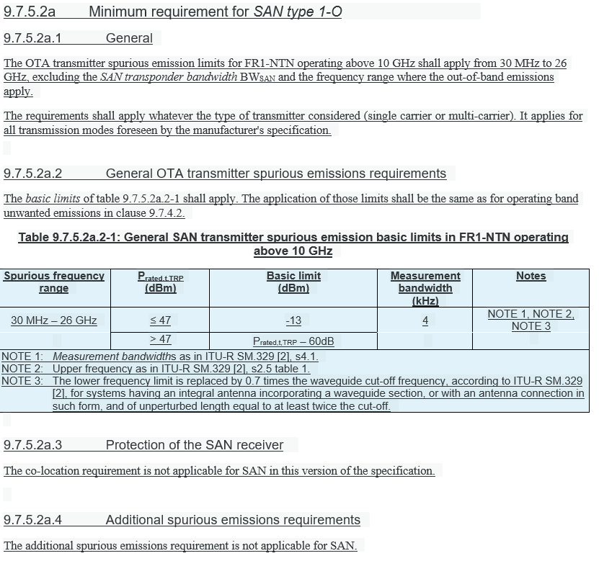  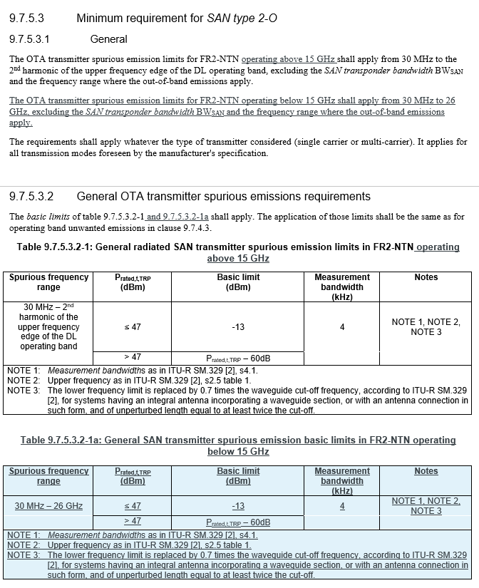

Open issues summary

Sub-topic 3-1: Alignment of SSB and Sync raster SCS
- Proposals:
- CR from CATT in R4-2520060
- Moderator Recommendation:
- Based on the endorse CR at RAN4 #116bis in R4-2513153, approve the CR in R4-2520060

Sub-topic 3-2: SAN channel bandwidth of ACLR for SAN operating under Ku band Proposals:
- Proposals:
- CR from CATT in R4-2520171
- Moderator Recommendation:
- Discussion required

Sub-topic 3-3: Correction of NTN Ku band SAN requirements for section 9.4, 9.6, 10.3, 10.4 and 10
- Proposals:
- CR from CHTTL, Ericsson, ZTE Corporation, SGS Wireless in R4-2520999
  - Aligning the clause title as “SAN type 1-O operating below 10GHz”, and “SAN type 1-O above operating 10GHz” for section 9.4.2.2, 9.4.4, 9.6.1.2, 9.6.1.2a (new), 9.6.2.2, 9.6.2.2a (new), 10.4.2.
  - Add note 2 to Table 10.3.2a-1 to align with Table 10.3.3
- Moderator Recommendation:
- The CR is based on the endorsed draft CR at RAN4 116bis in Endorse the draft CR in R4-2515140 or endorse change 2 in R4-2514025
- Approved the CR in R4-2520999

Sub-topic 3-4: EVM window length
- Proposals:
- Draft CR from ZTE Corporation, CHTTL in R4-2521056
- Moderator Recommendation:
- This is a re-presentation of the endorsed draft CR at RAN4 #116bis in R4-2514024. Approve the draft CR in R4-2521056

Sub-topic 3-5: EIRP, TRP tolerances and OTA transmitter spurious emissions
- Proposals:
- CR from ZTE Corporation, CHTTL in R4-2521057
  - 1. Revise EIRP and TRP tolerance for FR2-NTN Ku bands
  - 2. Revise OTA transmitter spurious emissions for FR1-NTN and FR2-NTN Ku bands.
  - 3. Change SAN type 1-O and SAN type 2-O to italics.
  - 4. Change some words to non-italic such as “operating below 10 GHz”.

- Moderator Recommendation:
- This is a re-presentation of the endorsed CR from RAN4 #16bis in R4-2514025. Approve the CR 2 in R4-2521057

Topic #4: RRM requirements (agenda 4.2.7.4)

Companies’ contributions summary
All Tdocs related to the following topics (agenda 4.2.7.4) are listed here:

T-doc | Company | Proposals / Observations
R4-2520314 | LG Electronics | Clarify terminology and complete missing definitions for FR2 satellite switching requirements, and align exception handling consistently between hard and soft switch.  The requirements for FR2 satellite switching were updated for consistency and completion.  - replace “cell” with “satellite” in 6.1C.3.3  - include ssb-TimeOffset alongside t-ServiceStart-18 in the SI condition for the exception, and change “is acquired by” to “are available for” in 6.1C.3.3.3
R4-2521441 | vivo | Correct the UE capability in Note 3 of Table 7.1C.2-3 from ntn-VSAT-AntennaType-r19 to ntn-VSAT-MobilityType-r19.  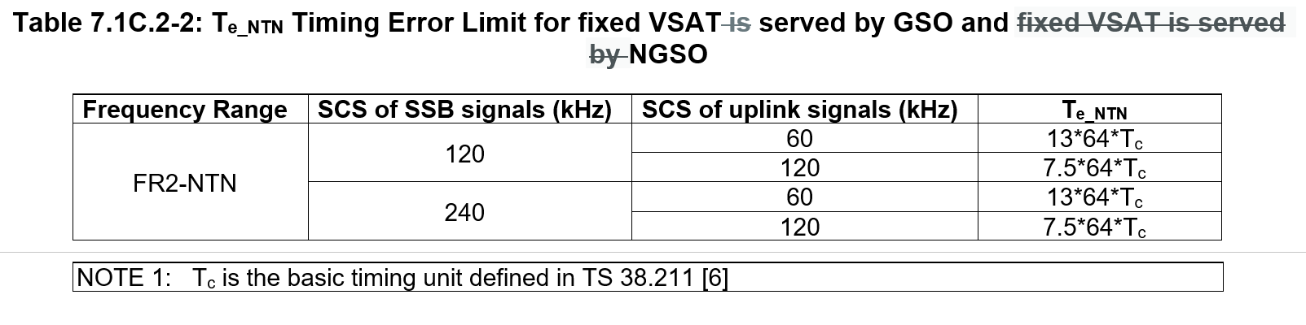  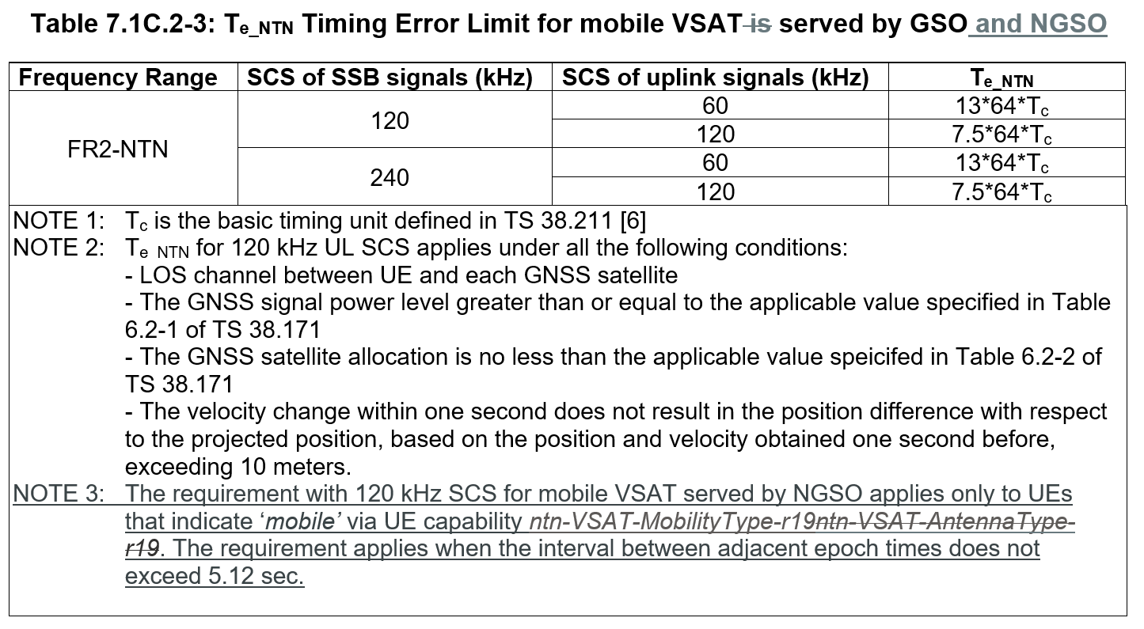
R4-2521542 | ZTE Corporation, Sanechips | Proposal 1: RAN4 shall not introduce a new window to cover SSB which does not fall in any SMTC.
R4-2521631 | Huawei, HiSilicon | Proposal: For soft satellite switch, when SSB of the target satellite does not fall in any SMTC, the scheduling restriction is defined based on a window:  - The offset of the window is the latest subframe that is no later than the SSB of the target satellite,  - The duration of the window is the smallest number in subframe that is no smaller than the burst length of the SSB of the target satellite,  - The periodicity of the window is the periodicity of the SSB of the source satellite.
R4-2521632 | Huawei, HiSilicon | The applicability of RRM requirements for VSAT UE in FR1-NTN is captured in clause 3.6. However, in clause 9 there are similar applicability specified for measurement requirements. Defining applicability for individual requirements is redundant and it cause the confusion for interpreting applicability of other individual requirements.  Remove the requirement applicability specified in clause 9 for measurement.  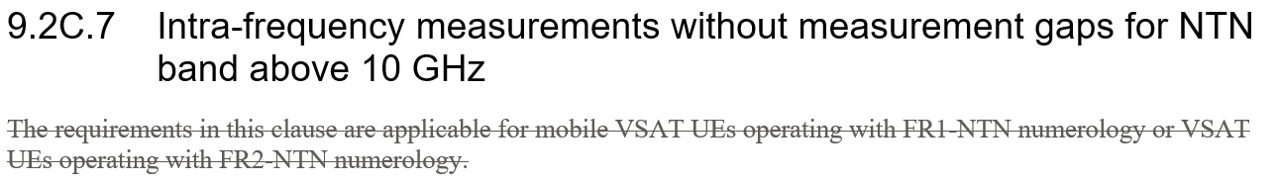  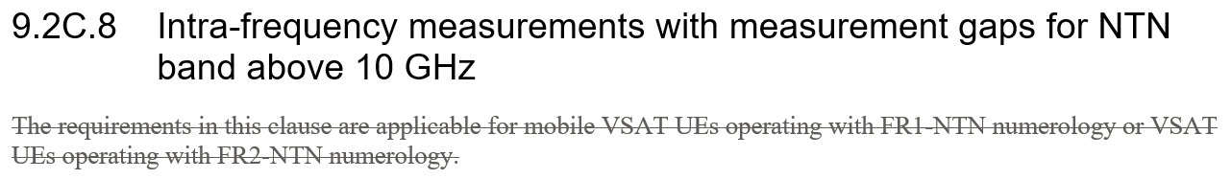  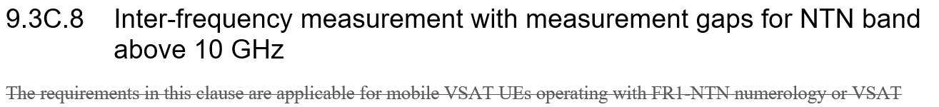  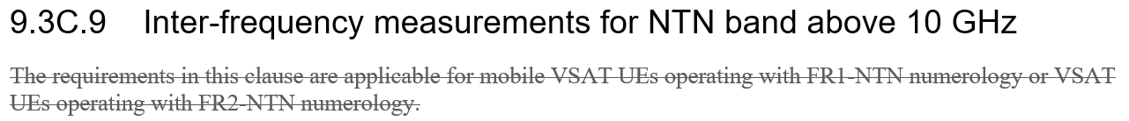  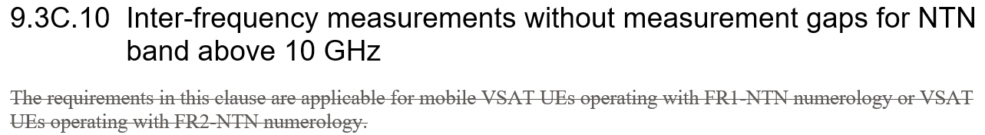

Open issues summary

Sub-topic 4-1: Corection to satellite switch requirements and exception handling
- Proposals:
- CR from LG Electronics in R4-2520314
- Moderator Recommendation:
- This is a re-presentation of the draft CR at RAN4 #116bis in R4-2515167. Note, the CR title is generic and unhelpful.
- Approve the CR in R4-2520314

Sub-topic 4-2: Correct the UE capability in Note 3 of Table 7.1C.2-3 from ntn-VSAT-AntennaType-r19 to ntn-VSAT-MobilityType-r19.
- Proposals:
- CR 2 from Vivo in R4-2521441
- Moderator Recommendation:
- This is a re-presentation of the draft CR at RAN4 #116bis in R4-2513912. Note, the CR title is generic and unhelpful.
- Approve the CR in R4-2521441

Sub-topic 4-3: Correction to use of ntn-VSAT-MobilityType-r19
- Proposals:
- Proposal 1 from ZTE Corporation, Sanechips in R4-2521542
  - Proposal 1: RAN4 shall not introduce a new window to cover SSB which does not fall in any SMTC. Moderator Recommendation:
- Moderator Recommendation:
- Discussion required. Since the status quo is being proposed, no action is required.

Sub-topic 4-4: Correction to use of ntn-VSAT-MobilityType-r19
- Proposals:
- Proposal from Huawei, HiSilicon in R4-2521631
  - Proposal: For soft satellite switch, when SSB of the target satellite does not fall in any SMTC, the scheduling restriction is defined based on a window:
  - The offset of the window is the latest subframe that is no later than the SSB of the target satellite,
  - The duration of the window is the smallest number in subframe that is no smaller than the burst length of the SSB of the target satellite,
  - The periodicity of the window is the periodicity of the SSB of the source satellite.
- Moderator Recommendation:
- Discussion required

Sub-topic 4-5: Clarification of applicability of requirements
- Proposals:
- CR from Huawei, HiSilicon in R4-2521632
  - The applicability of RRM requirements for VSAT UE in FR1-NTN is captured in clause 3.6. However, in clause 9 there are similar applicability specified for measurement requirements. Defining applicability for individual requirements is redundant and it cause the confusion for interpreting applicability of other individual requirements.
  - Remove the requirement applicability specified in clause 9 for measurement.
- Moderator Recommendation:
- This is a re-presentation of the draft CR from RAN4 #116bis in R4-2514160. Note, the CR title is generic and unhelpful.
- Approve the CR in R4-2521632

