3GPP TSG-RAN4 Meeting #117

Dallas, USA, 17th Nov 2025 – 21st Nov 2025

Agenda item: 4.1.3
Source: Moderator (Eutelsat Group)
Title: [117][303] Ku_band_Maintenance ad hoc minutes
Document for: Information

Introduction
This is the topic summary for Ku Band maintenance.
:
    - Introduction of Ku Band for NR NTN [NR_NTN_Ku_bands-Core]
      - System parameters [NR_NTN_Ku_bands-Core]
      - UE RF requirements [NR_NTN_Ku_bands-Core]
      - SAN RF core requirements
      - RRM core requirements
.

Topic #1: System parameters (agenda 4.2.7.1)

Open issues summary

Sub-topic 1-1: Clarification of NTN frequency ranges
- Proposals: CRs from CATT in R4-2520057 and R4-2520058 and CRs from Xiaomi in R4-2520502 fand R4-2520501
CR to 38.101-5
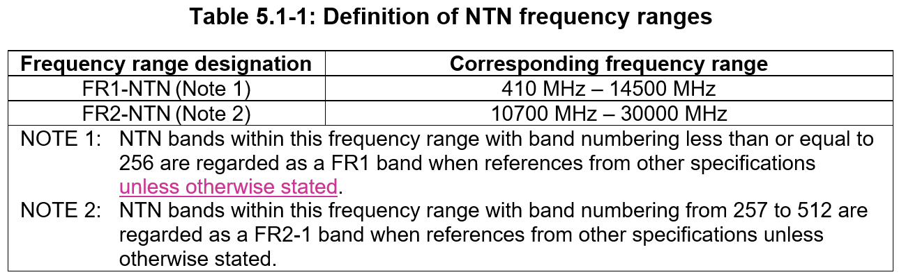

CR to 38.108
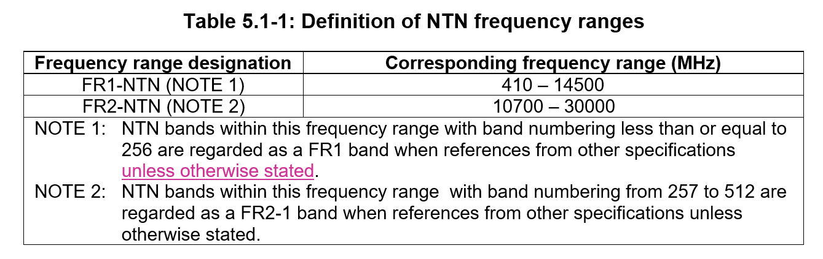
CR on NTN frequency range definition (38101-5)

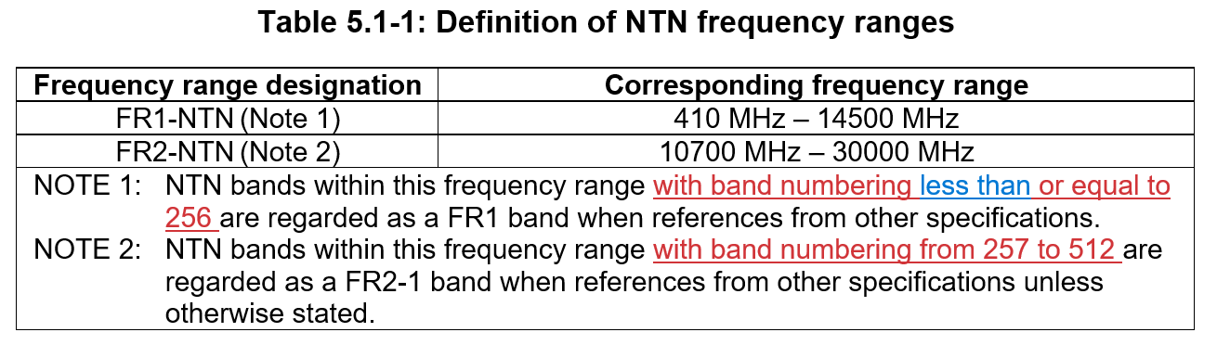

CR on NTN frequency range definition (38.108)

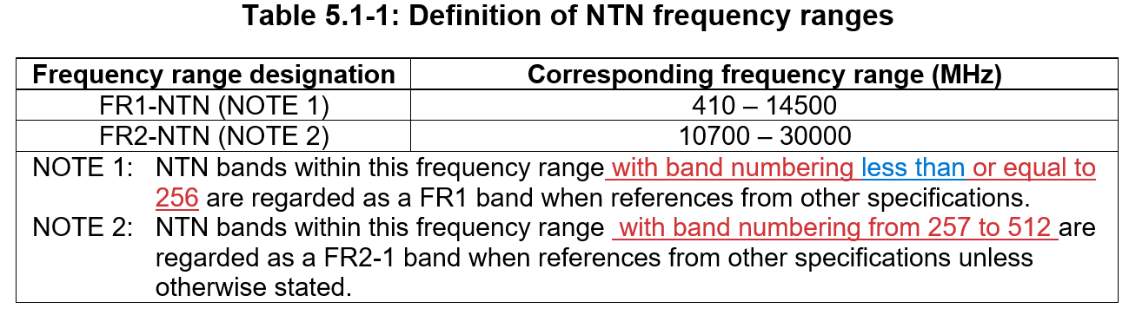
- Moderator Recommendation:
- Based on the endorsed draft CRs at RAN4 #116bis in R4-2515135 and R4-2515136 the CRs in R4-2520057 and R4-2520058 should be approved.
- Based the discussion document R4-2520056 the principle in the CRs of in R4-2520057 and R4-2520058 is agreeable, however, the CRs are based on an assumption that the draft CRs in R4-2515135 and R4-2515136 were already implemented, rather than the current version of 38.101-5 and 38.108 which do not yet include these changes. There fore the CRs in R4-2520057 and R4-2520058 need to be revied to reflect the current version of 38.101-5 and 48.108. The two sets of CRs do not overlap, so can each reflect specific changes, and the spec rapporteur can merge them.
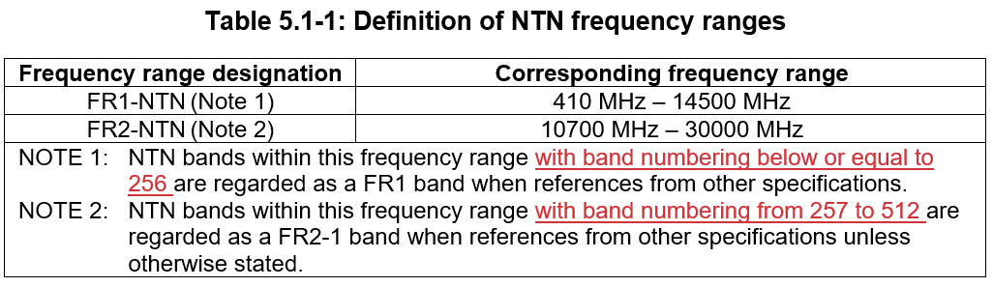

- Moderator Recommendation:
- Endorse the draft CRs in R4-2513449 and R4-2513450
Not discussed

Sub-topic 1-2: Regulatory updates
- Proposals: CR from Ericsson in R4-2521427
- Moderator Recommendation:
- The CR is a re-presentation of the endorsed draft CR at RAN4 #116bis in R4-2513831. Approve the CR in R4-2521427.
Not discussed

Sub-topic 1-3: Corrections to 38.101-5 related to NR_UE_OTA_Enh Testability

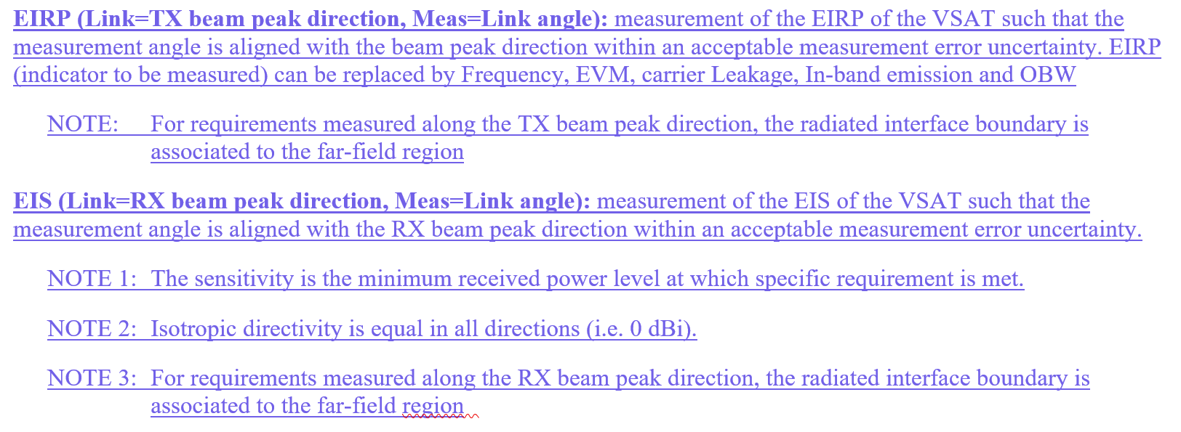
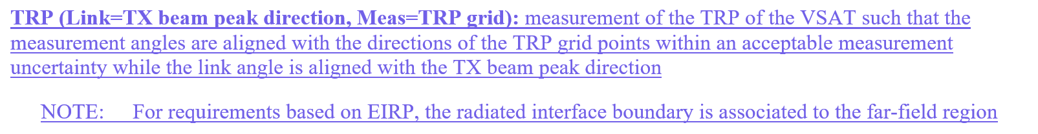
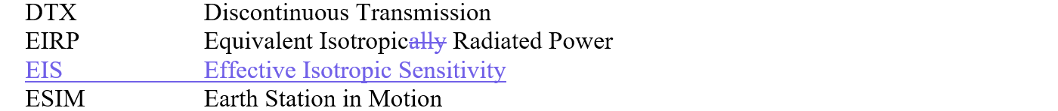
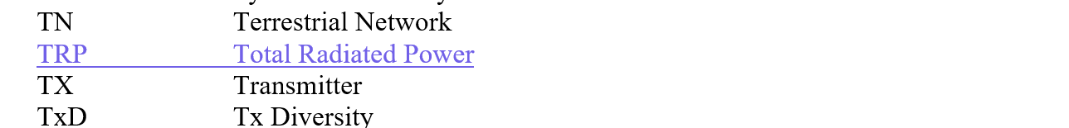
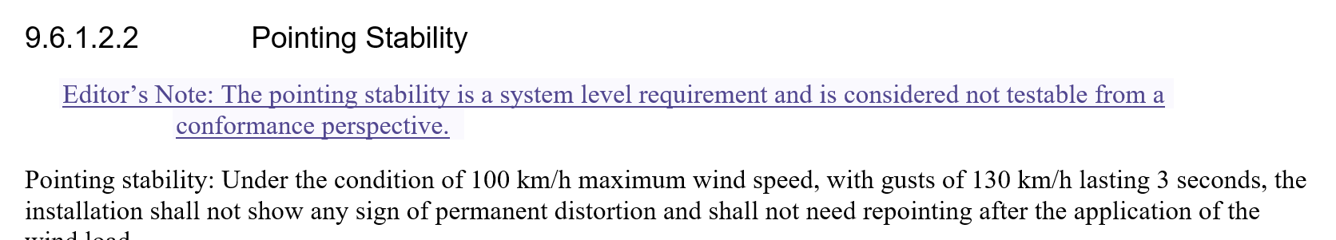
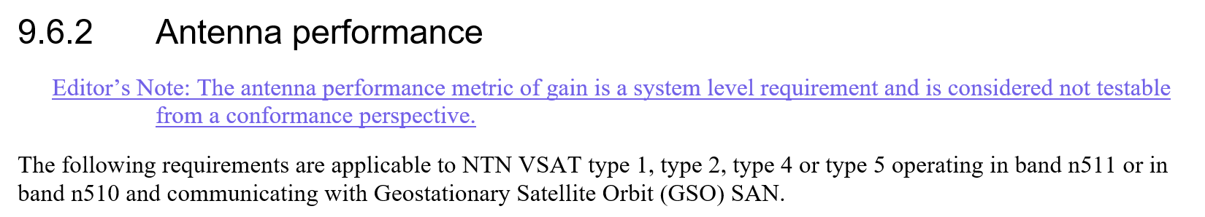

- Moderator Recommendation:
- Approve the CR rom Keysight in R4-2522034
Not discussed

Topic #2: UE RF requirements (agenda 4.2.7.2)

Open issues summary

Sub-topic 2-1: Alignment of SSB and Sync raster SCS
- Proposals:
- CR from CATT in R4-2520059
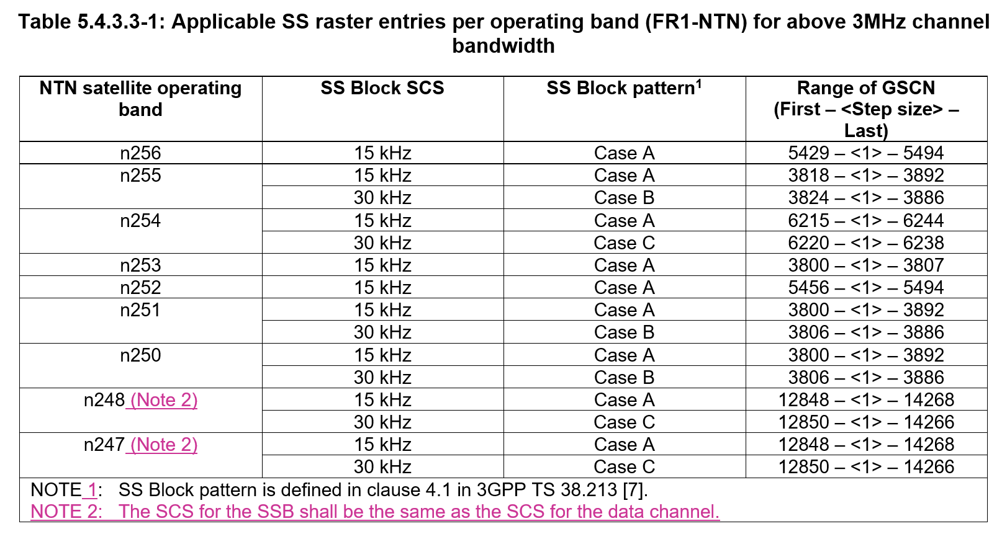
- Moderator Recommendation:
- Based on the endorse CR at RAN4 #116bis in R4-2513150, approve the CR in R4-2520059
Not discussed

Sub-topic 2-2: Max Peak EIRP value for NTN UE in Ku-band
- Proposals:
- CR from LGE and Thales in R4-2520528
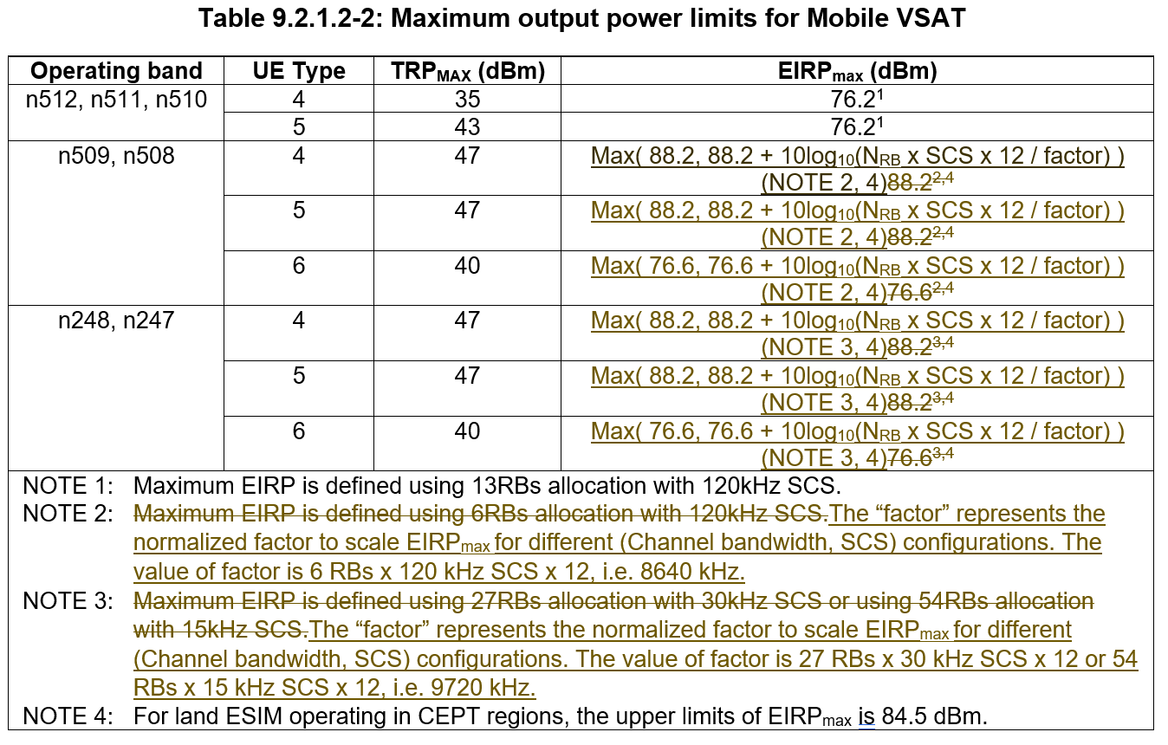
- Moderator Recommendation:
- Discussion required
LGE: Power is fixed for narrower bandwidths and increases at some transition bandwidth (100 MHz).
CHTTL: OK with approach but if we agree to do this then simplify it for EIS.
Mediatek: Agree with the LGE approach.
ZTE: Some concern, propose to use the same way as Ka band. Not in favor of scaling, Only need a fixed value due to lack of co-existience results for other bandwidths.
LGE: How then is power defined for different bandwidths? There will be a gap in the requirements.
Mediatek: Support LGE.

Moderator: Further offline discussion required.

Sub-topic 2-3: Min Peak EIRP value for NTN UE in Ku-band
- Proposals:
- CR from LGE in R4-2520529
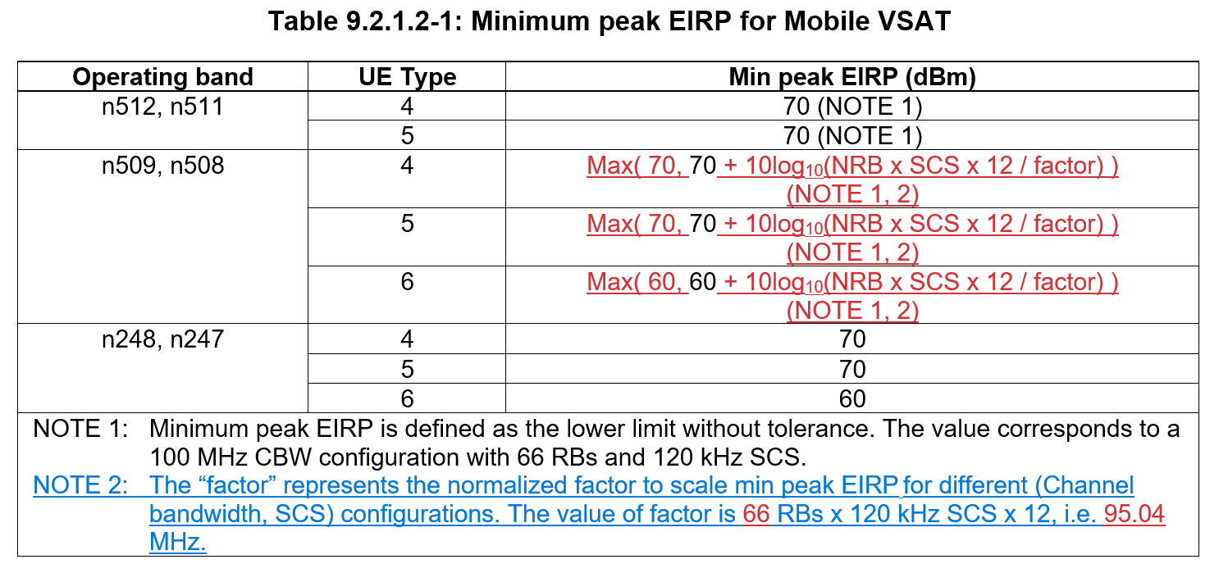
- Moderator Recommendation:
- Discussion required
LGE: Approach same as EIRP.
Mediatek: Think we should use Min not Max
LGE: Formula is correct.
Mediatek: FR2 formula OK. Why not use it for FR1?
LGE: Because 100 MHz is the upper limit for FR1, so no scaling is needed
CHTTL: Can it be simplified?

Moderator: Further offline discussion required.

Sub-topic 2-4: Correction of NTN Ku band VSAT requirements for section 10.3, 10.5 and 10.6
- Proposals:
- CR from CHTTL, LG Electronics, ZTE Corporation, SGS Wireless in R4-2520962
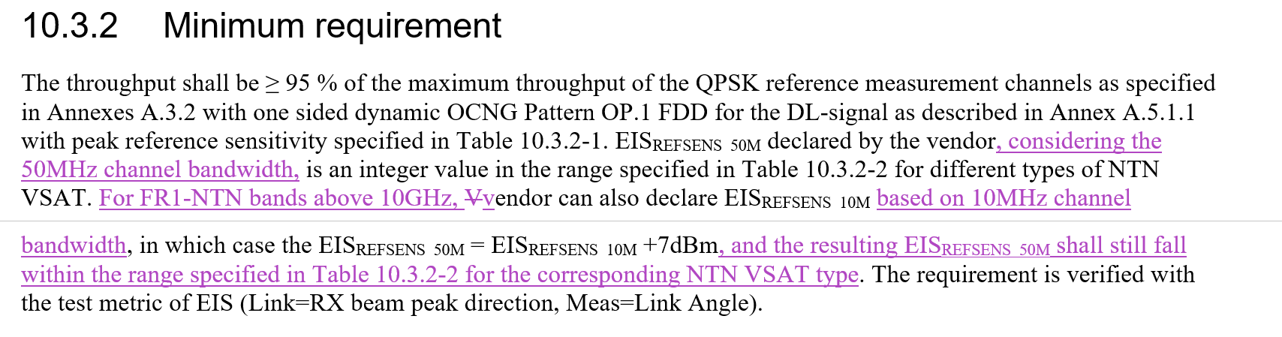
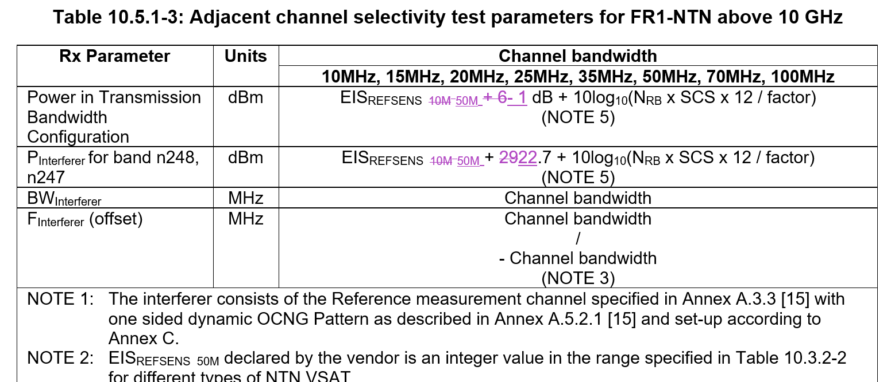
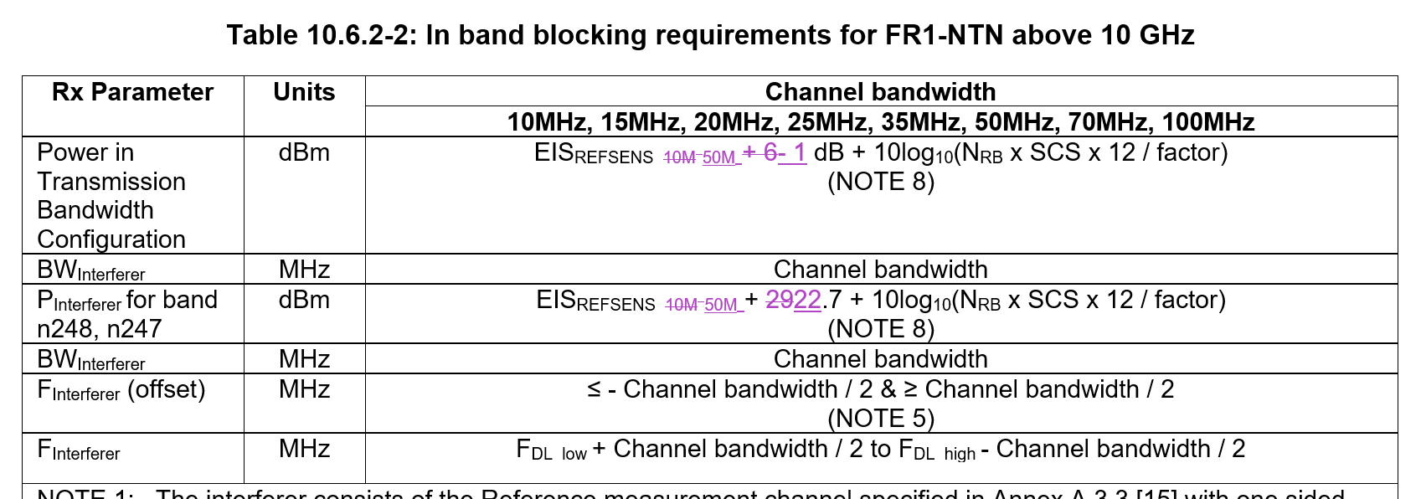

- Moderator Recommendation:
- The changes above are consistent with the endorsed CR at RAN4 #116bis in R4-2515138. The exception is the addition of the definition of EIS_{REFSENS_10M} in 3.2.
- Approve the CR in R4-2520962
Not discussed

Sub-topic 2-5: Configured transmitted power
- Proposals:
- CR from ZTE Corporation, Sanechips in R4-2521054
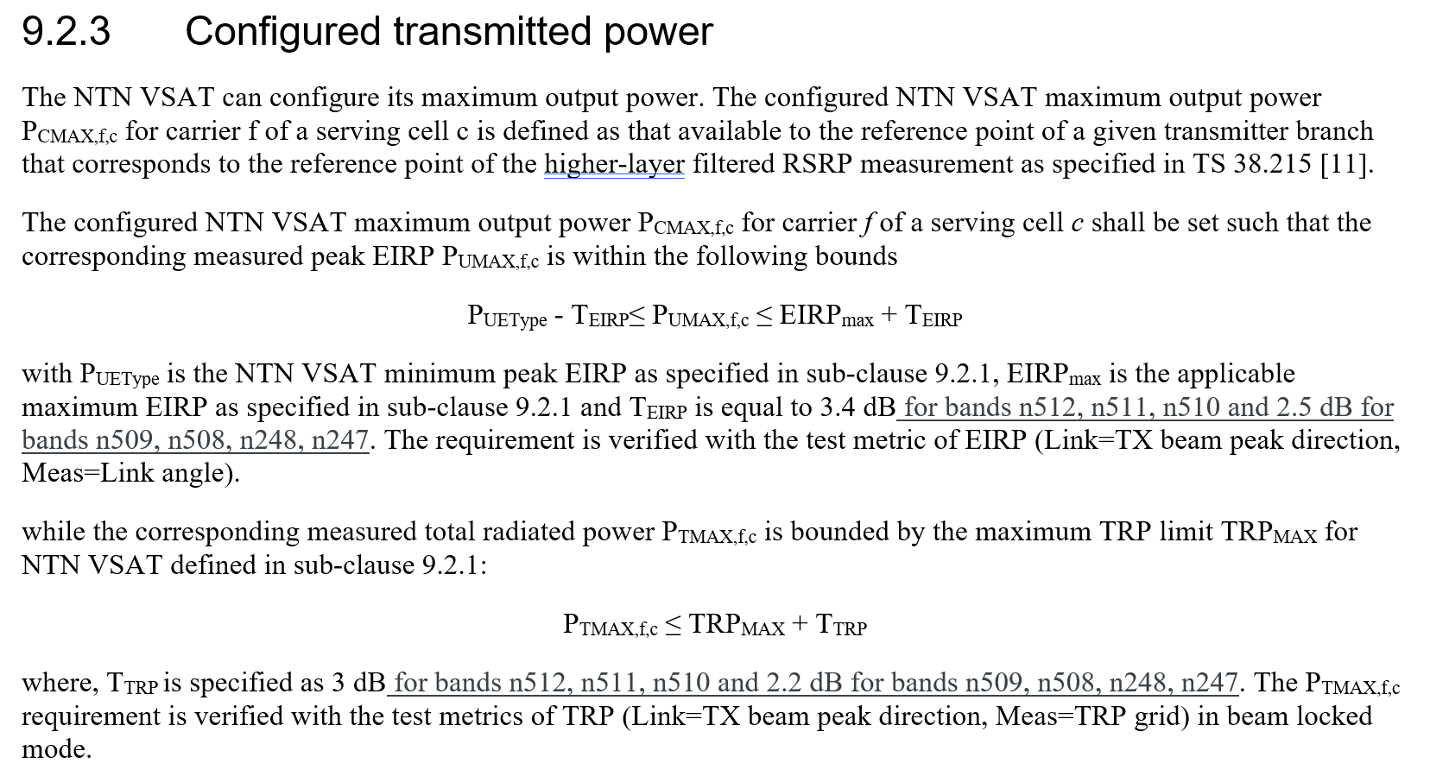
- Moderator Recommendation:
- This CR is a resubmission of the endorsed draft CR at RAN4 116bis in R4-2515138.
- Approved the daft CR in R4-2521054
Not discussed

Sub-topic 2-6: Applicability of antenna off-axis performance to “NS_206N
- Proposals:
- CR from ZTE Corporation Sanechips in R4-2521055
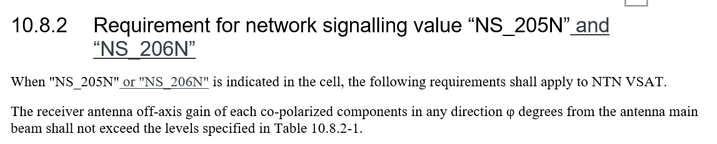
Editorial corrections
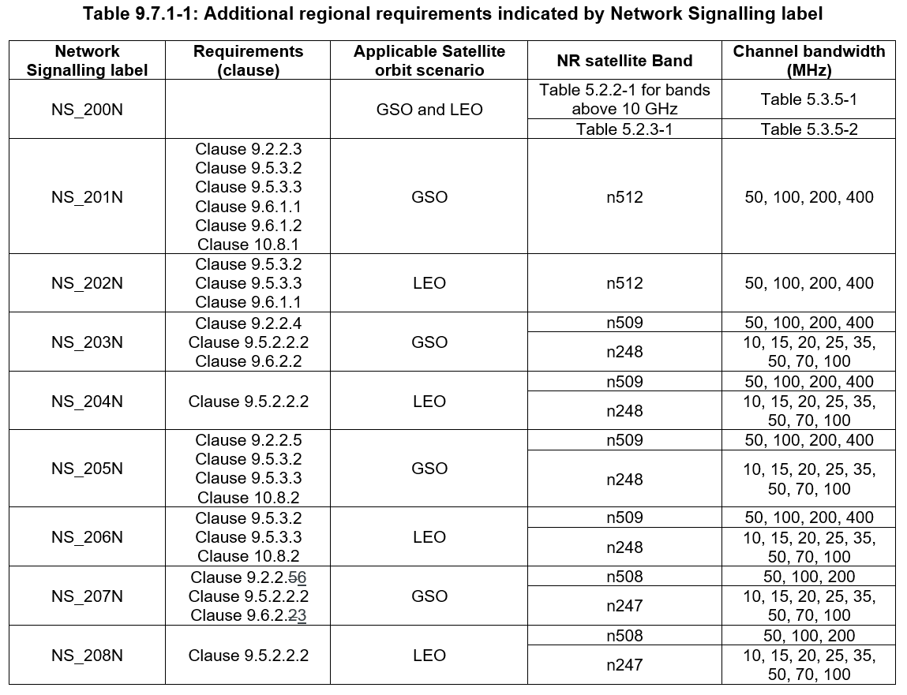
- Moderator Recommendation:
- This CR is a resubmission of one of the changes in the draft CR at RAN4 116bis in R4-2514023. The CR cover sheet incorrectly states it is a resubmission of the endorsed draft CR in R4-2515138 which is a different topic.
- Revise the cover sheet to correct the history. The content is agreeable.
Related to 2-9.

Moderator: Further offline discussion required.

Sub-topic 2-7: PFD limits
- Proposals:
- CR from Ericsson and Thales in R4-2521426
- Moderator Recommendation:
- This CR is based on the endorsed principle at RAN4 #116bis in R4-2513828.
- Clarification on what EIRP assumptions were used for the selected limits would be useful
- Discussion required
Ericsson: Includes statement not to test
CHTTL: Want offline discussion with Ericsson. CR also mentions VSAT operating in the territory of an administration. Change wording to “any” administration.
Huawei: What would RAN5 make of the no test configuration statement?
Ericsson: Needed to complete the spec for regulatory purposes but not necessary to test.
Moderator: Potentially revised the wording
“NOTE: No test configuration is provided for this requirement.” to align with wording used to define operational requirements that are not tested.
E.g., “The PFD requirement is a system level requirement that applies to one or more UE and is not necessary to test on a single UE.

Moderator: Further offline discussion required.

Sub-topic 2-8: Clarification and corrections related to minimum EIRP and maximum EIRP
- Proposals:
- CR from MediaTek Inc. in R4-2521448
- Moderator Recommendation:
- Does this impact Rel-18? Discussion required
Mediatek: Issues are slightly different, A Cat F CR to Rel-18 is provided separately.
CHTTL: A change to the core requirement definition needs discussion.
Qualcomm: Also agree with CHTTL, which needs more discussion.
CHTTL: Also impacts configured transmitted power section.

Moderator: Further offline discussion required.

Sub-topic 2-9: Corrections for NS_206 and NS_207
- Proposals:
- CR from MediaTek (Wuhan) Inc. in R4-2521605

- Moderator Recommendation:
- CR title is too generic, a more specific title would help for the spec change history
- Discussion required.
Mediatek: Class B up to 25 degrees. Prefer to use class B.
CHTTL: One class is LEO only, the other LEO and GSO. Select the most stringent.

Moderator: Further offline discussion required.

Topic #3: SAN RF requirements (agenda 4.2.7.3)

Open issues summary

Sub-topic 3-1: Alignment of SSB and Sync raster SCS
- Proposals:
- CR from CATT in R4-2520060
- Moderator Recommendation:
- Based on the endorse CR at RAN4 #116bis in R4-2513153, approve the CR in R4-2520060
Not discussed

Sub-topic 3-2: SAN channel bandwidth of ACLR for SAN operating under Ku band Proposals:
- Proposals:
- CR from CATT in R4-2520171
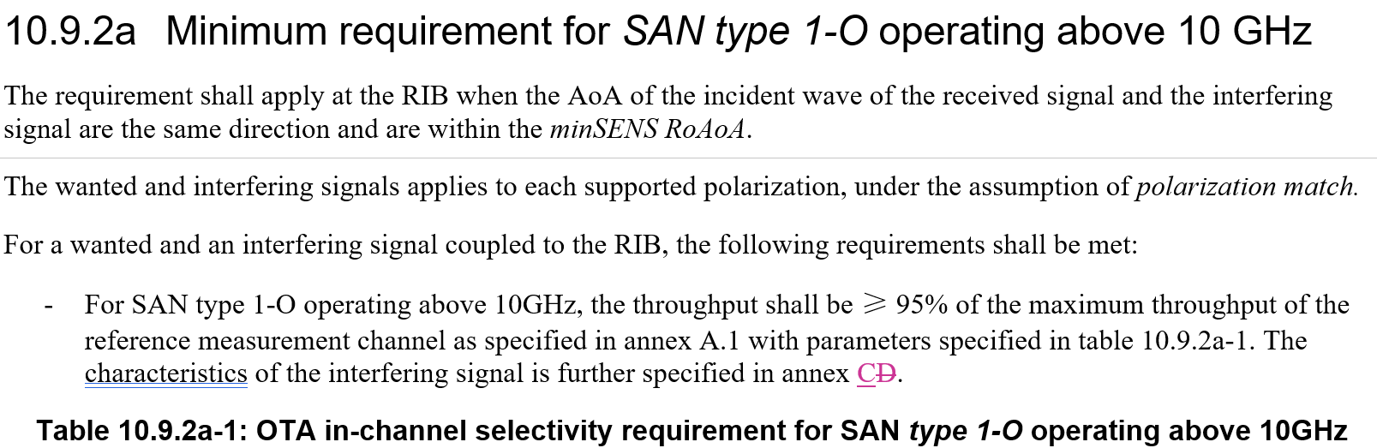
- Moderator Recommendation:
- Discussion required
Agreeable.

Sub-topic 3-3: Correction of NTN Ku band SAN requirements for section 9.4, 9.6, 10.3, 10.4 and 10
- Proposals:
- CR from CHTTL, Ericsson, ZTE Corporation, SGS Wireless in R4-2520999
  - Aligning the clause title as “SAN type 1-O operating below 10GHz”, and “SAN type 1-O above operating 10GHz” for section 9.4.2.2, 9.4.4, 9.6.1.2, 9.6.1.2a (new), 9.6.2.2, 9.6.2.2a (new), 10.4.2.
  - Add note 2 to Table 10.3.2a-1 to align with Table 10.3.3
- Moderator Recommendation:
- The CR is based on the endorsed draft CR at RAN4 116bis in Endorse the draft CR in R4-2515140 or endorse change 2 in R4-2514025
- Approved the CR in R4-2520999
Not discussed

Sub-topic 3-4: EVM window length
- Proposals:
- Draft CR from ZTE Corporation, CHTTL in R4-2521056
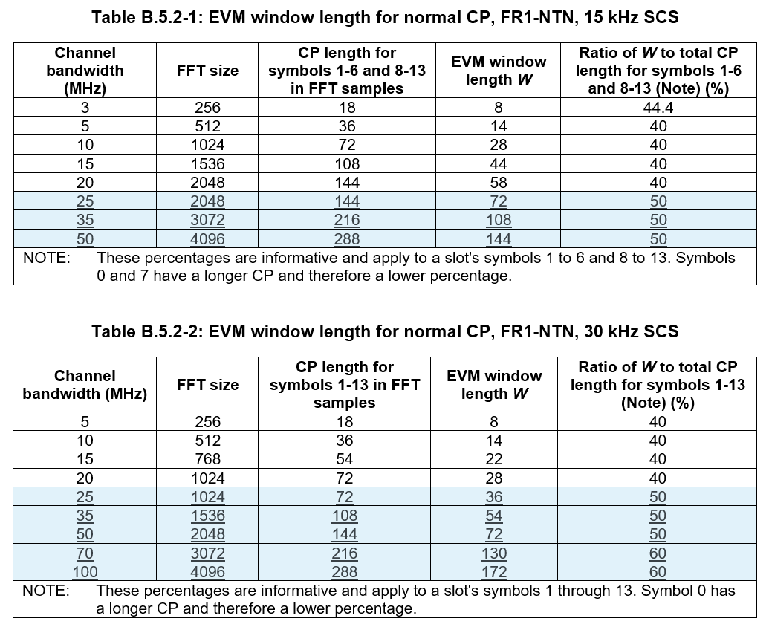
- Moderator Recommendation:
- This is a re-presentation of the endorsed draft CR at RAN4 #116bis in R4-2514024. Approve the draft CR in R4-2521056
Not discussed

Sub-topic 3-5: EIRP, TRP tolerances and OTA transmitter spurious emissions
- Proposals:
- CR from ZTE Corporation, CHTTL in R4-2521057
  - 1. Revise EIRP and TRP tolerance for FR2-NTN Ku bands
  - 2. Revise OTA transmitter spurious emissions for FR1-NTN and FR2-NTN Ku bands.
  - 3. Change SAN type 1-O and SAN type 2-O to italics.
  - 4. Change some words to non-italic such as “operating below 10 GHz”.

- Moderator Recommendation:
- This is a re-presentation of the endorsed CR from RAN4 #16bis in R4-2514025. Approve the CR 2 in R4-2521057
Not discussed

Topic #4: RRM requirements (agenda 4.2.7.4)

Open issues summary

Sub-topic 4-1: Correction to satellite switch requirements and exception handling
- Proposals:
- CR from LG Electronics in R4-2520314
- Moderator Recommendation:
- This is a re-presentation of the draft CR at RAN4 #116bis in R4-2515167. Note, the CR title is generic and unhelpful.
- Approve the CR in R4-2520314
Not discussed

Sub-topic 4-2: Correct the UE capability in Note 3 of Table 7.1C.2-3 from ntn-VSAT-AntennaType-r19 to ntn-VSAT-MobilityType-r19.
- Proposals:
- CR 2 from Vivo in R4-2521441
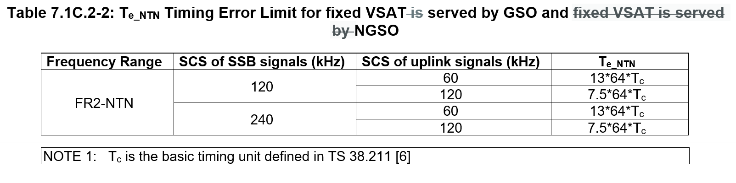
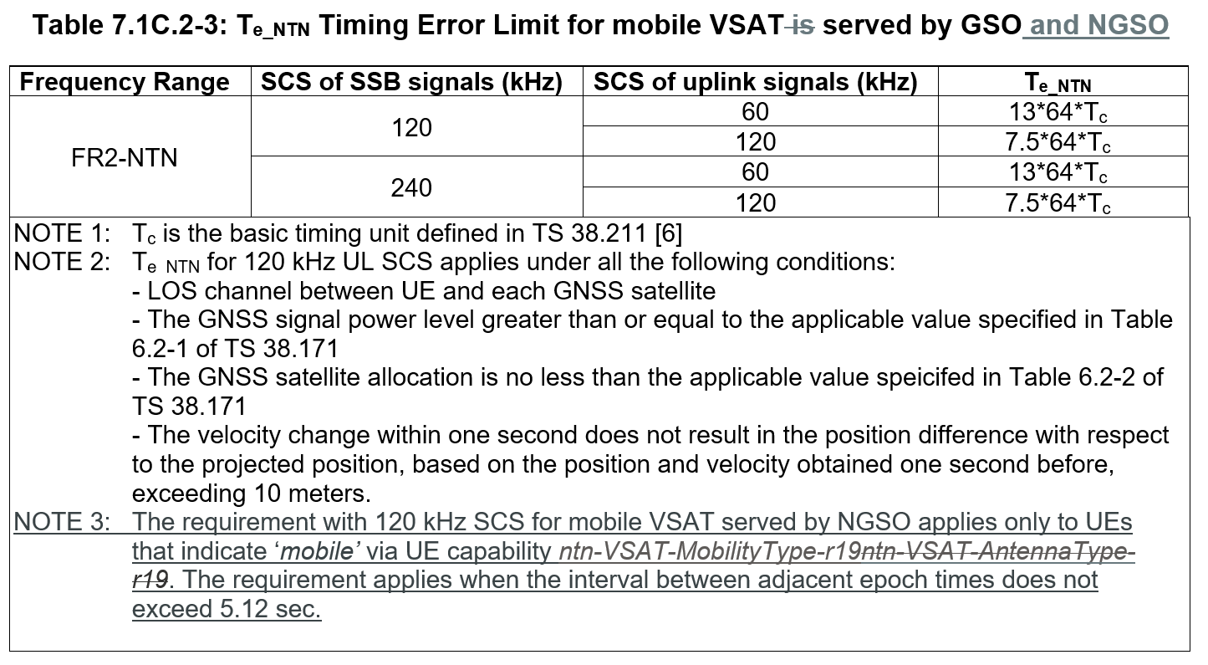
- Moderator Recommendation:
- This is a re-presentation of the draft CR at RAN4 #116bis in R4-2513912. Note, the CR title is generic and unhelpful.
- Approve the CR in R4-2521441
Not discussed

Sub-topic 4-3: Correction to use of ntn-VSAT-MobilityType-r19
- Proposals:
- Proposal 1 from ZTE Corporation, Sanechips in R4-2521542
  - Proposal 1: RAN4 shall not introduce a new window to cover SSB which does not fall in any SMTC. Moderator Recommendation:
- Moderator Recommendation:
- Discussion required. Since the status quo is being proposed, no action is required.
Huawei: Can agree with ZTE’s proposal but capture a side condition for satellite switch target SSB will be within the SMTC.
Eutelsat: Don’t need SMTC for soft satellite switch to work. Take care with the side condition that we are mandating an implementation.
Huawei: The target satellite SSB is inside or outside SMTC depending on implementation. If inside, then no new window is needed. If not, then either say requirements don’t apply (side condition) or define a new window. Could modify LG CR in R4-2520314 to include a side condition.
Qualcomm: This issue is linked to 4-4. Option 1 is ZTE (with a side condition), option 2 is Huawei in 4-4.

Moderator: Further offline discussion required.

Sub-topic 4-4: Correction to use of ntn-VSAT-MobilityType-r19
- Proposals:
- Proposal from Huawei, HiSilicon in R4-2521631
  - Proposal: For soft satellite switch, when SSB of the target satellite does not fall in any SMTC, the scheduling restriction is defined based on a window:
  - The offset of the window is the latest subframe that is no later than the SSB of the target satellite,
  - The duration of the window is the smallest number in subframe that is no smaller than the burst length of the SSB of the target satellite,
  - The periodicity of the window is the periodicity of the SSB of the source satellite.
- Moderator Recommendation:
- Discussion required
Eutelsat: There are two types of satellite switch: hard and soft. Sub-topic 4-4 is just soft. For soft switch to work, the VSAT must see the SSB from both satellites. Without overlapping there is no soft switch.
LGE: Oppose introducing a virtual window as it is unnecessary. It would require additional virtual windows for all exceptional measurement windows in the future. Cross-scope expansion could occur This was never discussed in FR1.
ZTE: Same view as LGE. Oppose virtual window. If the SSB is not in any SMTC, the UE will not measure. It is a generic issue, not just for satellite switch.
Qualcomm: This is getting complicated. It should be business as usual.

Moderator: Further offline discussion required.

Sub-topic 4-5: Clarification of applicability of requirements
- Proposals:
- CR from Huawei, HiSilicon in R4-2521632
  - The applicability of RRM requirements for VSAT UE in FR1-NTN is captured in clause 3.6. However, in clause 9 there are similar applicability specified for measurement requirements. Defining applicability for individual requirements is redundant and it cause the confusion for interpreting applicability of other individual requirements.
  - Remove the requirement applicability specified in clause 9 for measurement.
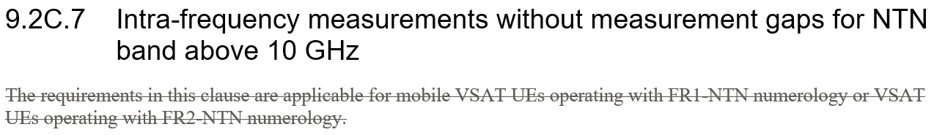
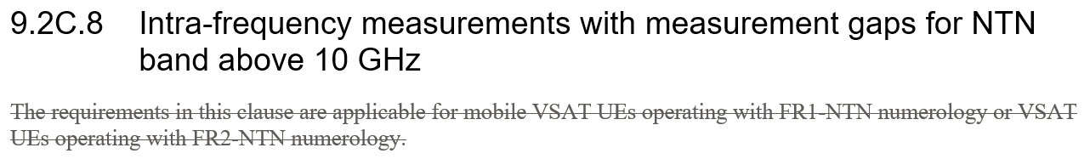
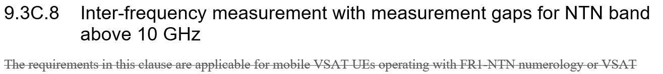
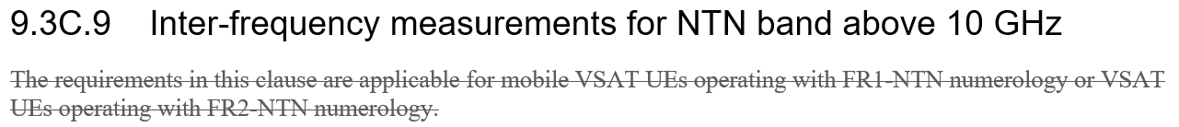
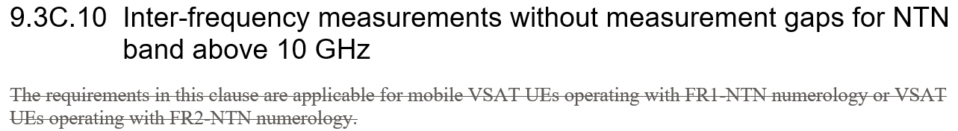
- Moderator Recommendation:
- This is a re-presentation of the draft CR from RAN4 #116bis in R4-2514160. Note, the CR title is generic and unhelpful.
- Approve the CR in R4-2521632
Not discussed

