3GPP TSG-RAN Working Group 4 (Radio) Meeting #117 R4-252xxyy

Dallas, US, 17th – 21st November 2025
CR-Form-v12.4
CHANGE REQUEST
 | 37.941 | CR | 0064 | rev | 1 | Current version: | 19.0.0
For HELP on using this form: comprehensive instructions can be found at
https://www.3gpp.org/Change-Requests.

Proposed change affects: | UICC apps |  | ME |  | Radio Access Network | X | Core Network

Title: | (NR_BS_RF_req_evo) CR to TR 37.941: Improvements to Rel-19 BS RF evolution outcome in clause 6.4.4
Source to WG: | Ericsson
Source to TSG: | R4
Work item code: | NR_BS_RF_req_evo |  |  |  |  |  | Date: |  |  | 2025-11-21
Category: | F |  |  |  |  |  | Release: |  |  | Rel-19
 | Use one of the following categories:  F (correction)  A (mirror corresponding to a change in an earlier release)  B (addition of feature),  C (functional modification of feature)  D (editorial modification)  Detailed explanations of the above categories can  be found in 3GPP TR 21.900. |  |  |  |  |  |  |  | Use one of the following releases:  Rel-8 (Release 8)  Rel-9 (Release 9)  Rel-10 (Release 10)  Rel-11 (Release 11)  …  Rel-17 (Release 17)  Rel-18 (Release 18)  Rel-19 (Release 19)  Rel-20 (Release 20)
Reason for change: |  | This CR adds missing information and corrects editoral errors with the intention to improve readability of Rel-19 outcome from BS RF evolution work related to co-location requirement improvements.  This is a revision of R4-2521051.
Summary of change: |  | - Improvements to background in clause 6.4.4.1  - Improvements to coupling loss analysis in clause 6.4.4.2  - Improvements to requirement derivation background in clause 6.4.4.3
Consequences if not approved: |  | If not approved, the current information could potentially cause confusion in the future.
Clauses affected: |  | 6.4.4
 |  | Y | N
Other specs |  |  | X | Other core specifications |  |  |  | TS/TR ... CR ...
affected: |  |  | X | Test specifications |  |  |  | TS/TR ... CR ...
(show related CRs) |  |  | X | O&M Specifications |  |  |  | TS/TR ... CR ...
Other comments:
This CR's revision history:

Clause 6.4.4:
    - Co-location measurements for higher frequency bands

6.4.4.1 Background on CLTA alternatives discussion
The Rel-19 work item on NR base station RF requirement evolution for FR1/FR2 and testing (NR_BS_RF_req_evo work item) captured one objective related to the OTA Co-Location Reference Antenna (CLTA). One of the triggers for this work, was concern on the availability of suitable Co-Location Test Antenna (CLTA) suitable for conformance testing of products operating with bands in the upper region in FR1. Therefore, it was seen beneficial to further investigate alternatives of the CLTAs, with the assumption that Rel-15 definition of the co-location scenario based on CLRA and conformance test based on CLTAs is still the baseline.

- Investigation of the core definition and the CLRA relates to if the scenarios defined and the CLRA definition still represent a reasonable (worst case) scenario for high frequency FR1 bands.
- Investigation into the conformace and the CLTA relates to the practical test methodology of the test antenna definition, its suitability and its availability.

Furthermore, the work on CLTA alternatives was backed by the statement already captured in the TS 38.141-2 [6] and TS 37.145-2 [4] specification, saying:
“Translation of the requirements to other test antennas are not precluded but suitable translations between the co-location reference antenna and test antenna must be provided to demonstrate that the method is within the specified MU.”
Core objective of the NR_BS_RF_req_evo work item aimed to investigate whether the BS/IAB OTA CLRA definition required to be improved for FR1, and to investigate if solutions alternative to the CLRA are available. Coformance-related objective was to investigate whether the CLTA-based test approach could be improved and potentially improve test methods for BS/IAB OTA co-location requirements and tests for AAS BS and corresponding test specifications for FR1. Conformance testing methodology was investigated to explore possible CLTA alternatives.

      - BS-to-BS coupling loss analysis
The BS-to-BS coupling loss between two co-located base stations have been evaluated from OTA measurement and OTA co-loation simulation results. The coupling loss have been evaluated for intra-band and inter-band scenarios, considering the coupling loss as Sub-Array-to-Sub-Array (SA-to-SA) coupling loss, Array-to-Sub-Array (A-to-SA) coupling loss and Array-to-Array (A-to-A) coupling loss.
Coupling loss for different scenarios is listed in Table 6.4.4.2-1 and Table 6.4.4.2-2.
Table 6.4.4.2-1: Intra band coupling loss summary
Co-location  scenario | Coupling loss  type | Coupling loss  (dB)
Co-location  scenario | Coupling loss  type | 2.6 GHz | 3.5 GHz | 4.9 GHz | 7 GHz
Vertical  Separation | SA-to-SA | M: 54 | M: 53 | M: 56
Horizontal  Separation | SA-to-SA | M: 31 | M: 34 | M: 46
Horizontal  Separation | A-to-SA |  | M: 35  S: 55±15 | M: 51  M: 69 | M: 55  S: 70±15
Horizontal  Separation | A-to-A |  |  |  | S: 77±15
M: measurement results
S: simulation results.

Table 6.4.4.2-2: Inter band coupling loss summary
Co-location  scenario | Coupling loss  type | Coupling loss  (dB)
Co-location  scenario | Coupling loss  type | 3.5 GHz to 7 GHz
Horizontal  separation | A-to-SA | S: 57±10
Horizontal  separation | A-to-A | S: 54±10
M: measurement results
S: simulation results.

The outcome of coupling loss evaluation indicates that the assumption taken from the conducted co-location scenario where BS-to-BS port coupling loss of 30 dB for BS type 1-C and BS type 1-H at high FR1 frequencies is not relevant anymore.
From the combined result from measurements and simulations it can be concluded that the general trend indicates coupling loss increase for bands in the upper region of FR1.
      - Impact on the co-location requirements

6.4.4.3.1 General
The co-location requirements are requirements which are based on a given BS-to-BS co-location scenario, for NR BS type 1-C and NR BS type 1-H (and corresponding MSR AAS requirement sets) it is assumed that this scenario has a coupling loss value of 30dB. The intention with these requirements is to ensure that BSs serving different bands can be co-sited at the same site and/or tower.
Table 6.4.4.3.1-1: Overview of NR co-location requirements
Requirement | Reference to clauses in NR BS specification TS 38.104 | Description
Transmitter spurious co-location emission | BS type 1-C and BS type 1-H in Clause 6.6.5.2.4.  BS type 1-O in Clause 9.7.5.2.5. | This requirement is defined to protect BS operating in other 3GPP band(s) co-located at the same site.
Receiver out-of-band blocking | BS type 1-C and BS type 1-H in Clause 7.5.3.  BS type 1-O in Clause 10.6.2.2. | This requirement is defined to guarantee UL operation when a BS is co-located to another BS operating at another 3GPP band(s).
Transmitter OFF power | BS type 1-C in Clause 6.4.1.2.  BS type 1-H in Clause 6.4.1.3.  BS type 1-O is Clause 9.5.2.2. | This requirement is defined to protect other BSs in the same network in neighbouring cells.
Transmitter intermodulation | BS type 1-C in Clause 6.7.2.  BS type 1-H in Clause 6.7.3.  BS type 1-O in Clause 9.8.2. | This requirement guarantees transmitter robustness with respect to an external interferer.

Originally all requirements were derived for non-AAS BS (BS type 1-C). In Rel-13, hybrid AAS BS was introduced (In NR specifications referred to as BS type 1-H) and in Rel-15 all OTA AAS BS was introduced (In NR specifications referred to as BS type 1-O). For BS type 1-C and BS type 1-H, all requirements are defined at the transceiver ports (also known as the Transceiver Array Boundary (TAB) connector(s)). For BS type 1-O all co-location requirements are defined based on a concept of a co-location reference antenna. In conformance testing a practical implementation of this antenna is defined and is called as the Co-Location Test Antenna (CLTA).
Looking at the details related to the technical background for each individual requirement it can be noticed that the BS-to-BS coupling loss assumed is of different type depending on requirement. In Table 6.4.4.3.1-2, some further details for each requirement are presented.
Table 6.4.4.3.1-2: Requirement derivation assumptions
Requirement | Frequency  aspect | Description
Transmitter spurious emission | Inter band | The requirement is defined to protect another band, hence coupling between bands are relevant. The approach used to derive the requirement level is defined to consider A-to-A coupling.
Receiver out-of-band blocking | Inter band | The requirement is defined to protect another band, hence coupling between bands are relevant. Since the receiver blocking related to induvial receiver branches, A-to-SA is considered when the BS type 1-C and 1-H requirement level is derived. The BS type 1-O requirement is based on receiver sensitivity so whilst the means of interference to each receiver branch is from A-to-SA the requirement is based on the A-to-A system performance
Transmitter OFF power | Intra band | The requirement is defined for TDD operation to protect the neighbouring BS in the same network. The approach used to derive the requirement level is defined to consider A-to-A coupling within the same band. The A-to-A coupling for this requirement should be based on to neighbouring BS and not side-by-side.
Transmitter intermodulation | Intra band | This requirement is defined to guarantee than unwanted emission requirements is met in the case of an interferer signal. The interferer signal is injected within the band. Since the requirement is related to induvial transmitter branches, A-to-SA is considered when the BS type 1-C and 1-H requirement level is derived. The BS type 1-O requirement is based on TRP emissions so whilst the means of interference to each transmitter branch is from A-to-SA coupling the requirement is based on the spurious output from the entire array.

It is worth to notice that the analysising BS-to-BS coupling for all requirements listed in Table 6.4.4.3-2, may require a numer of different scenarios A complete technical background for all requirements would require a coupling evaluation including the following cases:
Intra band A-to-A for relevant band combinations
Inter band A-to-SA for relevant band combinations
Intra band A-to-A for relevant bands considering coupling to neighbouring BS
Intra band A-to-SA for relevant bands
The relevance of each of the decided Minimum Coupling Loss (MCL) values to each of the BS types and how they are used in deriving the core and conformance requirements also needs to be clearly stated. Analysing the results presented in Table 6.4.4.2-1 and Table 6.4.4.2-2 would indicate that assuming BS-to-BS port coupling loss equal to a value larger than 30 dB would be reasonable for bands in the upper region of FR1.
In the following clauses, impact on individual requirements is further elaborated.

6.4.4.3.2 Transmitter OFF power requirement
For TDD FR1 NR BS the transmitter OFF power requirement level is defined in terms of PSD in dBm/MHz. The requirement level is derived following the approach:
Transmit OFF power < kT₀ + NF – 6dB + MCL + 10log(1MHz)
< -174 + 5 – 6 + MCL+60
< -115dBm/MHz + MCL
Considering the worst case is that BSs are assumed to be co-located, and for BS type 1-O the requirement is specified at the output of the CLRA/CLTA the minimum coupling loss between co-located BSs would have no impact on the definition of core requirement. For the existing BS type 1-C and type 1-H the transmitter OFF power -85dBm/MHz, is specified at the antenna connectors and it is based on the assumption of MCL between two co-located BS as 30 dB so the core requirement would be affected by a change in the minimum coupling loss assumption.

6.4.4.3.3 Co-location spurious emission requirement/Protection of BS receiver of own or different BS
The protection of own or different BS is based on desensitizing a victim receiver by 0.8dB (corresponding to 7 dB below noisefloor) with the assumption the victim receiver has the same performance as the system under test.

For BS type 1-O requirement based on CLRA/CLTA the interference power level is specified at the co-located antenna output and is given by:

Spurious Emission Level_{WA_1-O} ＜ kT₀ + NF + 10*log10(100kHz) －7dB
= -174dBm/Hz + 5dB + 50dB－7dB = -126dBm/100kHz
The requirement level is scaled based on 8 TRX so it is actually -126dBm/100kHz + 9dB = -117dBm/100kHz.

For BS type 1-C and BS type 1-H the requirement level is specified at the antenna port/TAB connector(s) as:

Spurious Emission Level_{WA_1-C} ＜ kT₀ + NF + 10*log10(100kHz) －7dB + MCL
= -174dBm/Hz + 5dB + 50dB－7dB + MCL

Where MCL refer to the minimum coupling loss between co-located BSs, therefore the BS-to-BS isolation analysis would have the impact on the definition of the BS type 1-C and BS type 1-H co-location spurious emission requirement/Protection of BS receiver of own or different BS. MCL is assumed as 30dB in the existing specification.
The BS of different classes will have different Noise figures. Generally, in most 3GPP specifications, it is assumed that the WA NF = 5dB, MR NF = 10dB, and LA NF = 13dB.
For BS type 1-H the spurious emission derived is summed over all TAB connectors.

6.4.4.3.4 Transmitter intermodulation requirement
For FR1 transmitter intermodulation requirement, interfering signal level is equal to Rated total output power (P_{rated,t,AC}) in the operating band.
For BS type 1-O, the interfering signal level is specified at the input to the CLRA/CLTA.
For BS type 1-C and BS type 1-H, the interfering signal level is specified as P_{rated,t,AC} – MCL.
MCL refers to the minimum coupling loss which is assumed to be 30dB in the existing specification.

6.4.4.3.5 Co-located OOB Blocking requirement
For FR1 co-located Out-of-Band (OOB) receiver blocking requirement, it is assumed that the two co-located systems are of the same BS class.
The interfering signal level for WA, MR and LA is calculated based on the following assumption of aggressor transmit power:
1) 46dBm
2) 38dBm
3) 24dBm
For BS type 1-O the interferer level is specified at the CLRA/CLTA input RF port.
For BS type 1-C and BS type 1-H the interferer level is specified at the antenna connector or TAB connector and as such is affected by the MCL:
1) 46dBm-MCL
2) 38dBm-MCL
3) 24dBm-MCL
Where MCL refer to the minimum coupling loss which is 30dB in the past for 3GPP, therefore the BS-to-BS isolation analysis would have the impact on the definition of BS type 1-C and BS type 1-H receiver’s co-located OOB blocking requirement.

6.4.4.4 CLTA alternatives - Wideband horn antenna
The use of wideband horn antenna (as an alternative to the OTA co-location testing with CLTA) has a number of potential advantages:
- Wideband horn antennas are easily available and cover wide frequency range.
- Testing with wideband horn antennas is expected to require smaller number of test antennas to cover the whole tested frequency range (e.g., in case of spurious emissions). This may be most beneficial in case where no off-the-shelf single column antennas are available for certain bands, requiring custom-made test antennas.
- Testing may be less time-consuming. For a standard horn antenna, the antenna characteristics is provided in customer documentation (e.g., gain, radiation pattern, etc.), which may differ in case of custom-made CLTA products.
There are some basic differences with wideband horn antennas and CLTAs:
- Wideband horn antennas are intended to be used directed towards the DUT.
- Wideband horn antennas are different size than CLTA (considering that co-location testing with CLTA has certain DUT dimension-related restrictions).
- Wideband horn antennas are receiving different frequencies in different depths of the horn.
- Wideband horn antenna structure is semi-open from two sides and closed from two sides or closed from all four sides.
- Measurements were made with the horn antenna replacing the CLTA using the current CLTA arrangement. The horn antenna was placed next to the DUT keeping the 10cm distance and its boresight was facing the same direction as the DUT. Example measurement setup is shown in figure 6.4.4.4-1.
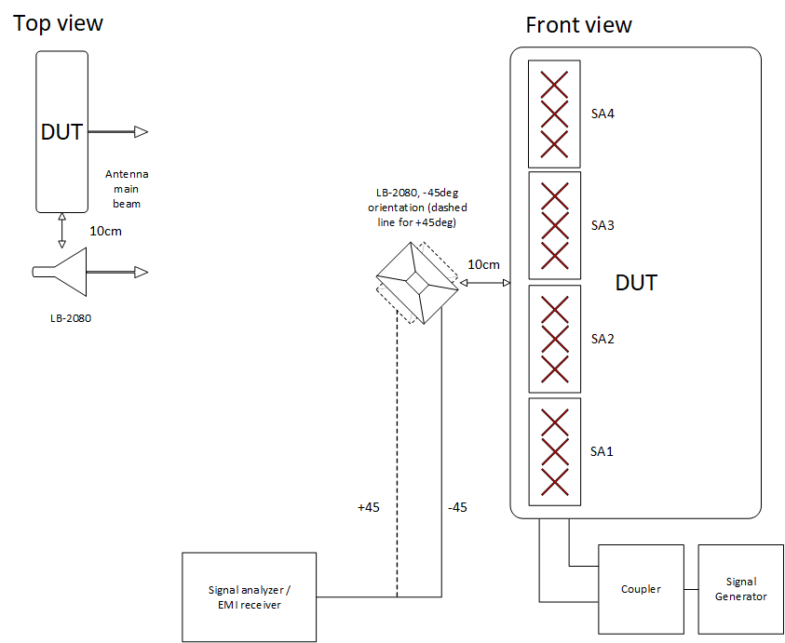
Figure 6.4.4.4-1: Co-located horn antenna example measurement setup
Based on measurements with CLTA arrangements and different configurations, it was observed that:
- The size of the wideband horn antenna has a significant effect on the coupling loss results.
- There is no immediate correlation between the coupling loss in the near-field, increasing distance from 10 cm (i.e., OTA co-location test setup specific arrangement) to 20cm or even to 50cm doesn’t guarantee higher coupling loss.
- CLTA test setup arrangement (as detailed in e.g., TS 38.141-2 [6]) as such is not optimal for wideband horn antennas due to the structure of the antenna and would need to be further studied.
- There is no straightforward one-to-one translation to use wideband horn antenna as CLTA with the current CLTA arrangement. This could be considered as a potential study area in future.

Single column passive antennas may not be readily available (for the purpose of CLTA test antenna) for all of the required frequency bands. They typically meet the CLTA requirements only at relatively narrow frequency ranges (e.g., 410 MHz – 467.5 MHz). Currently multiple custom-made antennas may be needed to cover OTA co-location testing in the required frequency range. This could make testing in higher and lower frequencies become unnecessarily complex and time-consuming. Therefore, a new or additional method for the OTA co-location testing may be needed to simplify testing.

