If the n+Tharq+6 is the slot of SCell on-duration as per switching pattern, UE shall switch to SDL SCell by end of n+Tharq+5; otherwise UE shall switch to the SDL SCell by end of the slot immediately prior to the 1st slot in the SCell on-duration based on the switching pattern.

First 3 examples are for immediate switching:
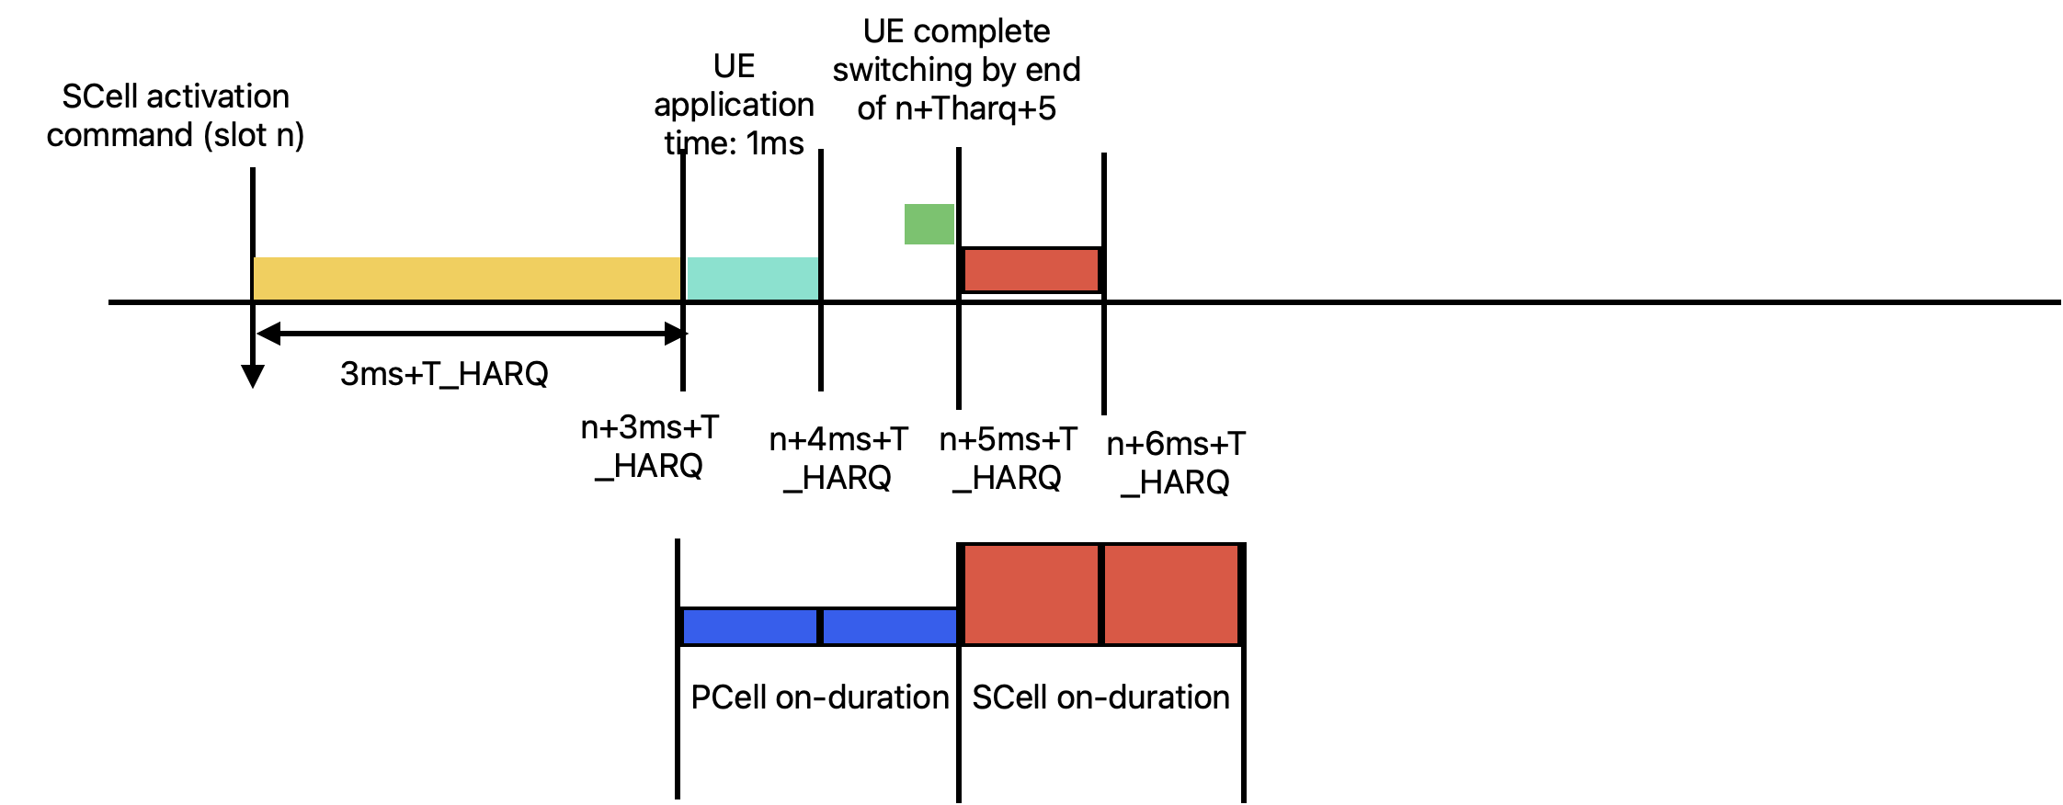
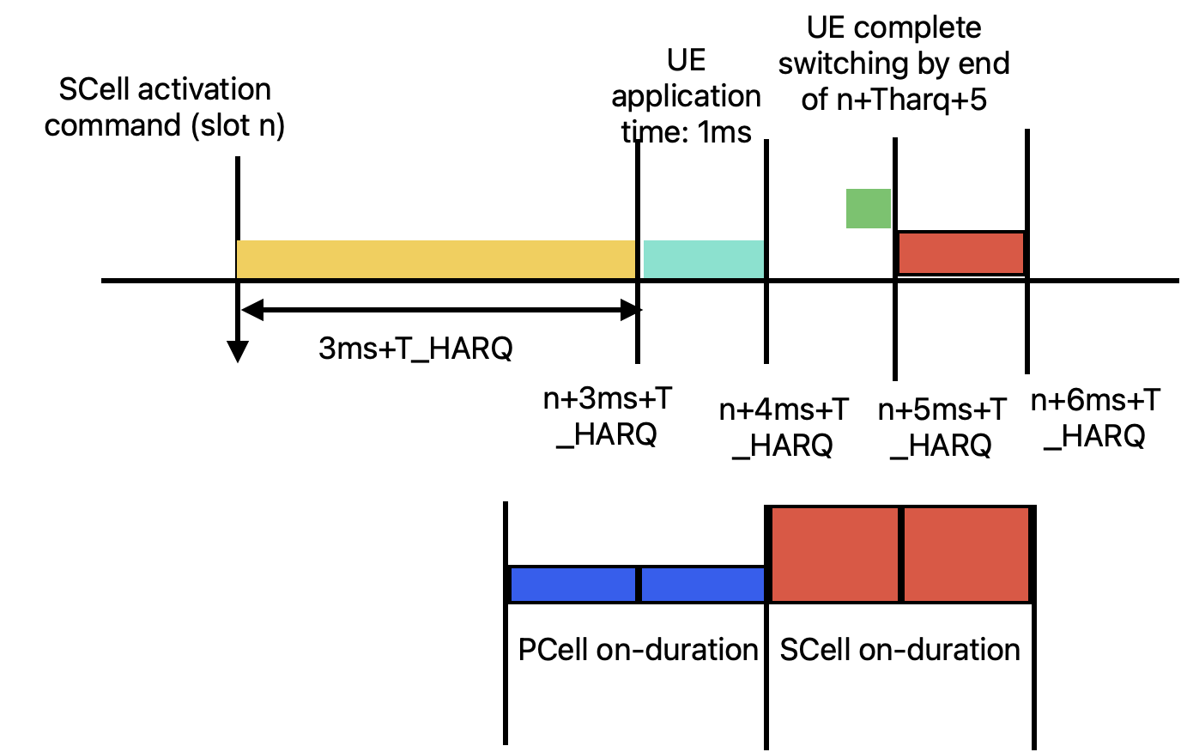
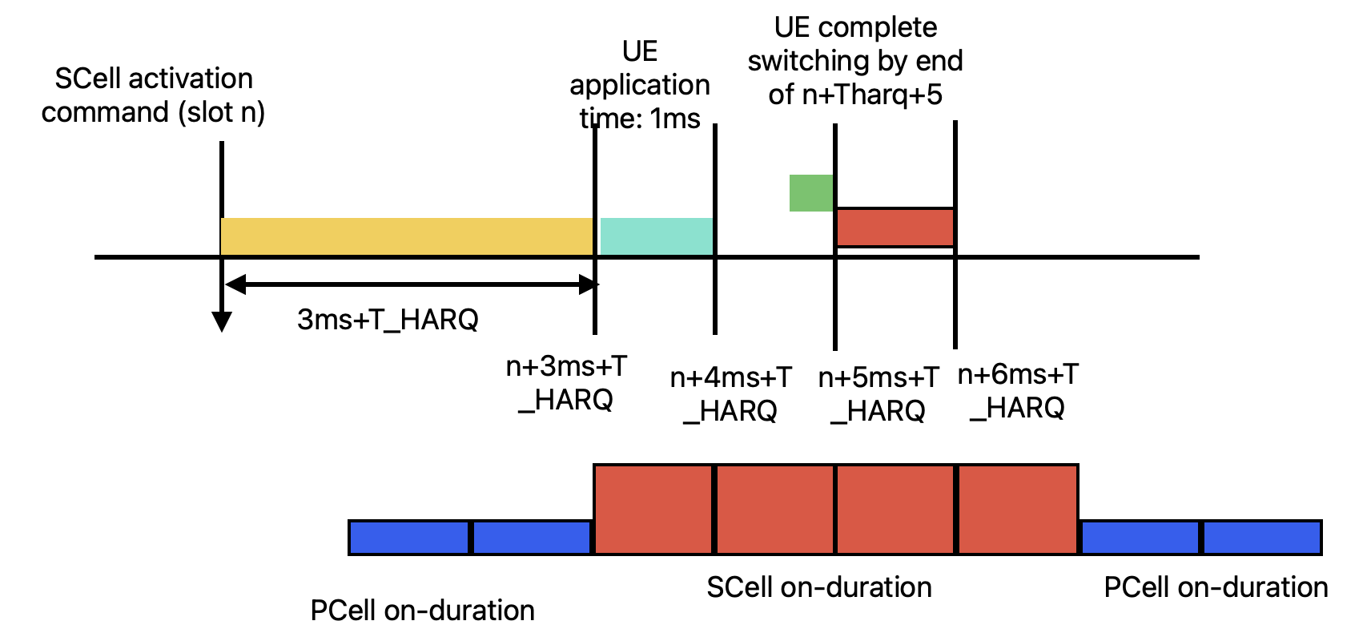

Other examples are for switching on next transition period:
