3GPP TSG RAN WG4 Meeting #117 R4-2521292
Dallas, USA., 17th – 21st, Nov. 2025

Source: ZTE Corporation, Sanechips

Title: TP for PRD 01 to update Band combination workflow

Agenda Item: 5.2.6

Document for: Approval

Introduction
For Rel-19 basket WIDs, there are several objectives in one basket WID, and it was agreed in the WF [1] that big draft CR for each objective will be provided by the corresponding objective rapporteur to capture the band combinations in the endorsed CRs or approved TPs, then all the official draft big CRs are then merged into one formal Big CR by the 1st Rapporteur.
The WF is copy&paster in the following for convenience.

2 WF on proceed big draft CR/CRs for R19 basket WIs
Agreement:
Adopt the following option to proceed big draft CR/CRs for R19 basket WIs
- Multiple official draft big CRs drafted by the objective responsible Rapporteur which are then merged into one formal Big CR by the 1st Rapporteur
3 Ways of treating big draft CR/CRs in the post meeting
- No need to assign additional timelines for objective draft bigCRs; However, due to the merging effort needed, an early delivery of objective CR’s to the main rapporteur is expected.
  - All of the objective draft big CRs and formal big CRs should be available in the folder of each thread.
- Companies are only expected to check and comment the formal big CRs, and the 1st Rapporteur shall provide necessary revisions of the formal big CR(s)
- No updates for objective draft big CRs.
  - The objective draft big CRs are to be marked as “merged”.
  - Co-rapporteurs should inform if the objective draft big CR is not needed and can be withdrawn.
This TP to PRD is to reflect the above WF in the band combination workflow.

Reference
[1] R4-2420467, WF on proceed big draft CR/CRs for R19 basket WID
[2] Permanent Reference Document (PRD);Rules, guidelines and ways of working for introduction of band combinations in NR and LTE, v0.5.0

Text Proposal
----- Start of TP -----

4.2.1 Band combination workflow

4.2.1.1 The workflow on introduction of band combinations for block approval
In order to improve the efficiency of RAN4’s work, it’s necessary to introduce a clear workflow on the introduction of band combinations for block approval. The workflow on the introduction of band combinations for block approval is shown as figure 5.1A.1.1-1 as a typical example for one RAN4 meeting in one quarter. The specific steps are listed as below.
#1 Band combinations should be requested by contact person using request template. And the request spread sheet should be shared in the reflector 3GPP_TSG_RAN_WG4_NR_BANDS for NR CA, MR DC and SUL band combinations or 3GPP_TSG_RAN_WG4_CA for LTE CA band combinations before RAN4#(X-1) meeting.
#2 Band combinations should be captured into the draft revised WIDs during RAN4#(X-1) meeting by rapporteurs.
#3 The official revised basket WIDs can be approved together with requested band combinations during RAN#(Y-1) meeting.
#4 Proponents should prepare and submit the corresponding contributions, e.g. draft CR, TP before RAN4#X meeting. If a draft CR or TP is depending on approval of lower order fallbacks submitted at the same meeting, this need to be clearly mentioned in the cover sheet of the draft CR or in the heading of the TP.
#5 The Block/Approval procedure is applicable to the band combinations in one week before formal RAN4#X meeting, if there is no general issues observed.
#6 The contributions will be discussed during RAN4#X meeting. If there are no technical concerns and if all the needed fallbacks are completed, the band combinations can be approved. And the final decision will be made by chairman.
#7 If the contributions are approved or endorsed, the corresponding band combinations should be captured into the objective draft big CRs and/or TRs for each objective by responsible rapporteurs and multiple objective draft big CRs are then merged into one formal big CR by the 1st Rapporteur. Note: The objective draft big CR and formal big CR are official CRs and the formal big CR is used to capture all the corrections for one specification by the 1st rapporteur under basket WI.
#8 Email approval can be used for the objective draft big CRs, formal big CRs and/or TRs in one week after formal RAN4#X meeting. Note: No updates for objective draft big CRs.
#9 The status of band combinations is expected to be shared by contact person after formal RAN4#X meeting.
#10 The status of band combinations should be captured into the WID and/or SR by rapporteurs.
#11 RAN #Y will approve the formal big CRs and revised WIDs.
#12 The agreed band combinations will be introduced into the specification in next version.
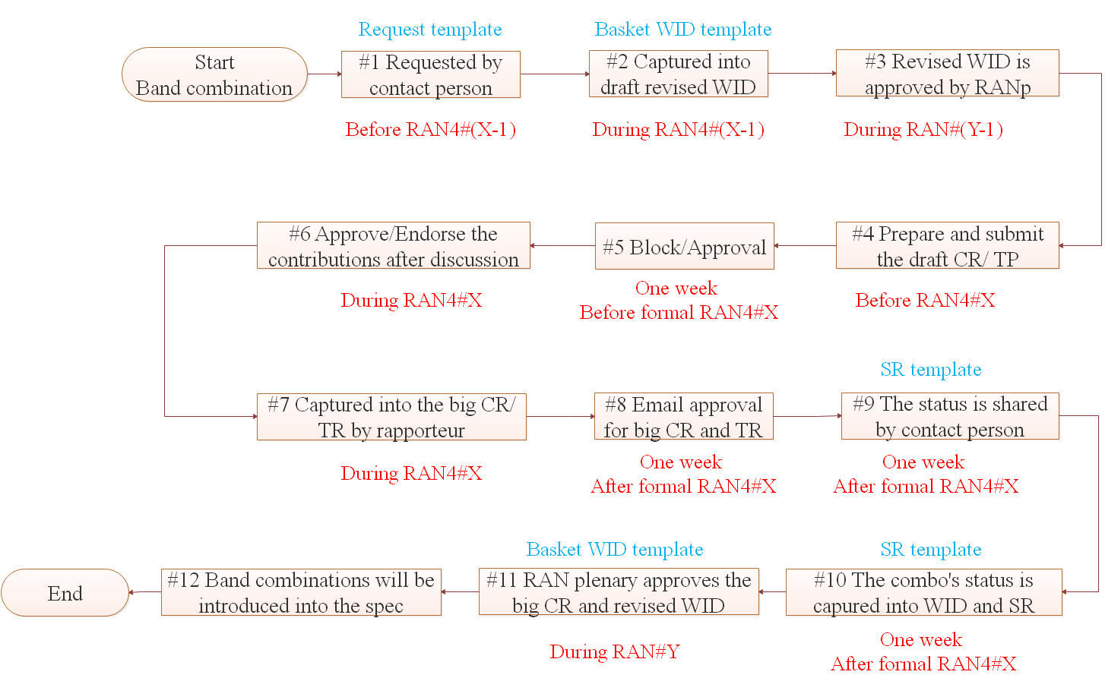
Figure 4.2.1.1-1 The workflow on the introduction of band combinations for block approval

----- End of TP -----

