Simulation results on KPI-1 and KPI-2
Simulated scenario:
- Scenario 1: Wide beam (SSB based) to predict narrow beam (CSI-RS based)
- Scenario 2: Narrow beam (SSB based) to predict narrow beam (CSI-RS based)
Background:
Agreement in RAN4#116bis
  - Regarding the metric for beam ID only prediction, where top-K predicted beam(s) are reported, RAN4 only specifies the requirements for the following scenario(s):
    - K=1
      - In this case, the ground truth RSRP of the predicted beam is larger than or equal to the ground-truth RSRP of the strongest genie-aided beam(s) – x dB
Agreement in RAN4#114
Issue 2-1: Metrics/KPIs for beam ID prediction
Agreement:
- Metrics/KPIs for beam ID prediction, at least for the case if only beam ID is reported:
The successful rate for the correct prediction,
  - The correct prediction is considered as maximum ground-truth RSRP among top-K predicted beams larger than or equal to the ground-truth RSRP of the strongest genie-aided beam(s) – x dB,

KPI 1: Beam prediction accuracy
The successful rate for the correct prediction which is considered as maximum ground truth RSRP among top-K predicted beams is larger than the ground truth RSRP of the strongest genie-aided beam – x dB, where K=1,2,3,4,5, X= 1, 2, 3dB

Scenario 1: Wide beam (SSB based) to predict narrow beam (CSI-RS based)
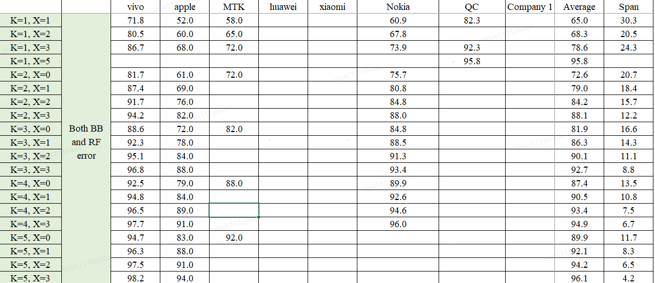
Scenario 2: narrow beam (SSB based) to predict narrow beam (CSI-RS based)
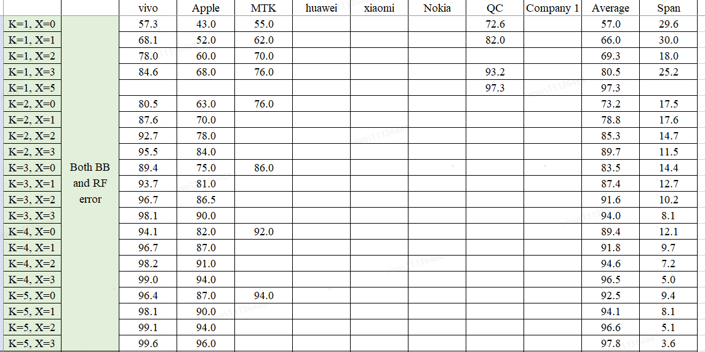

KPI 2: RSRP accuracy(dB)
90%-tile L1-RSRP difference between the predicted L1-RSRP of the Top-1/ Top-3/ Top-5 predicted beam(s) and the ground truth L1-RSRP of the same beams

Scenario 1: Wide beam (SSB based) to predict narrow beam (CSI-RS based)
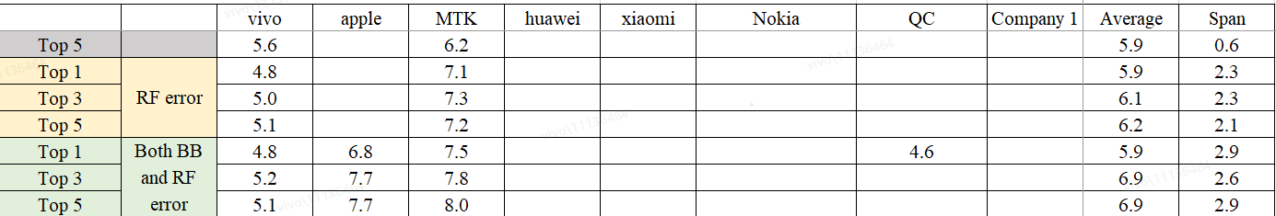

Scenario 2: narrow beam (SSB based) to predict narrow beam (CSI-RS based)

Whether/How to define requirement based on simulation results
Case 1: Beam ID only prediction (K=1 only)
Based on the aforementioned simulation results with a very large gap/difference (span is over 20%), we recommend
- Option 1: Not to define accuracy requirement for Case 1
- Option 2: To define accuracy requirements with the exclusion of results with significant gaps/differences from companies
  - Further, RAN4 to discuss and decide
    - X value (e.g., RAN4 to define requirements based on K=1, X=3)
    - the criteria for how to exclude results with significant gaps/differences
    - How to define accuracy requirements (e.g., averaging the results of various companies after excluding results with significant differences)
Case 2: both Beam ID and RSRP prediction
we recommend RAN4 to define accuracy requirements with the exclusion of results with significant gaps/differences from companies.
  - Further, RAN4 to discuss and decide
    - K and X value
Recommendation: RAN4 to define requirements on
      - K=1, X=3
      - K=2, X=3
      - K=4, X=2
    - the criteria for how to exclude results with significant gaps/differences
    - How to define accuracy requirements (e.g., averaging the results of various companies after excluding results with significant differences)

