3GPP TSG-RAN WG4 Meeting#117 R4-251xxxx
Dallas, USA, 17 – 21 Nov, 2025
Agenda item: 8.1
Source: Moderator (ZTE)
Title: Topic summary for [116bis][109] 6G sensing
Document for: Information

1 Introduction
Based on the latest approved RAN working group level SID on 6G Radio [RP-252912], RAN4 study on sensing including RF, coexistence, testability, with the detailed objective provided as:
- Sensing – Studies to be based on use cases and associated requirements, as defined in [TR38.914]
- PHY functions and procedures for sensing technology (e.g., waveform. reference signals, measurement feedback, etc…) [RAN1, RAN4]
- Evaluate sensing performance and if necessary, extend channel modelling, for the selected use cases [RAN1]
- Aspects of integration with communication services [RAN1]
- higher layer procedures and protocol aspects [RAN2]
- RAN4 aspects of sensing including RF, coexistence, and testability in coordination with other WGs [RAN4]
Note: RAN1 identify detailed requirements, if triggered by TSG RAN

In the last RAN4#116bis meeting, based on the initial discussions on 6G sensing, we reached the following consensus:

Key agreements

General scope and timeline
Before April 2026, the agenda for sensing will be kept. RAN4 discussion will primarily focus on the following aspect
- Sensing related regulatory status and requirement survey
- Potential architecture consideration based on the RAN plenary use case study
- views sharing on the potential RAN4 scope based on the identified use cases out of RAN plenary study
- Identify less RAN1 design dependent RAN4 aspects if any

In the running summary [R4-2521752], we also captured the agreement reached for sensing in RAN/RAN1/RAN2 to provide the background information to facilitate RAN4’s sensing discussion. In this thread, we summarized the contribution submitted under the agenda 8.10 for the discussion.

2 Topic: 6G sensing

Open issues summary
Issue 1-1: General principle
- Proposal 1: RAN4 should await detailed discussions on 6G ISAC until the fundamental concepts are first clarified and agreed in RAN and RAN1. [Ericsson]
- Proposal 2: RAN4 should active work closely with RAN1 on design of sensing signal from system performance impacts and coexistence perspective. [CATT]
- Recommended WF:
  - RAN4 should work closely with RAN1 on design of sensing signal from system performance impacts and coexistence perspective.
  - The principle of proposal 1 could be discussed case by case. e.g. which part is up to RAN/RAN1 decision.

Issue 1-2: Use case
- Proposal 1: for RAN4 study, it is proposed to consider use cases of detection and/or tracking of passive objects, at least including UAVs, human, vehicles and AGVs. [CMCC]
- Proposal 2: RAN4 to start with the use cases of detection and/or tracking of passive objects, at least including UAVs, humans, vehicles and AGVs. UAVs as passive objects can be considered to leverage the NR ISAC study for the 6G sensing study. [Nokia]
- Proposal 3: Propose RAN4 to start the discussion on the following use case (UAVs, human, vehicles and AGVs) and prioritize one or two use cases (e.g. UAV) to trigger the initial technical discussions. [ZTE]
- Proposal 4: RAN4 can start to do warm-up discussion on 6G ISAC assuming UAV case and BS [/UE] mono-static as an example initially before next April. [CATT]
- Recommended WF:
  - To follow RAN guidance:
    - at least including UAVs, human, vehicles and AGVs. Other use case is up to RAN’s decision.
  - In RAN4 sensing study:
    - Prioritize the UAV case which is under the evaluation in 5G ISAC before next April, 2026 at least.

Issue 1-3: Sensing mode
- Proposal 1: For 6G sensing, UE based sensing modes and feasibility/limitations should be carefully studied in RAN4. [OPPO]
- Proposal 2: it is proposed to study the impact on UE measurement for the sensing modes involving UE. [Xiaomi]
- Proposal 3: RAN4 considers TRP monostatic sensing mode, TRP-to-TRP bistatic sensing mode, TRP-to-UE sensing mode, and UE-to-TRP sensing mode in ISAC technology study at first. [Samsung]
- Proposal 4: RAN4 may select one possible sensing mode as the warm-up option to push forward the in-depth technical discussions, then align the topic with RAN1 after RAN1 6G ISAC study begins. [Samsungs]
- Proposal 5: RAN4 to consider the six sensing modes (i.e., TRP monostatic, UE monostatic, TRP-TRP bistatic, TRP-UE bistatic, UE-TRP bistatic, and UE-UE bistatic) at the start of the 6G study. Further updates on the considered sensing modes can be made based on input from RAN1. [Nokia]
- Proposal 6: In initial stage, RAN4 shall focus on the study on reference architecture and RF feasibility of interference handling on receiver side from gNB side (TRP-TRP mono static sensing) [Xiaomi]
- Proposal 7: Propose RAN4 to prioritize the following two sensing mode TRP monostatic and UE-TRP bistatic in RAN4. [ZTE]
- Recommended WF:
  - The following sensing modes are not precluded from RAN4 perspective:
    - TRP monostatic, UE monostatic, TRP-TRP bistatic, TRP-UE bistatic, UE-TRP bistatic, and UE-UE bistatic and multistatic
  - Prioritize the TRP based monosatic sensing mode before April, 2026
  - FFS for other sensing mode (e.g. TRP-UE bistatic or UE-TRP bistatic sensing mode);

Issue 1-4: Regulatory requirement for sensing
- Proposal 1: FFS on the available spectrum for sensing service in IMT spectrum based on regulatory status in ITU and region specific requirements. [OPPO]
- Proposal 2: RAN4 could adopt the existing requirements in regulations as starting point or reference for 6GR ISAC discussions. [Samsung]
- Recommended WF:
  - Encourage the regulatory inputs from different regions;
  - In case of no implicit sensing requirements defined so far, propose to adopt the relevant regulatory requirements for radar system as starting point.

Issue 1-5: Operating frequency
- Proposal 1: RAN4 could study the characteristics and regulations of different frequency band, then discuss which frequency band/bands should be adopted for the 6GR ISAC system. [Samsung]
- Proposal 2: RAN4 to discuss whether frequency bands in this study will be prioritized or open to all of availability. [Samsung]
- Proposal 3: For 6G ISAC study, consider FR1 TDD with available spectrum wider than 100MHz at least, FR2-1 bands and FFS for 7-24GHz; [ZTE]
- Proposal 4: For UAV case, RAN4 can start to do warm-up discussion on 6G ISAC assuming 3.5GHz/4.9GHz/7GHz as exemplary centre frequency initially before next April. [CATT]
- Proposal 5: For UAV use case, RAN4 should discuss if the 5m range resolution and above can meet the requirements or not.
- Recommended WF:
  - For 6G sensing, at least FR1 and FR2-1 is not precluded in RAN4.
  - From the co-existence evaluation and RF feasibility for UAV use case:
    - 4GHz (this can cover both 3.5GHz and 4.9GHz to simplify the workload)
    - Around 7GHz (optional in 5G ISAC study in RAN1)
    - 28GHz (optional in 5G ISAC study in RAN1)

Issue 1-6: The assumption for sensing signal in RAN4
- Proposal 1: When adopting the benefits of other technologies, such as radar technologies, into 3GPP domain to solve sensing issues mentioned in RAN and RAN1, consider adjusting them to be LTE/NR compatible to reduce the workload and reduce the impact to RF. [Nokia]
- Proposal 2: the characteristics above for Pulse Wave (PW) Radar and Continuous Wave (CW) Radar can be considered as the part of RAN4 6G ISAC study.
 | Pulse Wave (PW) Radar | Continuous Wave (CW) Radar
Time Domain characteristic | 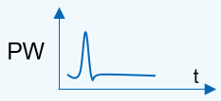  Or 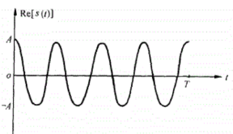 | 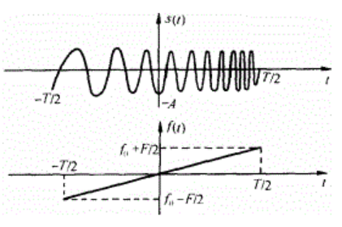
Frequency Domain  characteristic | 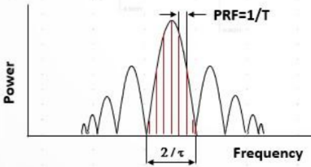 | 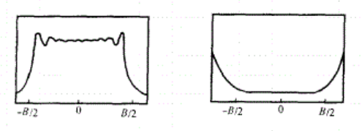
Time-Bandwidth Product (TBP) | $$τ×B=1$$ | $$τ×B>1$$
Operating State of the transmitter PA | Saturation State for larger output power | Saturation State or linear State due to large TBP
Duplex Mode | The operation of transmission and receiving is in the Time Division Duplex (TDD). | The operation of transmission and receiving is in the Full Duplex at the same time and frequency (bandwidth).
Self-interference | As TDD is used for transmission and receiving, there is no self-interference issue. | There is a strong receiving self-interference coupled from transmitter. Generally, the methods of moving target detection technology should be used to eliminate the self-interference, e.g. self-heterodyne, Pulse-Doppler Method.
Range Blind Zone | cτ/2 | If Full Duplex Operation between transmission and receiving is used, there is no Range Blind Zone for CW Radar.
Pulse Compression | Not supported | Supported. For example, matched filter is used to complete the Pulse Compression for LMF signal, but the side lobe of strong Object may interfere the detection of the small Object.

- Recommended WF:
  - Discuss the sensing signal as proposed above in RAN4.

Issue 1-7: Evaluation metric
- Proposal 1: It is proposed to take Table 1 as stating point for metric discussion for sensing. [CMCC]
Table 1 Metrics for sensing
Metric | Definition
Miss detection probability | Miss detection probability is the probability that a true target is not associated with a detected target.  From the aspect of evaluation, it is defined as  $$P_{md}={\sum_{n=0}^{N−1}{\frac{D_{n}}{M_{n}}}}/N$$  Where,  - $D_{n}$ is the number of missed targets in the drop n, i.e., the true target not associated with any detected object  - $M_{n}$ is the number of true targets in the drop n.  - $N$ is total number of drops with at least one target per drop
False alarm probability | Definition Type 1 (no target dropped in simulation area): False alarm probability is defined as the probability that an object is detected when there is no target present in simulation area is considered a false alarm.  From the aspect of evaluation, it is defined as  $$P_{f1}=\frac{\sum_{n=0}^{N−1}{Q_{n}}}{N}$$  Where,  - $Q_{n}$ equal to 1 if at least one object is detected when there is no target dropped in the simulation area in the drop n, otherwise $Q_{n}$ equal to 0.  - $N$ is the total number of drops without targets in the simulation area.  Definition Type 2 (targets dropped in simulation area): False alarm probability is defined as the probability that an object is detected but not associated with any true targets in the simulation area is considered as a false alarm.  From the aspect of evaluation, it is defined as  $$P_{f2}={\sum_{\begin{aligned}0≤n<N \\ M_{n}^{'}≠0\end{aligned}}{\frac{D_{n}^{'}}{M_{n}^{'}}}}/K$$  Where,  - $D_{n}^{'}$ is the number of detected objects but not associated with any true targets in the drop n.  - $M_{n}^{'}$ is the total number of detected objects in the drop n.  - $K$ is number of drops (N)
Horizontal/Vertical Positioning Accuracy | Horizontal/vertical positioning accuracy is defined as the 95th percentile point of the cumulative distribution function (CDF) of the horizontal/vertical position estimation error.  From the aspect of evaluation, the horizontal/vertical position estimation error is the norm of the difference between the estimated horizontal/vertical position and the corresponding true position of a sensing target.
Velocity Accuracy | Velocity accuracy is defined as the 95th percentile point of the cumulative distribution function (CDF) of the velocity estimation error.  From the aspect of evaluation, the velocity estimation error is the norm of the difference between the estimated velocity and the corresponding true velocity of a sensing target.
Sensing Capacity  Note 1 | Sensing capacity is defined as the maximum number of the targets per sector when sensing results of all targets in observation zone fulfil QoS requirements with 95% probability. The QoS requirements are defined by other KPIs (except sensing capacity itself) on sensing.
Max sensing service latency | Max sensing service latency is the time elapsed between the event triggering the determination of the sensing result and the availability of the sensing result at the sensing system interface.
Refreshing rate | Refreshing rate is the rate at which the sensing result is generated by the sensing system. It is the inverse of the time elapsed between two successive sensing results.
Note 1: An intuitive evaluation methodology for sensing capacity can be found in Annex A.

- Proposal 2: For the UAV use case of 6G ISAC study at least, propose to consider the distance, angle estimation and velocity estimation as the basic metric for the study in RAN4. [ZTE]
- Proposal 3: For the UAV use case of 6G ISAC study at least, propose to consider the distance accuracy impacts, angle estimation accuracy impacts and velocity estimation accuracy impacts to quantify the performance impacts from both co-channel and adjacent channel. [ZTE]
- Proposal 4: for the 6G ISAC coexistence study in RAN4, for 6GR performance metric, propose to use the legacy throughput loss as basic metric. [ZTE]
- Recommended WF:
  - Discuss the evaluation metric for different use case in Issue 1-2 in case by case manner;
  - For UAV use case, propose to consider the Horizontal/Vertical Positioning Accuracy and Velocity Accuracy as evaluation metric and FFS on Miss detection probability, False alarm probability

Issue 1-8: KPI for sensing
- Proposal 1: It is proposed to take Table 2 as stating point to discuss KPI on sensing. [CMCC]
Table 2 KPIs on sensing
Use case | Positioning Accuracy |  | Velocity Accuracy  [m/s] | Max sensing service latency  [ms] | Refreshing rate  [Hz] | Sensing Capacity  [per sector] | Missed detection  [%] | False alarm  [%]
Use case | Horizontal  [m] | Vertical  [m]
UAV detection | 10 | 10 | 1 | 1000 | 1-10 | 100 | 1 | 1
UAV tracking | 1 | 1 | 1 | 100-1000 | 1-10 | 100 | 0.1-1 | 1
Automotive detection and tracking | 1 | N/A | 1 | 1000-5000 | 10 | 100 | 1 | 3
Human detection | 1 | N/A | N/A | 1000 -5000 | 10 | 100 | 5 | 2
Note 1: Metrics for tracking can be different with detection. And metrics for tracking should be evaluated independently.

- Recommended WF:
  - Postpone the KPI relevant discussion since this is up to RAN/RAN1 discussion

Issue 1-9: General issue for coexistence study for sensing
- Proposal 1: it’s RAN4’s scope for self-interference cancellation/spatial isolation analysis and the adjacent carrier co-existence simulation for following scenarios [CMCC]
  - Between 5G legacy network and 6G sensing network
  - Between 6G normal network and 6G sensing network based on detailed interference avoidance scheme.
- Proposal 2: RAN4 should waits the agreements from RAN1 to decide whether the coexistence study is necessary. [Xiaomi]
- Proposal 3: RAN4 should discuss the necessity of the coexistence study for the scenario of ISAC-UAVs to other base stations. [Xiaomi]
- Proposal 4: In initial stage, RAN4 shall focus on the study on reference architecture and RF feasibility of interference handling on receiver side from gNB side (TRP-TRP mono static sensing) [Xiaomi]
- Proposal 5: RAN4 could discuss the potential types of the adjacent channel coexistence problem for the ISAC system and decide which type of the coexistence problem to be prioritize. [Samsung]
- Proposal 6: for the 6G ISAC BS, the coexistence studies between ISAC system(s) and the legacy system need to be conducted to figure out the appropriate RF requirements. [ZTE]
- Proposal 7: for the different use case of ISAC deployment, propose to consider differentiating the deployment to make the evaluation more realistic and closer to the deployment. [ZTE]
- Recommended WF:
  - Further discuss whether the following adjacent channel coexistence case should be considered
    - Between 5G legacy network and 6G sensing network
    - Between 6G normal network and 6G sensing network
  - Prioritize the TRP mono-static sensing mode for UAV use case before April, 2026 at least.

Issue 1-10: Assumptions for TRP based mono-static sensing mode, UAV use case
- Proposal 1: RAN4 to identify the antenna configuration for monostatic sensing mode before further performance discussions. [Samsung]
- Proposal 2: For TRP monostatic sensing, RAN4 should prioritize TDM and FDM method, while deprioritizing SDM due to its processing complexity and restrictions on precoding selection. [Samsung]
- Proposal 3: for the simulation assumption for UAV sensing evaluation in RAN4, propose to follow the agreement of simulation assumption reached in RAN1. [ZTE]
- Proposal 4: for the simulation assumption for TN BS, propose to follow the simulation assumption as captured in TR 38.858 for TDD network. [ZTE]
- Proposal 5: for the RCS of sensing target, propose to consider the RCS model as captured in clause 7.9.2.1 of TR 38.901 and simplify the RCS in the large scale pathloss model if necessary. [ZTE]
- Proposal 6: For the 6G ISAC study, consider TDM based sensing operation and full duplex based sensing operation. [ZTE]
- Proposal 7: For the 6G ISAC BS with option 1 TDM operation, consider the RF feasibility evaluation from the receiver’s in-channel linearity and also out of carrier blocking performance. [ZTE]
- Proposal 8: For the 6G ISAC BS with option 2 FDM operation, consider the RF feasibility including fully overlapping transmission/reception between DL and UL. [ZTE]
- Proposal 9: RAN4 should discuss how to detect the UAV objectives in the Blind Spot if we reuse the existing performance of vertical antenna array and element. Alternatively, RAN4 can discuss whether the configurations of vertical antenna array and element can be adjusted for ISAC BS. [CATT]
- Proposal 10: RAN4 should discuss if the summarized azimuth / elevation angular resolution above can meet the requirements or not for UAV use case. [CATT]
- Proposal 11: RAN4 should discuss how the BS antenna arrays are used for BS supporting ISAC.
  - P3-1: discuss whether the existing TDD BS antenna arrays for communications can be directly reused for BS to support ISAC.
  - (P3-1) Possible Answer: the purpose for BS supporting ISAC is to reuse the existing TDD BS hardware / antenna arrays as much as possible.
  - P3-2: If BS has to support BS monostatic ISAC for UAV use case, it’s unclear whether additional BS antenna array need to be implemented, e.g. additional Rx antenna array which is separated from Tx antenna array.
  - (P3-2) Possible Answer: it depends on whether Pulse Wave or Continues Wave is used as the ISAC waveform.
  - For Pulse Wave ISAC BS, the existing shared antenna array between Tx and Rx can be reused since the operation of transmission and receiving for Pulse Wave ISAC BS is in the Time Division Duplex (TDD).
  - For Continues Wave ISAC BS, additional Rx antenna array is needed to provide better isolation between BS transmitter and receiver. Thus, for this case, the BS antenna arrays supporting SBFD can be reused for Continues Wave ISAC BS.
  - P3-3: Apart from Tx and Rx antenna array, it’s unclear whether the antenna elements and the vertical spacing $d_{V}$ should be adjusted, for example: more elements/BB chain is needed, and/or adjust $d_{V}$ from 0.7/2.1λ to 0.5λ.
  - (P3-3) Possible Answer: it depends on the targeted scenarios and the performance of azimuth/elevation angular resolution.
- Recommended WF:
  - For TRP monostatic sensing mode for UAV use case, RAN4 should prioritize TDM and FDM method, while deprioritizing SDM
  - For the simulation assumption for UAV sensing evaluation in RAN4, propose to follow the agreement of simulation assumption reached in RAN1 as starting point.
  - For the simulation assumption for TN BS, propose to follow the simulation assumption as captured in TR 38.858 for TDD network as starting point.
  - FFS on the Blind Spot according to simulation assumption;
  - FFS on azimuth / elevation angular resolution of proposed antenna array can meet the requirements or not for UAV use case.

Issue 1-11: RF requirements
- Proposal 1: RAN4 to study the RAN4 impact on UE RF requirements once RAN1 makes sufficient agreements. [Nokia]
- Proposal 2: Further study the mechanisms to increase the synchronization accuracy level between UEs and TRPs to enable bi-static sensing. [Nokia]
- Proposal 3: RAN4 to study the RAN4 impact on BS RF requirements once RAN1 makes sufficient agreements. [Nokia]
- Recommended WF:
  - FFS on RF requirements for sensing node e.g. BS or UE.
  - For the bi-static sensing mode, the sync performance between different nodes (TRP vs UE and TRP vs TRP) should be carefully considered.

Issue 1-12: the architecture for sensing in RAN4
- Proposal 1: For the architecture study for 6G sensing in RAN4, propose to focus on the RF architecture of sensing node for different use case. [ZTE]
- Recommended WF:
  - For architecture discussion for sensing in RAN4, focus on RF architecture for sensing system;

Issue 1-13: RRM
- Proposal 1: it is proposed to study the impact on UE measurement for the sensing modes involving UE. [CMCC]
- Proposal 2: Which types of RRM requirements shall be studied in 6G SI can wait for the other WGs’ progress. [Xiaomi]
- Proposal 3: RAN4 can consider the several common measurements requirements below for sensing purpose: [Xiaomi]
  - Power strength, timing delay, Doppler, angle in sensing RX
  - Power strength, timing delay, Doppler, angle per path in the sensing RX
  - Accuracy for the measurements which used for the final positioning/velocity estimation
- Proposal 4: RAN4 can take the KPIs of 5G sensing as a start point to discuss the necessary measurement requirement. E.g. [Xiaomi]
  - the delay of a successful measurement report
  - the confidence level for a successful detection
  - the minimum accuracy report granularity
- Proposal 5: From RAN4 perspective, the measurement gap pattern for sensing especially for the Doppler shift estimation can be reconsidered. [Xiaomi]
- Proposal 6: for the 6G ISAC RRM requirement, propose to postpone the discussion until there are sufficient progress made in RAN1/RAN2/RAN3 [ZTE]
- Recommended WF:
  - For RRM for sensing, propose to postpone the discussion until there are sufficient progress made in RAN/RAN1/RAN2;

Issue 1-14: Testability
- Proposal 1: RAN4 agrees to include object emulation as an approved method to verify and validate ISAC in the (to be defined) test procedures. [ROHDE & SCHWARZ]
- 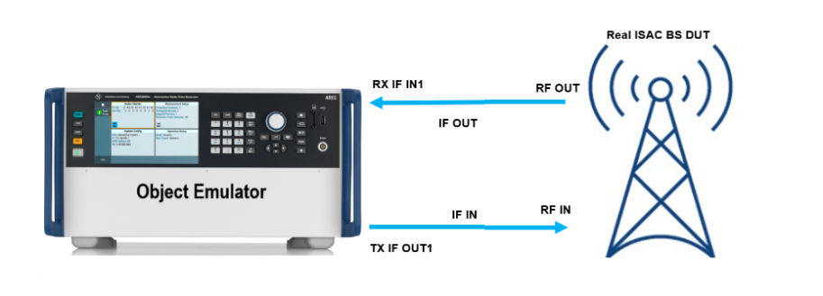
- Proposal 2: ISAC 3GPP tests could be subdivided into two formats viz Conformance and Performance. The Conformance section could focus on the functional aspects of ISAC where we check position and velocity metrics under ideal conditions. The Performance section could be more centric to test the missed detection and false alarm probabilities under fading conditions [ROHDE & SCHWARZ].
- Proposal 3: RAN4 need to study test method for ISAC considering movement of sensing targets, new sensing requirement metric and ISAC channel model. [Xiaomi]
- Proposal 4: RAN4 could begin the testability related topics study for 6GR ISAC once there is any decision on the sensing modes. [Samsung]
- Propsal 5: RAN4 to start the study by focusing on testability aspects with priority given to test cases that involve UE participation. [Nokia]
- Proposal 17: for the 6G ISAC conformance testing, propose to discuss the OTA test setup for conformance testing of moving sensing target. [ZTE]
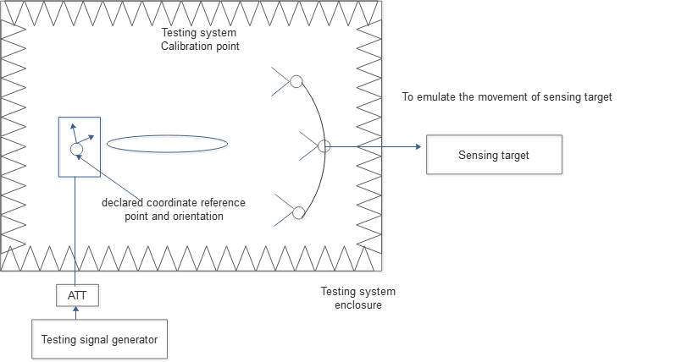
Figure 2.8-1.Illustration of OTA conformance testing for ISAC BS
- Recommended WF:
  - For different ISAC use case, propose to discuss the test setup case by case;
  - For TRP mono-static sensing mode for UAV use case, discuss how to build object emulator in the testing chamber.
  - FFS for other sensing mode and use case;

Issue 1-15: Other
- Proposal 1: RAN4 to further discuss the possibility of introduce more OTA requirements for 1-H. On the other side, OTA requirements numbers are limited to reduce testing workload. [CMCC]
- Recommended WF:
  - Postpone the discussion for above proposal until the set of RF requirement for sensing BS is stable.

Companies’ contributions summary
T-doc number | Company | Proposals / Observations
R4-2520094 | CATT | Discussion on Sensing/ISAC for 6G study
R4-2520338 | ROHDE & SCHWARZ | ISAC test with object emulation
R4-2520434 | CMCC | Discussion on 6GR sensing
R4-2520509 | Xiaomi | View on 6GR sensing
R4-2520556 | Samsung | Discussion on sensing for 6GR
R4-2520603 | Apple | Views on 6G sensing
R4-2521252 | Nokia | Sensing in 6G networks
R4-2521751 | ZTE Corporation, Sanechips | Discussion on 6G Sensing study
R4-2522019 | Ericsson | On radio based sensing in 6G communications networks
R4-2521571 | OPPO | Views on 6G sensing

