3GPP TSG RAN WG2 Meeting #133 R2-260xxxx
Gothenburg, Sweden, Feb. 9th-13th 2026
Agenda Item: 5.1.3.2
Source: Xiaomi
Title: Report of [AT133][603][Maint] 1Tx-1Tx UL switching (Xiaomi)
Document for: Discussion and Decision

Introduction
This report provides a summary for the following discussion:
- [AT133][603][Maint] 1Tx-1Tx UL switching (Xiaomi)
Scope:
    - Discuss offline if a CR is needed and if so, create such a CR (face-to-face preferred)
Intended outcome:
    - Agreed CR(s) in R2-2601251, R2-2601252, R2-2601253, R2-2601254
    - Approved LS in R2-2601255
Deadline:
    - Wednesday 17:00. The intention is to agree over email.

Online Discussion Background
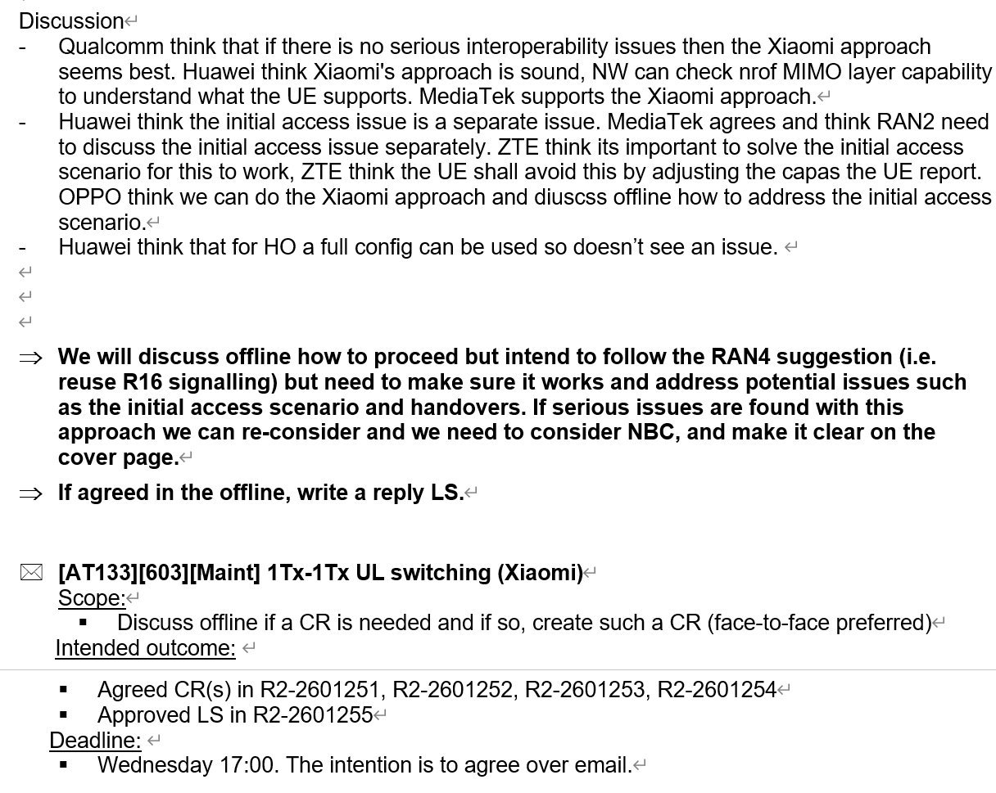

Discussion on Leftover issue
handover
Nokia[0921]
‘One risk is that if UEs immediately start (re)using the same capability for 1Tx-1Tx switching while networks are not prepared to validate that alternative scenario (e.g. if networks are only supporting 1Tx-2Tx switching with that capability and expecting 2-layer UL MIMO on one of the bands), then the network may perceive this erroneously.’

[discussion]
network is expected to check UE capability before providing RRC configuration to UE, even during handover. Based on 6G discussion, different releases, inter-vendor handover (pain point of using delta signalling), normally full configuration will be used as well.

- If there’s an issue, full configuration can be used. there’s no issue during handover.

[ZTE] target gNB assumes if source gNB configures, then it will configure the same as source. [Nokia] particularly during inter-vendor. [QC] there are many cases, which is not new. Full configuration option can be used. checking configuration coming from the source as part of ASN.1. [HW] same view as QC. target gNB can decide based on MIMO layer. [Nokia] target may assume a 1T-2T as 1T-1T. [Nokia] new configuration to check for 1T-1T.

initial access
ZTE[0372] ‘If the 1Tx-1Tx NUL-SUL capable UE is allowed to select SUL carrier for RACH during initial access procedure, there is inter-operability issue when the 1Tx-1Tx NUL-SUL capable UE accesses to an old gNB (which hasn’t been upgraded to support Option 1).’

[discussion]
1. understanding of 1T-2T NUL+SUL capable UE performing initial access on SUL band of a R15 gNB.
Rapp: Rel-16 designs BC signaling structure of 1T-2T UL Tx switching independent from legacy BC list. That means, a 1T-2T NUL+SUL capable UE doesn’t need to report legacy BC list for NUL+SUL.

- 1T-2T NUL+SUL capable UE performing initial access on SUL band to Rel-15 gNB, without indicating the support of NUL+SUL BC list in Rel-15 BC list.
[ZTE] we didn’t discuss this in 1T-2T. it’s not clear about network behavior. 1) direct release the UE due to mismatch capability 2) reconfigure NUL. ZTE thinks UE will be released in this case.
[QC] don’t agree with ZTE on the network implementation. we cannot change UE behavior, and leave this to network implementation. the UE consequence is the same as 1T-2T.
[ZTE] want to clarify that there’s existing UE and network can release.
[SPR] network can reconfigure the UE based on capability, it’s up to network implementation. [Apple] thinks Rel-16 can report NUL+SUL BC and initial access SUL.
[HW] during initial access, network doesn’t check UE capability, and UE can choose any carrier. It’s separate procedure from connected mode. [Oppo] thinks current MAC specification allow UE can perform initial access on SUL band. not sure we need to capture the 2nd sentence. [ZTE] ZTE thinks there is RAN1 spec on the 2nd sentence.

ZTE wants to check is there any existing UE:
1T-2T doesn’t report legacy NUL+SUL band.
QC needs to check. HW and spreadtrum confirms.

[discussion on new configuration/category]
Comment on CR R2-2600217:
- remove ENDC
- cat C, interoperability and report RAN2 consensus to RAN that:
If UE supports this feature and network doesn’t, network may or may not recognize the configuration. It is up to network implantation how to handle this.
- clarify this is the alignment CR to align with RAN4

For online comeback
Proposal 1: RAN2 has consensus on below agreements:
  - RAN2 agrees to indicate the support of switching period of 1Tx-1Tx UL Tx switching for NR inter-band UL CA and SUL band combinations by reusing uplinkTxSwitchingPeriod-r16 of ULTxSwitchingBandPair-r16 since Rel-16.
  - 1T-2T NUL+SUL band UE may not report legacy BC in Rel-15 capability. It is up to network implementation how to handle such UE if it performs initial access on SUL band.
  - 1T-1T NUL+SUL UL Tx switching UE has the same behavior as 1T-2T NUL+SUL band UE during initial access.
  - UE supporting Rel-16 1T-1T inter-band UL CA/NUL+SUL only with non-zero UL switching time will only report BC UL Tx switching via Rel-16 capability, and will not report legacy BC in Rel-15 capability. This will be captured in TS 38.306, therefore no RAN1 impact from RAN2 perspective. It is up to network implementation how to gracefully handle such UE.
  - If the UE reports the ULTxSwitchingBandPair-r16 and ULTxSwitchingBandPair-r18 simultanesouly, a UE supporting UL 1Tx-1Tx switching shall also indicate the support of UL 1Tx-1Tx switching in ULTxSwitchingBandPair-r16 for the corresponding band pair. It is up to network either use Rel-16/18 capability.

