3GPP TSG-RAN2 Meeting #133 R2-2601304
Gothenburg, Sweden, 9 - 13 February 2026 Revision of R2-2600711

Agenda Item: 8.4.2 Corrections
Source: Ericsson Nokia, ZTE Corporation, Sanechips, Vodafone, Interdigital, T-Mobile
USA, BT Plc, Deutsche Telekom, NTT DOCOMO INC., Verizon, Sony, Nordic Semiconductor ASA
Title: LP-WUS and low mobility criterion
Document for: Discussion and Decision

Introduction
Low mobility criterion for LP-WUS is discussed further in this contribution.

Discussion
RAN2 discussed low mobility criterion for LP-WUS and made the following agreements:
- Introduce low mobility criterion, and the capability for UE supporting low mobility criterion is optional if the UE supports Rel-19 RRM relaxation/offloading
- RAN2 understand that there is no RAN4 impact if we introduce the low mobility criterion.
RAN2 was tasked to discuss the details further offline and come to an agreement on the way forward:
- [AT133][201][LPWUS] On low mobility criteria (vivo)
Intended outcome: Summary with Proposals/TPs in R2-2601171
Deadline: before CB
Updated TPs
The TPs in the Annex have been updated to make the low mobility criterion optional for a UE supporting LP-WU. For easy reference the four changes are listed below:
- Low mobility criterion in clause 5.2.4.12.x is fulfilled, if lowMobilityEvaluationLPWUS is configured and supported by the UE.

5.2.4.12.x Low mobility criterion for UE supporting LP-WUS
The low mobility criterion for UE supporting LP-WUS is fulfilled when for a period of TSearchDeltaPLPWUS the condition below is fulfilled, otherwise the low mobility criterion is not fulfilled:

Relaxation of serving cell and neighbouring cell RRM measurements and offloading of serving cell RRM measurements | It is mandatory to support relaxation of serving cell and neighbouring cell RRM measurements and offloading of serving cell RRM measurements if a UE supports reception of LP-WUS in RRC_IDLE/RRC_INACTIVE. A UE supporting this feature shall also indicate the support at least one of lpwus-OOK-r19 and lpwus-OFDM-r19. A UE supporting this feature may also support low mobility criterion for LP-WUS.

lowMobilityEvaluationLPWUS
Indicates the criteria for a UE supporting low mobility criterion for LP-WUS to detect low mobility, in order to relax serving cell and neighboring cell RRM measurement requirements for cell reselection (see TS 38.304 [20], clause 5.2.4.12.x).

Also note that if low mobility criterion is configured, but the UE does not support low mobility criterion, then the relaxed measurement criterion and serving cell measurement offloading criterion are not fulfilled, i.e. the UE is not allowed to use relaxation nor offloading.
Offline #203
During #203 online the following agreements were made:
Proposal 1: RAN2 to agree the below offline agreements:
- For low mobility criterion for Rel-19 RRM relaxation/offloading, no separate exit condition other than ‘not fulfilling the entry condition’.
- For MR measurement based low mobility criterion (if any), Srxlev is used to evaluate the low mobility criteria.
- For LR measurement based low mobility criterion (is any), Qrxlevmeas_lr is used to evaluate the low mobility criteria.
- No separate threshold for low mobility criteria is configured for RRM relaxation and RRM offloading. It applies to both when both RRM relaxation and RRM offloading are configured.
- For low mobility criteria, same threshold/evaluation time is provided for both OOK and OFDM LR, if the criteria is based on LR measurement.
- If UE supporting low mobility, then UE could perform RRM relaxation/RRM offloading only when both low mobility criterion and “not cell edge” are fulfilled when NW configures both.
Proposal 2: RAN2 to discuss the below options on how to evaluate low mobility:
- Option 1: The low mobility criterion is based on serving cell measurement on LR only. Two companies have strong concern.
- Option 2: For low mobility criteria for RRM relaxation and offloading, NW should provide thresholds for both LR and MR. At UE, if MR measurement is available, low mobility is evaluated based on MR measurement. If MR measurement is not available (i.e. during offloading), low mobility is evaluation based on LR measurement. Three companies have strong concern.
Proposal 3: RAN2 to discuss the UE behaviour when not supporting low mobility:
- Option 1: when NW configures both criteria, but UE only supports not-at-cell-edge, UE use not-at-cell-edge criteria to perform RRM relaxation/offloading
- Option 2: when NW configures both criteria, but UE only supports not-at-cell-edge, UE is not allowed to perform RRM relaxation/offloading
Relaxation:
- For low mobility criterion evaluation: Use LR measurements when LR threshold is configured, otherwise the UE uses MR measurements:
  - both when UE is in low mobility and not in low mobility
  - which measurements to use to evaluate low mobility depends on the configuration

Offloading:
- LR threshold is configured for entry:
  - For low mobility criterion evaluation: Use LR measurements:¨
    - both when UE is in low mobility and not in low mobility
    - which measurements to use to evaluate low mobility depends on the configuration
- LR threshold is not configured for entry:
  - For entry the UE only uses MR measurements, for exit the UE always uses LR measurements only
  - The measurements to use to evaluate Low Mobility depends not only on the configuration but also whether the UE is in offloading state or not.
For relaxation an LR threshold is optionally configured for entry/exit:
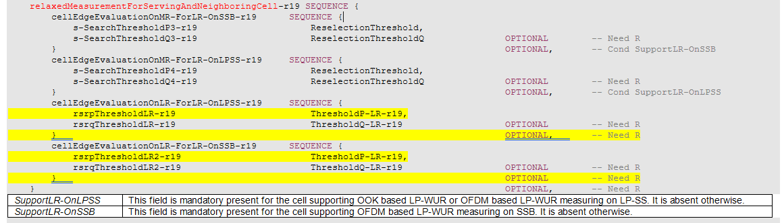

For offloading and LR threshold is optionally configured for entry and mandatory for exit:
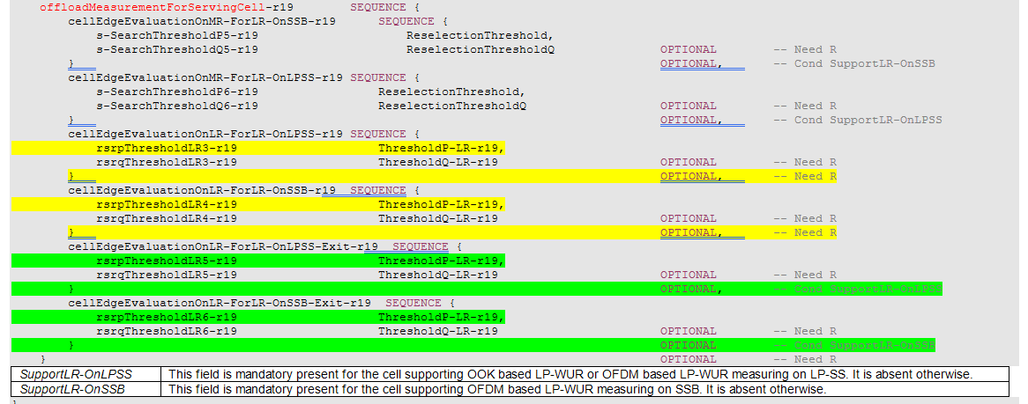

The measurements to use to evaluate Low Mobility with offloading depends not only on the configuration but also whether the UE is in offloading state or not.
To avoid the complexity with offloading I see two options:
- If Low mobility is configured with offloading then the NW always configures the LR threshold for entry. And to evaluate the low mobility criterion the UE always uses LR measurements for both
- Low mobility cannot be configured with offloading.
In my view Low mobility for offloading is not needed, but co-sourcing companies wanted to keep this option. Please find the following motivation why it is not needed:
The NW has to configure the offloading threshold above or equal Sintrasearch:
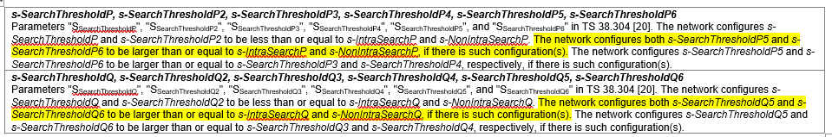
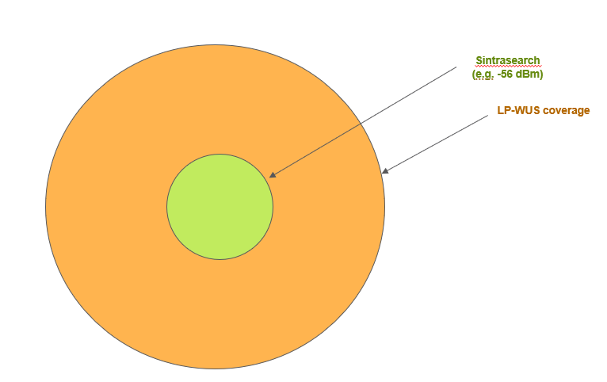

This implies that the UE is only in offloading state when the UE is above Sintrasearch. But when the UE is above Sintrasearch then the UE is not required to measure intra-frequency neighbour cells, i.e. that is legacy behavior. And there is no motivation to require UEs that are not in Low mobility state (i.e moving UEs) to measure intra-frequency neighbours.

For option 1 and 2 the TPs are different w.r.t.:
Option 1:
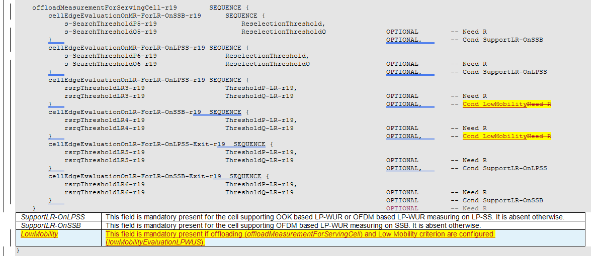
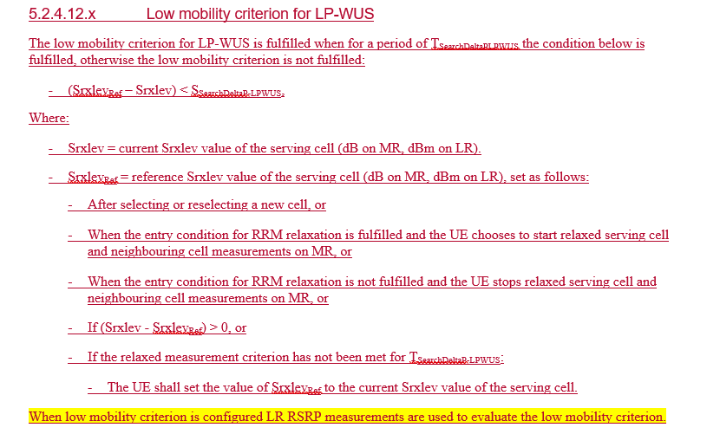
Option 2:
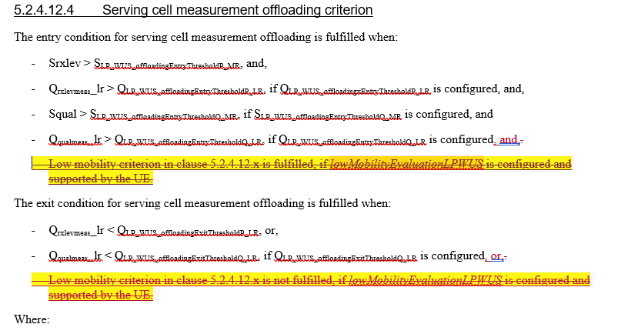
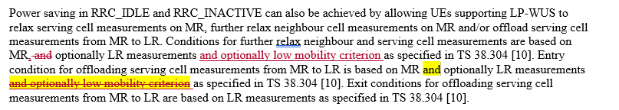
Way forward
In discussion with some of the UE vendors offline no compromise could be reached. It is also not clear what a compromise in the middle would look like.
From a proponent perspective the following observations can be made:
- It is not clear why there is such strong opposition to low mobility criterion, i.e. the feature is of low complexity and already specified for RRM/RLM/BFD relaxation in Rel-16 and Rel-17.
- UE vendors indicated to understand the problem but prefer to leave it to UE implementation. However it is inconsistent to have low mobility specified in Rel-16/17 but leave it to UE implementation in Rel-19. However UE vendors have not indicated how the UE would implement this, i.e. apparently that is not so obvious how to do this.
- Even when no agreement can be reached, the problem will not go away. It can be expected that when Rel-19 LP-WUS would be deployed that there will be UE requirements imposed by the operator, i.e. the problem is resolved outside 3GPP. From NW vendor and operator perspective it is clear that this issue cannot be left to UE implementation, not now and not later either.
Therefore it is proposed:
- RAN2 to agree on the TPs in the Annex.
In case no agreement can be reached, the concerns of NW vendors and operators should be captured in the chairman notes. For further discussion the following text is provided:
NW vendors and operators have concerns about Rel-19 further RRM relaxation with LP-WUS:
- When the relaxation threshold is configured below S_{intraSearch} there is a risk that the UE is not camped on the strongest cell and creates interference when it performs access.
- When the relaxation threshold is configured equal to S_{intraSearch} the usage of LP-WUS is limited to cell centre.

Summary
RAN2 is kindly asked to discuss low mobility criterion for LP-WUS:
Proposal 1 RAN2 to agree on the TPs in the Annex.

References
- R2-2600711, LP-WUS and low mobility criterion, Ericsson Nokia, ZTE Corporation, Sanechips, Vodafone, Interdigital, T-Mobile USA, BT Plc, Deutsche Telekom, NTT DOCOMO INC., Verizon, Sony, Nordic Semiconductor ASA, DISC, Ericsson, RAN2#133
- R2-2600291, Discussion on low mobility criteria for LP-WUS WUR, vivo, DISC, RAN2#133
- R2-2600701, Discussion on the remaining issues on low mobility criterion in LP-WUS, OPPO, RAN2#133
- R2-2600549, Discussion on remaining issues in LP-WUS, ZTE Corporation, Sanechips, DISC, RAN2#133

TP 38.300, 38.304, 38.306 and 38.331
38.300
Power saving in RRC_IDLE and RRC_INACTIVE can also be achieved by allowing UEs supporting LP-WUS to relax serving cell measurements on MR, further relax neighbour cell measurements on MR and/or offload serving cell measurements from MR to LR. Conditions for further relax neighbour and serving cell measurements are based on MR, optionally LR measurements and optionally low mobility criterion as specified in TS 38.304 [10]. Entry condition for offloading serving cell measurements from MR to LR is based on MR, optionally LR measurements and optionally low mobility criterion as specified in TS 38.304 [10]. Exit conditions for offloading serving cell measurements from MR to LR are based on LR measurements as specified in TS 38.304 [10].
38.304

5.2.4.12.2 Relaxed measurement criterion
The relaxed measurement criterion for serving cell and neighbouring cell measurement relaxation on MR is fulfilled when:
- Srxlev > S_{LP_WUS_RelaxThresholdP_MR}, and,
- Q_{rxlevmeas}_lr > Q_{LP_WUS_RelaxThresholdP_LR}, if Q_{LP_WUS_EntryThresholdP_LR} is configured, and,
- Squal > S_{LP_WUS_RelaxThresholdQ_MR}, if S_{LP_WUS_RelaxThresholdQ_MR} is configured, and,
- Q_{qualmeas}_lr > Q_{LP_WUS_RelaxThresholdQ_LR}, if Q_{LP_WUS_EntryThresholdQ_LR} is configured, and,
- Low mobility criterion in clause 5.2.4.12.x is fulfilled, if lowMobilityEvaluationLPWUS is configured and supported by the UE.
Where:
- Srxlev = current Srxlev value of the serving cell (dB).
- Squal = current Squal value of the serving cell (dB).
- Q_{rxlevmeas}_lr = current measured cell RX level value of the serving cell based on LR (RSRP).
- Q_{qualmeas}_lr = current measured cell quality value of the serving cell based on LR (RSRQ).
- S_{LP_WUS_RelaxThresholdP_MR}: The Srxlev threshold for the criterion for serving cell and neighbouring cell measurement relaxation based on MR.
- S_{LP_WUS_RelaxThresholdQ_MR}: The Squal threshold for the criterion for serving cell and neighbouring cell measurement relaxation based on MR.
- Q_{LP_WUS_RelaxThresholdP_LR}: The cell RX level threshold for the criterion for serving cell and neighbouring cell measurement relaxation based on LR.
- Q_{LP_WUS_RelaxThresholdQ_LR}: The cell quality threshold for the criterion for serving cell and neighbouring cell measurement relaxation based on LR.
These thresholds can be configured separately for LR measurements based on LP-SS and LR measurements based on SSB if a cell supports both measurement types as specified in TS 38.331 [3]. S_{LP_WUS_RelaxThresholdP_MR} is the parameter S_{SearchThresholdP3} or S_{SearchThresholdP4} in TS 38.331 [3]. S_{LP_WUS_RelaxThresholdQ_MR} is the parameter S_{SearchThresholdQ3} or S_{SearchThresholdQ4} in TS 38.331 [3]. Q_{LP_WUS_RelaxThresholdP_LR} is the parameter S_{RSRPThresholdLR} or S_{RSRPThresholdLR2} in TS 38.331 [3]. Q_{LP_WUS_RelaxThresholdQ_LR} is the parameter S_{RSRQThresholdLR} or S_{RSRQThresholdLR2} in TS 38.331 [3]. If UE supports both measurement types, it is up to UE implementation to choose LR measurements based on LP-SS or based on SSB for the determination of the relaxed measurement criterion for serving cell and neighbouring cell measurement relaxation on MR.

5.2.4.12.4 Serving cell measurement offloading criterion
The entry condition for serving cell measurement offloading is fulfilled when:
- Srxlev > SLP_WUS_offloadingEntryThresholdP_MR, and,
- Q_{rxlevmeas}_lr > QLP_WUS_offloadingEntryThresholdP_LR, if QLP_WUS_offloadingxEntryThresholdP_LR is configured, and,
- Squal > SLP_WUS_offloadingEntryThresholdQ_MR, if SLP_WUS_offloadingEntryThresholdQ_MR is configured, and
- Q_{qualmeas}_lr > QLP_WUS_offloadingEntryThresholdQ_LR, if QLP_WUS_offloadingEntryThresholdQ_LR is configured, and,
- Low mobility criterion in clause 5.2.4.12.x is fulfilled, if lowMobilityEvaluationLPWUS is configured and supported by the UE.
The exit condition for serving cell measurement offloading is fulfilled when:
- Q_{rxlevmeas}_lr < QLP_WUS_offloadingExitThresholdP_LR, or,
- Q_{qualmeas}_lr < QLP_WUS_offloadingExitThresholdQ_LR, if QLP_WUS_offloadingExitThresholdQ_LR is configured, or,
- Low mobility criterion in clause 5.2.4.12.x is not fulfilled, if lowMobilityEvaluationLPWUS is configured and supported by the UE.
Where:
- Srxlev = current Srxlev value of the serving cell (dB).
- Squal = current Squal value of the serving cell (dB).
- Q_{rxlevmeas}_lr= current measured cell RX level value of the serving cell based on LR (RSRP).
- Q_{qualmeas} _lr = current measured cell quality value of the serving cell based on LR (RSRQ).
- SLP_WUS_offloadingEntryThresholdP_MR: The Srxlev threshold for entry condition of serving cell measurement offloading based on MR.
- SLP_WUS_offloadingEntryThresholdQ_MR: The Squal threshold for entry condition of serving cell measurement offloading based on MR.
- QLP_WUS_offloadingEntryThresholdP_LR: The cell RX level threshold for entry condition of serving cell measurement offloading based on LR.
- QLP_WUS_offloadingEntryThresholdQ_LR: The cell quality threshold for entry condition of serving cell measurement offloading based on LR.
- QLP_WUS_offloadingExitThresholdP_LR: The cell RX level threshold for exit condition of serving cell measurement offloading based on LR.
- QLP_WUS_offloadingExitThresholdQ_LR: The cell quality threshold for exit condition of serving cell measurement offloading based on LR.
These thresholds can be configured separately for LR measurements based on LP-SS and LR measurements based on SSB if a cell supports both measurement types as specified in TS 38.331 [3]. SLP_WUS_offloadingEntryThresholdP_MR is the parameter S_{SearchThresholdP5} or S_{SearchThresholdP6} in TS 38.331 [3]. SLP_WUS_offloadingEntryThresholdQ_MR is the parameter S_{SearchThresholdQ5} or S_{SearchThresholdQ6} in TS 38.331 [3]. QLP_WUS_offloadingEntryThresholdP_LR is the parameter S_{RSRPThresholdLR3} or S_{RSRPThresholdLR4} in TS 38.331 [3]. QLP_WUS_offloadingEntryThresholdQ_LR is the parameter S_{RSRQThresholdLR3} or S_{RSRQThresholdLR4} in TS 38.331 [3]. QLP_WUS_offloadingExitThresholdP_LR is the parameter S_{RSRPThresholdLR5} or S_{RSRPThresholdLR6} in TS 38.331 [3]. QLP_WUS_offloadingExitThresholdQ_LR is the parameter S_{RSRQThresholdLR5} or S_{RSRQThresholdLR6} in TS 38.331 [3]. If UE supports both measurement types, it is up to UE implementation to choose LR measurements based on LP-SS or based on SSB for the determination of the entry/exit conditions of serving cell measurement offloading.

5.2.4.12.x Low mobility criterion for LP-WUS
The low mobility criterion for LP-WUS is fulfilled when for a period of T_{SearchDeltaPLPWUS} the condition below is fulfilled, otherwise the low mobility criterion is not fulfilled:
- (Srxlev_{Ref} – Srxlev) < S_{SearchDeltaP-LPWUS},
Where:
- Srxlev = current Srxlev value of the serving cell (dB on MR, dBm on LR).
- Srxlev_{Ref} = reference Srxlev value of the serving cell (dB on MR, dBm on LR), set as follows:
- After selecting or reselecting a new cell, or
- When the entry condition for RRM relaxation is fulfilled and the UE chooses to start relaxed serving cell and neighbouring cell measurements on MR, or
- When the entry condition for RRM relaxation is not fulfilled and the UE stops relaxed serving cell and neighbouring cell measurements on MR, or
- If (Srxlev - Srxlev_{Ref}) > 0, or
- If the relaxed measurement criterion has not been met for T_{SearchDeltaP-LPWUS}:
- The UE shall set the value of Srxlev_{Ref} to the current Srxlev value of the serving cell.
When low mobility criterion is configured LR RSRP measurements are used to evaluate the low mobility criterion.
When low mobility criterion is configured with relaxed measurement criterion and Q_{LP_WUS_EntryThresholdP_LR} is configured then also LR RSRP measurements are used to evaluate the low mobility criterion. But when low mobility criterion is configured with relaxed measurement criterion and Q_{LP_WUS_EntryThresholdP_LR} is not configured then MR RSRP measurements are used to evaluate the low mobility criterion.

38.306
Relaxation of serving cell and neighbouring cell RRM measurements and offloading of serving cell RRM measurements | It is mandatory to support relaxation of serving cell and neighbouring cell RRM measurements and offloading of serving cell RRM measurements if a UE supports reception of LP-WUS in RRC_IDLE/RRC_INACTIVE. A UE supporting this feature shall also indicate the support at least one of lpwus-OOK-r19 and lpwus-OFDM-r19. A UE supporting this feature may also support low mobility criterion for LP-WUS.

38.331
SIB2 ::= SEQUENCE {
…
relaxedMeasurement-r16 SEQUENCE {
lowMobilityEvaluation-r16 SEQUENCE {
s-SearchDeltaP-r16 ENUMERATED {
dB3, dB6, dB9, dB12, dB15,
spare3, spare2, spare1},
t-SearchDeltaP-r16 ENUMERATED {
s5, s10, s20, s30, s60, s120, s180,
s240, s300, spare7, spare6, spare5,
spare4, spare3, spare2, spare1}
} OPTIONAL, -- Need R
cellEdgeEvaluation-r16 SEQUENCE {
s-SearchThresholdP-r16 ReselectionThreshold,
s-SearchThresholdQ-r16 ReselectionThresholdQ OPTIONAL -- Need R
} OPTIONAL, -- Need R
combineRelaxedMeasCondition-r16 ENUMERATED {true} OPTIONAL, -- Need R
highPriorityMeasRelax-r16 ENUMERATED {true} OPTIONAL -- Need R
} OPTIONAL -- Need R
…
relaxedMeasurementForServingAndNeighboringCell-r19 SEQUENCE {
cellEdgeEvaluationOnMR-ForLR-OnSSB-r19 SEQUENCE {
s-SearchThresholdP3-r19 ReselectionThreshold,
s-SearchThresholdQ3-r19 ReselectionThresholdQ OPTIONAL -- Need R
} OPTIONAL, -- Cond SupportLR-OnSSB
cellEdgeEvaluationOnMR-ForLR-OnLPSS-r19 SEQUENCE {
s-SearchThresholdP4-r19 ReselectionThreshold,
s-SearchThresholdQ4-r19 ReselectionThresholdQ OPTIONAL -- Need R
} OPTIONAL, -- Cond SupportLR-OnLPSS
cellEdgeEvaluationOnLR-ForLR-OnLPSS-r19 SEQUENCE {
rsrpThresholdLR-r19 ThresholdP-LR-r19,
rsrqThresholdLR-r19 ThresholdQ-LR-r19 OPTIONAL -- Need R
} OPTIONAL, -- Need R
cellEdgeEvaluationOnLR-ForLR-OnSSB-r19 SEQUENCE {
rsrpThresholdLR2-r19 ThresholdP-LR-r19,
rsrqThresholdLR2-r19 ThresholdQ-LR-r19 OPTIONAL -- Need R
} OPTIONAL -- Need R
} OPTIONAL, -- Need R
offloadMeasurementForServingCell-r19 SEQUENCE {
cellEdgeEvaluationOnMR-ForLR-OnSSB-r19 SEQUENCE {
s-SearchThresholdP5-r19 ReselectionThreshold,
s-SearchThresholdQ5-r19 ReselectionThresholdQ OPTIONAL -- Need R
} OPTIONAL, -- Cond SupportLR-OnSSB
cellEdgeEvaluationOnMR-ForLR-OnLPSS-r19 SEQUENCE {
s-SearchThresholdP6-r19 ReselectionThreshold,
s-SearchThresholdQ6-r19 ReselectionThresholdQ OPTIONAL -- Need R
} OPTIONAL, -- Cond SupportLR-OnLPSS
cellEdgeEvaluationOnLR-ForLR-OnLPSS-r19 SEQUENCE {
rsrpThresholdLR3-r19 ThresholdP-LR-r19,
rsrqThresholdLR3-r19 ThresholdQ-LR-r19 OPTIONAL -- Need R
} OPTIONAL, -- Need R
cellEdgeEvaluationOnLR-ForLR-OnSSB-r19 SEQUENCE {
rsrpThresholdLR4-r19 ThresholdP-LR-r19,
rsrqThresholdLR4-r19 ThresholdQ-LR-r19 OPTIONAL -- Need R
} OPTIONAL, -- Need R
cellEdgeEvaluationOnLR-ForLR-OnLPSS-Exit-r19 SEQUENCE {
rsrpThresholdLR5-r19 ThresholdP-LR-r19,
rsrqThresholdLR5-r19 ThresholdQ-LR-r19 OPTIONAL -- Need R
} OPTIONAL, -- Cond SupportLR-OnLPSS
cellEdgeEvaluationOnLR-ForLR-OnSSB-Exit-r19 SEQUENCE {
rsrpThresholdLR6-r19 ThresholdP-LR-r19,
rsrqThresholdLR6-r19 ThresholdQ-LR-r19 OPTIONAL -- Need R
} OPTIONAL -- Cond SupportLR-OnSSB
} OPTIONAL, -- Need R
lowMobilityEvaluationLPWUS-r19 SEQUENCE {
s-SearchDeltaP-LPWUS-r19 ENUMERATED {dB3, dB6, dB9, dB12, dB15, spare3, spare2, spare1},
t-SearchDeltaP-LPWUS-r19 ENUMERATED {s5, s10, s20, s30, s60, s120, s180, s240, s300, spare7,
spare6, spare5, spare4, spare3, spare2, spare1}
} OPTIONAL -- Need R
]]
}
…

lowMobilityEvaluationLPWUS
Indicates the criteria for a UE supporting low mobility criterion for LP-WUS to detect low mobility, in order to relax serving cell and neighboring cell RRM measurement requirements for cell reselection (see TS 38.304 [20], clause 5.2.4.12.x).
s-SearchDeltaP-LPWUS
Parameter "S_{SearchDeltaP-LPWUS}" in TS 38.304 [20]. Value dB3 corresponds to 3 dB, dB6 corresponds to 6 dB and so on.
t-SearchDeltaP-LPWUS
Parameter "T_{SearchDeltaP-LPWUS}" in TS 38.304 [20]. Value in seconds. Value s5 means 5 seconds, value s10 means 10 seconds and so on.
s-SearchThresholdP, s-SearchThresholdP2, s-SearchThresholdP3, s-SearchThresholdP4, s-SearchThresholdP5, s-SearchThresholdP6
Parameters "S_{SearchThresholdP}", "S_{SearchThresholdP2}", "S_{SearchThresholdP3}", "S_{SearchThresholdP4}", "S_{SearchThresholdP5}", and "S_{SearchThresholdP6}" in TS 38.304 [20]. The network configures s-SearchThresholdP and s-SearchThresholdP2 to be less than or equal to s-IntraSearchP and s-NonIntraSearchP. The network configures both s-SearchThresholdP5 and s-SearchThresholdP6 to be larger than or equal to s-IntraSearchP and s-NonIntraSearchP, if there is such configuration(s). The network configures s-SearchThresholdP5 and s-SearchThresholdP6 to be larger than or equal to s-SearchThresholdP3 and s-SearchThresholdP4, respectively, if there is such configuration(s).
s-SearchThresholdQ, s-SearchThresholdQ2, s-SearchThresholdQ3, s-SearchThresholdQ4, s-SearchThresholdQ5, s-SearchThresholdQ6
Parameters "S_{SearchThresholdQ}", "S_{SearchThresholdQ2}", "S_{SearchThresholdQ3}", "S_{SearchThresholdQ4}", "S_{SearchThresholdQ5}", and "S_{SearchThresholdQ6}" in TS 38.304 [20]. The network configures s-SearchThresholdQ and s-SearchThresholdQ2 to be less than or equal to s-IntraSearchQ and s-NonIntraSearchQ. The network configures both s-SearchThresholdQ5 and s-SearchThresholdQ6 to be larger than or equal to s-IntraSearchQ and s-NonIntraSearchQ, if there is such configuration(s). The network configures s-SearchThresholdQ5 and s-SearchThresholdQ6 to be larger than or equal to s-SearchThresholdQ3 and s-SearchThresholdQ4, respectively, if there is such configuration(s).
<TEXT OMITTED>

