3GPP TSG-RAN WG2 Meeting #132 R2-250xxxx
Dallas, USA, 17th – 21st Nov, 2025

Agenda item: 8.19.1
Source: Samsung
Title: Report of [305] TEI19 corrections (Samsung)
WID/SID: TEI19
Document for: Discussion and Decision

Introduction
This is the report of the following offline discussion:
- [AT132][305][TEI19] TEI19 corrections (Samsung)
Scope: discuss a revision on the TEI19 CRs
Intended outcome: agreeable CRs
Deadline for revised CRs (in R2-2509208 and R2-2509209): Friday 2025-11-21 08:00
...

NR TN to NR NTN corrections
Regarding corrections for NR TN to NR NTN, the following was noted online:
- Corrections for [NR_TN_NTN_redir]
R2-2508330 [S058][B002] Correction to TN to NTN redirection [NR_TN_NTN_redir] Samsung CR Rel-19 38.331 19.0.0 5574 - F TEI19
- Xiaomi agrees with the CR. QC/Apple also agree
- vivo and Google also support this.
- ZTE thinks we also need to solve the FFS value in the ASN.1
- The change is agreed but we can continue in offline 305 on the wording in the field description.
- Revised in R2-2509208
R2-2509208 [S058][B002] Correction to TN to NTN redirection [NR_TN_NTN_redir] Samsung CR Rel-19 38.331 19.0.0 5574 1 F TEI19
- CB Friday

We encourage companies to provide comments directly to the CR.
If there are any more fundamental questions that may need a proposal, then we provide opportunities for companies to give some comments on NR TN to NR NTN (hopefully none):
Company | Comments

Offline comments:

Rapporteur conclusion:
...
Proposal 1: ....

NB-specific list for E-UTRAN to NB-IoT NTN mobility
Regarding corrections for E-UTRAN to NB-IoT NTN mobility:
- Corrections for [EUTRAN-to-NBIOTNTN] [IoT_TN_NTN_redir]
R2-2508331 [S906] Removing NB-specific satellite info list [EUTRAN-to-NBIOTNTN] [IoT_TN_NTN_redir] Samsung, Google, Vivo CR Rel-19 36.331 19.0.0 5175 - F TEI19
- Revised in R2-2509308
R2-2509308 [S906][V218] RRC RIL corrections on TN-NTN mobility [EUTRAN-to-NBIOTNTN] [IoT_TN_NTN_redir] Samsung, Google, Vivo CR Rel-19 36.331 19.0.0 5175 1 F TEI19
- First change is Agreed
- ZTE disagrees with the second change
- Ericsson thinks we can just remove the extension list
- Continue in offline 305 for the second change
- Revised in R2-2509209
R2-2509209 [S906][V218] RRC RIL corrections on TN-NTN mobility [EUTRAN-to-NBIOTNTN] [IoT_TN_NTN_redir] Samsung, Google, Vivo CR Rel-19 36.331 19.0.0 5175 2 F TEI19
- CB Friday

Some related agreements and discussions on this is in RAN2#129:
R2-2500086 On LTE TN to NB-IoT NTN Mobility Handling vivo discussion Rel-19 TEI19
Proposal 1: Define a new IE for NB-IoT satellite assistance information and a new neighbour satellite information list to provide the NB-IoT satellite information in SIB33.
- Xiaomi thinks p1 is not needed. Vivo suggests to have a separate list to be able to signal more, aligned to the NR design
- Samsung wonders if 4 would be enough. Google agrees
- QC thinks it is useful to have the possibility to broadcast more
- Xiaomi thinks that if 4 is not enough this is not a specific issue for this case
- Agreed (to be reflected in the CR for the next meeting)
Proposal 2: maxSat-r17 (i.e. 4) is reused for the maximum number of NB-IoT satellites.
- Agreed (to be reflected in the CR for the next meeting)
Proposal 3: NeighSatelliteInfo-r18 is reused for including NB-IoT satellite information.
- Agreed (to be reflected in the CR for the next meeting)

Agreements:
- Define a new IE for NB-IoT satellite assistance information and a new neighbour satellite information list to provide the NB-IoT satellite information in SIB33.
- maxSat-r17 (i.e. 4) is reused for the maximum number of NB-IoT satellites.
- NeighSatelliteInfo-r18 is reused for including NB-IoT satellite information.

As can be seen from RAN2#129, there was an agreement to introduce a new IE for NB-IoT satellite assistance information, but however there were questions on whether it was needed at the time. As can be seen from the comments it was agreed with the understanding that the separate list would allow to signal more satellite elements.
Regardless of the agreement, the current neighSatelliteInfoList-NB-r19 is not aligned with the elegant satellite assistance design in IoT NTN. SIB33 is essentially designed as a pool of satellite-specific information elements. The design from Release 18 can be seen in Figure 1.
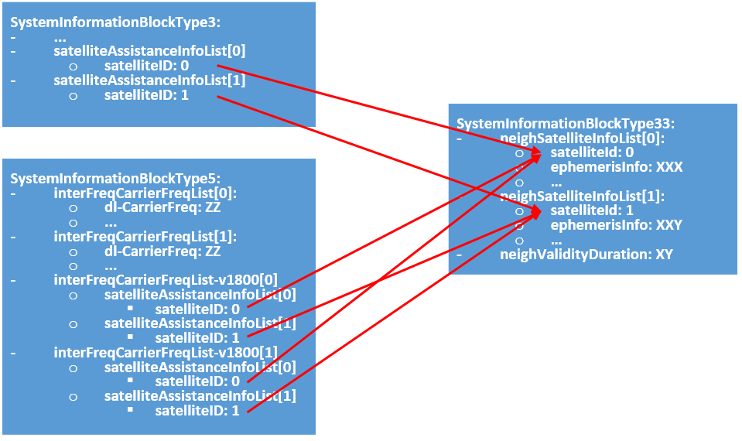
Figure 1
For release 19, it has been agreed to introduce intra-RAT and inter-RAT cell selection, reselection and redirection. The NR-specific satellite info list is only introduced because the fields of the satellite assistance payload between E-UTRAN and NR is different. However, for an E-UTRAN and NB-IoT cell, the fields are the same.
Observation 1: For E-UTRAN and NB-IoT the fields in the satellite assistance information are the same.
In the most likely deployment, the E-UTRAN cell will only broadcast satellite assistance elements of an NB-IoT frequency as seen in Figure 2A. In this case, there is no reason to have a neighSatelliteInfoList-NB-r19. This will not have an impact on legacy UEs, or legacy UEs that support Release 18 eTMC TN to eMTC NTN cell reselection. This is because the UEs supporting Release 18 eMTC TN to eMTC NTN will only see a SIB33 with satellite assistance information elements, but with no satellite IDs tied to any frequency that the UE “sees”, meaning that the satellite assistance information elements are not used. Figure 2B shows what the Release 18 eMTC TN to eMTC NTN (that is not capable of NB-IoT NTN inter-RAT cell selection) sees.
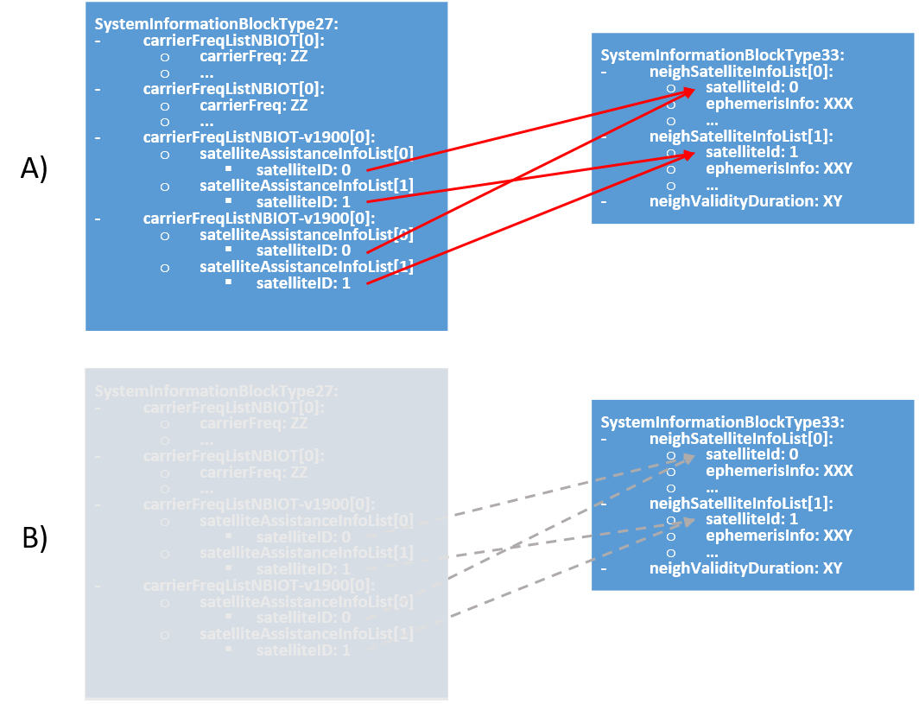
Figure 2. A) Mapping of ephemeris element and NB-IoT frequency for Rel-19 E-UTRAN TN to NB-IoT NTN-capable UEs, B) mapping as seen by a UE not capable of Rel-19 E-UTRAN TN to NB-IoT NTN.

Observation 2: For E-UTRAN and NB-IoT the fields in the satellite assistance information are the same.
In the very unlikely case that an EUTRAN TN would broadcast eMTC NTN frequency information via SIB5 and NB-IoT NTN cell selection assistance information in SIB27, then the design without the neighSatelliteInfoList-NB-r19 would still be supported. In this case, the eMTC NTN and NB-IoT may be provided by the same or different satellites. This can be seen in Figure 3.
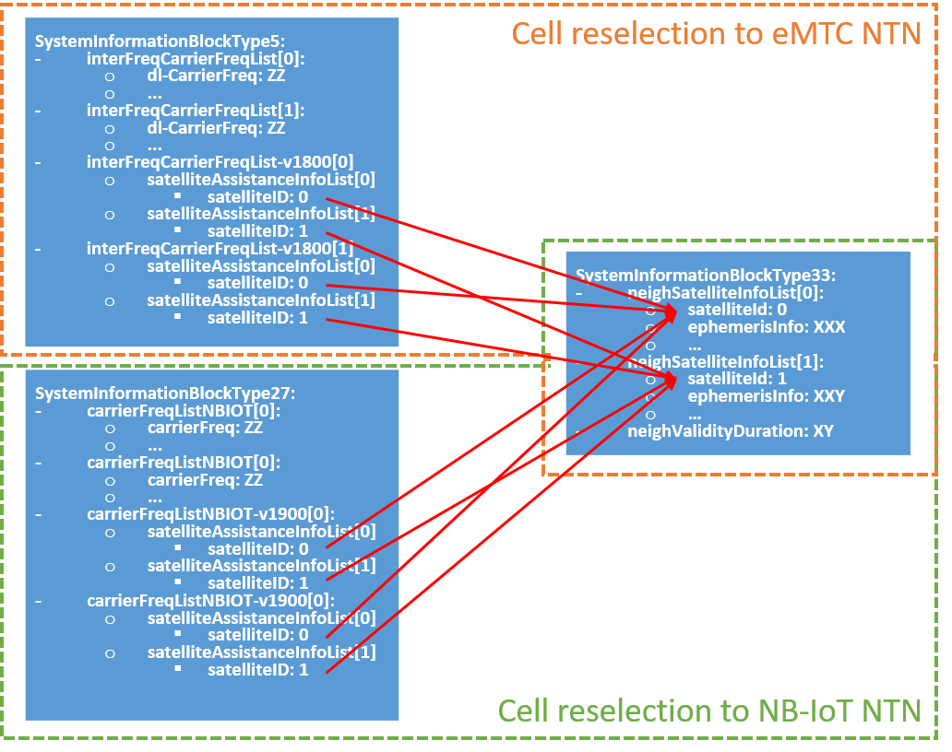
Figure 3
If the design with the neighSatelliteInfoListNB-r19 is kept, then in the unlikely case eMTC NTN and NB-IoT NTN are both signalled, which are provided with the same satellite, then both neighSatelliteInfoList-r18 and neighSatelliteInfoListNB-r19 would have to repeat exactly the same satellite assistance information. Furthermore, there will have to be more clarifications, as currently everything related to E-UTRAN TN to NB-IoT NTN refers to the field neighSatelliteInfoList-r18 and not the neighSatelliteInfoListNB-r19. And there would have to be clarifications whether neighSatelliteInfoList-r18 can contain NB-IoT satellites. This would be required to ensure that both the network how to implement the signalling, and for the UE to know how to interpret the various possibilities that the specifications allow. For LTE TN to NR NTN, many clarifications were added to make it crystal clear.
Observation 3: There is no reason with the current satellite assistance design in 36.331 to have an –NB specific.
Observation 4: If neighSatelliteInfoListNB-r19 is kept, there would have to be clarifications on how a network shall implement E-UTRAN TN to NB-IoT NTN mobility and how a UE can interpret the different options that current specifications allow.
With the above understanding that something is needed, we can start to discuss the two options to RIL S906:
- Option 1: Make the –NB list an extended list of neighSatelliteInfoList-r18 satellite assistance information elements. This allows a terrestrial E-UTRAN to broadcast a larger amount of satellite assistance elements. Note that this will be broadcasted in an E-UTRAN cell where the SIB sizes does not have the NB-IoT/eMTC size restrictions, and where it can be assumed that the coverage is better.
- Option 2: Remove the –NB-specific list. This allows for a more simple implementation.

Company | Option 1 (-Ext list) / Option 2 (remove list) | Comments
Samsung | Option 2 – Remove list | Simpler and avoids some issues if we ever want to introduce new satellite information.
Ericsson | Option 2 | Agree with the arguments provided by the rapp. In addition, for this specific use-case, we do not think 8 satellites are needed.

Offline comments:

Rapporteur conclusion:
...
Proposal 1: ....

Conclusion
In this contribution, we discussed corrections related to TEI19:
Observation 1: ...

Proposal 1: ...

Reference
- RP-251867, Revised WID on Non-Terrestrial Networks (NTN) for Internet of Things (IoT) Phase 4, Vivo, RAN#108, Prague, Czechia, June 2025.

