3GPP TSG-RAN WG2 Meeting #132 DRAFT_ R2-2509115
Dallas, USA, 17th - 21st November 2025

Source: Session chair (Huawei)
Title: Report from session on XR and LTE-based 5G Broadcast

List of AT-meeting offline discussions

- [AT132][500] Organizational – Session on XR and LTE-based 5G Broadcast (Session chair)
Scope:
      - Share plans and list of ongoing email discussions for the session
      - Share meeting notes and agreements for review and endorsement

- [AT132][502][XR] Updated RLC CR (vivo)
Scope: Update the RLC CR with the agreements from this meeting
Intended outcome: Agreeable CR in R2-2509243
Deadline: Friday 2025-11-21, 08:00

List of POST-meeting offline discussions
- [POST132][501][XR] Final RRC CR (Huawei)
Scope: Agree to the final rapporteur RRC CR
Intended outcome: Agreeable CR in R2-2509242
Deadline: Short

2.4 Instructions

CRs
- Use latest CR template version 12.3 for all CRs submitted to RAN2 meeting

Rel-18 and earlier maintenance CRs
- Only essential/critical corrections are expected
- Editorial and clarification corrections should be sent to be reviewed and approved by spec rapporteurs prior to submission.
- Editorials corrections should be collected and submitted by spec rapporteurs.
- NOTE: the tdoc limit applies to all CRs (i.e. WI spec rapporteurs are NO longer expected to submit individual contributions). They can submit a company CR where they also include miscellaneous corrections that have been sent to them.

Rel-18 UE capabilities
- EUTRA UE capabilities corrections are covered by separate CRs
- RAN1/RAN4 NR UE capabilities (new) and corrections are covered in Rel-18 common MegaCRs (38306 and 38331) covering all rel-18 WIs (end outcome).
- UE capabilities in LPP 37355 and SLPP 38355 are covered in the main CRs for the Positioning WI.

Rel-19 CRs
- CR already agreed in principle but not yet officially agreed must be submitted to RAN2#131 for formal approval under in-principle agreed CRs AIs
- CR editors / Rapporteurs continue to support maintenance related to their respective CR / WI and are required to follow drafting rules
- Single correction CR per spec coordinated by CR editor/rapporteurs will be agreed per feature for RAN#132
- Rapporteurs (except for RRC) should create open issue list for correction phase. See below.
- CR editors / Rapporteurs should gather miscellaneous and non-controversial issues, if any, for their respective specification prior to submission deadline. Other companies are expected to give editorial inputs to the rapporteurs and not have contributions on such issues.
- Emails to CR editors/rapporteurs should follow the following naming convention when sending emails to rapporteurs:
[Pre_RAN2#132][CR xx.yyy] Clarification CRs
- The organizational AIs for each WIs are reserved for rapporteurs only. CR rapporteurs are expected to submit only 1 CR per spec.
- Companies are expected to submit Tdocs with TP (not CRs). More specifically, the Tdoc should contain description of open issues/proposal and the proposed corrections/TP in the contribution itself. Small issues can be included in the tdoc with just short justification same level of detail as in cover sheet.
- RRC ASN.1 changes can be drafted in a NBC way until ASN.1 is frozen, to avoid unnecessary RRC overhead. The focus should be on drafting the changes in the best possible way.
- Inter-op analysis on Rel-19 CR coverpages in NOT needed
Open issues
- A list of open issues for correction phase is expected to be created per CR per WI if an ongoing email discussion has been assigned(except for RRC specification - issues will be maintained in RIL list) and shared as soon as possible. Companies can contribute to the open issue list and input (if requested) possible resolution. Rapporteurs can set intermediate deadlines.
- Rapporteur and/or company identifying issue can provide proposal on how to resolve the issues
  - For each issue, rapporteurs are requested to explicitly indicate whether further contribution input on the open issue is needed. Input should be requested only for difficult to resolve issues and/or new open issues for which there wasn’t sufficient discussion time to resolve it.
  - Rapporteurs should critically consider the need for contribution on an issue. If the issue can be resolved with a quick offline during the meeting, then the issue should be marked as to be resolved offline without contributions on that topic.
- Stage 2 corrections and UE capability corrections should be given to rapporteur directly over email and no contributions are expected, unless really needed as specified by rapporteur.
- Companies should follow rapporteurs guidance (i.e. only address open issues for which the rapporteur indicates further input is needed).
- Companies should clearly indicate the open issue number they are addressing in their section and proposal, e.g. Proposal x: (RIL-1, MAC-1, etc) Agree to bla bla

ASN.1 and Handling of RILs
- Please review Hakan's email instructions on ASN.1 review.
- Companies are expected to provide their TPs/Comments in the RIL Comment file and not submit contributions. WI CR and RRC spec Rapporteurs can identify the critical RILs that require further contribution inputs.
- Single Tdoc containing 1 or more RIL resolutions per WI is expected. Companies are highly encouraged to work offline to resolve the issues.

Rel-19 UE capabilities
- EUTRA UE capabilities are covered by separate CRs
- All NR UE capabilities will be included common Mega CRs (38306 and 38331) covering all Rel-19 WIs (end outcome).
During the work on NR UE caps:
- In a Common Rel-19 Agenda Item (AI): RAN1 and RAN4 feature corrections are handled jointly under a common AI, with some explicit exceptions. UE capabilities will be included in UE cap MegaCR directly from UE capability rapporteur
- In WI-specific Rel-19 Agenda Items: RAN2 specific UE capabilities are handled per WI and endorsed as individual CRs. Final endorsed CRs will be merged into mega CR post meeting.

Tdoc limitations
Tdoc limitations doesn’t apply to Rapporteur Input, i.e.
- Assigned summary rapporteur input of the summary.
- Email / offline discussions outcomes by discussion rapporteur,
- Limit of 1 WI/SI rapporteurs input for WI planning. The work plan is not expected to be updated/submitted every meeting, unless needed. It can include progress of other WG groups in the same Tdoc (i.e. separate Tdocs on other WG agreements are not required).
- TS rapporteur input for TS maintenance.
- Contact Company of a LSin that triggers RAN2 action may submit one tdoc to facilitate the LS reply. This only applies to one of the contact companies in case there are several (default the first).
Tdoc limitations doesn’t apply to Input created at the meeting, revisions, assigned documents etc.
Tdoc limitations doesn’t apply to shadow / mirror CRs (Cat A), or In-Principle Agreed CRs.
Tdoc limitations applies to all other submitted tdocs (e.g. discussion tdoc and CR tdoc are counted as two).
Postponed CRs still count towards tdoc limit unless 3 or more companies are co-sourcing it.
For each R19 feature, 1 additional tdoc on top of the limit is allowed for a primary co-sourcing company for co-sourced contribution with 4 or more companies (this also applies to RILs).

Tdoc request/submission for RAN2#132 deadlines:
- Tdoc Submission deadline: Nov. 7th, 2025

7.0.2 Rel-18 corrections

7.0.2.16 XR Enhancements for NR
(NR_XR_enh-Core; leading WG: RAN2; REL-18; WID: RP-230786)
R2-2508256 Correction on DSR triggering Vivo, LG, Nokia, Nokia Shanghai Bell, Apple, Ericsson, Lenovo, Qualcomm, Sharp, OPPO CR Rel-18 38.321 18.7.0 2139 - F NR_XR_enh-Core
- CR is agreed
R2-2508257 Correction on DSR triggering Vivo, LG, Nokia, Nokia Shanghai Bell, Apple, Ericsson, Lenovo, Qualcomm, Sharp, OPPO CR Rel-19 38.321 19.0.0 2140 - A NR_XR_enh-Core
- CR is agreed
R2-2508393 Correction for delay status report MAC CE Huawei, HiSilicon CR Rel-18 38.321 18.7.0 2141 - F NR_XR_enh-Core
- Change the category to Cat. D
- With this change the CR is agreed in R2-2509241

- QCM is fine with the CR, but perhaps it should be Cat. D.

R2-2509241 Correction for delay status report MAC CE Huawei, HiSilicon CR Rel-18 38.321 18.7.0 2141 1 D NR_XR_enh-Core
- The CR is revised in R2-2509246 (wrong meeting date on the cover page)

R2-2509246 Correction for delay status report MAC CE Huawei, HiSilicon CR Rel-18 38.321 18.7.0 2141 2 D NR_XR_enh-Core
- The CR is agreed

Not treated
R2-2508586 XR Remaining Issues ZTE Corporation, Sanechips discussion

8.7 XR Enhancements Ph3
(NR_XR_Ph3-Core; leading WG: RAN2; REL-19; WID: RP-250107)
Time budget: 0 TU
Tdoc Limitation: 1 tdoc

8.7.1 Organizational
LS, rapporteur input/CRs, open issues lists etc.

Incoming LS
R2-2508026 LS Reply on uplink rate control (S2-2509334; contact: vivo) SA2 LS in Rel-19 NR_XR_Ph3-Core, XRM_Ph2 To:RAN2, RAN3
- Noted

ASN.1 review
R2-2508132 R19 XR RRC comment file Huawei, HiSilicon discussion Rel-19 NR_XR_Ph3-Core
- The following RILs are agreed: V053, V054, V055

Rapporteur CRs
R2-2508133 Correction to RRC spec for R19 XR Huawei, HiSilicon CR Rel-19 38.331 19.0.0 5504 2 F NR_XR_Ph3-Core R2-2507813

- Huawei explains that we may still need to include some Class 0 issues as per the request from RRC rapporteur.

- [POST132][501][XR] Final RRC CR (Huawei)
Scope: Agree to the final rapporteur RRC CR
Intended outcome: Agreeable CR in R2-2509242
Deadline: Short

R2-2508035 Corrections for XR enhancements Qualcomm France CR Rel-19 38.321 19.0.0 2136 - D NR_XR_Ph3-Core
- The CR is agreed

R2-2508889 XR PDCP corrections LG Electronics Inc. CR Rel-19 38.323 19.0.0 0151 - F NR_XR_Ph3-Core
- CR is agreed

R2-2508484 Draft 38.306 CR for Rel-19 XR UE capabilities Xiaomi draftCR Rel-19 38.306 19.0.0 F NR_XR_Ph3-Core
- The CR is endorsed

R2-2508253 Miscellaneous corrections on RLC for R19 XR vivo CR Rel-19 38.322 19.0.0 0066 1 F NR_XR_Ph3-Core R2-2507016

- [AT132][502][XR] Updated RLC CR (vivo)
Scope: Update the RLC CR with the agreements from this meeting
Intended outcome: Agreeable CR in R2-2509243
Deadline: Friday 2025-11-21, 08:00

R2-2509243 Miscellaneous corrections on RLC for R19 XR vivo CR Rel-19 38.322 19.0.0 0066 2 F NR_XR_Ph3-Core R2-2507016
- The CR is agreed

8.7.2 Essential corrections
Essential corrections, including RIL issues and user plane specifications

RLC-H02: STATUS PDU construction after t-RxDiscard expires
R2-2508135 Discussion on remaining issues for R19 XR Huawei, HiSilicon discussion Rel-19 NR_XR_Ph3-Core
Proposal 1: Specify the content of the RLC STATUS PDU triggered by the t-RxDiscard expiry in a separate paragraph where ACK_SN is set to RX_Next.

When constructing a STATUS PDU not triggered by the expiry of t-RxDiscard, the AM RLC entity shall:
- for the RLC SDUs with SN such that RX_Next <= SN < RX_Highest_Status that has not been completely received yet, in increasing SN order of RLC SDUs and increasing byte segment order within RLC SDUs, starting with SN = RX_Next up to the point where the resulting STATUS PDU still fits to the total size of RLC PDU(s) indicated by lower layer:
=====omitted===
When constructing a STATUS PDU triggered by the expiry of t-RxDiscard, the AM RLC entity shall:
- set the ACK_SN as the updated RX_Next

R2-2508433 Discussion on RLC-H02 issue LG Electronics Inc. discussion Rel-19 NR_XR_Ph3-Core
Proposal 1. (RLC-H02) RAN2 confirm that the case RX_Next is equal to RX_Highest_Status is not a problem and no solution is needed for this case.
Proposal 2. (RLC-H02) When t-RxDiscard expires, update RX_Highest_Status to the SN of the first RLC SDU with SN >= RX_Next_Discard_Trigger for which not all bytes have been received, and set the ACK_SN to the RX_Highest_Status in the STATUS PDU as in legacy (TP is given below).
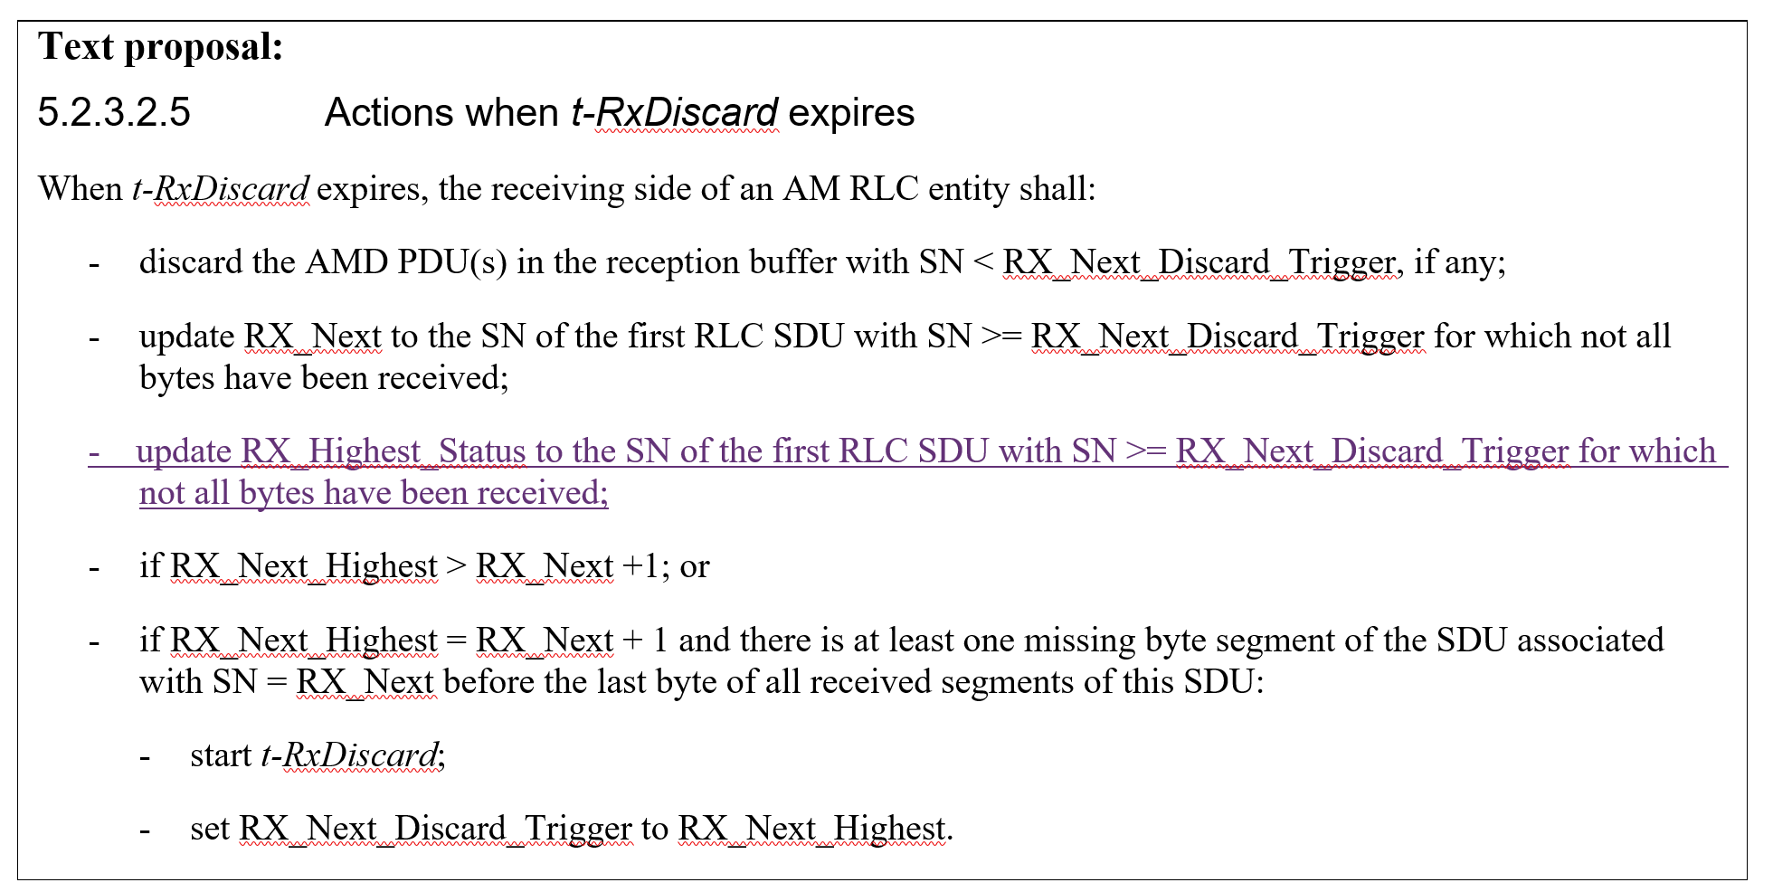

R2-2508254 Discussion on open issues for R19 XR vivo discussion Rel-19 NR_XR_Ph3-Core
Proposal 1 [RLC-H02] Keep clause 5.3.4 of the current specification unchanged for issue RLC-H02.

DISCUSSION:
- Nokia thinks legacy text covers this use case. We can add a clarification for setting the ACK_SN to the SN of the first not received RLC SDU, instead of “next”.
- LGE thinks Nokia’s proposal changes legacy text which we should avoid. They don’t think it solves the issue.
- NEC thinks we can follow LGE’s TP. But they think this should only be done under the problematic case.
- Xiaomi prefers to update Rx_Highest_Status. Xiaomi thinks we should limit only to the problematic case to avoid side-effects.
- Fujitsu thinks both ways work, but it is cleaner to update highest status. This is similar to t_reassembly expiry.
- Ericsson thinks we can avoid this issue.
- Nokia agrees with LGE’s solution, but think we need to consider what NEC mentioned.
- Samsung also supports LGE’s way.
- Xiaomi and Huawei do not think Rx_Higheststatus should move backwards. This means that we wait two times for the same RLC SDU.

- [RLC-H02] We solve RLC-H02 by updating Rx_Highest_Status only for the problematic case, i.e. RX_Highest status should not move backwards.

RLC-N01: RX_Next definition
R2-2509058 Discussion on remaining issues in RLC for R19 XR Nokia, Nokia Shanghai Bell discussion Rel-19 38.322 NR_XR_Ph3-Core
Observation 1: [RLC-N01] Specifying update of RX_Next for t-RxDiscard in the procedural text of clause 5.2.3.2.5 requires additional change in the clause 6.2.3.10 and 5.3.4.
- [RLC-N01] The definition of RX_Next in clause 7.1 is updated along those lines (exact wording to be reviewed during CR review):
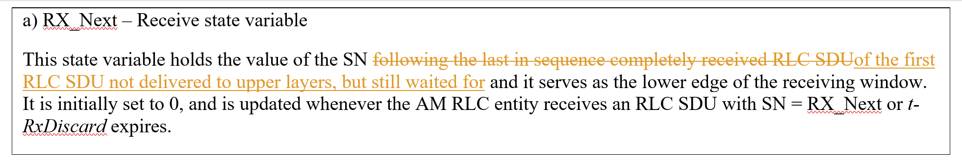
- [RLC-N01] We remove the previous change made for this issues, i.e. we remove “- consider the RLC SDU(s) with SN < RX_Next_Discard_Trigger, as completely received;” from section 5.2.3.2.5
Not treated
R2-2508585 XR Remaining Issues ZTE Corporation, Sanechips discussion

Proposal 1(RLC-N01): keep the description for RX_Next – Receive state variable, except to update the RX_Next updating condition that “It is initially set to 0, and is updated whenever the AM RLC entity receives an RLC SDU with SN = RX_Next or t-RxDiscard expires”.

RLC-N02: NOTE in clause 5.3.3.3
R2-2508571 Discussion on RLC-N02 Nokia, Nokia Shanghai Bell, Apple, LG Electronics Inc., Samsung, Vivo discussion Rel-19 38.322 NR_XR_Ph3-Core

Proposal 1: [RLC-N02] The NOTE in clause 5.3.3.3 is updated as below:
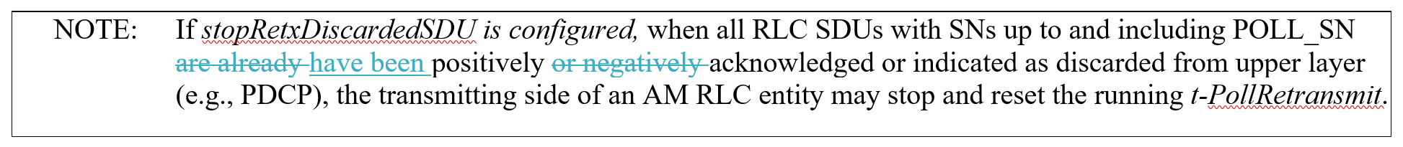

R2-2508638 Remaining RLC open issues for XR InterDigital discussion Rel-19 NR_XR_Ph3-Core
Proposal 1: Modify the NOTE captured in Clause 5.3.3.3 as follows:
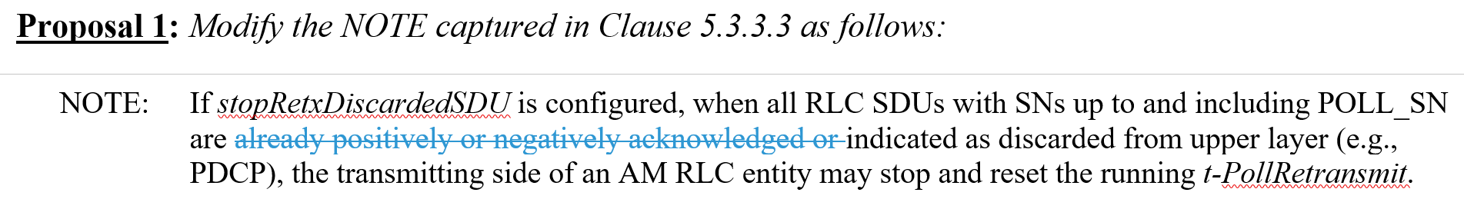

R2-2508230 Discussion on [RLC-N02] and Other Leftover Issue CATT discussion Rel-19 NR_XR_Ph3-Core
Proposal 1: (RLC-N02) RAN2 clarifies that the handling of the mix case (positively or negatively acknowledged and indicated as discarded from upper layer) is included in the current NOTE.
Proposal 2: (RLC-N02) Keep the current Note in clause 5.3.3.3 that “NOTE: If stopRetxDiscardedSDU is configured, when all RLC SDUs with SNs up to and including POLL_SN are already positively or negatively acknowledged or indicated as discarded from upper layer (e.g., PDCP), the transmitting side of an AM RLC entity may stop and reset the running t-PollRetransmit.”.

DISCUSSION:
- LGE explained why they changed their mind from IDT’s proposal to Nokia’s proposal.

- [RLC-N02] The NOTE in clause 5.3.3.3 is updated as below:

MAC issues
R2-2508265 Discussions on XR remaining issues [RLC-N02], [RLC-H02] and rate query Fujitsu discussion Rel-19 NR_XR_Ph3-Core
Proposal 5: The bit rate query for a QoS flow is cancelled if the UE receives a UL Rate Control MAC CE including the bit rate for this QoS flow.
- Not pursued, we keep current cancellation conditions

- Nokia supports this, but indicates it was discussed before.
- QCM indicates that triggering is anyway up to UE implementation, so the UE can cancel anyway.
- OPPO thinks we can leave this up to UE. Xiaomi agrees.
- Samsung thinks that EU can still report its preference if it’s different from what NW provides.
- CATT also thinks UE can handle this.
- LGE thinks cancellation is clearly specified.

R2-2508230 Discussion on [RLC-N02] and Other Leftover Issue CATT discussion Rel-19 NR_XR_Ph3-Core
Proposal 3: RAN2 clarifies the operating object of additional priority determination is the selected logical channel in clause 5.4.3.1.2.
- Not pursued

- Xiaomi thinks some UE implementations may behave differently than in this proposal.
- CATT thinks this is a different issue.
- Apple thinks the UE can adjust priority before receiving the grant. There is no need for this restriction.
- Samsung think this is more a clarification for an intended behaviour.
- QCM agrees with Xiaomi and Apple. This is just capturing some UE internal behaviour.
- Nokia agrees this is not essential.

Agreements
- [RLC-H02] We solve RLC-H02 by updating Rx_Highest_Status only for the problematic case, i.e. RX_Highest status should not move backwards.
- [RLC-N01] The definition of RX_Next in clause 7.1 is updated along those lines (exact wording to be reviewed during CR review):
- [RLC-N01] We remove the previous change made for this issues, i.e. we remove “- consider the RLC SDU(s) with SN < RX_Next_Discard_Trigger, as completely received;” from section 5.2.3.2.5
- [RLC-N02] The NOTE in clause 5.3.3.3 is updated as below:

R2-2508206 Discussion on open issues for RLC Samsung discussion Rel-19
R2-2508575 Discussion on RLC open issues OPPO discussion Rel-19 NR_XR_Ph3-Core
R2-2508602 Discussion on the issue of RLC-H02 HONOR discussion Rel-19 NR_XR_Ph3-Core
R2-2508653 Discussion on RLC-H02 and RLC-N02 Lenovo discussion Rel-19
R2-2508667 Discussion on RLC-H02 Xiaomi discussion Rel-19 NR_XR_Ph3-Core
R2-2508771 Solution to Address RLC-H02 Ericsson discussion Rel-19

8.18 LTE-based 5G Broadcast
(LTE_terr_bcast_Ph2; leading WG: RAN1; REL-19; WID RP-250794)
Time budget: 0 TU
Tdoc Limitation: 0 tdocs
No Tdocs other than rapporteur CRs are expected for this meeting. Companies should pre-coordinate with the CR rapporteurs and each other in case they identify an issue that needs to be addressed.

8.18.1 Organizational
Incoming LS, rapporteur input/CRs etc.
R2-2508280 Correction on the capability of LTE-based 5G Broadcast Huawei, HiSilicon, Samsung, Lenovo CR Rel-19 36.306 19.0.0 1934 1 F LTE_terr_bcast_Ph2 R2-2507924
- Check with MCC if we can renumber the sections
- Revised in R2-2509350

R2-2509350 Correction on the capability of LTE-based 5G Broadcast Huawei, HiSilicon, Samsung, Lenovo CR Rel-19 36.306 19.0.0 1934 2 F LTE_terr_bcast_Ph2
- The CR is agreed

R2-2508755 WI TerrBcast ASN.1 comments file Qualcomm Incorporated discussion Rel-19 LTE_terr_bcast_Ph2-Core R2-2507467 Late
- Noted

R2-2508756 WI TerrBcast ASN.1 review file Qualcomm Incorporated discussion Rel-19 LTE_terr_bcast_Ph2-Core R2-2507468 Late
- Noted
R2-2508757 Corrections to LTE-based 5G Broadcast Phase 2 after ASN.1 review Qualcomm Incorporated, Samsung, EBU CR Rel-19 36.331 19.0.0 5168 3 F LTE_terr_bcast_Ph2-Core R2-2507927
- The CR is agreed

R2-2508207 Clarification on notification configuration Samsung, ZTE, Nokia discussion Rel-19
Observation 1: Clarification on notification configuration regarding usage of additional non-MBSFN subframes is useful for 5G Broadcast implementations, which are expected to be based on Rel-19 spec, and in preventing IODT issues.
Observation 2: RAN1 agreement validated the usage of additional non-MBSFN subframes for notification configuration for 5G Broadcast; the related description belongs to RRC spec.
Proposal 1: RAN2 to adopt TP1 to clarify the notification configuration in Rel-19 RRC Spec:
• For an MBMS-dedicated cell, if E-UTRAN configures a value other than "0" for additionalNonMBSFNSubframes within MasterInformationBlock-MBMS, notificationSF-Index-r9 configuration indicates the subframe pointed out by additionalNonMBSFNSubframes and MBMS-NotificationConfig-v1430 is not configured, when one of the additional subframes is used to transmit MCCH change notifications on PDCCH.

- QCM thinks this is already clear. If we make a clarification, we need to be clear it does not change any behaviour, i.e. just explains an intended behaviour.
- Samsung agrees. It is captured on the cover page of their CR.

R2-2509244 Clarification on Notification Configuration Samsung, ZTE, Nokia, Ericsson Rel-19 36.331 19.0.0 5186 - F LTE_terr_bcast_Ph2-Core
- Revise a cover page as follows:
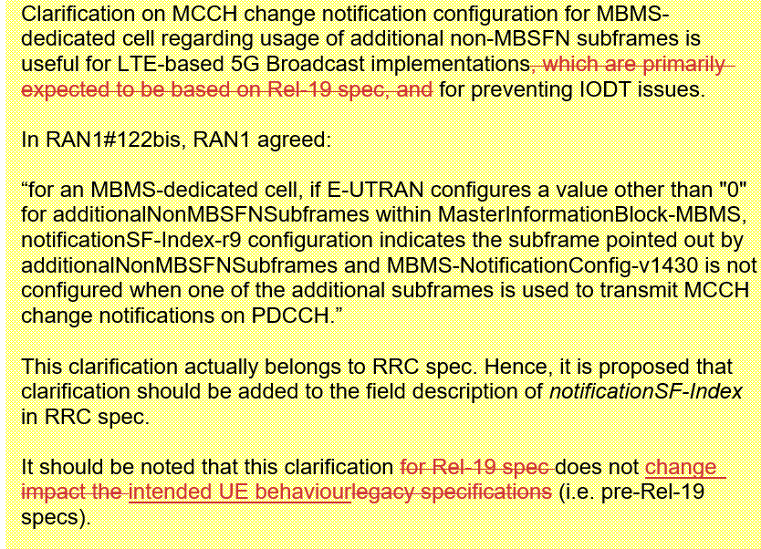
- Remove unchanged IEs
- With this change the CR is agreed in R2-2509245

R2-2509245 Clarification on Notification Configuration Samsung, ZTE, Nokia, Ericsson Rel-19 36.331 19.0.0 5186 1 F LTE_terr_bcast_Ph2-Core
- The CR is agreed

