3GPP TSG RAN WG1 #124 R1-260xxxx
Gothenborg, Sweden, February 9th ~ 13th, 2026

Agenda item: 9.1.1
Source: Moderator (Qualcomm)
Title: FL summary 1 on CSI compression via two-sided model
Document for: Discussion and Decision

Introduction
Based on the conclusion of the Rel-19 study [1], spatial-frequency CSI compression (with temporal aspects) via two-sided AIML model proceeds to the normative work, with following objective [2] for RAN1.
CSI feedback enhancement, encompassing (two-sided model) [RAN1, RAN2]:
- CSI spatial/frequency compression without temporal aspects (“Case 0”),
- Specify necessary signalling/mechanism(s) as per the identified potential specification impacts in FS_NR_AIML_Air , including:
  - Model pairing procedure including ID and applicability reporting
  - Inference aspects including target CSI type, measurement and report configuration, CQI RI determination, payload determination, quantization configuration codebook, UCI mapping, CSI processing criteria and timeline, priority rules for CSI reports
  - NW and UE side data collection for training,
    - Target CSI format
    - Note The framework defined in BM and CSI prediction use cases could be reused
  - Specify performance monitoring

Inter-vendor training collaboration for two-sided AI/ML models
- Fully defined/specified reference model (“Direction C”) with RAN1 scalability study outcome taken into account [RAN4/RAN1] – check-point in RAN#110 upon RAN4 feedback
  - Specification of standardized encoder model structure plus parameter exchange (“Direction A, sub-option 3a-1” without target CSI sharing) leveraging defined/reference model of “Direction C” and taking RAN1 scalability study outcome into account [RAN4/RAN1/RAN2/RAN3] – check-point in RAN#110 upon SA WG feedback
- Specification of standardized dataset format/content plus dataset exchange (“Direction A, sub-option 4-1”) [RAN1/RAN2/RAN3/RAN4] – check-point in RAN#110 upon SA WG feedback

The above objectives are further split into two agenda, i.e., inference aspects plus other aspect including data collection and monitoring, and inter-vendor collaboration. This document summarizes the issues regarding agenda item 9.1.1 (Inference and other aspects of two-sided CSI compression) in RAN#124.

Contact Information
Please provide your contact information.
Company | Name | E-mail
Moderator (Qualcomm) | Chenxi Hao | chenxih@qti.qualcomm.com
OPPO | Wendong Liu | liuwendong1@oppo.com
Lenovo | Vahid Pourahmadi  Bingchao Liu | vpourahmadi@lenovo.com  liubc2@lenovo.com
Ofinno | Jaehoon Chung | jchung@ofinno.com
NTT DOCOMO | Xin Wang | wangx@docomolabs-beijing.com.cn
Sharp | Pochun Chou | bertrand.pc.chou@sharp-world.com.tw
CMCC | Yi Zheng  Yuhua Cao | zhengyi@chinamobile.com  caoyuhua@chinamobile.com
Ericsson | Xinlin Zhang  Jingya Li | xinlin.zhang@ericsson.com  jingya.li@ericsson.com
Futurewei | Zhigang Rong | zrong@futurewei.com
MediaTek | Reubengeorge Stephen  Pedram Kheirkhah Sangdeh | Reubengeorge.stephen@mediatek.com  Pedram.kheirkhah@mediatek.com
CEWiT | Shivshankar  Advaith | shivshankar@cewit.org.in  advaith22@cewit.org.in
CATT | Qianrui Li | liqianrui@catt.cn
Panasonic | Tetsuya Yamamoto  Hidetoshi Suzuki  Xuan Tuong Tran (Henry) | yamamoto.tetsuya001@jp.panasonic.com  suzuki.hidetoshi@jp.panasonic.com  xuantuong.tran@sg.panasonic.com
Samsung | Ameha Tsegaye Abebe | amehat.abebe@samsung.com
LG Electronics | Minseok Jo (MJ) | ms.jo@lge.com
TCL | Pu Yuan  Tianqi Wu | Pu.yuan@tcl.com  tianqi1.wu@tcl.com
NEC | Peng Guan  Yi Jiang  Shafivulla Sayyed | guan_peng@nec.cn  y-jiang_ct@nec.com  Sayyed.Shafivulla@india.nec.com
Apple | Huaning Niu  Yuan Zhu | huaning_niu@apple.com  yuan_zhu3@apple.com
Vivo | Yuanyuan Wang | yuanyuan.wang.txyj@vivo.com
InterDigital | Afshin Haghighat | afshin.haghighat@interdigital.com
ETRI | Anseok Lee | alee@etri.re.kr
China Telecom | Nanxi Li | linanxi@chinatelecom.cn
Fujitsu | Xin Wang  Liqiang Jin | wangxin@fujitsu.com  liqingjin@fujitsu.com

Payload and quantization related aspects

Summary of companies’ proposals
Company | Proposals
Futurewei | Evaluation of VQ vs. SQ  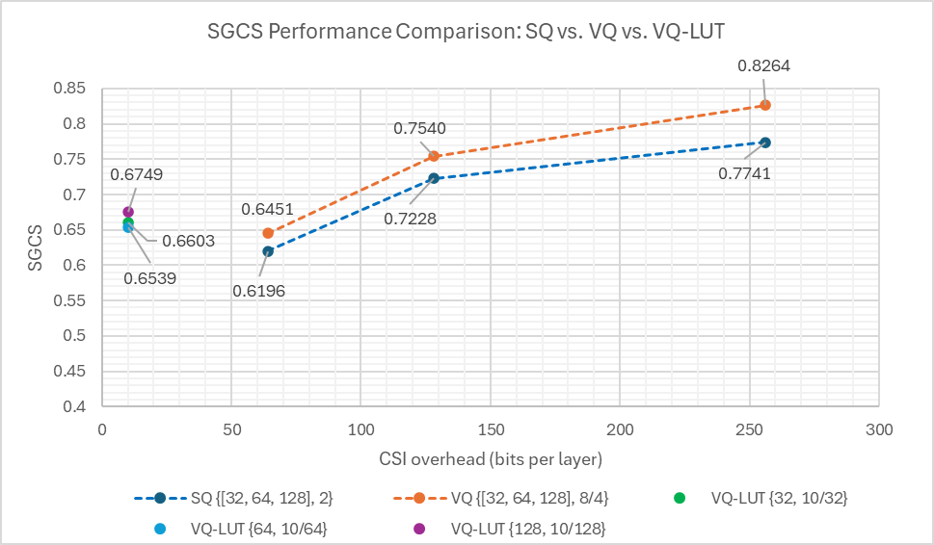  Figure 2.4-1: Performance comparison: SQ vs. VQ vs. VQ-LUT  Observation 2: For Rel-20 AI/ML-based CSI spatial/frequency compression without temporal aspects (“Case 0”), when comparing SGCS performance between SQ with parameter configuration $\left\{d^{l,ν},Q^{l,ν}\right\}$ = {32, 2}, {64, 2}, {128,2} and VQ with segmentation using parameter configuration $\left\{d^{l,ν},Q^{l,ν}/L\right\}$ = {32, 8/4}, {64, 8/4}, {128, 8/4} (corresponding to CSI payload size of 64, 128 and 256, respectively):  - VQ outperforms SQ in all parameter configurations.  - The average SGCS gain across all CSI payload sizes evaluated is ~4.05%.  Observation 3: For Rel-20 AI/ML-based CSI spatial/frequency compression without temporal aspects (“Case 0”), when comparing SGCS performance between VQ-LUT with CSI payload of 10 bits per layer and SQ with 64 bits per layer:  - VQ-LUT with parameter configurations of {32, 10/32}, {64, 10/64}, {128, 10/28} consistently outperforms SQ.  - The average SGCS gain is ~7.0%.  Observation 4: For Rel-20 AI/ML-based CSI spatial/frequency compression without temporal aspects (“Case 0”), when comparing testing SGCS performance between VQ-LUT with CSI payload of 10 bits per layer and VQ with 64 bits per layer:  - VQ-LUT with parameter configurations of {32, 10/32}, {64, 10/64}, {128, 10/28} can achieve comparable or better performance than VQ and the average SGCS gain is ~2.8%.  Observation 5: For Rel-20 AI/ML-based CSI spatial/frequency compression without temporal aspects (“Case 0”), when using parameter configurations of {32, 10/32}, {64, 10/64}, {128, 10/28}, VQ-LUT can save CSI overhead of ~84% while still achieving better or comparable performance compared to SQ and VQ.  Proposal 4: For Rel-20 AI/ML-based CSI spatial/frequency compression without temporal aspects (“Case 0”), if NW side exchanges a quantization codebook, the exchanged codebook is VQ. The exchanged quantization codebook can be in the form of the codebook itself or can be parameters of the codebook based on which the codebook can be reconstructed.  Proposal 5: For Rel-20 AI/ML-based CSI spatial/frequency compression without temporal aspects (“Case 0”), further support per-layer payload parameter pairs {128,10/128}, {64, 10/64} and {32, 10/32}.
  CSI payload per layer | Latent space length (d) | Quantization method | Segment len (L) | {d, Q or Q/L} | SGCS | Gain (VQ vs. SQ)
  64 | 32 | SQ | NA | {32, 2} | 0.6196 | -
  64 | 32 | VQ | 4 | {32, 8/4} | 0.6451 | 4.10%
  128 | 64 | SQ | NA | {64, 2} | 0.7228 | -
  128 | 64 | VQ | 4 | {64, 8/4} | 0.7540 | 4.32%
  256 | 128 | SQ | NA | {128, 2} | 0.7741 | -
  256 | 128 | VQ | 4 | {128, 8/4} | 0.8264 | 3.72%
Ericsson | From the above table, we can observe that compared to Alt1, the gain of Alt2 over Alt1 is really unclear. At low load, Alt2 may provide some gain at low load, where inaccurate CSI may not generate much interference. However, at medium and higher load, such inaccurate CSI starts to hurt the performance and Alt 2 becomes inferior to Alt1. With unstable gain and extra complexity to support an addition {d, Q} pair, we don’t Alt2 shall be supported.  - For payload combinations for PC with rank-1 payload of 64 bits, support Alt 1.  From the above table, we can observe that Alt1.1 and Alt2 performs better compared to the other alternatives that have been agreed in the last meeting, while Alt1.1 performs best for rank 3 and Alt2 performs best for rank4. Based on this result, either Alt1.1 or Alt2 can be selected  In addition, we also note that the payload combination of {192, 1} introduces significant performance loss, hence it can be deselected from the payload combination for AI CSI compression.  - A new alternative, Alt4, gives the best performance for payload combinations for PC with rank-1 payload of 384 bits, where {96, 2}, {96, 2}, {192, 2} and {64, 2}, {64, 2}, {128, 2}, {128, 2} are for rank 3 and rank 4, respectively.  - The payload parameter combination {192, 1} introduces significant performance loss in system level throughput.  - For payload combinations for PC with rank-1 payload of 384 bits, support either Alt1.1 or Alt2.  - The payload combination of {192, 1} is not supported.
  Rank adaptation | Relative throughput
  Rank adaptation | 20% RU | 50% RU | 70% RU
  Alt 1 | 100% | 100% | 100%
  Alt 2 | 105% | 93% | 94%
  Alt | UPT for Rank = 3 |  |  | UPT for Rank = 4
  Alt | 20% RU | 50% RU | 70% RU | 20% RU | 50% RU | 70% RU
  Alt1.1 | 100.0% | 100.0% | 100.0% | 100.0% | 100.0% | 100.0%
  Alt1.2 | 91.0% | 79.9% | 69.1% | 97.5% | 93.1% | 90.6%
  Alt2 | 98.7% | 97.4% | 98.3% | 101.8% | 101.4% | 99.7%
  Alt3.1 | 98.7% | 97.4% | 98.3% | 100.0% | 100.0% | 100.0%
  Alt3.2 | 98.7% | 97.4% | 98.3% | 97.5% | 93.1% | 90.6%
Huawei | Proposal 4: For the PC with rank 1 payload of 64 bits, support Alt2 with {32, 2} / {32, 2}, {32, 2} for rank1/2, respectively, and {32, 1}, {32, 1}, {32, 2} / {32, 1}, {32, 1}, {32, 1}, {32, 1} for rank 3/4.  Proposal 5: Support a new PC entry, with {32, 1} / {32, 1}, {32, 1} for rank1/2 and NA for rank 3/4.  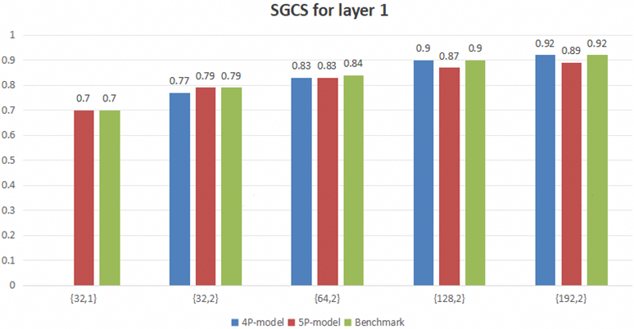  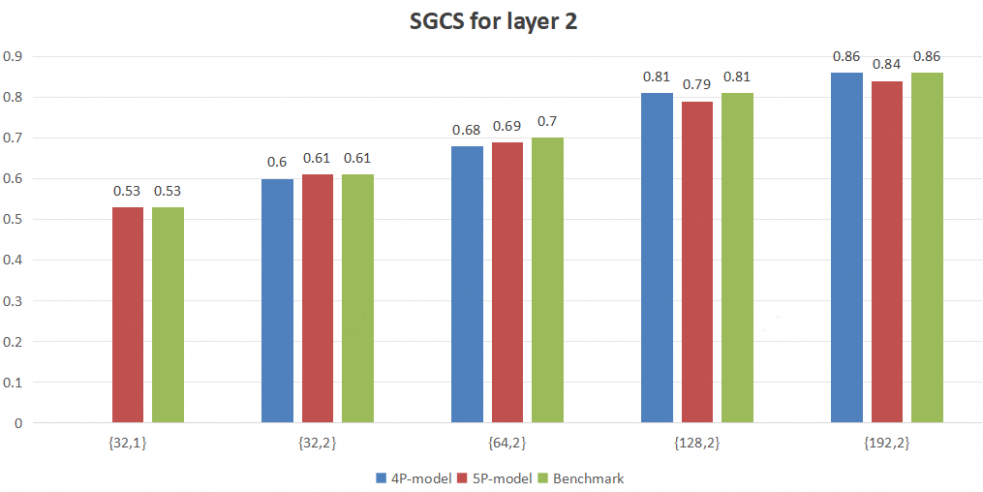  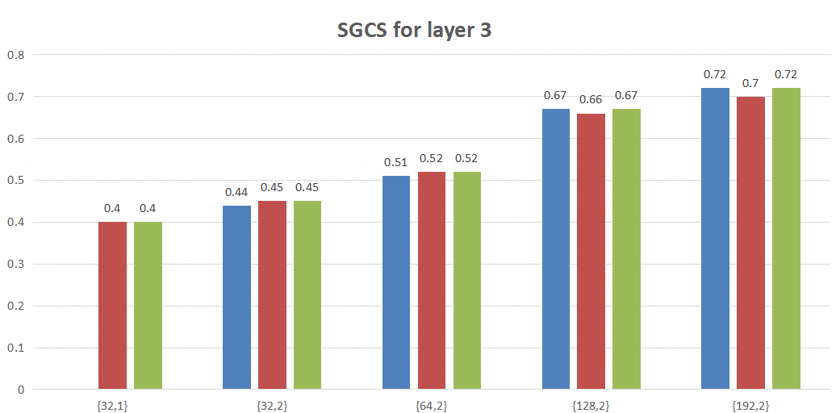  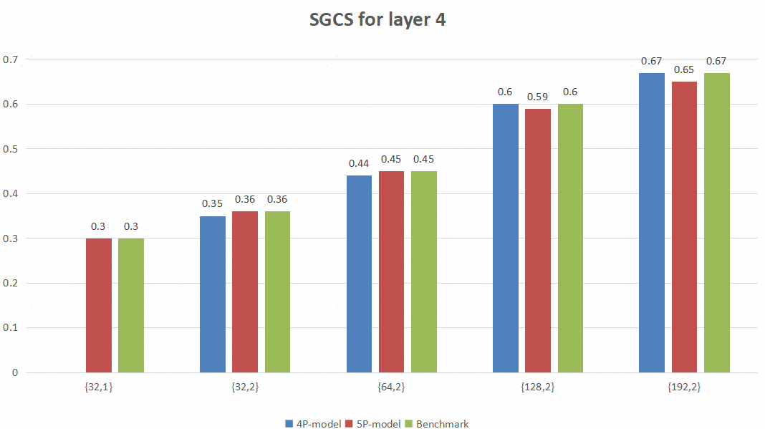  Proposal 6: No need to consider {96,2} or {192, 1} into the per layer CSI payload size pool.  - For the PC with rank 1 payload of 384 bits, consider Alt2 with {192, 2} / {192, 2}, {192, 2} / {128, 2}, {128, 2}, {128, 2} / {64, 2}, {64, 2}, {128, 2}, {128, 2} for rank1/2/3/4, respectively.  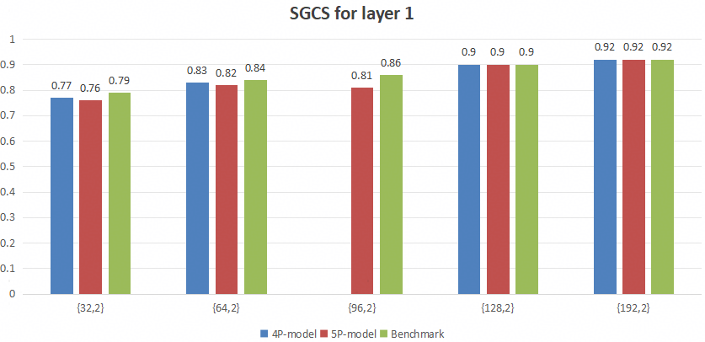  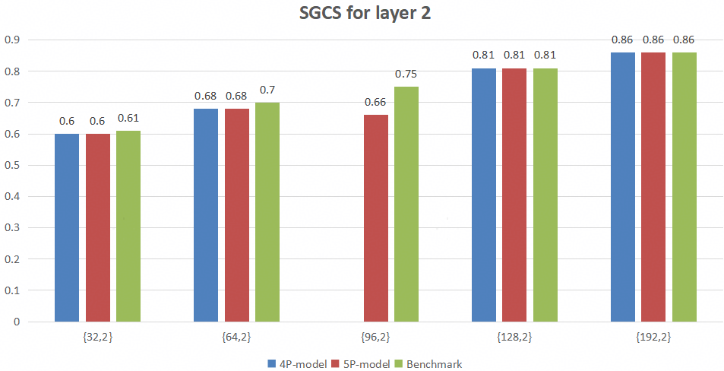  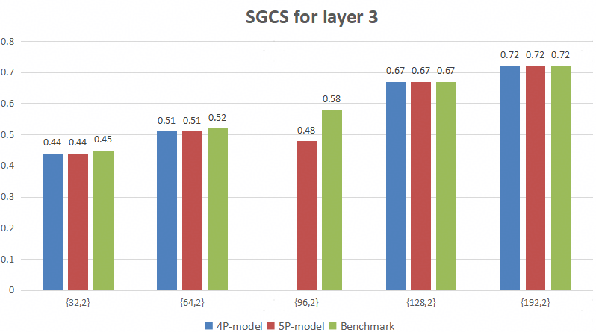  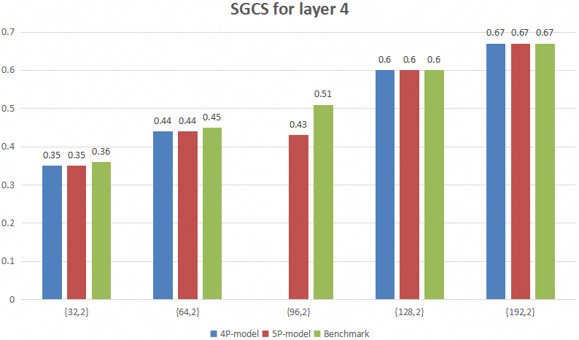  Figure 10 SGCS for 4 pair-model, 5 pair-model (including {96, 2}), and Benchmark  Proposal 7: Both SQ and VQ may be supported.  - The same set of per-layer payload parameter triplets and PCs applied to SQ are supported for VQ, where, for any supported SQ payload pair of ($d_{z}^{l,ν}, Q_{SQ})$, a corresponding VQ payload pair of ($d_{z}^{l,ν}, Q_{VQ}/L)$ is also supported with $Q_{SQ}=Q_{VQ}/L$ and $L=2.$  - Note: Examples of the PC entries for VQ are provided in Table 3.  Table 3 $d_{z}^{l,ν}$ and $Q^{l,ν}/L$ settings for VQ in different PC, ranks, and layers  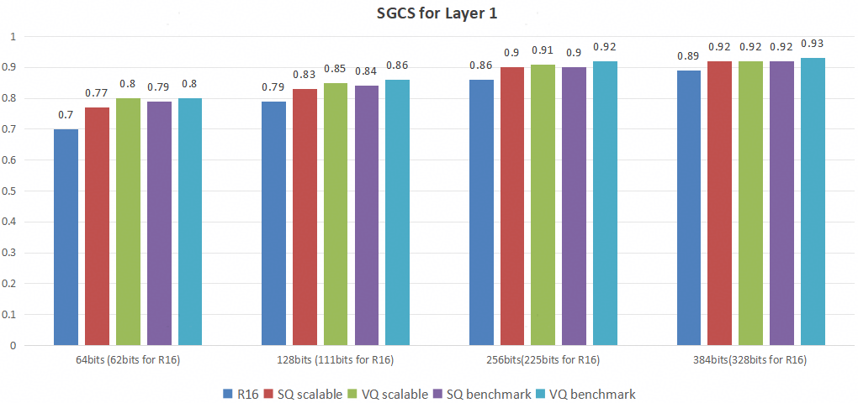  Proposal 8: To simplify the design for VQ and SQ codebooks:  - For SQ, uniform quantization is considered.  - For VQ, a master codebook including the set of codewords (i.e., floating vectors) and fixed $L$ are considered over all layers/Rx antennas.  - Flexible selection of subset of codewords from the master codebook can be considered to achieve different quantization granularities.  Proposal 9: For the look up table for SQ quantization,  - For Q=1, the 2 code points are mapped to the values of 0.25, and 0.75, respectively.  - For Q=2, the 4 code points are mapped to the values of 0.125, 0.375, 0.625, and 0.875, respectively.
  PC | Rank1 | Rank2 | Rank3 | Rank4
  1 | {32, 2/2} | {32, 2/2}, {32, 2/2} | NA | NA
  2 | {32, 4/2} | {32, 4/2}, {32, 4/2} | {32, 2/2}, {32, 2/2}, {32, 4/2} | {32, 2/2}, {32, 2/2}, {32, 2/2}, {32, 2/2}
  3 | {64, 4/2} | {64, 4/2}, {64, 4/2} | {32, 4/2}, {32, 4/2}, {64, 4/2} | {32, 4/2}, {32, 4/2}, {32, 4/2}, {32, 4/2}
  4 | {128, 4/2} | {128, 4/2}, {128, 4/2} | {64, 4/2}, {64, 4/2}, {128, 4/2} | {64, 4/2}, {64, 4/2}, {64, 4/2}, {64, 4/2}
  5 | {192, 4/2} | {192, 4/2}, {192, 4/2} | {128, 4/2}, {128, 4/2}, {128, 4/2} | {64, 4/2}, {64, 4/2}, {128, 4/2}, {128, 4/2}
Spreadtrum | Proposal 3: Only support SQ as the quantization method.  Proposal 4: For quantization codebook, support use a standardized quantization codebook decided by RAN1.  The output of the encoder can be directly quantized uniformly on [0,1].  Proposal 5: If target CSI type is pre-coder matrix, at least for SQ, for the PC with rank-1 payload of 64 bits, support the following payload combinations across layers and ranks. The layers are reported in the order of decreasing strength.  Proposal 6: If target CSI type is pre-coder matrix, at least for SQ, for the PC with rank-1 payload of 384 bits, support the following payload combinations across layers and ranks. The layers are reported in the order of decreasing strength.
  Rank1 | Rank2 | Rank3 | Rank4
  {192, 2} | {192, 2}, {192, 2} | {96, 2}, {96, 2}, {192, 2} | {96, 2}, {96, 2}, {96, 2}, {96, 2}
  Rank1 | Rank2 | Rank3 | Rank4
  {32, 2} | {32, 2}, {32, 2} | NA | NA
OPPO | Proposal 1: Support SQ only.  Proposal 2: Regarding SQ codebook exchange, support NW directly exchange NW-defined codebook.  Proposal 3: Support exchanged non-specified quantization PCs along with dataset and quantization codebook in Option 4-1.  Proposal 4: Regarding parameter combination with rank-1 payload, support Alt 1 for 64 bits and Alt 2 for 384 bits.  Proposal 5: Regarding CSI feedback payload determination, support UE reported actual CSI feedback payload for each layer in CSI part 1.
ZTE | Proposal 9: Standardizing multiple codebooks increases spec complexity without providing substantial performance benefits.  Proposal 10: For SQ, support a standardized SQ codebook associated to the pairing ID, e.g., uniform quantization with a common quantization resolution Q=2 and quantization range [0, 1].  Observation 5: The length of the latent message (i.e., the compression ratio) contributes more to the per-layer SGCS performance than the quantization bit width per scalar Q.  Observation 6: On top of agreed per-layer payload parameter pairs {32, 2}, {64, 2}, {128, 2}, and {192, 2}, adding the per-layer payload parameter pair {96, 2} lead to -0.12%~0.52% per-layer SGCS performance improvements.  Observation 7: On top of agreed per-layer payload parameter pairs {32, 2}, {64, 2}, {128, 2}, and {192, 2}, adding the per-layer payload parameter pair {32, 1} lead to -5.78%~-0.54% per-layer SGCS performance loss.  Proposal 11: On top of agreed per-layer payload parameter pairs {32, 2}, {64, 2}, {128, 2}, and {192, 2}, support one additional per-layer payload parameter pair {96, 2} to improve SGCS performance and enhance NW scheduling flexibility.  Proposal 12: If target CSI type is pre-coder matrix, at least for SQ, support Alt 1 for the PC with rank-1 payload of 64 bits.  Observation 10: Regarding the five alternatives for the PC with rank-1 payload of 384 bits, Alt 1.1 generally has the best per-layer SGCS performance and requires the least number of payload pairs for this PC, which is friendly to the UE's computational and storage burdens.  Proposal 13: If target CSI type is pre-coder matrix, at least for SQ, support Alt 1.1 for the PC with rank-1 payload of 384 bits.  Proposal 14: For payload determination of AI/ML CSI feedback, support the quantization parameters (e.g., d, Q, or L) of each layer to be directly configured by the network.
  Case  Payload size | Case 1 | Case 2 | Case 3
  32 bit | N/A | N/A | Layer 1: 0.6195  Layer 2: 0.4763
  64 bit | Layer 1: 0.7450  Layer 2: 0.6108 | Layer 1: 0.7441 (-0.12%)  Layer 2: 0.6100 (-0.13%) | Layer 1: 0.7078 (-4.99%)  Layer 2: 0.5755 (-5.78%)
  128 bit | Layer 1: 0.8194  Layer 2: 0.7151 | Layer 1: 0.8214 (+0.24%)  Layer 2: 0.7188 (+0.52%) | Layer 1: 0.8145 (-0.60%)  Layer 2: 0.7097 (-0.76%)
  192 bit | N/A | Layer 1: 0.8637  Layer 2: 0.7803 | N/A
  256 bit | Layer 1: 0.8864  Layer 2: 0.8153 | Layer 1: 0.8884 (+0.23%)  Layer 2: 0.8176 (+0.28%) | Layer 1: 0.8816 (-0.54%)  Layer 2: 0.8091 (-0.76%)
  384 bit | Layer 1: 0.9165  Layer 2: 0.8625 | Layer 1: 0.9172 (+0.08%)  Layer 2: 0.8639 (+0.16%) | Layer 1: 0.9113 (-0.57%)  Layer 2: 0.8563 (-0.72%)
CATT | Proposal 5: For AI CSI Compression, Q=1 is not supported for model inference.  Proposal 6: For the PC with rank-1 payload of 64 bits, down select to Alt1 where rank>2 is not supported.  Proposal 7: For the PC with rank-1 payload of 384 bits, down select to Alt2.  Proposal 8: For AI CSI compression, only support the SQ codebook for quantization codebook exchange,  - If codebook is not exchanged, 2-bit uniform quantization can be adopted as the default quantization scheme  - Exchange the ID of a standardized SQ codebook in case of multiple standardized codebooks if multiple standardized codebooks are defined.
MTK | Proposal 7: Support scalar quantization for quantizing the output of the encoder in the inference stage if down selection is needed.  Proposal 8: Prioritize standardized quantization codebooks decided by RAN1 for SQ and exchange of respective IDs during inter-vendor collaborations.  Table ‎2-3: Evaluation results for exploring impact of quantization codebook and latent segments on the performance of scalable AI/ML models.  - It is feasible to use more than one quantization codebooks to generate different payloads through a scalable model. Whether the used latent segments are the same, overlapping, or disjoints does not impact feasibility.  - The average performance degradation for generating two payloads with a scalable model is 1.6% when we use the same quantization codebook and is 2.1% when we use two different codebooks (w.r.t their respective performance via non-scalable model).  - Introducing a new quantization codebook to generate the third payload in a scalable model, further decreases the performance of other two payloads by additional 2%.  Proposal 9: For the PC with rank-1 payload of 64 bits, support Alt 2.
   | Set 1: Payloads 32, 64, 128 |  |  | Set 2: Payloads 96, 192, 384
  $$(d,Q)$$ | {32,1} | {32,2} | {64,2} | {96,1} | {96,2} | {192,2}
  Case 0 – (1P1Q) | 0.741 | 0.843 | 0.899 | 0.874 | 0.915 | 0.935
  Case 1-1 – (2P1Q) |  | 0.834  (-1.1%) | 0.864  (-3.9%) |  | 0.913  (-0.2%) | 0.924  (-1.2%)
  Case 1-2 – (2P2Q) | 0.740  (-0.1%) |  | 0.854  (-5.0%) | 0.868  (-0.7%) |  | 0.911  (-2.6%)
  Case 2-1 (3P2Q-disjoint) | 0.737  (-0.5%) | 0.815  (-3.3%) | 0.833  (-7.3%) | 0.852  (-2.5%) | 0.889  (-2.8%) | 0.896  (-4.2%)
  Case 2-2 (3P2Q-overlapping) | 0.740  (-0.1%) | 0.815  (-3.3%) | 0.844  (-6.1%) | 0.864  (-1.1%) | 0.897  (-2.0%) | 0.909  (-2.8%)
CMCC | Proposal 7: For quantization codebook used for quantizing the feedback, at least scalar quantization (SQ) should be supported when NW side exchange a codebook to the UE side, and the exchanged codebook is associated to the pairing ID.  Proposal 8: For quantization codebook used for quantizing the feedback, if NW side exchanges a codebook, the NW-defined codebook or the ID of a standardized SQ codebook is not needed to explicitly indicate to UE side, it can be conveyed implicitly via pairing ID or even payload configuration.
Xiaomi | Proposal 1: Support NW-defined SQ codebook if NW side needs to exchange a NW-defined codebook.  Fig 1 SGCS performance with different payload parameter pairs $d^{l,ν}$ and $Q^{l,ν}$ for rank=2.  Proposal 2: Support payload parameter pair ($d^{l,ν}, Q^{l,ν}$)={(96,2) } other than {32, 2}, {64, 2}, {128, 2}, {192, 2}.  Proposal 3: Support parameter combination Alt1 for 64 bits, i.e., {32, 2} per layer for rank=1 and 2, and no parameter combination for rank=3 and 4.  Proposal 4: Support parameter combinations Alt1.1 or Alt 2 for 384 bits, i.e., {192, 2} for rank=1, 2 and 4, while {{96, 2}, {96, 2}, {192,2}} for rank=3 for Alt1.1, and {192, 2} for rank=1, 2, and {128,2} for rank=3, {64, 2}, {64, 2}, {128, 2}, {128, 2} for rank=4 for Alt2.
Vivo | Comparisons of SGCS with Different Codebook Sizes and Quantization Levels  Proposal 2: Support Alt 1: exchange quantization codebook from NW-side to UE-side along with each exchanged dataset or model parameters  Proposal 3: For exchanged quantization codebook, multiple L (e.g., 1, 4) can be supported for SQ and VQ.  Proposal 4: A payload-common codebook can be exchanged from NW-side to UE-side along with each exchanged dataset or model parameters.  The performance comparison with Q=2, or with multiple Q{Q=1 and 2}  The performance comparison for PC with rank-1 payload of 384 bits  - For SQ, case 2 with multiple Q(including, Q=1 and Q =2) incurs a small to medium performance loss (1%~3.4%) for medium or large payloads compared with case 1{Q=2 only}, in contrast, for VQ case(i.e., case 3), there is no performance loss for supporting multiple Q (including, Q=1 and Q =2) ) .  - For the PC with rank-1 payload of 64 bits, Alt 2 can only be considered for VQ case  - At least for SQ for the PC with rank-1 payload of 384 bits, support Alt 1.1
  $$\text{payload}$$ | $$d_{z}^{l,v}$$ | VQ parameter | $$L$$ | Q | SGCS_float 32 | SGCS_int8
  64 | 32 | 1024(common codebook) | 4 | 8 | 0.74665(-0.5%) | 0.74667(-0.5%)
  128 | 64 | 1024(common codebook) | 4 | 8 | 0.79601(-0.1%) | 0.79601(-0.1%)
  64 | 32 | 52488(common codebook) | 8 | 16 | 0.74750(-0.06%) | 0.74748(-0.06%)
  128 | 64 | 52488(common codebook) | 8 | 16 | 0.79736(0.2%) | 0.79735(0.2%)
  Case | {$d^{l,ν}, Q^{l,ν}$} | SGCS_layer1 | SGCS_layer2 | SGCS_layer3 | SGCS_layer4
  Case 1(baseline):  {multiple $d$, Q=2 for SQ} | {32, 2} | 0.77195 | 0.63803 | 0.52736 | 0.44767
  Case 1(baseline):  {multiple $d$, Q=2 for SQ} | {64, 2} | 0.84321 | 0.73041 | 0.62623 | 0.54252
  Case 1(baseline):  {multiple $d$, Q=2 for SQ} | {96, 2} | 0.87861 | 0.78521 | 0.68966 | 0.60733
  Case 1(baseline):  {multiple $d$, Q=2 for SQ} | {128, 2} | 0.89757 | 0.81943 | 0.73313 | 0.65453
  Case 1(baseline):  {multiple $d$, Q=2 for SQ} | {192, 2} | 0.91934 | 0.85833 | 0.78595 | 0.71538
  Case 2:  {multiple $d$, Q=1 or Q=2 for SQ} | {32, 1} | 0.71282 | 0.56772 | 0.45397 | 0.37838
  Case 2:  {multiple $d$, Q=1 or Q=2 for SQ} | {32, 2} | 0.77366(+0.2%) | 0.63985(+0.3%) | 0.52992(+0.4%) | 0.45081(+0.7%)
  Case 2:  {multiple $d$, Q=1 or Q=2 for SQ} | {64, 2} | 0.83495(-1%) | 0.71938(-1.5%) | 0.61214(-2%) | 0.52844(-2.6%)
  Case 2:  {multiple $d$, Q=1 or Q=2 for SQ} | {128, 2} | 0.88762(-1%) | 0.80413(-1.8%) | 0.7126(-2.8%) | 0.63209(-3.4%)
  Case 2:  {multiple $d$, Q=1 or Q=2 for SQ} | {192, 2} | 0.91024(-1%) | 0.8445(-1.6%) | 0.76619(-2.5%) | 0.69257(-3.2%)
  Case 3:  {multiple $d$, Q=1 or Q=2 for VQ} | {32, 1} | 0.71833 | 0.57282 | 0.45957 | 0.38274
  Case 3:  {multiple $d$, Q=1 or Q=2 for VQ} | {32, 2} | 0.77857(+0.8%) | 0.64520(+1.1%) | 0.53785(+2.0%) | 0.45928(+2.6%)
  Case 3:  {multiple $d$, Q=1 or Q=2 for VQ} | {64, 2} | 0.84331(0%) | 0.72915(-0.2%) | 0.62423(-0.3%) | 0.54021(-0.4%)
  Case 3:  {multiple $d$, Q=1 or Q=2 for VQ} | {128, 2} | 0.89675(0%) | 0.81684(-0.3%) | 0.72958(-0.4%) | 0.65081(-0.5%)
  Case 3:  {multiple $d$, Q=1 or Q=2 for VQ} | {192, 2} | 0.91987(0%) | 0.85809(0%) | 0.78584(0%) | 0.71508(0%)
   | Rank1 | Rank2 | Rank3 | Rank4
  Alt1.1 | {192, 2} | {192, 2}, {192, 2} | {96, 2}, {96, 2}, {192, 2} | {96, 2}, {96, 2}, {96, 2}, {96, 2}
  Alt1.1 | 0.91934 | 0.888835 | 0.81659 | 0.740203
  Alt2 | {192, 2} | {192, 2}, {192, 2} | {128, 2}, {128, 2}, {128, 2} | {64, 2}, {64, 2}, {128, 2}, {128, 2}
  Alt2 | 0.91612 | 0.88553 | 0.810457 | 0.733068
  Alt3.1 | {192, 2} | {192, 2}, {192, 2} | {128, 2}, {128, 2}, {128, 2} | {96, 2}, {96, 2}, {96, 2}, {96, 2}
  Alt3.1 | 0.91934 | 0.888835 | 0.81671 | 0.740203
   | Rank1 | Rank2 | Rank3 | Rank4
  Alt1.1 | {192, 2} | {192, 2}, {192, 2} | {96, 2}, {96, 2}, {192, 2} | {96, 2}, {96, 2}, {96, 2}, {96, 2}
InterDigital | Observation 3: The inference complexity of the VQ operation depends on the VQ codebook size and the segment size, which may lead to higher complexity for higher codebook sizes. SQ alone shows limited efficiency, as it suffers from poor reconstruction with low bit budgets and requires excessive overhead to achieve higher accuracy.  Proposal 3: For both Direction A and Direction C, support hybrid VQ + SQ quantization to reduce the VQ overhead and complexity, while also avoiding the inefficiency of standalone SQ.  Observation 4: To better evaluate different quantization methods, an estimate of payload size should be provided for the hybrid VQ–SQ approach.  Proposal 4: For the hybrid VQ-SQ approach add the following definition on payload size.  - If hybrid VQ-SQ is supported, it refers to the quantization of a segment of $L$ consecutive real values jointly, and the segment(s) are separately quantized, and independent quantization of a scalar per each segment.  - The payload size for layer $l$ and rank $ν$ is determined by $\frac{d_{z}^{l,ν}}{L}×Q_{VQ}^{l,ν}$+ $L×Q_{SQ}^{l,ν}$, where $Q_{VQ}^{l,ν}$ is the number of bits per segment, $Q_{SQ}^{l,ν}$is the number of bits per scalar.  Proposal 5: Support non-uniform scalar quantizer design based on the distribution of latent samples where the UE and NW exchange the non-uniform scalar quantizer parameters.
Google | Proposal 7: Do not support to specify the quantization scheme.  - The quantization operation can be exchanged during inter-vendor collaboration procedure
NEC | - For determining the payload parameters combinations, support both SQ and VQ.  - Whether to use fixed PC in model inference depends on the inter-vendor training. For instance, only a fixed PC is used in the inter-vendor training.
China Telecom | Proposal 7: Support only Scalar Quantization (SQ) as the quantization method for the codebook configured by the network, and prioritize configuration via standardized codebook IDs to reduce UE complexity and RRC signaling overhead.  Proposal 8: Prioritize support for {48, 2} and {96, 2} to enhance payload scalability. Do not support the {d, 1} (1-bit quantization) option unless its superiority is proven by simulation results.
Samsung | Observation#1: From Rel-18 evaluations captured in TR 38.843  - Quantization non-aware training (Case 1) results in significant degradation as compared to quantization-aware (Case 2) training for both scalar and vector quantization  - For quantization-aware training, fixed (non-trainable) scalar quantization (SQ Case2-1) performs better than fixed (non-trainable) vector quantization (VQ 2-1).  - For quantization-aware training, trainable vector quantization (SQ Case 2-2) performs better than trainable scalar quantization (VQ Case 2-2).  Proposal#4: Support scalar quantization codebooks catered for different dynamic range $\left[z_{min},z_{max}\right]$ output of the latent message $z_{j}^{l}$ for $j=0,…,d_{z}^{l,v}-1.$  - Support range [-1,1] and [0,1] and uniform quantization  - Support uniform number of quantization bits, i.e., $Q=Q^{l,v}$ for all $l,v.$At least $Q=2$ is supported.  - For direction A, network exchanges ID of at least one of the specified quantization codebooks along dataset and/or parameter.  - For Direction C, the quantization codebook is determined in relation to last layer activation function and $Q.$  Proposal#5: Support the following scalar quantization codebooks catered for the different dynamic range for elements of the latent message $\left[z_{min},z_{max}\right]$  Quantization Table for Q=2, $\left[z_{min},z_{max}\right]=\left[-1,1\right]$  Quantization Table for Q=2, $\left[z_{min},z_{max}\right]=\left[0,1\right]$  Proposal#6: Regarding quantization codebooks, support Alt2: Use a standardized quantization codebook decided by RAN1.  - For Direction C, the quantization codebook is determined along the specified reference model  - For Direction A, the network indicates one of the specified quantization codebooks along dataset/parameter  Observation#4: In Direction A, NW-shared VQ CB, if supported, behaves as a fixed VQ (non-trainable) for UE-side encoder training. As fixed VQ performs worse than fixed SQ, supporting it is not justified.  Proposal#7: Do not support network-exchanged VQ CB as it behaves as a fixed CB (non-trainable) for UE-side encoder training and performs worse than fixed SQ CB.  Proposal#8: Considering the agreed principles for payload size determination, do not support multiple pair of values for $\left\{d^{l,ν},Q^{l,ν}\right\}$ that would result in the same payload size $X_{l,v}=d^{l,ν}×Q^{l,ν}$.  Proposal#9: For PC led by {32,2}, i.e., X1=64, support Alt1  Proposal#10: For payload size determination, support parameter values $d^{1,1}∈\left\{32, 64, 96, 128, 192\right\}$, $Q$=2 and the total payload size across layers of rank $v$  - $X1=d^{1,1}×Q$ for $v=1$  - $2X1$ for $v=2,3,4.$  Proposal#11: For PC led by {192,2}, i.e., X1=384, support the following  Proposal#12: Add one more PC led by {96,2}, i.e., X1=192 support the following PC and additional latent vector dimension $d^{l,v}=48$ for $for v=3,4.$
  Quantized value | Codeword
  -3/4 | ‘00’
  -1/4 | ‘01’
  1/4 | ‘10’
  3/4 | ‘11’
  Quantized value | Codeword
  1/8 | ‘00’
  3/8 | ‘01’
  5/8 | ‘10’
  7/8 | ‘11’
  Alt1 | {32, 2} | {32, 2}, {32, 2} | NA | NA
  Alt1.1 | {192, 2} | {192, 2}, {192, 2} | {96, 2}, {96, 2}, {192, 2} | {96, 2}, {96, 2}, {96, 2}, {96, 2}
  PC3 | {96, 2} | {96, 2}, {96, 2} | {48, 2}, {64, 2}, {96, 2} | {48, 2}, {48, 2}, {48, 2}, {48, 2}
Lenovo | Proposal 1: If target CSI type is precoding matrix, at least for SQ, select Alt.1 for the PC with rank-1 payload of 64 bits, and Alt.1.1 for the PC with rank-1 payload of 384 bits.  Proposal 2: Support SQ for the CSI payload with a common standardized SQ codebook.
Apple | Proposal 9: Supports VQ as the only quantization method for latent quantization:  - Support VQ with $\left\{d^{l,ν}, L=4,Q^{l,ν}=8\right\}$.  - The jointly trained VQ is signaled in inference configuration with/via pairing ID.  Proposal 10: Support number of payload sizes to be 4, e.g., ${\{d}^{l,ν},Q^{l,ν}\}∈\{\{32,2\}, \{64,2\}, \{128,2\}, \{196,2\}\}$:  - If rank 3/4 is to be supported with 64 bits payload, additionally support ${\{d}^{l,ν},Q^{l,ν}\}=\{16,2\}$.  Proposal 11: For rank-1 payload size of 384 bits, support alt. 1.1 for different layers of different ranks:  - Rank3: {96, 2} {96, 2} {192, 2}  - Rank4: {96, 2} {96, 2} {96, 2} {96, 2}
Fujistu | Proposal-1: Both SQ and VQ are supported for codebook exchange from NW side to UE side.  Proposal-2: For SQ, RAN1 specifies 2-bits uniform quantization between 0 and 1 for codebook exchange. Other quantization bits can also be discussed when necessary.  Proposal-4: For payload parameter pairs, RAN1 considers Alt.1 for both rank-1 payloads of 64 and Alt.1.1 for 384 bits.
LGE | Proposal 2: For the parameter combination with rank-1 payload of 64 bits, support Alt2.  Proposal 3: For the parameter combination with rank-1 payload of 384 bits, prioritize Alt1.1/Alt1.2.  Proposal 7: Regarding exchange of quantization codebook for CSI feedback, support vector quantization (VQ).  Proposal 8: Consider a non-uniform quantization method as the standardized SQ codebook, e.g., 2-bit NormalFloat (NF2).  Table 2. Look-up table of 2-bit NormalFloat (NF2)  Proposal 9: Further study on following quantization alignment methods.  - Via model identification procedure  - Via dataset {target CSI, CSI feedback} exchange, where data format for CSI feedback may be specified as  - codeword index of NW-determined codebook with additional signaling for quantization configuration (e.g., codebook exchange)  - unquantized version with indication of NW’s selection from standardized (3GPP-specified) quantization codebooks
  $$i$$ | $$q_{i}$$ | Bin interval
  0 | -1.0 | ($-∞$, -0.626284]
  1 | -0.2525685 | (-0. 62628424, 0)
  2 | 0.2525685 | [0, 0.626284)
  3 | 1.0 | [0.626284, $∞)$
HONOR | Proposal 1: For the same payload size, only one {d, Q} configuration should be supported.  Proposal 2: To avoid introducing multiple quantization codebooks, {96,2} is preferred to {192,1}, and deprioritize Alt1.2 and Alt3.2 for the PC with rank-1 payload of 384 bits.  Proposal 3: For the PC with rank-1 payload of 384 bits, support Alt 3.1.  Proposal 4: For the PC with rank-1 payload of 64 bits, do not support rank 3 and rank 4.  Proposal 5: For quantization methods, uniform scalar quantization is preferred.  Proposal 6: For quantization methods, support network‑defined quantization codebook.
ETRI | Proposal 2: For AI/ML-based CSI compression, prioritize to consider the vector quantization and consider the scalar quantization in the framework of vector quantization, if needed.  Proposal 3: Regarding the PC with rank-1 payload of 64 bits, support Alt. 2 (i.e., {32, 1}, {32, 1}, {32, 2} for Rank3 and {32, 1}, {32, 1}, {32, 1}, {32, 1} for Rank4).  Proposal 4: Regarding the PC with rank-1 payload of 384 bits, support Alt. 1.2 (i.e., {192, 1}, {192, 1}, {192, 2} for Rank3 and {192, 1}, {192, 1}, {192, 1}, {192, 1} for Rank4).
Transsion Holdings | Proposal 3: Regarding configuration of scalar quantization, the following can be aligned between Network and UE:  - The number of bits per latent dimension, i.e., $Q^{l,ν}$  - The minimum and/or maximum range of quantization  Proposal 4: Regarding configuration of vector quantization, the following can be aligned between Network and UE:  - The number of bits per segment, i.e., $Q^{l,ν}$  - Segment size, i.e., $L$  - The size of codebook  Proposal 5: Regarding codebook design of vector quantization, the following alternatives can be considered:  - Alt-1: A unified codebook is designed for all the segments of latent vector  - Alt-2: A dedicated codebook is designed for each segment of latent vector  Proposal 6: Regarding the alignment of payload parameters (e.g.,$d^{l,ν}, L,Q^{l,ν}$), payload parameter can be configured by Network in CSI report configuration or reported by UE in CSI part 1.
Fraunofer | Proposal 5: Support both SQ and VQ for latent message quantization, with a bounded set of standardized quantization configurations.  Proposal 6: Ensure alignment by associating quantization codebook with the model pairing e.g., pairing ID for Direction A and Direction C.
Nokia | Proposal 4: Adopt, at minimum, standardized scalar quantization as the quantization method for AI/ML-based CSI compression and a means for indicating the details of the standardized codebook used for each CSI feedback set during inter-vendor training collaboration.  Proposal 5: Support uniform scalar quantization of the latent space with latent space elements limited to a range of -1 to 1. Support the number of bits per element defined in the agreed parameter combinations.  Proposal 6: For 64-bit rank-1 feedback, support Alt. 2.  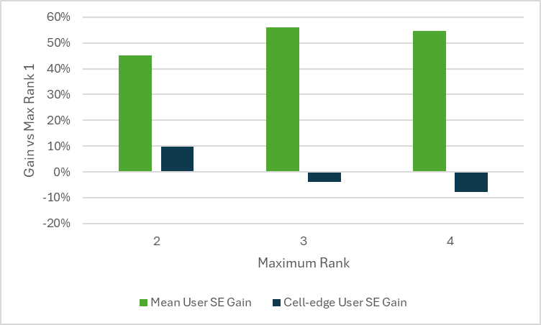  Figure 1: MU-MIMO SE Gain over Maximum Rank 1 at 20% target RU  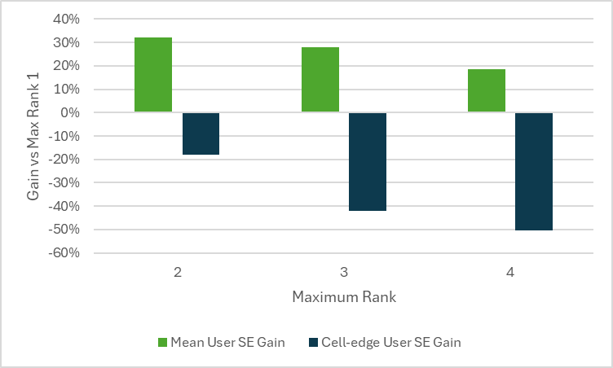  Proposal 7: For 384-bit rank-1 feedback, we support Alt. 1.1 and Alt. 1.2 with a preference for Alt. 1.1.  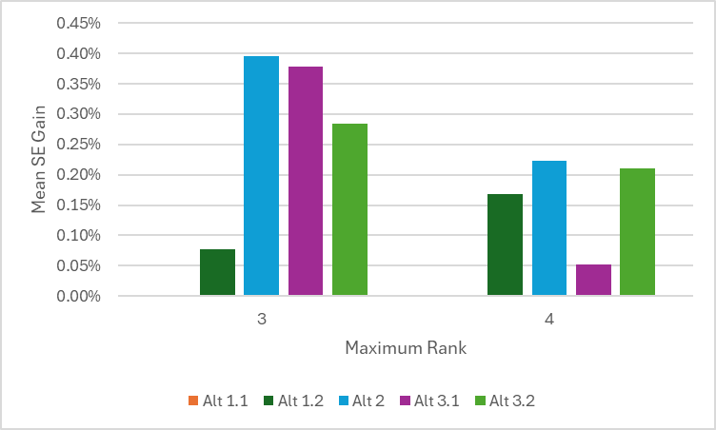  Figure 3: Mean SE gains for 384-bit rank-1 payload (20% target RU). Relative to Alt 1.1.  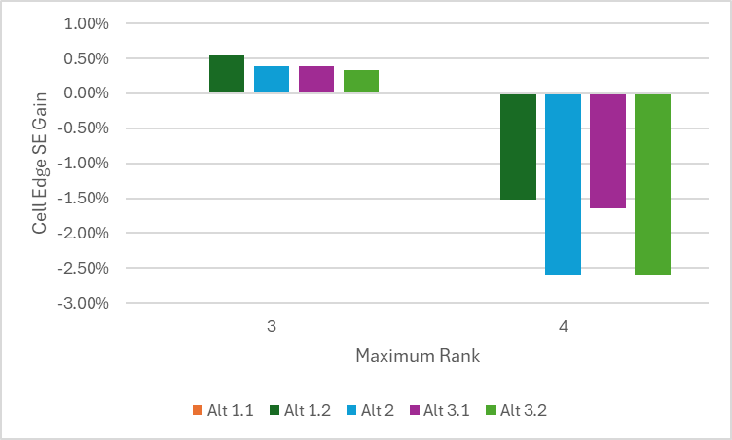  Figure 4: Cell edge SE gains for 384-bit rank-1 payload (20% target RU). Relative to Alt 1.1.  Proposal 8: Consider feeding back indicators of relative layer strength and intra-cell interference in addition to the precoding matrices.
Ofinno | Proposal #1: Regarding a formulation of quantization for latent message, support SQ only.  Proposal #2: Regarding latent-based CSI quantization, support a two-part quantization method on latent vector by splitting coarse part and finer part for each component of the latent vector to ensure reconstruction completeness and robustness against UCI omission.
Toyota ITC | Proposal 1: The association between Pairing ID and parameters combinations codebook should be dynamic. A certain Pairing ID should not be statically associated with a fixed PCs codebook.  Proposal 2: The parameters combinations (PCs) codebook is exchanged upon CSI compression configuration via CSI-reportConfig.
DCM | Proposal 4  - For the PC with Rank-1 payload of 384 bit, support Alt.2, i.e., {128, 2}, {128,2}, {128,2} for Rank 3 and {64, 2}, {64, 2}, {128,2}, {128,2} for Rank 4.  - For the PC with Rank-1 payload of 64 bit, support Alt.2, i.e., {32,1}, {32,1}, {32,2} for Rank 3 and {32,1}, {32 1}, {32, 1}, {32,1} for Rank 4.  - Not support introducing more {d, Q/L} pairs and corresponding PCs.  Proposal 5  - Support only SQ for the exchanged codebooks.  - Support the exchange of a single look-up table for SQ associated with the pairing ID attached with the exchanged dataset or model parameters.
Qualcomm | Proposal 1: Support Alt1 for the payload configuration of upto 128 bits of rank2.  Proposal 2: Support Alt1.1 for the payload configuration of upto 768 bits.  Proposal 3: When NW defines and exchanges a codebook, support VQ with L=2 and Q=4  - Adopt the same payload combination table for SQ and VQ, where the number of quantization bits represents the quantization resolution per scalar  - If NW defines and exchanges a SQ codebook, NW can exchange a VQ codebook with same codewords on each entry.  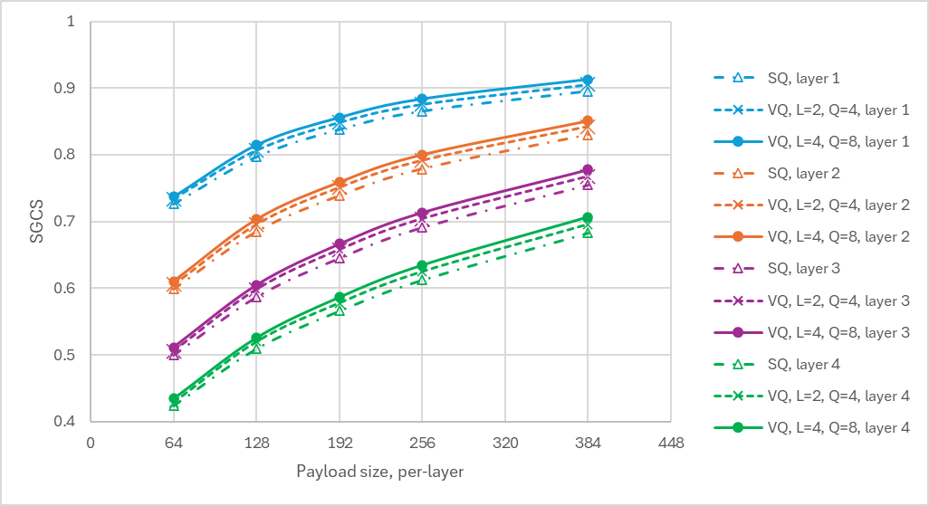  Proposal 4: For the standardized SQ codebook with 2-bit quantization, adopt [-0.75, -0.25, 0.25, 0.75]
   | Rank1 | Rank2 | Rank3 | Rank4
  Alt1 | {32, 2} | {32, 2}, {32, 2} | NA | NA
   | Rank1 | Rank2 | Rank3 | Rank4
  Alt1.1 | {192, 2} | {192, 2}, {192, 2} | {96, 2}, {96, 2}, {192, 2} | {96, 2}, {96, 2}, {96, 2}, {96, 2}

Discussion
In this section, proposals and discussions are elaborated based on companies’ proposals. The discussion will be carried out by payload pairs and quantization methods.

Payload combinations across layers / ranks
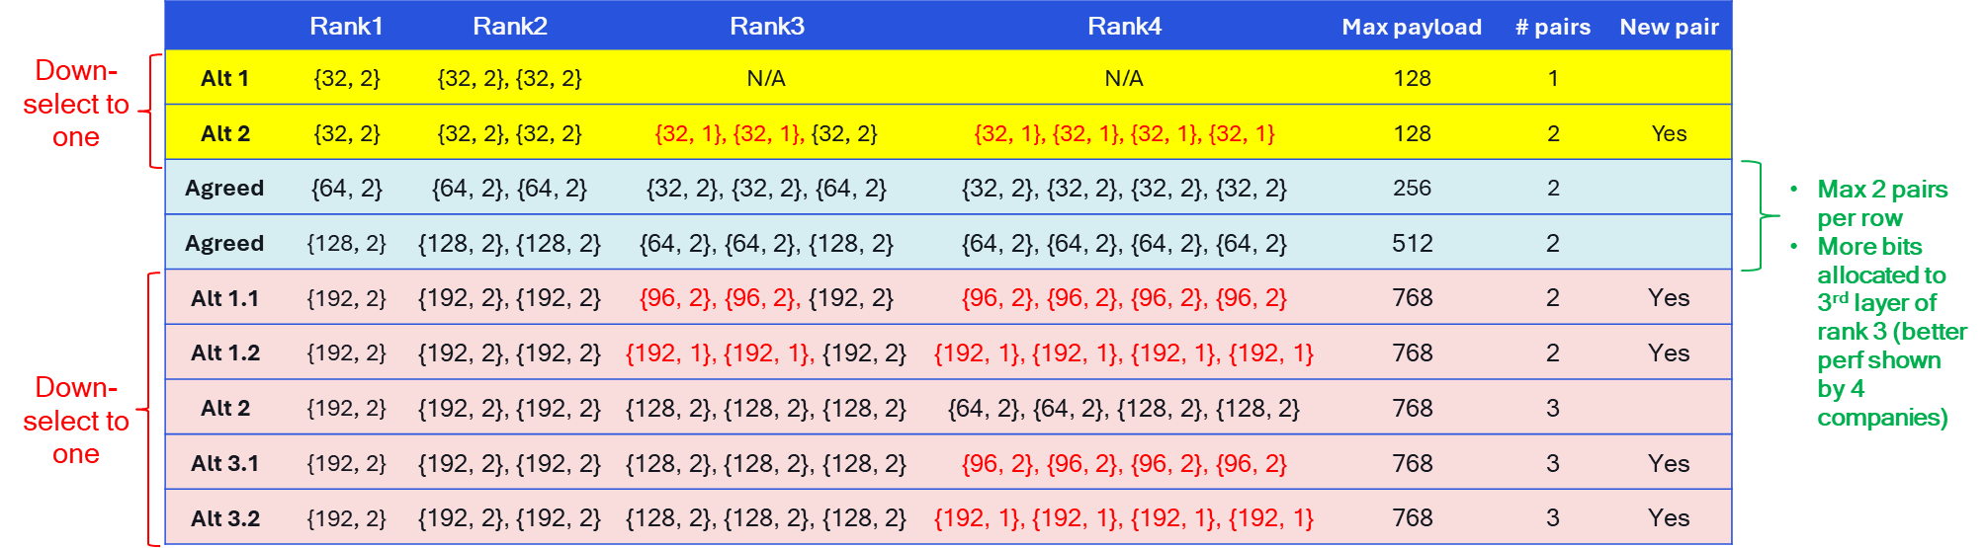
Rank-1 payload of 64 bits:
- Observations:
  - Ericsson shows Alt2 > Alt1 at low RU, Alt2 < Alt1 at medium and high RU.
  - Nokia shows a good possibility of rank3/4 in MU-MIMO SLS
  - Huawei shows {32, 1} as an additional pair does not degrade overall performance.
  - ZTE shows adding {32,1} lead upto -5.78% loss.
  - LGE shows usefulness of {32,1} at low payload range
  - QC shows {32,1} does not degrade the overall performance, but concern on the real benefit
- Views
  - Alt1 (12), without {32, 1}: Ericsson, Spreadtrum, OPPO, ZTE, CATT, Xiaomi, Samsung, Lenovo, Apple, Fujistu, HONOR, QC
  - Alt2 (7), with {32, 1}: Huawei, MTK, vivo (only for VQ), LGE, ETRI, Nokia, DCM
Rank-1 payload of 384 bits:
- Observations:
  - Ericsson shows the best is given by {96, 2}, {96, 2}, {192, 2} for rank 3 and {64, 2}, {64, 2}, {128, 2} and {128,2} for rank 4. In other words, uneven allocation with more bits to weaker layer is beneficial.
  - Ericsson shows {192, 1} is not needed, brings significant loss.
  - Huawei shows having {96,2} does not degrade the scalable model performance, but the gap to benchmark is high.
  - ZTE shows adding {96,2} brings -0.12% ~ 0.52% loss
  - Nokia shows marginal difference among the alternatives
  - QC shows marginal different among the alternatives
- Views:
  - Alt1.1 (13): Ericsson, Spreadtrum, ZTE, Xiaomi, vivo, CT, Samsung, Lenovo, Apple, Fujistu, LGE, Nokia, QC
  - Alt1.2 (2): LGE, ETRI
  - Alt2 (6): Ericsson, Huawei, OPPO, CATT, Xiaomi, DCM
  - Alt3.1: HONOR
New PC with rank-1 payload of 32bit: Huawei (depending on Alt2 of rank-1 payload of 64 bits is adopted)
New PC with rank-1 payload of 96-bit: Samsung
FL note on PC:
For PC of 64-bit, in terms of scalability, some companies provide results showing supporting {32,1} does not degrade the overall performance of other payload pairs. For the throughput performance, one company show Alt2 with rank 3/4 supported by {32, 1} brings negative impact. One company explain concern on the real benefit of it as small payload is more meaning in frequency-flat or LOS where low rank is the typical case. On the other hand, Alt1 can be achieved by configuring rank restriction on top of Alt2, so the concern can be addressed. Let us proceed with a more flexible solution.
For PC of 384-bit, Alt1.1 is the majority view. Among all the reported results, the gap between the 5 alternatives is marginal. As mentioned by FL in the previous meeting, when performance is similar, let use consider complexity with a higher priority. Alt1.1 contains two payload pairs, so that the complexity in model loading and processing is minimum among these alternatives. Let us take Alt1.1 which aligns with PC2/PC3 principle.

Proposal 2.1 (high): PCs
For precoding matrix feedback via two-sided model, support following payload combinations. The layers are reported in the order of decreasing strength.
Total payload size | Rank1 | Rank2 | Rank3 | Rank4
128  (Alt2) | {32, 2} | {32, 2}, {32, 2} | {32, 1}, {32, 1}, {32, 2} | {32, 1}, {32, 1}, {32, 1}, {32, 1}
256 | {64, 2} | {64, 2}, {64, 2} | {32, 2}, {32, 2}, {64, 2} | {32, 2}, {32, 2}, {32, 2}, {32, 2}
512 | {128, 2} | {128, 2}, {128, 2} | {64, 2}, {64, 2} | {64, 2}, {64, 2}, {64, 2}, {64, 2}
768  (Alt1.1) | {192, 2} | {192, 2}, {192, 2} | {96, 2}, {96, 2}, {192, 2} | {96, 2}, {96, 2}, {96, 2}, {96, 2}

Companies | Comments

Quantization type and codebook:
Observations:
- Futurewei reports
  - VQ with L=4 outperforms SQ by 4% for all payload ranges.
  - VQ without segmentation outperforms SQ by 7% and with 6x less payload size.
  - VQ without segmentation outperforms VQ with L=4 by 2.8% and with 6x less payload size
- Huawei reports VQ is better especially for low payload regime.
- Apple reports that VQ significantly outperforms SQ for the same per-layer payload size. For VQ, larger L has a better SGCS performance at the cost of a larger VQ layer.
- QC reports VQ L=2 outperforms SQ with moderate gain, VQ L=2 is close to VQ L=4.
- SS reports that exchanged VQ codebook is equivalent to a fixed codebook for UE side training, so the real benefit is gone and even performance loss than fixed SQ.
Views on VQ vs. SQ:
- Only SQ (10): Ericsson, Spreadtrum, OPPO, MTK, CMCC (at least), Xiaomi, China Telecom, Samsung, Ofinno, DCM
- Support 2 standardized SQ codebook and exchange ID: Samsung
- VQ (6):
  - No segmentation: Futurewei
  - L=2 and same PC with SQ: Huawei, QC
  - L=4: vivo, Apple
  - Support in general: NEC, Fujistu, LGE
- Hybrid VQ + SQ: InterDigital
- Two-part quantization: Ofinno
Other aspects:
- ZTE, Toyota, Transsion Holdings: payload parameters are configured by network
- Nokia: indicating relative layer strength

FL note on NW exchanged codebook:
There are good number of companies interested in VQ and show that VQ is beneficial in some cases. This observation aligns with Rel-18 study which is captured in TR 38.843. Thus, it seems to be reasonable to accommodate it, and the final decision of VQ or SQ is upto NW choice in the NW-first training and inter-vendor collaboration.

Proposal 2.2 (high): NW exchange a codebook
When NW exchanges a codebook, support a common framework that accommodates both NW-defined SQ and NW-defined VQ.
- Specify two look-up tables for mapping between codepoints (from “0” to “$2^{Q-1}$”) to codewords “$x_{k}$” for SQ or “$x_{k}=\left[x_{k,1},x_{k,2},⋯,x_{k,L}\right]$” for VQ where $k=0,…, 2^{Q}-1$.
Table 1: SQ table
Codepoints | Codewords
0 | $$x_{0}$$
1 | $$x_{1}$$
… | …
$$2^{Q-1}$$ | $$x_{2^{Q-1}}$$
Table 2: VQ table
Codepoints | Codewords
0 | $$\left[x_{0,1},x_{0,2},⋯,x_{0,L}\right]$$
1 | $$\left[x_{1,1},x_{1,2},⋯,x_{1,L}\right]$$
… | …
$$2^{Q-1}$$ | $$\left[x_{2^{Q-1},1},x_{2^{Q-1},2},⋯,x_{2^{Q-1},L}\right]$$

- NW exchanges the table ID and the codewords to the UE during inter-vendor collaboration.
- For VQ, downselect to one table with one L value and Q value.
  - Opt1: L=2, Q=4
  - Opt2: L=4, Q=8
  - Opt3: L=d, Q=10

Companies | Comments

Views on standardized SQ codebook:
- Uniform range between 0 and 1.
  - Q=1, 0.25 and 0.75, Q=2, 0.125, 0.375, 0.625 and 0.875: Huawei, Fujistu
- Uniform within -1 and 1: QC
  - -0.75, -0.25, 0.25, 0.75
- Uniform quantization: CATT, HONOR
- 2 standardized SQ codebook, and exchange an ID of them in inter-vendor collaboration: Samsung
  - -0.75, -0.25, 0.25, 0.75
  - 0.125, 0.375, 0.625, 0.875
- SQ designed for Normal distribution (NormalFloat): LGE
  - -1, -0.2525685, 0.2525685, 1
FL note on standardized SQ codebook:
There are three codebooks identified from companies tdoc: uniform between 0 and 1, uniform between -1 and 1, non-uniform between -1 and 1 according to Normal distribution. The first two codebooks are according to different activation functions, i.e., sigmoid and Hyperbolic tangent function, FL tend to think that as long as quantization aware training is applied, the difference can be quite marginal. Activation function is not a critical issue, even if Alt2 is agreed, Alt1 can be used by applying a scaling / offset factor. The third one is an interesting choice as the output of the encoder is quite close to Gaussian. However, given that only two bits are used and the quantization is pre-defined, the performance difference is mall.

Proposal 2.3 (high): Standardized SQ codebook
For standardized SQ codebook with Q=2, downselect to one from the following alternatives
- Alt1: uniform distribution between 0 and 1, i.e., [1/8, 3/8, 5/8, 7/8]
- Alt2: uniform distribution between -1 and 1, i.e., [-3/4, -1/4, 1/4, 3/4]
- Alt3: Gaussian distribution between -1 and 1, i.e., [-1, -0.2525685, 0.2525685, 1]
Companies | Comments
Mod | Companies please vote for Alt1 / Alt2 / Alt3. Can we take Alt1 as a baseline in case if no clear majority pick?  The performance difference of these three quantization schemes should be marginal considering that quantization aware training is performed. So, let us try to pick one with more supporters in this meeting.

UCI mapping and omission

Summary of companies’ proposals
Companies | Proposals
InterDigital | Proposal 9: Support reusing the two-part CSI reporting design of Type II codebook, where Part I includes at least RI/CQI, and Part II contains bits for compressed CSI.  Proposal 10: Support enhancing UCI omission rules for AIML based CSI feedback based on resources, timing and processing constraints as well as the type of CSI report (i.e., inference, monitoring, data collection  Proposal 11: Support segment-based UCI omission for each layer, where CSI Report Part II may be partially omitted by truncating lower-priority segments of the compressed CSI payload.
Furturewei | Proposal 6: For Rel-20 AI/ML-based CSI spatial/frequency compression without temporal aspects (“Case 0”), for UCI mapping for inference, support carrying the CSI feedback in two parts. The first part is of a fixed size and should include CQI for the first codeword, RI, and an indication of the size of the second part. The second part should at least include the content of the UE encoder output and CQI for the second codeword, if applicable.
Spreadtrum | Proposal 1: For CSI report in inference, CSI part 1 will include the factor representing the size of part 2, and CSI part 2 will include encoder output.
Vivo | Proposal 7: For CSI compression with UE side model, two parts CSI are suggested for reporting  - Part 1 contains RI, CQI and potential payload truncation indication of each layer  - Part 2 contains bit sequence of CSI feedback with UE side model  Proposal 8: New omission rule, e.g., per layer omission, or payload truncation can be considered
CMCC | Proposal 10: For AI/ML based CSI compression, one CSI report includes CSI part 1 + CSI part 2. CSI part 1 includes CQI for first codeword, LI and RI; CSI part 2 includes the content of CSI generation part output
NEC | Proposal 6: In CSI spatial/frequency compression, support two-part as CSI report format. The CSI Part 1 includes CRI, RI, CQI (for first codeword) and information determining the payload size of the compressed PMI, while CSI Part 2 includes compressed PMI.  - Whether/which information determining the payload size of the compressed PMI is included in the CSI Part 1 depends on the outcome of discussion about ‘payload determination’.  Proposal 7: Study the multiplexing of AI/ML-based CSI feedback with existing Uplink Control Information (UCI) to ensure efficient coexistence on shared uplink resources.  Proposal 9: In CSI spatial/frequency compression, for CSI omission, support CSI payload reduction for layer(s), e.g., CSI puncturing/truncating.
CATT | Proposal 18: For UCI mapping of AI/ML-based CSI compression, two part CSI mechanism can be reused.  - The CSI feedback bit for AI model output can have different priorities according to the corresponding layer and/or subband configuration.
Xiaomi | Proposal 6: For two-sided AI model based CSI feedback, support two-part CSI reporting and CSI part 1 at least including RI and CQI if applicable, CSI part 2 including the output of CSI generation part.  Proposal 7: The mapping order of CSI part 1 for two-sided AI model based CSI feedback reuses the mapping order of CSI part 1 for legacy eType II codebook based CSI feedback.  Proposal 8: CSI part 2 of two-sided AI model based CSI feedback is divided into multiple groups for UCI mapping, and how to divide CSI part 2 into multiple groups need to further study
ZTE | Proposal 15: For CSI feedback using two-sided model, for UCI mapping, the UE may omit a portion of the Part 2 CSI according to pre-defined priority rules.  Proposal 16: Consider the following methods for CSI omission for potential down-selection: layer-based CSI omission, subband or subband group based CSI omission, truncation/masking of encoder output.
OPPO | Proposal 9: Support to reuse the legacy UCI multiplexing and resource allocation framework for AI/ML based CSI report.  Proposal 10: Support CSI omission for CSI part 2 on PUSCH with per-layer truncation before or after quantization.
LGE | - Study on the CSI encoding method with payload size indication, where part 1 of the CSI report can include either of the following: compression ratio, payload indicator, or the number of multiple information blocks (if applicable).  - Consider report of both inference result and monitoring result together when monitoring occasion is occurred.
KT | - Leverage network-assisted signalling of latent entry criticality, reflecting the non-uniform impact of latent entries on CSI reconstruction performance, to support omission decisions for AI/ML-based CSI feedback under limited PUSCH resources.  .
Sharp | Proposal 1: For CSI feedback via two-sided AI/ML model for CSI compression, support to use two-part CSI reporting:  - Part 1 CSI at least include RI and part 2 CSI  - FFS: whether to support the indication of the parameter combinations (PC) of $\left\{d^{l,ν},Q^{l,ν}\right\}$ or $\left\{d^{l,ν}, L,Q^{l,ν}\right\}$ in part 1 CSI or UE follows a specific indication of PC configured by the gNB.  - Part 2 CSI includes the quantized latent messages.  - For partial omission of part 2 CSI, layer-based omission can be supported.  Proposal 2: To discuss whether/how the UE exchanges sorting information related to the precoding information.
Samsung | Proposal#13: For two-sided model-based CSI compression, support two parts CSI. The PMI information is mapped to Part 2 CSI. Support Part 2 CSI dropping.  FFS: whether/how to define groups for Part 2 CSI including priority formula for PMI bits.  FFS: dropping granularity for Part 2 CSI.  FFS: content of Part 1 to determine size of Part 2
Fujistu | Proposal 5:  - For CSI compression Case 0, UCI mapping should follow the legacy framework of CSI Part 1 and Part 2, and the output of AI encoder should be included in CSI Part 2.  - The payload size of CSI Part 2 is determined by RI in CSI Part 1 and payload parameter pairs.  Proposal 6: If there is no performance degradation and/or feasibility issue, RAN1 supports keeping the same rank value in UCI grouping.
Nokia | Proposal 11: For the UCI mapping of an inference-based CSI report, reuse legacy design for Rel-16 eType-II, i.e. two-part CSI with Part 1 containing RI (if reported) and CQI and Part 2 containing the quantized latent message.  Proposal 13: RAN1 is invited to study mechanisms to support the following features for latent-vector-based Part 2 CSI reporting:  - Adoption of Criticality-Based Dimension Ordering:  For latent-vector-based Part 2 CSI reporting, the NW-UE vendors shall support an ordering of latent dimensions according to their criticality, where criticality reflects the impact of dimension omission on reconstruction performance.  - Support for Dimension-Wise Omission:  When uplink resources are insufficient, the UE shall omit Part 2 CSI with dimension-level granularity, following the criticality-based ordering and starting from the lowest-criticality dimensions, in order to minimize degradation of the reported CSI.
Lenovo | Proposal 4: Both single part and two parts CSI should be considered for AI/ML-based compressed CSI report.  Proposal 6: Support indication of the length of the AI/ML-based compressed CSI (Payload size) other than CRI, RI and CQI within the CSI-Report.  Proposal 9: Support new CSI omission rule for the AI-based compression report with priorities to minimize performance impact.
ETRI | Proposal 4: For AI/ML-based CSI feedback, investigation of a mechanism that enables flexible adjustment of the payload size and explicit indication of the CSI Part 2 size is required.  Proposal 5: For AI/ML-based CSI feedback, adopt type2-r16 UCI mapping as the baseline and investigate a new method for mapping the CSI Part 2 information into groups, for example, by layers.
HONOR | Proposal 6: For UCI mapping, support UCI grouping based on portions of each layer, further study the following options:  - Option1: Grouping based on output dimension index or segment index.  - Option2: Grouping based on quantized bit index.
Apple | Proposal 12: For AI based CSI compression inference configuration, the NW configures the maximum payload configuration and a rank restriction. The UE determines the rank and a payload configuration and include the CSI size info in CSI part 1.  Proposal 15: For AI based CSI compression, CSI part 1 includes RI/CQI/number of bits per layer, CSI part 2 includes CSI feedback per each layer in order.  Proposal 16: For AI based CSI compression, for CSI omission, the CSI feedback is dropped layer by layer.
MTK | Proposal 5: Consider the following options for CSI omission:  - Option 1- Layer-wise omission: All feedbacks bits corresponding to a layer will be omitted at a time.  - Option 2 - Group-wise omission: group(s) of feedback bits from all layers will be omitted at a time.  Proposal 6: Prioritize group-wise omission where group(s) of feedback bits from all layers are omitted if omission is required.  Proposal 7: Discuss how to group the CSI feedback bits for potential group-wise omission in the following aspects:  - Number of groups  - Whether grouping changes for layers and ranks  - Impact on inter-vendor collaboration
Transsion Holdings | Proposal 7: Regarding CSI omission in CSI spatial/frequency compression, the following alternatives can be considered:  - Alt-1: Layer-based priority rule  - Alt-2: Segment based priority rule for vector quantization  - Alt-3: Scalar of latent space based priority rule for scalar quantization.  Proposal 8: In CSI spatial/frequency compression, study the necessity of grouping the compressed target CSI and whether the compressed target CSI can be grouped based on layer information.  Proposal 9: Regarding the alignment of payload parameters (e.g.,$d^{l,ν}, L,Q^{l,ν}$), payload parameter can be configured by Network in CSI report configuration or reported by UE in CSI part 1.
Fraunhofer | Proposal 7: Support switching to a lower payload size/quantization by UE in case of limited resources.  Proposal 11: Support reusing legacy two-part CSI reporting for two-sided AI/ML CSI compression: Part 1 fixed and including at least RI and CQI and Part 2 carrying the quantized output of the CSI generation/encoder  Proposal 12: Support defining CSI Part 2 as an ordered sequence of multiple segments, where the mapping from model output to segments is deterministic and the segment order implies a priority.
Qualcomm | Observation 7: Shuffling the coefficients across layers, and perform UCI mapping and omission rule based on coefficients indices are lack of technical justification, it increases processing complexity but provide no performance benefit (a significant low quality rank-4 reporting).  Observation 8: Reusing eT2 UCI mapping and omission rule will complicate training effort, increase processing complexity and may bring performance loss.  Observation 9: UCI mapping and omission based on truncation will introduces new parameter pairs, thus further increasing the training effort and degrade the performance of other parameter pairs.  Observation 10: Hierarchy or non-hierarchy latent message structure is upto NW and UE implementation choice.  Proposal 5: UCI omission is a corner case, RAN1 should adopt the simplest solution for UCI mapping / omission ordering based on layer indices.

Discussion
Two-part UCI is the common understanding as the actual payload would at least depend on the RI reported in CSI part 1. From companies’ proposal, the major controversial parts lie in 1) UCI grouping, mapping and omission order. and 2) whether the payload parameter combination is configured, or can be decided by UE and reported in CSI part 1.
UCI grouping and omission
Following approaches of UCI grouping are reported by companies:
- General study (6): ZTE, Samsung, Fujistu (keeping rank if no perf loss), Lenovo (minimize performance impact), ETRI, Transsion holdings
- Segment-based / truncation-based UCI mapping and omission (8)
  - InterDigital, vivo, NEC, OPPO, Nokia, HONOR, MTK, Fraunhofer
- Layer-based UCI mapping and omission (3)
  - Sharp, Apple, Qualcomm
FL note on UCI mapping order
There are generally two approaches for UCSI mapping. One is based on layer indices which is the most straightforward approach. Another option is critical-based, or segment-based approach similar to the eT2 approach. The former maintains the per-layer quality when CSI omission occurs but rank decreases, while the latter maintain the rank while reducing the dimension for each layer and allowing truncation-based CSI omission.
For the second approach (omitting portion of layers), a hierarchical structure of the latent message or quantization is needed to ensure the omitted CSI is still readable by the NW. The key aspect of the discussion is that whether the hierarchical structure leads to performance degradation compared to the non-hierarchy latent message. One source reports SGCS results which shows noticeable performance loss at high payload regime. Furthermore, the omission may result in new payload options, which even increases the inter-vendor training challenges and may even further degrade the performance.
There were some discussions occurred during the last meeting, From FL perspective, and as also mentioned by some companies, UCI mapping scheme should be a simple approach, which should not impact the performance. In Rel-19, there were discussions on the performance of supporting scalable payload using multiple output layers or supporting scalable payload using a common layer with truncation-based approach. It should be noted that some companies observe the former has noticeable performance gain over the latter, while some other companies did not report such observation. Hence, a more reasonable way forward is to leave it to implementation, rather than forcing the latent message to be hierarchical in the standard.
It is also important to note that, by prioritizing SQ over VQ, having layer-common rank-common and payload scalable model, the tiny loss incurred in each step are accumulating. Further supporting the hierarchy structure would further accumulate more loss, then it is questionable how much gain we still have compared to eType II.
FL observation
- UCI mapping should be a simple approach which does not degrade the performance.
- UCI omission is a corner case, over-optimization is not needed.
- Hierarchical / critical-based latent message may or may not lead to performance degradation compared to latent message without such restriction.
- The choice of Hierarchical / critical-based latent message or not should be left to implementation choice.
- UCI mapping should accommodate both Hierarchical / critical-based latent message and non-hierarchical / non-critical-based latent message.

Conclusion 3.1 (high): latent message structure
Whether the latent message has a hierarchy / critical-based structure to support different payload sizes is upto NW and UE implementation.
- Note: Hierarchy / critical-based structure of a latent message means that a latent message with a lower payload size is a subset of a latent message with a higher payload size
Companies | views
Mod | The hierarchy structure can be upto NW and UE implementation, there is no need to restrict such format in the spec. Please take a look at the FL observation.

UE reporting actual payload size
FL note on UE reporting actual payload size:
This topic was discussed in the last meetings, and it seems quite controversial whether the UE can determine the actual payload size.
From reading of the proposals, the motivation can be categorized as following:
- To avoid CSI omission
- To further reduce overhead, similar to the NNZC reporting in eT2.
For avoiding CSI omission, FL does not think it is feasible. It should be noted that UCI packing and CSI processing are two orthogonal and independent process. When UE measures and compute the CSI, UE does not know how much the available UL resources is as there would be other UCI multiplexed with the CSI reports.
For further reducing overhead, it seems to be a different situation than eT2. The angular-delay domain representation in eT2 may be sparse, but it may not be the case for latent space. Furthermore, indicating the location of these non-zero entries also requires some additional overhead.
Based on above, FL propose following conclusion.

Conclusion 3.2 (medium, UE reporting actual payload size,)
There is no consensus on determining the actual payload size based on UE indications other than RI.
Companies | views

Codebook subset restrictions

Summary of companies’ proposals
Companies | Proposals
Ericsson | Proposal 11: Support CBSR for two-sided CSI compression use case.  Proposal 12: Consider defining CBSR based on legacy beam restriction and SGCS value between restricted beam and target CSI.
CATT | Proposal 13: For AI CSI compression, the configuration of CBSR is not necessary.
Google | Proposal 2: For CBSR, support one of the following options:  - Option 1: Only 1-bit indication with the value of {0, 1} per beam is supported  - Option 2: Introduce the W2 as the target CSI for CBSR with multi-bit indication per beam
Samsung | Proposal#2: Consider expressing the target CSI in the basis representation $W_{in}^{l}=W_{1}W_{2}W_{f}^{H}$ to facilitate configuration of CBSR.
Apple | Proposal 8: For AI based CSI compression inference configuration, configuration parameters of AI based CSI compression comprises spatial restriction parameters, e.g., restricted DFT beams with an SGCS threshold:  - Total number of restricted spatial directions is a small number, e.g., 4; and  - Oversampling factor might not be needed.
ETRI | Proposal 8: For AI/ML-based CSI compression, investigate the feasibility of introducing codebook subset restriction in the AI/ML-based CSI feedback framework.
Frauhonfer | Proposal 18: Consider expressing the target CSI in a basis representation to facilitate CBSR configuration using a common reference basis/grid aligned with legacy CBSR semantics.  Proposal 19: Support hard CBSR as the baseline for AI/ML CSI compression.
Nokia | Proposal 10: Define an uncompressed and unquantized reference format for the target precoding matrices for inference, for example as a special parameter combination of Rel-16 eType-II, with $L=N_{1}N_{2}$, $M_{υ}=N_{3}$ and with $K_{0}=2N_{1}N_{2}N_{3}$ unquantized nonzero coefficients per layer.  Proposal 11: Support the possibility to configure hard codebook subset restriction (CBSR) for a CSI reporting setting for inference, based on legacy CBSR higher-layer parameter (hard CBSR only).
Ofinno | Proposal #5: Further investigate the necessity and feasibility of CBSR for AI-CSI compression, with a focus on clarifying the restriction metrics, the maximum number of restricted directions, and the impact on latent message reconstruction.
DCM | Proposal 1  - Support the restrictions for AI/ML-based CSI compression to achieve similar effects as the CBSR of the legacy codebooks.  - Restrict the amplitude of the target CSI in NW-configured directions.  - To reduce the UE complexity, only the hard CBSR can be supported.
Qualcomm | Proposal 6: Study following approaches for achieving CBSR via CSI-RS precoding at NW side  - CSI-RS precoding via muted DFT bases in a certain direction, e.g., $W_{1}×A×W_{1}^{H}$, where $A$ is a masking matrix $A=diag\left\{\underset{1st pol}{\underbrace{1, 1, ⋯,0}},\underset{2nd pol}{\underbrace{1, 1, ⋯,0}}\right\}$ and $W_{1}$ is formed by the full set non-oversampled DFT bases.  Proposal 7: Study the generalization performance of CBSR considering the case where training dataset does not perform CBSR while the testing set does.

Discussion
The interests of CBSR increases compared to the last meeting, while some companies propose to study the necessity and feasibility of CBSR. Companies proposal can be summarized as following:
- Represent W in uncompressed eType II format, and apply hard CBSR: Google, Samsung, Fraunhofer, Nokia, DCM
- Legacy beam restriction with SGCS as metric: Ericsson, Apple
- investigate necessity and feasibility of CBSR focusing on restriction metrics, max number of directions: ETRI, Ofinno
- Hard CBSR with non-oversampled DFT bases can be achieved via NW side CSI-RS precoding: Qualcomm

FL note on CBSR:
There are three solutions from companies’ proposals.
- Solution 1 is applying CBSR at UE side, similar to legacy, by representing the precoding matrix via linear combination of spatial bases.
- Solution 2 is also applying CBSR at UE side, but difference compared to legacy is that SGCS is considered as the metric.
- Solution 3 is applying CBSR in CSI-RS precoding. Specifically, if NW does not want UE to report a CSI in a certain direction, NW can send the CSI-RS which is not beamformed towards such direction.
Among these three solutions, following aspects or issues are identified from companies tdocs, and need further study before drawing any conclusions.
- What is the UE processing and complexity to achieve the CBSR.
  - In solution 1, UE project the channel to unrestricted beam, then do SVD, and after that project back to port domain using unrestricted beam.
  - In solution 3, it is also clear that UE behaviour is common with and without CBSR as CSI-RS beamforming is transparent to UE.
  - In solution 2, from FL perspective, the UE processing is not clear. According to Apple’s comment in the last meeting, a simple implementation is that UE should exclude a layer from the target CSI if the layer has an SGCS with the restricted DFT beam(s) higher than the SGCS threshold. But the algorithm seems to be lack of optimization as UE may have to drop all layers.
- Whether the DFT bases is over-sampled or not, how many oversampling group can be restricted, how many beams / bases can be restricted
  - E.g., if oversampling is supported in solution 1, UE may use the unrestricted oversampling group to do the projection, so the final target CSI to be fed into the encoder is the same as the target CSI without CBSR.
- What is the metric used for restriction, hard restriction or soft restriction.
- Model generalization performance, e.g., training from dataset without CBSR, but test in a dataset with CBSR, or vice versa.
With above, let us consider following proposal as a starting point for discussion.

Proposal 4.1 (CBSR, medium):
Study the feasibility of following solutions to facilitate restricting the reported CSI in a certain beam direction:
- Solution 1: Representing precoding matrix W=W1*W2 or W=W1*W2*Wf, and apply restrictions on the DFT bases in W1.
- Solution 2: The SGCS between the reported precoding matrix W and a set of restricted DFT bases should not exceed a configured SGCS threshold.
- Solution 3: The beam restriction is absorbed into the CSI-RS beamforming
The study includes following aspects:
- Whether the DFT bases is over-sampled or not, how many oversampling group can be restricted, how many beams / bases can be restricted
- What is the metric used for restriction, hard restriction or soft restriction.
- Associated UE behaviour and complexity
- Model generalization performance, e.g., training from dataset without CBSR, but test in a dataset with CBSR, or vice versa.
Companies | Comments
Mod | FL’s understanding of these three solutions are elaborated as follows. Let us use is as a starting point to align the understandings.  In solution 1, UE project the channel to unrestricted beam $W_{1}×A$ where $A=diag\left\{\underset{1st pol}{\underbrace{1, 1, ⋯,0}},\underset{2nd pol}{\underbrace{1, 1, ⋯,0}}\right\}$ represent the unrestricted beams from the full DFT matrix. Then UE does SVD, and after that, UE projects back to port domain using unrestricted beam $A×W_{1}^{H}$. If oversampled DFT is supported, UE can use the unrestricted oversampled DFT group to do the projection, then after projecting back to the port domain, the target CSI is same as without doing CBSR.  In solution 2, UE processing to achieve the SGCS threshold and the difference compared to solution 1 is unclear, need a better clarification.  In solution 3, the CSI-RS is precoded by $W_{1}×A×W_{1}^{H}$ where A represents the unrestricted beams same as solution 1. Then UE just perform an SVD to the measured channel, and the same precoding matrix is obtained as solution 1.

Data collection

Summary of companies’ proposals

Quantization and normalization
Companies | Proposals
Futurewei | Proposal 7: In AI/ML-based CSI compression using two-sided model Case 0, for Option 1 (scalar quantization) of NW side data collection with higher layer reporting, support the following:  - Option 1a: Each complex element of the Target CSI sample is quantized to real value and imaginary value  - FFS on the value of k1/k2.
Ericsson | Table 4: SGCS performance with target-CSI format Option 1 (scalar quantization of the eigenvectors), for 32 CSI-RS ports and 13 subbands.  Table 5: SGCS performance with target-CSI format Option 1 (scalar quantization of the eigenvectors), for 128 CSI-RS ports and 19 subbands.  Table 6: SGCS performances of model trained with quantized dataset.  Proposal 5: Support Option 1a as the target CSI format for NW-side data collection, i.e., each complex element of the Target CSI sample is quantized to real value and imaginary value, with the following  - Support fixed value of k1=k2=3  - Support uniform quantization in the interval $-c/\sqrt{N_{ports}}$ to $c/\sqrt{N_{ports}}$, where $N_{ports}$ is the number of CSI-RS ports  - Support the quantized values of codepoints: $Q=\left[\frac{­7}{8}, \frac{­5}{8}, \frac{­3}{8}, \frac{­1}{8}, \frac{1}{8}, \frac{3}{8}, \frac{5}{8}, \frac{7}{8}\right] c/\sqrt{N_{ports}}$
  Format | Total Payload | SGCS
  Format | Total Payload | Layer 1 | Layer 2 | Layer 3 | Layer 4
  Float32 (32-bit real and 32-bit imaginary) | 106 496 | 1.0000 | 1.0000 | 1.0000 | 1.0000
  Scalar 8-bit (4-bit real and 4-bit imaginary) | 13 312 | 0.9908 | 0.9904 | 0.9901 | 0.9896
  Scalar 6-bit (3-bit real and 3-bit imaginary) | 9 984 | 0.9645 | 0.9637 | 0.9631 | 0.9622
  Scalar 4-bit (2-bit real and 2-bit imaginary) | 6 656 | 0.8712 | 0.8682 | 0.8661 | 0.8633
  Format | Total Payload | SGCS
  Format | Total Payload | Layer 1 | Layer 2 | Layer 3 | Layer 4
  Float32 (32-bit real and 32-bit imaginary) | 622 592 | 1.0000 | 1.0000 | 1.0000 | 1.0000
  Scalar 8-bit (4-bit real and 4-bit imaginary) | 77 824 | 0.9914 | 0.9913 | 0.9905 | 0.9897
  Scalar 6-bit (3-bit real and 3-bit imaginary) | 58 368 | 0.9667 | 0.9665 | 0.9648 | 0.9636
  Scalar 4-bit (2-bit real and 2-bit imaginary) | 38 912 | 0.8774 | 0.8770 | 0.8728 | 0.8696
  Format | SGCS
  Format | Layer 1 | Layer 2 | Layer 3 | Layer 4
  Float32 (32-bit real and 32-bit imaginary) | 0.7328 | 0.5961 | 0.4896 | 0.4177
  Scalar 8-bit (4-bit real and 4-bit imaginary) | 0.7362  (+0.5%) | 0.5991  (+0.5%) | 0.4903  (+0.1%) | 0.4178  (+0.0%)
  Scalar 6-bit (3-bit real and 3-bit imaginary) | 0.7334  (+0.1%) | 0.5974  (+0.2%) | 0.4869  (-0.6%) | 0.4165  (-0.3%)
  Scalar 4-bit (2-bit real and 2-bit imaginary) | 0.7161  (-2.3%) | 0.5793  (-2.8%) | 0.4711  (-3.8%) | 0.4052  (-3.0%)
Huawei, HiSilicon | Proposal 16: For the quantization of Target CSI for NW side data collection:  - Regarding the quantization solution, support Opt 1a: Each complex element of the Target CSI sample is quantized to real value and imaginary value.  - Regarding quantized value for each codepoint for NW side data collection, support a k1= k2 bit uniformly distributed quantization within [-1, 1] range where the i-th codepoint is mapped to -1+$\frac{2i-1}{2^{k_{1}}}$ for $i=1,…,2^{k_{1}}$.  - Regarding whether/how to perform normalization, support Alt.2-1: At least one element among all real and imag elements in the Target CSI matrix correspond to any of T_{min} and T_{max}.
OPPO | Proposal 13: Support Option 1a with Alt 2-2 for NW-side data collection.  Proposal 14: Regarding the linear normalization parameters $x_{min}$ and $x_{max}$ reporting, support:  - per sample normalization and reporting (S = 1)  - per reporting normalization and reporting (S>1)
ZTE | Observation 11: When the models are trained with a quantization option (either Option 1a with k1 = k2 = 3 or Option 1b with k1 = 3, k2 = 4) but tested on FP32, the performance is comparable to that of the FP32 baseline.  Observation 12: When the models are trained and tested using the same quantization option, whether it is Option 1a with k1 = k2 = 3 or Option 1b with k1 = 3 and k2 = 4, the performance consistently falls below the FP32 baseline.  Observation 13: When the models are trained and tested using the same quantization option, Option 1b with k1 = 3 and k2 = 4 exhibits slightly better performance compared to Option 1a with k1 = k2 = 3 at the expense of increased overhead.  Proposal 21: For Option 1 (scalar quantization) of NW side data collection with higher layer reporting, support configurable quantization resolutions (i.e., k1, k2 value) for better future proofness and performance-overhead tradeoff adaptive to diverse scenarios.  Observation 14: If the target CSI type is precoding matrix in spatial-frequency domain, the precoding vector of each layer has unit norm and real/imaginary parts of all entries are within the range from -1 to 1.  Observation 15: Compared with amplitude+phase part quantization, real+imaginary part quantization can help reduce the UE complexity as it eliminates the need for further conversion of the complex element.  Proposal 22: For Option 1 of NW side data collection with higher layer reporting,Support Option 1a where each complex element of the Target CSI sample is quantized to real value and imaginary value.  Proposal 23: For Option 1 (scalar quantization) of NW side data collection with higher layer reporting, support Alt. 2-1 where at least one element among all real and imag elements in the Target CSI matrix (per layer and per subband) correspond to any of Tmin and Tmax in the quantization table.
CATT | Proposal 19: For AI/ML based CSI compression, if Opt 1b scalar quantization of target CSI is supported, a standardized quantization range can be used for amplitude part for all number of Tx ports.  Proposal 20: For AI/ML based CSI compression Case 0, regarding the Opt1a scalar quantization of target CSI in NW-side data collection, support the same quantization bits for the real and imaginary part, i.e., k1=k2.  Observation 1: For AI/ML based CSI compression, if Option 1b scalar quantization of target CSI is supported, optimal performance can be achieve when k1<k2 and normalization is applied.  Table 2 Metric#2 SGCS for Option 1a and Option 1b with/without normalization under different overhead with 32/16 Tx  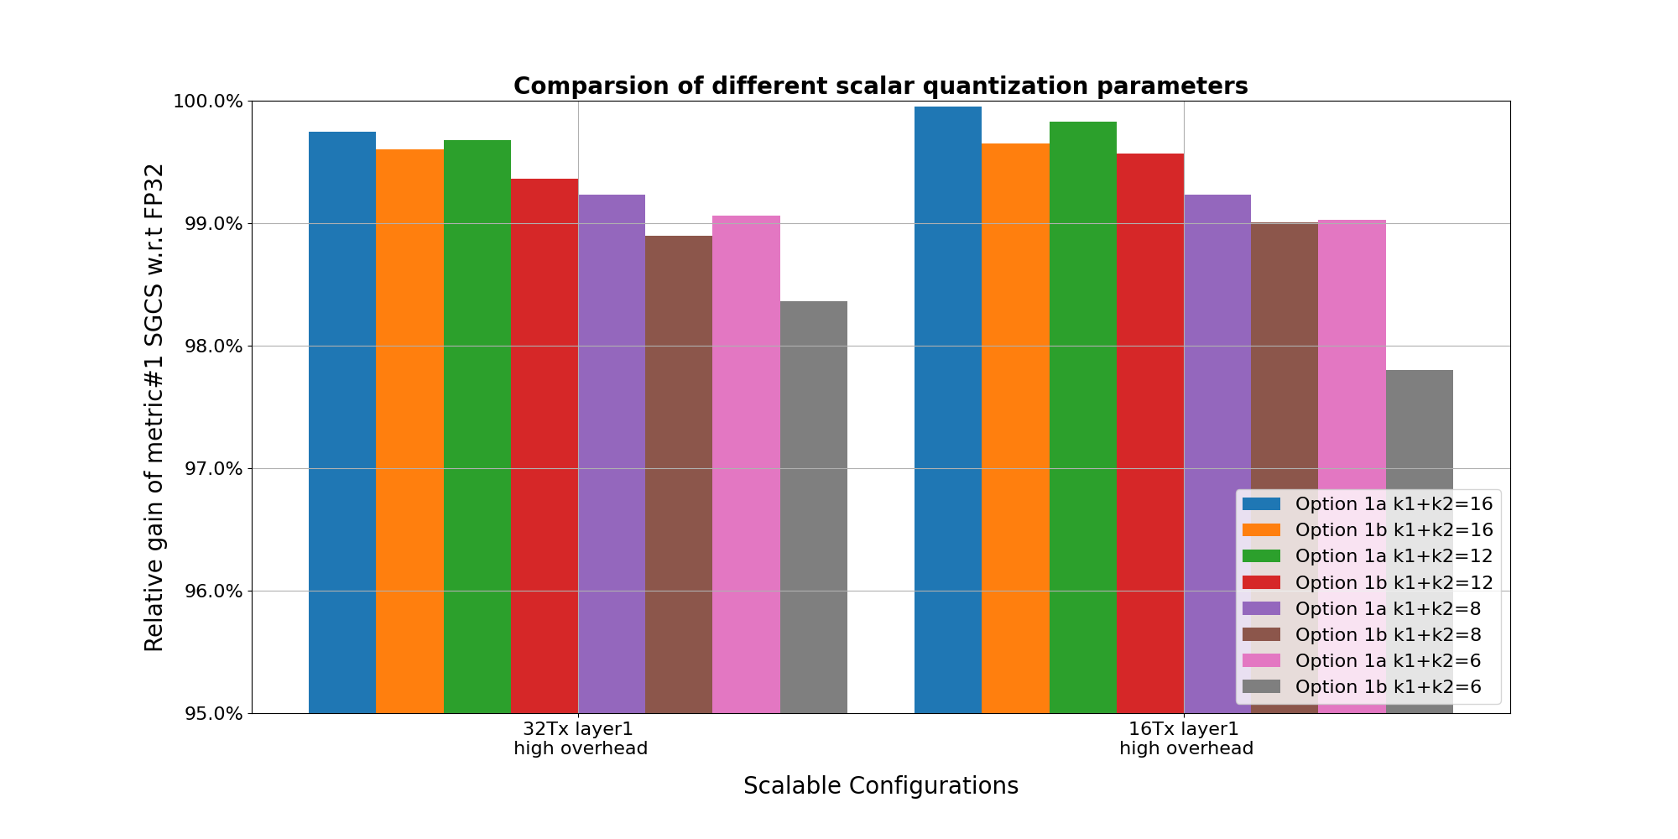  Observation 2: For quantization of target CSI, Option 1a delivers marginally higher SGCS than Option 1b.  Proposal 21: For AI/ML based CSI compression Case 0, regarding the Opt1 scalar quantization of target CSI in NW-side data collection, support separate quantization of the real and imaginary part.  Proposal 22: For AI/ML based CSI compression Case 0, regarding the Opt1 scalar quantization of target CSI in NW-side data collection, support at least one of the following quantization bits configurations for the real and imaginary part, where whether/how to apply normalization and truncation can be UE implementation-specific:  - k1=k2=8bits  - k1=k2=6 bits  - k1=k4=4 bits  Proposal 23: For AI/ML based CSI compression Case 0, regarding the Option 1a scalar quantization of target CSI in NW-side data collection, support the same quantization range for the real and imaginary part as [-1,1], i.e., T1_{min}=T2_{min}=-1, T1_{max}=T2_{max}=1.
  k1+k2 | Normalization | k1 | k2 | 32Tx SGCS | 16Tx SGCS
  6 | No | 3 | 3 | 0.913 | 0.931
  6 | No | 2 | 4 | 0.904 | 0.917
  6 | No | 4 | 2 | 0.843 | 0.848
  6 | Yes | 3 | 3 | 0.950 | 0.949
  6 | Yes | 2 | 4 | 0.961 | 0.961
  7 | No | 3 | 4 | 0.942 | 0.961
  7 | No | 4 | 3 | 0.943 | 0.949
  7 | Yes | 3 | 4 | 0.980 | 0.980
  7 | Yes | 4 | 3 | 0.956 | 0.955
  8 | No | 4 | 4 | 0.973 | 0.980
  8 | No | 3 | 5 | 0.950 | 0.969
  8 | No | 5 | 3 | 0.954 | 0.955
  8 | Yes | 4 | 4 | 0.986 | 0.986
  8 | Yes | 3 | 5 | 0.988 | 0.988
  8 | Yes | 5 | 3 | 0.957 | 0.957
  12 | No | 6 | 6 | 0.998 | 0.999
  12 | No | 5 | 7 | 0.995 | 0.997
  12 | No | 7 | 5 | 0.997 | 0.997
  12 | Yes | 6 | 6 | 0.999 | 0.999
  12 | Yes | 5 | 7 | 0.999 | 0.999
  12 | Yes | 7 | 5 | 0.997 | 0.997
  k1+k2 | Method | 32Tx SGCS | 16Tx SGCS
  6 | Option 1a | 0.963 | 0.966
  6 | Option 1b | 0.961 | 0.961
  7 | Option 1b | 0.980 | 0.980
  8 | Option 1a | 0.982 | 0.983
  8 | Option 1b | 0.988 | 0.988
  10 | Option 1a | 0.991 | 0.991
  12 | Option 1a | 0.993 | 0.993
  12 | Option 1b | 0.999 | 0.999
  16 | Option 1a | 0.999 | 0.999
  16 | Option 1b | 0.999 | 0.999
MTK | Proposal 18: For option 1 of NW-side data collection, deprioritize (k1, k2) values with k1+k2>8.  Proposal 19: For amplitude/phase quantization, prioritize (k1, k2) = (2,4) and (3,5). For real/imaginary quantization, prioritize (k1, k2) = (3,3) and (4,4).  Proposal 20: Support only one of real/imaginary quantization and amplitude/phase quantization for option 1.
CMCC | Proposal 13: In CSI compression using two-sided model use case, for scalar quantization to the target CSI, each complex element of the Target CSI sample is quantized to amplitude value and phase value.
Xiaomi | Proposal 15: Option 1b, i.e., each complex element of the Target CSI sample is quantized to amplitude value and phase value, could be considered, if the performance of Option 1a and Option 1b is similar with the same feedback overhead.  Proposal 16: Support Alt.1, i.e., it is UE implementation to perform scale up/down to fit the fixed range, and amplitude normalization is performed per layer and across all subbands.
Vivo | Proposal 14: Each complex element of the Target CSI sample is quantized to real value and imaginary value(Option 1a) with k1/k2=3 or k1/k2=4
TCL | Proposal 12: For scalar quantization, quantize amplitude and phase values separately.  Proposal 13: Support amplitude normalization per dimension, with the UE reporting the normalization dimension(s).
Southeast University | Proposal 1-1: Consider prioritizing Option 1b (amplitude/phase quantization) in the down-selection, given its potential to achieve close-to-upperbound SGCS with fewer total bits by enabling asymmetric bit allocation between amplitude and phase.  Proposal 1-2: Study a deterministic and implementation-friendly guideline for selecting (k1, k2) pairs and the corresponding quantization codepoints for Option 1b, including recommended bit splits for each studied k1+k2 target.  Proposal 1-3: Study magnitude-aware phase precision under Option 1b and its signaling impact. In particular, study whether variable-length behavior is acceptable; if not, study a fixed-payload alternative by imposing a per-sample total phase-bit budget and distributing phase bits across coefficients according to their magnitudes.  Proposal 1-4: Study the potential UE complexity for Option 1b, including the cost of amplitude/phase conversion, and the necessity (if any) of higher-layer signaling enhancement for large (k1, k2) configurations or advanced phase-bit allocation rules.  Proposal 1-5: When $x_{1}/x_{2}$ represent the real and imaginary parts of target CSI samples, set $k_{1}=k_{2}$ and $T_{1,min}=T_{2,min}$, $T_{1,max}=T_{2,max}$ as a baseline. When $x_{1}/x_{2}$ represent the amplitude and phase parts, the bit allocation and range design require further study due to their asymmetric statistical properties and encoding mechanisms.  Proposal 1-6: If a down-selection is to be made between using real–imaginary and amplitude–phase inputs for the two-side CSI feedback model, it should be further studied whether and how the chosen model-input modality affects the content and quantization format of NW side data collection.  Proposal 1-7: Further study magnitude-aware adaptive phase quantization, where phase precision is coarsened for low-magnitude coefficients and refined for high-magnitude coefficients, to achieve better payload-efficiency without notable performance loss.  Proposal 1-8: Study how to reduce data collection signaling overhead for training two-side CSI compression model when S>1.  Proposal 1-9: Study the dataset selection and dataset distillation-based method to further reduce the data collection signaling overhead.
Google | Proposal 8: For network side data collection, support Option 1b (amplitude/phase) for target CSI report.  Proposal 9: For network side data collection, the normalization is up to UE implementation.
Sharp | Proposal 10: For option 1 of NW side data collection with higher layer reporting, down-selection to option 1a.
China Telecom | Proposal 1: Support Option 1a to ensure low complexity and numerical stability.  Proposal 2: Support symmetric bit allocation (where$k=k1=k2$) and support configuration of mixed Target CSIs subject to multiple {k1, k2} values each corresponding to a specific port/subband/layer configuration. Note: RRC signaling enhancement is not necessary.  Proposal 3: Support Alt.1 for Target CSI normalization with a fixed output range, using the same scaling factor for all layers.
Samsung | Proposal#16: For Target CSI in NW-side data collection, for the overhead evaluation of the options for Target CSI, consider parameter values that would fit at least one Target CSI sample of a baseline configuration into 9kB RRC message.  - Consider 2N1N2=128, Nsb=19, v=4 as a baseline configuration of a Target CSI sample.  Proposal#17: For NW-side data collection, support amplitude-phase quantization with at least parameter combination set to {k1,k2}={3,4} , i.e., 3bits amp and 16-PSK for phase quantization.  - For precoding vector corresponding to layer $l=1,…, v,$ and subband $n_{3}=1,…,N_{3},$denoted as $w_{{l,n}_{3}}={[w_{{l,n}_{3},1}, …,w_{{l,n}_{3},P}]}^{T},$ the coefficients are represented as $w_{{l,n}_{3},p}=a_{{l,n}_{3},p}exp⁡(\frac{j2πc_{{l,n}_{3},p}}{N_{psk}})$. Consider the following table for amplitude quantization:  Proposal#18: For NW-side data collection, per-each precoding vector, UE normalizes the coefficient corresponding to the maximum amplitude to 1, i.e., UE reports at least one coefficient with amplitude coefficient corresponding to value ‘1’ and phase coefficient corresponding to value ‘0’.
  $$a_{{l,n}_{3},p}$$ | $$quantized amp.$$  value
  0 | $$\frac{1}{8\sqrt{2}}$$
  1 | $$\frac{1}{8}$$
  2 | $$\frac{1}{4\sqrt{2}}$$
  3 | $$\frac{1}{4}$$
  4 | $$\frac{1}{2\sqrt{2}}$$
  5 | $$\frac{1}{2}$$
  6 | $$\frac{1}{\sqrt{2}}$$
  7 | 1
Lenovo | Proposal 15: Support Option 1a to quantize the real and imaginary values for the NW side data collection with higher layer reporting.  Table 3: SGCG results with models trained by the datasets with different scalar quantization options
   |  | Payload size per sample | Layer 1 | Layer 2 | Layer 3 | Layer 4
  FP32 (k1=k2=32) |  | 13312 | 0.8630 | 0.7997​ | 0.6763​ | 0.6664
  Option 1a | Scalar 16-bit (k1=k2=8) | 3328 | 0.8482 | 0.7850 | 0.6576 | 0.6356
  Option 1a | Scalar 8-bit (k1=k2=4) | 1664 | 0.8463 | 0.7844 | 0.6522 | 0.6393
  Option 1a | Scalar 6-bit (k1=k2=3) | 1248 | 0.8433 | 0.7794 | 0.6479 | 0.6292
  Option 1b | Scalar 16-bit (k1=k2=8) | 3328 | 0.8619 | 0.7977 | 0.6803 | 0.6668
  Option 1b | Scalar 8-bit (k1=k2=4) | 1664 | 0.8579 | 0.7938 | 0.6703 | 0.6627
  Option 1b | Scalar 6-bit (k1=k2=3) | 1248 | 0.8559 | 0.7922 | 0.6711 | 0.6488
Apple | Proposal 18: Scale the target CSI by $\sqrt{N_{tx}}$ and apply fixed quantization range, e.g., [-1.82, 1.82], for each of the ${2N}_{1}N_{2}N_{3}v$ real/imaginary part except for a reference element which is a real number (imaginary=0):  - UE indicates the position of the reference element.  Proposal 19: For NW side data collection, 5bits per real or imaginary part scalar quantization is adopted to evenly quantize each real or imaginary part within a quantization range.
Fujistu | Proposal-7: Support option 1a as the scalar quantization method for target CSI for its simplicity.  Proposal-8: Regarding k1 and k2 selection, the model performance with the selected bit-width should be better than the performance of Option 4 (eT2 like codebook with new parameters) due to its higher payload size.  Proposal-9: Regarding normalization processing, noise floor related to ADC/RF and channel estimation errors should be considered. More evaluations are needed to determine which Alternative is better.
LGE | Proposal 18: For normalization of target CSI for NW-side data collection, support Alt 2 (the normalization to fit the value range to the fixed quantization range [Tmin, Tmax]).  Proposal 19: For NW-side data collection, report of scaling/offset factors is not needed.  Proposal 20: For NW-side data collection, support amplitude/phase quantization (option 1b).  Observation 5: Regarding the amplitude/phase quantization with normalization for NW-side data collection, there is negligible SGCS performance (Metric #1) loss for total 6 bits quantization (k1+k2$≥6$) compared to baseline (k1=k2=FP32).  Proposal 21: To resolve the overhead issue for NW-side data collection, consider lower quantization resolution (e.g., k1+k2= 6 bits or 7 bits).
HONOR | Proposal 10: For Option 1a, support per layer per-sample normalization.  Proposal 11: For Option 1a, k1=k2=3bits or k1=k2=2bits can be considered.  Proposal 12: Between Option 1a and Option 1b, Option 1a is preferred due to its better performance.  Proposal 13: For normalization, a fixed quantization range, e.g., [0, 1], can be standardized.  Proposal 14: For option 1a normalization, alt 2-2 is preferred and per layer per sample normalization parameter can be reported by UE.  - Alt.2-2: Reporting scaling factor and offset factor for denormalization.
ETRI | Proposal 9: Regarding the sub-options for Option 1(scalar quantization), prioritize to consider Option 1a (i.e., quantization of real and imaginary values).
Nokia | Observation 18: Increasing overall bit size improves SGCS<Quantize,Ideal data> (Metric#2), with diminishing returns beyond 10 bits:  - Real-Imag: 6 bits → 0.885; 10 bits → 0.994; 12 bits → 0.998; 16 bits → ~1.00000.  - Mag-Phase: 6 bits → 0.917; 9–10 bits → ≥0.993; 12–16 bits → ~0.999–0.9999.  Observation 19: Magnitude-Phase domain representation generally preserves eigenvectors better than Real-Imaginary domain representation (higher SGCS<Quantize,Ideal data> a.k.a. Metric#2).  Proposal 17. RAN1 to down select Option 1b for NW-side data collection with scalar quantization.  Proposal 18: For strong preservation of eigenvector information, prioritize overall bit size within 9–12 range.  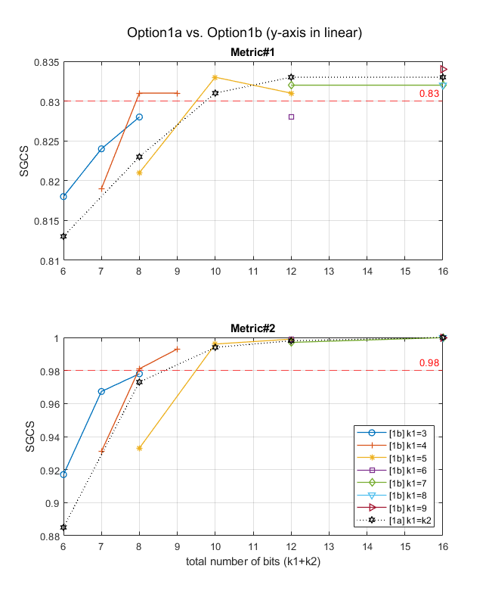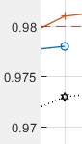  Proposal 19: RAN1 to agree on Option 1b, i.e., each complex element of the Target CSI sample is quantized to amplitude value and phase value.  Proposal 20: With respect to the alternatives for normalization, RAN1 is recommended to support Alternative 1, under which the normalization scaling (i.e., scaling up or down to fit the fixed range) is left to UE implementation.  Proposal 21: UE/modem vendors are recommended to consider normalization scheme based on standard deviation of real/imaginary parts of the measured target CSI data.  Proposal 22 : RAN1 is invited to identify an appropriate normalization configuration for the $k_{1}=3, k_{2}=4$case, under magnitude/phase conversion of the target CSI, that can achieve acceptable Metric #1 performance.
DCM | Proposal 11  - Support Option 1a with k1 + k2 = 6 or 8 bits (i.e., k1 = k2 = 3 or 4 bits).  Observation 4  - Option 1b-unfiorm performs better than Option 1b-log given the same k1 + k2.  - Option 1b-unform has a minor performance gain compared with Option 1a. When k1 + k2 = 6 bits, the SGCS gain is 0.002, and when k1 + k2 = 8 bits, the SGCS gain is less than 0.001 with 32 antenna ports. The SGCS gap at the 10⁻³ level is ignorable with respect to its impact on final performance, since the SGCS gap for the reconstruction is about 0.2 or more significant, i.e., at the 10⁻¹ level. Given the additional complexity, there is little motivation to support Option 1b.  - When k1 + k2 = 6 bits, Option 1a/1b can achieve at least 0.965 SGCS, which is significantly greater than the SGCS of model reconstruction.  - When k1 + k2 = 8 bits, Option 1a/1b can achieve at least 0.991 SGCS, which is almost error-free.  Proposal 13  - Support the specified normalization granularity, per subband and per layer.  - Support Alt.2-1: At least one element among all real and imaginary elements in the Target CSI matrix corresponds to T_{max} in the quantization table.
Qualcomm | Proposal 11: Support k1=3 bits quantization for amplitude and k2=4 bit for phase. The amplitude quantization starts from 0dB with -1.5dB step size.  Proposal 12: It is UE implementation to perform scale up/down to fit the fixed range.

Data quality, target CSI splitting, other information
Companies | Proposals
Huawei, HiSilicon | Proposal 17: For the report of Target CSI for NW side data collection, one Target CSI sample can be split into multiple segments, each of which corresponding to a subset of layers (for precoding matrix) and/or subbands and is carried by a separate RRC message.  Proposal 18: For the additional information for NW side data collection,  - Target CSI (for precoding matrix) is generated following the number of layers configured by NW.  - UE additionally reports data quality related information accompanied with the reported Target CSI sample, such as quality indicator, RSRP or CQI.
ZTE | Proposal 24: For NW side data collection of CSI compression, the content of the collected data can include pairing ID which is beneficial for both NW side and UE side.  Proposal 25: To enable high-quality data collection from the UE to the NW, further study the following options:  - The UE reports data quality-related information to the NW, e.g., SINR, CQI, positioning information  - The NW configures a data quality threshold to the UE and the UE only reports qualified data
CATT | Proposal 24: For AI/ML based CSI compression Case 0, additional content can be optionally included in NW-side data collection report:  - to distinguish the layer/rank  - to indicate data quality  - to facilitate precoding matrix reconstruction from a specific target CSI configuration
MTK | - Discuss the assistant information that UE needs to include in reporting CSI samples to NW for training purpose.
CMCC | Proposal 14: In CSI compression using two-sided model use case, for target CSI reporting for NW-side data collection, the rank of the target CSI is configured by gNB and RI reporting in CSI is not needed.  Proposal 15: In CSI compression using two-sided model use case, regarding target CSI reporting for NW-side data collection, CQI reporting in CSI is not needed.  - FFS: whether CRI or LI is needed for reporting or not
TCL | Proposal 14: Provide quality information (e.g., CSI-SINR, CQI) alongside target CSI samples, or use NW-configured quality thresholds.
Sharp | Proposal 11: For CSI compression, for NW side data collection for training, support that NW can indicate rank information for target CSI reporting.
NEC | Proposal 12: In Direction A sub option 4-1, the UE side can determine similarity information between the newly collected data/dataset and the exchanged (training) dataset and provide it to the NW side, to assist the NW side to determine whether the newly collected data is needed to avoid unnecessary dataset exchange.  Proposal 13: In CSI spatial/frequency compression, support the UE-side to provide data quality information (e.g., L1-RSRP) during NW-side data collection for training.  - Collecting data quality information may consume additional power, processing units and memory resources at UE side, whether to perform such data quality collection should be at least determined by UE-side based on its own status and conditions.
Samsung | Proposal#21: For NW-side data collection, consider the following additional information reporting  - Rank information  - Data quality information, e.g., explicit quantities including eigenvalues, SINR, etc., or implicit quantities such as SGCS, CQI.
Lenovo | Proposal 18: Support specification of procedures/signaling for transmission of additional information such as sample-group size, quality indicator, distortion level along the transmission of the sample itself.  Proposal 20: Support associating additional information with the dataset/model parameters generated by the NW-side and indicating that to the UE-side along the exchange of the dataset/model parameters.
Fujistu | Proposal-10: To meet 9Kbyte limit of one single RRC message, the maximum layer number of target CSI reporting can be configured by NW.
ETRI | Proposal 10: Regarding consideration of the maximum payload size in the higher layer signaling, consider applying segmentations if transmitting using only one message is not always possible.
Nokia | Proposal 23 : Additional quality related information is not needed for NW-sided data collection.
DCM | Proposal 10  - For NW side data collection,  - Support a data quality indicator report for the NW side data collection.  Proposal 12  - It is up to RAN2 to design the high-layer signaling to accommodate the payload of collected CSI samples.  - RAN1 does not consider dividing a CSI sample into multiple parts based on layers, subbands, or antenna ports unless requested by RAN2.
Qualcomm | Observation 20: If 7-bit per complex number is used for data collection, one RRC message is able to carry one target CSI sample; if higher quantization resolution is needed, two data collection configurations can be used to collect target CSI samples on different set of subbands.  Observation 21: Splitting one target CSI sample into two pieces may be a common case when packing logged data to one RRC message and the RRC message size is not the integer multiple of the payload size of one target CSI sample. RAN2 should have mechanism to support it.

Other aspects, e.g., configuration of pairing ID, CPU, etc
Companies | Proposals
Ericsson | Proposal 6: Pairing ID is not needed for configuring NW-side data collection, and UE shall log at least cell ID, measurement configuration ID and target CSI samples per CSI logged measurement configuration per cell.
Huawei | Proposal 19: For UE side data collection,  - Pairing ID(s) is optionally provided by NW in CSI-ReportConfig.  - Multiple Pairing IDs provided in one CSI-ReportConfig for UE side data collection, and the collected data is applicable to any of the Pairing IDs.
Spreadtrum | Proposal 10: For UE-side data collection of CSI compression, the CPU occupancy duration can reuse the rule of R19 CSI prediction with extended Z3’.  Proposal 11: For UE-side data collection, the pairing ID can be optionally used for UE to collect UE-side target CSI for model training and fine-tuning.  Proposal 12: For NW-side data collection, do not support configuration of the pairing ID to UE.
OPPO | Proposal 15: For UE-side data collection, pairing ID is required and can be configured in CSI-ReportConfig.  Proposal 16: For UE-side data collection, support up to two pairing IDs in one CSI-ReportConfig.  Proposal 17: For NW-side data collection from serving cell, pairing ID is not needed.  Proposal 18: For NW-side data collection not from serving cell, whether pairing ID assigned from previous cells is valid for serving cell requires further study
ZTE | Proposal 26: For UE-side training data collection, pairing ID can be configured to address data distribution mismatch issues regarding NW-side/UE-side additional conditions. FFS other necessary information.  Proposal 27: For CPU counting of UE side data collection for AI/ML CSI compression, the CPU occupancy starts from the first symbol of each P/SP-CSI-RS occasion till Z3’ symbols after the last symbol of the P/SP-CSI-RS occasion.
CATT | Proposal 25: For AI/ML based CSI compression Case 0, UE can optionally request the specific configuration for UE-side data collection.  - Multiple candidate configurations for UE-side data collection can be configured by NW  - UE can indicate preferred configuration from candidate configurations for UE-side data collection  Proposal 36: For AI/ML based CSI compression Case 0, do not support configuration of pairing ID for NW-side data collection.  Proposal 37: For AI/Ml based CSI compression Case 0, multiple pairing ID can be optionally provided by the NW for UE-side data collection.
MTK | Proposal 16: Support mandatory inclusion of pairing ID for UE-sided data collection and optional inclusion of pairing ID for NW-side data collection  Proposal 17: For UE-side data collection, CSI-ReportConfig is used for configuring the resources for data collection purpose without CSI report; the corresponding indication is that reportQuantity is set to ‘none-r20-CSI’
CMCC | Proposal 16: In CSI compression using two-sided model use case, Pairing ID can be optionally indicated in CSI-ReportConfig for UE side data collection.  Proposal 17: In CSI compression using two-sided model use case, one Pairing ID is in one CSI-ReportConfig for UE side data collection.  Proposal 18: In CSI compression using two-sided model use case, the CPU occupancy duration of UE side data collection can reuse the existing CPU occupation time for a CSI report with CSI-ReportConfig with reportQuantity set to 'none' and TRS-info not configured.
Xiaomi | Proposal 17: Pairing ID is mandatorily included in CSI-ReportConfig for UE side data collection.  Proposal 18: Configurating Pairing ID for NW side data collection and multiple Pairing IDs in one CSI-ReportConfig for UE side data collection are not needed.  Proposal 19: UE side data collection based on UE request is supported for CSI compression, and the procedure of UE side data collection for beam management and CSI prediction is reused.
Vivo | - Indicate one or more configuration(s) in CSI-ReportConfig used for UE side data collection  - E.g., multiple port configurations, multiple subband configurations, and multiple payload size configuration
TCL | Observation 6: The UE side data collection for training can be performed in both an opportunistic and proactive manner.
Southest University | Proposal 1-10: Further discuss the possibility of alleviating data collection requirements by introducing CSI-free unsupervised CSI compression model training scheme.  Proposal 1-11: Study whether CSI-free unsupervised CSI compression model training scheme can co-exist with ordinary CSI compression model training scheme.
Sharp | Proposal 12: For UE side data collection, consider to increase the CPU occupation time compared with CSI reports configured to 'none', 'none-bm-r19', or 'none-csi-r19', e.g. ($Z_{2}$/$Z_{2}^{'}$) as defined for Rel-16 eTypeII codebook.  Proposal 13: For data collection for UE side model, reportQuantity is set to a dedicated value to notify UE of the data collection for CSI compression.
NEC | Proposal 14: Pairing ID should be mandatory for both NW and UE side data collection.
China Telecom | Proposal 5: Do not configure Pairing ID for NW-side data collection.  Proposal 6: Support configuring multiple Pairing IDs within a single CSI-ReportConfig for UE-side data collection.
Samsung | Proposal#19: For efficiency, a CSI-ReportConfig can be configured for both NW-side and UE-side data collection  - Linkage between CSI-LoggedMeasurmentConfig and CSI-ReportConfig for NW-side data collection.  - ReportQuantity set to ‘none’  Proposal#20: Support providing Pairing ID(s) in CSI-ReportConfig for both UE side and network side data collection  - Pairing ID configuration is mandatory configuration  - Pairing ID configuration is supported for NW-side data collection  - whether multiple Pairing IDs provided in one CSI-ReportConfig for UE/NW side data collection can be discussed after some clarity on Pairing ID.  Proposal#23: For CPU counting of UE side data collection,  - the occupancy starts from the first symbol of the earliest one of each transmission occasion of periodic or semi-persistent CSI-RS resource for channel measurement until $Z_{3}^{'}$ symbols after the last symbol of the latest one of the CSI-RS/SSB resource for channel measurement.  Proposal#24: For NW-side and UE-side data collection report configurations, consider  - CPU counting/occupancy  - CSI processing timeline  - Interpretation of other configurations, e.g., CBSR, RI restrictions, if supported.
Lenovo | Proposal 16: Support specification of procedures/signaling enabling transmission of subset of CSI samples with more informative content among the set of measured/collected CSI samples.  Proposal 17: Support specification of procedures/signaling enabling transmission of subset of CSI samples based on the experienced distortion level or a quality indictor.  Proposal 19: Support specification of procedures/signaling enabling UE to report UE-side additional conditions and also the NW conditions/additional conditions under which the data/samples have been collected.  Proposal 21: Study the necessary of the ID associated (i.e., associated ID) with the conditions to generate and tune the dataset/model parameters.
Apple | Proposal 1: Pairing ID(s) is mandatory in CSI-ReportConfig for UE side data collection.  Proposal 2: Paring ID(s) are used for NW side data collection for performance monitoring configuration and report.  Proposal 3: When the paring ID is used for UE side data collection for training, the pairing ID is configured together with resourcesForChannelMeasurement (e.g., part of CSI-ResourceConfig).  Proposal 20: For UE side data collection, when a UE initiates a data collection procedure for training purposes, it may also recommend a CSI-RS-related configuration such as CSI-RS density and association ID, to optimize the quality of the collected data.
LGE | Proposal 13: Pairing ID is not needed for NW-side data collection, since NW can categorize the collected data by implementation.  Proposal 17: For UE-side data collection, reuse CPU occupancy duration of Rel-19 beam/CSI prediction with setting reportQuantity to ‘none-CSI-r20’, i.e.,  - CSI report occupies CPU(s) from the first symbol of each transmission occasion of periodic or semi-persistent CSI-RS resource for channel measurement, until ${Z'}_{3}$ symbols after the transmission occasion of periodic or semi-persistent CSI-RS resource for channel measurement.
HONOR | Proposal 15: For UE-side data collection, for CSI-RS with more than 32 ports, the CPU occupancy starts from the first symbol of earliest P/SP-CSI-RS occasion till Z3’ symbols of the latest the P/SP-CSI-RS occasion. Otherwise, the CPU occupancy starts from the first symbol of each P/SP-CSI-RS occasion till Z3’ symbols after the P/SP-CSI-RS occasion.
ETRI | Proposal 11: Consider configuring Pairing ID for NW-side data collection to ensure consistency between the inference of the AI/ML models and the NW-side additional condition.
Nokia | Proposal 24: No Pairing ID is needed for configuring NW-side data collection.  Proposal 25 : Pairing ID for UE-side data collection should be optional. No need for multiple pairing IDs in CSI-ReportConfig as pairing IDs corresponding to the same encoder can be linked via linkage between datasets.  Proposal 32: For CPU counting of UE side data collection of CSI compression, the same CPU occupancy duration as Rel-19 beam prediction and CSI prediction data collection (with the changes suggested in R1-2508948) shall be applied.
Panasonic | Proposal 6: Paring ID configuration for UE-side data collection should be mandatory.  Proposal 7: Paring ID(s) can be optionally configured in CSI-RerpotConfig for NW-side data collection.  Proposal 8: For NW-side data collection, the necessity and feasibility of UE reporting UE-side additional conditions to network should be studied. Instead of informing actual configuration, UE-side associated ID is necessary.
Qualcomm | Proposal 13: Support configuring pairing ID as a mandatory IE in the CSI report configuration for UE data collection.

Discussion

Details of data format
Observations
Ericsson: 6-bit scalar quantization (3 bits for the real value and 3 bits for the imaginary value) seems to give a decent performance
Format | SGCS
Format | Layer 1 | Layer 2 | Layer 3 | Layer 4
Float32 (32-bit real and 32-bit imaginary) | 0.7328 | 0.5961 | 0.4896 | 0.4177
Scalar 8-bit (4-bit real and 4-bit imaginary) | 0.7362  (+0.5%) | 0.5991  (+0.5%) | 0.4903  (+0.1%) | 0.4178  (+0.0%)
Scalar 6-bit (3-bit real and 3-bit imaginary) | 0.7334  (+0.1%) | 0.5974  (+0.2%) | 0.4869  (-0.6%) | 0.4165  (-0.3%)
Scalar 4-bit (2-bit real and 2-bit imaginary) | 0.7161  (-2.3%) | 0.5793  (-2.8%) | 0.4711  (-3.8%) | 0.4052  (-3.0%)

Huawei: 4+4 is close to floating point. real/imaginary quantization shows better performance and lower complexity compared to amplitude/phase quantization.
Metric#1 | layer 1 | layer 2 | layer 3 | layer 4
FP32 | 0.929 | 0.838 | 0.689 | 0.626
k1=4, k2=4 (real/imaginary) | 0.925 | 0.835 | 0.682 | 0.620
k1=4, k2=4 (amplitude/phase) | 0.915 | 0.826 | 0.679 | 0.618

ZTE: 1b is slightly better than 1a due to one more bits, and they are close to floating32.
 | Training/testing data format | Layer 1 SGCS | Layer 2 SGCS | Layer 3 SGCS | Layer 4 SGCS
Case 1-1 | Trained by FP32, Tested on FP32 | 0.8261 | 0.7296 | 0.6387 | 0.5663
Case 1-3 | Trained by Option 1a with k1=k2=3,  Tested on FP32 | 0.8249 | 0.7287 | 0.6368 | 0.5653
Case 1-5 | Trained by Option 1b with k1=3, k2=4  Tested on FP32 | 0.8247 | 0.7292 | 0.6381 | 0.5662
 | Training/testing data format | Layer 1 SGCS | Layer 2 SGCS
Case 2-1 | Trained by FP32,  Tested on FP32 | 0.9239 | 0.8706
Case 2-3 | Trained by Option 1a with k1=k2=3,  Tested on FP32 | 0.9231 | 0.8709

CATT: For quantization of target CSI, Option 1a delivers marginally higher SGCS than Option 1b.
Vivo: 1a and 1b performance are close, 6-bit or 8-bit seems to be sufficient
Quantization information of training data | CSI payload size | Metric#1  SGCS(Target CSI of FP32, recovery CSI) |  |  | Metric#2  SGCS(Target CSI of FP32, Target CSI of quantization )
Quantization information of training data | CSI payload size | Average SGCS | SCGC_layer1 | SCGC_layer2
Benchmark#1(FP 32) | {32, 2} | 0.71828 | 0.78914 | 0.64743 | 1.00000
Benchmark#1(FP 32) | {128, 2} | 0.87762 | 0.91362 | 0.84163 | 1.00000
k1+k2=Int8+Int8 for (real+imaginary) | {32, 2} | 0.71929 | 0.78914 | 0.64743 | 0.99990
k1+k2=Int8+Int8 for (real+imaginary) | {128, 2} | 0.87733 | 0.91362 | 0.84163 | 0.99990
k1+k2=Int4+int4  (real+imaginary) | {32, 2} | 0.71995 | 0.79093 | 0.64898 | 0.97574
k1+k2=Int4+int4  (real+imaginary) | {128, 2} | 0.87723 | 0.91314 | 0.84132 | 0.97574
k1+k2=Int3+int 3  (real+imaginary) | {32, 2} | 0.71714 | 0.78778 | 0.64651 | 0.90957
k1+k2=Int3+int 3  (real+imaginary) | {128, 2} | 0.87512 | 0.91110 | 0.83914 | 0.90957
k1+k2=Int2+int 2  (real+imaginary) | {32, 2} | 0.70184 | 0.77229 | 0.63139 | 0.71238
k1+k2=Int2+int 2  (real+imaginary) | {128, 2} | 0.83194 | 0.87005 | 0.79461 | 0.71238
k1+k2=Int6+int 6  (amplitude+phase) | {32, 2} | 0.71695 | 0.78780 | 0.64610 | 0.99900
k1+k2=Int6+int 6  (amplitude+phase) | {128, 2} | 0.87729 | 0.91350 | 0.84108 | 0.99900
k1+k2=Int4+int 4  (amplitude+phase) | {32, 2} | 0.71815 | 0.78942 | 0.64687 | 0.98351
k1+k2=Int4+int 4  (amplitude+phase) | {128, 2} | 0.87722 | 0.91322 | 0.84122 | 0.98351
k1+k2=Int3+int 5  (amplitude+phase) | {32, 2} | 0.72068 | 0.79194 | 0.64943 | 0.97990
k1+k2=Int3+int 5  (amplitude+phase) | {128, 2} | 0.87650 | 0.91285 | 0.84015 | 0.97990
k1+k2=Int3+int 4  (amplitude+phase) | {32, 2} | 0.71884 | 0.79014 | 0.64754 | 0.96952
k1+k2=Int3+int 4  (amplitude+phase) | {128, 2} | 0.87672 | 0.91285 | 0.84059 | 0.96952
k1+k2=Int4+int 3  (amplitude+phase) | {32, 2} | 0.71865 | 0.78952 | 0.64778 | 0.93438
k1+k2=Int4+int 3  (amplitude+phase) | {128, 2} | 0.87628 | 0.91217 | 0.84040 | 0.93438
k1+k2=Int3+int 3  (amplitude+phase) | {32, 2} | 0.71972 | 0.79008 | 0.64936 | 0.92206
k1+k2=Int3+int 3  (amplitude+phase) | {128, 2} | 0.87518 | 0.91152 | 0.83884 | 0.92206
Mix data with { k1=k2=3}and  { k1=k2=4} | {32, 2} | 0.71885 | 0.79094 | 0.64883 | 0.94359
Mix data with { k1=k2=3}and  { k1=k2=4} | {128, 2} | 0.87665 | 0.91315 | 0.84015 | 0.94359

Apple: Performance are similar if k1=k2>=3 for real-imaginary.
Nokia: Increasing overall bit size improves SGCS<Quantize,Ideal data> (Metric#2), with diminishing returns beyond 10 bits:
- Real-Imag: 6 bits → 0.885; 10 bits → 0.994; 12 bits → 0.998; 16 bits → ~1.00000.
- Mag-Phase: 6 bits → 0.917; 9–10 bits → ≥0.993; 12–16 bits → ~0.999–0.9999
Magnitude-Phase domain representation generally preserves eigenvectors better than Real-Imaginary domain representation (higher SGCS<Quantize,Ideal data> a.k.a. Metric#2)
Method | Overall Bits | k1 | K2 | SGCS <Quantize, Ideal data> | SGCS <128 Bits, Quantize data> | SGCS <128 Bits, Ideal data>
Real Img | 6 | 3 | 3 | 0.885 | 0.746 | 0.813
Real Img | 7 | 4 | 3 | 0.927 | 0.781 | 0.823
Real Img | 7 | 3 | 4 | 0.926 | 0.775 | 0.823
Real Img | 8 | 4 | 4 | 0.973 | 0.805 | 0.823
Real Img | 9 | 4 | 5 | 0.983 | 0.817 | 0.829
Real Img | 9 | 5 | 4 | 0.983 | 0.818 | 0.829
Real Img | 10 | 5 | 5 | 0.994 | 0.827 | 0.831
Real Img | 12 | 6 | 6 | 0.998 | 0.832 | 0.833
Real Img | 16 | 8 | 8 | 0.99999 | 0.833 | 0.833
Mag Phase | 6 | 3 | 3 | 0.917 | 0.770 | 0.818
Mag Phase | 7 | 4 | 3 | 0.931 | 0.780 | 0.819
Mag Phase | 7 | 3 | 4 | 0.967 | 0.804 | 0.824
Mag Phase | 8 | 3 | 5 | 0.978 | 0.814 | 0.828
Mag Phase | 8 | 4 | 4 | 0.981 | 0.820 | 0.831
Mag Phase | 8 | 5 | 3 | 0.933 | 0.783 | 0.821
Mag Phase | 9 | 4 | 5 | 0.993 | 0.825 | 0.831
Mag Phase | 10 | 5 | 5 | 0.996 | 0.830 | 0.833
Mag Phase | 12 | 5 | 7 | 0.999 | 0.830 | 0.831
Mag Phase | 12 | 6 | 6 | 0.999 | 0.828 | 0.828
Mag Phase | 12 | 7 | 5 | 0.997 | 0.830 | 0.832
Mag Phase | 16 | 7 | 9 | 0.9999 | 0.832 | 0.832
Mag Phase | 16 | 8 | 8 | 0.9999 | 0.832 | 0.832
Mag Phase | 16 | 9 | 7 | 0.9998 | 0.834 | 0.834

Qualcomm: amplitude/phase and real/imag are similar, amplitude/phase is a bit more efficient.
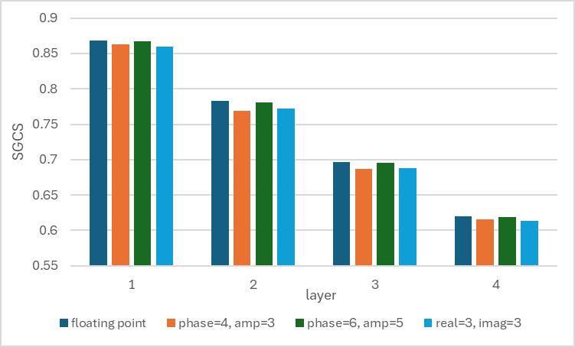

Views on quantization option
- Option 1a (14): real + imaginary
  - Futurewei, Ericsson, Huawei, OPPO, ZTE, CATT, vivo, Sharp, China Telecom, Lenovo, Apple, HONOR, ETRI, DCM
- Option 1b (8): phase + amplitude
  - CMCC, Xiaomi, TCL, Southeast University, Google, Samsung, Nokia, QC
Views on resolution
- Option 1a,
  - 2+2: HONOR
  - 3+3: Ericsson, CATT, MTK, vivo, LGE, HONOR, DCM
  - 4+4: CATT, MTK, vivo, DCM
  - 5+5: Apple
  - 6+6: CATT
- Option 1b,
  - 2+4: MTK
  - 3+4: Samsung, Nokia, QC
  - 3+5: MTK
- General views
  - Deprioritize k1+k2 > 8: MTK
  - Fit into one RRC message: Samsung
  - 9-12 bit to preserve the eigen-vector resolution: Nokia
- Configurable resolution: ZTE, China Telecom
FL note on target CSI quantization method
From companies reported results, ZTE, Huawei, vivo and QC observe comparable performance between option 1a and 1b. CATT sees larger benefit of option1a for small payload of k1=k2=3 bits, while Nokia reports opposite observation.
Regarding quantization resolutions, almost all companies report that k1+k2 >=6 bits may be able achieve a very close performance than floating point, while Nokia observe that k1+k2 should be at least >= 9 bits to preserve same performance as floating point as target CSI.
Based on the proposals, option 1a has a bit more supporters, and 3+3 is slightly more popular than others resolution pairs, so let us take them as baseline.
In addition, 5+5 can be supported in the for performance guarantee in the field. NW configures one of them in the data collection configuration. FL don’t think we need to limit ourselves to k1+k2<8 to fit one sample into one RRC message. There are precedence examples of splitting reporting content into multiple RRC segmentation, thus RAN2 will handle the issue properly. It is also worth to mention that even if a single sample can fit into one RRC message, there might be still a need to split it as UE will pack the samples back-to-back to RRC messages and do segmentation when necessary.
Another alternative of way forward is that, given that there are only 5 companies compare 1a vs. 1b, and the evaluated quantization pairs are a bit diverge, we may narrow down the options and expect more evaluations in the next meeting.
FL expect companies to express their views on the following three alternatives, but tend to proceed with Alt1 because the quantization method and format does not seem to be a critical issue.

Proposal 5.1 (high): target CSI format
Alt1: Support k1=k2=3 bit quantization of the real part and imag part of each complex numbers of the target CSI.
Alt2: Support quantization of the real part and imag part of each complex numbers of the target CSI
- Support k1=k2=3 or 5 upto NW configuration where k1 and k2 are the number of bits for quantizing the real part and imag part, respectively.
Alt3: Down-selection from the following options in RAN1 124-bis:
- Option 1a-33: real / imag part quantization via 3-bit
- Option 1a-44: real / imag part quantization via 4-bit
- Option 1a-55: real / imag part quantization via 5-bit
- Option 1b-34: amplitude quantization via 3-bit, phase quantization via 4-bit
- Option 1b-55: amplitude quantization via 5-bit, phase quantization via 5-bit
- SGCS metric 1 is used as the metric, i.e., SGCS between target CSI FL32 and reconstructed CSI inferred by model trained using target CSI of the respective format
Companies | Views
Mod | Please share your preferred way forward. FL tend to take Alt1 as a baseline considering that the resolution >=6 should not be a critical issue for eigen-vectors.  FL don’t think we need to limit ourselves to k1+k2<8 to fit one sample into one RRC message. There are precedence examples of splitting reporting content into multiple RRC segmentation, thus RAN2 will handle the issue properly. Please also check conclusion 5.6.  It is also worth to mention that even if a single sample can fit into one RRC message, there might be still a need to split it as UE will pack the samples back-to-back to RRC messages and do segmentation when necessary.

Views on quantization codebook
- $\left[\frac{­7}{8}, \frac{­5}{8}, \frac{­3}{8}, \frac{­1}{8}, \frac{1}{8}, \frac{3}{8}, \frac{5}{8}, \frac{7}{8}\right] c/\sqrt{N_{ports}}$, c=1.82: Ericsson, Apple
- -1+$\frac{2i-1}{2^{k_{1}}}$ for $i=1,…,2^{k_{1}}$: Huawei, DCM
- Linear in dB domain with =1.5dB step size, $[1, \frac{1}{\sqrt{2}}, \frac{1}{2}, \frac{1}{2\sqrt{2}},\frac{1}{4}, \frac{1}{4\sqrt{2}},\frac{1}{8}, \frac{1}{8\sqrt{2}}]$: Samsung, QC
- Normalization is implementation: CATT, Xiaomi, China Telecom, Nokia, QC, LGE
- Report at least one of strongest value: Huawei, ZTE, Samsung, DCM
- UE reports the scaling factor: OPPO, HONOR

FL note on target CSI quantization codebook
Three codebooks were proposed from companies’ tdoc. The first codebook is uniform distribution within [-1, 1] and it is the simplest among the three. The second codebook is a scaled version of the first codebook. The usefulness of the scaling factor is not clear as it will be gone once NW side normalizes the received target CSI to be unit norm. The third one is uniform distribution in dB domain similar to eT2 amplitude quantization, it takes the advantage of high resolution for strong values but lower resolution for weak values.
There are not much comparisons between them, FL think we can further decide in the next meeting or progress in this meeting if there is a consensus that the difference among them is marginal.

Proposal 5.2 (high): quantization codebook
For real / image part quantization of option 1a and amplitude quantization of option 1b, down-selection from following codebooks
- CB1: $-1+\frac{2i-1}{2^{k_{1}}}$ for $i=1,…,2^{k_{1}}$
- CB2: $\left(-1+\frac{2i-1}{2^{k_{1}}}\right)c/\sqrt{N_{ports}}$ for $i=1,…,2^{k_{1}}$ and $c=1.82$
- CB3: linear in dB domain with 1.5dB step size, $10^{\left(-1.5×i/10\right)}$, for $i=1,…,2^{k_{1}}$
Companies | Views
Mod | Tend to focus on CB1 and CB3, the usefulness of the scaling factor $c/\sqrt{N_{ports}}$ is unclear. The factor will be gone once NW normalizes the received quantized target CSI to unit norm (per layer per subband).  Let us try to make the down-selection even in this meeting.

Additional information reported by UE
Rank, layers of target CSI
- Configured by NW: Huawei, CMCC, Sharp, Fujistu
- Reported by UE: Samsung
FL note on the rank of target CSI
Regarding the rank of the reported target CSI, since the purpose is data collection, it is expected that sufficient number of samples should be collected. Having UE perform rank adaptation does not align with this main objective. If there are many cell-edge UEs, the number of rank-3/4 sample will be very small.
On the other hand, tt is also understandable that at cell edge the weaker layers may not be useful as their characteristics may be impacted by the noise and interference significantly. A proper way may be to consider this issue in data quality discussion. In other words, let us collect enough samples as much as possible, and how to use them is left for NW implementation. We will further discuss if additional information is needed to assist NW side decision on which layers should be used in model training.

Proposal 5.3 (medium): rank of target CSI
In NW data collection, UE reports target CSI with a rank configured by the NW.
Companies | Comments
Mod | Let us collect enough samples as much as possible, and how to use them is left for NW implementation. We will further discuss if additional information is needed to assist NW side decision on which layers should be used in model training

Other information reported by UE
- cell ID, measurement config ID: Ericsson
- pairing ID: ZTE
- layer / rank distinguish: CATT
- data quality
  - RSRP: Huawei, NEC
  - SINR: ZTE, TCL, Samsung
  - CQI: Huawei, TCL, Samsung
  - Quality indicator: DCM, Lenovo
  - Not needed: Nokia, CMCC (CQI not needed)
  - Upto NW configured threshold: TCL, QC
  - Upto UE status / condition: NEC, QC
- Positioning information: ZTE
FL note on other additional information
Reporting data quality was raised in Rel-19 phase NW side data collection, and its usefulness is not yet concluded. From FL understanding, RAN2 during Rel-19 has defined a framework for UE to log data such as configuring a RSRP threshold. The discussion of reporting data quality should consider this framework as a baseline. Additionally, CQI does not seem to be a relevant option as the CQI reflects the receiver assumption while data collection will not be used for DL scheduling. CQI also requires a full CSI processing at UE, which increases the complexity

Discussion 5.4 (low): data quality
To assist the NW side model training, e.g., determine which rank / layer should be used in the training, does UE need to report additional indication or is there a need to enhance the data logging event defined by RAN2.
Companies | Comments
Mod | RAN2 existing framework seems to be sufficient, reporting CQI requires full CSI processing which increase complexity and is also not deemed necessary as data collection is not used for scheduling.

Discussion 5.5 (low): labelling of target CSI
Is it beneficial to report the cell ID, measurement configuration ID, pairing ID, or any other information as labelling to NW along with target CSI samples in NW data collection.
Companies | Comments

Other aspects
Target CSI sample splitting
- Huawei: split by layers / subbands
- ETRI: segmentations when transmitting one sample is not possible
- DCM, QC: upto RAN2
FL note on target CSI sample splitting
In previous three meetings, concerns were raised when the payload size of one target CSI sample exceed one RRC message. Solutions were proposed regarding how to split the target CSI sample, such as based on layers or based on subband indices. To facilitate the splitting, two separate data collection configurations may be needed, each is configured for a specific set of layers or subbands.
One missing point of the previous discussion was that splitting one target CSI into multiple pieces and carried by different RRC messages may be a generic case (not only occurs when the payload size of a single target CSI sample exceeds the RRC message) which is already supported by RAN2 in some other scenarios, e.g., UE capability reporting, QoE reporting, etc. For example, UE may continuously log many target CSI samples, and pack them back-to-back into RRC messages. Here, there may be one sample which cannot be carried by the current RRC message, and has to be split into two pieces so that the first part goes into the current RRC message, while the second part goes to the next. With such consideration, the RRC segmentation is a RAN2 centric problem without the need of RAN1 involvement.

Conclusion 5.6 (medium): RRC segmentation
It is upto RAN2 to decide how to split one target CSI sample into multiple pieces and sent in different RRC messages.
Companies | Comments
Mod | There exist precedence examples of splitting reporting content into multiple RRC segments, e.g., UE capability reporting, QoE reporting, etc. Thus, it’s upto RAN2 to decide how to apply the RRC segmentation to NW data collection.

Following issues have no consensus or can be treated with low priority. Let us discuss in later meetings.
Configuration of pairing ID in UE data collection
- Optional: Huawei, Spreadtrum, CATT, CMCC, Nokia
- Mandatory: OPPO, ZTE, MTK, Xiaomi, NEC, Samsung, Apple, Panasonic, QC
- UE can request data collection: CATT, Xiaomi, TCL, Apple
- Multiple pairing ID: Huawei, CATT, vivo, OPPO, China Telecom
  - Negative: CMCC, Xiaomi, Nokia
Configuration of pairing ID in NW data collection
- Not needed: Ericsson, Spreadtrum, OPPO, CATT, Xiaomi, China Telecom, LGE, Nokia
- needed: NEC, Samsung, Apple, ETRI, Panasonic
CPU for data collection
- Reuse CPU duration defined in R19 CSI prediction UE data collection: Spreadtrum, ZTE, CMCC, Sharp, LGE, Nokia
- Differ by > or <=32 ports: HONOR
Other aspects:
- Whether pairing ID in previous cell still valid need discussion: OPPO
- Common configuration for NW and UE data collection, linkage between CSI-LoggedMeasurementConfig and CSI report config for NW data collection: Samsung

Performance monitoring

Summary of companies’ proposals

NW side monitoring
Companies | Proposals
Futurewei | Proposal 8: In AI/ML-based CSI compression using two-sided model Case 0, at least for NW-side monitoring, consider supporting L1 signaling for Target CSI reporting and further study the mechanism(s) in satisfying both the desired latency and Target CSI precision.  Proposal 9: In AI/ML-based CSI compression using two-sided model Case 0, at least for NW-side monitoring, if L1 signaling for Target CSI reporting is supported, adopt the following option for the content:  - Option 2: Target CSI only (assuming NW obtains CSI feedback via inference CSI report)
Ericsson | Proposal 7: Support UE reporting multiple target CSI and CSI feedback pairs via high-layer signaling for NW-sided performance monitoring:  - Reuse the target-CSI format defined for NW-side training data collection  - Enhance the higher-layer signaling mechanism designed for NW-side training data collection to support UE reporting target CSI and CSI feedback pairs
Huawei, HiSilicon | Proposal 20: For NW side monitoring, support inclusion of the following content in the report:  - Paired Target CSI and CSI feedback if L3 reporting is supported.  - Quantization format of Target CSI is the same as for NW side data collection.  - Target CSI if L1 reporting is supported.  - Note: In this case, NW obtains the associated CSI feedback via inference CSI report.
Spreadtrum | Proposal 13: For performance monitoring, support NW-side monitoring based on the ground-truth CSI reported by UE with legacy Rel-16 eType II codebook.  Proposal 14：For NW-side monitoring, L1 signaling is preferred that allows NW to quickly monitor model performance and trigger fallback if necessary.
OPPO | Proposal 19: Regarding the performance monitoring, not support of NW-side monitoring only with L1/L3 reporting.  Proposal 20: Regarding the performance monitoring, support both of UE-side monitoring Case 2-1/Case 2-2 and NW-side monitoring.  - NW-side monitoring only with L1/L3 reporting is not supported.  - Possible combination of UE-side monitoring Case 2-1 and NW-side monitoring is supported.  Proposal 21: Regarding the CSI report configuration for NW-side monitoring, consider:  - Option 1: one CSI report configuration for both of inference and monitoring report on the same CSI report resource.  - New reportQuantity or combination of two PMIs in reportQuantity is required to indicate UE reports both of inference from AI/ML based CSI and target CSI with legacy codebook for monitoring  - Option 2: dedicated CSI report configuration for monitoring report on dedicated CSI report resource different from inference report.  Codebook type and parameter combinations for target CSI calculation should be configured
ZTE | Proposal 28: For AI/ML CSI feedback, support NW-side performance monitoring based on the target CSI reporting with CSI codebook enhancement via higher resolution parameter combination.  Proposal 29: For AI/ML CSI feedback, prioritize NW-side performance monitoring and take UE-side performance monitoring as second priority.
CATT | Proposal 26: For AI/ML based CSI compression Case 0, regarding performance monitoring, support L1 signaling via CSI report.  Proposal 27: For AI/ML based CSI compression Case 0, support NW-side monitoring based on the target CSI reported by the UE via high resolution codebook.  - Monitoring report content is the target CSI, i.e., SF-domain eigenvector  - Legacy Rel-19 eType II codebook can be considered as the starting point  Proposal 28: Regarding AI/ML based CSI compression Case 0, for NW-side monitoring based on target CSI reporting, monitoring report is separately configured from inference report.  - Association between monitoring report and inference report is managed by gNB in a specification transparent manner  Proposal 39: For AI/ML based CSI compression Case 0, it is unnecessary to configure the pairing ID in performance monitoring report.
MTK | Proposal 22: Deprioritize UE-side monitoring due to additional burden on UE with no significant benefit.  Proposal 23: For NW-side monitoring with L1 signaling, only support legacy codebook for reporting target CSI  Proposal 24: Support L3 signaling for NW-side monitoring to transfer multiple Target CSI samples to NW.  Proposal 25: For NW-side monitoring with L3 signaling , there is no need to report CSI feedback .
CMCC | Proposal 23: In CSI compression using two-sided model use case, the Pairing ID is not used for monitoring configuration.  Proposal 26: For CSI compression using two-sided model use case, support L1 signaling for NW side monitoring, and the content is Target CSI only.  - Quantization format of Target CSI is the same as for NW side data collection.
Xiaomi | Proposal 20:Higher layer reporting for performance monitoring at NW side is supported.  Proposal 21:The report content including pairs of target CSI and AI based compressed precoder.  Proposal 22:The paring ID is indicated to UE for higher layer reporting for performance monitoring at NW side.
Vivo | - target CSI and CSI feedback pair report can be supported for NW side monitoring and error cause identification  - Target CSI format is the same as the format for data collection  - The CSI feedback is the output derived from the Target CSI
TCL | Proposal 9: RAN1 should consider whether/how to transmit raw CSI for monitoring purposes.  - FFS: Overhead reduction schemes based on spectral or temporal processing.  Proposal 15: For NW-side monitoring, label acquisition should utilize the existing CSI report framework (e.g., configuring both target CSI and CSI feedback).  Proposal 17: The association between the inference report and the monitoring report should be indicated.  - Option 1: A common ID is indicated in both report configurations for inference and monitoring.  - Option 2: A common ID, e.g., the pairing ID, is carried by both inference and monitoring reports.  Proposal 18: The request for Target CSI, encoder output, and quantizer output for root cause analysis should be based on the existing CSI report framework.
Southest University | Proposal 2-1: Define two target CSI reporting configurations (Co-located Reporting with combined AI-CSI/legacy CSI, Dedicated Reporting with separate resources linked to inference CSI-RS) for Rel-20 to enhance network deployment flexibility.  Proposal 2-2: Define NW configuration of codebook types/parameters for target CSI calculation, and support UE reporting of paired target CSI/CSI feedback via high-layer signaling (reusing NW training data mechanisms) to enable NW-side reference/UE CSI comparison for root-cause identification.  Proposal 2-3: Support L1 and L3 signaling for NW-side monitoring. For L1 reporting, only target CSI is required; for L3 reporting, paired target CSI and CSI feedback must be reported.
InterDigital | Proposal 14: For NW-side model monitoring, support use of predefined vector sets, e.g., basis vectors, and/or redundancy elements.  Proposal 17: Support using the Pairing ID for monitoring configuration.
Google | Proposal 11: If NW-side performance monitoring is supported, support the NW configures the UE to report the CSI based on eType2 codebook with enhanced parameters based on the eType2 CSI report framework  - Support the UE to report CQI additionally to facilitate CSI acquisition
Sharp | Proposal 14: For NW side monitoring, target CSI reporting via eTypeII codebook can be supported as baseline.  - Support target CSI reporting with configured rank by network  Proposal 15: For NW side monitoring, support to reuse CSI framework for monitoring report in L1 signalling to carry target CSI via eTypeII codebook.  - For monitoring report type, semi-persistent on PUSCH and aperiodic CSI report are supported.  - FFS: whether some contents in existing quantity can be omitted and whether a new report quantity is configured.  Proposal 16: For NW side monitoring, consider using higher layer signalling to report target CSI of high resolution in the same format as NW side data collection.
NEC | Proposal 19: For NW-side monitoring, support reporting paired compressed CSI and target CSI in one CSI report.  Proposal 20: For NW-side monitoring, if the compressed CSI and target CSI are reported in separate reports, support both L1 signaling and L3 signaling for reporting the target CSI.  Proposal 21: For NW-side monitoring, if the compressed CSI and target CSI are reported in separate reports, discuss whether it is still necessary to report other information besides PMI (e.g., RI, CQI) for the latter report in the time domain.  Proposal 22: For Case 2‑3 monitoring, the Rel‑19 linkage mechanism may be enhanced by specifying a valid time‑offset range for associating monitoring RS transmission occasions with CSI feedback instances.  Proposal 23: NW can configure target CSI reporting based on the SGCS results, with MAC CE to indicate whether target CSI reporting needs to be performed.  Proposal 24: Study the mechanism and specification impact of identifying root causes for performance degradation, enabling accurate diagnosis across different root causes with corresponding impacts on LCM actions.
Samsung | Proposal#27: Study the benefits and cost of the following monitoring types after some progress in the reference model discussion and Target CSI format  - Type 1: UE-assisted monitoring: UE calculates monitoring metric  - Type 1-1: UE-assisted monitoring without precoded CSI-RS  - Type 1-2: UE-assisted monitoring with precoded CSI-RS  - Type 2: NW-side monitoring: NW calculates monitoring metric from report ground-truth CSI  - Note: cost analysis should include at least measurement and feedback overhead, UE complexity and network complexity.
Apple | Proposal 22: For CSI compression using two-sided model, for UE side performance, support RLF/BFD like mechanism. UE transmit fallback request via the applicability report procedure with UAI.  Proposal 23: For CSI compression using two-sided model, for NW side performance monitoring, UE report CSI feedback and target CSI pair using immediate MDT with logging framework. The MDT framework can be used for root cause detection following UE side performance monitoring.
Fujistu | Proposal-13: Support NW-side performance monitoring based on target CSI reporting from UE, by using the format of eT2 codebook and eT2-like codebook.  Proposal-14: Regarding the content of CSI report for NW-side performance monitoring, both L1 report and L3 report are supported.  - Support the reporting of a paired Target CSI and CSI feedback.
LGE | Proposal 23: For NW-side monitoring, support target CSI reporting via L1 signaling with paired target CSI and CSI feedback.
HONOR | Proposal 16: Support L1 signaling for NW-side monitoring.  Proposal 17: For L1 performance monitoring, reuse the legacy codebook without introducing new codebook parameters.  Proposal 18: Based on the legacy PC table, for the inference reports with rank > 2, partial layers of the Target CSI can be reported by UE via higher-resolution codebook with PC#8.
ETRI | Proposal 12: For AI/ML-based CSI compression, study both NW-side and UE-side performance monitoring to leverage their respective advantages.  Proposal 13: For AI/ML-based CSI compression, for NW-side performance monitoring, consider L1 signaling for low latency, and consider report config ID or pairing ID for linkages between AI/ML-based CSI feedback and the ground-truth CSI.
Transsion Holdings | Proposal 9: Regarding the content of CSI report for NW side performance monitoring, the following options can be considered:  - Option1: Paired Target CSI and CSI feedback  - Option2: Target CSI and time information of paired CSI feedback
Nokia | Proposal 26 : L1 based NW-side monitoring can be supported by restricting the target CSI report to a subset of layers and sub-bands. The selection of layers and sub-bands can be indicated by the gNB in the performance monitoring report configuration.  Proposal 27 : For NW side monitoring, support L1-based monitoring on a small subset of layers and sub-bands for fast real-time monitoring and L3-based monitoring for more accurate non-real-time performance monitoring.  Proposal 28 : For NW-side performance monitoring, support option 2 (reporting of target CSI only on a subset of layers and sub-bands) for L1-based monitoring and option 1 (reporting of paired target CSI and CSI feedback) for L3-based monitoring.
DCM | Proposal 8  - If the Layer 3 signalling is adopted for the ground truth reporting, only Target CSI is reported.  - The signalling selection is up to RAN2. RAN1 should further study the following issue,  - The latency requirements, report occasions, and payload size of the report, which help RAN2 to select the reporting mechanism.  - The periodicity of the report, including the support of event-triggered reporting.  - The association between the Layer 3 ground truth report and Layer 1 inference report.  - Opt. 1: Include a series number in the CSI report for the association purpose.  - Opt. 2: Define a timeline considering the characteristics of Layer 3 signallings.  Proposal 9  - Support a unified quantization approach with different payload sizes for the Target CSI report for performance monitoring and the NW side data collection.  - The unified quantization approach means that the payload for performance monitoring can be obtained from the payload of the NW side data collection by omitting some bits.
Qualcomm | Proposal 14: Performance monitoring based on eventual KPI can be used; the necessity of specifying dedicated monitoring methods needs justification.  - If needed, any standardized performance monitoring for two-sided AIML CSF should consider UE complexity and require additional capability than the feature itself.  Proposal 15: For NW side monitoring with target CSI acquisition, support following frameworks,  - L3 signalling and mechanism, take the framework and data format for NW training data collection as a starting point.  - L1 signalling and mechanism based on existing eType II CSI feedback without the need of specification impact.

UE assisted monitoring
Companies | Proposals
OPPO | Proposal 22: UE-side monitoring Case 2-1 and Case 2-2 with SGCS report can be supported.  Proposal 23: Regarding SGCS report format in UE-side monitoring, $SGCS_{1}$ and $SGCS_{2}$ agreed in CSI prediction agenda can be reused, wherein:  - $SGCS_{1}$ denotes the SGCS between target CSI and proxy model output in Case 2-1 or the direct output of SGCS estimator in Case 2-2.  - $SGCS_{2}$ denotes the SGCS using legacy codebook configured by NW-side within the CSI report configuration.  Proposal 24: Regarding the CSI report configuration for UE-side monitoring, consider:  - Option 1: one CSI report configuration for both of inference and monitoring report on the same CSI report resource.  - New reportQuantity or combination of PMI and SGCS in reportQuantity is required to indicate UE reports both of inference from AI/ML based CSI and SGCS monitoring result  - Option 2: dedicated CSI report configuration for monitoring report on dedicated CSI report resource different from inference report.  Codebook type and parameter combinations for $SGCS_{2}$ calculation should be configured  Proposal 25: Support UE-triggered NW-side monitoring to reduce the reporting overhead of target CSI and improve the accuracy of UE-side monitoring.
Spreadtrum | Proposal 15: For performance monitoring, support UE-side monitoring based on the recovery CSI indicated by NW or precoded RS transmitted from NW.
Huawei, HiSilicon | Proposal 21: There is no strong motivation for specifying the UE side proxy model (Case 2-1/2-2) for monitoring.  Proposal 22: Precoded RS based monitoring can be achieved with implementation.
Ericsson | Proposal 9: To ensure the quality of UE reported monitoring metric, at least the following spec impacts are identified:  - RAN4 testing of the quality of UE reported monitoring metric  - Mechanisms (e.g., RRC-message based methods) to support UE reporting target CSI, encoder output, together with the associated intermediate-KPI based performance metric to the NW.  Proposal 10: UE-side performance monitoring based on precoded RS transmission from NW is not supported.
CATT | Proposal 29: For AI/ML based CSI compression Case 0, performance monitoring at UE side based on reference model or proxy model can be deprioritized.  Proposal 30: For AI/ML based CSI compression Case 0, support UE-side monitoring based on precoded RS (e.g., CSI-RS) transmitted from NW with RS precoded by the output of the CSI reconstruction model (i.e., decoder output).  - Consider monitoring metrics (i.e., report quantity for monitoring report) including SGCS, RSRP/differential RSRP.  Proposal 31: Regarding AI/ML based CSI compression Case 0, for UE-side monitoring based on decoder output precoded RS, reuse performance monitoring mechanism via CSI report for AI BM and AI CSI prediction in Rel-19:  - Dedicated resource set for monitoring and report configuration for monitoring are configured in a dedicated CSI report configuration used for monitoring  - The ID of an inference report configuration is configured in the configuration for monitoring to link inference report configuration and monitoring report configuration  - For the time behavior of monitoring report, semi-persistent and aperiodic reporting are supported  - The following combination for inference report type and monitoring report type are supported  - For time domain behavior of monitoring RS resources, semi-persistent and aperiodic resources are supported. Legacy rule on CSI report should be applied for allowed time domain behavior combination of RS resources and monitoring report.  Proposal 39: For AI/ML based CSI compression Case 0, it is unnecessary to configure the pairing ID in performance monitoring report.
  Monitoring report type  Inference report type | SP report | AP report
  AP report | Not support | Support
  SP report | Support | Support
CMCC | Proposal 23: In CSI compression using two-sided model use case, the Pairing ID is not used for monitoring configuration.  Proposal 24: For CSI compression using two-sided model use case, it is proposed to deprioritize UE side monitoring with proxy model / direct estimator of KPI / reference decoder.  Proposal 25: For CSI compression using two-sided model use case, it is proposed to deprioritize UE side monitoring with precoded RS.
Xiaomi | Proposal 23: Precoded RS based solution is preferred comparing with model-based solution for UE side performance monitoring, and the following two options can be considered to monitoring model performance at UE side.  - Option 1: Reusing legacy eventual KPI reporting with precoded CSI-RS, e.g., CQI report subject to “cri-RI-CQI”, i.e., no additionaly spec impact.  - Option 2: Gap of precoding gain between ${\left\|H_{T0} v_{Target(T0)}\right\|}^{2}$ and ${\left\|H_{T1} v_{Precoded(T0)}\right\|}^{2}$.  Proposal 24: The configuration for UE side performance monitoring is linked with a CSI report configuration for inference which including a paring ID, if UE side performance monitoring is supported.
Vivo | Proposal 17: UE side monitoring can be supported for CSI compression with proxy model based solution.  - SGCS can be a report format for monitoring  Proposal 18: Similar to CSI predication, periodic, semi-persistent, and aperiodic CSI-RS are supported, and semi-persistent, and aperiodic monitoring report types are supported for the monitoring of CSI compression.
TCL | Proposal 16: For UE-side monitoring, the UE should report monitoring metric values or a monitoring outcome indicator.  Proposal 17: The association between the inference report and the monitoring report should be indicated.  - Option 1: A common ID is indicated in both report configurations for inference and monitoring.  - Option 2: A common ID, e.g., the pairing ID, is carried by both inference and monitoring reports.
Southest University | Proposal 2-4: Specify UE-side performance monitoring based on a lightweight proxy decoder, with requirements including architecture, training, and performance metrics.  Proposal 2-5: Define the evaluation metrics as normative performance requirements for UE-side proxy monitoring, specifying the calculation method and minimum/maximum allowed values for each: average SGCS prediction gap, classification precision and recall, and UE-NW reconstruction alignment.  Proposal 2-6: Specify signaling and reporting mechanisms to support the proxy decoder framework. The NW shall signal the proxy decoder’s configuration (e.g., architecture ID, distillation parameters) to the UE via RRC signaling during model activation. The UE shall report the proxy’s predicted SGCS (or a SGCS range indicator) to the NW alongside the CSI feedback to enable joint performance analysis.
InterDigital | Observation 12: UE-side monitoring is beneficial due to the lower latency and reporting overhead compared to NW-side monitoring.  Proposal 12: Support UE-side monitoring in addition to NW-side monitoring.  Proposal 13: For UE-side model monitoring, support both timer-based and event-triggered based reporting.  Proposal 17: Support using the Pairing ID for monitoring configuration.
Google | Proposal 10: If UE assisted performance monitoring is supported, support the UE to report the SGCS between the channel measured from a precoded CSI-RS and the target CSI and channel measured from a CSI-RS for AI/ML based CSI report.  - Reuse the R19 framework for the SGCS report
Sharp | Proposal 17: For UE side monitoring, RAN1 should further conclude the necessity of supporting the UE side monitoring for CSI compression.  - If UE side monitoring is supported, study details for each option and down-select to at most one option.
NEC | Proposal 17: For UE-side monitoring, support SGCS per layer as performance metric, SGCS per layer is calculated based on target CSI and reconstructed CSI.  Proposal 18: For UE-side monitoring, support event triggered performance monitoring report. The event is defined based on the SGCS lower than a threshold value for a time duration.
Lenovo | Proposal 22: Support Option 1 (i.e., Case 2-1/2-2) for the UE side monitoring via reporting the estimated SGCS in monitoring CSI report via L1 signaling.  Proposal 23: Conclude that the local decoder model (or proxy model) that is trained using data shared in Direction A sub-option 4-1 and Direction C has a good match with the NW-side decoder model and it can be used for UE-side monitoring and UE-side root-cause determination.  Proposal 24: Conclude that UE-sided model monitoring can be used at least for inter-vendor collaboration options based on Direction A sub-option 4-1 and Direction C.  Proposal 25: For monitoring of CSI-compression, configure the UE with additional report-config instructing it how to generate the additional data needed for monitoring of the model, e.g., the quantized version of the RAW CSI for NW-side monitoring or computed performance metric for UE-assisted monitoring.  Proposal 26: Support the following combinations for the AI-output CSI-report and the type of monitoring report.  Proposal 27: Further specify the required procedure/signalling for model updating, switching or model fall-back as a result of a) model monitoring outcome, or b) request from the UE, or c) change of some configuration parameters.
  Monitoring report type  AI-output report type | P report | SP report | AP report
  AP report | Not support | Not support | Support
  SP report | Not support | Support | Support
  P report | Support | Support | Support
Apple | Proposal 21: For CSI compression using two-sided model, support UE side performance monitoring with pre-coded RS using output CSI. Define monitoring KPI using precoding gain difference between KPI_{codebook} and KPI_{actual.}
Fujistu | Proposal-15: Regarding UE-side performance monitoring, AI/ML-based performance monitoring is not supported unless the monitoring model’s performance can be guaranteed is clarified/verified.  Proposal-16: Suggest deprioritizing the study on the standard impact for UE-side performance monitoring.
LGE | Proposal 24: Deprioritize UE-side performance monitoring.
HONOR | Proposal 19: Deprioritize UE-side performance monitoring, if supported, precoded RS based monitoring can be considered.
ETRI | Proposal 14: For AI/ML-based CSI compression, for UE-side performance monitoring, consider L1 signaling to report performance metric such as SGCS.
Nokia | Proposal 29 : If UE side monitoring is supported, it should be carried out via L1 reporting of the performance monitoring metrics calculated at the UE.  Proposal 30 : If UE side monitoring is supported, pairing ID for UE-side performance monitoring is not needed.  Proposal 31 : If UE side monitoring is supported, consider ways for the gNB to indicate, in full or in part, the reconstructed CSI associated to an inference report.
DCM | Proposal 7  - Support the NW-side performance monitoring with UE-reported ground truth.  - The UE-side performance monitoring with proxy model or direct KPI estimation can be supported given the following conditions,  - The NW-side performance monitoring is supported, and the ground truth report can be event-trigger-based.  - The UE-side performance metric serves only as a trigger for the ground truth report.
Qualcomm | - Deprioritize UE side monitoring.

Discussion
General way forward:
- Prioritize NW side monitoring/Deprioritize UE side monitoring (7):
  - Ericsson, ZTE, Qualcomm, LGE, MediaTek, Fujitsu, Honor
- Support both:
  - InterDigital
- Prioritization on UE monitoring:
  - OPPO
NW side monitoring
- L1 signaling and mechanism:
  - With legacy eT2 (9):
    - Spreadtrum, MTK, Sharp, NEC, Huawei, LGE, Fujistu, ETRI, QC
  - With high-resolution format, enhanced eT2 or same format as data collection (4):
    - ZTE, CATT, CMCC (same format as data collection), Google
  - With configuration enhancement (2):
    - HONOR (partial layer reporting using PC8), Nokia (selection of layer / subband)
  - With association or the same report config to inference report (7):
    - CATT (separate with association), OPPO (separate with association or same report with new quantity), TCL (association), ETRI (association), DCM (association), NEC (time-offset based), LGE (same report)
  - No spec impact (3):
    - QC, MTK, Apple
- L3 signaling and mechanism:
  - L3 enhancement built upon data collection framework with same data format (11):
    - Ericsson, MTK, Xiaomi, Southeast University, Sharp, NEC, Apple (RLF/BFD), Fujistu, Huawei, Nokia, QC
- Reporting content
  - Target CSI only (5): Futurewei (if L1), Huawei (if L1), MTK, Nokia, DCM
    - Concern: if L3 signaling is used, NW would not know the logged Target CSI corresponds to which reported resources during inference (Ericsson, Huawei)
  - Pair of target CSI and CSI feedback (7): Ericsson (L3), Huawei (L3), Xiaomi, NEC, Apple, LGE (L1), Transsion Holdings
  - Pair of target CSI and CSI feedback generated using the target CSI format: vivo
- Other
  - Monitoring based on predefined vector sets: InterDigital
  - Define unified quantization approach with different payload size: DCM
FL note on NW side monitoring
Regarding L1 signaling, following conclusion was proposed in the last meeting. Based on the discussion, previous FL (Yuan, Huawei) observed that some companies want to introduce some enhancement (configured information or enhanced CB parameters) on top of L1 report mentioned, while some others do not think enhancement is needed. Thus, it may be difficult to achieve consensus on L1 level enhancements.
From my perspective, specifying a L1 signalling (in the sense of either codebook enhancement or configuration enhancement) for target CSI reporting is essentially a new CSI reporting scheme on top of the two-sided model. It requires eT2 as a pre-requisite feature. More importantly, this new CSI reporting schemes is intended to play as a ground-truth for the CSI reported by the two-sided model. This makes the two-sided model lose its merit of performance benefit. Logic wise, let us exploit L3 signaling merit for obtaining the target CSI with high resolution.
Proposed conclusion 3.1 (L1 signaling) in RAN1 #123:
For NW side monitoring, it is NW implementation to perform NW side monitoring with legacy methods, e.g., eType II codebook via L1 signaling, SRS, eventual KPI, etc.

For L3 signaling, in the last meeting, based on the comments populated by companies (R1-2509508), the main concern of L3 signaling cannot meet the latency requirement for performance monitoring. FL think that single sample reported via L1 signaling is not sufficient to make any decision on whether data drift happens, because it might be just a bad sample of the existing distribution. The most important aspect is to collect enough samples to evaluate the SGCS variation. In light of this, aggregating the time span of multiple L1 signaling will result in similar latency of L3 signaling.
Besides, two issues were raised. One is that the NW may not always log the received CSI feedback from inference. Another issue is that the CSI omission occurs so the received CSI feedback may not reflect the real model inference performance. Thus, it is preferred to report the pair of target CSI and the CSI feedback without omission. From FL understanding, the first issue seems to be a valid concern, thus having the pair-wise report would help reduce NW side complexity. However, the second issue is less concerned because layer-based omission can be performed and omission is really a corner case.
Thus, let us resume from the following proposal discussed in the last meeting.

Proposal 6.1 (medium): L3 signaling for NW side monitoring
For NW side monitoring, support the higher layer signaling for reporting.
- Regarding the reporting content, at least consider paired Target CSI and CSI feedback
  - FFS: CSI feedback is the one before or after UCI omission.
- Quantization format of Target CSI is the same as for NW side data collection.
Company | View
Mod | Regarding the latency concern:  Single sample reported via L1 signaling is not sufficient to make any decision on whether data drift happens, because it might be just a bad sample of the existing distribution. The most important aspect is to collect enough samples to evaluate the SGCS variation. In light of this, aggregating the time span of multiple L1 signaling will result in similar latency of L3 signaling.  Regarding the pair-wise reporting: Let us consider an approach that address NW side implementation complexity.

UE assisted monitoring (high level summary):
- SGCS / KPI estimate based on direct estimator or proxy decoder:
  - Support (6 or 9?): OPPO, vivo, Southeast University, Lenovo, DCM, Ericsson, [Samsung, NEC, TCL]
  - Concern (3): Huawei, CATT, CMCC
- Precoded CSI-RS with enhancement on reporting metrics (6):
  - Support: CATT, Xiaomi, Google, Apple, HONOR, Huawei (with implementation)
  - Concern (1): Ericsson
- NW indicated reconstructed CSI:
  - Support (2): Spreadtrum, Nokia
- Not support any UE side monitoring (3):
  - LGE, MTK, QC
- Other aspects:
  - Robustness needs target CSI reporting and RAN4 testing: Ericsson, Fujistu
  - Report triplet of {target CSI, CSI feedback, associated intermediate-KPI}: Ericsson
  - Timer / event-trigger based on reporting: InterDigital, NEC
  - UE initiated SGCS report can be used to reduce NW-side monitoring overhead: OPPO
  - Report SGCS1 for AIML CSI and SGCS2 for eT2: OPPO
This topic was not discussed much in the previous meetings. Companies’ proposals and views remain the same. FL copy the summary from the last meeting as follows.
Brief summary made in RAN1 #123, R1-2509508:
Supporters to UE side monitoring Option 1 (i.e., Case 2-1/2-2)
- Case 2-1 (based on UE side decoder): vivo, Samsung, Lenovo (UE trained decoder under Direction A, or specified decoder), OPPO, NEC, Tejas, TCL, Sharp, Southeast University
  - Spec impact:
    - vivo: Format (e.g., SGCS) of the metric.
      - Reuse the definition of SGCS for CSI prediction
      - How to generate the metric (e.g., SGCS) is purely UE implementation
    - Vivo: P/SP/AP CSI-RS types. SP/AP CSI report types.
    - Samsung: Specify the proxy decoder, or NW to share the proxy decoder
    - NEC: Format (SGCS) of the metric. Event triggered report.
- Case 2-2 (direct estimation of intermediate KPI): Ericsson, Samsung, OPPO, TCL, Sharp, ETRI, TCL
  - Spec impact:
    - Ericsson: Format (e.g., a SGCS range indicator) and reporting signaling (L1) of the metric.
    - Ericsson: RAN4 testing of the quality of UE reported monitoring metric
    - Ericsson: Mechanisms (e.g., RRC-message based methods) to support UE reporting target CSI, encoder output, together with the associated intermediate-KPI based performance metric to the NW
- Other format:
  - NTT DOCOMO, NEC, Rakuten, TCL: UE-side performance metric serves only as a trigger/event, which can trigger NW-side performance monitoring
  - MediaTek: a set of metrics (e.g., SGCS drift, estimated SGCS, distribution shifts, etc.), or occurrence/not occurrence of a monitoring event
- Not support 2-1/2-2: Huawei, HiSilicon, CATT, CMCC

Content of the reporting for Option 1:
- SGCS: ETRI, Ericsson (range indicator), vivo (between Target CSI and recovered Target CSI), Samsung, NEC
- SGCS₁ and SGCS₂: OPPO (SGCS₁ between Target CSI and recovered Target CSI, or estimated SGCS; SGCS₂ for legacy CB)

Supporters to UE side monitoring Option 2 (based on precoded RS): Google, Huawei, HiSilicon (implementation), CATT, Samsung, Apple,
- Option 2-1: Reusing legacy eventual KPI reporting with precoded CSI-RS, e.g., CQI report subject to “cri-RI-CQI”, i.e., no additionaly spec impact. Huawei, HiSilicon, Xiaomi, Honor (if supported)
- Option 2-2: SGCS between $v_{Target(T0)}$ and $v_{Precoded(T0)}$ CATT
  - FL assessment: UE needs to perform channel measurement on another non-precoded CSI-RS to obtain $H_{T1}$, and then extracts $v_{Precoded(T0)}$
  - Xiaomi: Such calculation refers to the inverse operation of $H_{T1}$. However, inverse of $H_{T1}$ is not exist if $H_{T1}$ is not a full rank or column full rank matrices
- Option 2-3: Gap of precoding gain between ${\left\|H_{T0} v_{Target(T0)}\right\|}^{2}$ and ${\left\|H_{T0} v_{Precoded(T0)}\right\|}^{2}$, or ${\left\|H_{T0} v_{Target(T0)}\right\|}^{2}$ and ${\left\|H_{T1} v_{Precoded(T0)}\right\|}^{2}$. Samsung, Xiaomi (latter solution), Google (latter solution)
  - FL assessment: Former solution: UE needs to perform channel measurement on another non-precoded CSI-RS to obtain $H_{T1}$, and then extracts $v_{Precoded(T0)}$, and mutiplies it with $H_{T0}$. Latter solution: Seems easy, but there is gap between $H_{T0}$ and $H_{T1}$, which may cause inaccuracy.
  - Xiaomi: Former solution is similar to Option 2-2. Latter solution (gap of precoding gain ${\left\|H_{T0} v_{Target(T0)}\right\|}^{2}$ and ${\left\|H_{T1} v_{Precoded(T0)}\right\|}^{2}$) can be used to evaluate model performance if $H_{T0}$ and $H_{T1}$ are similar
- Option 2-4: Gap of precoding gain between ${\left\|H_{T1} v_{Precoded(T0)}\right\|}^{2}$ and ${\left\|H_{T1} v_{PMI}\right\|}^{2}$, where a second precoded RS is transmitted at T1 precoded with non-AI PMI/legacy CB of $v_{PMI}$. Apple, CATT
  - Content: SGCS, RSRP/differential RSRP CATT
  - FL assessment: UE needs to feedback another non-AI based PMI/legacy CB, i.e., $v_{PMI}$, to NW at T0, and perform channel measurement on another precoded CSI-RS precoded by $v_{PMI}$.
  - Xiaomi: Option 2-4 requires NW to send two precoded CSI-RS to UE.
- Note: T0 is the time for channel measurement for CSI feedback. T1 is the time when precoded RS is transmitted. $H_{T0}$ is the measured channel at T0. $H_{T1}$ is the measured channel at T1. $v_{Target(T0)}$ is the precoder based on Target CSI at T0. $v_{Precoded(T0)}$ is the precoder based on recovered Target CSI, and applied to the precoded RS.
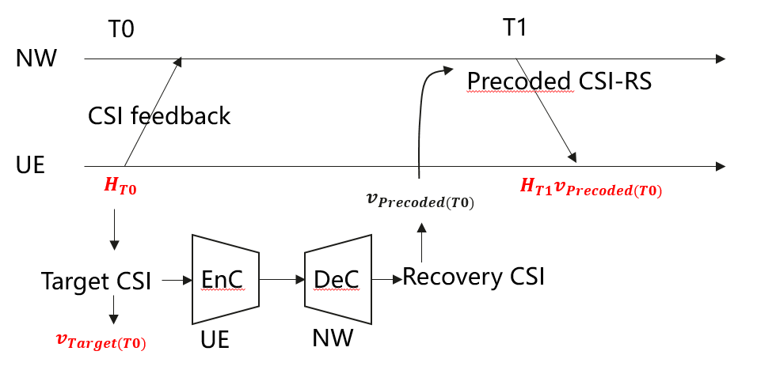
- Not support: Ericsson, CMCC
  - Argument 1: UE-specific CSI-RS overhead scaled with UE number
  - Argument 2: Additional latency between CSI feedback and precoded CSI-RS

- Other views:
  - Apple: support RLF/BFD like mechanism, where UE transmit fallback request

Signaling and RS type for UE side monitoring
- L1 signaling: Ericsson, vivo, CATT, Lenovo, ETRI
- Support P/SP/AP CSI-RS resource types vivo,
- Support SP/AP CSI reporting types vivo CATT, Lenovo

Linkage between monitoring report and inference CSI report Xiaomi, CATT
- Monitoring configuration should associate with one CSI report configuration for inference which including the paring ID Xiaomi
- Inference CSI-reportConfigId is configured for monitoring, which is analogous to Rel-19 AI BM monitoring report and AI CSI prediction monitoring report CATT

FL note on UE assisted monitoring:
Based on companies’ comments in the FL summary in the last meeting (R1-2509508), FL observes the following concerns on option 1 and option 2.
- Option 1 concern: Generalization performance, additional LCM, UE side complexity
- Option 2 concern: impact by channel aging, additional latency, non-scalable UE-specific CSI-RS
Besides, it is also worth noting that companies also mention that the benefit of UE side monitoring is addressing the overhead issue of NW side monitoring if an even-trigger or timer-based mechanism is supported.
Regarding the concerns on option 1, FL’s assessment is the following
- Robustness of the reported SGCS and LCM can be guaranteed if NW side performance with target CSI reporting is supported as prerequisite function. NW is able to evaluate the SGCS between the reconstructed CSI and the target CSI, this SGCS can be used as a “ground-truth” for the SGCS reported via SGCS estimator or proxy decoder. If the reported SGCS is biased from the SGCS calculated from target CSI, NW may choose to turn off the UE side monitoring.
- For UE side complexity, there exists a possibility of employing a low-complexity (formed by FCs) model to predict the SGCS directly. This SGCS estimator can be developed together with the encoder.
Regarding the concerns on option 2, the non-scalable UE-specific CSI-RS seem to be a critical issue considering that precoded RS is rarely deployed. The additional latency also loses the merit of L1 signaling. For those who think option 2 is supported in transparent manner, we don’t need to spend much time on this option as it is supported by default, and now we are discussing a potentially better solution.
In light of above analysis, let us try to move one-step further.

Proposal 6.2 (medium): UE side monitoring:
For UE side monitoring, study the following option:
- Option 1 (i.e., Case 2-1/2-2): UE reports estimated SGCS in monitoring CSI report via L1 signaling.
  - How to generate the estimated SGCS is UE implementation from RAN1 perspective.
  - FFS definition of estimated SGCS, e.g., between Target CSI and reconstructed Target CSI
  - FFS format of estimated SGCS, e.g., statistic value, mean value, or range.
  - FFS association of the monitoring CSI report with the inference CSI report
  - FFS define event-trigger or timer-based mechanism and used together with L3 NW side monitoring
Companies | Views
Mod | Let us try to be flexible on this option with the understanding that NW side monitoring is supported and can be used to monitor the SGCS estimator or proxy decoder. If not agreeable, I tend to conclude there is no consensus on UE side monitoring as the situation remains the same.  I use the wording “study” to soften the tone because the performance of option 1 is only evaluated by few companies. Hope more companies can join the group and provide evaluations next meeting so that we can confirm its specification.  The last FFS is a new bullet added to the proposal in the last meeting. The intention is to emphasize the potential combination with L3 NW data collection, so as to exploit the merit of L1 SGCS reporting.

CQI assumptions

Summary of companies’ proposals
Companies | Proposals
Ericsson | Proposal 7 Support option 1a as the method for CQI calculation.
Futurewei | Proposal 3: For Rel-20 AI/ML-based CSI spatial/frequency compression without temporal aspects (“Case 0”), for CQI determination, if the actual or reference CSI reconstruction model is available at UE, adopt Option 2a to determine CQI at UE: CQI is calculated based on CSI reconstruction output, if CSI reconstruction model is available at the UE and UE can perform reconstruction model inference with potential adjustment.  Observation 1: Without the knowledge of the actual decoder at UE side, the reported CQI can be significantly biased, and the amount of bias may change significantly from report to report, and this is a big issue for OLLA to meet the target BLER. The consequence of not reporting CQI correctly is not only hurting the performance but also defeating the purpose of using AI/ML-based CSI feedback compression functionality  the difference between the CQI calculated based on the reconstructed CSI and the CQI calculated based on the target CSI will also vary significantly over time, rendering Option 1a and 1b infeasible as it is difficult to configure/set an adjustment for such a big and fluctuated CQI difference and it is difficult for outer-loop link adaptation (OLLA) to compensate such a big difference.  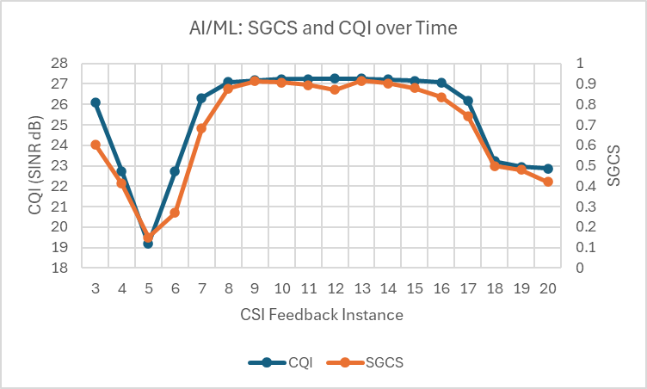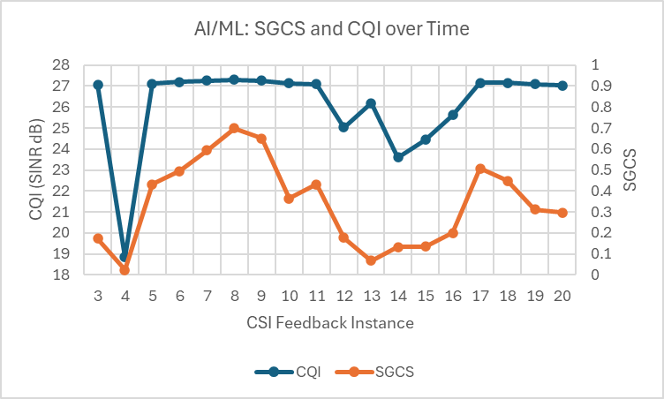
Spreadtrum | Proposal 2: For CQI determination in CSI report, support option 1 as starting point.
Huawei, HiSilicon | Proposal 11: For CSI feedback with two-sided model, CQI/RI determination is up to UE implementation.
InterDigital | Observation 2: In Options 1a and 1c, the potential mismatch between the UE-side measured CSI and the NW-side reconstructed CSI cannot be compensated. In Option 2a, proprietary issues may arise, and it can significantly increase UE complexity. However, Options 1b and 2b do not exhibit such drawbacks, and can provide a same or better accuracy for CQI reporting.  Proposal 2: Support at least one of Option 1-b or Option 2-b for CQI determination.
Google | Proposal 4: Support the RI/CQI calculation and report based on precoded CSI-RS.
CATT | Proposal 16: For inference report of AI/ML-based CSI compression, if CQI in CSI report is configured, CQI is calculated based on target CSI with realistic channel measurement.  • Same quantization scheme can be reused as in legacy CQI reporting  Proposal 17: For inference report of AI/ML-based CSI compression, RI is determined by UE with rank adaption. RI restriction is supported.
Vivo | - For CQI determination in CSI report, CQI can be calculated based on precoding matrix before compression
Xiaomi | Proposal 5: Option 2b could be regarded as a baseline, and Option 1a can be considered if obvious performance gain could be obtained.
ZTE | Proposal 7: For CSI feedback using two-sided model, for CQI determination in a CSI report, support Option 1a: CQI is calculated based on target CSI with realistic channel measurement.  Proposal 8: For CSI feedback using two-sided model, for RI determination in a CSI report, legacy RI determination can be reused as a starting point.
Samsung | Proposal#9: Defer the discussion on CQI determination schemes for two-sided model-based CSI compression until some progress on PMI feedback is achieved.
Lenovo | Proposal 5: For AI based CSI compression report, CQI is calculated based on the output of CSI reconstruction part from the realistic channel estimation.  Proposal 6: For AI based CSI compression report, RI is calculated based on the realistic channel estimation based on the CSI-RS resource indicated by CRI as legacy.
Panasonic | Proposal 3: For CSI feedback via two-sided model inference, the CQI calculation method is up to UE implementation assuming RAN4 would define the performance requirement.
OPPO | Proposal 7: Regarding the RI determination, support the RI report with $min⁡(RI_{1},RI_{2})$, where $RI_{1}$ is calculated with PMI as target CSI and $RI_{2}$ is calculated with PMI as legacy codebook.  - Type I as the default codebook to calculate $RI_{2}$  Proposal 8: Regarding the CQI determination, support CQI report with both of $CQI_{1a}$ and $CQI_{1c}$, where $CQI_{1a}$ is calculated with PMI as target CSI and $CQI_{1c}$ is calculated with PMI as legacy codebook  - Type I as the default codebook to calculate $CQI_{1c}$
Tejas Networks | Proposal 1: For two-sided model CSI feedback, adopt Option 1a for CQI reporting, where the UE derives the CQI based on the measured target CSI obtained from realistic channel estimation prior to compression.  Proposal 2: For RI reporting under two-sided CSI compression, the UE should rely on the existing legacy RI determination procedure as the initial method, without requiring changes to the current rank selection approach.
HONOR | Proposal 4: For CQI determination, support option 1a, CQI is calculated based on target CSI with realistic channel measurement.
Nokia | Proposal 8: For calculating the CQI, support CQI calculation based on target CSI (Options 1a). An adjustment of the CQI may be applied by a UE, based on the receiver implementation in a network-transparent manner.
LGE | Proposal 4: For CQI determination in CSI compression using two-sided model, consider to prioritize Option 1b (via realistic channel measurement + potential adjustment) or Option 1c (via legacy codebook).
Apple | Proposal 9: For AI based CSI compression, CQI/RI is calculated based on target CSI with realistic channel measurement, with potential adjustment.  Proposal 10: UE determines the potential adjustment via measuring one or more precoded RSs (CSI-RS and/or DM-RS) in a time window, wherein the one or more precoded RSs are precoded corresponding to the target CSI.
NEC | Proposal 8: For CQI determination in CSI report, if a proxy CSI reconstruction part at UE side is proven to be feasible, support Option 2a; if not, support Option 1a/1b.
Sharp | Proposal 1: For CQI determination, for option 1c, discuss the precoding information type of the output CSI.  Proposal 2: For CQI determination, prioritize option 1c and option 2a-2.  For UEs with different capabilities, UEs may support different options based on their capabilities.  Proposal 3: Support a type of CQI determination based on UE capability.
Transsion Holdings | Proposal 2: Regarding CQI determination, support Option 1b:  • Option 1b: CQI is calculated based on target CSI with realistic channel measurement and potential adjustment
Fujistu | Proposal 3:   For CSI compression Case 0, prioritize Option 1a and Option 1b for CQI/RI determination.  o Option 1a: CQI is calculated based on target CSI with realistic channel measurement.  o Option 1b: CQI is calculated based on target CSI with realistic channel measurement and potential adjustment.
MTK | Proposal 1. Support only a single option for determining CQI.  Proposal 2. For CQI determination using two-sided AI/ML models for CSI compression: i) deprioritize sub-options 1c, 2a, and 2b; and ii) Further clarify potential adjustment in option 1b.
ETRI | Proposal 1: For AI/ML-based CSI compression, prioritize to consider the Option 1a and 2a for CQI determination method
CMCC | Proposal 4: CQI should be reported in the AI/ML based CSI compression report.  Proposal 5: Take Option 1 as the assumption of CQI determination for AI/ML based CSI compression:  - Option 1: CQI is NOT calculated based on the output of CSI reconstruction part from the realistic channel estimation  Proposal 6: Take Option 1a as the starting point of CQI determination for AI/ML based CSI compression:  - Option 1a: CQI is calculated based on target CSI with realistic channel measurement
Ofinno | Proposal #6: Regarding CQI determination, prioritize Option 1a. Also, consider adopting PMI based approach (Option 1c) as a fallback when the CQI from Option 1a is unreliable.  Proposal #7: Consider RI determination to minimize the number of utilized AI models while maintaining accuracy-overhead performance across the full range of supported ranks with consideration of AI/ML processing unit occupation.
Qualcomm | Proposal 8: No need to change the CQI definition in RAN1 spec, RAN4 may define a relaxed testing requirement to accommodate CQI estimation options 1a/1b/2a.
DCM | Proposal 3  - RI and CQI are determined based on the same option.  - Support Option 1a as the baseline for both RI and CQI determination.  - Option 1b is the UE implementation based on Option 1a.  - Not support Option 2a due to the UE complexity and inaccuracy of UE reconstructed CSI, which cannot be compensated at the NW side because the NW does not know the UE implementation.  - Not support Option 2b due to the additional round-trip latency for the CQI reporting.
Fraunhofer | Proposal 8: For CQI in two-sided AI/ML CSI compression, support CQI calculation based on target CSI (Option 1a); any CQI adjustment (Option 1b) is implementation-specific and not standardized.  Proposal 9: Deprioritize CQI options that require redundant UE processing chains or introduce large latency/overhead (Option 1c, Option 2a, Option 2b).  Proposal 10: For RI in two-sided AI/ML CSI compression, reuse legacy RI determination as a starting point, based on realistic channel measurement with no new mandatory reconstruction-dependent assumptions.

Discussion
CQI assumptions identified in R18 includes the following.
- Option 1: CQI is NOT calculated based on the output of CSI reconstruction part from the realistic channel estimation, including
- Option 1a: CQI is calculated based on target CSI with realistic channel measurement
- Option 1b: CQI is calculated based on target CSI with realistic channel measurement and potential adjustment
- Option 1c: CQI is calculated based on legacy codebook
- Option 2: CQI is calculated based on the output of CSI reconstruction part from the realistic channel estimation, including
- Option 2a: CQI is calculated based on CSI reconstruction output, if CSI reconstruction model is available at the UE and UE can perform reconstruction model inference with potential adjustment
- Note: CSI reconstruction part at the UE can be different comparing to the actual CSI reconstruction part used at the NW.
- Option 2b: CQI is calculated using two stage approach, UE derive CQI using precoded CSI-RS transmitted with a reconstructed precoder.

FL note:
Companies’ proposals remain the same compared to previous meeting. Let us resume the discussion from the last meeting. FL’s observations regarding the 5 options are elaborated as follows:
- Option 1a and 1b are implementation options and their boundary is blur. The target CSI and whether adjustment is applied is inside the UE and transparent to the NW.
- Option 2a is also an implementation option. In other words, the CQI is adjusted by running a proxy decoder, or by a direct CQI estimator similar to the SGCS estimator. This model is transparent to the network.
- Option 1c is actually the CQI of the codebook-based PMI, and it can be obtained by a separate CSI report.
- Option 2b is already supported by existing spec.
From above, FL tend to draw a conclusion in the last meeting that CQI calculation method is upto UE implementation to accommodate option 1a/1b/2a. The major comments can be summarizes as follows
- Q1: Whether the precoding matrix assumption is also upto UE implementation?
- Q2: Can RAN4 adopt same performance requirement for CQI testing?
FL tend to think that the precoding matrix assumption is still the same as current specification – the precoding matrix constructed from the CSI feedback. This is the CQI definition used even since LTE, so let us reuse this definition. The only difference here is that UE is not able to obtain the exact precoding matrix, so instead the UE employs some other method to approximate the CQI. So, the only mattering factor is that RAN4 may need to revisit the performance requirement for CQI testing.
Moreover, if changing the precoding matrix assumption in CQI definition opens the door to the case where the reported CQI is based on a different precoding matrix than the one obtained by the NW. Let us keep this principle considering forward compatibility.
Some companies mentioned that the CQI calculation method needs to be indicated to the NW. Again, let us try reuse the CQI definition, and allow various implementation options, but the implementation method does not need to be indicated to the NW. Considering performance complexity trade-off, UE should implement a proper algorithm to approximate the CQI.

Proposal 7.1 (medium): CQI
For CSI feedback via two-sided model inference, reuse the CQI definition and precoding matrix assumption in current spec considering
- The CQI calculation method (1a/1b/2a) is upto UE implementation.
- It is upto RAN4 to decide whether to adopt a different performance requirement for CQI testing
Companies | Comments
Mod | CQI definition is there since LTE, so let us keep it as it is and reuse the same principle.  The only difference here is that UE is not able to obtain the exact precoding matrix, so instead the UE employs some other method to approximate the CQI. So, the only mattering factor is that RAN4 may need to revisit the performance requirement for CQI testing.  The implementation method does not need to known by the NW, UE will implement an algorithm to approximate the CQI and pass RAN4 test.

Report configuration

Summary of companies’ proposals
Companies | Proposals
Futurewei | Proposal 1: For Rel-20 AI/ML-based CSI spatial/frequency compression without temporal aspects (“Case 0”), support using CSI-ReportConfig for inference measurement and report configuration. Indicate at least the following in CSI-ReportConfig:  • An ID for pairing encoder at UE side and decoder at NW side  • A new report quantity, e.g., “AIML-cri-RI-PMI-CQI”  • Number of TX antenna ports  • Number of subbands  • CSI-RS resources for channel measurement  • Resources for interference measurement
Huawei, HiSilocon | Proposal 10: Configuration of pairing ID is sufficient to distinguish the CSI feedback with two-sided model from other legacy CSI reports.  Proposal 12: For Rel-20 CSI feedback via two-sided AIML models, support up to 128 ports, 19 subbands, and rank 4 when precoding matrix is the Target CSI.
Google | Proposal 1: The CSI report configuration for AI/ML based CSI compression is based on the Rel-19 eType2 CSI report configuration  - The CSI report configuration can additionally provide a list of paring IDs corresponding to different CSI payload size  - The UE selects the model according to the maximum payload size for the CSI report to avoid the CSI omission
CATT | Proposal 1: For AI/ML based CSI compression, rank <= 4 can be supported.  Proposal 2: For AI/ML based CSI compression, up to 128 Tx ports can be supported.  Proposal 3: For AI CSI compression, support the following options for configurable subband sizes:  • Option 1: Reuse the legacy mechanism.  • Option 2: Select one subband size for each BWP  Proposal 4: The reported subband configuration (i.e., csi-ReportingBand) can be restricted for AI/ML-based CSI compression.  Proposal 9: For inference report configuration of AI/ML based CSI compression, new reportQuantity or new parameters dedicated to AI CSI compression can be introduced.  Proposal 10: The value of N1,N2 as well as RI restriction can be configured for inference for AI CSI compression.
TCL | Proposal 3: In the case of CSI compression using a two-sided model, the design of an AI/ML-specific CSI-RS resource and CSI reporting configuration that may be compatible with the traditional CSI reporting scenario should be considered in the following aspects:  • AI/ML-specific CSI-RS resource configuration for CSI compression  • AI/ML-specific fields in CSI-ReportConfig IE  • Dedicated report quantities and report configurations for AI
Samsung | Proposal#1: For Target CSI in port-subband domain denoted for layer l by $W_{in}^{l}=[W_{in,0}^{l}, W_{in,1}^{l},⋯,W_{in, N_{sb}-1}^{l}]$, support the parameter $R∈\{1,2\}$ and the legacy eType II rule for the determination of $N_{sb}$ and the PMI subbands.  Proposal#3: Support at least the following for the CSI measurement and reporting for inference  - A single CSI-RS resource  - 16, 32 ports  - Up to rank 4  - FFS: restrictions on the number of sub-bands  - FFS: other configuration aspects, e.g., rank restriction, CBSR
Lenovo | Proposal 3: Reuse CSI-ReportConfig to configure the CSI report with AI based CSI compression by introducing new reportQuantity.  Proposal 5: Support to associate more than one pairing ID in the same CSI-ReportConfig and the UE reports which one of them is used for a certain CSI report corresponding to this CSI-ReportConfig.
Panasonic | Proposal 1: At least for inference, new RRC parameter for CSI report configuration to distinguish CSI report of AI/ML-based report and non-AI/ML-based report.  Proposal 2: For inference configuration, the same ID as pairing ID for AI/ML-based CSI compression can be used.
OPPO | Proposal 7: Support to indicate whether the CSI report is through AI/ML or legacy codebook, following options can be considered:  • Option 1: introduce new reportQuantity, e.g., AI-PMI.  • Option 2: introduce new codebookType, e.g., codebookAI-r20  • Option 3: introduce a new field, e.g., AI-r20, instead of within codebookType field.
Tejas Networks | Proposal 4: For CSI spatial and frequency-domain compression using AI/ML methods, the inference report configuration can extend the existing CSIReportConfig by adding fields such as the model ID/pairing ID and relevant quantization parameters.
Nokia | Proposal 1: Include at least the following parameters as part of the inference configuration of AI/ML-based CSI compression via two-sided models:  - The gNB antenna port configuration given by the parameters $N_{1}$ and $N_{2}$.  - The codebook parameter combination  - The rank restriction  - Codebook subset restriction (CBSR) configuration  - A single pairing ID  Proposal 2: Use the supported combined antenna port configurations from the Rel-16 and Rel-19 eTypeII codebooks as a starting point for discussing the port configurations to support for AI/ML-based CSI compression.  Proposal 3: AI/ML-based CSI compression supports ranks 1-4.
Apple | Proposal 5: For AI based CSI compression inference configuration, a paring ID should be configured to identify the matching CSI generation and CSI reconstruction model. Several signaling options can be considered:  • Alt 1: Pairing ID is configured together with resourceForChannelMeasurement.  • Alt 2: Pairing ID is included within codebookConfig.  • Alt 3: Pairing ID is associated directly with reportQuantity.  • Alt 4: Pairing ID is introduced as a separate field within CSI-reportConfig.  Proposal 6: For AI based CSI compression inference configuration, introduce a new report quantity aiPMI, to distinguish PMI feedback using legacy codebook.  Proposal 7: For AI based CSI compression inference configuration, introduce a new IE (e.g., AI-CSICompressionConfig or CodebookConfig-r20) to consolidate configuration parameters relevant to AI based CSI compression. The IE minimum contains rank restriction parameters.
NEC | Proposal 1: In CSI spatial/frequency compression, support inference report configuration reuse the CSI-ReportConfig with additional contents of model ID/ pairing ID and quantization parameters.  Proposal 2In CSI spatial/frequency compression, the following options can be considered to distinguish between AI/ML-based CSI report and non-AI/ML-based CSI report:  - Option 1: introduce new reportQuantity for compressed PMI in CSI-ReportConfig.  - Option 2: pairing ID (if it is regarded as a mandatory configuration).
Transsion Holdings | Proposal 1: The following potential spec impacts related to CSI report configuration of CSI compression should be considered:  • Signaling to trigger the AI/ML model CSI compression  • Pairing between CSI generation model and CSI reconstruction model  • Indicate the CSI feedback payload  • CSI-RS resource configuration  • CSI reporting configuration
CMCC | Proposal 1: In addition to up to 32 ports CSI, 48, 64, 128 ports CSI should also be supported in AI/ML based CSI compression.  Proposal 2: For up to 32 ports CSI, only one CSI-RS resource can be configured for one CSI report configuration, each CSI-RS resource is configured with up to 32 ports.  Proposal 3: For 48, 64 and 128 ports CSI, up to 4 CSI-RS resources can be configured for one CSI report configuration, each CSI-RS resource is configured with up to 32 ports, and these CSI-RS resources are aggregated to form up to 128 CSI ports.
MTK | Proposal 16. For identifying an AI/ML CSI report via two-sided inference support introducing a new report quantity, i.e., Alt 2.
China Telecom | Proposal 4: Define the Pairing ID as an optional parameter in CSI-ReportConfig, and specify that when the Pairing ID is absent, the UE performs general data collection (e.g., raw channel data) by default.
Fraunhofer | Proposal 4: In CSI-ReportConfig for AI/ML CSI compression, include at least: (i) pairing/model ID, (ii) explicit AI indication (new reportQuantity), (iii) Tx ports/subbands/payload size, (iv) CMR/IMR resources, (v) rank restriction and CBSR-related parameters, (vi) UCI omission/multiplexing related parameters.

Discussion
Companies’ proposals are similar to the previous two meetings. A bunch of necessary RRC configurations are proposed and listed as follows. The controversial parts are highlighted in yellow and cyan. The gNB antenna port configuration given by the parameters $N_{1}$ and $N_{2}$.
- The codebook parameter combination
- The rank restriction
- Codebook subset restriction (CBSR) configuration
- Pairing ID (single or multiple)
- Subband configurations
- Report quantity (new or reusing legacy)
- New RRC parameter to distinguish from legacy codebook
- New codebook type

FL note on distinguishing the ML CSI feedback from the legacy
The motivation of the yellow parts is to distinguish the CSI feedback via two-side model from the legacy. From FL perspective, the reason of having a new RRC parameter in R19 CSI prediction is that all other RRC parameters are the same as the R18 CSI prediction, thus a new indicator is needed. For R19 CSI prediction monitoring report, a new report quantity is needed because the SGCS is a new metric. However, for CSI feedback via two-sided model, the pairing ID is the unique parameter that does not exist in any CSI report before, thus it is sufficient to use pairing ID to represent the feature.
Based on the discussion in the last meeting, new report quantity seems to be popular. However, the CSI feedback of two-sided CSI is analogous to a new PMI codebook, where CSI report quantity is still CQI, RI, CRI and PMI. Having a new report quantity is misleading. After some discussion in the last meeting, it seems that more companies agreed to use pairing ID to distinguish from legacy CSI feedback schemes.

Conclusion 5.1a (distinguish with other CSI report, low priority)
Configuration of pairing ID is sufficient to distinguish the CSI feedback with two-sided model with other legacy CSI reports.
Companies | views

For other necessary configurations, let us have more solid discussion after the feature becomes stable.

Processing timeline, criteria, active resource and capability

Summary of companies’ proposals
Companies | Proposals
Spreadtrum | Proposal 6: For CSI compression, for inference, for PU occupancy, for the number of AI/ML PU (OAPU) and/or legacy CPU (OCPU) are occupied,   OAPU= 0 or N is reported by UE   OCPU=0 or M is reported by UE   Note: Detailed values of N and M can be further discussed in UE feature.   Note: Combination of OAPU= 0 and OCPU=0 is not allowed  Proposal 7: For occupancy duration of CPU and APU for CSI compression.  • Rel-15 CPU occupation time is reused for CPU occupation time of the CSI report  • Rel-15 CPU occupation time is reused for AI/ML PU occupation time of the CSI report  Proposal 8: For the determination of CSI report priority value of a CSI report for inference, the existing Pri_iCSI (y,k,c,s) is reused   k = 1 for the CSI report for inference.
Huawei, HiSilcon | Proposal 11: Regarding the occupancy of PU for AI/ML-based CSI compression, for inference, OAPU and/or OCPU are occupied with UE capability report.   Combination of OAPU = 0 and OCPU =0 is not allowed.   For the OAPU > 0 and OCPU > 0 case, if any of the unoccupied PU cannot satisfy the corresponding required PU by the CSI report, the CSI report is not required to be updated, and neither of the PUs are occupied.   CPU/APU occupation starts from the latest RS occasion (for SP-CSI report) / DCI (for A-CSI report) till PUSCH carrying the CSI report.  Proposal 12: Regarding the CSI processing timeline for AI/ML-based CSI compression, for inference, extend legacy Z_2/ Z_2^' to Z_2+d/ Z_2^'+d, where additional delay d is reported by UE per SCS.  Proposal 13: Regarding the CSI priority rules, reuse existing CSI priority 〖Pri〗_iCSI (y,k,c,s) by considering k=1 for inference CSI report.
InterDigital | Proposal 7: Support CPU pool sharing between legacy CSI reporting and AI/ML-based CSI.  Proposal 8: Support PU pool sharing by different AI/ML functionalities (e.g., AI/ML based CSI reporting, AI/ML based BM, AI/ML based POS).  Proposal 9: Support AI/ML Processing Units (PU) occupancy definition per AI/ML functionality (e.g., AI/ML based CSI reporting, AI/ML based BM, AI/ML based POS).
Google | Proposal 5: For CPU/APU rule, support to reuse the same mechanism of AI/ML based CSI prediction for AI/ML based CSI compression  • UE reports the number of CPUs, number of APUs and the APU pool for AI/ML based CSI compression  Proposal 6: For minimum processing delay, support to reuse the same mechanism of AI/ML based CSI prediction for AI/ML based CSI compression  • UE reports the additional processing delay for AI/ML based CSI compression on top of the processing delay for Rel-19 eType2 CSI report
CATT | Proposal 14: For inference report of AI/ML-based CSI compression, support the following for PU occupancy  • OAPU= 0 or N is reported by UE  • OCPU=0 or M is reported by UE  • The values of N and M are reported by UE  • Combination of OAPU= 0 and OCPU=0 is not allowed  Proposal 15: For inference report of AI/ML-based CSI compression, the legacy mechanism of occupancy duration for R19 eType II codebook can be reused, if associated monitoring report is not configured.  Proposal 16: For CSI compression, for inference, in addition to legacy Z/Z’ for R19 eTypeII codebook, UE report the value of t per SCS  • The value of t is reported by UE  Proposal 17: For inference report of AI/ML-based CSI compression, the priority of the inference report is the same as CSI report not carrying L1-RSRP or L1-SINR (analogous to Rel-19 eType II codebook).
Vivo | Proposal 13: For CSI compression using UE-side model, the similar rule that agreed in CSI predication can be reused, e.g.,  - For PU occupancy, support Dedicated AI/ML PU (O_{APU}) and/or legacy CPU (O_{CPU}) are occupied,  - the same occupancy duration is used if both CPU and APU are reported non-zero value  - the occupied PU of $\{48,64,128\}$ ports can be $O_{PU}=\left\lceil P/32\right\rceil *O_{PU_reported}$ or $O_{PU_reported}$  Proposal 14: For CSI compression using UE-side model, for inference of up to 32 ports, in addition to legacy Z/Z’ for type II codebook, UE may report the value of t per SCS  - Detailed value of t can be discussed in UE feature  Proposal 15: For CSI compression using UE-side model, for inference of $\{48,64,128\}$ ports, the Z value can be $\left\lceil \frac{P}{32}\right\rceil$ times of Z value of 32 port, or equal to Z value of 32 port  Proposal 16: For the determination of CSI report priority value of a CSI report for inference, the existing Pri_iCSI (y,k,c,s) is reused  - k = 1 for the CSI report for inference  Proposal 17: For the determination of CSI report priority value of a CSI report for monitoring, the existing Pri_iCSI (y,k,c,s) is reused  - k = 1 for the CSI report for monitoring
Xiaomi | Proposal 9: Reuse legacy CSI reporting priority rule definition, and k=1 for two-sided AI model based CSI feedback.  Proposal 10: For two-sided AI model based CSI compression, reuse the CSI processing criteria for AI based CSI prediction, and extend legacy Z/Z’ to Z/Z’+t’ for CSI generation part model inference, where value of t’ is reported by UE per SCS.
TCL | Proposal 3: The definition of AI/ML-specific priority for CSI compression should be considered in conjunction with traditional CSI priority rules.  Proposal 4: When a UE supports both AI/ML and non-AI/ML CSI reporting, redefine the priority rules to address collisions. Potential options include:  - Option 1: AI/ML CSI always has higher priority.  - Option 2: AI/ML CSI always has lower priority.  - Option 3: If priority values are identical, AI/ML CSI takes precedence; otherwise, follow the priority value.  - Option 4: If priority values are identical, non-AI/ML CSI takes precedence; otherwise, follow the priority value.  Proposal 5: Consider to reuse the definition of AI/ML PU occupancy in CSI prediction.  - FFS whether the O_{APU} value remains the same.  - FFS whether the value O_{APU} occupancy duration remains the same.  Proposal 7: Study the selection rule when the AI-related CSI report is jointly determined by the legacy CPU and AI/ML PU constraints.  - Option 1: Prioritize AI/ML PU constraints.  - Option 2: Prioritizes legacy CPU constraints.  - Option 3: Jointly consider both constraints.  Proposal 6: Consider if different values of O_{CPU} should be defined for different target CSI.  Proposal 8: The occupation time of CPU and AI/ML PU should be considered separately. The duration of PU occupation could be configured by the NW.
ZTE | Proposal 16: For CSI feedback using two-sided model, dedicated AI/ML PU (OAPU) and/or legacy CPU (OCPU) are occupied for an inference report, where OAPU= 0 or N is reported by UE in UE capability report, and OCPU= 0 or M is reported by UE in UE capability report.  Proposal 17: For CSI feedback using two-sided model, for an inference report, Rel-15 CPU occupation time is reused for APU occupation time and/or CPU occupation time.  Proposal 18: For CSI feedback using two-sided model, for an inference report, extend legacy Z2 / Z2’ to Z2+d / Z2’+d’, where d and d’ are reported by UE per SCS in UE capability report.  Proposal 19: For the determination of CSI report priority, the existing Pri_iCSI (y,k,c,s) is reused, where k = 1 for CSI reports for inference and monitoring.
Samsung | Proposal#10: Defer the discussion on CSI processing criteria and priority rule for two-sided model-based CSI compression until some progress on PMI feedback is achieved.
Lenovo | Proposal 10: For AI based CSI compression report, for PU occupancy, dedicated AI/ML PU and/or legacy CPU are occupied, and the UE separately report the number of AI/ML PUs and the number of CPUs for a CSI compression report.  Proposal 11: For AI based CSI compression report, based on legacy (Z_2,〖Z'〗_2 ), the UE indicates where additional CSI computation is needed.  Proposal 12: Specify a few classes for model complexity. The encoder of the AI-based CSI-feedback is then assigned to one of the classes of the model complexity.  Proposal 13: Specify a few classes for AI HW capability. The UE reports the HW capability group to the NW. Knowing the active AI model, the gNB is able to determine the required APU.
Panasonic | Proposal 4: For CSI compression using two-sided model, to calculate the inference report, UE reports the number of dedicated AI/ML PUs and /or legacy CPUs by reusing the mechanism of CSI prediction as the baseline.  Proposal 5: For CSI compression using two-sided model, for inference, in addition to legacy processing timeline, UE may report the offset value per SCS.
OPPO | Proposal 12: Regarding the aspects of CPU/APU design and occupation time, active resource/port counting, timeline, reuse the related specification outcome for inference in BM and CSI prediction agenda.  Proposal 13: Support to distinguish the priority of AI/ML and legacy CSI report for inference, and the priority of CSI report for inference and monitoring.
HONOR | Proposal 6: For CPU/APU occupancy, further study whether CPU/APU occupancy is specific for different layers/ranks.
LGE | Proposal #10: For CSI compression, study on PU counting rule considering  • Different types of CSI reports, e.g., inference or monitoring  • Different types of AI/ML models, e.g., encoder, proxy/nominal decoder, intermediate KPI estimator  Proposal #11: Study on methods to manage the NW-side computing capability for two-sided model, e.g., NW indication of inference skipping.  Proposal 12: Take APU/CPU occupancy and timeline for Rel-19 AI CSI predication as a baseline, and FFS on further enhancement to address high-dimensional inputs.
Apple | Proposal 9: For AI based CSI compression CPU/APU, use R19 CPU/APU framework as a starting point.
NEC | Proposal 10: In CSI spatial/frequency compression, to calculate the inference report for compressed CSI,  - For PU occupancy, support:   Dedicated AI/ML PU (OAPU) and/or legacy CPU (OCPU) are occupied,   OAPU= 0 or N is reported by UE   OCPU=0 or M is reported by UE   Note: Detailed values of N and M can be further discussed in UE feature.   Note: Combination of OAPU= 0 and OCPU=0 is not allowed   Note: if any of the unoccupied PU cannot satisfy the corresponding required PU by the CSI report, the CSI report will follow the legacy behaviour of exceeding the CPU limit, neither of the PUs are occupied  - For occupancy duration of CPU and APU,   the CPU occupancy time for CSI report with reportQuantity set to 'cri-RI-PMI-CQI' can be reused   the same occupancy duration is used if both CPU and APU are reported non-zero value  Proposal 11: In CSI spatial/frequency compression, for a CSI report for inference, extend legacy Z2/Z2’ to Z2+d / Z2’+d’, where d and d’ are reported by UE per SCS for CSI spatial/frequency compression.  - Detailed values of d and d’ can be further discussed in UE feature.  Proposal 8: In CSI spatial/frequency compression, support to define additional new priority rule for the following collisions:  - AI/ML-based CSI report and non-AI/ML-based CSI report.  - Inference CSI report and monitoring CSI report.
Fujistu | Proposal 8:   The legacy calculation of priority values could be reused for AI/ML-based CSI feedback.   The AI/ML-based CSI report should have a higher priority over the codebook-based CSI report, which could be realized by implementation.
MTK | Proposal 3: As priority rules for AI/ML-related CSI reports, assign equal priority to monitoring and inference reports.  Proposal 11: Consider a dedicated AI/ML PU for AI/ML-based CSI Compression which will not be shared with other AI/ML functionalities.  Proposal 12: Consider adding additional delay based on UE’s capability report into legacy timeline in order to accommodate delays incurred from loading AI/ML model onto dedicated AI processing unit and its execution.
CMCC | Proposal 11: For AI/ML based CSI compression, to calculate the inference report,  • For PU occupancy, support  o Dedicated AI/ML PU (OAPU) and/or legacy CPU (OCPU) are occupied,  - OAPU= 0 or N is reported by UE  - OCPU=0 or M is reported by UE  - Note: Detailed values of N and M can be further discussed in UE feature.  - Note: Combination of OAPU= 0 and OCPU=0 is not allowed  - Note: if any of the unoccupied PU cannot satisfy the corresponding required PU by the CSI report, the CSI report will follow the legacy behaviour of exceeding the CPU limit, neither of the PUs are occupied  • For occupancy duration of CPU and APU,  o the same occupancy duration is used if both CPU and APU are reported non-zero value  o if associated monitoring report is not configured, reuse following legacy occupancy duration  - For periodic and semi-persistent CSI report (excluding an initial semi-persistent CSI report on PUSCH after the PDCCH triggering the report), occupation starts from the first symbol of the earliest one of each CSI-RS/CSI-IM/SSB resource, respective latest CSI-RS/CSI-IM occasion no later than CSI reference resource, until the last symbol of the PUSCH carrying the report  - Aperiodic CSI report occupies PU(s) from the first symbol after the PDCCH triggering the CSI report until the last symbol of the scheduled PUSCH carrying the report.  - An initial semi-persistent CSI report on PUSCH after the PDCCH trigger occupies CPU(s) from the first symbol after the PDCCH until the last symbol of the scheduled PUSCH carrying the report.  Proposal 12: For AI/ML based CSI compression, extend legacy Z/Z’ to Z+d / Z’+d’, where d is reported by UE per SCS  • Detailed values of d can be further discussed in UE feature  Proposal 13: For AI/ML based CSI compression, for the determination of CSI report priority value of a CSI report for inference, the existing 〖Pri〗_iCSI (y,k,c,s) is reused  k = 1 for the CSI report for inference
ETRI | Proposal 9: For AI/ML-based CSI compression, adopt the priority rules for the legacy type2-r16 CSI reports.
Qualcomm | Proposal 9: Adopt existing framework of CPU and APU counting for CSF via two-sided model, UE may report dedicated CPU and APU cost for this feature. Study if different timeline is needed for CSI feedback of <=32 ports and >32 ports.  Proposal 10: Adopt existing timeline formulation for CSF via two-sided model, UE may report dedicated additional time requirement t for both the aperiodic CSI reporting and semi-persistent CSI reporting.
DCM | Proposal 6  - UE reports the CPU occupation number, and one CPU,2 or CPU,3 occupation number for AI/ML CSI compression.  - The CPU occupation duration of Rel-16 eType2 CSI is the baseline for the occupation duration of CPU and CPU,2/CPU,3 for AI/ML CSI compression.  - Relaxation of the processing timeline can be discussed if necessary.
Sharp | Proposal 3: For CSI compression via two-sided AI/ML model, for processing of the CSI report for inference at UE side, the following options are supported:  - Opt.1: Only legacy CPU resources are used.  - Opt.2: Only dedicated APU resources are used.  - Opt.3: Both the legacy CPU and APU resources are used.  - Note: the value of corresponding CPU resources or APU resources are reported by UE.  Proposal 4: For processing of the CSI report for inference at UE side for CSI compression, Rel-15 CPU occupation time for SP/AP CSI report on PUSCH is reused for CPU occupation time of the CSI report for inference.  Proposal 5: For determination of CSI report priority value of a CSI report for inference for CSI compression, the existing ${Pri}_{iCSI}(y,k,c,s)$ is reused where $k$ =1 for the CSI report.  Proposal 6: Further consider extending the CSI computation time for P/SP CSI report in CSI compression.
Fraunhofer | Proposal 13: For CSI compression inference, reuse legacy occupancy-duration rules at least when an associated monitoring report is not configured.  Proposal 14: For CSI compression inference, extend the legacy CSI computation timeline by an additional UE-reported time offset to account for model-related latency.  Proposal 15: Reuse existing CSI report priority value determination for AI/ML CSI compression reports (inference/monitoring), with extended values for CSI compression reports.  Proposal 16: For AI/ML CSI compression, define report-type priority ordering: inference and monitoring same priority; data collection lowest priority.  Proposal 17: Study intra-report priority e.g. for UCI omission priority for AI/ML CSI Part 2 and down select an interoperable omission order.

Discussion
(same comment as last meeting)
FL note: From the proposals, almost all companies propose to reuse the legacy CSI processing unit rules and legacy AI processing unit rules. Two companies propose to adopt dedicated processing units pool for CSI compression. In RAN-plenary #108, it has been agreed to adopt two processing unit pools and it’s upto UE to select which pool to use for each feature. FL think this proposal can be handled within the scope of this proposal, i.e., UE selecting a dedicated pool for CSI compression without sharing with other features.
Similarly, most companies propose that legacy timeline framework can be adopted by allowing UE to report additional processing time for this feature. There is one proposal from InterDigital considering model loading time for inactive models. In Rel-19 study, model loading time has been studied, and the assumption is that it can be absorbed into the specified / reported timeline.
For priority rule, lots of company propose to adopt k=1 for AIML CSI compression, just like other non-AI CSI feedback. Some other companies prefer to considering different priority for AIML and non-AI CSI feedback, while some others think this may be handled by NW implementation by assigning different report IDs.
All above aspects can be discussed in a later stage of the release after the PMI type, CQI, payload, UCI mapping become stable and clear.
FL observation 6.1 (not for online / offline session)
- Majority companies propose to adopt legacy CSI processing unit rule and legacy AIML processing unit rule for CSI compression via two-sided model. Specific CPU and APU occupation values can be reported by UE capability
- Majority companies propose to adopt Rel-19 timeline formulation for CSI compression via two-sided model, allowing UE to report additional time requirement on top of existing {Z, Z’} values.
- Majority companies propose to adopt same priority rule to address CSI collision by setting k=1 for CSI compression via two-sided model.
Companies | Comments

Other target CSI type

Summary of companies’ proposals
Companies | Proposals
Furturewe | Proposal 2: For Rel-20 AI/ML-based CSI spatial/frequency compression without temporal aspects (“Case 0”), for inference, consider channel matrix as target CSI type for further performance improvements.
InterDigital | Proposal 1: Support SRS configurations associated with CSI-RS or CSI feedback resources through explicit offsets, dynamic triggering rules.
Huawei, HiSilicon | Proposal 1: Discuss the channel matrix as Target CSI type within the scope of 5GA Rel-20.  Proposal 2: For the evaluation assumption of channel matrix as Target CSI type, at least consider the following configurations:  - SRS period/hopping: For 100MHz BWP with 272PRBs,  - SRS period includes at least 10ms, 20ms, 40ms.  - SRS measurement is considered with at least 17 hops each with 16 PRBs.  - DL/UL reciprocity error modeling: at least consider channel estimation error to DL channel and UL channel, where DL/UL channel matrix are generated by adding DL/UL channel estimation error depending on DL/UL SNR, respectively.  - Frequency granularity: For 100MHz BWP with 272PRBs, at least consider the Encoder input as the DL channel matrixes for 17 subbands, where a certain PRB among the 16 PRBs is selected per subband for generating the DL channel matrix.  - DL Rx number: at least consider 4 Rx, where the DL channel vectors per subband per Rx antenna are considered as individual Tokens.  Proposal 3: Regarding the Target CSI type, support channel matrix (H) as Target CSI type.  - Note: Fusion with SRS measurement is NW implementation and is transparent to the UE.  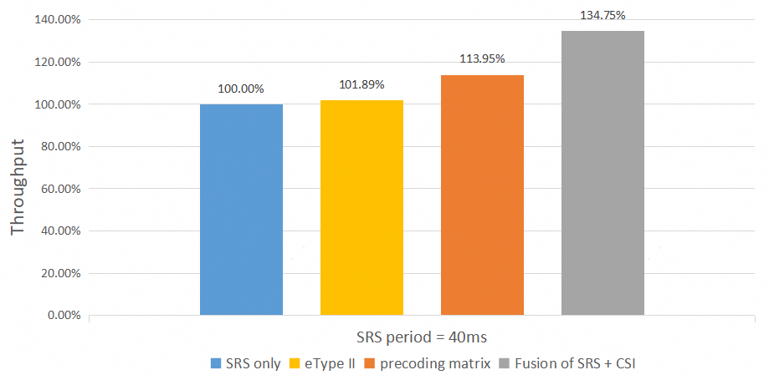  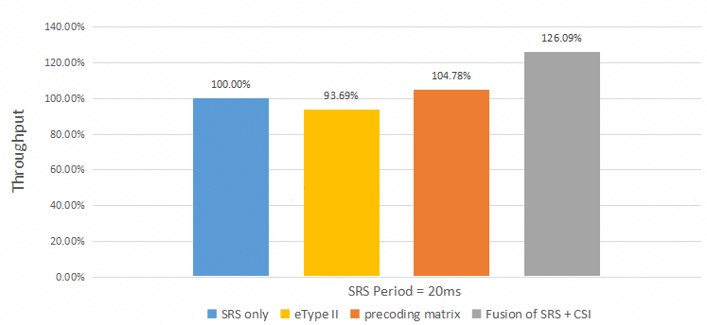  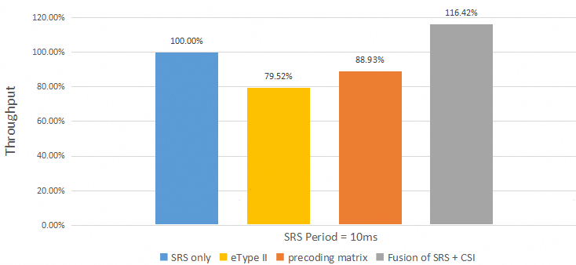  Observation 4: From the evaluation results over different target CSI types, under TDD scenario, with SRS periodicity of 10ms, 20ms, and 40ms,  - Channel matrix as Target CSI (with NW implemented fusion) can outperform SRS measurement only with 16.42%~34.75% throughput gains, and 21%~90% SGCS gain over 4 layers.  - Channel matrix as Target CSI (with NW implemented fusion) can outperform precoding matrix as Target CSI with 18.26%~30.9% throughput gains, and 17%~90% SGCS gain over 4 layers  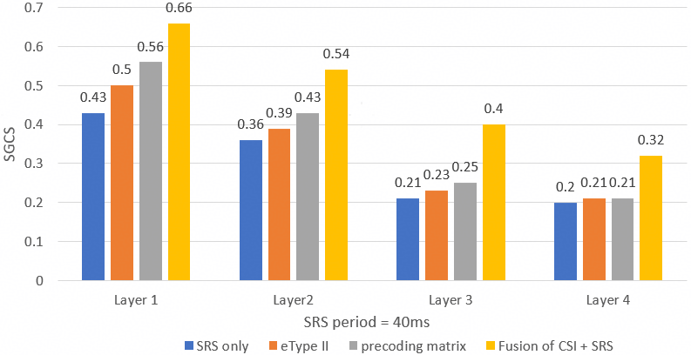  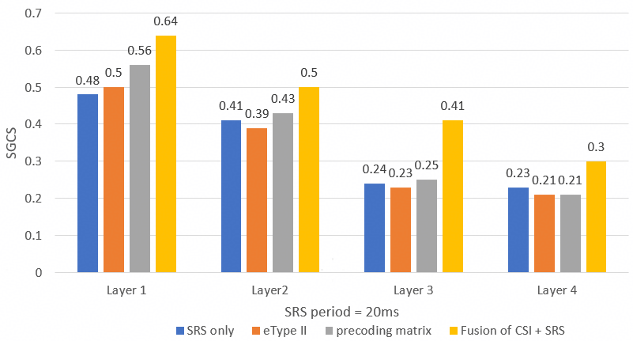  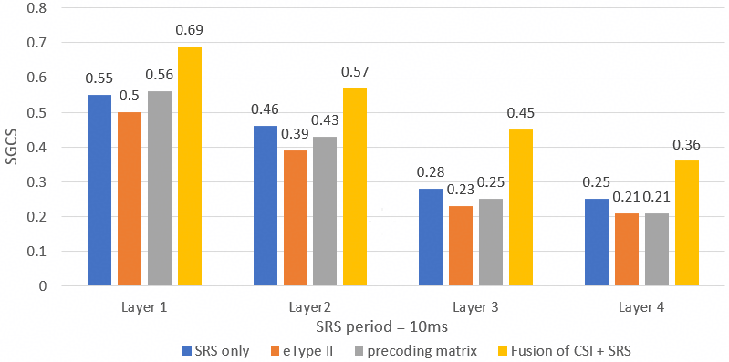
TCL | Observation 1: The results indicate the channel matrix feedback leveraging SRS-assisted fusion significantly improves the intermediate KPI over the Full-CSI-PMI baseline, and the performance could be slightly improved by adopting SNR as additional information for model input.  Proposal 1: Support the channel matrix feedback to improve the performance in TDD scenario.  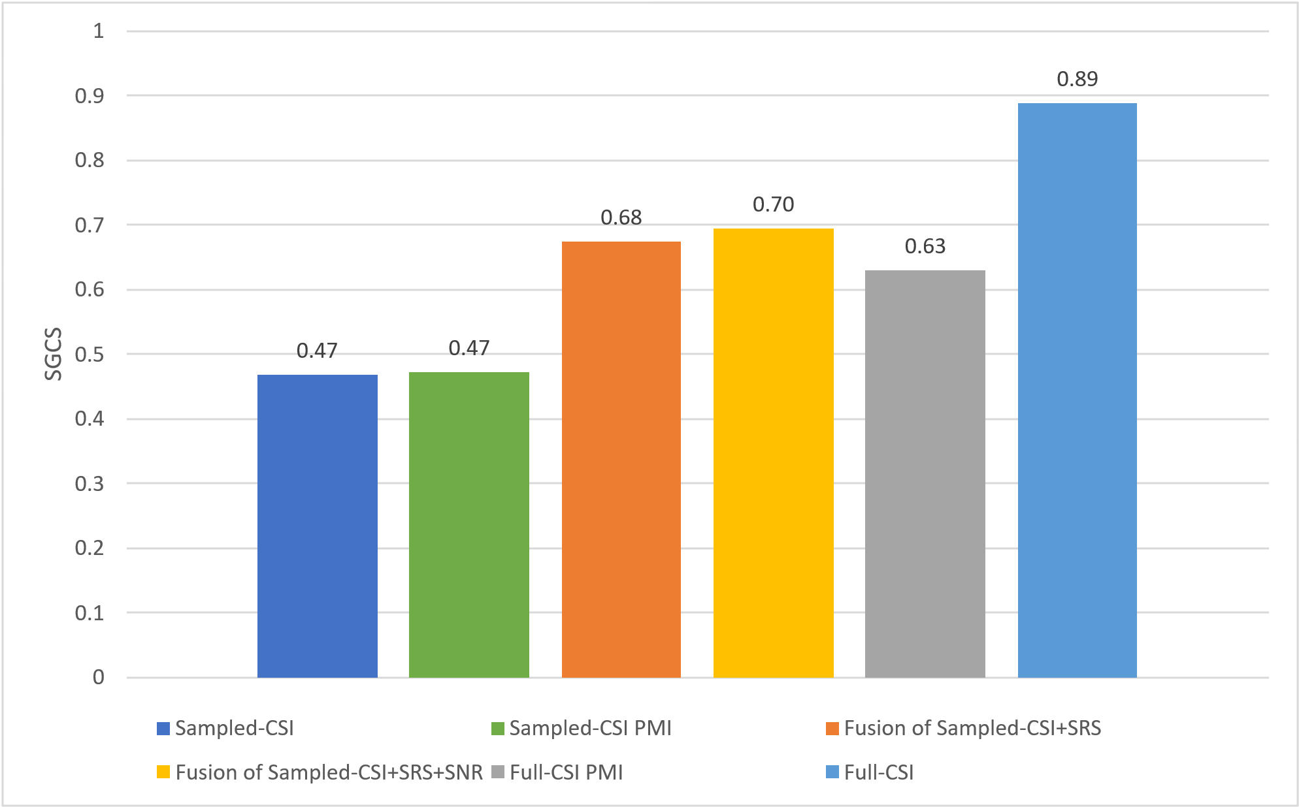
ZTE | Observation 1: Under the PC1 payload configuration, the AI/ML-based CSI compression with SRS achieves SGCS performance gains of 75%, 39%, and 17.5% compared to pure SRS measurements, traditional eType II Codebook, and SRS prediction, respectively.  Observation 2: Under the PC6 payload configuration, the AI/ML-based CSI compression with SRS achieves SGCS performance gains of 130%, 31%, and 54% compared to pure SRS measurements, traditional eType II Codebook, and SRS prediction, respectively.  - For Rel-20 study on channel matrix as target CSI type, consider the evaluation assumptions, methodology, and KPIs in TR 38.843 for CSI feedback enhancement as a starting point.  - FFS on additional assumptions, e.g., SRS configurations, bandwidth.  - Note: additional EVM and the corresponding template to collect the results can be updated.
KT | Proposal 1: Study the feasibility of also supporting channel matrix as target CSI type, particularly for scenarios with a large number of transmit antennas.
Qualcomm | - Channel feedback has the issue of disclosing Rx port information and has phase coherency issue if SRS fusion is employed. The frequency granularity and channel gain information may also impact the performance. To address these concerns, covariance matrix may be a good candidate for study.
Tejas Networks | Proposal 3: Support CSI feedback using a two-sided model, support specifying the precoding matrix as the primary target CSI type, ensuring alignment with existing CSI measurement procedures and maintaining consistency with current feedback mechanisms.
Lenovo | - Further evaluate the performance of the AI-based CSI compression with the channel matrix as target CSI type, followed by the discussion on necessary.
Fraunhofer | Proposal 1: In addition to the baseline precoding matrix target CSI, support channel matrix as an optional target CSI type for Rel-20 Case 0, at least for inference/monitoring/data collection and especially for TDD scenarios with SRS fusion.  Proposal 2: For channel-matrix target CSI, study an angle-delay domain representation.

Discussion
Based on the proposals in the contribution, FL observes following proposals on the target CSI type.
- Support the specification of channel matrix as target CSI:
  - Futurewei, Huawei, ZTE, InterDigital (SRS fusion), Fraunhofer
- Study the performance and feasibility of channel matrix as target CSI
  - KT, Lenovo
- Study channel covariance matrix as target CSI:
  - Qualcomm
FL note on target CSI type
From companies proposal, the situation remains similar to the last meeting. Based on the discussion in the previous meeting (comments populated in R1-2509216), there are a few companies mentioning that there is no need to repeat the study 5GA as there is an ongoing study in 6G. Thus, I will keep the following discussion same as last meeting, and let us see if more companies are interested in this topic before moving forward. For now, we may focus on other aspects with higher priority.

Discussion 6.1 (low): explicit CSI feedback
This use case is being studied 6G AIML agenda, is there a need to repeat the study in R20 5GA?
Companies | Comments
Futurewei | We are open to the study in R20 5GA considering the potential performance gain already illustrated by multiple companies. We don’t think we need to wait till 6G to grap such a low hanging fruit.
ZTE | We are open to further study this use case in 5G-A scope. For 6G scope, the use case study and discussions are premature. There are many new use cases on the table and the allocated time for the discussion of each use case is quite limited. While for 5G-A scope, we have done many works related to channel feedback in previous releases including evaluation assumptions and potential spec impacts, which builds a solid foundation for further study of new target CSI type.
Huawei, HiSilicon | Firstly, it is clearly in the 5GA scope as captured in the agreement. Let’s say it in another way around: there is not need to lead a duplicated study at 6G.  Secondly, as mentioned by ZTE, there is huge uncertainty to ensure the CSI compression case with SRS fusion (which has only 3 supporters) can survive with the competition of other ~20 new use cases/sub use cases.
  Agreement:
  For CSI feedback via two-sided model, support at least precoding matrix as target CSI type.
  - FFS whether consider raw channel matrix as further improvement, starting with evaluations, e.g. potential fusion with SRS measurement (SRS period/hopping, DL/UL reciprocity), frequency granularity of channel matrix, number of Rx antennas, etc.
  - Specify necessary signalling/mechanism(s) as per the identified potential specification impacts in FS_NR_AIML_Air , including:
    - Model pairing procedure including ID and applicability reporting
    - Inference aspects including target CSI type, measurement and report configuration, CQI RI determination, payload determination, quantization configuration codebook, UCI mapping, CSI processing criteria and timeline, priority rules for CSI reports
InterDigital | We are open to discuss explicit CSI feedback.
Nokia | No need to duplicate the study in R20 5GA
SPRD | No need to repeat the study in R20 5GA
vivo | We are open to further study this use case in 5G-A scope, at least we can evaluate the performance firstly especially considering that 10.1 is more focused on the performance and spec impact of CSI.
Panasonic | Considering specification effort point of view, to consider it for 6G would be reasonable.
China Telecom | We think it can be studied in 5GA. Since lots of related work for CSI feedback has been done in 5GA, it’ll be more mature to study new target CSI type here, we don’t need to wait for 6G. Thus, if time permits, we support to study this use case in 5GA.
TCL | No need to repeat the study in R20 5GA
Mod | I keep the discussion table from the last meeting, and let us resume from here.

Proposal 6.2 (on hold): explicit CSI feedback EVM
For the study of explicit channel feedback as another target CSI type, consider following evaluation assumption of channel matrix as Target CSI type, at least consider the following configurations:
- Candidate target CSI type
  - DL Channel matrix: a certain PRB among the $N_{RB}^{SB}$ PRBs of a subband is selected.
  - Covariance matrix : $H_{i}$ is the channel measurement on RB $i$ of a certain suband with size $SBsize$, covariance matrix is such that $\frac{1}{N_{RB}^{SB}}\sum_{i=0}^{N_{RB}^{SB}}{H_{i}^{H}⋅H_{i}}$
- Benchmark
  - CSI feedback via two-sided model with precoding matrix as target CSI type
  - eType II PC 1-8
  - SRS (if TDD system is considered)
- Frequency band:
  - 100MHz BWP with 272 RBs, subband size $N_{RB}^{SB}=16$
  - 20MHz BWP with 50 RBs, subband size $N_{RB}^{SB}=4$
- If TDD system is considered, SRS fusion can be considered as NW implementation
  - NW side model input: CSI feedback, channel measurement from SRS, covariance matrix / precoding matrix calculated from the SRS measurement.
  - SRS period includes at least 10ms, 20ms, 40ms.
  - SRS hopping
    - 17 hops or 5 hops for 100MHz BWP
  - DL/UL reciprocity error modeling:
    - DL/UL channel estimation error subject to DL/UL SNR.
    - DL/UL calibration error
    - Tx/Rx phase drift between each SRS hop
    - Antenna imbalance

Other proposals

Summary of companies’ proposals
Companies | Proposals
ZTE | - For the CSI reporting setting for inference, support UE to indicate whether the CSI content is generated using the legacy codebook or the deployed AI/ML model.
Google | Proposal 3: Support hybrid AI/ML based and non-AI/ML based CSI measurement and report  - UE reports the CSI based on AI/ML if it reports a small RI and the UE can report the CSI based on Type1 codebook if it reports a large RI
DCM | Proposal 2  - Support specifying a phase normalization method for the target CSI.

Discussion
There seems to be no essential issues in the section. Please provide your views on any other essential issues that have not yet been captured in the discussion.
Companies | Comments

Proposals for online sessions

Monday

Tuesday

Wednesday

Thursday

Friday

FL closing remark

Previous agreements

RAN1 #122
Agreement:
For CSI feedback via two-sided model, support at least precoding matrix as target CSI type.
- FFS whether consider raw channel matrix as further improvement, starting with evaluations, e.g. potential fusion with SRS measurement (SRS period/hopping, DL/UL reciprocity), frequency granularity of channel matrix, number of Rx antennas, etc.
Agreement
Specify the precoding matrix feedback via two-sided model as follows: For a certain layer $l$ and rank $ν$,
- A precoding matrix is mapped with a latent message $z^{l}=\left[z_{0}^{l}, z_{1}^{l},⋯,z_{d_{z}^{l,ν}-1}^{l}\right]$, with l = 1, ..., $ν$ where $l$ is the layer index.
  - The mapping is subject to [at least] a pairing ID configured by high-layer signalling.
  - FFS $d_{z}^{l,ν}$is common or specific for different layers or ranks
  - Note: the terminology “latent message” is used for discussion purposes, the detailed name can be discussed further
- $z^{l}$ is quantized and mapped to bit sequence before reporting.

Agreement
For precoding matrix feedback, for a certain layer $l$ of rank $ν$, the latent message $z^{l}$ contains $d_{z}^{l,ν}$ real values
- If scalar quantization (SQ) supported, it refers to the quantization of each real value independently,
  - The payload size for layer $l$ and rank $ν$ is determined by $d_{z}^{l,ν}×Q^{l,ν}$, where $Q^{l,ν}$ is the number of bits per scalar.
- If vector quantization (VQ) is supported, it refers to the quantization of a segment of L (L>1) consecutive real values jointly, and the segment(s) are separately quantized.
  - The payload size for layer $l$ and rank $ν$ is determined by $\frac{d_{z}^{l,ν}}{L}×Q^{l,ν}$, where $L$ is the length of the vector segment, $Q^{l,ν}$ is the number of bits per segment
  - Note: Combining two real-values as a complex value and performing amplitude-phase quantization is precluded.

Agreement:
For precoding matrix feedback, consider the following aspects for payload determination
- Support only SQ, or only VQ or both
- $d_{z}^{l,ν}$and / or $Q^{l,ν}$ and / or $L$ are fixed values or determined from multiple values based on NW configuration or UE reporting.
- $d_{z}^{l,ν}$and / or $Q^{l,ν}$ is layer-common or layer-specific, rank-common or rank-specific.
- If configured, $d_{z}^{l,ν}$and / or $Q^{l,ν}$ and / or $L$ above are configured separately from pairing ID, or configured by Pairing ID.
  - The configuration may be via other parameters which are used to derive $d_{z}^{l,ν}$, L and $Q^{l,ν}$.
Note: Consider limiting the total number of possible payload sizes considering the inter-vendor training challenges.
Note: $d_{z}^{l,ν}$, $Q^{l,ν}$ and $L$ are independent on subband and port configurations,
- FFS each combination of $d_{z}^{l,ν}$, $Q^{l,ν}$ and $L$is applicable to a certain set of subband and port configurations

Agreement:
For inference report configuration, support separate configuration of subband, Tx port and payload size from pairing ID.

Agreement:
For quantization codebook used for quantizing the feedback,
- For inter-vendor collaboration Direction A, select one of the following:
  - Alt1: Exchange quantization codebook from NW-side to UE-side along with each exchanged dataset or model parameters
  - Alt2: Use a standardized quantization codebook decided by RAN1.

Agreement:
For model pairing procedure for inference, consider the applicability report procedure of Rel-19 AI/ML beam management for UE side model as a starting point.
- Pairing ID(s) (i.e., ID for pairing related discussion) is indicated (e.g., in CSI-reportConfig) in Step 3.
  - FFS whether/how to link the Pairing ID with the inter-vendor collaboration
  - FFS whether/how Paring ID(s) are reported in Step 4
- FFS whether to support both Option A (CSI-ReportConfig for inference configuration) and Option B (sets of inference related parameters for applicability report only).
  - FFS CSI compression specific inference configuration or inference related parameters.

Agreement:
For NW side data collection of CSI compression, discuss the content and format of the collected data by assuming higher layer based signalling.
- Details on signaling is up to RAN2.

Agreement:
To enable UE side data collection, CSI-ReportConfig can be used for configuring the resources for data collection purpose without CSI report
- P-CSI-RS and SP CSI-RS are supported

Agreement:
For NW side data collection, study the solution for quantizing Target CSI, from the aspects of overhead, quantization loss/performance, and complexity. E.g.,:
- Option 0: Reusing legacy e-Type II codebook
- Option 1: Scalar quantization to the Target CSI. FFS number of bits for real/imaginary, whether coefficients for quantization are obtained from transformation of Target CSI.
- Option 2: Enhanced methods to reduce the SVD/EVD decomposition complexity, reduce frequency/spatial/beam domain basis searching, with potentially relaxed overhead, e.g., Type II like codebook with scalar quantized W2 similar to Option 1 scalar quantization.
- Option 3: Enhanced method for improved overhead saving, e.g., reporting the dominant eigenvalues/eigenvectors of per layer precoding matrix.
- Option 4: eType II like codebook with new parameter values (e.g. larger L, p_{v}, beta, amplitude, phase)
- Note: the quantizaton format should consider the maximum payload size per reporting (e.g., 9KBytes) of the current higher layer signaling.
- Note: At least take precoding matrix as Target CSI type. FFS channel matrix.
- FFS: EVM, metric, benchmark (e.g., FP32, eT2 with PC6/8), by reusing R18 study EVM as baseline.

RAN1 #122bis
Agreement:
Support precoding matrix with port-subband domain representation as target CSI type.
- For a certain layer $l$, a precoding matrix on N_sb subband and P CSI-RS ports is $W_{in}^{l}=[W_{in,0}^{l}, W_{in,1}^{l},⋯,W_{in, N_{sb}-1}^{l}]$ with $W_{in,k}^{l}$ being a $P×1$ vector.
- Note: Only sub-band PMI reporting is supported.
Agreement:
For determining the payload parameters combinations $\left\{d^{l,ν},Q^{l,ν}\right\}$ or $\left\{d^{l,ν},L,Q^{l,ν}\right\}$ across all layers and ranks, consider following general principles for precoding matrix-based target CSI
- Rank-common and layer-common model with payload-scalable design is considered as the baseline implementation for discussion purpose.
  - Note: layer-specific / rank-specific (if supported) payload parameters are supported by this rank-common and layer-common model with payload-scalable design.
- Limiting the total number of (per-layer) payload parameters combinations $\left\{d^{l,ν},Q^{l,ν}\right\}$ or $\left\{d^{l,ν},L,Q^{l,ν}\right\}$ across all layers and all ranks.
- At least for medium to high per-layer payload regime, the total payload size of rank 2, rank 3 and 4 are comparable to each other.
- Spectral efficiency or system throughput and trade-off with feedback overhead are considered as the performance metric.

Agreement:
When the Target CSI is precoder matrix, in order to down-select to N per-layer payload parameter combinations (PC) of $\left\{d^{l,ν},Q^{l,ν}\right\}$ or $\left\{d^{l,ν}, L,Q^{l,ν}\right\}$ based on performance, overhead and complexity trade-off results, consider the following candidate values:
- Candiate values for $d^{l,ν}$: 32, 64, 96, 128, 192
- Candidate values for $Q^{l,ν}$: 1, 2, 3, 4, (8, 10 only for VQ)
  - 2 is considered as the baseline assumption for SQ.
- Candidate values for L: L=2, 4, $d^{l,ν}$
- Candidate values for N: 4, 5, 6
- Note: These N payload PCs of $\left\{d^{l,ν},Q^{l,ν}\right\}$ or $\left\{d^{l,ν}, L,Q^{l,ν}\right\}$ are considered as the pool for the payload PC for each layer and each rank.
- Note: The above is for discussion purpose, how to configure the PCs (across layers and ranks) is a separate discussion.
- Note: Rank-common and layer-common model with payload scalable design is considered.
- Note: The above does not mean support of both SQ and VQ.
- Note: The number of parameters combinations configurations (Y) does not exceed 8.

Agreement:
For payload parameter combinations (PC), consider followings
- Support Y configurable PCs (across layers and ranks) as below, where X_n, Xn_31, Xn_32, Xn_33, Xn_41, Xn_42, Xn_43, Xn_44 represent a pair of $\left\{d^{l,ν},Q^{l,ν}\right\}$ or a triplet of $\left\{d^{l,ν}, L,Q^{l,ν}\right\}$ chosen from the per-layer PC pool.
 | Rank1 | Rank2 | Rank3 | Rank4
PC1 | X1 | X1, X1 | X1_31, X1_32, X1_33 | X1_41, X1_42, X1_43, X1_44
PC2 | X2 | X2, X2 | X2_31, X2_32, X2_33 | X2_41, X2_42, X2_43, X2_44
…

- For rank 1 and rank 2, layer-common and rank-common payload is supported.
- For rank 3, consider alternatives of {Xn_31, Xn_32, Xn_33} = {a, a, a}, {a, a, b}, {a, b, b} for potential down selection.
- For rank 4, consider alternatives of {Xn_41, Xn_42, Xn_43, Xn_44} = {a, a, a, a}, {a, a, b, b}, {a, b, b, c}, {a, a, b, c} or {a, b, c, c} for potential down selection.
- Note: The table is for discussion purpose, how to configure the PCs (across layers and ranks) is a separate discussion.
- Note: a, b values in rank3 can be different from that in rank 4.
Agreement:
Consider following for evaluation:
- For down-selection of per-layer pairs of $\left\{d^{l,ν},Q^{l,ν}\right\}$ or a triplets of $\left\{d^{l,ν}, L,Q^{l,ν}\right\}$ , average SGCS across per layer can be considered as performance metric.
- For down-selection of the rank-specific and layer-specific patterns (e.g., {Xn_31, Xn_32, Xn_33} and {Xn_41, Xn_42, Xn_43, Xn_44}), spectral efficiency or throughput should be considered.
Agreement:
For CSI feedback via two-sided AIML models, reuse legacy CSI reporting framework
- Support CSI report based on periodic, semi-persistent and aperiodic CSI-RS resources with legacy measurement resource configurations.
- Support aperiodic report and semi-persistent CSI report on PUSCH and reuse legacy triggering mechanism.

Agreement:
For NW side data collection with higher layer reporting, for further study of Option 1 (scalar quantization), consider the following definition for evaluation:
- Content: for a number of S=1 (as baseline) Target CSI samples each with the dimensions of 2N₁N₂ ports, N₃ subbands, v layers for precoding matrix, and real+imaginary (or amplitude+phase) parts, which has overall 2N₁N₂*N₃*v complex elements, and any complex element has a real (or amplitude) part of x1 and an imaginary (or phase) part of x2.
  - Note: Companies to report whether real value and imaginary value are quantized, or amplitude value and phase value are quantized.
- Format: x1 is quantized to k1 bits within range of [T1_{min}, T1_{max}], and x2 is quantized to k2 bits within range of [T2_{min}, T2_{max}]. E.g., for Scalar8, k1=8 bits for quantizing the real part, and k2=8 bits for quantizing the imaginary part. Uniform quantization is assumed.
  - Note: Companies to report whether/how the normalization is performed, and whether it is normalized within or across 2N₁N₂ ports/ N₃ subbands/ v layers/ real and imaginary (or amplitude and phase) parts.
- Fixed parameter values of k1/k2/T1_{min}/T1_{max}/T2_{min}/T2_{max} across complex elements, as a baseline for evaluations. Companies to report the values.
- Note: It is up to company to use number of samples S>1 in their evaluations. In this case, companies need to provide information how S samples are quantized in their evaluation.

Agreement:
For NW side data collection with higher layer reporting, regarding Option 4 (eType II like codebook with new parameter), further study the following candidate enhanced parameter values with potential down selection.
- L= 4/6/12/16/(N1*N2), pv=0.6/0.75/1, Beta = 0.5/0.8/1. Reference amplitude = 4bits/6bits, differential amplitude = 3bits/4bits, and phase = 4bits/6bits
  - Company to report the quantization step for reference amplitude for 6bits.
- No restriction to the total number of non-zero coefficients for a specific rank.
- Other combinations can be considered and reported by companies.

Agreement:
For the study of NW side data collection with higher layer reporting, following evaluation assumptions are considered:
- Benchmark#1: FP32 (k1=k2=32 bits)
- Benchmark#2: legacy eType II with PC6 (for layer 1/2/3/4), PC8(for layer 1/2)
- CSI payload size: at least consider large CSI payload Z ≥ 230 bits per layer, optionally consider low/medium CSI payload size X/Y per layer.
- Tx port: 32, 64, or 128 up to companies.
- Subband number: 13, or 19 up to companies.
- Performance metric:
  - Metric#1: SGCS for specific layer(s) between Target CSI of FP32 and recovery CSI, for a model trained with quantized Target CSI with a specific quantization option.
  - Metric#2: SGCS for specific layer(s) between the Target CSI of FP32 with its quantized version subject to a specific quantization solution
  - Overhead per sample and per layer SGCS results are reported per layer
- Note: Complexity should be analysed.
- For Option 1, consider k1+k2=4, 6 ,7, 8, 16, 32
- Other assumptions follow R18 study EVM

Agreement
For CPU counting of UE side data collection,
- O_{CPU}=1
- FFS: The CPU occupancy duration

RAN1 #123
Agreement:
Support NW side optionally exchanges codebook to the UE side.
- If NW side exchanges a codebook, the exchanged codebook is associated to the pairing ID.
  - FFS SQ / VQ / both is supported
  - FFS the details, e.g., whether exchange the NW-defined codebook or the ID of a standardized SQ codebook in case of multiple standardized codebooks.
- If NW side does not exchange a codebook or an ID of a standardized SQ codebook in case of multiple standardized codebooks, a standardized SQ codebook is associated to the pairing ID.
- Note: For the same quantization resolution, a common codebook is used for all the scalars/segment(s), all the layers of pre-coding matrix and all parameter pairs/triplets for the associated pairing ID.
Agreement:
If target CSI type is pre-coder matrix, at least support per-layer payload parameter pairs {32, 2}, {64, 2}, {128, 2}, {192, 2}
- FFS: Whether support per-layer payload parameter pairs {32, 1}, {48, 2}, {96, 1}, {96, 2}, {192, 1}, {128,10/128}
- Note: The above pair refers to the pair of latent dimension and quantization resolution, i.e., {d, Q} for SQ or {d, Q/L} for VQ.

Agreement:
If target CSI type is pre-coder matrix, at least for SQ, for the PC with rank-1 payload of 128 bits, support the following payload combinations across layers and ranks. The layers are reported in the order of decreasing strength.
Rank1 | Rank2 | Rank3 | Rank4
{64, 2} | {64, 2}, {64, 2} | {32, 2}, {32, 2}, {64, 2} | {32, 2}, {32, 2}, {32, 2}, {32, 2}

Agreement:
If target CSI type is pre-coder matrix, at least for SQ, for the PC with rank-1 payload of 256 bits, support the following payload combinations across layers and ranks. The layers are reported in the order of decreasing strength.
Rank1 | Rank2 | Rank3 | Rank4
{128, 2} | {128, 2}, {128, 2} | {64, 2}, {64, 2}, {128, 2} | {64, 2}, {64, 2}, {64, 2}, {64, 2}

Agreement:
If target CSI type is pre-coder matrix, at least for SQ, for the PC with rank-1 payload of 64 bits, select one alternative from following alternatives in RAN1 #124.
- The layers are reported in the order of decreasing strength.
- Note: For the purpose of comparison, consider the following:
  - For comparing Alt.1 and Alt. 2, consider payload scalability.

 | Rank1 | Rank2 | Rank3 | Rank4
Alt1 | {32, 2} | {32, 2}, {32, 2} | NA | NA
Alt2 | {32, 2} | {32, 2}, {32, 2} | {32, 1}, {32, 1}, {32, 2} | {32, 1}, {32, 1}, {32, 1}, {32, 1}

Agreement:
If target CSI type is pre-coder matrix, at least for SQ, for the PC with rank-1 payload of 384 bits, select one alternative from following alternatives in RAN1 #124.
- The layers are reported in the order of decreasing strength.
 | Rank1 | Rank2 | Rank3 | Rank4
Alt1.1 | {192, 2} | {192, 2}, {192, 2} | {96, 2}, {96, 2}, {192, 2} | {96, 2}, {96, 2}, {96, 2}, {96, 2}
Alt1.2 | {192, 2} | {192, 2}, {192, 2} | {192, 1}, {192, 1}, {192, 2} | {192, 1}, {192, 1}, {192, 1}, {192, 1}
Alt2 | {192, 2} | {192, 2}, {192, 2} | {128, 2}, {128, 2}, {128, 2} | {64, 2}, {64, 2}, {128, 2}, {128, 2}
Alt3.1 | {192, 2} | {192, 2}, {192, 2} | {128, 2}, {128, 2}, {128, 2} | {96, 2}, {96, 2}, {96, 2}, {96, 2}
Alt3.2 | {192, 2} | {192, 2}, {192, 2} | {128, 2}, {128, 2}, {128, 2} | {192, 1}, {192, 1}, {192, 1}, {192, 1}

Agreement
For NW side data collection with higher layer reporting, regarding Target CSI quantization, Option 1 (Scalar quantization) is supported.
Note: Supporting target CSI payload size greater than single RRC message may need RAN2 justification.

Agreement:
For Option 1 (scalar quantization) of NW side data collection with higher layer reporting, down select between Option 1a and Option 1b:
- Option 1a: Each complex element of the Target CSI sample is quantized to real value and imaginary value
  - Further study at least k1=k2=3, 4, 5, 6, and 8 to ensure the performance (e.g., the minimum value that achieves the close performance to upperbound).
  - Further study the quantized value of each codepoint.
- Option 1b: Each complex element of the Target CSI sample is quantized to amplitude value and phase value
  - Further study at least k1+k2=6, 7, 8, 12, and 16 with k1>k2, k1<k2 or k1=k2 to ensure the performance (e.g., the minimum value that achieves the close performance to upperbound).
  - Further study the quantized value of each codepoint.
- Further study the potential UE complexity between Option 1a and Option 1b, e.g., considering the potential conversion to amplitude/phase domain of Option 1b.
- Consider Metric#1 (SGCS for a trained model) for the evaluation.
- The study at least considers 32 ports, 64 ports, and 128 ports; 19 subbands; rank 4.
- It is up to companies to study mixed Target CSIs subject to multiple {k1, k2} values each corresponding to a specific port/subband/layer configuration, for training scalable model.
- Study the necessity of RRC signaling enhancement, e.g., for a large k1, k2 pair if needed.

- Further study whether/how to perform normalization for Option 1a and Option 1b, e.g., the ranges of both [T1_{min}, T1_{max}] and [T2_{min}, T2_{max}] are fixed and specified as [-1, 1] for real/imag quantization, or [0, 1]/[0, 2π) for amplitude/phase quantization. Select one among the alternatives:
  - Alt.1: It is UE implementation to perform scale up/down to fit the fixed range.
  - Alt.2: Additional specification on the quantization, e.g.,
    - Alt.2-1: At least one element among all real and imag elements in the Target CSI matrix (FFS per layer and/or per subband) correspond to any of T_{min} (where T_{min}=T1_{min}=T2_{min}) and T_{max} (where T_{max}=T1_{max}=T2_{max}) in the quantization table or at least one element among all amplitude elements in the Target CSI matrix (FFS per layer and/or per subband) correspond to T1_{max}
    - Alt.2-2: Reporting scaling factor and offset factor used for denormalization.
    - Alt.2-3: Fixed scaling factor used for normalization.

Agreement:
Support providing Pairing ID(s) in CSI-ReportConfig for UE side data collection
- FFS mandatory or optional
- FFS whether to configure Pairing ID for NW side data collection
- FFS whether multiple Pairing IDs provided in one CSI-ReportConfig for UE side data collection

References
- TR 38.843 v19.0.0, “Study on Artificial Intelligence (AI)/Machine Learning (ML) for NR air interface” (Release 19), June 2025
- RP-251870, “New WI: Artificial Intelligence (AI)/Machine Learning (ML) for NR air interface enhancements”, Qualcomm (Moderator), 3GPP TSG RAN #108, June 2025

