3GPP TSG RAN WG1 #124 R1-2601308
Gothenburg, SE, Feb. 9th ~ 13th, 2026
Agenda item: 10.5.3.1
Source: Samsung, vivo (moderators)
Title: Feature lead summary #2 on DL-based CSI acquisition
Document for: Discussion and Decision

Introduction
This paper is to summarize the proposals/observations based on companies’ contributions submitted to 10.5.3.1, for DL-based CSI acquisition, including CSI framework, CSI reporting, CSI measurement and CSI-RS design, for both AI and non-AI based schemes.
Detailed list of companies’ proposals/observations were captured in Annex.

Evaluation methodology

SLS assumption
Table 2.1A General Assumption
Parameters | Proposals | Companies’ view
#1  Carrier frequency | Around 700MHz (FDD)  Around 2 GHz (FDD)  Around 4 GHz (TDD)  Around 7 GHz (TDD)  Other carrier frequency is not precluded | Around 700MHz (FDD):(3) Ericsson, Apple, Samsung  Around 2 GHz (FDD): (3) Huawei, Apple, Samsung  Around 4 GHz (TDD):(6) Huawei, CATT. Ericsson, vivo, Apple, Samsung  Around 7 GHz (TDD): (7) Huawei, CATT. Ericsson, vivo, Apple, Samsung, ATT  Around 15GHz (TDD):(1) Apple  Around 28GHz (TDD): (2) Ericsson, DCM  Around 30GHz (TDD): (2) Apple, DCM
#2  Simulation bandwidth | 20MHz  100MHz (not applicable for 700MHz)  Other BW is not precluded  System/channel bandwidth assumption is reported by companies. | 10MHz: Samsung  20MHz: Huawei, CATT, Ericsson, Apple, Samsung  100MHz: Huawei, MediaTek, Ericsson, CATT (opt)  200MHz: Huawei, CATT (opt)  300MHz: Huawei, CATT (opt)  400MHz: Huawei, CATT (opt)
#3  Number of subbands and subbands size | Number of SBs  1 for WB  13 SB for 20MHz  TBD SB for 100MHz  Subband size:  4 or 8 PRBs for 20MHz  TBD PRBs for 100MHz  Note: Temporary, before subband size for 6GR is decided  Other number can be reported. | MTK: 4, 8. 16 for 20Mh and 32 for 100MHz
#4  Scenario | Dense urban  Urban macro  Suburban Marco  Rural Macro  Other scenarios are not precluded and can be reported. | Dense Urban (4): Huawei, CATT, Ericsson (4GHz,7 GHz, 28GHz), Apple  Suburban Marco (4): Ericsson (700Mhz, 4GHz), ATT, Samsung(7GHz), Apple  Urban Macro (4): Huawei, Ericsson (700Mhz, 4GHz, 7GHz), Samsung (4GHz), Apple  Indoor: Apple,xiaomi  Rural Macro: Samsung(700MHz), vivo(R-18 CJT scenario)  HST: CMCC, KT, etc
#5  UE number/cell | 10, 30  Other numbers is not precluded.
#7  Layout/deployment | 1-ring (7*3), 2-ring (19*3)  Other layout/deployment are not precluded. | Samsung，Nokia:1-ring (7*3), 2-ring (19*3)
#7 Channel model | Rel-19 TR 38.901
#8 Numerology | OFDM, 15 kHz for FDD, 30 kHz for TDD | Ericsson: 120kHz for 28GHz
#9  Transmit power  (per 20MHz) | Dense urban: 44dBm  Urban macro: 46dBm  Suburban Marco:49dBm  Rural Macro: 49dBm  Other values can be reported by companies.  Note: For evaluation purpose, BS Tx power scales up with bandwidth proportionally under the limitation of the maximum BS Tx power is 56dBm for outdoor and 33dBmfor indoor for the above carrier frequencies.
#10  BS antenna configuration | Configuration for around 700MHz:  4TXRU 32AEs (Combination 1)  (M, N, P, Mg, Ng; Mp, Np) = (8, 2, 2, 1, 1, 1, 2). (dH, dV) = (0.5, 0.5)λ  8TXRU 8AEs  (M, N, P, Mg, Ng; Mp, Np) = (2, 2,2,1,1,2,2). (dH, dV) = (0.5, 0.5)λ  8TXRU 64AEs (Combination 2, Optional as in Agenda 10.1)  (M, N, P, Mg, Ng; Mp, Np) = (8, 4, 2, 1, 1; 1, 4), (dH, dV) = (0.5, 0.5)λ  Configuration for around 2GHz:  64TXRU 192AEs (Combination 2)  (M, N, P, Mg, Ng; Mp, Np) = (12, 8, 2, 1, 1, 4, 8). (dH, dV) = (0.5, 0.5)λ  16TXRU 32AEs  (M, N, P, Mg, Ng; Mp, Np) = (4,4,2,1,1,2,4). (dH, dV) = (0.5, 0.8)λ  4TXRU 32AEs (Combination 1)  (M, N, P, Mg, Ng; Mp, Np) = (8, 2, 2, 1, 1, 1, 2). (dH, dV) = (0.5, 0.5)λ  Configuration for around 4GHz:  64TXRU 192AEs (outdoor combination 1)  (M, N, P, Mg, Ng; Mp, Np) = (12, 8, 2, 1, 1, 4, 8). (dH, dV) = (0.5, 0.8)λ  32TXRU 128 AEs  (M, N, P, Mg, Ng; Mp, Np) = (8,8,2,1,1,2,8). (dH, dV) = (0.5, 0.8)λ  Configuration for around 7GHz:  128TXRU 768AEs (Combination 1) as one Baseline  (M, N, P, Mg, Ng, Mp, Np) = (24,16,2, 1, 1, 4,16). (dH,dV) = (0.5,0.8)λ  One Baseline from:  256TXRU 1024AEs (Combination 2)  (M, N, P, Mg, Ng; Mp, Np) = (32, 16, 2, 1, 1, 8, 16). (dH, dV) = (0.5, 0.8)λ  256 TXRUs 1536AEs (Combination 3)  (M, N, P, Mg, Ng, Mp, Np) = (48, 16 ,2, 1, 1; 8, 16). (dH, dV) = (0.5, 0.8)λ  Optional:  512TXRU 2048AEs (Combination 5):  (M, N, P, Mg, Ng; Mp, Np) = (64, 16, 2, 1, 1; 16, 16). (dH, dV)= (0.5, 0.5) λ  128 TXRUs, 2048 AEs  (M, N, P, Mg, Ng, Mp, Np) = (32, 32, 2, 1, 1; 8, 8), (dH, dV) = (0.5, 0.5)  Other BS antenna configurations are not precluded and to be considered.. | 700MHz:  Samsung: M,N,P)=(2,2,2) 8 ports; (Baseline)  (M,N,P)=(8,4,2) 8 ports  Apple: Combination 1: (8, 2, 2, 1, 1; 1, 2) for (M,N,P,Mg,Ng; Mp, Np), and (0.5, 0.5)λ for (dH,dV)  Ericsson: (8, 2, 2, 1, 1; 1, 2) (0.5, 0.5)λ  Vivo: Rel-18 for CJT  Xiaomi  both indoor and outdoor scenarios  Nokia  For 2,4 and 7GHz  8 ports: (4,4,2,1,1,1,4), (dH,dV) = (0.5, 0.8)λ  16 ports: (8,4,2,1,1,2,4), (dH,dV) = (0.5, 0.8)λ  32 ports: (8,8,2,1,1,2,8), (dH,dV) = (0.5, 0.8)λ  Huawei  Combination 3 1536 256 (48, 16 ,2, 1, 1; 8, 16) (0.5, 0.8)λ  Ericsson  As 32 ports is deployed in 5G NR, we should add an antenna configuration for this. We suggest (8, 8, 2, 1, 1; 2, 8) (0.5, 0.8)λ for 32 ports.  Subarray virtualization tilt angles to be reported by companies.  Futurewei  128 TXRUs, 2048 AEs, (M, N, P, Mg, Ng, Mp, Np) = (32, 32, 2, 1, 1; 8, 8), (dH, dV) = (0.5, 0.5)
#11  UE power class | 23dBm(for 700MHz)  26dBm (for others)
#12  UE antenna configuration | 4R, 8R  Details follow corresponding agreements in Agenda 10.1 | ZTE; 16 Rx, can be considered for advanced CPE UEs.
#13  UE antenna modelling | TR 38.901 | OPPO: both legacy UE antenna modelling and handheld UE antenna modelling can be used.
#14 UE Receiver | MMSE-IRC as the baseline | Qc: R-ML should be the baseline
#15  Traffic model | FTP Model 3 (0.5 Mbyte packet sizes)  - Low RU about 30%  - Medium RU about 60%  - High RU about 70%  Other model is not precluded. | FTP3: Huawei, CATT, Apple, Samsung, MediaTek  - RU 10~50: Apple  - RU 30: Samsung  - RU 50: Samsung (Opt)  - RU 60-70: MediaTek,  eFTP: Ericsson,  Huawei:  Suggest to simulate 30%, 50% and 70% for low, medium and high RU.  Full buffer: Huawei, CATT
#16  Scheduling | PF
#17  Inter-cell interference model | Explicitly and realistically modelled
#18  Channel estimation assumption | Realistic channel estimation for CSI-RS.  Companies to report channel estimation error model(s) and assumptions to corresponding CSI-RS assumptions, if applicable | Qc: Companies to report channel estimation error model(s)
#19  CSI feedback | CSI periodicity: 10ms, 20ms  Scheduling delay: 4ms | CSI periodicity  5ms: Apple  10ms: Ericsson, CATT, samsung  20ms: Ericsson, CATT, samsung, Apple, OPPO, MediaTek  40ms: Apple  ZTE: more scheduling delay values can be considered, e.g., 2ms, 4ms, or 8ms.
#20  MIMO scheme | SU-MIMO  MU-MIMO (up to 4 layer)  with rank adaptation  NR CW-to-layer mapping is used. | OPPO: NR CW-to-layer mapping  ZTE:  MU operation with more layers should be considered, e.g., up to 8/16 layers.  Huawei: 4 layers per UE.
#21  Feedback assumption | Error-free UCI reception as baseline, UCI error rate can be additionally modelled | Qc: UCI error should be modelled as baseline
#22  Evaluation Metric | Throughput and CSI feedback overhead as baseline metrics, the CSI feedback overhead is the actual feedback overhead statistics per system level evaluation | MTK: average feedback overhead per each CSI report
#23  Baseline for performance evaluation | Rel-19 Type I Scheme A/B  Rel-19 eType II Codebook  Ideal SVD for calibration
#24  Wideband phase error | FFS | Ericsson:  Wideband phase error between Tx antenna port 0 and Tx antenna port n (n>0) can be modeled in the following way:  independent random phase offset uniformly distributed between 0 and 2π between any two Tx antenna ports.  FFS: whether/how to model subband phase error

Table 2.1B CJT Scenario
CJT Scenario 1: Intra-cell (DMIMO) scenario | CJT Scenario 2: intra-site, inter-cell
4 TRPs/RRHs per CJT set  Layout:  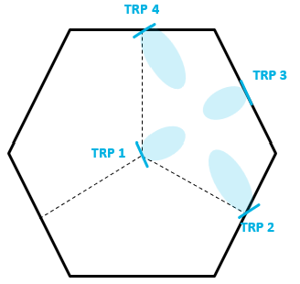 | 3 TRPs per cooperative set  Layout:  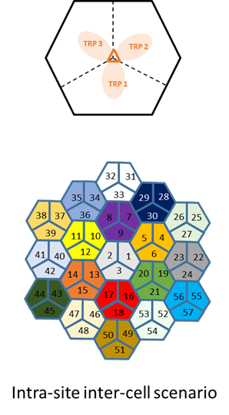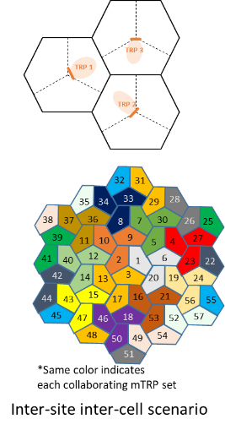
Companies to report backhaul assumption.
Other number of TRPs for CJT is not precluded.
Same antenna configuration and Tx power is assumed across TRPs.

Proposal 2.1-1
Adopt the table 2.1A and Table 2.1B as the basic assumption of SLS for evaluation of DL-based CSI acquisition.
Company | Item | Input
Mod v0 | # x | Please provide comments for each item(proposals are in the first columns), by indicating the number.  Or if anything missing, please put # X, #Y, #Z and your corresponding comment
Samsung | #6  Layout  /deployment. | This row is whether we use 1-ring or 2-ring in the layout. Rather than using only 7*3, we suggest to replace it by 1-ring (7*3), 2-ring.(19*3) layout.  In our view, 1-ring can be useful and relaxed to simulation time for AI-scheme SLS, and 2-ring can be used for non-AI-scheme SLS as we have used it as baseline in LTE/NR.
Samsung | #10 | Although we are OK to study up to 256 ports, it hasn’t been supported so far and we are in study stage (meaning it may not be supported in the end), we suggest the corresponding configuration (256TXRU..) as optional.  For the configuration of 512TXRU, suggest it to remove.
MediaTek | #1,  #3,  #4,  #22 | #1 and #4:  We would like to first check with FL whether each company need to provide the evaluation result for all the scenarios/frequencies listed in the proposal? Or it is up to company to prioritize some case(s) according to its own interest? If all the cases are required, we prefer to narrow down the candidates. Otherwise, that will cause huge simulation effort.  #3:  We suggest first discussing the possible value of the CSI subband size. For 20MHz, the legacy size (i.e., 4, 8, 16) can be a good starting point. For large BW case (i.e., 100MH), the extended CSI subband size (e.g., 32 RBs) can be considered/studied in the joint consideration of the reasonable amount of reporting overhead.  #22:  We fully agree to utilize actual feedback overhead statistics in the simulation as the metric, which can better reflect the overhead according to rank adaption. Furthermore, we would like to suggest considering the average feedback overhead per each CSI report as the KPI of overhead assessment.
Qualcomm | #2 | Need to clarify the relationship between “simulation bandwidth” and “system bandwidth”, e.g., if 20MHz simulation bandwidth is assumed for 100 MHz system bandwidth, what is the assumed multipath resolution.  Clarify 100MHz simulation bandwidth is not applied to 700MHz carrier frequency
Qualcomm | #8 | 60kHz SCS for 7GHz can be considered also
Qualcomm | #9 | Following the agreement on Agenda 10.1, BS total Tx power can be different for different scenarios, outdoor/indoor deployment and simulation bandwidth.
Qualcomm | #10 | If CJT is considered, the assumption on backhaul should be included. We think the non-ideal backhaul and synchronization should be assumed as the baseline assumption  For 700MHz, it is not clear why BS array configuration is different for sTRP and mTRP.
Qualcomm | #14 | MMSE-IRC is not a realistic assumption at least for DL. R-ML should be the baseline.
Qualcomm | #11 | 29 dBm has been included in the agreed general evaluation assumption. We think it should be included at least for 7GHz.
Qualcomm | #18 | Companies to report channel estimation error model(s)
Qualcomm | #19 | Clarify scheduling delay is the time duration from the time when CSI-RS is transmitted to the time when PDSCH using the CSI computed based on that CSI-RS is transmitted. Depending on the detailed UE CSI computation and gNB CSI reconstruction algorithm, companies to report the scheduling delay value used in the simulation. The baseline value is 4ms for NR Type I and eType II CSI for <= 32 ports.
Qualcomm | #21 | Modelling UCI error should be the baseline. We cannot assume large UCI can be error-free transmitted at very low SNR condition. It is not fair comparison for different CSI schemes without consideration of UCI error.
OPPO | #10 | For 4GHz, the antenna configuration should be outdoor configuration 1.  For 7GHz outdoor configuration 5, the antenna configuration should be  (M, N, P, Mg, Ng; Mp, Np) = (64, 16, 2, 1, 1; 16, 16). (dH, dV)= (0.5, 0.5) λ
OPPO | #13 | Better to clarify that both legacy UE antenna modelling and handheld UE antenna modelling can be used.
OPPO | #20 | The NR CW-to-layer mapping can be assumed as a starting point for SLS.
CMCC | #4  Scenario  #7  Layout/deployment | For the scenario item, to evaluate the performance of SFN and DPS schemes in HST scenario, we also want to highlight the high speed train scenario, where the accuracy of CSI is important to improve the capacity and DL performance.  For the layout in high speed train scenario, we propose the following deployment, where multiple RRHs connect to one BBU with fiber and share the same cell ID in order to reduce the number of handovers as much as possible, as illustrated in Figure 2. For each RRH, usually there are two TRPs which orient opposite directions along the track, the inter-site distance is about 500 m between two RRHs, and 3RRHs/6 TRPs connect to one BBU with fiber and share the same cell ID to form one large macro cell.  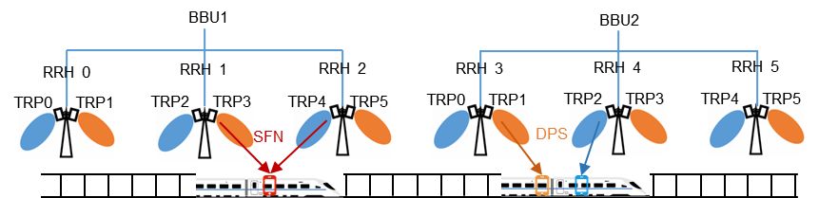  Figure 2: Deployment of HST (several RRHs distributed equidistantly along the track with the same Cell ID)  FL: other layout/deployment are not precluded.
Xiaomi | #7 and #13  #10 | General question:  There are numerous combinations of scenarios (e.g., #1 and #4), it’s better to discuss whether some baseline combinations should be considered to reduce the simulation efforts.  FL: May not be easy to be agreed on “basic”  #7 and #13:  Rel-19 introduced new channel models (e.g. NF and SNS) and new UE antenna models, it’s better to clarify that both pre-Rel-19 and Rel-19 channel models and UE antenna models will be used for study.  #10:  Prefer to consider both indoor and outdoor scenarios as agreed in previous meetings.
Nokia | #7  #10 | 57-sector layout (19x3) can be added for CJT scenario 2  For single TRP, for 2,4 and 7GHz, we should also consider  8 ports: (4,4,2,1,1,1,4), (dH,dV) = (0.5, 0.8)λ  16 ports: (8,4,2,1,1,2,4), (dH,dV) = (0.5, 0.8)λ  32 ports: (8,8,2,1,1,2,8), (dH,dV) = (0.5, 0.8)λ  For CJT we can reuse Rel-18 CJT antenna layouts  For >128 ports, as they have not been studied before, companies should state their assumptions on TXRU structure and the associated TXRU-to-port virtualization
ZTE | #12, 19, 20, 23 | - For UE antenna configuration, we think larger # of antenna ports, e.g., 16 Rx, can be considered for advanced CPE UEs.  - For CSI scheduling delay, it would be better to further clarify the definition, e.g., whether the scheduling delay is the time gap from the CSI-RS measurement to the CSI report application, or the time gap from the CSI report reception to the the CSI report application. Besides, more scheduling delay values can be considered, e.g., 2ms, 4ms, or 8ms.  - For MIMO scheme, MU operation with more layers should be considered, e.g., up to 8/16 layers.  - For the baseline for performance evaluation, Rel-15 Type-I and Rel-16 eType-II should also be considered, because Rel-19 Type-II/eType-II do NOT support <=32 ports.  - Besides for above, the # of TRPs for CJT should also be captured in the EVM, and up to 6/9 TRPs can be considered.
Huawei, HiSilicon | #9  #10  #12  #15  #18  #20  Table 2.1B | #9:  An option of 43dBm tx power can be added. As agreed in last meeting, the maximum BS tx powe at outdoor is 56dBm, then if 400MHz system bandwidth is assumed, 20MHz simulation bandwidth will result in 43dBm.  #10:  For 7GHz, we support to keep 512TXRU to study the performance of large antenna arrays. In addition, propose to add the combination of 1536AE, i.e., to simulate the performance with HBF.  #12:  As agreed in RAN plenary, 16R should also be considered.  #15  MIMO should study both low RU and high RU, as both are typical scenarios in real network. Suggest to simulate 30%, 50% and 70% for low, medium and high RU.  #18:  To clarify, this means the realistic channel estimation for CSI-RS.  #20:  To clarify, for MU-MIMO, it’s up to 4 layers per UE.  Table 2.1B:  In NR, inter-site CJT has been supported with up to 4 TRPs. For 6GR, the inter-site inter-cell scenario should also be considered for CJT.
  Combination 3 | 1536 | 256 | (48, 16 ,2, 1, 1; 8, 16) | (0.5, 0.8)λ
vivo | # 10  # 16 | #10: For UE antenna modelling of handheld UE, the modelling of TR 38.901 should be adopted as it is closer to the actual antenna layout. The actual Rx antenna of the UE should select from at least some of these 8 antenna positions. Besides, at least for 8Rx, SNS modelling in section 7.6.14.2 in TR38901 is considered.  #16: Additive noise modeling can be considered for channel estimation of CSI-RS REs, i.e., $\hat{H_{k}}\left(i,j\right)=H_{k}\left(i,j\right)+E_{k}\left(i,j\right)$, where $E_{k}\left(i,j\right)\sim CN\left(0,MSE_{k,i,j}\right)$. The i and j denote the receive antenna port index and the transmit antenna index associated with the RB index k. Companies can report the determination of $MSE_{k,i,j}$. In addition, for lower frequency density CSI-RS, sample and hold is assumed as baseline for RBs without CSI-RS. Companies to report if other assumptions are used.
Samsung | #5,#7 | We also propose single cell and single UE evaluations at least for CSI-RS coverage analysis to make results more comparable among companies and to reduce efforts
InterDigital | #2 | To keep simulation effort under control support 10 and 20 MHz bandwidths with 100 MHz as optional.
Ericsson |  | Proposal 2.1-1  Calibration error for classical radios with passive antennas is a real world issue and should be modelled in the evaluation assumptions. This is mostly relevant to the 4TXRU case. We can model the calibration error as follows:  Wideband phase error between Tx antenna port $0$ and Tx antenna port $n$ ($n>0$) can be modeled in the following way:  independent random phase offset uniformly distributed between $0$ and $2π$ between any two Tx antenna ports.  FFS: whether/how to model subband phase error  FL: this can be discussed separately.  Comments on #1,  A frequency around 28-30 GHz is need. We suggest to pick ether 28 GHz or 30 GHz.  Comments on #4:  Why is CJT scenario 1 only limited to Rural Macro? We do not think CJT scenario 1 should be limited to Rural Macro only. We can study the listed homogeneous scenarios for CJT evaluations Also, if Rural Macro is to be simulated, we don’t think it should be limited to CJT.  Comments on #5:  The current numbers are limited to FTP model 3. We don’t think mimo evaluations should be limited to only a single traffic model as performance of different MIMO schemes may be sensitive to the traffic model. FTP model 1 and eFTP model should be added to the evaluation assumptions.  Comments on #8:  Suggest to add 120kHz for either 28 GHz or 30 GHz.  Comments on #10:  As 32 ports is deployed in 5G NR, we should add an antenna configuration for this. We suggest (8, 8, 2, 1, 1; 2, 8) (0.5, 0.8)λ for 32 ports.  Not sure if we need to add a special port layout for CJT. We can use a common layout for CJT and non-CJT. Also, CJT should not be limited to only around 700 MHz.  Subarray virtualization tilt angles to be reported by companies.  Comments on #15:  We don’t think mimo evaluations should be limited to only a single traffic model as performance of different MIMO schemes may be sensitive to the traffic model. FTP model 1 and eFTP model should be added to the evaluation assumptions. Particularly, eFTP model is very important as it is more realistic than the legacy FTP models.  Comments on CJT Scenario:  Regarding CJT Scenario 1 what is the assumption on the TRPs? Do TRPs 1, 2, 3, and 4 have same antenna configuration and Tx power? Or do we consider a non-homogeneous scenario?  Another comment is that these scenarios don’t need to be limited to CJT. They can be applied to other multi-TRP schemes.
Sony | #1, #12 | #1: Same comment as MediaTek. If companies are expected to provide simulation results for all the listed carrier frequencies, narrowing down the list is necessary.  #12: UEs with 2Rx and 4Rx antennas are more realistic for the frequencies being considered. 8Rx can be optional for FWA/CPE devices. Furthermore, 1Rx should also be considered for IoT devices.
LG | #7  Layout/deployment | 19*3 should be considered as we widely used those layout/deployment in NR simulation.  For general comment: The combination of simulation cases are huge, so it seems hard to calibrate among companies. So, better to have baseline assumptions, at least for #1, #2, #4, #10 (if 7GHz is chosen).
NTT DOCOMO | #1, #8, #10 | Support to also evaluate FR2, e.g., Around 30 GHz, with corresponding SCS and BS antenna configurations.
Futurewei | #10 | For BS antenna configuration at around 7 GHz, large array size, such as 2048 AE, should be evaluated to ensure coverage matching 4 GHz. To reduce energy consumption and cost, 128 TXRUs or even lower should be evaluated. So the following or the like should be considered in SLS:  128 TXRUs, 2048 AEs, (M, N, P, Mg, Ng, Mp, Np) = (32, 32, 2, 1, 1; 8, 8), (dH, dV) = (0.5, 0.5)
FL |  | Some additional offline discussion is needed.
CATT2 | #7  #15 | We also support 2 ring (19x3), this can be used for CJT evaluations  For the RU, we suggest 50/70 % for SU/MU-MIMO and mTRP with rank adaptation, 20% for SU-MIMO with rank adaptation.
FL2 |  | If any comment on the non-stable ones, please continues.
Xiaomi | #7 | For 256TXRU, the same view with Huawei, we prefer the combination 3 as it’s better to identify the hybrid beamforming effect around 7GHz.  256TXRU 1536AEs (Outdoor Combination3):  (M, N, P, Mg, Ng; Mp, Np) = (48, 16 ,2, 1, 1; 8, 16). (dH, dV) = (0.5, 0.8)λ
ZTE | #10 | For 7GHz, the combination of 512TxRU should be removed. This configuration is not supported (as captured in the table), and there is no realistic use case.
Nokia | #13 | We suggest clarifying that the isotropic UT antenna pattern with X-pol (0/+90 degree) is the baseline assumption.  Handheld UT antenna modelling can be optionally assumed.
Sony | #11 | For the UE power class, we suggest adopting the following UE transmit powers, which we believe to be more common:  26dBm(for 7GHz)  23dBm (for others)
Sony | #12 | For the UE antenna configuration, 2R is expected for handheld devices operating at 700 MHz. Additionally, 1R is required for supporting IoT in 6GR (RP-253757). We therefore propose the following update:  1R, 2R, 4R, 8R  Details follow corresponding agreements in Agenda 10.1
Qualcomm | #9  #18  #19  #21 | Clarify Tx power here is per TRP for CJT scenario  Realistic channel estimation should be also considered for DMRS (PDSCH demodulation)  Clarify the definition of scheduling delay. 4ms delay is only for NR Type I and eType II CSI for <= 32 ports. Larger delay should be also considered  We cannot agree that error-free UCI reception is used as the baseline. As a compromise, we suggest company to report UCI error modelling in SLS simulation.
Qualcomm | #X | For spatial reduction, if full port CSI-RS is not transmitted, the gNB side antenna array RF impairment shall be modelled, e.g., antenna mutual coupling, asymmetric antenna patter, residual phase error, etc.  It would be better to add one note that other evaluation assumptions would follow the general EVM.
OPPO | #12  #13 | Similar comments as Sony. According to the agreements in AI 10.1, 1R, 2R should also be included for UE antenna configurations. Besides, both regular array structure and UE handheld device should be considered for UE antenna modelling.
OPPO | #20 | For the baseline of BS 7GHz antenna configuration, 256TXRU 1024AEs is more realistic. The configuration of 256 TXRUs 1536AEs (M, N, P, Mg, Ng, Mp, Np) = (48, 16 ,2, 1, 1; 8, 16). (dH, dV) = (0.5, 0.8)λ has even larger length than 512TXRU, which seems not reasonable as baseline. For companies hoping to evaluate with a large array, 512TXRU can be used.

LLS assumption
The following proposal is derived based on companies’ contributions to this meeting.

Proposal 2.2-1
Adopt the following table as the assumptions for LLS for DL based CSI acquisition.
Parameters | Value
#1 Carrier frequency | Around 700MHz (FDD)  Around 2 GHz (FDD)  Around 4 GHz (TDD)  Around 7 GHz (TDD)
#2 RB allocation for PDSCH | 24RB, 48RB, others are not precluded
#2a Channel BW | Depend on carrier frequency. Companies to report the assumed channel BW.
#3 Waveform and numerology for DL | CP-OFDM, 15 kHz for FDD, 30 kHz for others
#4 Channel model | CDL-A/B/C/D/E in TR 38.901  - Possible DS values = {10, 30, 100, 300, 1000} ns.  - ASA, ASD, ZSA, ZSD follow the values in sec 7.7.1 in TR 38.901  - Companies to report how randomization is performed if considered  For time domain CSI prediction, companies to report whether CDL or TDL is used.  - Note: it does not mean it is mandatory for companies to evaluate time domain CSI prediction in LLS  If UL transmission is simulated, companies to report the assumption for UL channel model.
#5 UE speed | 3 km/h, 30 km/h, 120km/h, 350km/h, 500km/h
#6 PRG | 2 RBs, 4 RBs as start point for evaluation  Other values are not precluded
#7 BS antenna configuration | Align with SLS  Configuration for around 700MHz:  4TXRU 32AEs (Combination 1)  (M, N, P, Mg, Ng; Mp, Np) = (8, 2, 2, 1, 1, 1, 2). (dH, dV) = (0.5, 0.5)λ  8TXRU 8AEs  (M, N, P, Mg, Ng; Mp, Np) = (2, 2,2,1,1,2,2). (dH, dV) = (0.5, 0.5)λ  8TXRU 64AEs (Combination 2, Optional as in Agenda 10.1)  (M, N, P, Mg, Ng; Mp, Np) = (8, 4, 2, 1, 1; 1, 4), (dH, dV) = (0.5, 0.5)λ  Configuration for around 2GHz:  64TXRU 192AEs (Combination 2)  (M, N, P, Mg, Ng; Mp, Np) = (12, 8, 2, 1, 1, 4, 8). (dH, dV) = (0.5, 0.5)λ  16TXRU 32AEs  (M, N, P, Mg, Ng; Mp, Np) = (4,4,2,1,1,2,4). (dH, dV) = (0.5, 0.8)λ  4TXRU 32AEs (Combination 1)  (M, N, P, Mg, Ng; Mp, Np) = (8, 2, 2, 1, 1, 1, 2). (dH, dV) = (0.5, 0.5)λ  Configuration for around 4GHz:  64TXRU 192AEs (outdoor combination 1)  (M, N, P, Mg, Ng; Mp, Np) = (12, 8, 2, 1, 1, 4, 8). (dH, dV) = (0.5, 0.8)λ  32TXRU 128 AEs  (M, N, P, Mg, Ng; Mp, Np) = (8,8,2,1,1,2,8). (dH, dV) = (0.5, 0.8)λ  Configuration for around 7GHz:  128TXRU 768AEs (Combination 1) as one Baseline  (M, N, P, Mg, Ng, Mp, Np) = (24,16,2, 1, 1, 4,16). (dH,dV) = (0.5,0.8)λ  One Baseline from:  256TXRU 1024AEs (Combination 2)  (M, N, P, Mg, Ng; Mp, Np) = (32, 16, 2, 1, 1, 8, 16). (dH, dV) = (0.5, 0.8)λ  256 TXRUs 1536AEs (Combination 3)  (M, N, P, Mg, Ng, Mp, Np) = (48, 16 ,2, 1, 1; 8, 16). (dH, dV) = (0.5, 0.8)λ  Optional:  512TXRU 2048AEs (Combination 5):  (M, N, P, Mg, Ng; Mp, Np) = (64, 16, 2, 1, 1; 16, 16). (dH, dV)= (0.5, 0.5) λ  128 TXRUs, 2048 AEs  (M, N, P, Mg, Ng, Mp, Np) = (32, 32, 2, 1, 1; 8, 8), (dH, dV) = (0.5, 0.5)  Other BS antenna configurations are not precluded and to be considered..
#8 UE antenna configuration | Follow agreements in agenda 10.1
#9 MIMO scheme | SU-MIMO, MU-MIMO.
#10 Receiver type | MMSE-IRC or rML for DL. MMSE-IRC for UL
#11 CW to layer mapping | NR CW to layer mapping (baseline)  Other codeword-to-layer mapping options are not precluded
#12 Channel coding | LDPC for PDSCH, Polar for CSI (for evaluation benchmark), when applicable
#13 MCS | For PDSCH:  QPSK (1/5, 1/3), 16QAM (2/5, 1/2, 3/4), 64QAM (1/2, 2/3, 5/6), 256QAM (2/3, 5/6)
#14 Channel estimation | Realistic as baseline  Companies to report the detailed CSI-RS channel estimation.
#15 Link adaptation | AMC/fixed MCS
#16 KPIs | Intermediate KPIs: SGCS/NMSE  BLER, SE/throughput
#17 Other CSI-RS parameters | Specified by proponent, e.g., CDM-group sizes, CDM group layout, PDSCH/CSI-RS multiplexing, etc.
#18 Maximum CSI-RS power boosting | 6dB (cf. R1-103331.FFS other values pending RAN4 feedback)
#19 CSI-RS periodicity | 10, 20 ms
#20 Scheduling delay | Minimum [4ms] from CSI measurement to CSI application  Companies to report if other assumptions are used
#21 CSI reception | At least for the CSI feedback without channel coding, e.g. JSCM, JSCC related study:  Simulate CSI receiver performance with realistic channel/interference+noise estimation under realistic assumptions.  Companies to report the detailed assumptions for UL channel/interference
#22  Phase errors for radios with uncalibrated antennas (for 4 TXRUs) | Wideband phase error between Tx antenna port 0 and Tx antenna port $n$ ($n>0$) can be modeled:  Independent random phase offset uniformly distributed between 0 and 2π between any two Tx antenna ports.
Note: additional necessary evaluation assumptions for CSI feedback without channel coding, e.g. JSCM, JSCC, are to be discussed separately

Company | Item | Input
Mod v0 | # x | Please provide comments for each item, by indicating the number.  Or if anything missing, please put # X, #Y, #Z and your corresponding comment
Samsung | # 7 | Same comment as we did above for SLS. Optional for 256TXRU configuration, and remove 512TXRU configuration
Qualcomm | #2 | Need to clarify the relationship between “simulation bandwidth” and “system bandwidth”, e.g., if 20MHz simulation bandwidth is assumed for 100 MHz system bandwidth, what is the assumed multipath resolution.
Qualcomm | #4 | CDL models in TR38.901 are not well-defined as there are many random variables, e.g., angle translation, angle spread scaling, antenna array orientation, etc. Companies to report how these random options are assumed.  For any time-domain channel prediction related simulation, CDL model is not a good option due to its deterministic nature. TDL model should be used.
Qualcomm | #10 | MMSE-IRC is not a realistic assumption at least for DL. R-ML receiver should be the baseline.
Qualcomm | #11 | Other codeword-to-layer mapping options are not precluded
Qualcomm | #13 | It would be better to cover both high rate end and low rate end of each modulation order, as specified in NR MCS table (the 256QAM table). For example, for 256QAM, it’s better to include rate ⅔, (e.g., it could replace rate 3/4), and rate ½ for QAM 64, and rate ⅖ for 16QAM
Qualcomm | #14 | Remove “For lower frequency density CSI-RS, sample and hold is assumed as baseline for RBs without CSI-RS.” How to deal with the RBs without CSI-RS should be up to UE implementation.
Qualcomm | #19 | Similar to #19 in SLS, scheduling delay should be modelled in the LLS.  Scheduling delay is defined as the time duration from the time when CSI-RS is transmitted to the time when PDSCH using the CSI computed based on that CSI-RS is transmitted. Depending on the detailed UE CSI computation and gNB CSI reconstruction algorithm, companies to report the scheduling delay value used in the simulation. The baseline value is 4ms for NR Type I and eType II CSI for <= 32 ports.
Qualcomm | #X | For CSI reporting protected by conventional channel coding (w/ CRC), either explicitly simulate the UL transmission and reception of UCI or model the UCI error.  For CSI reporting without conventional channel coding (e.g., analog feedback, JSCM, etc.), explicit simulate the UL transmission and reception of UCI is a must.
OPPO | #7 | Similar comments.  For 4GHz, the antenna configuration should be outdoor configuration 1.  For 7GHz outdoor configuration 5, the antenna configuration should be  (M, N, P, Mg, Ng; Mp, Np) = (64, 16, 2, 1, 1; 16, 16). (dH, dV)= (0.5, 0.5) λ
CMCC | #5 UE speed | For the UE speed, considering the high speed train scenario, we prefer to add 350 and 500 km/h.
ZTE | #8, 9, 14 | - For UE antenna configuration, larger # of antenna ports should be considered, e.g., 16 Rx.  - For SU-MIMO rank, we think option3, i.e., up to 8 layers, should be supported. Besides, MU-MIMO should also be considered in LLS.  - For channel estimation, the channel estimation assumption for both low-frequency-density and low spatial-density CSI-RS should be captured. For without-interpolation cases, we agree that the sample and hold can be a baseline assumption. Besides, for with-interpolation cases, the Wiener-filtering-based method should be a non-AI baseline assumption.
Huawei, HiSilicon | #7,#8,#9, #11, #18 | #7: the same as our comment to SLS, for 7GHz, propose to add the combination of 1536AE, i.e., to simulate the performance with HBF.  #8: As agreed in RAN plenary, 16R should also be considered.  #9: with 16R, up to 16 layers is also considered.  #11, for 16 layers, companies report the CW to layer mapping.  #18, it should be clarified to which baseline 6dB power boosting is applied.
  Combination 3 | 1536 | 256 | (48, 16 ,2, 1, 1; 8, 16) | (0.5, 0.8)λ
vivo | #8 | #8: For UE antenna modelling of handheld UE, the modelling of TR 38.901 should be adopted as it is closer to the actual antenna layout. The actual Rx antenna of the UE should select from at least some of these 8 antenna positions. Besides, at least for 8Rx, SNS modelling in section 7.6.14.2 in TR38901 is considered.
Samsung | # 16 | We propose to have SGCS comparison after CSI quantization for CSI-RS coverage evaluations. We observe that in some case PMI based quantization can improve SGCS performance at low SNR. In this case just using SGCS without CSI quantization based on PMI may provide wrong observations.
Ericsson |  | Proposal 2.2-1  Calibration error for classical radios with passive antennas is a real world issue and should be modelled in the evaluation assumptions. This is mostly relevant to the 4TXRU case. We can model the calibration error as follows:  Wideband phase error between Tx antenna port $0$ and Tx antenna port $n$ ($n>0$) can be modeled in the following way:  independent random phase offset uniformly distributed between $0$ and $2π$ between any two Tx antenna ports.  FFS: whether/how to model subband phase error  Comments on #7:  As 32 ports is deployed in 5G NR, we should add an antenna configuration for this. We suggest (8, 8, 2, 1, 1; 2, 8) (0.5, 0.8)λ for 32 ports.
Sony | #1, #8 | #1: Same comment as MediaTek. If companies are expected to provide simulation results for all the listed carrier frequencies, narrowing down the list is necessary.  #8: UEs with 2Rx and 4Rx antennas are more realistic for the frequencies being considered. 8Rx can be optional for FWA/CPE devices. Furthermore, 1Rx should also be considered for IoT devices.
LG | #7 | It would be better to narrow down the scope for #1 and #10.
Futurewei | #7 | As commented previously, for BS antenna configuration at around 7 GHz, large array size, such as 2048 AE, should be evaluated to ensure coverage matching 4 GHz. To reduce energy consumption and cost, 128 TXRUs or even lower should be evaluated. So the following or the like should be considered in SLS:  128 TXRUs, 2048 AEs, (M, N, P, Mg, Ng, Mp, Np) = (32, 32, 2, 1, 1; 8, 8), (dH, dV) = (0.5, 0.5)
FL |  | The table is updated based on companies’ input.  For BS and UE antenna part, we need to align SLS and LLS. Let’s discuss this in SLS, and then LLS can follow.
ZTE | #7 | For 7GHz, the combination of 512TxRU should be removed. This configuration is not supported (as captured in the table), and there is no realistic use case.
Qualcomm | #21 | We disagree with the current row #21 regarding UL UCI. This is about CSI reporting. UL realistic channel estimation and realistic noise+interference estimation should be simulated to evaluate the CSI reporting performance. Using an error model overly simplify UL UCI transmission performance evaluation which make the results uncountable. Using UL error model in UCI link level simulation is like using DL error model in PDSCH link level simulation, which does not make sense. We suggest to modify #21 as the following:  Simulate UL UCI receiver performance with realistic channel estimation and realistic noise+interference estimation, with UL interference simulated in link simulation.
Qualcomm | #X | For spatial reduction, if full port CSI-RS is not transmitted, the gNB side antenna array RF impairment shall be modelled, e.g., antenna mutual coupling, asymmetric antenna patter, residual phase error, etc.
FL |  | The only remaining issues are the yellow part. The green part won’t be touched either in online or offline.
OPPO | #20 | For the baseline of BS 7GHz antenna configuration, 256TXRU 1024AEs is more realistic. The configuration of 256 TXRUs 1536AEs (M, N, P, Mg, Ng, Mp, Np) = (48, 16 ,2, 1, 1; 8, 16). (dH, dV) = (0.5, 0.8)λ has even larger vertical length than 512TXRU, which seems not reasonable as baseline. For companies hoping to evaluate with a large array, 512TXRU can be used.

AI-based CSI compression
This part can be discussed if no big concern on study of JSCC/JSCM.

KPI and basic assumption for AI-based CSI compression
Agreement (RAN 1 #123)
For study/evaluation of the performance and feasibility of AI/ML use cases in 6GR, at least the following may be considered
  - Intermediate performance KPIs (e.g., SGCS), link level KPIs (e.g., BLER) and system level KPIs (e.g., throughput vs overhead), etc
  - Computation complexity/latency (inference/monitoring)
  - Power consumption, if feasible to evaluate
  - Model size
  - Data collection impact
  - Scalability (refer to the examples in TR 38.843)
  - Generalization performance
    - FFS on whether and how to consider realistic deployment scenarios
  - Overhead/complexity associated with data collection, inferencing, performance monitoring, online/site specific fine-tuning, inter-vendor collaboration (if applicable)
  - Online training/fine-tuning training latency, if feasible to evaluate
  - Inter-vendor collaboration impact, if applicable
Note: Details to be discussed per use case.
Note: above aspects may be considered for both AI/ML and non-AI counter part

Proposal 2.3.1-1C
For the study on AI-based CSI compression, the following is considered:
- Intermediate KPI: SGCS, PAPR (when applicable) (for LLS)
- System KPI: throughput vs CSI feedback overhead (for SLS)
  - The number of UL resource elements:

    - Companies to report “low/medium/high” values
  - Note: the overhead of DMRS (if applicable) is reported by company
- Model/computation complexity at UE side (when applicable): FLOPs/M
- Model/computation complexity at NW side: FLOPs/M
- Model size: Number of parameters/M
- Matrix size (when applicable): Mbytes
- Overhead of downloadable parameters for inference (when applicable): size of parameters (Mbytes) and updated frequency
- Overhead/complexity/impact of inter-vendor collaboration (when applicable)
- Benchmark: Rel-20 NR SSCM approach with 2-sided model and/or NR eType II feedback (link adaptation can be reported)
- Note: other evaluation assumptions follows general EVM and for uplink transmission (e.g., channel model, UL SNR range) during training/inference are reported by company
Support/fine | OPPO
Not support

Table 2.3.1A Additional inputs
Company | Input
Mod v0 | The above proposal is based on the agreement of RAN 1 #123, with details for AI-compression.  Scalability and generalization to be discussed separately in next proposal.  If any comment,
MediaTek | - The type of CSI feedback considered should also be stated (implicit/explicit/both)  FL: in proposals 4.2-1  - The model/computation complexity should not be considered in isolation for each use case. It should be considered comprehensively for all use cases. E.g., if AI-based CSI prediction and CSI compression are both performed at the UE, the model/computation complexity need not necessarily be the sum of the two individual complexities.  FL: at this stage, let’ start from simple cases  - We believe the 2-sided model should also be studied, so the overhead/complexity/impact of inter-vendor collaboration should not be FFS.
Qualcomm | It’s not clear what “for the study on AI-based CSI compression” means. Is the discussion only for JSCC/JSCM, or is the discussion for any AI-based CSI compression?  FL: apply for all cases  If the proposal is only for JSCC/JSCM, does the proposal mean that the 5G AI-based CSI compression with SSCC can be directly considered for 6G without study (as it has already been studied), while the new JSCC/JSCM needs to be studied?  To clarify the above points, we suggest discussing the overall AI-based CSI compression for 6G, including the 5G two-sided CSI compression with SSCC.  FL: it is already part of benchmark  Regarding the study of JSCC/JSCM, we believe that it’s important to perform link level evaluations to understand analog modulation. What the x-axis should be on the SLS needs more discussion. It’s too early to discuss inter-vendor collaboration. Let’s focus on feasibility, performance, generalization, and complexity.  Below is our suggested edit.  Below is our suggested edit:  For AI-based CSI acquisition for 6G, support CSI acquisition using two-sided AI/ML CSI compression (with SSCM) for AI/ML capable UEs. Study JSCC/JSCM for potential enhancement.  For the study on JSCC/JSCM, the following evaluation studies and KPIs are considered:  - Intermediate KPI: SGCS  - Link level evaluations: DL throughput vs SNR  - System level evaluations  - Model/computation complexity  - FLOPs/M and number of parameters/M for UE-side and NW-side  - Benchmark: other high resolution CSI acquisition schemes, e.g., two-sided CSI compression with SSCM, eType II feedback  Note: 5G AI-based CSI compression can be directly considered for 6G without the need of duplicated study.
Xiaomi | - It should be clarified that the intention is to report the evaluation assumptions used by companies. Inter-vendor collaboration is more related to spec impact, which can be removed.  FL: That was my original intention, but..  - Model input/output should be clarified for AI based CSI compression as it may impact the accuracy.  FL: to be discussed in separate proposal  - Regarding the benchmark, as two-sided model is still under discussion in 5G-A, it’s better not to take two-sided model as baseline. The well-defined legacy 5G codebboks are more appropriated for baseline comparison. In addition, as 6G design a codebook that is applicable for both SU and MU, we think both 5G Type I SP codebook and eType II can be considered as baseline.  FL: etypeII provide more challenge goal  - For the scope of AI-based compressions, please find our comments in proposal 4.2-1.
Nokia | Looks fine.  “The number of UL resource elements: 32, 72, 144” There is no need to specify the number  FL: removed
CATT | We propose to add one bullet for companies to report the UL channel assumption during training /inference :  - UL channel assumptions for uplink transmission (e.g., channel model, UL SNR range) during training/inference are reported by company  FL: done
ZTE | (Updated)  - We need to clarify the target CSI type for AI CSI compression, such as eigenvector, channel matrix, channel covariance matrix, etc. This will impact the model input dimension and also the baseline used for comparison. The number of UL REs needs more discussions, e.g., how to ensure comparable overhead with the non-AI PMI reporting, how to ensure gNB scheduling flexibility.  - FL: in separate proposal  - Regarding the AI benchmark, AI CSI compression should be compared with NR SSCC approach with 2-sided model with MCS adaptation. Otherwise, the comparison is not realistic, considering the gNB is always able to perform rate adaptation based on channel condition.  - FL: reflected
Huawei, HiSilicon | 1) For benchmark, the BS can perform dynamic link adaptation on SSCC, so the envelop of multiple SSCC curves with different modulation order and/or coding rates should be considered.  FL: reflected  2) UL PAPR should also be evaluated.  FL: reflected  3) Better to mention the candidate types of CSI for compression, e.g., implicit CSI, explicit CSI.  FL: in separate proposal  4) For system KPI, it is a bit early to decide the precise RE numbers of 32, 72, 144 (even in an example). It can be up to companies to report “low/medium/high” values. The number of Tx port, subband, number of layers/Rx ports can also be reported by companies from the SLS table.  FL: reflected  5) It is to be clarified to adopt SLS.  FL: reflected  6) We prefer to start with one-sided model, to avoid duplicated discussion with 5G R20.  FL: separate proposal  7) Why is “the overhead of DMRS” referred here?  FL: reflected.  8) Model/computation complexity at UE side (when applicable): FLOPs/M  FL: reflected  9) For UL channel modelling, we think we’d better evaluate with UL fading and UL interference, as they may have different impacts to analog based CSI reporting.  FL: reflected
vivo | Support.
Samsung | Support
InterDigital | We agree with QC that the scope is not clear. However, we certainly do not agree that any 5GA use case gets automatically selected. For 6GR, the baseline non-AI/ML design is under study, implying a need for assessment of the effective gains from AI/ML-based solutions to justify their support.  FL: agree  Regarding the list of KPIs, the OH associated with LCM aspects should be included. It is not clear what “matrix size” is referring to.  FL: I intent to remove that bullet. Let’s have some discussion  In fact, at this point, it would be more appropriate to first discuss the scope of the study – which sub-cases, and which approaches, including whether two-sided models are studied.  FL: separately discussed  We already have the general list of KPIs to start with from last meeting. It’ll be not prudent to try to fine tune the previous agreement when the use case scope may be ambiguous.
LG | For JSCM study, the impact from PAPR/EVM mismatch between JSCM-modulated signal and QAM signal should be considered.  FL: reflected
TCL | The type of target CSI should be clarified, i.e., explicit or implicit.  FL: in a separate proposal
China Telecom | We think here AI-based CSI compression refers to AI-based NR SSCC approach. We suggest that ‘For the study on AI-based CSI compression’ should be modified as ‘For the study on JSCC/JSCM’  FL: I personally support your view. but
OPPO | For the number of resource elements, it is recommended to use a RE range, instead of 32,72,144 numbers. For Tx ports, 32 port is preferred as the baseline since for NR SSCC, 32 ports are mostly evaluated.  FL: reflected
Ericsson | Proposal 2.3.1-1:  We are open to study JSCM use case. We think that it is too early to draw conclusions on whether to support a use case without a thorough study. Due to the inter-vendor collaboration complexity, we prefer to prioritize the study on one-sided JSCM use case.  Regarding overhead of downloadable parameters for inference, in addition to the size of downloadable parameters, how frequently the parameters need to be updated/downloaded shall also be considered.  - Overhead of downloadable parameters for inference (when applicable): the size of parameters (Mbytes), parameters update frequency  In addition, we think the following aspects shall be considered in the potential study of this use case:  - Performance impacted by non-ideal factors, such as channel estimation error, PA non-linearity, phase noise, IQ imbalance, interference measurement  - Performance impacted by considering RAN4 EVM requirements  FL: reflected some, and others in another proposal  Could FLs clarify the following:  - Why is the inter-vendor collaboration related bullet put in FFS?  Not all simulation parameters are listed in proposal 2.3.1-1 for potential study of this use case. Is the plan to select candidate parameters from the Tables discussed for general MIMO SLS/LLS assumptions, after the tables become stable?  FL: spec impact part, that can be discussed separately.
NTT DOCOMO | For benchmark, some clarification is needed: The NR SSCC approach with 2-sided model denotes Case 0 (Spatial and frequency domain CSI compression).  FL: R20 only has Case 0😊
Futurewei | We also think the proposal for the study is not clear, for example, whether just JSCC, JSCM, or including other sub cases as well. This point should be clarified first before discussing the evaluation considerations.  We also have the following comments on some of the bullet items:  - “Benchmark”: “NR SSCC approach with 2-sided model” may not be needed for all sub cases, e.g., for sub-case C (DLable basis/codebook) at least.  - “Model size”: model size at UE-side and at NW-side should be separately reported if it’s 2-sided model  - “Matrix size”: it is not clear what “matrix” means, please clarify.  - FL: this is for NW-sided model JSCM CSI compressing with compression matrix at UE side  - “Overhead of downloadable parameters for inference”: it is not clear what sub-case or training assumptions this is applicable for, is it for cub-case C (DLable basis/codebook) only or is it applicable for fine-tunning purpose? Please clarify.  - FL: for any case when applicable
FL2 | Proposal 2.3.1-1C is ready for next round comments
xiaomi | - For intermediate KPI, we don’t need to mention whether it’s for LLS or SLS since data collection for model training can either be LLS channel or SLS channel.  - Prefer to take single baseline, i.e., eType II. For Rel-20 two-sided model, it’s still under discussion in 5GA, the detailed parameter combinations or reference models are no yet finished. In addition, the performance of two-sided model is largely impacted by to the model complexity, generalization capability etc. It’s hard to align between companies.
Qualcomm | As both digital (SSCM/SSCC) and analog (JSCM) schemes are in the proposals, it’s important to perform link level evaluations to understand how the uplink errors (UCI loss, additive noise, interference, RF impairments) affect the final throughput. Looking at SGCS alone is insufficient. Therefore, we suggest adding:  BLER/SE/throughput vs SNR (for LLS)  Model/computation complexity at UE side (when applicable): FLOPs/M  Remove  Matrix size (when applicable): Mbytes  a linear projection matrix can be considered as a special case (FC layer) of a model and doesn’t need a separate bullet.
Qualcomm | We have the following comments:  - For Link level evaluations, RAN1 should evaluate final KPI, which is DL throughput vs SNR, besides intermediate KPIs.  - For link level simulations for AI based analog feedback such as JSCM, RAN1 should evaluate impact of Tx PA nonlinearity & RF impairment, UL fading channel, UL interference, Rx UL channel estimation, UL noise + interference estimation.  RAN4 related aspect such as EVM, ACLR, SEM, etc, should be studied to show the feasibility of AI based analog feedback such as JSCM. LS should be send to RAN4 to inform the necessity of the study.
MediaTek | We agree with QC’s comment that for JSCCM, link level evaluations are required to understand how UL errors affect the final DL link level KPIs like BLER and throughput. Further in the LLS assumptions in 2.2-1, and the note in this proposal, the UL channel model is left to companies to report. It is better to have a common UL channel model as well for LLS.  Further, it should be clarified what “AI-based CSI compression” refers to. Whether it includes any CSI compression sub-case with AI involved in any way (e.g., AI-trained basis) or it includes only those cases where AI inference is used (JSCC/JSCCM).
LG | We are generally fine with proposal 2.3.1-1C

Generalizations/Scalability for AI-CSI
Several companies provided generalization results for different uplink channels, e.g., AWGN, fading channel, different SNRs, different DL channel. Good generalization performance is observed for JSCM.
Table 2.3.2A: Preliminary Observations
Scenarios | Observations
#1  Uplink fading vs AWGN | 6 companies showed the good generalization performance for the case training over AWGN and testing over fading channel.
#2  Different uplink SNR | Most companies (Table 4.1-1B) reported good generalization performance with trained by mix UL SNR and testing by certain UL SNR.  3 companies showed the better performance with SNR specific models.
#3  Different DL channels | 1 company reported results, for testing over UMi  Case 2a: Model trained with UMi, for a given matrix trained with UMa  Case 2b: Model and matrix trained with Uma  It showed 0.09 SGCS loss for Case 2b; and 0.03 SGCS loss for Case 2a in high SNR only

In addition, some proposal can be found in Table 2.3.2D

Proposal 2.3.2-1C
For the evaluation of scalability/generalization for AI-based CSI compression, the evaluation methodology in NR (as in TR 38.843) can be considered as the starting point. The set of configurations are considered focusing on one or more of the following aspects:
- Various DL channels for compression, for example, deployment scenarios (e.g., UMa, UMi, InH), outdoor/indoor UE distributions (e.g., 10:0, 8:2, 5:5, 2:8, 0:10), antenna virtualization (TxRU mapping)
- Various uplink channel for uplink transmission (e.g., AWGN, CDL, TDL, SLS based Uma channel, different uplink SNR range)
- Various UL resource size, e.g., size, for CSI feedback (for JSCM)
- Various gNB (Rx chain, channel estimation, equalization) and UE (Tx chain, and RF impairments) implementations, if applicable
- Various number of Tx/Rx ports, if applicable
- Various number of subbands
Companies report the training and testing assumptions.
Support/fine | Nokia, Samsung, CATT, OPPO
Not support | Qualcomm

Table 2.3.2B Additional inputs
Company | Input
Mod v0 | I have checked the evaluations in R19 on generalization. For some aspects, we know it should be fine without re-evaluation. Therefore, I tried to combine those into “DL channels for compression”.  The extra part is UL channel, and UL resource for scalability.  Rx port may only apply for explicit H.  Please share some comments
MediaTek | The brackets can be removed for two-sided model  FL: reflected
Qualcomm | As in the earlier comment, it’s not clear whether the proposal is only for JSCC/JSCM or for the overall AI-based CSI compression, including SSCC and JSCC/JSCM.  Suggest to replace  - [Various gNB (Rx chain, channel estimation, equalization) implementations for two-sided model]  with  - Various UE (Tx chain) and gNB (Rx chain, channel estimation, equalization) implementations and RF impairments  FL: reflected
Nokia | Looks fine. The evaluation should also consider realistic JSCM symbols, it is not practical to consider arbitrary/unconstrained symbols, such as constrained modulation symbols (QAM or NUC in line with 6GR modulation assumptions).  FL: discussed separately.
CATT | Ok in general, we think that generalization/scalability for various number of subbands should also be considered. Therefore we propose to add one bullet:  FL: reflected
  - Various DL channels for compression, for example, deployment scenarios (e.g., UMa, UMi, InH), outdoor/indoor UE distributions (e.g., 10:0, 8:2, 5:5, 2:8, 0:10), antenna virtualization (TxRU mapping)
  - Various uplink channel for uplink transmission (e.g., AWGN, CDL, TDL, different uplink SNR range)
  - Various UL resource size, e.g., size, for CSI feedback (for JSCM)
  - [Various gNB (Rx chain, channel estimation, equalization) implementations for two-sided model]
  - Various number of Tx/Rx ports, if applicable
  - Various number of subbands
ZTE | - Before the generalization/scalability study, at least we need to clarify the target CSI type, i.e., raw channel matrix, eigenvector, or others.  FL: separate proposal  - Apart from the listed configurations, at least the following configurations shall be evaluated since they will impact the model input dimension: various bandwidths and/or frequency granularity, (e.g., subband size), various antenna port layouts, e.g., (N1/N2/P) and/or antenna port numbers, various rank numbers/layers, various UE Rx antenna port numbers, etc.  FL: I think most of them already been reflected  - Moreover, we think it is too early to say JSCM has good generalization performance. Note that, the EVM for CSI study is NOT even discussed yet, the assumptions for JSCM evaluation are NOT even aligned for companies.  FL: updated the title of the section
Huawei, HiSilicon | 1) For the 2nd bullet, SLS based uplink channel can be added to the example. e.g., AWGN, CDL, TDL, different uplink SNR range, SLS based Uma channel  FL: reflected  2) For the 4th bullet, we think the UE Tx chain is also subject to generalization evaluation. In addition, the UE Tx chain and BS Rx chain should be also applicable to one-sided model.  FL: reflected
vivo | Support
Samsung | Support
InterDigital | Following from our response to Proposal 2.3.1-1, we think it is too early to jump to this discussion when the scope needs to be discussed first. In our view, it’s premature to study two-sided models in parallel to 5GA work. We have had no opportunity to learn from 5GA with the feature still being worked on for the first time in 3GPP.  FL: to discuss separately
TCL | Support
OPPO | As per our understanding, the paired DL channel and UL channel should considered, i.e, different DL channel and UL channel modelling is not needed to evaluate.  FL: whether to coupling the channel for evaluation can be up to companies. I think not necessary.
Ericsson | Proposal 2.3.2-1  We suggest adding the following bullet for the scalability/generation study  - Various levels of non-ideal factors modelling different UE implementations, such as channel estimation error, PA non-linearity, phase noise, IQ imbalance, interference measurement  FL: reflected  Could FL clarify why the fourth bullet is put into brackets?
NTT DOCOMO | Support
FL2 | Proposal 2.3.2-1C is ready for next round comments
Qualcomm | Various DL channels for compression and/or downlink transmission, for example, deployment scenarios (e.g., UMa, UMi, InH), outdoor/indoor UE distributions (e.g., 10:0, 8:2, 5:5, 2:8, 0:10), antenna virtualization (TxRU mapping), downlink channels for LLS  Various uplink channel for uplink transmission (e.g., AWGN, CDL, TDL, SLS based Uma channel, different uplink SNR range, frequency selective interference)
Qualcomm | Before study the generalization and scalability of AI based CSI compression, the feasibility and performance of the AI based CSI compression should be studied.
MediaTek | It is better to clarify what “AI-based CSI compression” refers to. Whether it includes any CSI compression sub-case with AI involved in any way (e.g., AI-trained basis) or includes only those cases where AI inference is used (JSCC/JSCCM). Not sure if uplink channel generalizability is important for AI-trained basis.

Table 2.3.2C: Preliminary results
Company | Scenarios | Key observation and results
CMCC | #1 | 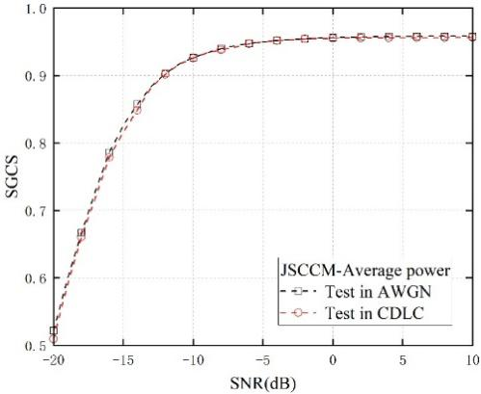  Figure 21. SGCS performance of JSCCM under different testing channels, where the training channel is AWGN and training SNR is 10dB.  Observation 20: The SGCS performance of JSCCM under AWGN and CDL-C channels is similar.  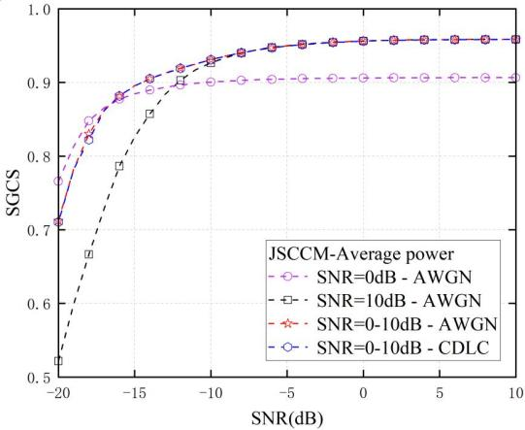  Figure 22. SGCS performance of JSCCM with mixed-SNR training, where the training channel is AWGN.  Observation 21: Compared to models trained at any fixed SNR level, the mixed-SNR-trained JSCC model is more robust and generalizable across diverse SNRs.
Samsung | #1, #2, #3 | 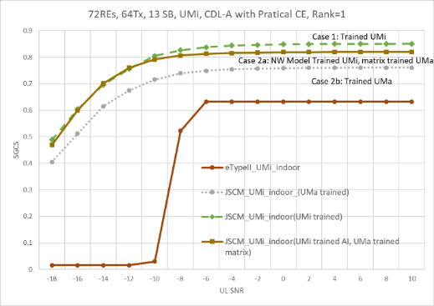  Figure 13. Generalization performance over CDL-A channel with PAPR restriction
MediaTek | #1, #2, | 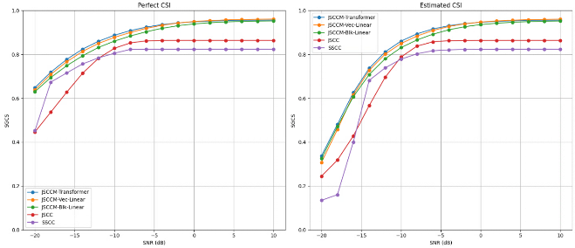  Figure-2.4.1.2.1 SGCS versus UL SNR for SSCC, JSCC and JSCCM.  Observation 2.4.1.2.1: JSCCM shows better performance than JSCC and SSCC in UL fading channels under conventional channel estimation (e.g., LS-CE with LMMSE interpolation) and equalization (e.g., LMMSE),
vivo | #1, #2, | 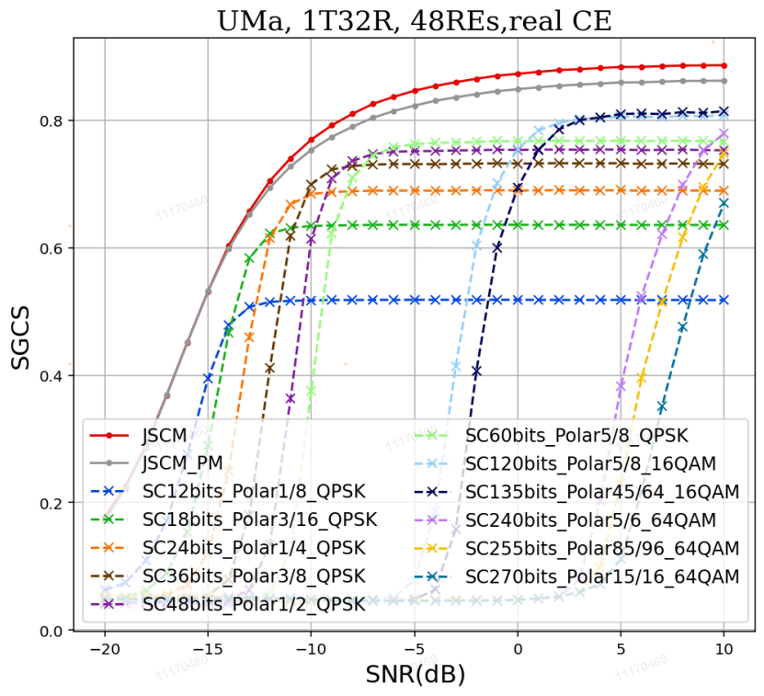  The comparison between the JSCM-based CSI feedback and the SSCC-based CSI feedback under UMa channel with ideal/real channel estimation
Lenovo | #1, #2, | 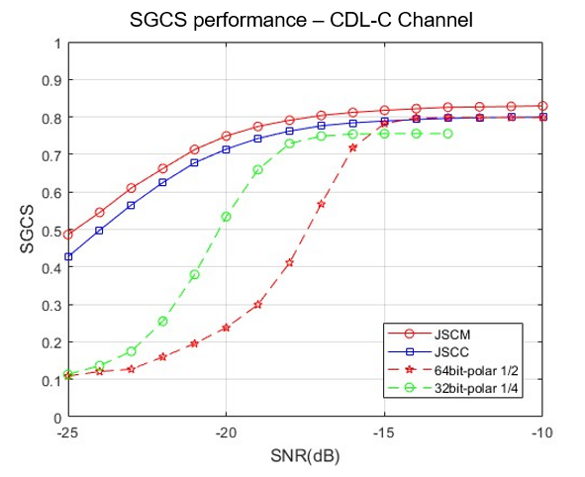  Figure 7. Performance of JSCC/JSCM for CSI feedback
BUPT | #1, #2, | 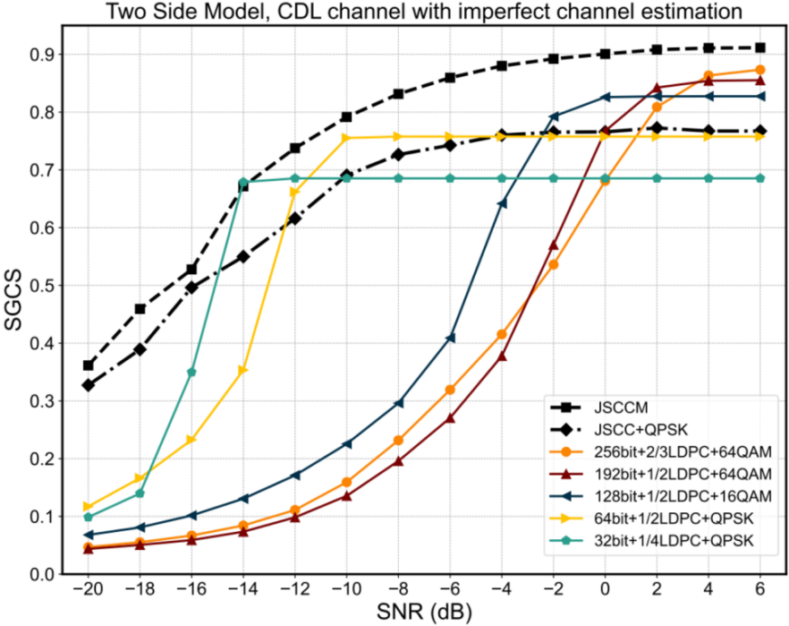  Fig. 5 Squared generalized cosine similarity (SGCS) vs. SNR under various schemes
Apple | #2, | 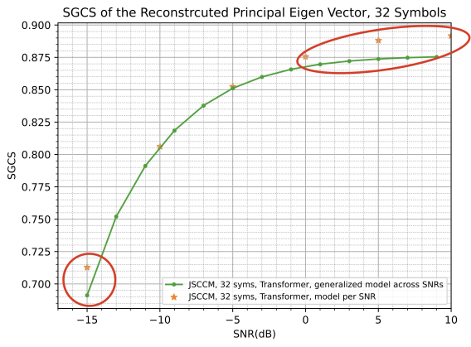  Fig. 3.2-2. Performance of JSCM with additional SNR information  Proposal 3-2-1: Study of AI based CSI compression using JSCM focus on enabling a simplified encoder at the UE side.  - Consider SNR signaling to enable UE side model input
Ericsson | #2, | 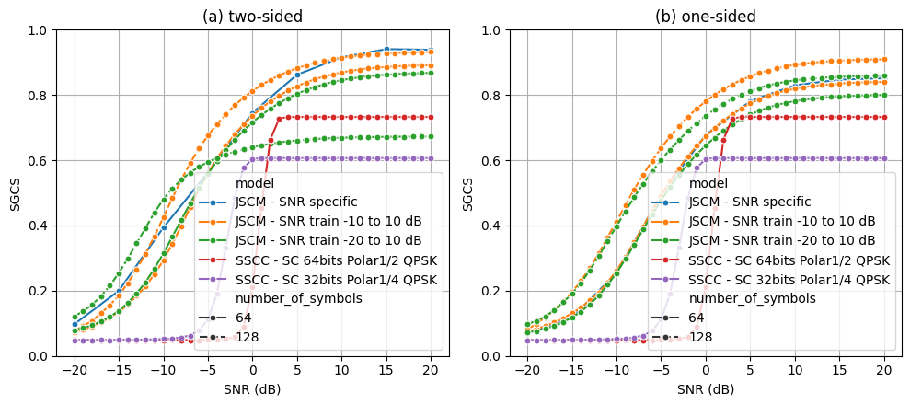  Figure 14: Performance of JSCM model for different payload sizes (number of TX symbols) trained for different SNR ranges. (a) two-sided. (b) one-sided.  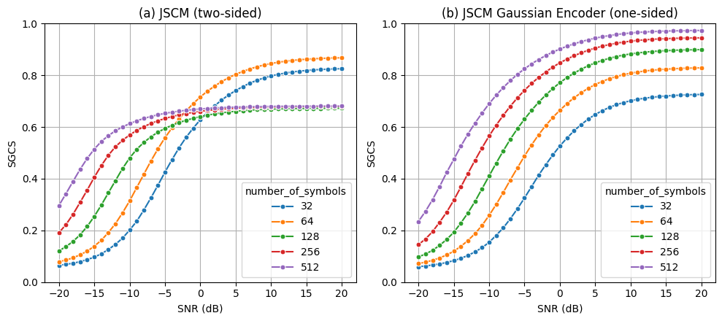  Figure 15: Performance of JSCM for different payload sizes (number of TX symbols) trained over SNR between -20 and 10 dB. (a) two-sided. (b) one-sided
Pengcheng | #1, #2, | 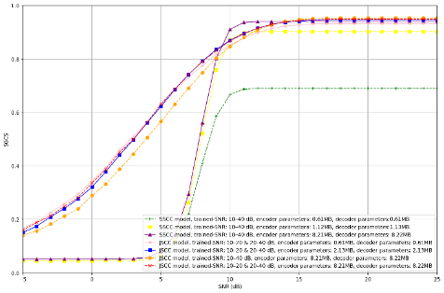  (a)SGCS versus SNR under multiple trainable-parameter budgets (reported as encoder/decoder parameter sizes).  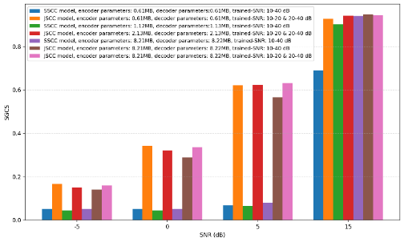  (b)SGCS at selected SNR points (e.g., −5/0/5/15 dB) to highlight the low-SNR region.  Figure 5: Complexity–performance trade-off between SSCC and JSCC.

CSI prediction
The following proposals are derived based on companies’ contributions.

Proposal 2.4-1
To evaluate the performance of non-AI/AI based CSI prediction at UE side or NW side, consider
- Intermediate metric: Subband/RB-level per layer eigenvector/precoder SGCS calculated between predicted channel and ground-truth channel
  - To compare NW side prediction with UE side prediction, the impact of CSI reporting shall be considered
  - FFS other intermediate KPI
- System-level metric: UPT (mean, 5%tile), CSI reporting overhead
  - CSI-RS overhead is considered in UPT calculation
  - Companies to report how to calculate CSI report overhead and CSI report mechanism
- Link-level metric: BLER/SE/throughput
- Complexity metrics: FLOPs/M
- For AI based prediction: number of parameters/M
- Baseline: Baseline#1 CSI measurement/report based on full CSI-RS ports/density
  - Baseline#2
    - Sample & Hold for frequency domain, companies to report how Sample & Hold is performed
    - Zero-padding for spatial domain
  - Other baselines are not precluded
- Companies to report sampling ratio and sampling pattern
  - Definition of sampling ratio and sampling pattern subjects to detailed domain for reduction
- FFS calibration error for BS antenna arrays other than 4TXRUs
- Companies to report the assumptions for spatial consistency modelling, if applicable
- The above is at least applicable to frequency/spatial domain prediction. Companies to report other sub-use case specific parameters, if applicable
Support/fine | OPPO
Not support

Company | Input
Qualcomm | Not clear in which domain the prediction is referred in Proposal 2.4-1. Suggest clarify the scope first, then we can discuss what aspects need to be considered in the evaluation.
Xiaomi | - Raw channel may be used for model input, so the SGCS calculation is not restricted to eigenvector.  - Spatial and frequency-domain CSI prediction may have different evaluation assumptions, e.g., port-pattern or frequency density.
CATT | Clarification on the scope is needed. We think “To evaluate the performance of non-AI/AI based frequency/spatial domain CSI-RS prediction at UE side” is more clear.
ZTE | - For the intermediate metric, we prefer raw channel matrix SGCS between predicted channel matrix and ground-truth channel matrix. For example, for low density CSI-RS design in the frequency domain, only channel information of partial RB can be measured, and then it’s more straightforward to use RB-level channel matrix as input for the CSI prediction. Conversely, for subband-level eigenvector SGCS, the derivation of eigenvector leads to additional UE complexity due to the associated SVD/EVD operations, and whether to perform average over multiple layers is not clear.  - For the last second bullet, companies to report not only sampling pattern but also sampling ratios. Additionally, for potential performance alignment across companies, we suggest to add a bullet to clarify ‘Companies to report details of models such as model structure, the number of layers, branches, format of parameters, etc.’  - For the baseline, to avoid overestimate of AI methods, we think it is better to define a non-AI prediction baseline, e.g., Wiener-filtering-based prediction.  - For the sample pattern, to align companies’ out puts, we think it is better to define the uniform sampling pattern as a baseline.
Huawei, HiSilicon | 1) For complexity metrics, the current “FLOPs/MACs or number of parameters” is for AI only. For non-AI, we need to consider the complexity of CSI measurement/generation based on non-AI methods, such as SVD decomposition.  2) For SLS metric, also need to consider UL CSI reporting overhead. For LLS metric, suggest to analyse CSI-RS overhead reduction.  3) To clarity: the full-dimension CSI is the CSI subject to full spatial/frequency dimension CSI-RS, right?  4) For first bullet, “ground-truth channel”=>”full spatial/frequency dimension ground-truth channel”  5) In some of our evaluations, spatial consistency is modelled for CSI prediction at UE side. In addition, for temporal domain CSI prediction, spatial consistency is also modelled in R18/19 evaluations. Therefore, we suggest to add spatial consistency modelling for applicable cases.  If applicable, spatial consistency Procedure A with 50m decorrelation distance from TR 38.901 is used for SLS (if not used, assumptions used need to be reported). UE velocity vector is assumed as fixed over time in Procedure A modelling.
vivo | Support
Samsung | To separately see the impact of the RS prediction performance, we suggest RB-level SGCS. Subband-level SGCS could be unnecessarily tied to the reporting scheme/config.  - Intermediate metric: SubbandRB-level eigenvector SGCS calculated between predicted channel and ground-truth channel
LG | Agree with Qualcomm,
TCL | For Intermediate metric, the NMSE could also be considered when full channel matrix as model input
China Telecom | Need to clarify whether the study focuses on CSI prediction in spatial domain/frequency domain, or both.
Ericsson | Proposal 2.4-1  There are different sub use cases captured in the observation table for CSI prediction, each use case may require different simulation assumptions and different baseline schemes for performance comparison. Is this proposal targeting for sub-case A: Frequency and/or spatial domain CSI prediction with sparse/low overhead CSI-RS with AI/ML?  For Sub-Case A, we think both UE-sided CSI prediction and NW-sided CSI prediction can be studied. Below we provide suggested changes for evaluating the performance of sub-case A:  To evaluate the performance of non-AI/AI based CSI-RS prediction frequency and/or spatial domain CSI prediction with sparse/low overhead CSI-RS at UE side or NW side, consider  - Intermediate metric: Subband-level eigenvector SGCS calculated between predicted channel and ground-truth channel (e.g., for NW-sided model), subband-level precoder based SGCS calculated between predicted channel and ground-truth channel (e.g., for UE-sided model)  - System-level metric: UPT (mean, 5%tile)  - Link-level metric: BLER/SE/throughput;  - Model/computation complexity at UE side or NW side: FLOPs/M  - Model size: Number of parameters/M  - Baseline: Baseline#1: sample & hold, Baseline#2: full-dimension CSI measurement/report based on full CSI-RS ports  - Companies to report sampling pattern  - Companies to report the considered non-ideal factors, if assumed, e.g., BS RF and array impairments, UE channel estimation errors  Not all simulation parameters are listed in proposal 2.4-1 for potential study of this use case. Is the plan to select candidate parameters from the Tables discussed for general MIMO SLS/LLS assumptions, after the tables become stable?  For temporal domain CSI prediction sub use case, we think the evaluation methodology used in NR study can be largely reused for 6G, by considering newly introduced MIMO evaluation parameters for 6G.
NTT DOCOMO | It should be clarified that the CSI prediction includes the spatial/port domain and frequency domain.  When the spatial/port domain is considered, the baseline#1 sample & hold should be clearly defined. It can be up to company to select which measured port is used for predicting other ports.
FL | The proposal is updated based on companies’ input.  Regarding the scope of this proposal, a note is added to clarify.
Qualcomm | The section title is CSI prediction, while the proposal says CSI-RS prediction. We are not sure what is CSI-RS prediction. Can FL please clarify?

Proposal 2.4-2
For AI based CSI prediction, evaluate generalization/scalability performances of prediction models at least across one or more of the following scenarios/configurations
- Various deployment scenarios, e.g., UMa, InH
- Various carrier frequencies
- Various indoor/outdoor distributions
- Various BS antenna configurations, e.g., antenna spacing, antenna virtualization/TxRU mapping, antenna port layouts, antenna port numbers
- Various sampling ratios and/or sampling patterns
- Various UE side parameters, e.g., UE speeds, UE channel estimation errors, UE antenna configurations
- The above is at least applicable to frequency/spatial domain prediction. FFS other sub-use case specific generalization aspects, if any
Support/fine | OPPO
Not support

Company | Input
Qualcomm | Not clear in which domain the prediction is referred in Proposal 2.4-2. Suggest clarify the scope first, then we can discuss what aspects need to be considered in the evaluation.  If the proposal is referring to temporal domain CSI prediction, it has already been studied in 5G, so there is no need of duplicated study.
CATT | Same as Proposal 2.4-1, clarification on the scope is needed. We think “For AI based frequency/spatial domain CSI prediction” is more clear.
ZTE | - For the generalization evaluation, if time domain CSI prediction is assumed, at least the UE speeds (e.g., 10km/h, 30km/h, 60km/h, etc.) should be considered since the CSI prediction largely relies on the channel correlation across time instances.  - For the last bullet, not sure the necessity of evaluating various sampling ratios for generalization/scalability purpose. The change of sampling rations leads to different model input dimensions, which can be enabled by the same or different UE-side models, up to UE implementation.
Huawei, HiSilicon | OK for spatial/frequency domain CSI prediction.  For temporal domain prediction, need to additional consider UE speeds.  For cross beam prediction or cross carrier prediction, need to consider sub-use case specific generalization cases, such as frequency bands, codebooks, different properties of RF modules, etc.
vivo | Support
Samsung | Support
InterDigital | Agree with Qualcomm: the overall scope for AI based CSI prediction is not clear, it needs to be clarified first. However, as also commented in response to CSI compression, we do not think use cases from 5GA should get an automatic pass – assessment against appropriate non-AI/ML baseline for 6GR would be necessary eventually.
LG | Support
TCL | Support to varying the UE velocity as it impacts the channel coherent time.
ETRI | Proposal 2.4-2: Similar view with QC that clarification of domain for CSI prediction should be needed.
Ericsson | Proposal 2.4-2  We suggest adding the following into the study list  - Various UE speeds  - Various UE channel estimation errors  - Various UE antenna configurations
FL | The proposal is updated based on companies’ input.  Regarding the scope of this proposal, a note is added to clarify.

CSI framework

Unified CSI signaling framework

Brief summary on design principle
Design a CSI acquisition framework at least the following guiding design principles:
- Common framework for supporting multiple scenarios, for the serving cell CSI, LTM CSI, and CSI for SCell activation. E.g., based on the LTM CSI measurement and reporting configuration framework.
- A unified framework for both AI and non-AI.
- Managing the increase in RS overhead, CSI feedback overhead, and UE complexity.
- Support UEs with different capabilities
- Minimized RRC configuration overhead

FL: No intention to spend time to discuss this proposal. Just want to acknowledge the above design principle, and we will keep that in mind for the discussion in the future.

Observation
For an efficient 6GR CSI framework design, at least the following aspects can be improved:
- Scheduling restriction and UE complexity from the coupled operation of triggering CSI measurement and reporting
- Duplicated operation of P-CSI and SP CSI, making the CSI framework overcomplicated
- Unclear justification of CSI on PUCCH, causing complex UCI multiplexing rule
- The need of early CSI acquisition in the initial access to avoid conservative link adaptation
- The need of UE initiated CSI reporting to reduce latency/overhead and to facilitate efficient adaptation to DL CSI
- The need of spatial domain adaptation for NES in consideration of CSI measurement and reporting.
- Overcomplicated CPU calculation and timeline design

Company | Input
Mod v0 | Several companies suggested to write an observation.  This is what I can summarized based on the inputs from companies, which actually can match the proposals.  So, maybe no need to spend time on polishing the wording of this?

CSI reporting framework design
Several companies proposed simplification on CSI-RS triggering and report framework. Following directions/justifications have been proposed by companies:
Table 3.2A: Summary for directions for CSI framework simplification
Directions | Summary of observations | Summary of companies’ views
#1  Decoupling of CSI measurement triggering and reporting Triggering. | Motivation  1. Relax UE processing timeline  2. Avoid out of order issue  3. Reduce UE complexity and power  4. Relax scheduling restriction, mitigate scheduling latency.  FL assessment: Wide supported | Supported by (1516): Nokia, Interdigital, ZTE, MediaTek, CMCC, xiaomi, Ericsson, NEC (Unified for UEI-/NWI-), China Telecom, Sony, DOCOMO, Qualcomm, Samsung. Apple, vivo
#2  Restriction of uplink channel for CSI report | Motivation of olution #2-1: CSI report only in PUSCH  1. PUSCH-only can result in simplifying UCI handling (multiplexing/prioritization) rules and procedures  2. Avoid complicated PUCCH resource determination  3. Easy to handle large payload.  4. Avoid duplicated function  Motivation of solution #2-2: AP-CSI report on PUSCH and P-CSI report on PUCCH.  1. Has been commercially deployed in 5G  FL assessment: can be discussed together with #3 | Solution #2-1: CSI report only in PUSCH  - Supported by (11): Nokia, Spreadtrum, InterDigital, OPPO, Lenovo, Fujistu (FFS on PUCCH), HONOR, Panasoic (FFS), Qualcomm, DOCOMO, Samsung  Solution #2-2: AP-CSI report on PUSCH and P-CSI report on PUCCH.  - Supported by (67): OPPO (low payload on PUCCH), CMCC, Huawei, Panasonic (FFS AP/SP on PUSCH, P on PUCCH), ZTE, Xiaomi, vivo
#3  Reduction of CSI reporting type | Issues for P-CSI  1. P-CSI is not needed on top of SP CSI.  2. Large overhead of P-CSI  Benefit of P-CSI  1.No PDCCH trigger  2. Wideband P-CSI on PUCCH widely used, especially for TDD  Issues for SP-CSI  1. SP-CSI can be treated as AP with multiple UL grant.  2. SP-CSI is not widely commercialized.  FL assessment: can be discussed together with #2 | Solution #3-1: Support P/AP CSI reporting, FFS on SP CSI reporting  - Supported by (45): Nokia, MediaTek, OPPO, Huawei, CMCC, vivo  Solution #3-2: Support AP CSI reporting, FFS on P/SP reporting  - Supported by (3): [CATT], Samsung (AP only, SP as a special case of AP), Fujitsu  no change from NR: Support P/SP/AP CSI reporting  - Supported by (3): InterDigital, ETRI, DOCOMO
#4  CSI report container/medium (L1 v.s. L2) | Concerns on CSI 1 L1:  Scheduling restriction, complex timelines and multiplexing rule  (expect to be resolved by #1 decoupling of triggering measurement and report)  Concerns on CSI in L2:  Significant delay, unnecessary overhead, significant UPT performance degradation, CSI reliability&robustness, issues for CSI retransmission, complexity of interworking of L1/L2  FL assessment:  Based on companies’ inputs and discussions:  - L1 for CSI reporting represents vast majority views with 18 companies supporting (v.s. 3 companies supporting L2 for CSI reporting)  - Some companies propose to further study this issue (e.g., for event-based reporting, whether PUSCH is used for UCI reporting etc.), and some companies point out that deciding between L1 and L2 for CSI reporting could depend on 6GR CSI payload range determination.  The vast majority companies support L1 for CSI reporting. Whether L2 can also be supported can still be studied after RAN1 has some initial discussions on the CSI payload range (probably after a few meetings). | Support of L1 (1617): Huawei/HiSilicon (PUCCH/PUSCH), InterDigital (PUCCH/PUSCH), OPPO (PUCCH/PUSCH), CATT, ZTE, Xiaomi, Ofinno, NEC, Samsung, Apple (PUCCH/PUSCH), Lenovo, Docomo (PUSCH only), Qualcomm (PUSCH only), Honor (PUSCH only), TCL, LGE, vivo  Support of L2 (3): MediaTek (as one option to simplify UCI), Ericsson, Intel (for non-latency-critical CSI)  Further study is needed (3): Nokia (study L2 for event-based reporting), ETRI, Panasonic (study CSI as L2 data when PUSCH is used for UCI reporting)

Table 3.2B: Preliminary simulation result
Company | SLS results
Company | Direction # | Metric | Observation
Samsung | #4 | UPT | Observation #23: in terms of average UPT, SLS results show that using L2 MAC CE for CSI reporting would result in significant performance degradation (~10% loss) relative to using L1 UCI for CSI reporting with a variety of codebook assumptions.  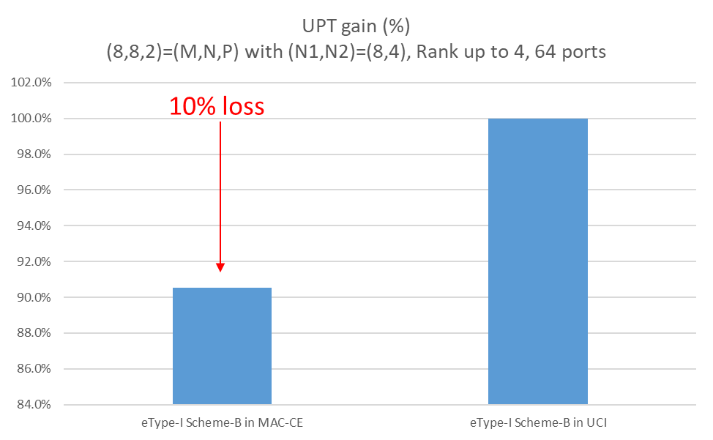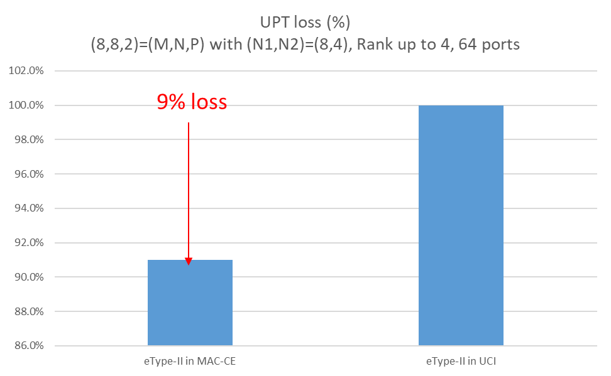
Ericsson | #1 | UL object tail latency

Based on the above summary, we have the following proposals:

Proposal 3.2-1C
For simplification of CSI reporting framework, study at least following:
- Decoupling of CSI measurement/generation/computation triggering and CSI reporting triggering
- In addition to AP-CSI report, whether/how to also support P- and/or SP-CSI report
- In addition to PUSCH, whether/how to also report CSI on PUCCH
- Other aspects are not precluded.
Support/fine | Nokia, Interdigital, ZTE, MediaTek, CMCC, xiaomi, Ericsson, NEC, China Telecom, Sony, DOCOMO, Qualcomm, Samsung. Apple, …
Not support

Proposal 3.2-2
Support CSI report in L1 as the basis for CSI container design. Study whether to also support CSI report in L2.
Support/fine | Huawei/HiSilicon, InterDigital, OPPO, CATT, ZTE, Xiaomi, Ofinno, NEC, Samsung, Apple, Lenovo, Docomo, Qualcomm, Honor, TCL, LGE, ….
Not support | MediaTek

Proposal 3.2-2C
For CSI container design, FFS on CSI report in L1 and/or CSI report in L2.
Support/fine | Huawei/HiSilicon, InterDigital, OPPO, CATT, ZTE, Xiaomi, Ofinno, NEC, Samsung, Apple, Lenovo, Docomo, Qualcomm, Honor, TCL, LGE, ….
Not support | MediaTek

Table 3.2C Additional inputs
Company | Input
Mod v0 | There were some other directions mentioned by some companies, e.g., CSI omission, which can be discussed later.  Based on my understanding of Tdoc view, I put some potential support companies’ name, pls check
Samsung | Proposal 3.2-1  Support. We think the proposal would be a good starting point. P and SP CSI are duplicated operation in our view, and P-CSI on PUCCH created complex UCI mux and priority rules in NR, which we don’t think it’s essentially needed. Supporting SP/AP-CSI only on PUSCH can streamline 6GR CSI framework while providing the same functionality.  Proposal 3.2-2  Support. As described in our tdoc, it’s unclear the benefit of reporting CSI in L2, given that it incurs large latency, overhead, UPT loss, and additional delay from frequent retransmissions.
MediaTek | Proposal 3.2-1:  - We would like to clarify decoupling “CSI-RS triggering” from CSI reporting triggering cannot shorten the preparation delay for an PUSCH with CSI request. The Longer preparation delay is mainly because UE takes the time for “computing the CSI”, such that we have Z/Z’ requirement defined in NR. Even the CSI-RS measurement is separately triggered, but UE still preform joint CSI computation and reporting once triggered, the long PUSCH preparation delay due to CSI computation is still observed. Hence, to literally loose UL scheduling restriction due to in-order scheduling requirement, we should study “ Decoupling of CSI measurement/generation triggering and CSI reporting triggering”.  - If “decoupling of CSI measurement/generation triggering and CSI reporting triggering” is agreed to be one study direction, then we may not need to define the CSI reporting type(s). Instead, only “CSI computation type” should be defined. For example, “CSI computation type” defines the time-domain behaviour when the UE should complete CSI computation and make the generated CSI be ready for transmission (i.e., periodic/aperiodic/even-triggered CSI computation), and when to transmit the generated CSI is according to NW allocation on the corresponding UL resource. Note that the above comment applies to either L1-based or L2-based CSI container we assume. Hence, we suggest revising “report” as “computation” if the first bullet is agreed.  Proposal 3.3-2:  It is too early to decide the baseline or prioritize any solution at the first meeting of the study item. Moreover, supporting both L1 and L2 at the end is NOT a good direction to go. That has no clear benefit. We are okay to study those two options but not okay to prioritize anyone for now.
OPPO | For Proposal 3.2-1, other simplification is not excluded.  For Proposal 3.2-2, support the proposal.
CMCC | Proposal 3.2-1:  We prefer to keep P CSI report on PUCCH.  P CSI report on PUCCH has been widely deployed in 5G commercial network, especially in TDD mode. It can not only work with SRS measurement to improve CSI accuracy for cell center UE, but also work as a default or fallback CSI for cell edge UE to guarantee the basic performance.  Proposal 3.2-2:  Support the proposal.
xiaomi | Proposal 3.2-1  The direction is fine for us. However, we think it may be a bit too early to come out solutions in the first meeting. Some high-level directions as the following may be enough. We can study more detailed solutions in the future meetings.  Study simplified CSI measurement and CSI reporting mechanisms, e.g.,  - Decoupling of CSI measurement triggering and CSI reporting triggering  - Time-domain behaviors of CSI report  - Physical channels for CSI report  For Proposal 3.2-2, support the proposal.
Nokia | Proposal 3.2-1:  Support study of decoupling measurement from CSI reporting triggering  Regarding the restriction on where different CSI report types are sent, our understanding of the proposal is to study whether reporting on PUCCH is needed and if so, which CSI report types it should be restricted to  Proposal 3.2-2:  This proposal is way too early in such a form, discussions more than welcome but maybe with not too aggressive proposal unless the views from companies are supporting this…We welcome here simplifications to the container design for CSI and PUSCH -only transmission.  Proposal 3.2-2 (update)  Consider CSI reporting in PUSCH-only as the basis for CSI container design. Whether container is L1 or MAC is for further study.
CATT | Proposal 3.2-1: OK in general  - Support to study decoupling CSI measurement triggering from CSI reporting triggering  - Ok with the direction, AP CSI reporting should be supported, further study whether/how to simplify P/SP CSI reporting  - OK with the direction. In 5G Type I codebook based P/SP CSI reporting can be reported on PUCCH because the overhead is relatively low. For 6GR, as most companies would like to consider a single parameterized codebook for both low and high resolution CSI feedback, and for both sTRP and mTRP, the CSI feedback overhead range can be very wide. For medium to large overhead, the advantage of multi-user UCI multiplexing on PUCCH cannot be achieved and there are little differences on transmission and delay performance for PUCCH and PUSCH based CSI reporting. In addition, we also acknowledge the benefits of simplified PUCCH format and multiplexing rules for only considering CSI reporting on PUSCH.  Proposal 3.2-1: Support
ZTE | - For Proposal 3.2-1, regarding the second bullet, we think at least P/AP CSI report should be supported, and we can further study whether/how to support SP CSI report. In real deployment, P CSI report is the most used type of CSI reports. Besides, we think it is also necessary to study the decoupling of CSI measurement and CSI report configurations. In legacy, the number of CSI-RS ports for CSI measurement and report are restricted to be same. However, as most companies proposed, it could be essential to support low-spatial-density CSI-RS, then the number of CSI-RS ports for CSI measurement could be significantly smaller than that for CSI report.  - For Proposal 3.2-2, we can be okay to study CSI report in L2 at current stage. However, we doubt the motivation of doing so. Firstly, CSI report is L1 information, the transmission of CSI report requires high robustness and low latency, and such requirement cannot be satisfied by L2 signaling. Secondly, CSI report has been reported in L1 since Rel-15 in NR, and it has been working well. Lastly, we did NOT see any necessity of reporting CSI in both L1 and L2, which could cause unnecessary chaos in the signaling design.
Huawei, HiSilicon | Proposal 3.2-1:  For the second bullet and the third bullet, as commercially deployed widely in NR, at least periodic CSI report on PUCCH should be supported. We are fine to further study SP-CSI report.  Proposal 3.2-2:  We don’t see the need to study L2-based CSI reporting, and prefer to only agree the first part.  In NR, both periodic CSI on PUCCH and aperiodic CSI on PUSCH are deployed. There is no fundamental problem in such a deployment that requires shifting the entire mechanism to L2. Due to reasons of efficiency, reliability & robustness, latency and coding performance, the CSI report as L1 UCI should only be supported.
vivo | Support Proposal 3.2-1. Further we also prefer AP-CSI report on PUSCH and P-CSI report on PUCCH.  Support Proposal 3.2-2.  Note: we add our preference to the Table 3.2A.
InterDigital | Support both proposals.
LG | We also prefer to keep P CSI report. For SP CSI report, we can consider SP CSI report on PUSCH only.  Ok with Proposal 3.2-2:
TCL | Regarding the mTRP, the focus should be on M-TRP with a single DCI.
ETRI | Proposal 3.2-1: Support in principle.  Regarding the decoupling of CSI measurement triggering and CSI reporting triggering, we think it should be carefully designed as a generalized framework considering various purposes and usages (e.g., sparse CSI measurement/reporting, CSI measurement/reporting for SD NES, event-driven CSI reporting, etc.). In addition to AP-CSI, we think that at least P-CSI reporting should be supported for fallback mode. P-CSI reporting overhead may be needed to acquire CSI for supporting lightweight functionality with long periodicity. For streamlined PUCCH design, we think CSI on PUCCH can be used for limited cases such as reporting lightweight P-CSI.  Proposal 3.2-2: Support.
Sharp | We support Proposal 3.2-1 and 3.2-2. For Proposal 3.2-2, we do not see the benefit to support L2-based CQI/PMI/RI reporting.
Ericsson | Proposal 3.2-1  The list of issues to be studied for CSI framework is incomplete. We think at least the following two should be added:  - Simplify the NR CSI resource configuration framework including whether/how to simplify the current 3-level structure for configuring measurement resources  - Study approaches to jointly configure resource sets for channel measurement resources and interference measurement resources  - Study how to dynamically update CSI related parameters to support dynamic adaptations in response to short/mid-term channel variations of channel  Note that all 3 above are related to minimizing RRC configuration overhead.  In addition, the first bullet of the proposal should include CSI measurement/computation triggering. If the first trigger is only for CSI-RS measurement, this may not solve issues such as PUSCH scheduling restriction, etc.  Proposal 3.2-2  Not support.  The 6GR study should begin by identifying and understanding the problems in the NR design rather than prematurely down-selecting solutions. In NR, CSI and HARQ feedback are constrained by tight, synchronous timelines defined by PUCCH/PUSCH formats, K-values, and fixed timing relationships. These constraints create worst-case timing bottlenecks due to DL/UL dependencies and result in UL “dead time” where resources cannot be used because UCI windows must be preserved. The limitations become particularly severe in multi-carrier, dynamic TDD and mixed-numerology scenarios.  In addition, PUCCH handling is inherently complex, with numerous multiplexing rules across UCI types, leading to complicated prioritization, limited extensibility for new UCI types, and lack of flexibility for large or irregular CSI reports. NR L1 UCI also suffers from coverage and power-limitation challenges. These issues are all part of a broader set of NR framework limitations that must be studied holistically.  The MIMO agenda is not the place to take decisions that would effectively pre-empt or disable the ongoing discussions on CSI/UCI transport in 6G. If the proposal were accepted, it would short-circuit the study of UCI transport options before the study item has even examined the problem space. Decisions on whether CSI resides in L1, L2/MAC, PDCP, or any other container must be studied jointly in RAN1 and RAN2 during the study item phase, not predetermined in the MIMO agenda.
NTT DOCOMO | 3.2-1: Basically fine, and discussion on the first bullet should be done after clarification of reusing 5G NR OoO scheduling restriction for 6GR.  3.2-2: if L1 is supported, study of L2 would be unnecessary. We suggest removing the second sentence.
CEWiT | Proposal 3.2-1:  - We feel that P-CSI should not be considered as a second option for AP-CSI. We agree with the issues mentioned for P-CSI. But, supporting only SP-CSI or A-CSI will lead to heavy dependency on DCI scheduling and this in turn will lead to higher CSI latency which is not desirable. We feel that all P-CSI should be supported in 6G. Similarly, supporting CSI only on PUSCH will lead to unnecessary dependency on DCI scheduling which is not desirable. We prefer to support CSI on PUCCH as well. Also, the UE-initiated CSI reporting, which was discussed in the later sections, works well in tandem with periodic reporting rather than A-CSI reporting.  Proposal 3.2-1:  - We support this proposal
NEC | Proposal 3.2-1: Support.  Proposal 3.2-2: We share similar view as Huawei, prefer to only agree on the first part..
Futurewei | Proposal 3.2-1:  In our view, P-CSI on PUCCH should also be supported in addition to AP-CSI.  Proposal 3.2-2:  We support CSI report in L1. The need of CSI report in L2 is questionable. In general, we think the container discussion can wait.
TCL | Proposal 3.2-1:  From a functional perspective, we believe that SP and P CSI reporting can be combined into a single CSI reporting type. Moreover, the third bullet regarding the CSI reporting container should be discussed under Proposal 3.2-2.  Proposal 3.2-1:  Support
FL2 | Proposals 3.2-1C and Proposal 3.2-2C have been updated and for comments
Fujitsu | Proposal 3.2-1C: Support.  Proposal 3.2-2C: Support.
Ofinno | Proposal 3.2-1C: Support the proposal in principle.
OPPO | Proposal 3.2-1C: Wording generation/computation seems not necessary. The CSI generation/computation is inherent in the measurement operation. Once the measurement of CSI-RS is done, the corresponding CSI generation/computation operation begins. Therefore, those operations are strongly coupling. It is okay to only have the wording “measurement”.  Proposal 3.2-2C: L1 report can be starting point and FFS L2.

Early/Fast CSI acquisition
Many companies propose to support/study early/fast CSI acquisition in the initial access procedure (e.g., Msg3) to avoid conservative link adaptation, as well as for Scell activation, lower layer mobility, and M-TRP CJT scenarios. In addition, some companies (Fujitsu, AT&T) suggested to defer the study until rel-20 work becomes stabilized.
Table 3.3A: Summary for scenarios for early/fast CSI acquisition
Directions | Summary of observations | Summary of companies’ views
#1  UE transition from IDLE/INACTIVE to CONNECTED mode, | Justification:  Early/fast CSI acquisition during initial access (e.g., CSI reporting via Msg3) can ensure timely link adaptation hence avoiding sudden throughput drop when the UE starts entering the CONNECTED mode.  This issue is being discussed in Rel-20 NR MIMO as one of the design objectives.  FL assessment: A number of companies showed interests and provide analysis/justification. | Supported by (12): Nokia, OPPO, ZTE, CMCC, Ofinno, xiaomi, Apple, ETRI, Ericsson, Panasonic, Sony, Qualcomm
#2  Early CSI for lower layer mobility | A number of companies have shown interests in and also performance benefits of early CSI acquisition during mobility, which may involve handover, cell switching and etc.  Rel-19 LTM has supported a form of early CSI acquisition. | Supported by (10): Interdigital, OPPO, TCL, ZTE, xiaomi，NEC, Apple, ETRI Sony, DOCOMO
#3  Scell deactivation to activation, and Scell dormancy state to active state | Similar observations as #1. | Supported by (7): Nokia, vivo, Apple, ETRI, Ericsson, Sony, DOCOMO
#4  M-TRP CJT scenarios | According to companies’ inputs, it is FL’s understanding that early CSI acquisition is important/beneficial for M-TRP CJT scenario. This should apply to both  (1) initial access (i.e., for the UE transitioning from IDLE/INACTIVE to CONNECTED) and  (2) lower layer mobility  FL assessment: According to discussions from companies and FL’s understandings of #1 and #2 above, FL proposes to include M-TRP CJT in the discussions of #1 and #2. | Supported by (3): TCL, ZTE, CMCC

Table 3.3B: Preliminary simulation result
Company | SLS results
Company | Direction # | Metric | Observation
ZTE | #4 | UPT,  # of XR packet | 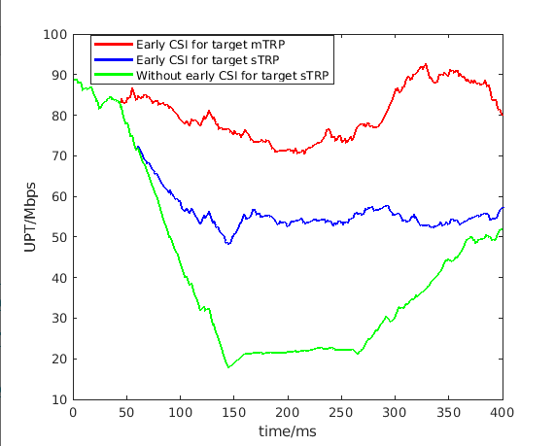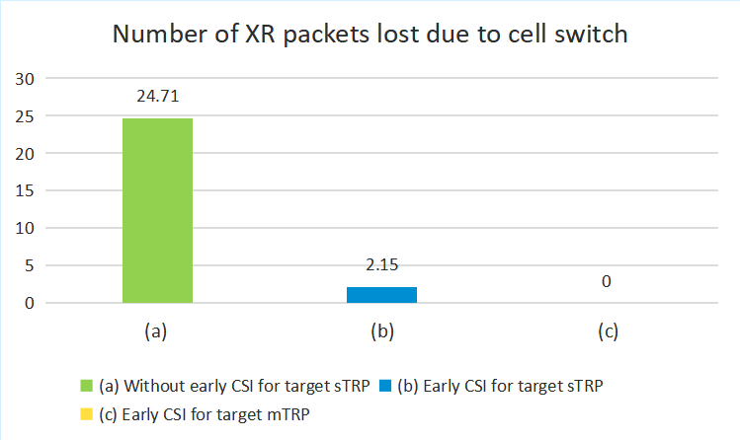  (a) (b)  Figure 15 Performance comparison of different early CSI acquisition schemes for (a) normal traffic model and (b) XR service model

Proposal 3.3-1B
Study on how to support early CSI triggering/reporting, at least including the following scenarios:
- UE transition to CONNECTED mode,
- During activation of serving cells
- Lower layer mobility

- Note: Early beam report is to be discussed separately in the Beam Management agenda
Support/fine | Nokia, OPPO, ZTE, CMCC, Ofinno, xiaomi, Apple, ETRI, Ericsson, Panasonic, Sony, Qualcomm, Interdigital, TCL, NEC, DOCOMO, vivo…
Not support

Proposal 3.3-1C
Study on how to support early CSI triggering/reporting, at least including the following scenarios:
- UE transition to CONNECTED mode,
- During activation of serving cells
- Lower layer mobility
- Note: Early beam report is to be discussed separately in the Beam Management agenda
Support/fine | Nokia, OPPO, ZTE, CMCC, Ofinno, xiaomi, Apple, ETRI, Ericsson, Panasonic, Sony, Qualcomm, Interdigital, TCL, NEC, DOCOMO, vivo…
Not support

Table 3.3C Additional inputs
Company | Input
Mod v0 | I suppose all companies should be ok with the above proposal.  If additional input,
MediaTek | Even we are supportive to all these use cases, we are not sure whether this is the right agenda item to discuss them:  - Procedure of UE transition from IDLE/INACTIVE to CONNECTED mode is unclear and is to be discussed in AI 10.5.1.1 or AI 10.5.1.2. Based our understanding from Rel-20 MIMO early CSI, more discussion focused on the procedure/signaling. W/o common understanding on the initial access and RACH procedure, it is difficult to agree on how to support early CSI/CSI-RS.  - Same question on Scell deactivation to activation and lower layer mobility, if the procedure is discussed in another agenda items, early CSI should be considered when we design the corresponding procedure. Meanwhile, it is also unclear whether 6G will support SCell dormancy state.
Qualcomm | Thanks for the proposal. We have two comments  - Suggest to remove “CJT” to also study other mTRP modes, e.g. NCJT, various sDCI/mDCI mTRP schemes. The concept of mTRP CJT has been on paper for decades, but whether it can bring meaning gain in reality is questionable. The implementation is full of challenges. At this stage, we prefer not only study CJT  - Suggest to also study early CSI for CA case in LTM. It is beneficial and straightforward to also enable early CSI for SCell in candidate config, in addition to PCell as in 5G  - Note: We didn’t include the proposal on early CSI for LTM, since it was unclear that mobility can also be discussed in this agenda  - UE transition from IDLE/INACTIVE to CONNECTED mode including sTRP and M-TRP CJT  - Scell deactivation to activation, and Scell dormancy state to active state  - Early CSI for lower layer mobility including sTRP and M-TRP CJT, PCell and SCell  - Use Rel-20 early CSI as a starting point  - Note: Early beam report is to be discussed separately in the Beam Management agenda
OPPO | Similar view with MTK. Based on our understanding, Rel-20 early CSI may not be the starting point for 6G study. First, Rel-20 early CSI is studied based on NR access procedure, which may not exactly hold for 6G. Second, Rel-20 early CSI WI has not been finalized yet. So for the 6G study, this constraint may not be needed.
Xiaomi | Regarding the mTRP, it should be more general rather than focused on CJT.  Another note may be needed:  Note: the study early CSI triggering/reporting should follow the progress of other agendas.
Nokia | Since terms such as INACTIVE mode, SCell dormancy, and lower layer mobility have not yet been defined for 6G, we should keep the proposal more generic at this stage. Also note that in Rel-19, early CSI acquisition was defined not only for LTM but also for L3 handover.  At this point, there is no need to highlight specific deployments such as sTRP or mTRP. These details can be discussed later.  The term “fast” seems redundant.  In addition, it is important to discuss how the study of this feature shall be conducted. For early CSI in each scenario (e.g., initial access, cell switch), the significant impacts comes because of scenario-specific signaling and procedures. One option is to study early CSI together with the study of each specific scenario. This should be discussed.  We suggest the following rewording  Proposal 3.3-1(early/fast CSI)  Study on whether/how to support early/fast CSI acquisition, at least including the following scenarios:  • UE transition from IDLE/INACTIVE to CONNECTED non-connected to connected mode including M-TRP CJT,  • During activation of serving cells Scell deactivation to activation, and Scell dormancy state to active state  • For cell switch Early CSI for lower layer mobility including M-TRP CJT,  • Note: AI/ML CSI prediction can be considered
CATT | Regarding the 3rd bullet, “Early CSI for lower layer mobility”, further clarification is needed, is it the same as the R19 CSI acquisition before cell switch command, or is it something else?
ZTE | Fine with Proposal 3.3-1.
Huawei, HiSilicon | The early CSI triggering and reporting can be postponed until the main framework of 6GR CSI measurement & report has been stable. Furthermore, to use Rel-20 early CSI as starting point, it could be further discussed when Rel-20 early CSI is finished.
vivo | We believe that over-optimization is unnecessary for initial access scenarios like IDLE/INACTIVE to CONNECTED mode with typically lesser traffic requirements and no obvious benefit. A lightweight approach relying on SSB-based SINR measurements to assist initial MCS selection is sufficient, avoiding the unnecessary complexity and overhead associated with full-scale CSI reporting. Therefore, we suggest adopting the following updates for Proposal 3.3-1.  Proposal 3.3-1  Study on whether/how to support early/fast CSI acquisition, at least including the following scenarios:  - UE transition from IDLE/INACTIVE to CONNECTED mode including M-TRP CJT,  - Scell deactivation to activation, and Scell dormancy state to active state  - Early CSI for lower layer mobility including M-TRP CJT,  - Use Rel-20 early CSI as a starting point  - Note: AI/ML CSI prediction can be considered  - Note: which type of CSI is required in each scenario should be carefully considered/evaluated to avoid excessive optimization
InterDigital | Support in principle, however the details on the aspects and scope can be discussed later.
LG | Similar view with Qualcomm. For the first subbullet, we think it is premature to limit mTRP scheme to CJT at this stage. So, following modification is proposed.  - UE transition from IDLE/INACTIVE to CONNECTED mode including sTRP and M-TRP CJT,
TCL | Regarding the mTRP, the focus should be on M-TRP with a single DCI.
ETRI | Support in principle. We generally agree with Nokia. From an efficient design perspective, we think it would be better to consider early CSI when designing the functionality for each scenario, rather than adding early CSI as an add-on feature. Although this may have relatively lower priority, we would like this to be addressed in the Rel-20 SI.
Sharp | We are generally fine with Proposal 3.3.1.
Ericsson | Proposal 3.3-1:  Not sure why we need to single out M-TRP CJT? If the intention is to also study MTRP schemes, then one could simply say ‘sTRP and MTRP’. To generate early CSI, one would have to also consider the UE computation complexity of the early CSI being computed.
Sony | Support.  For early CSI for lower-layer mobility, to prevent data rate drops during handovers, carrier aggregation should also be included:  Early CSI for lower layer mobility including sTRP and M-TRP CJT, and carrier aggregation.
NEC | Support the proposal.
Futurewei | We are fine with the direction of the proposal. However, the details can be discussed later.
FL2 | Proposal 3.3-1C is new one for comments
Apple | For the CA case, we believe the CSI measurement on CC1 can be useful for CC2 if CC1 and CC2 are either in the same RF band at least, and AI/non-AI approach can be studied.
Fujitsu | Proposal 3.3-1C: We are OK with the proposal.
Ofinno | Proposal 3.3-1C: Support the proposal.
Sony | Proposal 3.3-1C: Generally fine, but we still prefer the formulation “Lower layer mobility including sTRP and mTRP CJT, and PCell and SCell” to clarify the scope.
Qualcomm | Support Proposal 3.3-1C

UE-Initiated / Event-Triggered CSI
Many companies support to extend the Rel-19 UE-initiated beam reporting (UEIBR) to a more generic UE-initiated/event-triggered CSI reporting in 6GR, motivated by
- latency/overhead reduction for CSI reporting
- more efficient UL resource allocation for CSI reporting
- more adapting to channel dynamics.
It is also worth noting here that in the Beam Management agenda (10.5.2.4), UE-initiated/event-driven beam management will be separately discussed targeting different use cases. It may be better to have a unified design between the two (e.g., UL report medium), but the FL also acknowledges that there would be some differences – for instance, CSI reporting may have different event definitions and/or triggering conditions from beam reporting. Based on the above, the following FL proposal is provided.
- Supported by (15): Nokia, InterDigital, Spreadtrum, TCL, CMCC, CATT, OPPO, xiaomi, NEC, Samsung, LG, Intel, Fujitsu, ETRI, Sony
- AT&T: Study is needed
- Evidence: Nokia field data (TDD FR1, 100MHz) shows ~41% of periodic CSI reports are redundant (unchanged content) even with 160ms periodicity. UE-initiated reporting could skip these, saving energy/overhead.

Proposal 3.4-1C
Support NW triggered CSI reporting as baseline. Study whether/how/use cases to support UE-initiated or event-triggered CSI reporting.
- Note: UE-initiated (event-triggered) beam management is to be discussed separately in the Beam Management agenda, under a unified CSI framework
Support/fine | Nokia, InterDigital, Spreadtrum, TCL, CMCC, CATT, OPPO, xiaomi, NEC, Samsung, LG, Intel, Fujitsu, ETRI, Sony, Ericsson …
Not support

Table 3.4A Additional inputs
Company | Input
Mod v0 | I suppose all companies should be ok with the above proposal.  If additional input,
MediaTek | We are generally supportive to periodic/aperiodic/event-triggered manner for CSI acquisition/computation. But we have some suggestions on proposals:  - As commented in proposal 3.2-1, in the concept of decoupling CSI measurement/computation triggering from CSI reporting triggering, studying/defining "CSI computation type" is more important, instead of “CSI reporting type”. But it should be discussed after RAN1 has agreed on decoupling triggering between CSI measurement/computation and CSI reporting  - Periodic CSI acquisition is very essential and widely used in real-field deployment. It is worthy to support that in 6GR. Whether to assume aperiodic CSI acquisition as FL recommended needs more discussion.  We are fine with discussing UE-initiated (event-triggered) BM in the other agenda, but it may turn out different solutions supported for BM and CSI, when handled by two groups of people, like event-trigger reporting for LTM and BM in NR. That makes implementation inconsistency and has no benefit. Hence, it will be better to strive to have a unified solution to support UE-initiated (event-triggered) framework for different use cases.
OPPO | Support.
xiaomi | Fine with the proposal. To have a unified reporting procedure, we think the definition/reporting contents of UE-initiated beam report can be discussed in beam management agenda. However, the reporting channel and timeline can be discussed in this agenda.
Nokia | We would like to see here and understand the list of options (and potential combinations) we have on the table before agreeing on something in the first meeting. So the Proposal should be more like:  Proposal 3.4-1(NW-/UE-triggered CSI)  Study Support NW triggered CSI reporting as baseline. Study whether/how to support and UE-initiated or event-triggered CSI reporting.  - Note: UE-initiated (event-triggered) beam management is to be discussed separately in the Beam Management agenda
CATT | Similar view as Xiaomi. The unified CSI framework for gNB triggered and UE triggered/initiated CSI reporting can be discussed in this agenda, UEIBR related issues such as definition/reporting contents and events can be separately discussed in the Beam management agenda.
ZTE | Generally fine with the proposal. We do NOT think all CSI report types and scenarios need UE-initiated or event-triggered CSI reporting. So, we suggest to modify the wording as follows:
  - Support NW triggered CSI reporting as baseline. Study whether/how/scenarios/report types to support UE-initiated or event-triggered CSI reporting.
  - Note: UE-initiated (event-triggered) beam management is to be discussed separately in the Beam Management agenda
Huawei, HiSilicon | As this is related to 6GR CSI measurement & report details, it can be discussed when 6GR CSI measurement & report discussion is stable.
vivo | Support FL’s proposal.
InterDigital | Support.
LG | Support
TCL | Support
ETRI | Support
Sharp | Support.
Ericsson | Support
Sony | Support.
NTT DOCOMO | Support Proposal 3.4-1.
NEC | Support, we also prefer unified NW triggered and UE initiated CSI report.
Futurewei | Support in principle.
TCL | Support
FL2 | Proposal 3.4-1C is the new proposals for comments
Apple | Okay
Fujitsu | Support.
Ofinno | Support proposal 3.4-1.

CSI Framework design for spatial domain adaption (NES)
11 companies proposed to study on the support of NES for 6G.

Proposal 3.5-1C
Study whether/how to accommodate spatial-domain adaptation for NES in CSI Framework design in relation to CSI-RS design.
Support/fine | Nokia, vivo, Samsung, Lenovo, Fujitsu, LG, Sony, DOCOMO, AT&T, KDDI, InterDigital, MediaTek, Ericsson
Not support

Table 3.4A Additional inputs
Company | Input
Mod v0 | I may miss some supporting companies, pls feel free to add your name in above table.  And if you have any additional view, pls comment below
InterDigital | We support proposal 3.5-1
MediaTek | We support this proposal in principle.
Qualcomm | Suggest clarify whether the sub-configuration based framework would be reused or supported for 6G.
OPPO | Both spatial-domain and power-domain adaptation can be considered in 6GR study.
CMCC | We also support spatial-domain adaptation for NES in CSI Framework design.
Xiaomi | Open to study it. But the 6GR NES should not largely increase the UE complexity and report overhead.
Nokia | Support
CATT | Generally ok, apart from spatial-domain adaptation, dynamic TRP on/off can also be considered for NES, therefore we suggest the following modification:
  Study whether/how to accommodate spatial-domain adaptation and dynamic TRP on/off for NES in CSI Framework design in relation to CSI-RS design.
ZTE | Fine with Proposal 3.5-1.
vivo | We believe that saving CSI overhead is one of the important factors that need to be considered in the design of the NES CSI framework. Besides, in multi-TRP deployments, TRP-specific DTX/DRX (or ON/OFF control) based on traffic conditions would also be beneficial for network energy saving.  Therefore, we suggest adopting the following updates for Proposal 3.5-1.  Proposal 3.5-1  Study whether/how to accommodate spatial-domain adaptation (dynamic port subset selection or TRP ON/OFF) for NES in CSI Framework design in relation to CSI-RS design.  Note: saving CSI overhead of CSI reporting is one of the important factors that need to be considered in the design of the NES CSI framework.
LG | Ok with proposal 3.5-1
TCL | Support
ETRI | Support
Ericsson | Support
Sony | Support this proposal.
CEWiT | We prefer both spatial-domain and power-domain adaptation to be considered in 6GR study.
NEC | Support
Futurewei | Support in principle. Suggest making the proposal more general / high-level rather than tying spatial-domain adaptation to NES.

CPU/APU/Processing timeline
Several companies pointed out that the CPU/APU calculation and CPU processing timeline is too complicated. The rigid coupling of measurement, calculation, and reporting creates significant bookkeeping burdens for both the Network (NW) and User Equipment (UE).
FL assessment: Consider to open this discussion later, e.g., after decoupling of trigger and report.

CSI reporting
Most of the companies highlights that the excessive number of NR CSI codebooks designed for various use cases—including SU-MIMO, MU-MIMO, single-panel/multi-panel sTRP, mTRP, CSI prediction, and Beamformed (BFed) CSI-RS—has become a significant pain point. While scenario-specific codebooks offer flexibility, they introduce excessive implementation complexity for both NW and UE and increase the number of required UE capabilities, resulting in extreme market fragmentation. Furthermore, due to the high complexity of testing and implementation, only few of these codebooks are widely deployed or IoDT certified. Such fragmentation and complexity should be avoided in 6G.

Observation
6GR CSI codebook design shall strive to avoid the following aspects:
- An excessive number of CSI codebooks are specified, but only few are IoDT-tested and deployed in the current 5G NR.
- Different, complex UE implementations are required to support the codebooks, which incur UE complexity and hardware costs.
- The excessive number of codebooks necessitate unnecessarily complex signaling and CSI measurement mechanisms
Additionally, companies pointed out potential benefits of 1) AI-based CSI compression, which outperforms the non-AI CSI compression method, 2) DMRS-based CSI reporting that enables fast link adaptation without CSI-RS overhead, 3) UE-assisted reporting to aid NW in DL-based CSI acquisition, and 4) explicit channel feedback that decouples any DL transmission assumption in calculation of channel feedback. Those schemes are expected to offer an efficient DL acquisition in terms of overhead, accuracy, and spectral efficiency, as seen in the evaluation results from the contributions of many companies, hence worth to study.

Unified fixed codebook design
Almost all companies explicitly mentioned to support unified fixed codebook design for different scenarios.
Table 4.1A: Summary for directions for CSI framework simplification
Issues | Summary of observations | Summary of companies’ views
#1:  Baseline structure for the Unified Fixed Codebook. | Option 1: eType II structure as the baseline.  - Two companies showed their unified scheme (L=1) outperforms Rel-19 Type-I Scheme B (as in Table 4.1B).  Option 2: Type I structure as the baseline.  - eType-II is sensitive channel aging and performs worse than Type I in Line-of-Sight (LoS) conditions.  Option 3: Type-I and/or eType-II as the baseline (E.g., Type I for low resolution and eType II for Hi-resolution) | Option 1: eType II structure as the baseline.  - Supported by (16): ZTE, Samsung, Lenovo, KT, Honor, Ericsson, AT&T, CEWiT, NEC, MediaTek (explicit channel FB), Huawei, Nokia, Apple, Intel, CATT, CMCC  Option 2: Type I structure as the baseline.  - Supported by(2): Qualcomm, Tejas  Option 3: Type-I and/or eType-II as the baseline (E.g., Type I for low resolution and eType II for Hi-resolution)  - Supported by (8): InterDigital, OPPO, TCL (Type I or eType II), vivo (Type-I SP CB, the eType-II CB and the eType-II CB for CJT), Xiaomi, Fujitsu, LGE, DCM
#2  Use cases supported by unified codebook | #1: Coherent Joint Transmission (CJT)  #2: High Doppler / High Speed (HST)  #3: Near-Field Propagation  Several companies mention the support near-field propagation for FR3. Some expect to use UFC to support NF, however, some companies believed it requires some modification. In addition, some companies are skeptical on the need. | #1: Coherent Joint Transmission (CJT)  - Supported by (18): CMCC, CATT, Fujitsu, Samsung, ZTE, DOCOMO, LG, Panasonic, KDDI, CATT, vivo, Ericsson, Interdigital, Nokia, Huawei, OPPO, NEC, Lenovo  #2: High Doppler / High Speed (HST)  - Supported by (3): ZTE, CMCC, Fraunhofer  #3: Near-Field Propagation (NF)  - Supported by (11): Huawei, ZTE. vivo, xiaomi, Apple, Lenovo, LG, Honor, Panasonic, CEWiT, Google,  - Skeptical (2): NEC, OPPO

Table 4.1B: Preliminary simulation result
Company | SLS results
Company | Issue # | Metric | Observation
ZTE | #1 | UPT | 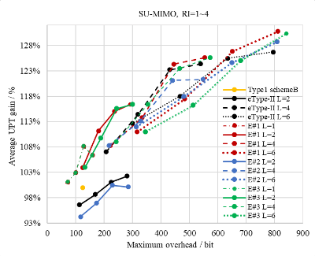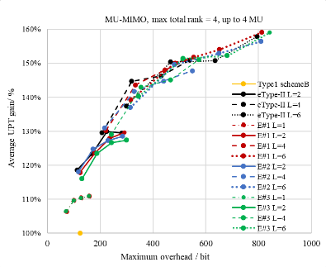  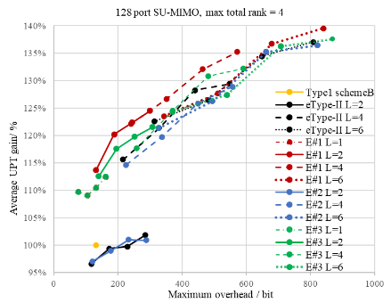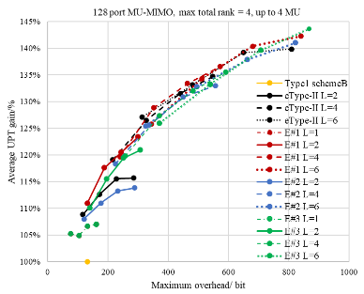  Figure 3 SLS results for unified fixed codebook in SU/MU-MIMO with 32/128 ports
Samsung | #1 | UPT | Observation #6: L ayer-specific SD vector selection with the following parameter combinations outperform the other schemes in a given overhead:  - For L=1,  - p_{v}={1/8,1/16};  - For L>1,  - L=2 and p_{v} ={1/8,1/16};  - L=3 and p_{v} ={1/8,1/16}; and  - L=3 and p_{v} ={1/4,1/8}.  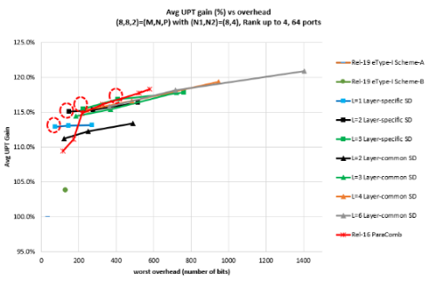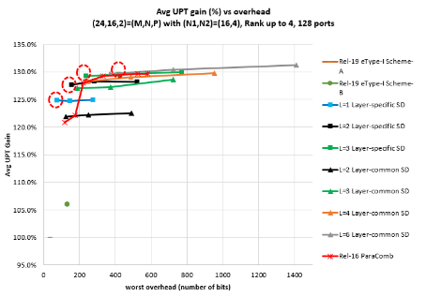  Figure 2. The case of 64 ports, RI_{MAX}=4, SU-MIMO, SB scenario  Figure 3. The case of 128 ports, RI_{MAX}=4, SU-MIMO, SB scenario  Observation #7: From the initial SLS results,  - replace layer-common SD basis selection with layer-specific SD basis vector selection in eType-II;  - remove high values of L (e.g., 4,6), since their performance isn’t improved much while incurring much overhead; and  - remove the b value; since it doesn’t improve UPT-vs-overhead tradeoff overall.  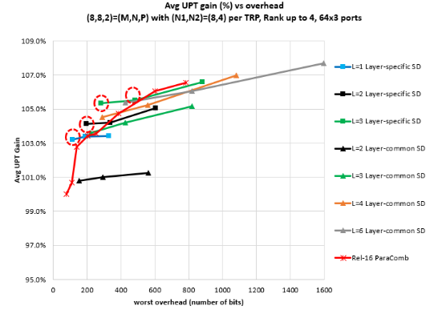  Observation #8: Similar to sTRP scenario, CJT with layer-specific SD vector selection (the proposed UFC method) with the following parameter combinations outperform the other schemes in a given overhead:  - For L=1,  - p_{v}={1/8,1/16};  - For L>1,  - L=2 and p_{v} ={1/8,1/16};  - L=3 and p_{v} ={1/8,1/16}; and  - L=3 and p_{v} ={1/4,1/8}.  Observation #9:  - A linear trend of UPT performance w.r.t. overhead is shown, i.e., eType-II with L=1 (up to 11% gain) > Rel-19 eType-I Scheme-B (up to 5% gain) > eType-I Scheme-A.  - eType-I Scheme-A (a.k.a Rel-15 Type-I) performs the worst.  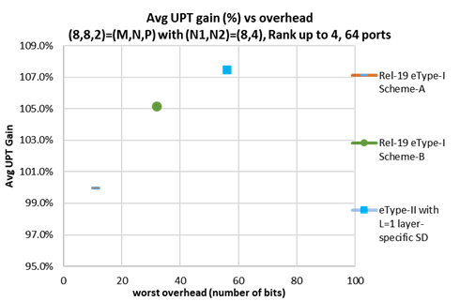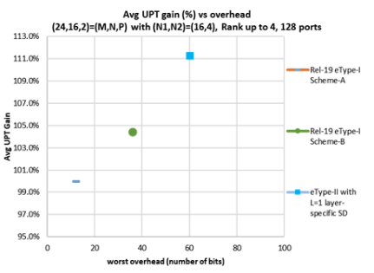
Qualcomm | #1 | UPT | 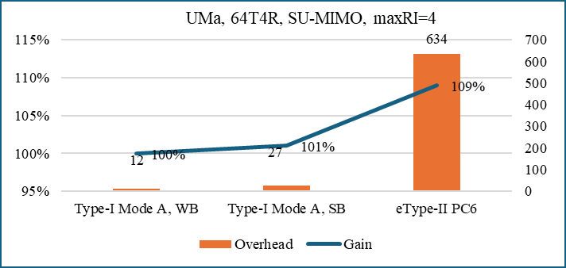  Figure 3-2: Performance gain and overhead comparison of Type‑I CB and eType‑II CB  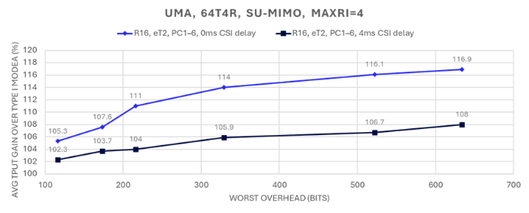  Figure 3-3: R16 eType II SU-MIMO Gain over Rel-19 Type I Mode A  Observation 14: Type II PMI is very sensitive to channel/interference aging. Evaluations show 2.3% - 8% performance loss when CSI feedback delay is considered.
Fraunhofer | #2  HST | UPT | 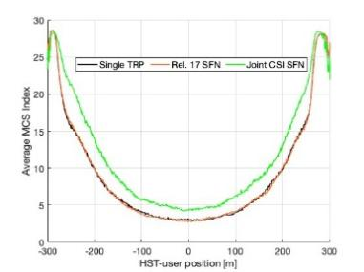  Figure 1: Selected Average MCS index by the HST-user at each transmission occasion along the track  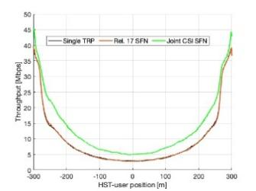  Figure 2: Achieved throughput [Mbps] at each transmission occasion along the track  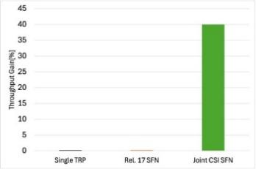  Figure 3: Throughput gain of single TRP, Rel. 17 SFN and Joint CSI SFN schemes with respect to the single TRP scheme.
vivo | #2 NF | SE | 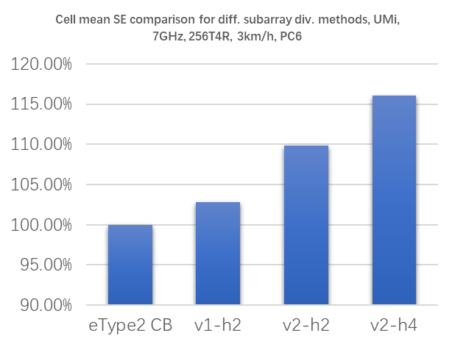  - Cell mean SE comparison for different sub-panel divisions  Observation: Subarray processing based on CJT CB can yield ~15% gains over eType2 CB at PC6.
Google | #2 NF | distribution | 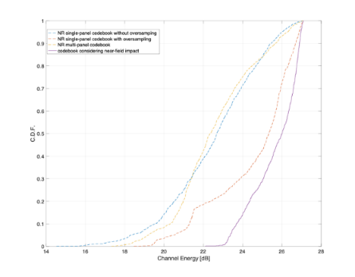  Figure 2: Simulation results for the codebook based on the near-field impact
Xiaomi | #2 NF | SE | 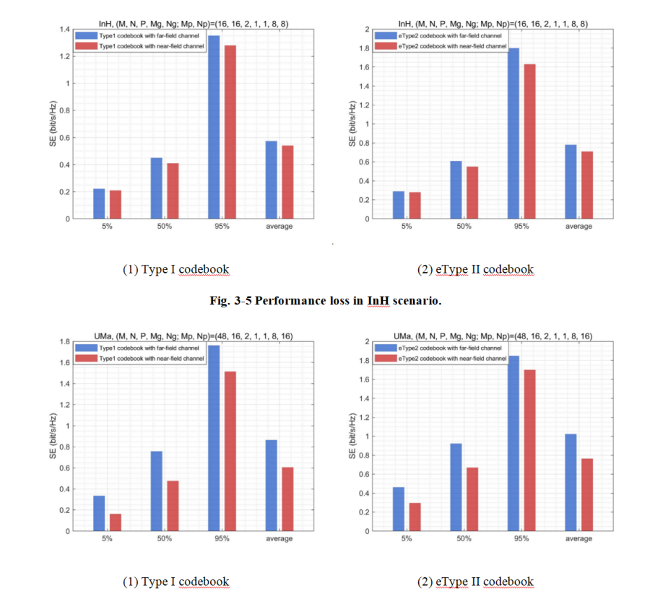  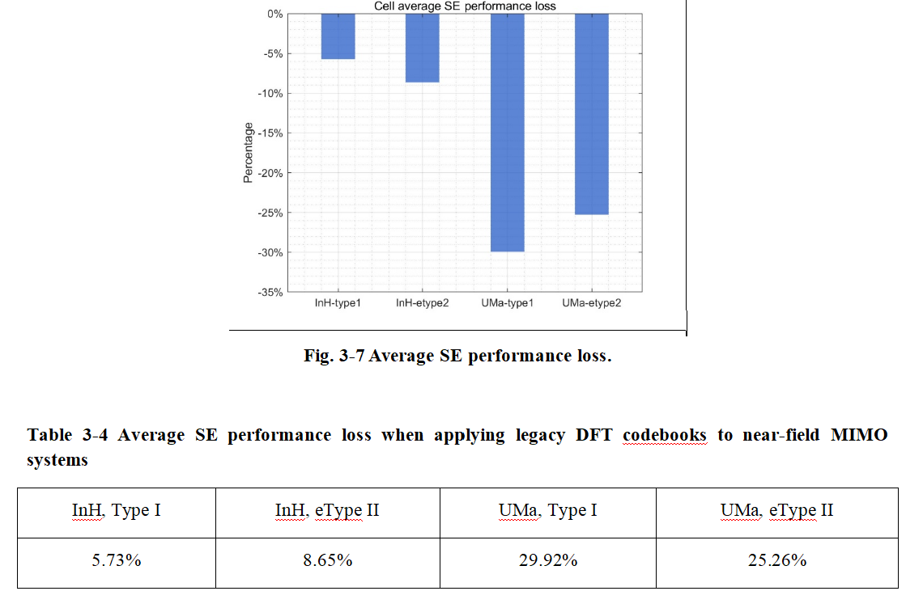

Proposal 4.1-1C
For study on CSI codebook, strive to provide a unified fixed codebook design, ensuring similar or better performance than 5G under feasible UE implementation complexity, at least for the following use cases
- SU-MIMO and MU-MIMO
- Single TRP and CJT
- FFS on whether to consider other use cases at least including High Doppler / High Speed Train (HST), Near-Field Propagation, spatial non-stationary (SNS)
  - For these use cases, FFS on whether/how to provide unified codebook design or necessary design/enhancement
Support/fine | CMCC, CATT, Fujitsu, Samsung, ZTE, DOCOMO, LG, Panasonic, KDDI, CATT, vivo, Ericsson, Interdigital, Nokia, Huawei, OPPO, NEC, Lenovo, …
Not support | Qualcomm (More comments in Table 3.4A)

Proposal 4.1-2
For the unified fixed codebook design,
- For high-resolution, use eTypeII (analogous to Rel-16 NR eType-II with L>1) structure as the basis for the design
- For low-resolution, as the basis for the design,
  - FFS: use either eType-II (analogous to Rel-16 NR eType-II with L=1) structure or Type-I (e.g. analogous to Rel-19 NR scheme A or Rel-19 NR scheme B)
- NR DFT basis can be assumed
Support/fine | ZTE, Samsung, Lenovo, KT, Honor, Ericsson, AT&T, CEWiT, NEC, Huawei, Nokia, Apple, Intel, CATT, CMCC, InterDigital……
Not support | Qualcomm (More comments in Table 3.4A)

Proposal 4.1-2C
For the unified-fixed codebook design, study a dual-stage structure with NR DFT basis as a starting point, e.g.,
- Rel-19 Type-I scheme A
- Rel-19 Type-I scheme B
- Rel-16 eType-II with L>1
- Rel-16 eType-II with L=1
Support/fine
Not support

Table 3.4A Additional inputs
Company | Input
Mod v0 | I suppose the proposals can be supported by the companies listed above. Please update if there is missing or if you have any additional comment
InterDigital | We support Proposal 4.1-2
Samsung | OK with Proposal 4.1-1.  OK with Proposal 4.1-2. As analysed/described in our tdoc, eType-II with the following simple modification offers good UPT-vs-overhead trade-off:  - Layer-specific SD basis selection with L=1 (low-resol) and L>1 (high-resol)  - FD compression same as eType-II  - Removing beta from the codebook parameters  This ensures a common UE implementation while offering sufficient UPT gain over the other legacy schemes and variants in a given overhead of wide range. The same principle can be applied to mTRP CJT and a similar performance trend is shown.
MediaTek | Proposal 4.1-1/ Proposal 4.1-2:  Unifying the codebook design is a good direction, but it is not must-have to us if it cannot ensure the consistent UE implementation in high-resolution and low-resolution CSI in term of precoder feedback. That should be carefully assessed by UE venders. For now, it is too early to take that. Our intention on unified CSI approach is to report the explicit channel for supporting various use cases. However, there is no doubt among companies to have some simplification on NR codebooks. Hence, we suggest refining the wording "Stive to provide the unified codebook design" as "Strive to simplify the codebook design" and identify the use cases which RAN1 should focus on.
Qualcomm | Comments to Proposal 4.1-1:  From the UE perspective, the benefits of a “unified” codebook are not entirely clear at this stage. While we recognize that a unified codebook may help streamline the specification, this does not necessarily imply that UE implementations can be fully unified in practice. We believe it would be beneficial to first have a more detailed discussion on the target scenarios and use cases, and then explore how the corresponding requirements can be addressed for each. In this regard, we feel that the study and design should be primarily driven by the requirements, rather than by the structural form itself. We think the most important thing for 6G codebook design is to ensure the baseline scheme performing similar or better than 5G for all scenarios, e.g., from low to medium and high mobility and under realistic CSI-RS configuration  Comments to Proposal 4.1-2:  The notion of “low” versus “high” resolution CSI would benefit from further discussion. From our perspective, the primary distinction is not resolution itself, as the inherently limited feedback granularity does not allow for truly high‑resolution CSI. We suggest first focusing on the relevant scenarios and use cases to clarify the underlying CSI requirements
OPPO | For proposal 4.1-1, in addition to HST, medium-high mobility should also be important scenario for 6G. Compared with HST, medium-high mobility scenario shows some different characteristics. Since UE speed is smaller than HST, CSI codebook design for medium-high mobility may not be that challenging. Meanwhile, medium-high mobility is also commonly used in transportations like cars/trains.  For proposal 4.1-2, support.
Apple | Comments to Proposal 4.1-1/4-1-2:  For low-resolution overhead CSI, Rel-19 Scheme B can be the starting point, for high resolution CSI, eType II can be the baseline, we feel a unified design is of course desirable if that means UE implementation can be simplified. However, that is not starting point, and whether a unified design (codebook formulation) itself leads to simplified UE implementation is not clear yet.  The high Doppler scenario is important, as at 7 GHz even if UE’s speed is not very high, the Doppler frequency can be high.
Xiaomi | Proposal 4.1-1/ Proposal 4.1-2:  For the codebook design, it’s better to firstly discuss the principles and scenarios to be studied.  For example, 6G codebook design should consider the following principles:  - Better performance vs. report overhead tradeoff: the 6GR unified codebook should achieve higher performance than NR codebooks under similar overhead.  - Simplified implementation complexity: across different configurations of the unified codebook, UE implementation complexity should remain similar.  - Forward compatibility: the unified codebook should be future-proof to new deployment scenarios.  Regarding the scenarios, it’s proposed to study without the down-selection at this stage:  - SU-MIMO and MU-MIMO  - Single TRP and mTRP  - High-mobility scenario  - Near-Field Propagation  - Other scenario-specific optimization (e.g., via downloadable codebook)
Nokia | Proposal 4.1-1:  Fine with the proposal but we suggest some rewording to focus on the use cases this single codebook should address. If these use cases are going to be solved by having low and high resolution codebooks, then this is the outcome of the study!  Proposal 4.1-1（Non-AI Codebook）  Strive to provide a unified fixed single codebook design, including low- and high-resolution, at least for the following use cases  • SU-MIMO and MU-MIMO  • Single TRP and CJT  • FFS on whether to consider other use cases in Rel-20 study at least including High Doppler / High Speed (HST), Near-Field Propagation  o For these use cases, FFS on whether/how to provide unified codebook design or necessary design/enhancement  Proposal 4.1-2:  Fine in principle, but we suggest some rewording to focus the study on the three design options as a starting point: Type I, eType II (L=1) and eType II (L>1)  Proposal 4.1-2（Non-AI Codebook）  For the unified fixed single codebook design, study the following options as the basis for the design  - For high-resolution, use eTypeII (analogous to Rel-16 NR eType-II with L>1) structure as the basis for the design  - For low-resolution, as the basis for the design, FFS: use either eType-II (analogous to Rel-16 NR eType-II with L=1) structure or  - Type-I (e.g. analogous to Rel-19 NR scheme A or Rel-19 NR scheme B)  - NR DFT basis can be assumed
CATT | Proposal 4.1-1: support in general  This unified fix codebook can also be used for CSI reporting on both measured CSI and predicted CSI (in frequency/spatial/temporal domain), therefore, we suggest to add one bullet:  Proposal 4.1-2: generally OK
  Strive to provide a unified fixed codebook design, including low- and high-resolution, at least for the following use cases
  - SU-MIMO and MU-MIMO
  - Single TRP and CJT
  - Measurement and prediction
  - FFS on whether to consider other use cases at least including High Doppler / High Speed Train (HST), Near-Field Propagation
    - For these use cases, FFS on whether/how to provide unified codebook design or necessary design/enhancement
ZTE | We are generally fine with the ideas of Proposal 4.1-1 and Proposal 4.1-2. However, we think it is too early to discuss the specific solutions. We shall first discuss the EVM (like section 2), the scope (like sections 3.3-3.5 and 4.3-4.5), and the CSI framework (like sections 3.1 and 3.2), then discuss the specific solutions based on the conclusions.
Huawei, HiSilicon | For proposals 4.1-1/2, before jumping into the details, it would be better to start from study on motivations, principles and metrics for 6GR codebooks, and list the candidate proposals for further study. Striving for a unified design and DFT based codebook can be proposed as one of the principles and candidate codebooks. The other proposals such as downloadable basis and port selection basis based codebooks can also be studied together with DFT based codebook.
vivo | In ELAA systems, different antenna elements may observe distinct sets of scatterers. This implies that channel statistics (e.g., angular power spectrum, spatial correlation) are no longer constant across the array. Besides, in Rel-19 channel model, the spatial non-stationary (SNS) channel characteristics is introduced to describe the impacts of the antenna element-wise power variation of the antenna array at both TRP and UE side.  Therefore, we support the Proposal 4.1-1 with the following update.  Proposal 4.1-1  Strive to provide a unified fixed codebook design, including low- and high-resolution, at least for the following use cases  - SU-MIMO and MU-MIMO  - Single TRP and CJT  - FFS on whether to consider other use cases in Rel-20 study at least including High Doppler / High Speed (HST), Near-Field Propagation, spatial non-stationary (SNS)  - For these use cases, FFS on whether/how to provide unified codebook design or necessary design/enhancement  Support Proposal 4.1-2.
LG | OK with Proposal 4.1-1.  OK with Proposal 4.1-2.
TCL | We are generally fine with the views of Proposal 4.1-1 and 4.1-2, but we believe that the unified fixed codebook design should remain a vision, while the practical codebook design should focus on requirements and performance. In the initial study, we should focus on the codebook design.
ETRI | Proposal 4.1-1: Okay in general. We tend to agree with Qualcomm and Apple. Regarding unified codebook design, we believe that while structural uniformity is important, efforts should be made to ensure that the design practically reduces UE CSI measurement complexity.  Proposal 4.1-2: Fine as a starting point.
Sharp | We support Proposal 4.1-1 and 4.1-2.
Ericsson | Proposal 4.1-1:  Before we go to this step, we should discuss what are the key design criteria for 6G codebook design including lessons learned from 5G NR. One key lesson is the vast number of codebooks specified in NR out of which only one is commercially deployed. Another pain point is the exploding number of UE capabilities resulting from these large number of codebooks. We can discuss the scenarios to consider for the design of 6G codebook.  As for the unified codebook, we can make it a study as it is still early. It would be good if we have some clarifications on terms such as low-resolution and high-resolution as it may not be clear to everyone when reading the proposal. Also, the we can just say a single codebook. No need to use the term ‘unified fixed codebook’ at this point.  Proposal 4.1-2:  This is a detailed design aspect and it may be too early to already agree this in the first meeting of the study. In Table 4.1A, our position is not accurately captured. In fact, our view is that for the case with L=1, further study is needed on whether to use  - eType II structure as baseline or  - Type I structure as baseline.  We should study this carefully taking into account UE complexity. For instance, in the case of eType II structure for layer specific L=1, we understand that some results presented assume that the subband SVD is computed on subband covariance matrix on port domain. This may be complex for the UE if the number of ports is very large, e.g., 128 or 256. We should study carefully schemes with lower UE complexity. But given this is the first meeting and we are just discussing evaluation assumptions, we should revisit the study after companies have a chance to evaluate/compare candidate schemes with agreed evaluation assumptions.
Sony | Support proposals 4.1-1 and 4.1-2, in principle.  For proposal 4.1-1, what does “fixed” mean in “unified fixed codebook design”?  For proposal 4.1-2, our understanding is that one starts from a high-resolution design and a low-resolution design and works up toward obtaining a single codebook design, i.e., a unified codebook design. This should be clarified.  Also, it is perhaps better to write “e.g., Rel-16 NR eType-II for sTRP or to Rel-18 NR eType-II CJT for CJT.”
NTT DOCOMO | Support Proposal 4.1-2.  Also, Regarding Table4.1B, please add following our simulation result.  This result is related to our proposal for low-resolution version of CJT with MP-based codebook, which can be counted as unified structure of low-resolution codebook design and CJT.  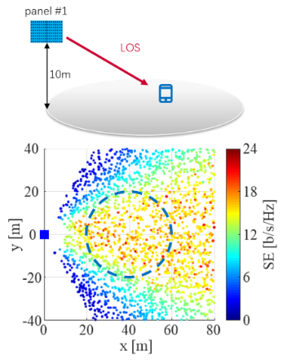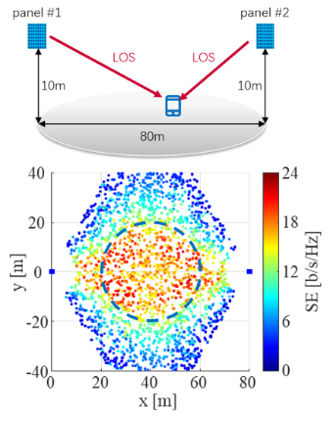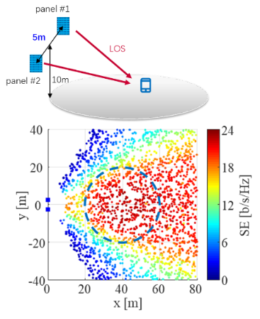  Figure 4-1: SE improvement of the proposed deployment (right) as compared to centralized (left) and distributed (middle) deployments at 7 GHz with 256-port gNB antennas and 4 UE antennas.
CEWiT | Proposal 4.1-1:  - We support the proposal. In addition to the provided use cases, we feel that the unified codebook should also consider single panel and multi panel scenarios.  Proposal 4.1-2:  - We support the proposal
NEC | Support the proposals.
Futurewei | Although we are in general fine with the direction of these two proposals, in our view, they get into too detailed solutions at this early stage of 6GR MIMO studies. They can be discussed later. The proposals may be modified to “Study a unified fixed codebook design, …” or the like.
TCL | Support both Proposal 4.1-1 and Proposal 4.1-2.
FL2 | Proposals were updated to Proposal 4.1-1C and Proposal 4.1-2B. please provide your comments
Fujitsu | Proposal 4.1-1C: Support.  Proposal 4.1-2: Support.  Proposal 4.1-2C: Support.
xiaomi | Proposal 4.1-1C:  - Performance vs. Report overhead/complexity tradeoff is important for codebook design. We have the following suggestion on the main bullet.  For study on CSI codebook, strive to provide a unified fixed codebook design, ensuring similar or better performance than 5G under feasible UE implementation complexity and comparable report overhead,  - 6G codebook should be future-proof for further enhancements. We would like to add one more aspect in FFS: scenario-specific optimization(e.g., via downloadable codebook).
Nokia | Proposal 4.1.1C  The terminology “unified” and “fixed” are not clear. The intended meaning is to strive to provide a common codebook for all considered use cases, so we suggest a more neutral wording:  Strive to provide a common codebook design… at least for the following use cases
Sony | Generally fine with the direction. For Proposal 4.1-1C, the meaning of “fixed” in “unified fixed codebook design” is not clear. For proposal 4.1-2C, what does “dual-stage” mean? Does it refer SD + FD “stages”?
Qualcomm | Proposal 4.1-1C  It is too early to agree on a unified codebook structure design principle without any study. As commented earlier, we should start from use cases and requirements and whether to use the unified codebook structure can be based on the study outcome. Also, we think the medium to high doppler is also important scenario for codebook design and should be included in the listed of user cases.  Below is the suggested revision.  For study on CSI codebook, strive to provide a unified fixed codebook design, ensuring similar or better performance than 5G under feasible UE implementation complexity, at least for the following use cases  - SU-MIMO and MU-MIMO  - Low, medium and high Doppler/mobility  - Single TRP and CJT  - FFS on whether to consider other use cases at least including High Doppler / High Speed Train (HST), Near-Field Propagation, spatial non-stationary (SNS)  For these use cases, FFS on whether/how/ to provide unified codebook design or necessary design/enhancement  Proposal 4.1-2C  We suggest removing the “unified” from the main bullet. It is too early to say unified codebook structure should be used for 6G.  For the unified-fixed codebook design, study a dual-stage structure with NR DFT basis as a starting point, e.g.,  - Rel-19 Type-I scheme A  - Rel-19 Type-I scheme B  - Rel-16 eType-II with L>1  - Rel-16 eType-II with L=1  Another general comment on the session title, the term “unified” is confusion since it has been not agreed. To avoid potential misunderstanding, we suggest removing “unified” from the session title.
OPPO | Proposal 4.1-1C: We agree to support unified codebook in principle. But the terminology may need to be further clarified to get aligned between companies, e.g. only the codebook structure need to be unified or computing procedure for obtaining PMI have to be unified? The target/motivation of unified codebook can be included as well.
NTT DOCOMO | Proposal4.1.2-C  Regarding this Proposal, we see the difference from original 4.1-2 is that, only a codebook is regarded as starting point. We are not sure about the intention and meaning of this proposal. For example, if ‘Rel-16 eType-II with L>1’ is determined as starting point for this Proposal, does it mean the low-resolution codebook can only be ‘Rel-16 eType-II with L=1’?  We consider both low-resolution codebook and high-resolution codebook should be supported in Day1. Whether the starting point of each codebook should be corelated needs further study. Thus, we think it is better to clarify the meaning of taking one codebook as starting point and its relation with determination of low-resolution/high-resolution codebooks.
Futurewei | For the use cases in Proposal4.1.2-C, we propose to include “Fully-digital and hybrid antenna architectures” to be more comprehensive. As we described before, hybrid architecture may be a common use case for typical deployment of 7 GHz, while fully-digital may be a common use case for dense deployment of 7 GHz. Both are very important. Thus we suggest:  Proposal 4.1-1C  For study on CSI codebook, strive to provide a unified fixed codebook design, ensuring similar or better performance than 5G under feasible UE implementation complexity, at least for the following use cases  - SU-MIMO and MU-MIMO  - Single TRP and CJT  - Fully-digital and hybrid antenna architectures  - FFS on whether to consider other use cases at least including High Doppler / High Speed Train (HST), Near-Field Propagation, spatial non-stationary (SNS)  - For these use cases, FFS on whether/how to provide unified codebook design or necessary design/enhancement  Furthermore, we suggest to clarify the term “unified fixed” as it may be subject to interpretation. For example, is parametrized DFT codebook fixed?  For the other two proposals, they seem to be very detailed at this stage. Maybe we can keep them more open as this is the first meeting of 6GR MIMO.
Fraunhofer IIS/HHI | We are fine with the general direction. The unified codebook should be carefully designed to cover the different scenarios, frequency bands and use cases. For the new FR3 (7 GHz) range, even low mobility UEs will experience a high Doppler. This should be kept in mind when designing the codebook while not precluding other codebook enhancement. Therefore, we think that Doppler Rel. 18 based Doppler codebook without UE/network side prediction should be considered. So, we should  Proposal 4.1-1C:  Agree. Prefer to remove FFS for the HST scenario.  Proposal 4.1-2/4.1-2C:  Support. Re the baseline, we think more study is needed to decide between Rel. 16 eTypeII codebook and Rel. 19 Type I Mode B.

AI-based CSI compression
Four AI-based CSI compression use cases have been proposed, with following summary.
Table 4.2A Summary for AI-CSI use cases
Sub-use cases | Summary of observations | Summary of companies’ views
JSCC/JSCM | 17 Companies provided evaluation on JSCC/JSCM against Rel-19 eType-II or Rel-20 SSCC baselines.  - Most companies showed SGCS or NMSE results for JSCC/JSCM  - Two companies provide UPT vs payload for JSCM  - Promising gain can be observed for UPT, and overhead reduction.  wherein  16 companies showed results of JSCM  10 companies showed results of JSCC | Supported by (22): Nokia, Spreadtrum, OPPO, ZTE, MediaTek, CMCC, vivo, BJTU, China Telecom, Samsung, Apple, Lenovo, Fujitsu, Ericsson, DOCOMO, BUPT, Pengcheng, LG, Qualcomm, TCL, CATT, NEC,
DLable codebook/Basis | 2 companies showed the SLS results for DLable codebook, wherein one showed gain in UPT another showed no gain in SGCS  1 company showed results for DLable basis, large gain for Type I WB/SB, marginal gain for eTypeII  FL assessment: There is contradictory observations from different companies. More justification is needed, as well as the clarification on DLable codebook or DLable basis. In addition, this may not able to study if expect to leverage UFC design of non-AI codebook. | Supported by (9): Futurewei, Interdigital, ZTE, OPPO, NEC, Apple， DOCOMO, LG, Qualcomm
SRS fusion | FL assessment:  No additional results or justification showed in this agenda.  Suggest to consider in agenda 10.5.3.3 | Supported by (4): Interdigital, OPPO, NVIDIA, Lenovo

Based on the above summary, we have the following proposal:
Proposal 4.2-1B

- For the study on JSCC and JSCM.
  - Both raw channel matrix and eigenvector(s) of the raw channel matrix is considered as target CSI for study. Other format is not precluded
- For DLable codebook/basis,
  - FFS on the target use cases, structures of codebooks and corresponding assumptions
- Note: CSI and SRS fusion is expected to be discussed in 10.5.3.3
Support/fine | Nokia, Spreadtrum, OPPO, ZTE, MediaTek, CMCC, vivo, BJTU, China Telecom, Samsung, Apple, Lenovo, Fujitsu, Ericsson, DOCOMO, BUPT, Pengcheng, LG, Qualcomm. TCL, CATT, NEC, …
Not support

Table 4.2B Additional inputs
Company | Input
Mod v0 | Note: NW-sided vs 2-sided to be discussed separately.  DLable basis/codebook may need more evaluation and justification. It is premature to conclude it now without suffer aligned results.  In addition,  Q: Do we need to prioritize one of JSCC or JSCM?
Qualcomm | First of all, the discussion in the dedicated AI/ML agenda was about identifying NEW use cases. The FL had made it clear that existing 5G use cases does not need duplicated study. That’s why existing 5G use cases such as serving cell intra-frequency beam prediction and AI-based CSI compression with separate source channel coding were not captured. Now, the discussion should move on from “new use case identification” to “what to support in 6G”. However, in the proposal, it is not clear what “At least support the study on JSCC and JSCM” means. Does the proposal mean that the 5G AI-based CSI compression with SSCC can be directly considered for 6G without study (as it has already been studied), while the new JSCC/JSCM needs to be studied? To clarify the above points, we suggest discussing the overall AI-based CSI compression for 6G, including the 5G two-sided CSI compression with SSCC.  To address this, we suggest adding the following note.  Note: 5G AI-based CSI compression can be directly considered for 6G without the need of duplicated study. (This does not preclude studying additional aspects such as using raw channel matrix as target CSI.)  Regarding JSCC vs JSCM, JSCC and JSCM belong to two totally different CSI feedback schemes. They should not be put into a same category to study. JSCC is still conventional digital CSI feedback. JSCM is analog CSI feedback. As a matter of fact, JSCM is just a particular form of analog CSI feedback with a projection matrix introduced at UE to compress source information. If RAN1 really wants to study JSCM, RAN1 should study general analog CSI feedback first to understand its performance, feasibility, and RAN4 impact. We don't see the motivation to narrow RAN1 study into a very special/particular form of analog CSI (which is JSCM) without looking at the big picture of analog CSI first.
OPPO | Support. For the input of JSCC/JSCM, it is recommended to use eigenvector(s) as the baseline for evaluation. Since whether/how to support channel matrix feedback in non-AI way is not stable.  We are okay to discuss CSI and SRS fusion in 10.5.3.3.
Xiaomi | We tend to agree with Qualcomm. For AI-based CSI compression Sub-use Case A/B/C as agreed in previous meetings, there are still some ambiguities need to be clarified:  - Sub-use Case A and B have different evaluation assumptions and spec impacts, which should be discussed separately.  - Does Sub-use Case A/B include two-sided model (with inter-vendor collaboration for model training? Our view is that two-sided model should be postponed/deprioritize at this stage.  - Does downloadable codebook include JSCC/JSCM? Or downloadable codebook only includes SSCC without relying on two-sided model?
CATT | Regarding the 1st sub-bullet under the first bullet, whether to consider both raw channel matrix and eigenvectors may have an impact on the CSI framework design, i.e., whether to support explicit CSI feedback or implicit CSI feedback. This is because if raw channel matrix is supported, at least during training phase, if NW side data collection is based on CSI reporting, explicit CSI should be supported.
ZTE | Do NOT support Proposal 4.2-1.  As we comment on Proposal 4.1-1 and Proposal 4.2-2, the discussion on specific solutions should be postponed until we have clear conclusions on EVM, study scope, and CSI framework. Moreover, the proposal seems to prioritize JSCC/JSCM over other methods. We think it is too early to determine the priorities of different methods. Note that, we even did NOT start the discussion of EVM for CSI study. We think all evaluations for Unified fixed codebook, SSCC, JSCC/JSCM, and DLable basis/codebook are premature. For JSCC/JSCM, most companies only considered intermediate KPI like SCGS, and lack of studies on the generalization, scalability, complexity... So, we think all methods should be considered in parallel at current stage.  Besides, we do NOT think JSCC/JSCM and DLable basis/codebook are necessarily captured as an AI-based method, each of them can be achieved by either non-AI or AI method. For DLable basis/codebook,  the typical implementation does NOT require AI-dedicated features, like data collection and LCM.  For future discussion, we think the proposal can be modified as follows:
  For non-AI and AI-based CSI compression,
  - At least support the Study on JSCC and JSCM.
    - Both raw channel matrix and eigenvector(s) of the raw channel matrix is considered as target CSI for study. Other format is not precluded
  - FFS Study on DLable codebook/basis for target use cases, codebooks and corresponding assumptions
  Note: CSI and SRS fusion is expected to be discussed in 10.5.3.3
Huawei, HiSilicon | We prefer to start with one-sided model.  At least support the study on JSCC and JSCM with one-sided model.  Thus, between JSCC and JSCM, we prefer to study with JSCM with one-sided model.
InterDigital | We think a discussion on the scope of the study, which includes the question of whether to focus on NW-sided models or two-sided models, is necessary first.  Both JSCC and JSCM schemes may be realized using NW-sided or use two-sided models. For two-sided models., the inter-vendor training collaboration for JSCC/JSCM is expected to be more complex compared to the NR AI/ML CSI Compression, which is currently under discussion (and not complete yet) in the Rel-20 WI. Evaluating the performance of either JSCC or JSCM independent of the impacts of the inter-vendor collaboration risks over-estimating any potential benefits the schemes may exhibit over a yet to be determined baseline. Additionally, the system impacts of JSCM in terms of format of the CSI feedback need to be first studied for non-AIML approaches.  Therefore, AI/ML-based CSI compression and feedback sub-cases involving two-sided models should not be considered in Rel-20 due to their significant complexity for the inter-vendor training collaboration, lack of clarity on suitable baseline(s) for 6GR, and to avoid parallel work and studies on very related topics across 5GA and 6GR.
LG | We have some comments below.  Regarding JSCC/JSCM, it should not be treated in the same category. These two approaches seem to make totally different RAN1/RAN4 effects.  Second, it is premature to prioritize the study of JSCC or JSCM over others CSI feedbacks (e.g. DLable codebook/basis and Rel-20 CSI feedback). So, following modification is suggested.  At least support the study on JSCC and JSCM.
China Telecom | Regarding JSCC and JSCM, we suggest eigenvector(s) of the raw channel matrix as target CSI format, since whether to use raw channel matrix is not identified.  In addition, JSCC and JSCM can be considered simultaneously.
ETRI | We share the similar view as ZTE. The scope of CSI compression should be open to non-AI based approaches as well.
NTT DOCOMO | We share the same view of several companies like HW and Xiaomi. The two-sided model should be postponed and the study of CSI compression with JSCC or JSCM can be started with the DL-able codebook/basis.  The CSI compression use cases can be clarified as the following,  - JSCC with the full-complexity two-sided model where the inter-vendor training collaboration is required.  - JSCC with DL-able operations (codebook/basis/computation/simple model)  - JSCM with the full-complexity two-sided model where the inter-vendor training collaboration is required.  - JSCM with DL-able operations (codebook/basis/computation/simple model)  We are open to study JSCC or JSCM but the downloadable operations should be prioritized. Therefore, we propose to remove the FFS in the 2nd bullet and combine the DL-able codebook/basis with the first bullet.

Table 4.2C Summary for AI-CSI use cases of evaluation results
Company | Use case | Metric | Key observation
Nokia | JSCC/JSCM | SGCS vs UL SNR | JSCC/JSCM for CSI compression and feedback primarily improves low‑SNR performance (mitigating the cliff effect). Furthermore, one‑sided JSCM performs close to two‑sided.  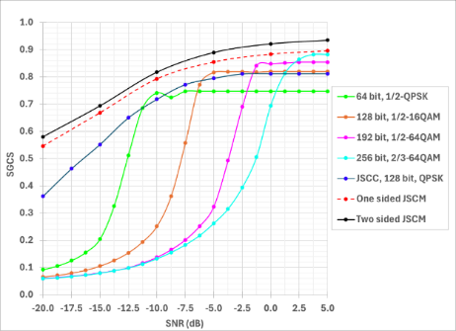
Spreadtrum | JSCC/JSCM | SGCS vs UL SNR | JSCC/JSCM leads to significant performance gain compared to the SSCC, especially at low SNR range.  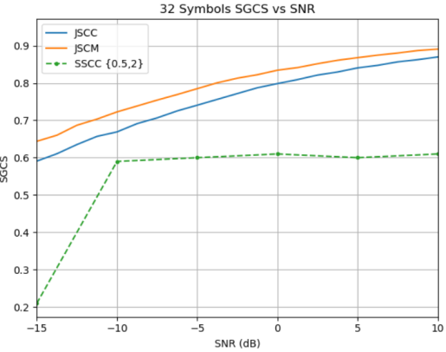
OPPO | JSCM | SGCS vs UL SNR | 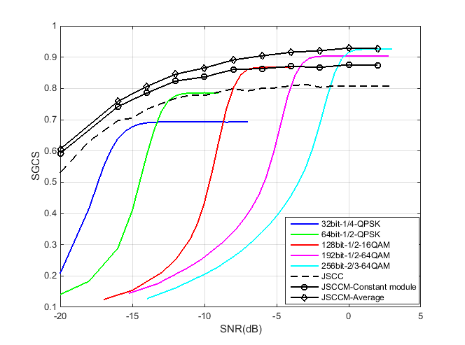  SGCS comparison among JSCC, JSCM and baseline; SGCS and CSI feedback payload comparison  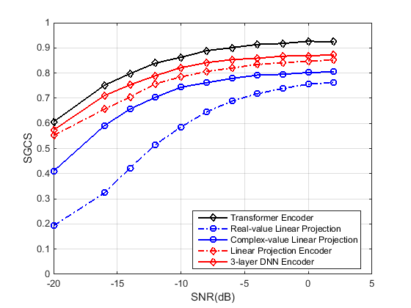  SGCS performance comparison for JSCM with two-side and NW-side model
ZTE | JSCM | SGCS vs UL SNR | 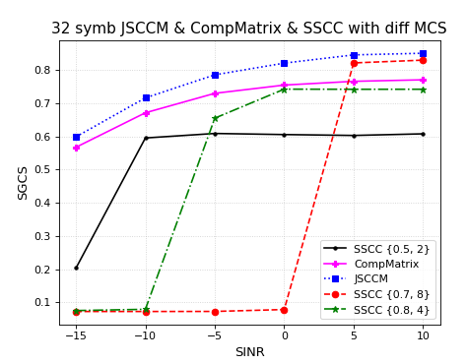  Figure 9 Simulation results of JSCCM (Note: SSCC {x, y} represents SSCC with a code rate of x and a modulation order of y)
MediaTek | JSCC/JSCM | SGCS vs UL SNR | Figure-2.4.1.2.1 SGCS versus UL SNR for SSCC, JSCC and JSCCM.  Observation 2.4.1.2.1: JSCCM shows better performance than JSCC and SSCC in UL fading channels under conventional channel estimation (e.g., LS-CE with LMMSE interpolation) and equalization (e.g., LMMSE),  Observation 2.4.1.2.2: A block-wise per-subband linear encoder for JSCCM (with shared weights across subbands) provides significant UE-side complexity reduction in terms of number of parameters and FLOPs compared to a vectorized full-band linear encoder and transformer-based encoders, with limited performance loss.  Proposal 2.4.1.2.1: Prioritize study of CSI compression and feedback with JSCCM over other CSI compression sub-cases, focusing on UE-side complexity reduction while retaining performance guarantees.
CMCC | JSCC/JSCM | SGCS vs UL SNR | 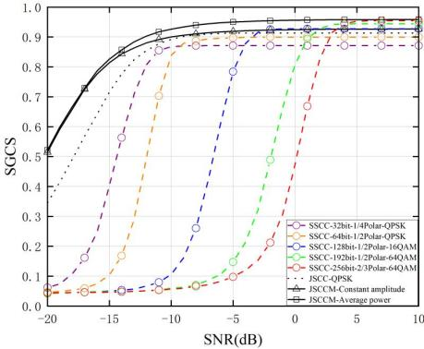  Figure 19. SGCS performance of SSCC, JSCC, and JSCCM.  Observation 17: For both constant amplitude and average power constraints, the JSCCM achieves an SGCS score around 0.9 when the SNR exceeds -10dB, and models trained at different SNRs have different SGCS performance.  Observation 18: At a given training SNR, the JSCCM with average power constraint maintains a performance advantage over the JSCCM with constant amplitude constraint throughout the inference SNR range.  Observation 19: For a given number of resource elements, JSCCM outperforms JSCC, and JSCC with QPSK exceeds SSCC. The resulting SGCS gain is particularly significant in low-SNR regimes.
vivo | JSCM | SGCS  UPT | 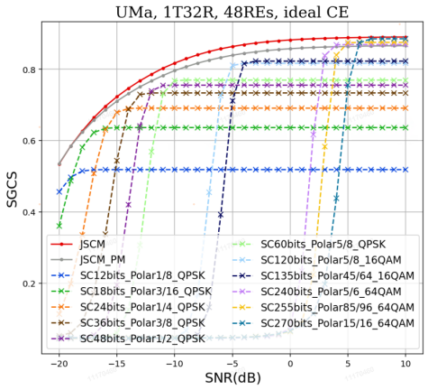  - The comparison between the JSCM-based CSI feedback and the SSCC-based CSI feedback under UMa channel with ideal/real channel estimation  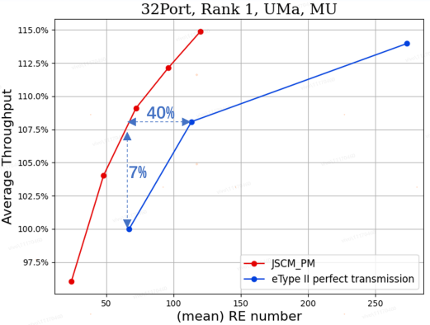  - The SLS comparison between the JSCM-based CSI feedback and the eType II with perfect transmission for CSI feedback  Observation 9: JSCM with PM as encoder addresses inter-vendor collaboration issue.  Observation 10: Compared with SSCC, JSCM could achieve 1~3 dB performance gain under UMa channel.  Observation 11: JSCM with PM could achieve acceptable performance with reduced parameter size and computational complexity.  Observation 12: Larger performance gain of JSCM under real CE can be observed compared with that under ideal CE.  Observation 13: Compared with eType II scheme, JSCM can achieve 7% throughput gain or 40% overhead reduction.
BJTU | JSCC/JSCM | NMSE | 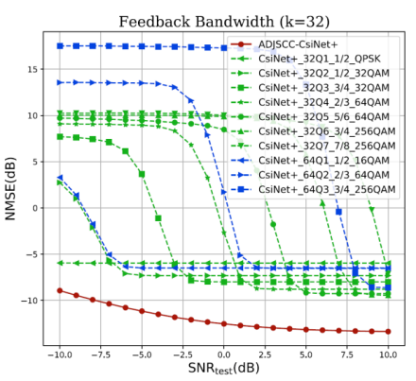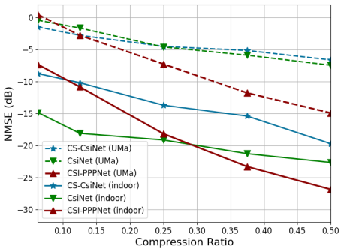  Fig. 4. Performance comparison of ADJSCC-based CSI feedback with SSCC-based CSI feedback.  Fig. 16. Performance comparison between one-sided and two-sided models [3].  Observation 1: Without introducing additional AI/ML model complexity, CSI feedback based on joint source channel coding (JSCC) is observed to improve the performance of CSI reconstruction accuracy.  One-sided CSI feedback frameworks based on JSCM (e.g., CSI-PPPNet) achieve competitive accuracy with far fewer parameters, reducing training and deployment overhead compared to two-sided models.
China Telecom | JSCC |  | Observation 1: For AI-based CSI enhancement, CNN-based JSCC achieves a SGCS of 0.86.
Samsung | JSCM | SGCS,  UPT  SE | 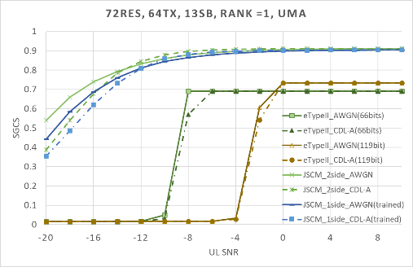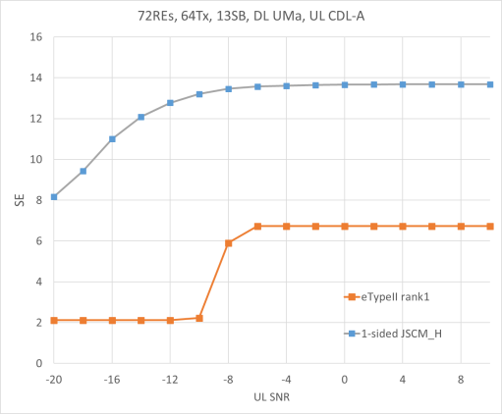  Figure 9. SGCS performance over Uplink AWGN channel and CDL-A channel (eigenvector)  Figure 10. Spectrum efficiency with eTypeII Rank 1 and explicit H (CDL-A channel for uplink)  Observation #16: JSCM provides signification overhead reduction (up to 70%) with UPT gain (up to 14% for SU and up to 7% for MU).  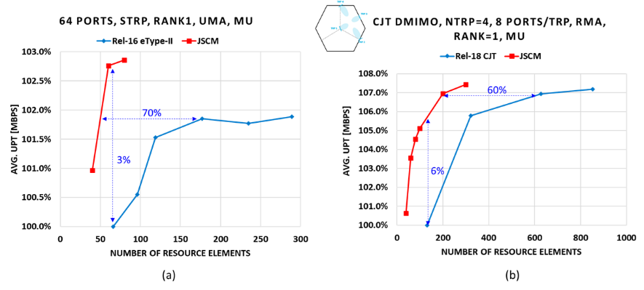  Figure 14. MU-MIMO: User perceived throughput (UPT) vs Rank 1 overhead (number of REs) (a) sTRP and (b) mTRP CJT scenarios  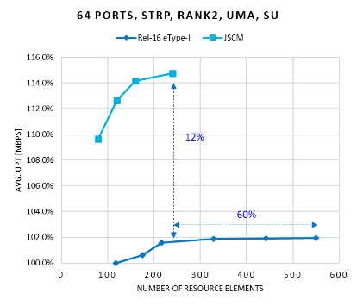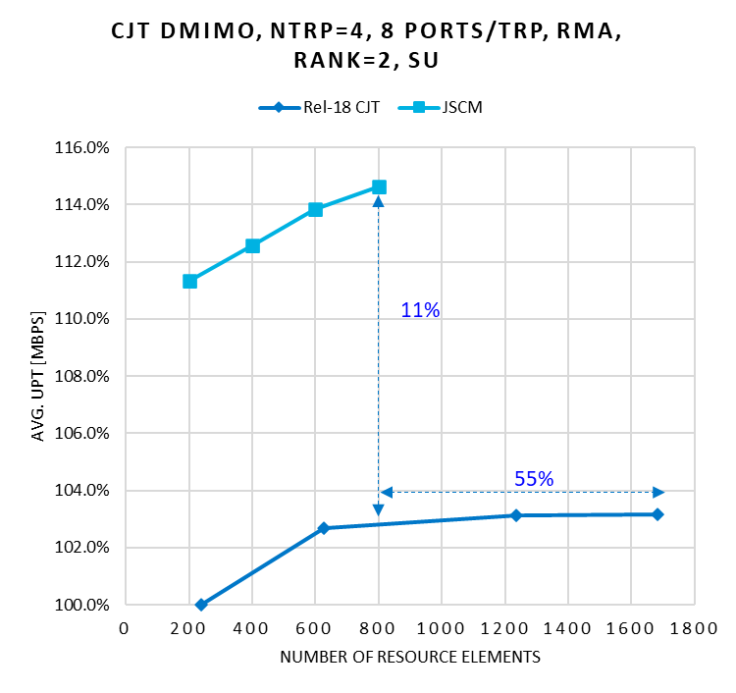  Figure 15. SU-MIMO: User perceived throughput (UPT) vs Rank 2 overhead (number of REs)
Apple | JSCM | SGCS | Fig. 3.2-1. Comparison of JSCCM with different encoder complexity with e-type 2 codebook
Lenovo | JSCC/JSCM |  | 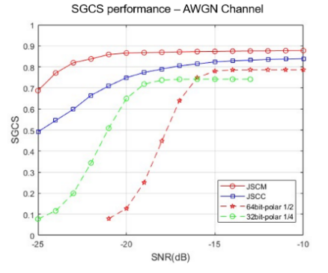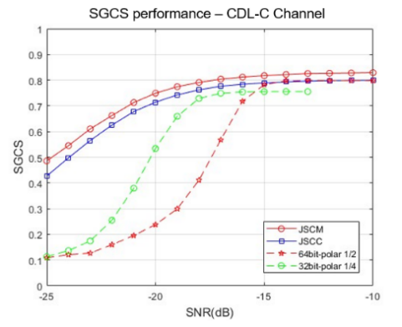  Figure 7. Performance of JSCC/JSCM for CSI feedback  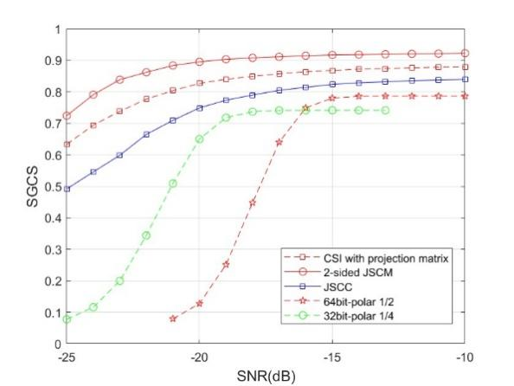  Figure 9. Performance of explicit CSl feedback based on projection matrix.
Fujitsu | JSCC/JSCM |  | - For CSI feedback, AI/ML based JSCC with two-sided model could achieve a better SGCS performance over SSCC (AI compression & polar codes) except for some SNR.  - For CSI feedback, AI/ML based JSCCM with one/two-sided model could achieve a better SGCS performance over SSCC (AI compression & polar codes) in the whole SNR region.  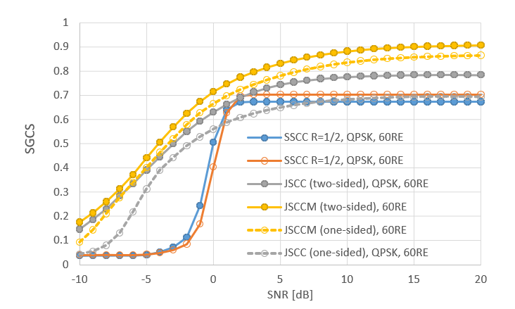  Figure 7 SGCS performances of JSCC, JSCCM and SSCC for DL CSI feedback.
Ericsson | JSCM |  | 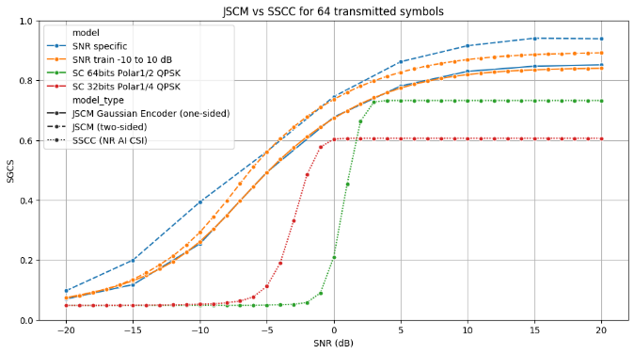  Figure 13: Performance of one-sided JSCM, two-sided JSCM and SSCC based CSI feedback schemes.
DOCOMO | JSCM | NMSE | 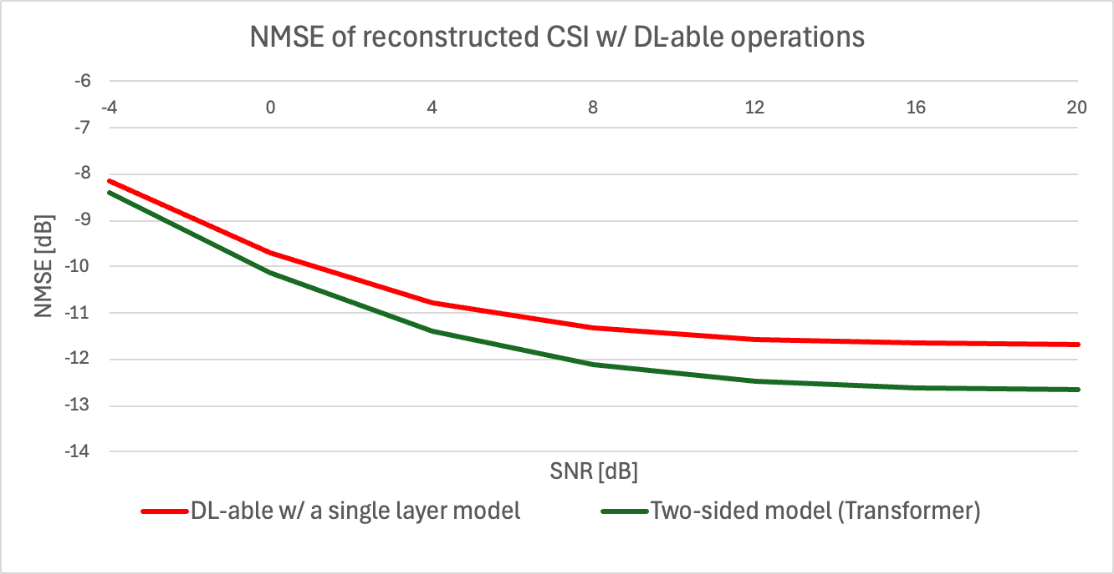  Figure 4-4: NMSE of the CSI compression schemes with DL-able operations
BUPT | JSCC/JSCM | SGCS | Fig. 5 Squared generalized cosine similarity (SGCS) vs. SNR under various schemes  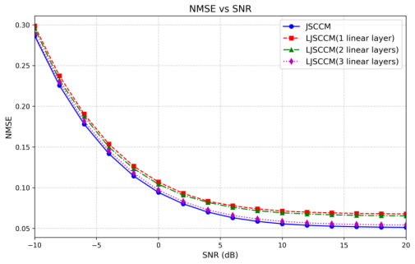  Fig. 6 NMSE vs. SNR under JSCCM-based and LJSCCM methods
Pengcheng | JSCC/JSCM | SGCS | 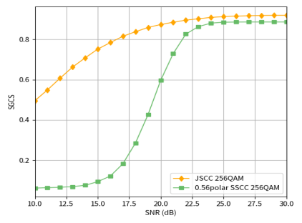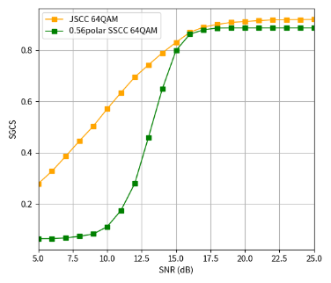  256QAM JSCC vs SSCC 64QAM JSCC vs SSCC  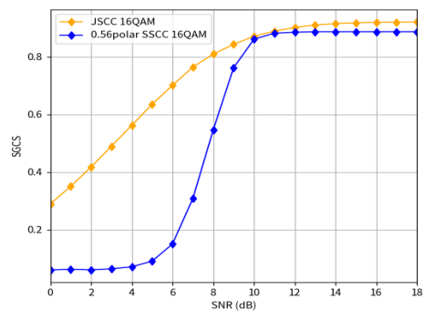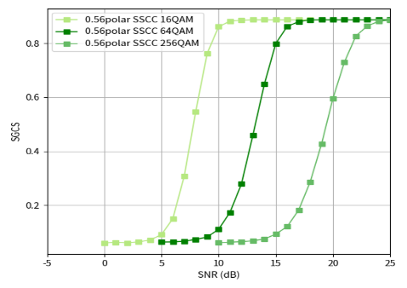  16QAM JSCC vs SSCC various QAM-Modulation SSCC CSI feedback  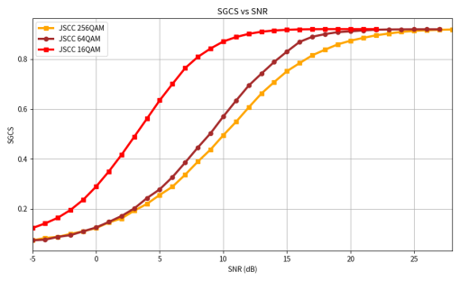  multiple QAM-Modulation JSCC CSI feedback  - SGCS performance of multiple QAM-Modulation JSCC-based CSI feedback and the AI/ML-based conventional CSI feedback  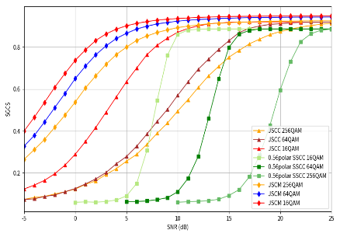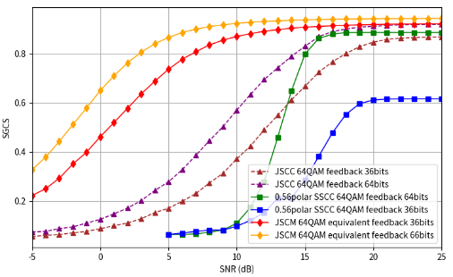  Figure 6 SGCS performance of various CSI feedback methods  Figure 7 Performance Comparison of SSCC, JSCC, and JSCM in SGCS: Impact of Feedback Bit Quantity and Signal-to-Noise Ratio
ZTE | DLable codebook | UPT | Observation 4: Type-I-like downloadable codebook (solution-1) can bring ~20% average UPT gain with same codebook size, or reduce 3/4 codebook size with same UPT performance, compared with legacy Type-I codebook.  Observation 5: Type-II-like downloadable codebook (solution-2) can bring 5~20% average UPT gain (much more in cell-edge), compared with eType-II (cell-specific CSI-RS) and FeType-II (UE-specific CSI-RS).  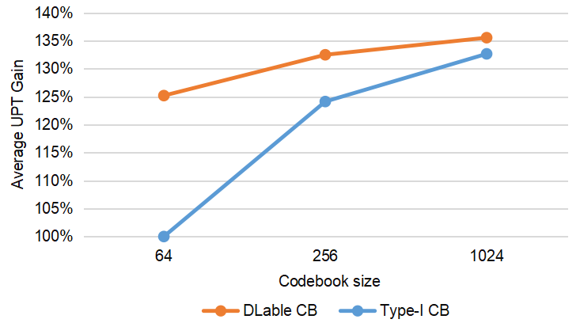  (a)  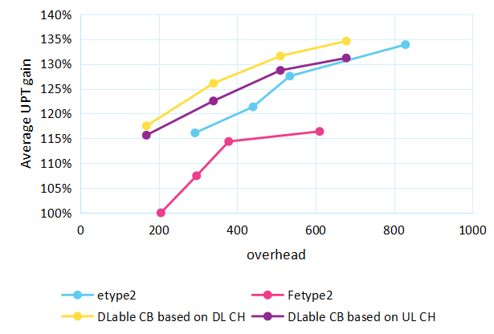  (b)  Figure 5 SLS results for (a) Type-I-like and (b) Type-II-like downloadable codebook
Lenovo | DLable codebook | SGCS | 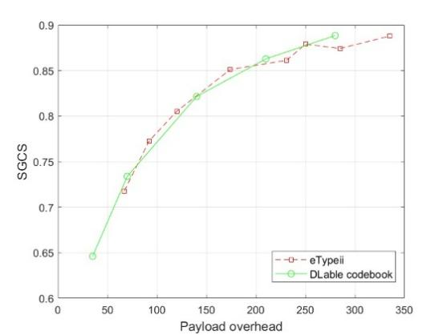  Figure 8. Performance of DLable codebook for CSI feedback.
Qualcomm | DLable basis | UPT | 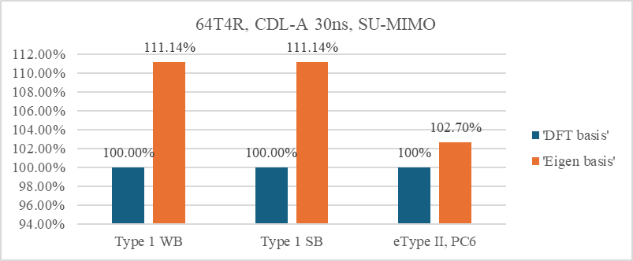  Figure 3-7: Gain of eigen basis over DFT with R19 Type I Mode A and eType II PMI

Proposal 4.2-1C
- For the study on JSCC and JSCM.
  - Both raw channel matrix and eigenvector(s) of the raw channel matrix is considered as target CSI for study. Other format is not precluded
- For DLable codebook/basis,
  - FFS on the target use cases, structures of codebooks and corresponding assumptions
- Note: CSI and SRS fusion is expected to be discussed in 10.5.3.3
Support/fine | Nokia, Spreadtrum, OPPO, ZTE, MediaTek, CMCC, vivo, BJTU, China Telecom, Samsung, Apple, Lenovo, Fujitsu, Ericsson, DOCOMO, BUPT, Pengcheng, LG,. TCL, CATT, NEC, …
Not support | Qualcomm

Table 4.2 D Additional inputs
Company | Input
FL2 | Proposals were updated to Proposal 4.2-1C. Please provide your comments.
Fujitsu | Support.
Qualcomm | Suggest changing  For the study on JSCC and JSCM  Into  For the study on AI-based CSI compression
Qualcomm | Like we commented before, there is no urgency to discuss JSCM. If one wants to study JSCM, the feasibility and RAN4 related aspects of non-AI generic analog CSF should be studied first before dive into a specific analog feedback scheme which is AI based JSCM.  For AI based JSCC, it is still conventional digital CSF. We are fine to study JSCC which can be viewed as an enhancement on 5G Rel-20 AI based SSCC.  Another comment is that, JSCC and JSCM are two very different schemes, JSCC is digital CSF while JSCM is analog CSF. We don’t see much motivation to put them in same category for study. We suggest FL have separate proposals for these two schemes.
LG | Ok with the proposal.
ETRI | Support

NW-side vs 2-sided
Some companies proposed to focus on NW-sided model for JSCM and/or DLable codebook/basis, while some companies
Table 4.2.1A: Summary on the view
Directions | Summary of observations | Summary of companies’ views
#1  Prioritized NW-sided model | 1. NW-sided model based JSCM can significantly reduce UE complexity by replacing the UE-side Neural Network with a Linear Projection (as in Table 4.2.1B)  2. NW-sided model can significantly reduce inter-vendor calibration effort.  3. Avoid overlap with NR standardization work  4. One-sided models generalize well and are easier to train than two-sided models. | Supported by (7): Spreadtrum, Interdigital, Huawei, OPPO, MediaTek, Xiaomi, DOCOMO
#2  Study both NW-sided and 2-sided model | 1. The study outcome of NR can be leveraged.  2. Focusing on complexity reduction.  FL assessment:  No need to repeat the discussion for 2-sided model intervenor collaboration, but focus on the delta part. | Supported by (3): Apple, Qualcomm, BUPT

Table 4.2.1B: Summary on UE complexity
Company | Observations
OPPO | - Complexity of UE-side encoder for JSCC/JSCM  - FLOPs comparison
  Model | FLOPs | Trainable parameters | Model Size
  Encoder | 93.95M | 10.70M | 48.43M Byte
  UE-side solution | FLOPs
  Transformer encoder | 93.95M
  Real-value linear projection | 0.21M
  Complex-value linear projection | 0.21M
  Linear projection encoder | 0.21M
  3-layer DNN encoder | 1.18M
MTK
  CSI compression scheme | Encoder  model | Decoder model | Encoder output dimension | Encoder parameter count | Encoder FLOPs
  SSCC | 2-layer transformer | 2-layer transformer | 11-58 (dynamic) | 1661k | 28.27m-28.35m
  JSCC | 2-layer transformer | 2-layer transformer | 72 | 1673k | 28.37m
  JSCCM | 2-layer transformer | 2-layer transformer | 144 | 1733k | 28.49m
  JSCCM | Vectorized linear encoder | 4-layer transformer | 144 | 120k | 239.62k
  JSCCM | Block-wise linear encoder | 4-layer transformer | 144 | 704 | 18.3k
CMCC | Table 11. UE complexity between low-complexity design and 2-side transformer
  UE complexity | Trainable parameters | FLOPs
  fixed random Gaussian matrix | / | 163840
  learnable Gaussian matrix | 82048 | 163840
  2-layer dense network | 196992 | 393216
  2-side transformer JSCCM | $$2.5×{10}^{6}$$ | $$7.135×{10}^{7}$$
vivo | - Parameter and Flops comparison of JSCCM_PM Encoder, JSCCM Encoder, and SC Encoder
  Scheme | Parameter | Flops
  JSCM_PM Encoder | 80 K | 160 K
  JSCM Encoder | 3 M | 9 M
  SC Encoder | 3 M ~ 6 M | 9 M ~ 21 M
Samsung | Table 4 Complexity for Rank =1 (SVD is not considered)
   | NW complexity  (Mflops) | UE Complexity  (Mflops)
  2-sided model | 86.19 | 86.19
  1-sided model | 86.19 | 1.92
BUPT | Table 2 Configurations of JSCCM and LJSCCM methods
  Related parameters | JSCCM | LJSCCM
  Total number of parameters/trainable parameters | 37,075,200 | 25,367,296/25,629,952/26,417,408
  Parameter size (float32) | 141.43 MB | 96.77/97.77/100.77 MB
  Number of Flops | 0.442G | 0.275/0.276/0.277G
  Encoder | 3-layer Transformer | 1/2/3 linear layers
  Decoder | 3-layer Transformer | 3-layer Transformer

Proposal 4.2.1-1C
For the study on AI-based CSI compression, the study on inter-vendor collaboration aspects including performance with inter-vendor joint training for 2-sided model to be discussed after performance study on 1-on-1 joint training for 2-sided model.
Support/fine | OPPO
Not support | Qualcomm

Table 4.2.1C Additional inputs
Company | Input
Mod v0 | I don’t think we need to rule out the performance study for 2-sided model. But no need to spend time to resolve inter-vendor collaboration issue. However, we can revisit it if the performance can be justified.  I cannot guess the view from two side about the above proposal. Therefore, I didn’t put any names in the above table. Please show you view in above table and additional view below, if any.
MediaTek | We think 2-sided model should not be precluded at this stage. It is not so clear why there should be an agreement to postpone discussion on inter-vendor collaboration aspects.
Qualcomm | Could the FL clarify if the proposal is about JSCC/JSCM or AI-based CSI compression in general, If it’s about JSCC/JSCM, we agree that we can defer the discussion of how the NW-side and UE-side model (including a linear projection matrix as a special case) are trained. Study can first focus feasibility, performance, generalization ability, and the complexity of different schemes.  However, the term inter-vendor collaboration is ambiguous. Does it refer to Direction A/B/C of the Rel-19 discussion, or does it only refer to Direction A? Also, the term 2-sided model is ambiguous; if the UE side uses a linear projection matrix, is it a NW-side model or a special case of two-sided model?  So, we propose to remove the proposal.
OPPO | We agree with FL, the collaboration for 2-sided model can be studied after performance evaluation. In this stage, the performance for both of 1-sided and 2-sided framework can be evaluated together, so that we can see how much performance loss for 1-sided compared to 2-sided model.
Xiaomi | We prefer to postpone or deprioritize the discussion of two-sided model relying on inter-vendor collaboration for model training.
Nokia | Fine with the proposal. Two-sided models can be deprioritized.
CATT | Generally OK
ZTE | OK to postpone the discussion on inter-vendor collaboration.
Huawei, HiSilicon | We prefer to start with one-sided model for both evaluation and potential standard discussions, to avoid duplicated discussion with 5G R20
vivo | Support.
InterDigital | We do not agree with the proposal. We do not think two-sided models should be studied right now – as also indicated by multiple companies in their contributions, for this use case, NW-sided models should be the focus.
LG | Generally ok that de-prioritization of study of two-sided model in 6G day1.
TCL | Fine with the proposal.
China Telecom | We also prefer priority evaluation of the performance of both 2-side and NW-side models.
ETRI | We are generally okay with the proposal if this is limited to JSCC/JSCM.
NTT DOCOMO | Same view with Xiaomi and HW. We should deprioritize the two-sided model for 6G Day 1 due to the inter-vendor collaboration complexity.  For clarification, we are open to the schemes that do not require the whole inter-vendor collaboration procedure, like the DL-able codebook, basis, or with a simple one-layer model which weights can be online updated.
Ericsson | Proposal 4.2.1-1  NR study indicates that different inter-vendor training options can result in different two-sided model pairs that have different performance with respect to various UE implementations, various NW implementations, and various data distribution mismatch levels between UE-side and NW-side.  It is unclear how to properly study/conclude the performance of two-sided model without discussing inter-vendor training options.
FL2 | Proposals were updated to Proposal 4.2-1C. Please provide your comments.
xiaomi | The proposal is not clear to us. Inter-vendor collaboration cannot be avoided even for performance evaluations. We prefer to focus on NW-side model.
Qualcomm | The proposal is ambiguous and up to different interpretations.  We think we could agree on  - Both 1-sided and 2-sided approaches are on the table for discussion  - 5G NR study can be leveraged.  - Initial study can focus on performance evaluation assuming joint training  We do not agree with the suggestion by some companies to deprioritize two-sided models due to inter-vendor collaboration complexity; inter-vendor collaboration challenges have been addressed through extensive studies in NR Rel-19 and are being specified in NR Rel-20.
Qualcomm | If the concern on two sided model is about complexity of inter vendor collaboration, that aspect is already sufficiently discussed in 5G. There is no new study needed on inter-vendor collaboration with 2-sided model. We don’t see any problem here.  The proposal is about performance study, we don’t see any reason that performance study with inter-vendor joint training for 2-sided model should be after performance study on 1-on-1 joint training for 2-sided model.
LG | Generally ok with this proposal. However, the term “1-on-1 joint training” is unclear to us.

Physical Layer Integration of JSCM/JSCC
While performance is promising, integrating "analog-like" JSCM symbols into the digital 6G PHY creates unique challenges identified by multiple companies.
Table 4.2.2A: Key challenge for JSCC/JSCM
Issues | Observations (according to Table 4.2.2D)
#1  PAPR (JSCM) | 3 Companies pointed out higher PAPR caused by JSCM for DFT-s-OFDM.  1 company provided solution and result to reduce PAPR caused by JSCM with minor or without performance loss in SGCS. (Table 2.3.2B)
#2  Reliability & Lack of CRC (JSCM/JSCC) | 3 companies pointed out JSCM/JSCC is lack of CRC and sNB may not able to validate received CSI.
#3  UCI Multiplexing/  interleaving issues  (JSCM/JSCC) | 3 companies pointed out UCI multiplexing issue and interleaving issue with other UCI.

Table 4.2.2B: Preliminary results
Company | Scenarios | Key observation and results
Samsung | #1 | 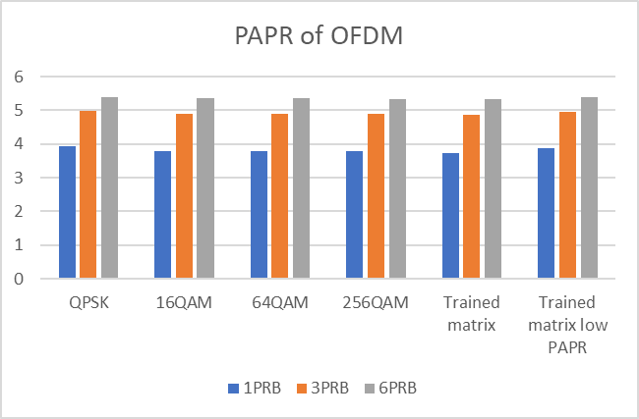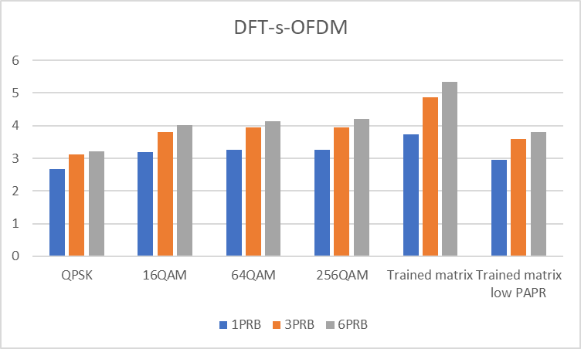  Figure 11. PAPR comparison.  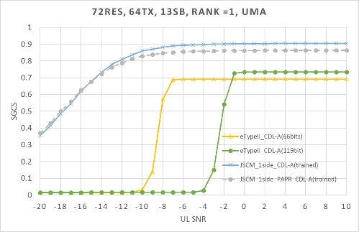  Figure 12. SGCS performance over CDL-A channel with PAPR restriction  Observation #14: it is observed that PAPR can be reduced for JSCM scheme with sufficiently small SGSC loss only in high SNR, where the PAPR is similar to the one of SSCC.

Based on discussion in Tdocs, the following is proposed:

Proposal 4.2.2-1C
For the study on JSCC/JSCM, study at least the following aspects:
- PAPR impact and how to reduce/restrict PAPR for JSCM
- Whether/how to define EVM requirements for agnostic/infinite constellation pattern
- Whether/how to support error detection/assessment by NW on reported JSCC/JSCM-based CSI from a UE
- Whether/how to multiplex JSCC/JSCM-based CSI with other UCI (e.g., non-JSCC/JSCM-based)
Support/fine | Nokia, TCL, CATT, NEC, Samsung, LG, Ericsson, Qualcomm, MediaTek
Not support | Qualcomm

Table 4.2.2C Additional inputs
Company | Input
Mod v0
MediaTek | It is necessary to study how the UE transmit chain can handle transmission of arbitrary constellation points instead of selecting from a given set of constellation points.
Qualcomm | JSCC and JSCM belong to two totally different CSI feedback schemes. They should not be put into a same category to study. JSCC is still conventional digital CSI feedback. JSCM is analog CSI feedback. As a matter of fact, JSCM is just a particular form of analog CSI feedback with a projection matrix introduced at UE to compress source information. If RAN1 really wants to study JSCM, RAN1 should study general analog CSI feedback first to understand its performance, feasibility, and RAN4 impact. We don't see the motivation to narrow RAN1 study into a very special/particular form of analog CSI (which is JSCM) without looking at the big picture of analog CSI first.
OPPO | We understand this is somehow critical issue. But we think it is better to firstly consider basic EVM for JSCM, and then study these aspects later.
Nokia | Fine with the direction. But the before “how to”, it is good to list these issues for evaluation
CATT | Generally OK
ZTE | Do NOT support, it is too early to discuss the details for a specific solution.
Huawei, HiSilicon | 1) The first bullet can be more generic as “Impact of RAN4 related aspects, e.g., PAPR, EVM, etc.” We think changing the constellation pattern to the agnostic/infinite space would involve RAN4 discussions as the legacy requirements are not applicable. E.g., whether/how to determine the EVM requirement for agnostic/infinite constellation pattern may need RAN4 study/confirmation.  2) What is error detection? If it means monitoring, we think it means label obtainment?
vivo | JSCC/JSCM is a lossy joint source–channel compression and transmission scheme, in which the source of the JSCC/JSCM-based CSI is not represented at the bit level. Therefore, before studying whether and how to support error detection for JSCC/JSCM-based CSI, it is necessary to clarify which objectives or components in the JSCC/JSCM framework can be protected by error detection.
InterDigital | We agree with QC that it may be more appropriate to first consider support of JSCM or “analog feedback” in general, and can even follow the ongoing fundamental studies on JSCC/JSCM in agenda 10.3.2.
LG | Similar view with Qualcomm. The three issues listed in the proposal are prerequisite for accessing whether studies on JSCC/JSCM study are feasible.
ETRI | We think it is too early to directly study the listed issues. As mentioned by several companies, we believe that identifying the impacts on RAN4-related issues, such as PAPR and EVM, should be addressed first.
NTT DOCOMO | Support
Ericsson | Suggest making the last bullet more generic, as following  Whether/how to support performance monitoring/assessment by NW on the received JSCC/JSCM-based CSI from a UE., e.g., CRC-like scheme
FL2 | Proposals were updated to Proposal 4.2.2-1C. Please provide your comments.
Fujitsu | Support.
Qualcomm | We maintain the same comments as earlier: for JSCM, RAN1 should study general analog CSI feedback first to understand its performance, feasibility, and RAN4 impact.
Qualcomm | Like we commented already, JSCC and JSCM are two totally different CSF scheme. The issues listed in the proposal are for JSCM, not for JSCC.  Besides OEM, there are many more RAN4 related aspects need to be studied for JSCM such as ACLR, SEM, MPR, etc. RAN1 should send LS to RAN4 to request RAN4 study these aspects.  Given JSCM is sensitive to UL error due to no CRC to detect UL error and no channel coding to correct error, UL interference should be modelled with its impact evaluated in the study.  Besides the above, the impact of Tx PA nonlinearity & RF impairment, UL fading channel, Rx UL channel estimation, UL noise + interference estimation should be evaluate as analog CSF is sensitive to these aspects as well.
LG | We are generally OK with this proposal. In addition, it should be noted that other aspects being identified during the study phase are not be excluded.
ETRI | Support

Table 2.3.3D Observations
Company | Observation/proposal
Nokia | The study should focus on evaluating JSCC/M (including single‑sided JSCM) under practical constraints, such as constrained modulation symbols (QAM or NUC in line with 6GR modulation assumptions), robustness and recovery behavior under bursty channel errors due to the absence of channel coding in JSCC/M, and other relevant non‑idealities, in order to assess the overall potential of this use case.
TCL | Proposal 17 : Different HARQ mechanisms for CSI compression with JSCC, e.g., CRC-free and CRC-attached, should be evaluated.
CATT | Interleaving Mismatch: Unlike JSCC which outputs bits compatible with legacy bit-level interleaving, JSCM outputs modulated symbols, requiring a redesign of interleaving mechanisms.  UCI Multiplexing: JSCM disrupts the existing framework where CSI and other UCI (e.g., HARQ-ACK) share the same coding/modulation chain, raising unresolved issues on resource mapping and multiplexing. Proposal: CATT urges RAN1 to select only one ultimate AI scheme (choosing among SSCC, JSCC, and JSCM) to avoid fragmentation, and mandates that evaluation must account for impacts on legacy UCI processing.
NEC | Proposal 18: Study the impacts of lack of CRC and scrambling for JSCCM CSI reporting and methods to transmit/multiplex JSCCM CSI report via PUSCH.
Samsung | Observation #14: it is observed that PAPR can be reduced for JSCM scheme with sufficiently small SGSC loss only in high SNR, where the PAPR is similar to the one of SSCC.
LG | Observation #5: JSCM-based modulated symbols may exhibit unconstrained modulation characteristics different from QAM/NU-QAM, leading to different PAPR and RF/PA processing behaviour; mixing JSCM-modulated symbols with QAM-modulated symbols within the same OFDM symbol should be avoided.  Proposal #25: For study of JSCM for CSI compression (Sub-use case B), the following two aspects shall be considered:  - method for parallel transmission of bit-wise essential CSI information  - method for multiplexing/separation with QAM/NU-QAM signals considering PAPR and RF/PA differences
Ericsson | RAN4 PAPR/EVM requirements and performance impacts
Qualcomm | Proposal 21: For the study of CSI compression and feedback with AI/ML-based JSCM,  Performance, robustness, and feasibility of analog feedback should be carefully studied.  Performance, generalization aspects, and feasibility should be studied to determine the merit and feasibility of downloadable models.  Study should consider rigorous link-level and system-level evaluations with careful modeling of UL MIMO fading channels, interference, and UE/gNB implementation artifacts
InterDigital | PAPR issues, including PAPR requirements to be addressed by RAN4.

DMRS-based CSI Reporting
DMRS-based CSI reporting was proposed by several companies with following summary

Table 4.3A: Summary on the views
Proposals | Summary of observations | Summary of companies’ views
#1  Utilizing DMRS for CSI updates (CQI/L1-SINR/Delta-MCS). | Justification  1. Fast link adaptation (Delta CQI) to track interference/aging without extra CSI-RS overhead.  2. CSI-RS based feedback may not inline with actual scheduled transmission  3. reduce overhead  4, better UPT/L1-RSRP (Table 4.3B)  Design  DMRS for on-demand CSI report  Skeptical  DMRS-based report should be considered later. | Support (110): Nokia (FFS), Huawei, ZTE, Tejas, MediaTek, GOOGLE, xiaomi, Samsung. Apple, Ericsson, Qualcomm  Skeptical (2)  Spreadtrum (low priority in 6G day-1) Fujitsu (later)
#2  PDCCH CSI feedback | PDCCH link adaptation using CSI feedback from reference signals in data region is suboptimal | Support (1): Ericsson

Table 4.3B: Summary on evaluation results
Company | Proposal/  Metric | Key observation and results
MediaTek | #1  UPT | 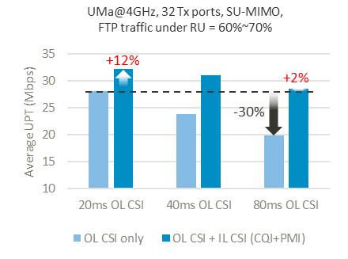  Figure-2.1.1 Average UPT performance of outer-loop CSI acquisition standalone vs. dual-loop CSI acquisition under different outer-loop CSI periodicities  Observation 2.1.1: A dual-loop CSI acquisition framework is motivated by the critical need to efficiently balance the trade-off between CSI update periodicity, resource consumption, and sustained high performance.  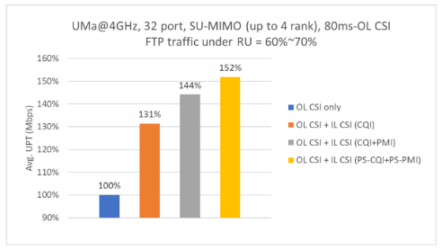  Figure-2.1.2.1 Average UPT performance of (1) Outer-loop CSI only, (2) dual-loop CSI with DMRS-based CQI tracking, (3) dual-loop CSI with DMRS-based CQI and PMI tracking and (4) dual-loop CSI with DMRS-based CQI and PMI tracking with DMRS port selection
Samsung | #1  CDF of L1-RSRP | 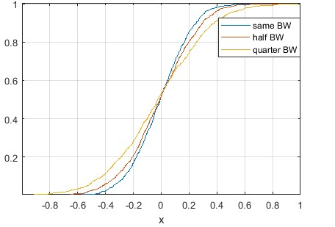  Figure 17: The CDF of L1-RSRP difference (x) between CSI-RS measurement and DM-RS measurement
Ericsson | #1  UPT | 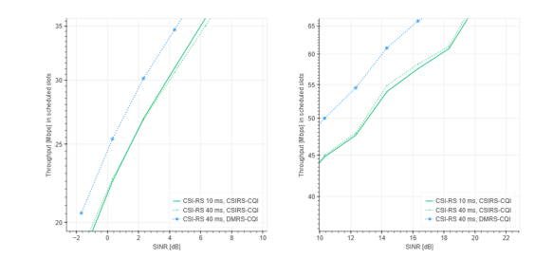  Figure 16: Throughput vs. SINR for CSI-RS-based CQI and PDSCH DMRS-based CQI in UMa scenario.  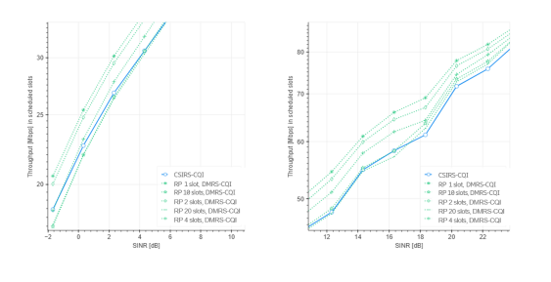  Figure 17: Throughput vs. SINR comparing CSI-RS-based CQI with DMRS-based CQI for different reporting periodicities (RP)

Proposal 4.3-1C
Support CSI-RS-based CSI reporting. Study on whether/how to support DMRS-based CSI reporting.

Support/fine | Nokia, Huawei, ZTE, Tejas, MediaTek, GOOGLE, xiaomi, Samsung. Apple, Ericsson, InterDigital, Qualcomm
Not support

Table 4.3C Additional inputs
Company | Input
Mod v0 | Hope spredtrum/Fujitsu is fine with the above proposal. I didn’t put your name in “not support”. But if you have strong concern, please update the above table.
Samsung | OK with proposal. DMRS-based CSI acquisition is for fast link adaptation in both of FR1/FR2. CQI/RSRP should be baseline to study for report quantity, while PMI relies on the legacy CSI reporting based on CSI-RS.
MediaTek | Support. We are interested in DMRS-based CQI/RI/PMI tracking.
OPPO | Support. Given the different role of DMRS-based CSI and CSI-RS-based CSI, DMRS-based CSI can be viewed as complementary for CSI-RS-based CSI. The proposal can be modified for further clarification.  Proposal 4.3-1  Support CSI-RS-based CSI reporting as baseline. Study on whether/how to support DMRS-based CSI reporting.
Xiaomi | DMRS-based CSI reporting has benefits on link adaption in addition to CSI-RS based CSI reporting.
Nokia | Support
CATT | Similar view as OPPO, CSI-RS based CSI reporting should be the baseline for DL based CSI acquisition. We think that the first step is to identify potential use cases for DMRS based CSI acquisition, if the use cases are promising, we can then study whether/how to support DMRS-based CSI reporting.
ZTE | Fine with the proposal.
vivo | Support further study. We believe that more evaluations are needed to prove its benefits and CSI-RS-based CSI reporting should be given priority.  First, The bandwidth of PDSCH DMRS depends on the scheduling, typically with a relatively narrow bandwidth and varying in time domain. At a given moment, the scheduled bandwidth of one PDSCH may not accurately reflect the CSI for subsequent different scheduled bandwidths.  Second, the analog beam and/or digital beam used for scheduling at different times may also vary.
LG | Similar view with OPPO, CSI-RS based CSI reporting should be a baseline.
TCL | We agree with OPPO’s opinion that CSI-RS -based CSI reporting should be used as the baseline, and the performance of DMRS-based CSI reporting needs to be further validated.
ETRI | Support.
Sharp | We are OK with this proposal.
Sony | We believe that “long-term channel information” should also be considered as a candidate for UE-assisted reports.
NTT DOCOMO | Support Proposal 4.3-1.
CEWiT | We support the proposal
NEC | Support for the study.
Futurewei | Generally fine with the proposal.
TCL | Support
FL | Proposal 4.3-1C
Fujitsu | We are OK with the proposal.
Ofinno | Support in general, but one question for clarification; is the DMRS in the proposal limited to PDSCH or other signal (e.g., PDCCH, PBCH)?

UE-assisted report
UE-assisted report was proposed for several cases as the summary:
Table 4.3A: Summary on the view
Proposals | Summary of observations | Summary of companies’ views
#1  CJT calibration (delay offset, frequency offset, DL/UL phase offset), | 1. Essential feature to enable CJT across non-collocated mTRPs via UE-assisted reporting for NW in calibrating any freq/time/phase mismatch among TRPs  2. Many companies suggest Rel-19 CJTC Dd/FO/PO as a starting point. | Supported by (10): ZTE, NEC, Samsung, Apple, Lenovo, Ericsson, vivo, OPPO, CMCC, CATT, InterDigital
#2  Long-Term Channel Property information report (e.g. TDCP and/or SDCP and/or FDCP) | Long-term channel property can facilitate efficient MIMO transmission operations (e.g., CSI acquisition with reduced overhead/feedback, aid proper codebook parameter selection L, pv, etc) | Supported by (9): OPPO, ZTE, CATT, vivo, ETRI (SDCP), Ericsson, DCM(FFS), Google (TDCP), Huawei (long-term channel information), InterDigital
#3  Interference plus noise (IPN) feedback | For SRS-based DL CSI acquisition, DL interference info is still needed for NW to calculate proper SINR/spectral efficiency. The legacy CQI could be coarse info than IpN FB. | Support (2): Ericsson, Futurewei (study)
#4  CJT interference mitigation | For mitigating CJT interference, UE reports the inferference from other CJT coordination set. | Supported by(1): ZTE

Table 4.3B: Summary on evaluation results
Company | Proposal/  Metric | Key observation and results
ZTE | #2  UPT | Observation 7: The UE-reported compressed long-term channel covariance delivers an average UPT gain of 7% and a cell-edge UPT gain of 36% for mTRP CJT
Ericsson | #3  UPT | Table 6: UPT gain of IPN-based reciprocity DL over baseline (reciprocity DL based on adjusting CQI) at 20% and 50% resource utilization in Dense Urban scenario at 4 GHz with 20MHz bandwidth, 256 antenna elements/64 TXRU., RS periodicity = 10 slots.
   | RU=20% |  | RU=50%
   | Mean UPT | 5th percentile UPT | Mean UPT | 5th percentile UPT
  Reciprocity based on IPN report | 19% | 10% | 14% | 3%
Huawei | #2  Average SE/Cell-edge SE vs overhead | 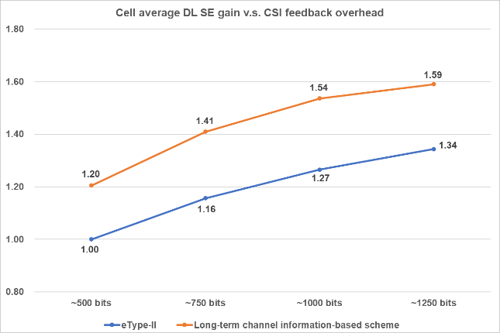  Figure 22. Cell average DL SE of long-term channel information-based explicit CSI feedback scheme  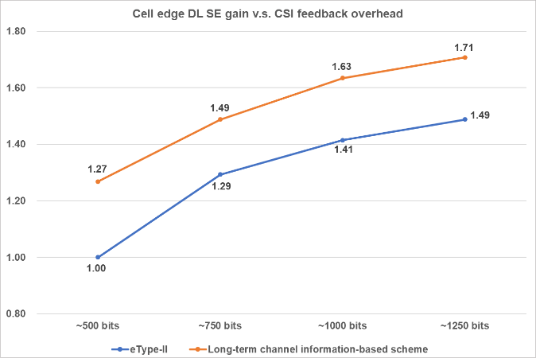  Figure 23. Cell edge DL SE of long-term channel information-based explicit CSI feedback scheme  Observation 14: For the same feedback overhead, long-term channel information-based explicit CSI feedback can improve cell average DL SE by +18% to +22% compared with eType-II scheme.  Observation 15: For the same feedback overhead, long-term channel information-based explicit CSI feedback can improve cell edge DL SE by +15% to +27% compared with eType-II scheme.
vivo | #1  Cell mean SE | 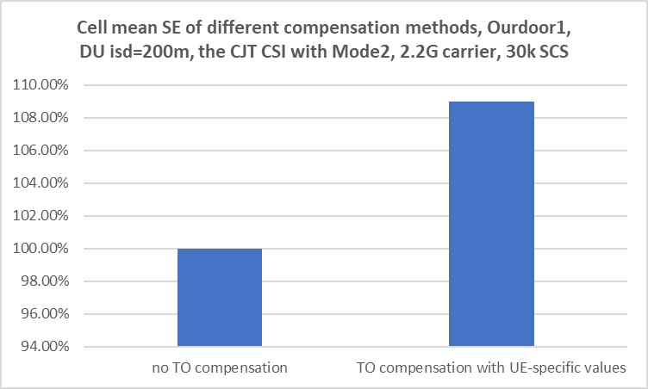  The comparison of SE performance for different approaches  UE compensation achieves larger performance gains of more than 8% compared to the baseline of no DO compensation.

Proposal 4.4-1B
Study on the solutions and benefit on UE-assisted report, at least including
- CJT calibration (delay offset, frequency offset, DL/UL phase offset)
- Channel Property Information report (e.g. Time-domain, Spatial-domain, Frequency-domain and/or UE's recommendation of CSI configuration parameters)
- FFS: CJT interference mitigation, Interference plus noise (IPN) feedback.

Support/fine | ZTE, NEC, Samsung, Apple, Lenovo, Ericsson, vivo, OPPO, CMCC, CATT，ETRI, DOCOMO, Google, Huawei, Futurewei, InterDigital, Qualcomm (partially), KDDI
Not support

Proposal 4.4-1C
Study on how to support CSI report for CJT calibration
- Rel-19 CJT calibration report can be used as a starting point (delay offset, frequency offset, DL/UL phase offset)
Study on the solutions and benefit on channel property information report (e.g. Time-domain, Spatial-domain, Frequency-domain and/or UE's recommendation of CSI configuration parameters)
- Other report content is not precluded.

Table 4.3C Additional inputs
Company | Input
Mod v0 | Consider the number of supporting companies, current put FFS for #3 and #4. Hope the proponent is ok with it.  If any addition comment,
InterDigital | We support proposal 4.4-1
Samsung | OK with the proposal. For CJT calibration reporting, considering to reuse Rel-19 CJTC would be a good start.  Suggest to remove ”…including long term and short term” in the second bullet, since it is especially not clear on what the short-term means (given that there are instantaneous CSI report quantities specified, CQI/PMI, etc)
MediaTek | It is unclear to us about what "Long term" or "Short term" channel property is and how to define those. Those need more study and discussion on the definition. For now, we think the proposal can be more general by removing the wording of "including long term and short term".
Qualcomm | The CJT calibration report introduced in Rel-19 could be the starting point. We sould study whether these NR reports can be supported in 6G. The term "DL/UL phase offset" is not used in the R19 spec. We suggest using only phase offset to avoid misunderstanding. WE support study long-term CSI feedback, but would to clarify (or study) firstly the benefits for the UE based reporting since these information can be acquired by gNB based on UL measurement. Also the inclusion of short-term channel property report is not clear to us. Suggest to remove it at least in the first stage.  Suggest to replace  Channel Property Information report (e.g. Time-domain, Spatial-domain, and/or Frequency-domain) including long term and short term  With  Long channel Property Information report (e.g. Time-domain, Spatial-domain, and/or Frequency-domain) including long term and the benefits compared to gNB based solution. FFS on short term channel property information report.
OPPO | Support in principle. Given that the reporting quantity in CJT calibration may not be aligned between companies, “e.g.” is also needed for the quantity of CJT calibration.
Xiaomi | - We also think ‘long term’ and ’short-term’ are not clear and can be remove at this stage.  - The necessity of UE reporting can be further discussed. In TDD system, network may acquire the information via UL channel without UE reporting. Thus, we suggest the following change:  Study on UE-assisted report/acquisition of assisted information, at least including
Nokia | We suggest clarifying the use case for long-term channel property reporting and to consider both the NW-initiated and event-driven solutions for this study  Proposal 4.4-1(UE-assisted report)  Study on UE-assisted report, at least including  • CJT calibration (delay offset, frequency offset, DL/UL phase offset)  • Long-term Channel Property Information report (e.g. Time-domain, Spatial-domain, and/or Frequency-domain), for reference signals and/or CSI reporting and adaptation, considering both NW- triggered and event-driven solutions,  • FFS: CJT interference mitigation, Interference plus noise (IPN) feedback.
CATT | Support in general.  Regarding the last FFS bullet, We are not sure if it is suitable to categorize these as UE-assisted report.  These are more like standalone interference measurement report. Our view is that the channel measurement reporting and interference measurement reporting are both classical CSI reporting. This is more an enhancement of interference measurement reporting.
ZTE | Fine with Proposal 4.4-1.
Huawei, HiSilicon | The related reports in sub-bullets are very different between each other. Suggest to discuss them in separate proposals.  For long-term channel information, not sure about the short-term information, suggest to remove it. To make it clear on what the long-term channel information is, and how to study the benefits, the second bullet can be refined as below:  Proposal: Study on long-term channel information report (e.g., time-domain, spatial-domain, frequency-domain)  - Further study on reporting content, e.g., MPC related information (PAS, PDP), channel covariance matrix.  - Further study on performance benefits, e.g. improved CSI accuracy via spatial/frequency-domain basis derived from long-term channel information, improved channel estimation accuracy with interference rejection and spatial/frequency-domain channel interpolation via long-term channel information, etc.
vivo | First, for cases where the Channel Property Information report is to configure proper codebook parameters to reduce CSI overhead, we consider that a more direct and efficient approach is that UE recommends CSI configuration parameters directly based on local measurements, rather than reports an intermediate metric.  Second, we believe that for CJTC, only errors caused by UE-specific factors require specification solution. If the hardware imperfections are common for all UEs in a cell, which can be estimated or handled based on implementation-based solutions, e.g., using over-the-air calibration or a reference UE deployed by operators.  Therefore, we suggest adopting the following updates for Proposal 4.4-1.  Proposal 4.4-1  Study on UE-assisted report, at least including  - CJT calibration (delay offset, frequency offset, DL/UL phase offset)  - Note: errors caused by UE-specific factors should be given priority, such as the UE-specific propagation path differences.  - Channel Property Information report (e.g. Time-domain, Spatial-domain, and/or Frequency-domain, and/or UE's recommendation of CSI configuration parameters),  - FFS: CJT interference mitigation, Interference plus noise (IPN) feedback.
LG | On the FFS bullet, CJT interference mitigation is not clear as the main sentence talks about reporting contents. Agree with MTK that “long term” and “short term” is not clear.
TCL | we believe the distinction between long-term and short-term is unclear, and much more clarification is needed.
ETRI | Support in principle. We suggest removing "short term" in the second bullet, as channel properties represent statistical characteristics that require sufficient averaging time, not short-term instantaneous measurements.
NEC | Support the proposal.
Futurewei | The term “UE-assisted report” is not clear to us. All the DL-based CSI reporting are UE reporting.
TCL | Support
FL | Proposal was updated to 4.4-1C
Fujitsu | Support.
KDDI | We support this in principle. However, as Qualcomm mentioned, the term "DL/UL phase offset" may lead to misunderstanding. In Rel-19 calibration reporting, "phase offset" referred not to the offset between DL and UL, but to the difference between the phase measured by the reference CSI-RS resource and that measured by the selected CSI-RS resource. Therefore, simply using "phase offset" is sufficient.
ZTE | It seems the CJT calibration report must be supported before study? I believe this is not the intention. So we suggest the following modification:
  Proposal 4.4-1C
  Study on how to support CSI report for CJT calibration
  - Rel-19 CJT calibration report can be used as a starting point (delay offset, frequency offset, DL/UL phase offset)
  Study on the solutions and benefit on channel property information report (e.g. Time-domain, Spatial-domain, Frequency-domain and/or UE's recommendation of CSI configuration parameters)
  - Other report content is not precluded.
ETRI | Support the updated proposal.
Ericsson | Regarding channel property information report, we also need to discuss the use cases for these reports. Then, we can study the benefits of the different channel property feedback under each use case. We suggest the following change:  Study on the use cases, solutions and benefit on channel property information report (e.g. Time-domain, Spatial-domain, Frequency-domain and/or UE's recommendation of CSI configuration parameters)  - Other report content is not precluded.

Explicit CSI Feedback
Explicit CSI feedback was proposed for by some companies as the summary:

Table 4.5A: Summary on the view
Issue | Summary of observations | Summary of companies’ views
#1  Whether to support explicit Feedback (Channel Matrix/Covariance/  Eigenvectors). | Rationale  Decouples UE from sNB precoding algorithms. Offer more freedom to sNB to utilize it for any MIMO transmission scheme (including MU-MIMO) , AI-based air interface (JSCM training), and SRS-free UEs.  Evidence  As in Table 4.5 B  Skeptical:  prefer implicit feedback as baseline due to overhead concerns. | Support/Study (11): Spreadtrum, Huawei, Samsung, MediaTek, CATT (implicit as baseline), LG, Intel, Qualcomm, TCL, ZTE, vivo  Skeptical (2): Ericsson, CMCC
#2  Definition and format of explicit CSI | Cat-H: Full Channel Matrix (Huawei, Samsung, Qualcomm, MediaTek).  Cat-R: Covariance Matrix (Samsung, Intel).  Projection: Y=AH, where A is a projection matrix (ZTE, vivo). | Cat-H(4): Huawei, Samsung, Qualcomm, MediaTek  Cat-R(23): Samsung, Intel, Qualcomm  Projection(2): ZTE, vivo

Proposal 4.5-1B
Support implicit CSI feedback (i.e. based on RI/PMI/CQI as defined in LTE and NR) as baseline. Study on whether/how to support explicit CSI feedback, including the definition and format of explicit CSI.
Support/fine | Spreadtrum, Huawei, Samsung, CATT (implicit as baseline), LG, Intel, Qualcomm, TCL, ZTE, vivo, InterDigital
Not support | MediaTek

Proposal 4.5-1C
Study on both implicit CSI feedback (i.e. based on RI/PMI/CQI as defined in LTE and NR) and explicit CSI feedback, including the definition and format of explicit CSI, including the definition and format of explicit CSI.

Table 4.5 B Additional inputs
Company | Input
Mod v0 | I didn’t put Ericsson and CMCC in “not support” and hope the study outcome can address their concern on reporting overhead.  If any comment,
InterDigital | We support Proposal 4.5-1
Samsung | Ok with proposal. We see the need of explicit FB especially for AI-based CSI compression, JSCM, as the artificial quantization for CQI would limit the efficiency of the compression for both of training and inference.
MediaTek | We understand people are more familiar with implicit CSI feedback, as it has been studied in LTE and NR. To us, both explicit and implicit channel feedback are essential to study, and we don't prioritize anyone at the beginning of SI.  We also understand people may be afraid of high overhead always for explicit channel feedback, but explicit channel feedback does not always require the extreme high feedback overhead. Observed from Huawei’s and our evaluation results, when we control/limit the feedback overhead to a certain level, explicit channel feedback outperforms Type-I based PMI and eType-II based PMI feedback. Furthermore, we expect that the feedback overhead of explicit channel feedback can be further optimized if applying Rx-side compression which is not yet enabled in our evaluation result.
Qualcomm | Suggest clarify that the baseline is implicit CSI feedback with conventional channel coding and CRC.
OPPO | OK with proposal.
CMCC | Actually we are supporting explicit CSI feedback in out Tdoc, where the CSI is in the format of angle-delay domain.
Nokia | Any proposal/agreement w.r.t the CSI feedback should imply studying those proposed techniques.
CATT | OK in general.
ZTE | Generally fine with Proposal 4.5-1. For more precise wording, the ‘explicit CSI feedback’ should be ‘explicit channel feedback’. Besides, for explicit channel feedback, our position is neutral.
LG | Ok with the proposal.
TCL | We are fine with Proposal 4.5-1, we believe that the explicit CSI feedback should be deprioritized
China Telecom | Same view as Samsung. We support explicit CSI feedback, which is beneficial to study on JSCC and JSCM.
ETRI | Fine with the proposal.
NTT DOCOMO | Support Proposal 4.5-1.
CEWiT | We are okay for studying the benefits of supporting explicit feedback.
Futurewei | Generally fine with the proposal.
Ericsson | For explicit CSI there are different schemes being discussed. It would be good if we list the candidate schemes proposed to avoid future confusion on what is the scope of the study.  If explicit CSI is to be studied, testability in RAN4 has to be considered, which is known to be very challenging.
FL2 | Proposals 4.5-1C was the new proposal for comments
Apple | While we are open to its study, the computational complexity should be kept low to be justified as an alternative to implicit feedback.
Fujitsu | Support.
Ofinno | Studying explicit report is fine to us, but we share similar view with Ericsson that feasibility/testability needs to be considered to prevent studying something not implementable.
Fraunhofer IIS/HHI | Fine with the proposal.

Table 4.5 B: Preliminary results
Company | Metric | Key observation and results
MediaTek | UPT | 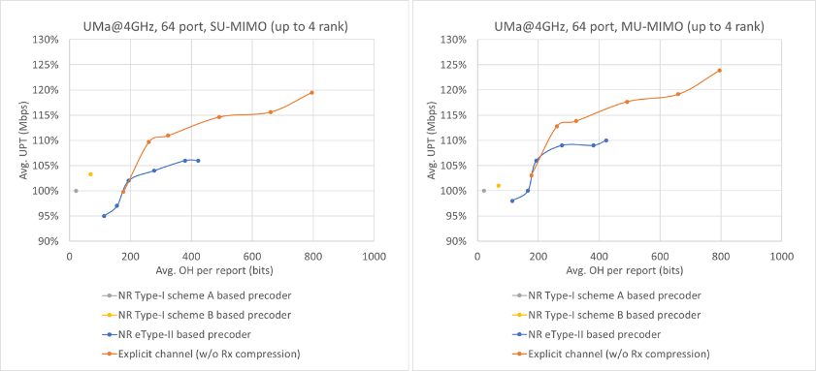  Figure-2.1.1.2 Average UPT performance of NR Type-I Scheme A precoder, NR Type-I Scheme B precoder, NR eType-II precoder vs. explicit channel feedback  Observation 2.1.1.3: Compared to NR eType-II codebook based SVD precoder feedback, explicit channel feedback offers lower UE implementation complexity and achieves better performance for the same level of feedback overhead.
Huawei | SE | Observation 14: For the same feedback overhead, long-term channel information-based explicit CSI feedback can improve cell average DL SE by +18% to +22% compared with eType-II scheme.  Observation 15: For the same feedback overhead, long-term channel information-based explicit CSI feedback can improve cell edge DL SE by +15% to +27% compared with eType-II scheme.
Samsung | SE | SE gain with AI-based JSCM for explicit H
Qualcomm | Sparsity level | 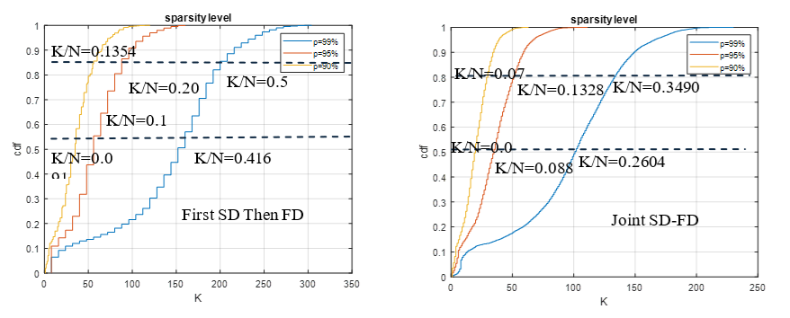  Figure 3-14: Sparsity level of the FD channel and the joint SD-FD channel  Observation 19: Channel compression using the joint SD-FD basis could improve the sparsity level by 100% compared to the compression with first SD then FD as Rel-16 eType II approach.

Others
Other proposals for CSI reporting design, including precoded CSI-RS, SRS free, some CQI related enhancement, NTN, etc.
More views are needed to trigger discussion in RAN1, or some dependency to other fundamental aspects.

CSI measurement

Channel measurement
Regarding channel measurement, we summarized the views as the table below
View summary |  | Companies
NZP CSI-RS as the channel measurement resource |  | Nokia, Futurewei, Spreadtrum, InterDigital, Huawei/HiSilicon, OPPO, TCL, ZTE, CATT, Tejas, MTK, CMCC, Xiaomi, vivo, IMU, Google, NEC, China Telecom, Samsung, Beammwave, Apple, Lenovo, Fujitsu, LG, Sharp, Honor, ETRI, Ericsson, Sony, NTT DCM, Qualcomm, ATT, KDDI, Rakuten, ASUSTek, China Unicom
Study DMRS as CSI measurement RS | For CQI/MCS reporting | Nokia, ZTE, Qualcomm(delta CQI), Ericsson, MTK, Apple(CQI/ Delta CQI), Google, Tejas
Study DMRS as CSI measurement RS | For RI reporting | Nokia, ZTE, MTK
Study DMRS as CSI measurement RS | For PMI reporting | MTK
Study DMRS as CSI measurement RS | For RSRP/SINR reporting | ZTE
Study DMRS as CSI measurement RS | For DMRS port selection | ZTE
Study DMRS as CSI measurement RS | Low priority for study | Spreadtrum
Almost all companies discuss CSI-RS for CSI measurement in this agenda. Multiple companies propose to study DMRS as the channel measurement RS for CSI, although 1 company propose to deprioritize this study.

Proposal 5.1-1:
6GR supports NZP CSI-RS as the channel measurement RS for DL CSI acquisition
- FFS other reference signals, e.g., DMRS
- FFS Aspects related with non-precoded CSI-RS or precoded CSI-RS
Support/fine | Nokia, Futurewei, Spreadtrum, InterDigital, Huawei/HiSilicon, OPPO, TCL, ZTE, CATT, Tejas, MTK, CMCC, Xiaomi, vivo, IMU, Google, NEC, China Telecom, Samsung, Beammwave, Apple, Lenovo, Fujitsu, LG, Sharp, Honor, ETRI, Ericsson, Sony, NTT DCM, Qualcomm, ATT, KDDI, Rakuten, ASUSTek, China Unicom, CEWiT
Not support

Company | Comment
MediaTek | Fine with the proposal. We are supportive to using DM-RS as the CSI reference signal.
Samsung | Support
OPPO | Support
Xiaomi | Support
CATT | Generally support. We suggest a small modification:
  6GR supports NZP CSI-RS as the channel measurement RS for DL CSI acquisition
  - FFS other reference signals, e.g., DMRS
ZTE | OK
Huawei, HiSilicon | One aspect affecting the measurement performance is how gNB transmit the CSI-RS, specifically, non-precoded CSI-RS or precoded CSI-RS. As illustrated in our paper, the cell specific precoded CSI-RS have benefits of coverage and sharing between UEs with different capabilities, which should also be considered in study. Therefore, we propose to add a bullet on further study on both non-precoded and precoded CSI-RS.  Proposal 5.1-1:  6GR supports NZP CSI-RS as the channel measurement RS for CSI  - FFS other reference signals, e.g., DMRS  - Further study on non-precoded and precoded CSI-RS
vivo | Support
InterDigital | Support
LG | Support
TCL | Support
ETRI | Support
CEWiT | Support
NEC | support
Futurewei | Ok.
FL | Update the proposal per companies’ input
Fujitsu | Support.
Ofinno | Support
Fraunhofer IIS/HHI | Support
Key observations
Company | Observation
Ericsson | Observation 13 PDCCH link adaptation using CSI feedback from reference signals in data region (e.g., CQI or L1-SINR based on CSI-RS) is suboptimal as the SINR experienced in data region and control region can be very different due to different loading experienced in these two regions.
Samsung | Observation #18: The measurement accuracy using PDSCH DM-RS has similar performance as the measurement accuracy using CSI-RS.

Interference measurement
Regarding channel measurement, we summarized the views as the table below
View summary |  | Companies
Resources | CSI-IM | Spreadtrum, vivo, Google, Samsung, LG, Qualcomm, Nokia
Resources | ZP CSI-RS | Samsung
Resources | NZP CSI-RS | Futurewei, Spreadtrum, Google  Concern: Samsung, Qualcomm, vivo, TCL
Resources | 5G SSB | Google
Resources | DMRS | Qualcomm (for CSI prediction), Nokia
Other enhancements | Report interference statistics | Futurewei
Other enhancements | Inter-cell interference coordination among multiple cells | MTK, Huawei/HiSilicon, CMCC
Other enhancements | Advanced UE-side interference suppression | MTK

Limited number of companies discuss interference measurement in contributions. Hence FL will wait for more input to derive proposal 3.3. Companies are encouraged to share their views on interference measurement for CSI in 6GR, esp. on the RS type.

Proposal 5.2-1
Consider CSI-IM as the baseline for interference measurement resource for DL CSI acquisition in 6GR
- FFS whether to combine CSI-IM and ZP CSI-RS
- FFS other RS types, e.g., NZP CSI-RS, 5G SSB, DMRS, etc

Support/fine | Spreadtrum, vivo, Google, Samsung, LG, Qualcomm, Nokia, CATT, LG, TCL, ETRI, Sony, Ericsson
Not support

Company | Comment
Samsung | We don’t see clear use case in real deployment utilizing NZP CSI-RS for IM yet, so we prefer to use only CSI-IM or ZP CSI-RS for IM.
Qualcomm | Suggest have separate rows for CSI-IM and ZP CSI-RS.  Qualcomm supports CSI-IM.  The feasibility of NZP CSI-RS for interference measurement should be revisited by careful link-level evaluation.
Nokia | We support CSI-IM for interference measurement. We also support a study on the use of DMRS for interference measurement
CATT | We support to study interference measurement in 6GR. Considering large number of ports and/or mTRP transmission in 6GR, simply relying on base station to adjust the reported CQI for MU-MIMO scheduling or CJT transmission is both suboptimal and challenging. Therefore, advanced interference measurement and mitigation mechanisms which target mTRP transmission and MU-MIMO should be studied.
vivo | The typical scenario of NZP-IMR is to measure the interference of MU, as it is UE-specific precoded CSI-RS. This means that if NZP IMR is configured, BS is conducting the pre-pairing of UEs and has identified the interference sources. The NZP IMR should be sent to the paired UEs to enable the UE to quickly report the modified CQI. However, in the NR design, the UE still needs to provide PMI and RI, which leads to significant latency and CSI aging. Moreover, as the number of paired UEs increases, the overhead of UE-specific CSI-RS also significantly increases. Last, the scheduler can estimate the SINR after MU pairing based on the PMI and CQI feedback from the UEs even without NZP-IMR. By fusion with the OLLA, a robust MCS can be determined for data transmission. Taking all factors above, the implementation of NZP-IMR is difficult in engineering.  Consequently, we propose the NZP-CMR and CSI-IMR in CSI measurement should be prioritized, while NZP-IMR should be deprioritized or removed from the 6G CSI measurement.
LG | CSI-IM can be a baseline and we can further discuss on NZP CSI-RS for IM. Similar to Qualcomm, CSI-IM and ZP-CSI-RS can be a discussed separately as those measurement RSs have different purpose, i.e., rate-matching or Interference measurement.
TCL | We support using CSI-IM or ZP CSI-RS for interference measurement. We also agree with QC’s view that using NZP CSI-RS for interference measurement requires careful link-level evaluation.
ETRI | We consider CSI-IM based interference measurement as the primary approach. We have similar views to CATT that study on IM for CJT and MU-MIMO is needed.
Sony | Support in principle.
Futurewei | NZP IMR is important to improve MU MIMO performance after MU pairing, as it allows the UE to better handle the MU interference. Therefore, NZP IMR should be further studied.
Ericsson | Support
FL | Proposal 5.2-1 is given based on companies’ input.
Fujitsu | Support.
Ofinno | Considering L1-CLI measurement introduced in Rel-19 is based on the reference signal (L1-CLI-RSSI, L1-SRS-RSRP) which is configured by the CSI report configuration, we propose to add them at least for the FFS bullet for other types.
Fraunhofer IIS/HHI | Support

Key observations
Company | Observation
MTK | Observation 2.1.3.1: High proportion of interference impacted CPEs of ~35% or more are observed in FWA networks.  Observation 2.1.3.2: FWA scenarios provides quasi-static channel properties with extended coherence times (e.g., >100ms), which makes interference coordination feasible and highly practical in FWA deployments.  As depicted in Figure-2.1.3.1, this yielded significant throughput gains: approximately 42% to 48% in indoor and outdoor 3.5GHz deployments, and 24% to 31% in 7GHz evaluations.

CSI prediction
Regarding CSI prediction, we summarized the views as the table below
View summary |  | Companies
UE side prediction | Frequency domain CSI prediction | Nokia, Futurewei, Spreadtrum, InterDigital, Huawei/HiSilicon (AI and non-AI), OPPO (AI and non-AI), TCL, ZTE (AI and non-AI), CATT, Tejas (AI and non-AI), MTK (Prioritize non-AI), CMCC, Xiaomi (AI and non-AI), vivo (AI and non-AI), NEC, Samsung, Nvidia, Apple, Lenovo, Fujitsu, LG, Sharp, Honor, ETRI, Ericsson (AI and non-AI), Panasonic (AI and non-AI), Sony, ATT, ASUSTek, China Unicom
UE side prediction | Spatial domain CSI prediction | Nokia, Futurewei, Spreadtrum, InterDigital, Huawei/HiSilicon (AI and non-AI), OPPO (AI and non-AI), TCL, ZTE (AI and non-AI), CATT, Tejas (AI and non-AI), MTK (Prioritize non-AI), CMCC, Xiaomi (AI and non-AI), vivo (AI and non-AI), NEC, Samsung, Nvidia, Apple, Lenovo, Fujitsu, LG, Sharp, Honor, ETRI, Ericsson (AI and non-AI), Panasonic (AI and non-AI), Sony, NTT DCM, ATT, ASUSTek, China Unicom
UE side prediction | Time domain prediction | Nokia (Rel-19 as start point, considering enhancement using multiple resource types), TCL (Joint prediction and compression), CATT, MTK (Prioritize non-AI, considering enhancement using multiple resource types for AI), vivo (AI and non-AI, NR with $N_{4}$=1 only as a starting point), IMU, BJTU, Samsung, Nvidia, Apple, Sharp, ETRI, Ericsson, Sony, Qualcomm (with interference prediction), Rakuten
UE side prediction | Cross beam/virtualization CSI prediction | Vivo, Apple, Sony, CATT
UE side prediction | Cross frequency unit (e.g., BWP, CC) CSI prediction | Samsung, Apple, LG, ETRI, Sony, NTT DCM
NW side prediction | Frequency domain CSI prediction | Futurewei, Huawei/HiSilicon (AI and non-AI), OPPO (AI and non-AI), NEC, Ericsson (AI and non-AI), NTT DCM, ATT, China Unicom
NW side prediction | Spatial domain CSI prediction | Futurewei, Huawei/HiSilicon (AI and non-AI), OPPO (AI and non-AI), NEC, Ericsson (AI and non-AI), NTT DCM, ATT, KDDI, vivo (for NES) , China Unicom
NW side prediction | Time domain prediction | Nvidia
NW side prediction | Cross frequency unit (e.g., BWP, CC) CSI prediction | NTT DCM
Assistance information | Full-dimension long term channel information | Huawei/HiSilicon (for AI and non-AI), vivo (for non-AI, Derived from full-dimension CSI-RS with longer periodicity), ZTE (Derived from full-dimension CSI-RS with longer periodicity), Tejas (Derived from full-dimension CSI-RS with longer periodicity), Xiaomi (Statistical power distribution in angular/frequency domain), ETRI (Derived from full-dimension CSI-RS with longer periodicity), Ericsson (Derived from full-dimension CSI-RS with longer periodicity), ATT (Long-term frequency domain or spatial domain correlation) , China Unicom
Assistance information | Compression/precoding matrix applied on CSI-RS | OPPO, MTK, Ericsson

It seems there is consensus to study non-AI or AI based CSI prediction among numerous domains. A large number of companies show attractive gain. The following proposals are derived based on companies’ contributions.

Proposal 5.3-1:
For 6GR, study the following non-AI and AI based low overhead CSI-RS or CSI prediction at UE and/or NW side
- Non-AI and AI based time domain CSI prediction
  - NR Rel-18/Rel-19 UE side CSI prediction is a start point with potential simplification
- Non-AI and AI based frequency/spatial domain prediction
  - Consider the following information options used to reconstruct the reduced-dimension measurement into full-dimension channel
    - Option 1: Full-dimension long term channel information (e.g., MPC related information, channel covariance matrix), either derived from full-dimension CSI-RS measurement or NW/UE signalling
    - Option 2: Compression/precoding matrix applied on CSI-RS
  - Note: the non-AI algorithm used for prediction is not limited to sample&hold
- [AI based cross beam/virtualization CSI prediction]
  - FFS the applied frequency range
- [AI based cross frequency unit (e.g., BWP, CC) CSI prediction]
  - FFS whether it is applied for intra band or inter band, and the relevant RF property modelling
Support/fine | Nokia, Futurewei, Spreadtrum, InterDigital, Huawei/HiSilicon, OPPO, TCL, ZTE, CATT, Tejas, MTK, CMCC, Xiaomi, vivo, NEC, Samsung, Nvidia, Apple, Lenovo, Fujitsu, LG, Sharp, Honor, ETRI, Ericsson, Panasonic, Sony, NTT DCM, ATT, ASUSTek, Rakuten, China Unicom, CEWiT, SJTU
Not support

Company | Comment
MediaTek | Supportive to this proposal. However, it a bit unclear to us what “cross virtualization” means?
Nokia | We need to clarify if the non-AI spatial/frequency prediction is limited to the baseline 1 (sample & hold) as in P2.4.1 or whether the study includes other techniques for spatial/frequency prediction. Option 1 and 2 and the last 2 bullet points need further clarification
ZTE | For the sub-bullet of the second bullet, we suggest the following revision. First, the full-dimension CSI-RS measurement can also be leveraged for AI method. For example, in our simulations, LSTM network is utilized for the CSI prediction, where full-port channel from the last time instance (either based on measurement or based on inference) and one partial-port measurement at the current time instance are used as model input. In this case, the information derived from full-dimension CSI-RS measurement may be anything which is actually black box to the outside. Additionally, precoding matrix in Option 2 can also be viewed as one kind of channel information exchanged between NW and UE, and then we can merge the two options.  - Non-AI and AI based frequency/spatial domain prediction  - At least for non-AI, consider the following information options used to reconstruct the reduced-dimension measurement into full-dimension channel  - Option 1: Full-dimension long term channel information, either derived from full-dimension CSI-RS measurement or NW/UE signalling  - Option 2: Compression/precoding matrix applied on CSI-RS
Huawei, HiSilicon | 1) If we do not urge to down select between NW side prediction and UE side prediction, better to say “and/or”  For 6GR, study the following non-AI and AI based low overhead CSI-RS or CSI prediction at UE and/or NW side  2) For the 2nd bullet of spatial/frequency domain CSI prediction, we need to point out that AI based solution can also leverage assistance information for reconstruction – taking long term channel information for example, it can serve as an identifier to resolve the “one input to multiple output” ambiguity.  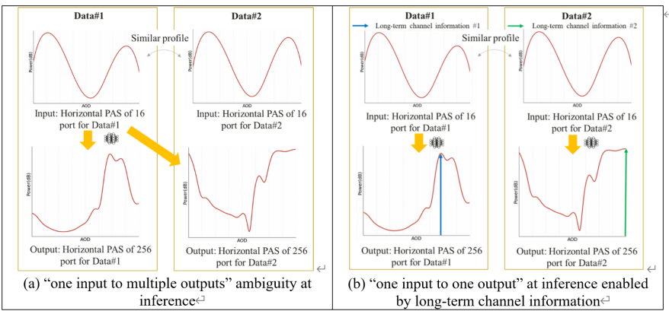  In addition, in case it lacks the explanation of the long term channel information, we add some examples in the round bracket.  At least for non-AI, For AI and non-AI, consider the following information options used to reconstruct the reduced-dimension measurement into full-dimension channel  - Option 1: Full-dimension long term channel information (e.g., MPC related information (PAS, PDP), channel covariance matrix), either derived from full-dimension CSI-RS measurement or NW/UE signalling  - Option 2: Compression/precoding matrix applied on CSI-RS  3) For AI based cross-beam/virtualization, and AI based cross frequency unit, better to provide with use case specific applicable scenario (and evaluation assumptions). E.g., for AI based cross-beam/virtualization, is it applied to FR2 or FR3? For AI based cross frequency unit, is it applicable for intra band or inter band; for inter band, how to model the cross band RF properties (beam codebook/ physical distance/downtilt angles across RF modules, etc.).
InterDigital | We support the first two main bullets and sub-bullets, but suggest to remove the last two bullets at this stage.
MediaTek2 | We also support studying CSI-RS pattern design using AI/ML, however, it is unclear if the above proposal covers the CSI-RS design aspect, or that would be treated in section 6.3. Further clarification is needed.  We need to clarify what long-term channel information means. Proper definition needs to be discussed and therefore we do not support adding “long-term channel information” in the proposal at this time.
LG | Generally fine with proposal 5.3-1. Regarding, subbullet “NR Rel-18/Rel-19 UE side CSI prediction with potential simplification is the start point”, some companies thinks that at least some enhancement on using different RS types, codebook enhancement, etc. So, it is better to remove simplification as below.  “NR Rel-18/Rel-19 UE side CSI prediction with potential simplification is the start point”,  For option 2 of second bullet, we are not sure on how to define “long-term” channel information. It is better to clarify.
ETRI | Proposal 5.3-1: We support the proposal, but clarification for definition of ‘cross virtualization CSI prediction’ should be needed.
Xiaomi | It’s better discuss high-level categorizations of non-AI and AI based CSI prediction. Detailed solutions/evaluations can be discussed later.
NTT DOCOMO | For non-AI and AI based time domain CSI prediction, as an extension to the Rel-18/19 CSI prediction, the CSI prediction for the early CSI enhancements can be included in the proposal, e.g.,  - Non-AI and AI based time domain CSI prediction  - NR Rel-18/Rel-19 UE side CSI prediction with potential simplification is the start point  Study the CSI prediction for early CSI acquisition
CEWiT | We support this proposal
FL | Update the proposal based on companies’ input
Ericsson | Regarding “Option 2: Compression/precoding matrix applied on CSI-RS” we would like to clarify that this is a general enhancement for beamformed CSI RS, rather than a CSI prediction scheme or a scheme that only reduces CSI-RS overhead.  In our view, it can be beneficial to have a dedicated topic on beamformed CSI RS, under which different beamformed CSI RS options can be studied and compared, such as compressed sensing based beamformed CSI RS, beamformed CSI RS based on port selection codebook etc  Such a separation would help maintain a clear scope for CSI prediction studies, while allowing a more structured and fair comparison of different beamformed CSI RS design options.
FL | Update the proposal based on companies’ input
Fujitsu | Support.
xiaomi | Option 2 is not clear to us. Does it only include non-AI based method(e.g., beamformed RS via compressive sensing)? For AI-based method, beamformed RS is not necessary.
NTT DOCOMO | Agree with Ericsson’s comment above, this is more general enhancement to BFed CSI-RS.

Proposal 5.3-2
For non-AI and AI based time domain CSI prediction, with NR Rel-18/Rel-19 UE side CSI prediction as the start point with potential simplification, FFS
- Whether to support both N4=1 and N4>1
- Whether/how to use combined configuration of P/SP and AP RS for data collection and inference
- Extension to large number of ports (>32 ports)
- CSI prediction with longer CSI-RS periodicities
- Whether/how to support CSI prediction for early CSI acquisition
- Whether/how to use of DMRS for interference prediction
Support/fine | Nokia, TCL, CATT, MTK, vivo, IMU, BJTU, Samsung, Nvidia, Apple, Sharp, ETRI, Ericsson, Sony, Qualcomm, Rakuten, InterDigital
Not support

Company | Comment
InterDigital | We support Proposal 5.3-2
ZTE | For the second bullet, the benefit of AP RS for training data collection is not clear. Frequent triggering signalings are to be used for data collection purpose which larges sacrifices the PDCCH capacity. The last bullet shall be removed or discussed separately since the main bullet already clarifies that NR Rel-18/Rel-19 UE side CSI prediction with potential simplification is the start point.
Samsung | Support. However, the use of DMRS for time-domain interference prediction is not clear? Does this rely on periodic DMRS for control channel? Or does it even be based PDSCH DMRS? If so, how to ensure multiple time domain measurements from PDSCH DMRS? May be proponents need to clarify this.
MediaTek | Generally support this proposal. One suggestion is to re-word the sub-bullet “Large number of ports (>32 ports)” as it gives the impression that <=32 ports should not be considered.
LG | Similar comment in Proposal 5.3-1
ETRI | Proposal 5.3-2: We support the proposal.
IMU | We are supporting this proposal
FL | Update the proposal per companies’ input
Ericsson | Proposal 5.3-2:  Here we are assuming the structure of the Rel-18 Doppler codebook which is based on Rel-16 eType II codebook. The 6G codebook may be different from this. So, we think it is too early to make this assumption. Suggest the following revision:  “with NR Rel-18/Rel-19 UE side CSI prediction as starting point for study with potential simplification”
FL | Update the proposal per companies’ input
Qualcomm2 | The proposal itself is unclear. Suggest the following modification:  For non-AI and AI based time domain CSI prediction, with NR Rel-18/Rel-19 UE side CSI prediction as the start point with potential simplification, FFSstudy at least the following aspects  - NR Rel-18/Rel-19 UE side CSI prediction as the start point with potential simplification  - Whether to support both N4=1 and N4>1  - Whether/how to use combined configuration of P/SP and AP RS for data collection and inference  - Extension to large number of ports (>32 ports)  - CSI prediction with longer CSI-RS periodicities  - Whether/how to support CSI prediction for early CSI acquisition  - Whether/how to use of DMRS for interference prediction
Fraunhofer IIS/HHI | Support

Proposal 5.3-3
For NW-side CSI prediction use cases based on AI or non-AI, study the following input for NW-sided model
- Sparse channel matrix
- Precoding matrix indicated by PMI
- Full-dimension long term channel information, e.g., transmitter covariance matrix
- Note: The use of instantaneous full-dimensional channel matrix from SRS is to be discussed under CSI-SRS fusion in 10.5.3.3
Support/fine | Futurewei, Huawei/HiSilicon, OPPO, NEC, Ericsson, NTT DCM, ATT, KDDI, vivo, Nvidia, China Unicom
Not support

Company | Comment
CATT | Further clarifications are needed for the NW-side CSI prediction use cases. If the NW-side CSI prediction is in a TDD system with SRS measurements as input for NW-sided model, there is no need to discuss because it’s up to implementation of base station. If the NW-side CSI prediction is in FDD system based on CSI reporting, this discussion is coupled with the CSI framework, i.e., whether to support explicit CSI feedback of channel matrix or UE-assisted report of long term channel information.  Therefore, we suggest to postpone this study until there is more progress in the CSI framework.
ZTE | The study for NW-side CSI prediction shall be postponed since the codebook used for PMI reporting is not clear and thus it’s hard to align the prediction performance.
Huawei, HiSilicon | Support.
Samsung | Fine but few comments  - Better to clarify this for spatial/frequency-domain prediction.  - We suggest to change the term “full-dimensional long term channel information” with “second order channel statistics”. We also suggest to give example, e.g., transmitter side covariance matrix, etc.  - A yet another input is instantaneous full-dimensional channel matrix from SRS, perhaphs from a small subset of frequency units. Can we clarify this is to be studied under CSI-SRS fusion in 10.5.3.3.?
MediaTek | Clarifications are required for this proposal. First, “sparse channel matrix” needs to be properly defined. Second, “long-term channel information” also needs to be properly defined since it carries different interpretations. We believe separate discussion on these two aspects should take place before this proposal can be discussed.
LG | Is it for frequency/spatial domain? Or temporal domain? Or all? It is better to clarify.
TCL | Support
ETRI | Proposal 5.3-3: In our view, NW-side CSI prediction is up to NW implementation.
Sony | Question for clarification: Is “full-dimensional long-term channel information” the same as “long-term covariance matrix”?
Ericsson | Proposal 5.3-3:  We assume that the intention of this proposal is to study the performance of NW-side CSI prediction use case by considering various input content/format. In this case, it is more appropriate to list these options in section 2.4, where the evaluation assumptions are discussed.
FL | Update the proposal per companies’ input

Key observations
Company | Observation
Nokia | UE side  Model 1 uses fewer transformer layers, with approximately 0.95 million trainable parameters and 54.54 million FLOPs, while Model 2 employs more layers, resulting in about 2.14 million parameters and 122.96 million FLOPs. Both models were trained over overall CSI-RS densities from ½ to 1/13, with a fixed SD = ½ and FD varies correspondingly and the corresponding NMSE improvements relative to linear interpolation are shown in Figure 4.  Due to its higher complexity, Model 2 consistently achieves about a 1 dB NMSE gain over Model 1, indicating that improved channel reconstruction from sparse CSI-RS can be obtained by increasing model complexity, with a clear performance–complexity tradeoff to be explored in future studies.  NW side  The main challenges of NW-sided frequency and/or spatial domain CSI prediction are high CSI feedback overhead and obtaining high quality labels.  Observation 15. For the frequency and/or spatial domain CSI prediction, it is beneficial to maintain conventional rectangular/square patterns as the baseline and consider support for additional patterns only when clear, generalizable gains are demonstrated, with appropriate capability handling to protect legacy operation.
Spreadtrum | Observation 5: For frequency domain low CSI-RS overhead, the loss of SGCS is less than 5% with 87% RS overhead reduction in frequency domain.  Observation 6: For spatial domain low CSI-RS overhead, the loss of SGCS is less than 5% with 75% RS overhead reduction in spatial domain.  Observation 7：AI/ML model can achieve good generalization performance in frequency domain reduction for the case that the training dataset and testing dataset are generated with various deployment scenarios.  Observation 8：AI/ML model can achieve good generalization performance in frequency domain reduction for the case that the training dataset and testing dataset are generated with various carrier frequencies.  Observation 9：AI/ML model can achieve good generalization performance in frequency domain reduction for the case that the training dataset and testing dataset are generated with various UE speeds.  Observation 10: For spatial domain reduction, the loss SGCS is approximately 28% compared to non- generalization with various scenarios.  Observation 11：AI/ML model can achieve good generalization performance in spatial domain reduction for the case that the training dataset and testing dataset are generated with various carrier frequencies.  Observation 12: AI/ML model can achieve good generalization performance in spatial domain reduction for the case that the training dataset and testing dataset are generated with various UE speeds.
InterDigital | Observation 18: According to presented results, for AI/ML-based CSI-RS overhead reduction,  - FDR-based results in very good SGCS performance (≥0.9) for the entire range of reduction factors of 2×, 4× and 8×. Also, the performance is maintained across different sizes of gNB antenna ports.  - SDR-based results in a reasonable SGCS performance (≥0.88) for the reduction factors of 2× and 4×. Compared to the FDR case, it appears that the SGCS performance is more sensitive to spatial domain reduction.  - It is feasible to use UE-side AI/ML prediction for CSI-RS overhead reduction in frequency and/or spatial domain (Sub-Case A).
Huawei/HiSilicon | See section 6.5 for Non-AI observations  Observation 12: Taking long-term channel information as additional information for CSI prediction can achieve SGCS gain especially for ultra-sparse CSI-RS in spatial domain.  Observation 13: The model size and training data size of AI/ML-based solutions with long-term channel information can be reduced by 75% and 55% respectively to achieve similar SGCS compared to AI/ML-based solutions without long-term channel information.
OPPO | Observation 5: With sparse CSI-RS density in frequency and/or spatial domain, high SGCS values can be achieved by UE-side model with FLOPs < 1M.
ZTE | Observation 8: Wiener-filtering-based CSI prediction (UE-side implementation) with SD low-overhead CSI-RS delivers 5.35% average UPT gain and 4.56% 5%-like UPT gain.  Observation 9: AI-based CSI prediction (UE-side model) with SD low-density CSI-RS delivers 5.61% average UPT gain and 7.31% 5%-like UPT gain.
CATT | Observation 1: For SDR, when the spatial compression rate is 1/4, the AI/ML output channel matrix can achieve SGCS of 0.971/0.963 (128 /256ports).  Observation 2: For FDR, when the frequency compression rate is 1/4, the AI/ML output channel matrix can achieve SGCS of 0.966/0.968 (128 /256ports).  Observation 3: For SFDR, when the spatial and frequency compression rates are both 1/4, the AI/ML output channel matrix can achieve SGCS of 0.953/0.944 (128 /256ports).  Observation 4: In SFDR, the equivalent compression rate can be 1/16 (i.e., the CSI-RS overhead can be reduced by 93%), while the SGCS performance is still satisfactory (nearly 0.95, only 0.01~0.02 performance degradation as compared with SDR/FDR).
Tejas | Observation 8 A 5.3% throughput gain with the flexible sounding approach is observed as compared to the baseline where all the CSI-RS ports are contiguously sounded.
MTK | Observation 2.4.2.1.1: For spatial domain CSI-RS reduction, the trained pattern achieves the best or near-best NMSE at all densities, showing the advantage of AI/ML-based joint CSI-RS pattern generation and CSI prediction, especially for high reduction ratio cases.  Observation 2.4.2.1.2: For frequency domain CSI-RS reduction, the trained pattern also achieves the best NMSE at all densities, showing the advantage of AI/ML-based joint CSI-RS pattern generation and CSI prediction, especially for high reduction ratio cases.  Observation 2.4.2.2.1: Over all time slots in prediction windows, Scheme#1(P/SP+AP RS) shows 8%, 187%, 271%, and 267% SGCS performance gain compared to the baseline for 3, 10, 20, and 30 km/h UE speed, respectively. Scheme#2 (P/SP RS) also shows 4%, 117%, 92%, 100% SGCS performance gain compared to baseline for 3, 10, 20, and 30 km/h UE speed, respectively.  Observation 2.4.2.2.2: Over all time slots in prediction windows, Scheme#1(P/SP+AP RS) shows 1%, 5%, 65%, 73% SGCS performance gain compared to Scheme#2 (P/SP RS) for 3, 10, 20, and 30 km/h UE speed, respectively.  Observation 2.4.2.2.3: Over all time slots in the prediction window, Scheme#1(P/SP+AP RS) shows 6.3dB, 14.0dB, 15.0dB, 11.8dB NMSE performance gain compared to the baseline for 3, 10, 20, and 30 km/h UE speed, respectively. Scheme#2 (P/SP RS) also shows -1.1dB, 6.2dB, 3.0dB, 3.1dB NMSE performance gain compared to baseline for 3, 10, 20, and 30 km/h UE speed, respectively.  Observation 2.4.2.2.4: Over all time slots in prediction window, Scheme#1(P/SP+AP RS) shows 3.8dB, 5.1dB, 10.6dB, 7.7dB NMSE performance gain compared to Scheme#2 (P/SP RS) for 3, 10, 20, and 30 km/h UE speed, respectively.  Observation 2.4.2.2.5: NMSE and SGCS gain of scheme#1 compared to scheme#2 comes with larger overhead for AP RS transmission and significantly shorter observation window (32% in our evaluations).  Observation 2.4.2.2.6: On Average over all slots in prediction window of each scheme, Sheme#1(P/SP+AP RS) shows 4%, 69%, 128%, and 155% SGCS gain over the baseline for 3, 10, 20, 30 km/h UE speed, respectively. Also, Scheme#2 (P/SP RS) shows 3%, 63%, 59%, and 71% SGCS gain over the baseline for 3, 10, 20, 30 km/h UE speed, respectively.  Observation 2.4.2.2.7: On Average over all slots in prediction window of each scheme, Sheme#1(P/SP+AP RS) shows 0.6dB, 8.6dB, 10.4dB, and 6.4dB NMSE gain over the baseline for 3, 10, 20, 30 km/h UE speed, respectively. Also, Scheme#2 (P/SP RS) shows -1.6dB, 5.4dB, 2.2dB, and 1dB NMSE gain over the baseline for 3, 10, 20, 30 km/h UE speed, respectively.
CMCC | Observation 10: Compared to benchmark methods like sample-and-hold or traditional interpolation, the AI model improves spatial domain CSI prediction performance (in terms of SGCS) by up to 18%, 45%, and 152% when the ratio of measured ports to total ports is 1/2, 1/4, and 1/8, respectively.  Observation 11: A good prediction performance (>0.94 in terms of SGCS) for AI/ML based spatial domain CSI prediction can be achieved with CSI-RS overhead reduced to 1/2, 1/4, and 1/8, respectively.  Observation 12: Compared to spatial domain CSI prediction under fixed port pattern, spatial domain CSI prediction under AI optimized port pattern has 0.1%, 1.2%, 1.6% loss in terms of SGCS when the ratio of measured ports to total ports is 1/2, 1/4, and 1/8, respectively.  Observation 13: Compared to benchmark methods like sample-and-hold or traditional interpolation, the AI model improves frequency domain CSI prediction performance (in terms of SGCS) by up to 5%, 7%, and 9%, when the frequency density for measurement is 1/2, 1/4, 1/8, respectively.  Observation 14: A good prediction performance (>0.98 in terms of SGCS) for AI/ML based frequency domain CSI prediction can be achieved with CSI-RS overhead reduced to 1/2, 1/4, 1/8, respectively.  Observation 15: A good prediction performance (>0.94 in terms of SGCS) for AI/ML based joint spatial and frequency domain CSI prediction can be achieved with CSI-RS overhead reduced to 1/32.  Observation 16: For the use case of Frequency and/or spatial domain CSI prediction, the following performance gain and model complexity are observed
Xiaomi | Observation 1: AI/ML based CSI prediction in frequency domains has better performance than baseline scheme in different channel qualities and different frequency densities.  Observation 2: When the frequency density is 1/8, the SGCS of AI/ML based CSI prediction is around 0.948, 0.872, 0.857 for SNR =10dB, 0dB, -10dB, respectively.  Observation 3: When the channel quality is good, AI/ML based CSI prediction can maintain good performance even when frequency density decreases to 1/16, which achieves around 50% SGCS gain than baseline scheme.  Observation 4: Compared with density reduction in frequency domain, the SGCS performance is more sensitive to the density reduction in spatial domain.  Observation 5: When the spatial density is 1/2, the SGCS of AI based CSI prediction is around 0.957, 0.866, 0.648 for SNR =10dB, 0dB, -10dB, respectively.  Observation 6: CSI-RS Tx port pattern for measurement as model input should be carefully designed as it impacts the prediction performance a lot.  Observation 7: Joint frequency domain and spatial domain CSI-RS OH reduction has the best performance among these three cases.  Observation 8: AI model for frequency domain and/or spatial domain CSI prediction has good scalability performance in input dimension.  Observation 9: AI model for frequency domain and/or spatial domain CSI prediction has good generalization performance in different channel qualities.  Observation 10: It is feasible to collect data samples for training for AI based CSI prediction in frequency and/or spatial domain by measurement on CSI-RS with RS density=1 and all ports.
vivo | Observation 2: For spatial domain CSI prediction, the AI/ML-based scheme can achieve a significant performance gain compared with the sample & hold baseline. For instance, the performance gain is more than 20% when density=1/2 with uniform port selection.  Observation 3: For AI-based spatial domain CSI prediction, non-uniform pattern can achieve better performance than uniform pattern.  Observation 4: For frequency domain CSI prediction, the AI/ML-based scheme can achieve 9% ~47% performance gain compared with the non-AI baseline.  Observation 5: For frequency/spatial domain CSI prediction, the non-AI-based scheme can yield significant performance gain compared with sample & hold baseline and achieve similar performance as AI-based scheme.  Observation 6: Compared with regular CSI-RS, the throughput loss of sparse CSI-RS with non-AI-based scheme is marginal when CSI-RS estimation error is considered.  Observation 7: Compared with the sample & hold scheme, the SGCS gains of the AI-based scheme on beam #2 at layer 1, layer 2, layer 3, and layer 4 are ~39%, ~60%, ~79% and ~82%, respectively.
BJTU | Observation 3: AI/ML based CSI prediction can achieve very high prediction accuracy compared with baseline non-prediction in terms of both NMSE and SGCS.
Samsung | Observation #26: Even under aggressive subsampling, e.g., SD density set to 1/8, the spatial domain CSI-RS prediction achieves high reconstruction performance e.g., layer-1 SGCS around 0.9.  Observation #27: For the same overhead, frequency-and-spatial-domain prediction outperforms frequency-domain-only prediction and spatial-domain-only prediction.  Observation #28: For full-buffer traffic, the proposed AI-based spatial-domain CSI prediction achieves considerable UPT gain over the baseline system with no CSI-RS OH reduction, e.g., N=256 ports, SD=1/4 with 5ms CSI-RS periodicity archives 20.8% UPT gain.  Observation #29: The proposed AI-based spatial-domain CSI prediction achieves a generalization on various port transformation patterns by using the mixed dataset.  Observation #30: From performance point of view, UE-side model-based cross-frequency CSI-RS prediction is feasible with near-perfect SGCS performance (>0.9) between RB-level layer-1 eigenvectors from predicted channel and ‘ground-truth’ channel.  Observation #31: NR’s study on CSI prediction observed considerable mean and cell-edge UPT gain as well as robustness against impairments such as channel estimation error and phase discontinuity over non-AI/ML-based prediction.
Lenovo | Observation 5: A CSI-RS overhead reduction of 98% in both FD and SD achieves a SGCS of at least 0.75.
Fujitsu | Observation 1 AI/ML-based CSI reconstruction can achieve 75% CSI-RS overhead reduction without obvious SGCS degradation.  Observation 2 Different TX port down-sampling pattern may have big performance differences.
LG | Observation #1: AI/ML-based spatial and/or frequency domain prediction demonstrates the capability to significantly reduce CSI-RS overhead while maintaining prediction accuracy (SGCS).  Observation #2: Cross-frequency CSI prediction achieves sufficiently high accuracy at the FB level, demonstrating its feasibility.  Observation #3: Performance degrades noticeably in inter-FR scenarios (e.g., FR1 FR3), especially when the frequency gap is large. These results indicate that effective cross-frequency CSI prediction at the FR level requires more refined active FR band selection and advanced AI/ML model design.
Qualcomm | From the above evaluation results and complexity, it is seen that  • Reducing CSI-RS density worsens channel estimation performance. This is due to (1) lower effective power allocated to CSI-RS, and (2) aliasing if the CSI-RS density is too low compared to the delay spread of the channel.  • Advanced receiver (OMP, NN) can mitigate the performance loss due to lower density CSI-RS, but the performance gain comes at the cost of very high UE complexity.
Ericsson | Observation 2 For UE-sided spatial CSI prediction for CSI-RS overhead reduction, considering the fixed random CSI-RS port muting pattern, AI/ML-based method outperform non-AI/ML approaches when inferring the channel for all CSI-RS ports based on measurements of a subset of ports.  Observation 3 For UE-sided spatial CSI prediction for CSI-RS overhead reduction, at least for AI based approaches, the partial port sounding pattern can impact the CSI prediction performance.  Observation 8 CSI acquisition based on NW-assisted beamformed CSI-RS is able to effectively reduce straddling loss compared to legacy beamformed CSI-RS, and improve the overall system level performance.
SJTU | Observation 3: The AI-based prediction method demonstrates superior performance compared to non-AI methods in terms of NMSE and SGCS. The complexity of the UE-sided model needs to be further studied for implementation, especially trade-off between computational cost and channel reconstruction accuracy.  Observation 4: The AI model maintains high reconstruction accuracy even with significantly reduced sampling ratios. The performance gap between full sampling and reduced sampling is minimal, indicating the model's robustness to sparsity and the feasibility of using sparse CSI-RS patterns.  Observation 5: While the AI model exhibits excellent performance in matched channel environments, its generalization capability across different channel scenarios (e.g., varying delay spreads or angular profiles) requires further improvement to ensure consistent reliability.

LCM for CSI prediction
Regarding LCM aspects for CSI prediction, we summarized the views as the table below
LCM components | Companies
Finetuning/Continuous learning | Nokia, Huawei/HiSilicon, China Unicom
Data collection with full-dimension CSI-RS | Huawei/HiSilicon, vivo, CATT, MTK, Offino, Sony, Rakuten, China Unicom
Monitoring, e.g., metric report for UE sided model, or label report for NW-sided model | Huawei/HiSilicon, vivo, MTK, BJTU, Honor, China Unicom
Associated ID | NEC

Proposal 5.3.1-1
To facilitate AI based CSI prediction in 6GR, study the following LCM aspects, including feasibility and necessity
- Finetuning/Continuous learning
- Data collection
- Performance Monitoring
- Consistency across training and inference
Support/fine | Nokia, Huawei/HiSilicon, vivo, CATT, MTK, Offino, Sony, Rakuten, BJTU, Honor, China Unicom
Not support

Company | Comment
CATT | General OK.  Regarding the last bullet, we think that associated ID is a bit too restrictive. A more general way to describe it can be the applicability reporting. Therefore, we propose the following modification:
  To facilitate AI based CSI prediction in 6GR, study the following LCM aspects
  - Finetuning/Continuous learning
  - Data collection with full-dimension CSI-RS
  - Monitoring
  - Associated ID Applicability reporting
ZTE | The concept of associated ID for AI CSI prediction is not clear, suggest to replace it with ‘consistency across training and inference’ to make it general. Additionally, the definition, feasibility, and necessity of finetuning in the first bullet need more clarifications.
Huawei, HiSilicon | Support.
Samsung | We are supportive of the directions. However, in order to properly study these LCM aspects, we need to first have common understanding on the scope, input/out relationships, etc of the prediction schemes.
InterDigital | It is too early to cherry-pick some detailed aspects of LCM. Approaches like continuous learning need further justification and clarification. Also, associated ID is a solution to ensuring consistency between training and inference, not an LCM objective/task."
LG | Agree with ZTE that motivation of introducing associated id is not clear at this stage.
TCL | Support
ETRI | Proposal 5.3.1-1: In our view, finetuning in CSI prediction should be clarified in terms of definition and necessity.
NTT DOCOMO | Support
Ericsson | Proposal 5.3.1-1:  The necessity of finetuning and associated ID requires further study for this use case. In addition, data collection, performance monitoring may benefit non-AI based approaches as well.  Hence, we suggest the following changes:  - Data collection with full-dimension CSI-RS  - Performance monitoring
FL | Update the proposal per companies’ input

CSI-RS design

Port number of CSI-RS
Regarding the port number of CSI-RS, we summarized the views as the table below
View summary |  | Companies
Follow 5G with up to 128 ports |  | Spreadtrum, Qualcomm
Study extension of 5G port number | Up to 256 | Futurewei, InterDigital, OPPO, TCL, ZTE, CATT, Tejas, MTK, Xiaomi, vivo, Google, NEC, China Telecom, Samsung, Apple, Lenovo, Fujitsu, LG, Sharp, Honor, ETRI, Ericsson, Panasonic, Sony, NTT DCM
Study extension of 5G port number | Up to 512 | Huawei/HiSilicon, MTK, vivo, LG, Sharp, Sony, ATT, China Unicom

More than 25 companies propose to study extending the maximum number of CSI-RS ports to 256 or 512, considering providing enough performance gap compared to 5G and meeting IMT-2030 requirement. Among them, several companies provide simulation results to justify the gain of 256 or 512 ports. 2 companies indicate their preference to keep NR maximum number, i.e., 128 ports, for 6GR.

Proposal 6.1-1
For CSI-RS for CSI acquisition in 6GR,
- For the maximum number of CSI-RS ports, support at least 128 ports
  - FFS whether all the NR port numbers are supported
- Study the extension of maximum number of ports to 256 or 512, including evaluation of the performance gain compared with 128 ports supported by NR, considering CSI-RS overhead and relevant complexity.
Support/fine | Futurewei, InterDigital, OPPO, TCL, ZTE, CATT, Tejas, MTK, Xiaomi, vivo, Google, NEC, China Telecom, Samsung, Apple, Lenovo, Fujitsu, LG, Sharp, Honor, ETRI, Ericsson, Panasonic, Sony, NTT DCM, Huawei/HiSilicon, ATT, China Unicom
Not support

Company | Comment
MediaTek | Support
Qualcomm | We do not support this proposal without thorough evaluation. Without detailed CSI-RS design, it’s premature to confirm the necessity of increasing the number of CSI-RS ports. Not to mention that there are several alternative solutions, e.g., using multiple CSI-RS resource and CRI reporting, optimizing the mapping from CSI-RS ports to TxRUs, hybrid use of SRS for cell-center UEs and cell-edge UEs, etc.
OPPO | Support. To be more clear, the performance metric should be the UPT w/ CSI-RS overheads. The UPT gain wo/ considering CSI-RS overheads is not realizable in practice. Companies can use their assumptions on the CSI-RS periodicity and CSI-RS overheads.
Xiaomi | The more important thing is what evaluations should be conducted to justify the need of more APs, e.g., the performance, overhead, complexity
ZTE | Do NOT support studying the maximum number of ports of 512. We do NOT think there exist clear use cases of 512 antenna ports, especially considering the high cost. Besides, the 512 antenna ports were introduced in 6G evaluation assumptions for future testing, NOT for spec evolution.
Huawei, HiSilicon | Support.
Samsung | OK with the direction. But we need to confirm that at least 128 ports is supported for 6GR.
InterDigital | Support
LG | Support. To our understanding, this proposal is not to confirm the necessity of extension of number of CSI-RS ports but just to study the performance gain of it. And also, we think detailed CSI-RS design can be considered with the supported maximum number of ports. So, it seems necessary to study for now.
TCL | Support
ETRI | Support
Sony | Support.
NEC | Support, we prefer up to 256 ports.
Futurewei | Support
Ericsson | One question is what is the assumption regarding lower number of ports? Are we assuming that all port numbers supported in NR will be supported in 6G? Maybe we have a separate proposal for that?  Regarding the study, we are supportive to study up to 256.
CATT2 | Support the proposal. The extension of maximum number of ports to 256 can be studied in 6GR. However, whether there is a need to support 256 ports requires further discussion.
FL | Update the proposal per companies’ input
Fujitsu | Support.
Ericsson | The proposal is a bit unclear now. Support at least 128 ports means that we are only agreeing to 128 ports now. It is unclear what happens to other number of ports like 2, 4, 8, 16, 32 supported and deployed in NR. Perhaps what you have in mind is the maximum number of ports. Suggest to reformulate as follows:  For CSI-RS for CSI acquisition in 6GR,  - For the maximum number of CSI-RS ports, Support at least 128 ports  - FFS whether all the NR port numbers are supported

Key observations
Company | Observation
Huawei, HiSilicon | Observation 4: 7GHz MIMO configured with 512 CSI-RS ports for 512 TXRUs improves cell average DL SE by +26% compared to the 256 CSI-RS ports for 512 TXRUs.  Observation 5: For a 7GHz MIMO system with 512 TXRUs, the SRS-based CSI acquisition approach leads to a 26.2% loss in cell average DL SE and a significant 72.8% loss in cell-edge DL SE, compared to the CSI-RS-based approach.
OPPO | Observation 2: With the same number of antenna elements, 256 ports can provide some gain over 128 ports, however 512 ports cannot provide additional performance gain.
MTK | Observation 2.2.1.1: To meet the requirements of IMT-2030, it is necessary for BS to support up to 256 or 512 TxRUs.
vivo | Observation 1: For an antenna array of 1024 AEs, the performance gain of the 256-port is 2.7 times that of the 128-port.
CATT | Figure 6 shows performance comparison of different number of ports for PDSCH transmission in 7GHz. In the simulation, the number of antenna elements and TxRUs are 1024 and 128, respectively. Simulation results show that increasing the number of CSI-RS ports from 32 to 256 yields an approximate 116% improvement in the average SE and a 150% improvement in the cell-edge SE. Moreover, increasing the number of CSI-RS ports from 128 to 256 yields 30% enhancement in average SE and 47% enhancement in cell-edge SE.

Basic methodology to support CSI-RS ports larger than 32
Regarding the basic methodology to support CSI-RS ports larger than 32, we summarized the views as the table below
View summary | Companies
Aggregating multiple resources based on <=32 ports | InterDigital (both homogenous and heterogenous), Tejas, Google
One resource to support >32 ports | Futurewei, Spreadtrum, Huawei/HiSilicon, OPPO, ZTE, Xiaomi, vivo, NEC, Samsung, BeammWave, Apple, LG, Honor, Ericsson, NTT DCM, China Unicom

16 companies support using one CSI-RS resource to support >32 ports, for achieving unified design for <=32 ports and > 32 ports. 3 companies propose to reuse the NR Rel-19 methodology, i.e., aggregating multiple resources to form >32 ports.

Proposal 6.2-1
For either X<=32-port or X>32-port CSI-RS in 6GR, support using one CSI-RS resource to contain the X ports.
Support/fine | Futurewei, Spreadtrum, Huawei/HiSilicon, OPPO, ZTE, Xiaomi, vivo, NEC, Samsung, BeammWave, Apple, LG, Honor, Ericsson, NTT DCM, China Unicom, MTK, Qualcomm, InterDigital, TCL, ETRI, Sharp, Sony
Not support | CEWiT

Company | Comment
MediaTek | Support
Qualcomm | We support this proposal.
OPPO | Support.
Xiaomi | Support
ZTE | OK
Samsung | Support
InterDigital | Support
LG | Support this proposal.
TCL | Support
ETRI | Support
Sharp | Support.
Sony | Support.
CEWiT | We feel that aggregation of CSI-RS resources should also be supported in 6GR
NEC | Support
Futurewei | Support
Ericsson | We agree with the FL that it is better to avoid fragmented design (like in NR where we have single resource for <= 32 ports and aggregation of resources for > 32 ports). A unified design in cleaner.
FL | Reflect companies’ positions in the table. No change of the proposal.  @CEWiT, given this is a very critical aspect for further discussion of CSI-RS pattern design, we need to have early decision on this. It is important for us to have a unified design for <=32 ports and >32 ports, and this is a good chance for us to study the best pattern considering >32 ports as well.
Fujitsu | Support.
CEWiT | We agree with the FL comments about having early decision on this. However, in the case of M-TRP, we cannot contain all X ports within a single CSI-RS resource since the TCI state may be different across different port groups. Hence, if we need a unified CSI-RS framework for both S-TRP and M-TRP, we feel that CSI-RS resource aggregation should be supported. Kindly correct us if our understanding is wrong.

CSI-RS pattern
Regarding the pattern of CSI-RS, we summarized the views as the table below
View summary |  | Companies
CSI-RS pattern for larger number of ports is defined on multiple RBs in time or frequency domain |  | OPPO, vivo, ZTE, Xiaomi, Samsung, Apple, Fujitsu, Ericsson, NTT DCM, ATT
CSI-RS pattern is defined as aggregation of CDM blocks |  | OPPO, vivo, ZTE, Xiaomi, Samsung, Apple, Fujitsu, Ericsson, NTT DCM, LG
CDM design | Reuse NR, i.e., CDM 2, 4, 8, with potential reduction of candidates | Vivo, Xiaomi, NEC
CDM design | Consider larger CDM size, e.g., CDM 16 | Apple, Ericsson, NTT DCM, LG
CDM design | New CDM type for NR CDM size | ZTE
Aspects to determine CSI-RS pattern, e.g., CDM block size, OCC | CSI-RS power considering power boosting limit | Samsung, Ericsson
 | CSI-RS sharing | Vivo, Samsung
 | MRSS | Ericsson

A number of companies discuss critical issues related with CSI-RS pattern design, which are summarized in the following proposal.

Proposal 6.3-1
6GR CSI-RS pattern is defined as aggregation of CDM blocks, for which study the following aspects
- Whether CSI-RS pattern is defined on single or multiple RBs in time/frequency domain
- For CDM design, consider the following options
  - Option 1: Reuse/Simplify NR, i.e., CDM 2, 4, 8 with potential reduction of candidates
  - Option 2: Larger CDM size, e.g., CDM 16
  - Option 3: New CDM type for NR CDM size (e.g., fd-CDM4 or cdm8-FD4-TD2)
- Aspects to be considered for designing CSI-RS pattern
  - CSI-RS coverage considering power boosting limit
  - CSI-RS sharing among multiple resources
  - MRSS
Support/fine | OPPO, vivo, ZTE, Xiaomi, Samsung, Apple, Fujitsu, Ericsson, NTT DCM, ATT, NEC, MTK, InterDigital, LG, TCL, ETRI, Sharp, Sony
Not support

Company | Comment
MediaTek | Support. On CDM, one potential direction could be simplying NR CDM type (not just reusing).
Xiaomi | Support
Nokia | At this early stage of the study we suggest keeping the CSI-RS resource (rather than pattern) definition a bit more general as an aggregation of port groups, with each port group comprising one or more CDM blocks  FL: Even we have multiple port groups, where each port group contains one or more CDM blocks, the whole CSI-RS resource pattern is still an aggregation of multiple CDM blocks. Is it correct?
ZTE | OK. For CDM design, CDM groups in one CSI-RS resource should be aggregated in an FDM manner as much as possible to enable fast CSI measurement and report.
Huawei, HiSilicon | To clarify the CSI-RS sharing among multiple resources, our understanding is that for UEs with different measurement capabilities, it is possible that one CSI-RS port can be configured to be within different CSI-RS resources with different #ports, for UEs with different measurement capabilities. In this way, UEs with different measurement capabilities can share the same CSI-RS without degrading measurement performance.
Samsung | In general proposal is OK. Suggest to slightly reword the proposal in the last bullet.  - Whether CSI-RS pattern is defined on single or multiple RBs in time/frequency domain  - For CDM design, consider the following options  - Option 1: Reuse NR, i.e., CDM 2, 4, 8 with potential reduction of candidates  - Option 2: Larger CDM size, e.g., CDM 16  - Option 3: New CDM type for NR CDM size (e.g., fd-CDM4 or cdm8-FD4-TD2)  - Aspects to be considered for designing CSI-RS pattern  - CSI-RS power coverage considering power boosting limit  - CSI-RS sharing among multiple resources  - MRSS
InterDigital | Support
LG | We are fine with the 6GR CSI-RS pattern defined as aggregation of CDM blocks and we have contributed our view in our Tdoc, so please add our company’s name in the above table. For CDM design, we also supportive to extension of CDM size.
TCL | Support
ETRI | Support
Sharp | Support.
Sony | Support in principle.
NEC | Support
Futurewei | This proposal can be discussed later.
FL | Update the proposal per companies’ input
CATT2 | Regarding the CDM design, clarification on the design in Option 2 is needed. In this option, whether only larger CDM size (e.g., 16) is considered or both larger CDM size and smaller CDM size (e.g., 2, 4, 8) can be considered?
Fujitsu | Support.
Nokia | @FL: yes, the aggregation of CDM groups always applies. But maybe we can clarify what a CDM block is. Does it always comprise a single CDM group (in which case we can use the legacy terminology of CDM group) or can it also comprise multiple CDM groups?

Key observations
Company | Observation
Apple | Observation 2-1-2: For 128-ports CSI-RS, at higher Doppler, we observe performance degradation of options (option 1, 3) with TD-OCC=4, compared to options with TD-OCC=2 (options 2, 4)  Observation 2-1-3: For 256-ports CSI-RS, at medium delay spread and higher Doppler, we observe performance degradation of options (option 1) with TD-OCC=4, compared to options with TD-OCC=2 (option 2), but overall degradation compared to lower delay spread

CSI-RS sharing
Regarding the CSI-RS sharing, we summarized the views as the table below
Use cases | Companies
Sharing among different numbers of ports | Nokia, Spreadtrum, MTK, vivo, Google, Samsung, Ericsson, NTT DCM, KDDI
Sharing among different densities | Vivo, InterDigital
Sharing among 5G and 6G UEs | Google

A number of companies propose to study CSI-RS RE sharing among multiple resources for different use cases, in order to save CSI-RS overhead from system-level perspective.

Proposal 6.4-1
For 6GR CSI-RS, study CSI-RS RE sharing among multiple resources considering the following use cases.
- Use case 1: Sharing a common set or subset of REs among different number of ports
- Use case 2: Sharing a common set or subset of REs among different densities
- Use case 3: Sharing a common set or subset of REs among 5G and 6G UEs
- Note: the above use cases are design principles at this stage. Whether there is specification impact subjects to further discussion.
- Note: the sharing of CSI-RS for these use cases may also need to consider factors like AI/non-AI, NES enabled/disabled, UEs with different measurement capabilities, etc
Support/fine | Nokia, Spreadtrum, MTK, vivo, Google, Samsung, Ericsson, NTT DCM, KDDI, InterDigital, ETRI, CEWiT, Huawei/HiSilicon, Xiaomi
Not support

Company | Comment
InterDigital | Support
MediaTek | Support
CMCC | In 5G, CSI-RS config is UE specific, and the sharing of Use case 1 and 2 is actually gNB implementation. I want to clarify it is only the design principle for 6GR CSI-RS.
Xiaomi | We’re supportive of this proposal. In order to have a unified CSI-RS design, CSI-RS sharing for AI/ML-enabled UE and non-AI/ML UE, NES-enabled and NES-disabled UE can also be considered.
ZTE | This proposal is already covered by the previous proposal in the sense that the CSI-RS pattern design in the time/frequency domain shall ensure CSI-RS RE sharing as much as possible to save overhead.
Huawei, HiSilicon | One issue of CSI-RS configuration is that network needs to configure different CSI-RS resources for UEs with different measurement capabilities (e.g., up to 8 ports or up to 32 ports), as a result, the CSI-RS overhead is increased. To address this issue, it should be possible for network to share the CSI-RS among UEs with different measurement capabilities. Therefore, we propose to add a use case:  - Use case 4: sharing among UEs with different measurement capabilities.
Samsung | Proposal requires some clarification on what sharing would mean?
LG | Similar view with CMCC.
TCL | We need some clarification on the meaning of RE sharing
ETRI | Support in general. We think the listed use cases are aspects that should be considered in CSI-RS design.
CEWiT | Support
FL | Update the proposal per companies’ input
Ericsson | In our view, the CSI-RS resource sharing can be done by network implementation. What needs to be discussed is if there is any specification impact due to CSI-RS resource sharing.
CATT2 | Support. Whether there is specification impact or not in the sharing procedure can be further discussed.
Fujitsu | Support.
Nokia | Good to clarify what is meant by multiple resources. In our understanding, the aim is to be able to share the same physical resources (REs) across multiple reference signal configurations. The details of these multiple configurations can be discussed in the study, e.g. whether each configuration is a separate resource
Qualcomm | We’d like some clarification on use case 3. Does it mean 6G CSI-RS need to be compatible with 5G CSI-RS?

CSI-RS overhead reduction
Regarding CSI- RS overhead reduction, we summarized the views as the table below
View summary |  |  | Companies
Sparse CSI-RS in frequency/spatial domain | Lower frequency density |  | Nokia (1/16, 1/32), InterDigital, Huawei/HiSilicon, OPPO, TCL, ZTE, CATT, Tejas (with RB level hopping), MTK (1/8 as lowest), Xiaomi, vivo, NEC, Samsung, Nvidia, Apple, Fujitsu, LG, Sharp, Honor, ETRI, Ericsson, Panasonic, Sony, NTT DCM, ATT, Rakuten, ASUSTek
Sparse CSI-RS in frequency/spatial domain | Sparse CSI-RS in spatial domain |  | Nokia, InterDigital, Huawei/HiSilicon, OPPO, TCL, ZTE, CATT, Tejas, MTK, Xiaomi, vivo, NEC, Samsung, Nvidia, Apple, Fujitsu, LG, Sharp, Honor, ETRI, Ericsson, Panasonic, NTT DCM, ATT, KDDI, Rakuten, ASUSTek
Sparse CSI-RS in frequency/spatial domain | Sparse pattern in frequency domain | Uniform pattern only
Sparse CSI-RS in frequency/spatial domain | Sparse pattern in frequency domain | Uniform and non-uniform pattern | TCL, Honor, ATT, NEC
Sparse CSI-RS in frequency/spatial domain | Sparse pattern in frequency domain | Random pattern
Sparse CSI-RS in frequency/spatial domain | Sparse pattern in frequency domain | With frequency hopping | Tejas
Sparse CSI-RS in frequency/spatial domain | Sparse pattern in spatial domain | Uniform pattern only | , Apple
Sparse CSI-RS in frequency/spatial domain | Sparse pattern in spatial domain | Uniform and non-uniform pattern | TCL, Honor, Ericsson, vivo, ATT,NEC
Sparse CSI-RS in frequency/spatial domain | Sparse pattern in spatial domain | Random pattern
Dynamically adapt the number of CSI-RS ports |  |  | Nokia, Spreadtrum, NTT DCM
Dynamically adapt the CSI-RS density |  |  | Sony, Rakuten
Dynamically adapt the CSI-RS periodicity |  |  | Lenovo, Sony, Rakuten
Using non-orthogonal CSI-RS ports for channel measurement |  |  | Lenovo

It seems we have more or less consensus to study CSI-RS overhead reduction.

Proposal 6.5-1
For 6GR CSI-RS, study CSI-RS design to achieve lower CSI-RS overhead considering the following possible directions
- Direction 1: Sparse CSI-RS in frequency/spatial domain
  - Consider AI or non-AI prediction to reconstruct the full-dimension channel
  - Study uniform or non-uniform pattern, random pattern, etc., as sparse pattern in frequency and/or spatial domain, including its impact on performance
- Direction 2: Dynamically adapt the CSI-RS parameters, e.g, the number of ports, periodicity, density
- Direction 3: Use non-orthogonal CSI-RS ports
- Note: whether CSI-RS overhead can be reduced from UE perspective or system perspective is part of the study
Support/fine | Nokia, InterDigital, Huawei/HiSilicon, OPPO, TCL, ZTE, CATT, Tejas, MTK, Xiaomi, vivo, NEC, Samsung, Nvidia, Apple, Fujitsu, LG, Sharp, Honor, ETRI, Ericsson, Panasonic, NTT DCM, ATT, KDDI, Rakuten, ASUSTek, Sony, Lenovo, China Unicom, CEWiT
Not support

Company | Comment
MediaTek | Support in principle. However, it seems this proposal is highly overlapped with Issue 5.3 CSI prediction. Maybe we could focus on basic CSI-RS design in this section.
Qualcomm | Before we discuss detailed directions, we suggest first clarify the use case, e.g., whether the reduced overhead CSI-RS shall be used for all UEs (both cell center and cell-edge). If it can only be used by some UEs, the “overhead reduction” claim is questionable.
OPPO | Support.
CMCC | Since these directions are mainly UE specific enhancement, we want to clarify it is to achieve measurement overhead reduction at UE side, not from system-level perspective.
ZTE | Prefer to take Direction 1 as the starting point and consider a unified CSI-RS design for AI and non-AI prediction.  For Direction 2, it seems relates to the specific signaling design and thus shall be postponed. Besides, the change of CSI-RS parameters such as port number or density usually comes with the model deactivation or switching since the model input dimension is changed. Therefore, semi-static adaption of CSI-RS parameters is more suitable.  For direction 3, it is unclear how the non-orthogonal CSI-RS ports work, or what is the impact on channel estimation and system performance. So, we think it should be further justified and the discussion should be postponed.
Huawei, HiSilicon | Regarding the non-uniform pattern under Direction 1, it should be noted that the CSI-RS pattern is strongly related with cell planning, mobility, inter-cell interference management, etc., and is working with cell-specific manner in general. From NW perspective, it is not likely to customize or use random CSI-RS pattern to one or several specific UE(s).
Samsung | Direction 2 requires a little bit more of clarification. Is it about dynamic adaptation of parameters of a CSI-RS resource? Otherwise, two different resources can be associated to different sets of parameters and they can be separately activated/triggered.
InterDigital | Support
LG | Support this proposal in principle. But we suggest to narrow down the directions e.g. focus on the direction 1, if aggregable.
TCL | For Direction 2, it should be postponed until the basic CSI-RS parameter is specified.  For Direction 3, we agree with ZTE’s view non-othogonal CSI-RS ports need to be further justified.
ETRI | Generally okay. We prefer Direction 1 as a starting point.
Sony | Support.
CEWiT | We support the proposal
NEC | Thanks FL for the summary. We support both uniform and non-uniform pattern for frequency and spatial domain, with our position updated in the table.
Futurewei | Ok in principle.
Ericsson | Non-orthogonal CSI-RS ports will likely result in interference between measured ports. Note that this is different from DMRS which is precoded and smaller delay spread in general. As a result, it is possible to have non-orthogonal DMRS ports. CSI-RS ports can typically be non-precoded and may experenence relatively larger delay spread compared to DMRS. Hence, non-orthogonal CSI-RS ports may results in interference between measured ports.
CATT2 | Support.
FL | Update the proposal per companies’ input
Fujitsu | Support.
Qualcomm | Need to clarify the definition of “full dimension channel”
Qualcomm | We are not sure of the overall gain of CSI-RS overhead reduction as CSI-RS is in general a sparse RS in time domain. The gain of CSI-RS overhead reduction may be diminished once averaged across all slots.  One might argue the motivation of CSI-RS overhead reduction might come from increased CSI-RS ports. However, we don’t see strong motivation to further increase CSI-RS ports on top of 5G.

Key observations in addition to section 5.3
Company | Observation
Huawei, HiSilicon | Observation 6: By exploiting long-term channel information at UE side, the SGCS under 1RE/1RB/1port CSI-RS density is significantly better than that achieved by estimation without long-term channel information under 1RE/1RB/1port CSI-RS density, for SNR=0/10dB.  Observation 7: By exploiting long-term channel information, MU-MIMO SE can be improved by +5% to +28% under the same CSI-RS overhead as 1RE/1RB/1port across varying SNRs.  Observation 8: By exploiting long-term channel information at UE side, the SGCS under 1RE/16RB/Port CSI-RS density is significantly better than that achieved by estimation without long-term channel information under 1 RE/RB/1port CSI-RS density, for SNR=0/10dB.  Observation 9: By exploiting long-term channel information at UE side, CSI-RS channel estimation accuracy in SGCS can be potentially improved by+45% to +78% under 1 RE/16 RB/1port CSI-RS density.  Observation 10: By exploiting long-term channel information at UE side, MU-MIMO SE can be improved by +15% to +51% compared to high-density CSI-RS in NR while reducing pilot overhead by 16X, due to following reasons.  - Increased PDSCH resources due to a reduction in CSI-RS overhead.  - Stabilized and improved channel estimation accuracy across all SNR ranges.  Observation 11: By exploiting long-term channel information at UE side, MU-MIMO SE can be improved by +50% to +120% under the same CSI-RS sparse density (e.g., 1RE/16RB/1port) across varying SNRs.
MTK | Observation 2.2.1.3: The existing low-density CSI-RS configurations in 5G NR Rel-20 (i.e., 1/4, 1/6, 1/8) represent a carefully balanced trade-off between overhead reduction and channel estimation accuracy. Any further decrease in density would severely compromise performance, making it an unviable option at least for non-AI based case.
Qualcomm | Observation 4: A fixed, sparse CSI‑RS pattern used across different UE categories (e.g., cell‑center and cell‑edge) in a broadcast configuration may be insufficient, as each group experiences different channel conditions, e.g. different SINR, delay spread, etc.  Observation 5: Configuring a lower‑density CSI‑RS pattern in the frequency domain may enforce the network to deploy UE‑specific CSI‑RS configurations, which in turn increases overall overhead compared with a dense broadcast‑type CSI‑RS approach.  Observation 6: Reducing the CSI‑RS density may introduce aliasing effects, which can degrade the quality of channel estimation, and, consequently, negatively impact the accuracy of CSI feedback.  Observation 7: For cell‑edge UEs, reducing the CSI‑RS density not only worsens channel estimation due to increased aliasing but also lowers the effective energy allocated to CSI‑RS, resulting in an even lower SNR. Both effects compound the degradation of channel estimation accuracy for these UEs.  Observation 8: Port muting can be sensitive to gNB RF and array impairments.

CSI-RS sequence
Regarding the sequence of CSI-RS, we summarized the views as the table below
View summary |  | Companies
NR Sequence is a start point |  | OPPO, vivo
Low-PAPR sequence for CSI-RS |  | Lenovo, Ericsson, vivo
Sequence type | PN | Spreadtrum
Sequence type | New sequence: Z4 sequence | MTK
Initialization | UE specific | Spreadtrum

Limited number of companies discuss CSI-RS sequence in contributions. Hence FL will wait for more input to derive proposal 6.6. Companies are encouraged to share their views on CSI-RS sequence in 6GR.

Proposal 6.6-1:

Support/fine
Not support

Company | Comment
MediaTek | On sequence for CSI-RS, we’d like to add one candidate “new sequence (e.g., Z4 sequence)”.
vivo | We are OK to study Low-PAPR sequence design for coverage enhancement. Besides, the sharing between CSI-RS resources with different port numbers or densities may have impacts on the sequence design.
Ericsson | Proposal 6.6-1:  We have to discuss the underlying the problem associated with 5G NR CSI-RS. Two of the key issues are the PAPR problem (which was discussed in Rel-16 but not resolved) and a false PMI detection issues we raised in our tdoc. The need for revising the sequence for CSI-RS is to resolve these issues.  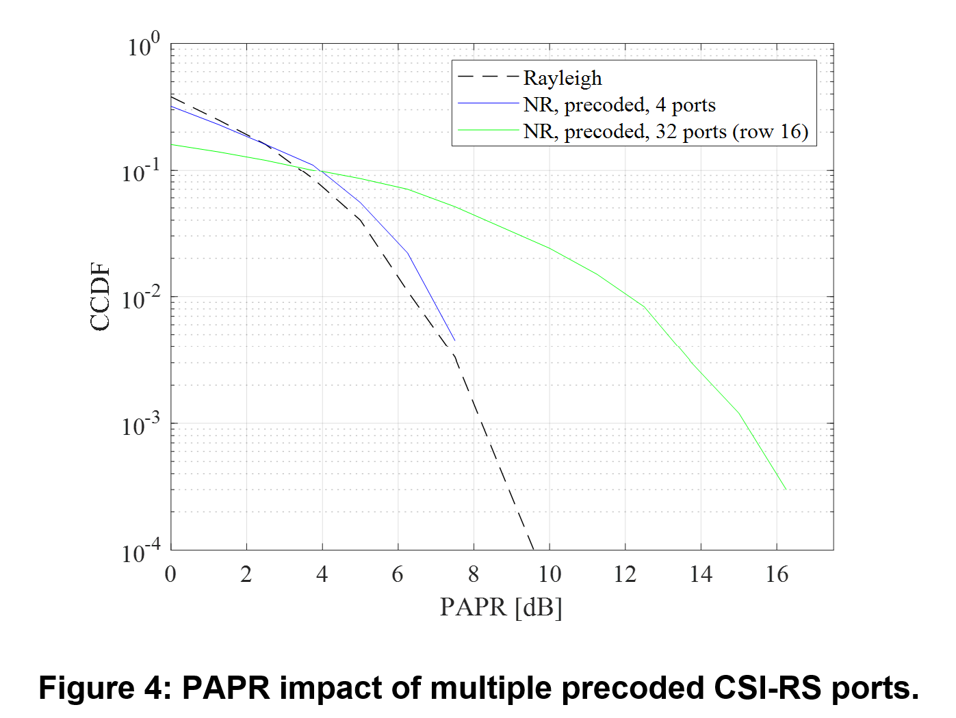  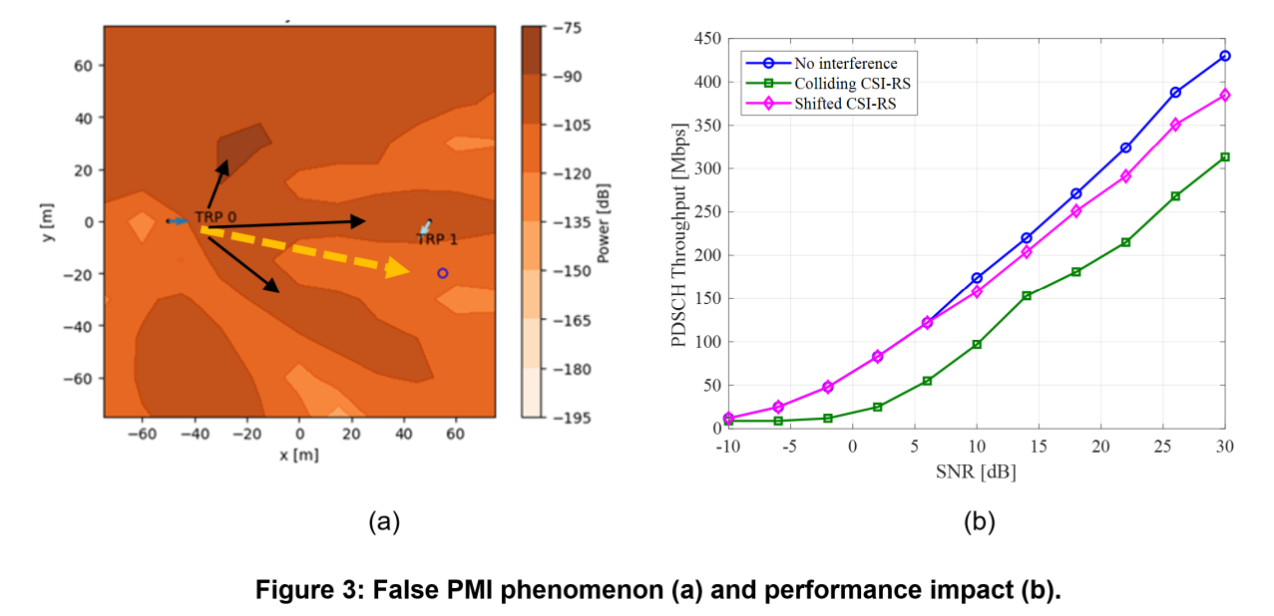
ETRI | We support the use of NR sequences as a baseline to enable CSI-RS sharing between 6G and NR UEs, and we are okay to study low-PAPR sequences for CSI-RS.

CSI-RS time domain type
Regarding CSI-RS time domain types, we summarized the views as the table below
View summary |  | Companies
Time domain type of CSI-RS | Periodic | Spreadtrum, InterDigital, vivo, Lenovo, LG, ETRI, MTK, IMU, NTT DCM  Concern: TCL
Time domain type of CSI-RS | Semi-persistent | Spreadtrum, InterDigital, TCL, LG, ETRI  Concern: MTK, vivo
Time domain type of CSI-RS | Aperiodic | Spreadtrum, InterDigital, TCL, vivo, Lenovo, LG, ETRI, MTK, IMU, NTT DCM  Concern:
Time domain type of CSI-RS | Burst P/SP | LG
Time domain type of CSI-RS | UE triggered CSI-RS | Sony, InterDigital

Limited number of companies discuss CSI-RS time domain types in contributions. Hence FL will wait for more input to derive proposal 6.7. Companies are encouraged to share their views on CSI-RS time domain types in 6GR.

Proposal 6.7-1

Support/fine
Not support

Company | Comment
vivo | In 5G, the CSI-RS Resources can be periodic, semi-persistent, or aperiodic, where periodic CSI-RS covers long-term stable demand, aperiodic CSI-RS covers dynamic demand, while semi-persistent CSI-RS seems to fall in between. Considering in the actual system, aperiodic CSI-RS is more efficient than semi-persistent CSI-RS. Therefore, we propose the periodic CSI-RS and aperiodic CSI-RS in CSI measurement should be prioritized.
IMU | Aperiodic resources are efficient way for UE to collect measurements but periodic measurements enable easier management for mobility procedures. Therefore, periodic and aperiodic measurements should be prioritized.
NTT DOCOMO | Support Periodic, Semi-persistent and Aperiodic CSI-RS
ETRI | We support P/SP/AP CSI-RS.

Key observations
Company | Observation
MTK | Observation 2.3.2: Semi-persistent CSI reporting/generation is actually rarely enabled in real-field deployment. Aperiodic CSI reporting with periodic CSI measurement has no clear use case but leads to unnecessary measurement as one of UE pain points that we identified. It is important to simplify the 6GR CSI framework which focuses on practical use cases with clear motivation or usage.

Proposals for online

Proposal A
For evaluation of multi-TRP,
- Same antenna configuration and Tx power is assumed across TRPs.
- Note: ideal backhaul is assumed for CJT. Other assumption can be reported by companies.
Table Multi-TRP scenarios
Multi-TRP Scenario 1: Intra-cell scenario, with 4 TRPs/RRHs per multi-TRP set | Multi-TRP Scenario 2: intra-site, inter-cell, with 3 TRPs per cooperative set  (as baseline) | Multi-TRP Scenario 3: Inter/intra-site, inter-cell with $N$ TRPs per cooperative set
 | 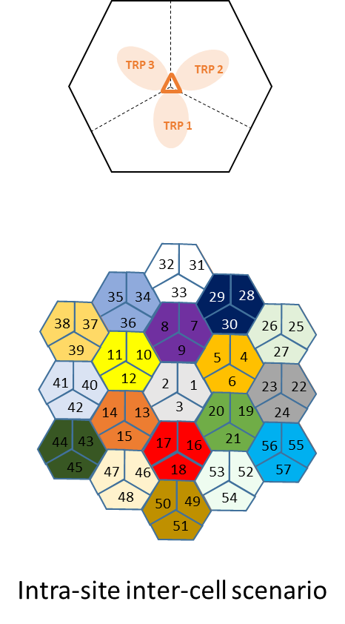 | Companies report the setting when N>1

Proposal B
For the study on AI-based CSI compression, the following is considered:
- KPI: SGCS (Intermediate), PAPR (when applicable), throughput vs CSI feedback overhead, DL throughput/BLER vs SNR
  - CSI feedback overhead: the number of UL resource elements
    - Companies to report values
  - Note: the overhead of DMRS (if applicable) is reported by company
- Model/computation complexity at UE side (when applicable): FLOPs/M
- Model/computation complexity at NW side: FLOPs/M
- Model size: Number of parameters/M
- Overhead of downloadable basis/codebook/matrix for compression (when applicable): size of parameters (Mbytes) and updated frequency
- Overhead/complexity/impact of inter-vendor collaboration (when applicable)
- Benchmark:
  - Rel-20 NR SSCC approach with 2-sided model (companies report the inter-vender collaboration assumption) and/or NR eType II feedback and/or NR Type I feedback
  - Link adaptation is considered
- Evaluation assumptions follow general EVM.
  - For uplink transmission (e.g., UL channel model, UL SNR range, UL channel estimation, UL noise + interference estimation) are reported by companies
  - Companies to report the considered non-ideal factors, if assumed, e.g., Tx PA nonlinearity & RF impairment, UL/DL channel estimation errors, uplink interference pattern
- Note: the above assumptions can also apply for non-AI schemes, i.e., without training/inference/data collection/projection, when applicable.

Proposal C
For 6GR codebook, study at least considering the following:
- Strive to provide a unified specified codebook design, ensuring similar or better performance than 5G under feasible UE implementation complexity
- SU-MIMO and MU-MIMO
- Single TRP, CJT and SFN
- High-resolution and low-resolution
- Low, medium and high speed
- TDD and FDD
- [Fully digital architecture and hybrid architecture]
- FFS on whether to consider other scenarios at least including High Doppler / High Speed Train (HST), Near-Field Propagation, spatial non-stationary (SNS),
  - For these use cases, FFS on whether/how to provide unified codebook design or necessary design/enhancement
For 6GR CSI acquisition study, study at least the following for CSI reporting:
- JSCC
- JSCM
- DLable codebook/basis
- CSI report for CJT calibration
- Channel property information report, e.g., time(Doppler)/freq(delay)/spatial(angular) domain
- CSI-RS based CSI reporting and DMRS based CSI reporting
- Non-precoded CSI-RS and precoded CSI-RS
- CRI based and non-CRI based
- Implicit CSI feedback and explicit CSI feedback
- Other aspects are not precluded.
- Note：both AI and non-AI solutions are considered
For 6GR CSI framework, study at least the following:
- Signaling/procedure design for CSI reporting framework,
  - E.g., whether/how to decouple triggering/configuration for CSI measurement/computation and triggering/configuration for CSI reporting
  - E.g., signaling for CSI reporting, CSI-RS, and CSI-IM
- CSI reporting container
- Early CSI triggering/reporting
- NW-triggered/UE-initiated/event-triggered CSI reporting
- Accommodation for NES
- CSI prediction
- Other aspects are not precluded.
- Note: both AI and non-AI solutions are considered

Contact information
Company | Delegate(s) | Email address
Moderator | Feifei Sun (CSI framework, CSI reporting)  Hao Wu (CSI measurement, CSI-RS design) | Feifei.sun@samsung.com  hao.wu@vivo.com
Xiaomi | Guozeng Zheng  Qin Mu | zhengguozeng@xiaomi.com  muqin@xiaomi.com
LG | Haewook Park  Minwoo Choi  Jinwoo Kim | Haewook.park@lge.com  minwoo.choi@lge.com  jinwoo03.kim@lge.com
OPPO | Wendong Liu  Wenhong Chen  Zidong Wu | liuwendong1@oppo.com  chenwenhong@oppo.com  wuzidong@oppo.com
NEC | Peng Guan  Yukai Gao | guan_peng@nec.cn  gao_yukai@nec.cn
KDDI | Takeo Ohseki | ta-ooseki@kddi.com
Ofinno | Jae-Nam Shim | jshim@ofinno.com
ETRI | Wooram Shin  Youngjoon Yoon | w.shin@etri.re.kr  youngjoon.yoon@etri.re.kr

Reference
- R1-2600039 On downlink-based CSI acquisition in 6GR Nokia
- R1-2600057 Discussion on aspects of downlink-based CSI acquisition for 6GR air interface FUTUREWEI
- R1-2600119 Discussion on aspects of downlink-based CSI acquisition for 6GR Spreadtrum, UNISOC
- R1-2600133 6GR CSI: Aspects of Downlink-based CSI Acquisition InterDigital, Inc.
- R1- 2601467 Aspects of downlink-based CSI acquisition Huawei, HiSilicon
- R1-2600194 Discussion on downlink based CSI acquisition OPPO
- R1-2600222 Aspects of downlink-based CSI acquisition TCL
- R1-2600231 Discussion on aspects of downlink-based CSI acquisition ZTE Corporation, Sanechips
- R1-2600306 Discussion on downlink-based CSI acquisition for 6GR CATT
- R1-2600339 Aspects of downlink-based CSI acquisition Tejas Network Limited
- R1-2600348 Aspects of downlink-based CSI acquisition MediaTek Inc.
- R1-2600396 Discussion on downlink-based CSI acquisition CMCC
- R1-2600436 Discussion on DL CSI acquisition for 6GR Xiaomi
- R1-2600511 Discussion on aspects of downlink-based CSI acquisition for 6GR vivo
- R1-2600559 IMU Views on Downlink-based CSI Acquisition IMU
- R1-2600571 Discussion on downlink based CSI acquisition BJTU
- R1-2600607 Views on Aspects of downlink-based CSI acquisition Ofinno
- R1-2600632 Aspects of Downlink Based CSI Acquisition Google
- R1-2600672 Discussion on downlink-based CSI acquisition NEC
- R1-2600700 Discussion on aspects of downlink-based CSI acquisition China Telecom
- R1- R1-2601516 Discussion on DL-based CSI acquisition and CSI-RS design Samsung
- R1-2600797 Discussion on aspects of downlink-based CSI acquisition BeammWave AB
- R1-2600805 Downlink-based CSI acquisition for 6GR air interface NVIDIA
- R1-2600835 Views on downlink-based CSI acquisition Apple
- R1-2600848 Aspects of downlink-based CSI acquisition Lenovo
- R1-2600875 Discussion on downlink-based CSI acquisition Fujitsu
- R1-2600880 Discussion on aspects of downlink-based CSI acquisition KT Corp.
- R1-2600890 Discussion on aspects of downlink-based CSI acquisition LG Electronics
- R1-2600911 Aspects of downlink-based CSI acquisition for 6GR study Intel Corporation
- R1-2600923 Aspects of downlink-based CSI acquisiton Sharp
- R1-2600948 Discussion on downlink-based CSI acquisition HONOR
- R1-2600980 Downlink CSI acquisition aspects for 6G Fraunhofer IIS, Fraunhofer HHI
- R1-2601010 Discussion on downlink-based CSI acquisition for 6GR ETRI
- R1- R1-2601451 Views on aspects of downlink-based CSI Acquisition Ericsson
- R1-2601051 Discussion on downlink based CSI acquisition Shanghai Jiao Tong University, NERC-DTV
- R1-2601068 Discussion on DL-based CSI Acquisition for 6G Panasonic
- R1-2601136 Discussion of aspects of downlink-based CSI acquisition Sony
- R1-2601189 Discussion on Aspects of downlink-based CSI acquisition NTT DOCOMO, INC.
- R1-2601225 Aspects of DL-based 6GR Channel Acquisition AT&T
- R1-2601280 Aspects of downlink-based CSI acquisition Qualcomm Incorporated
- R1-2601333 Discussion on downlink-based CSI acquisition KDDI Corporation
- R1-2601342 Discussion on Aspects of Downlink-Based CSI Acquisition Rakuten Mobile, Inc
- R1-2601352 Discussion on CSI acquisition ASUSTeK
- R1-2601399 Views on DL CSI acquisition in 6G CEWiT
- R1-2601425 Discussion on downlink-based CSI acquisition BUPT, X-NET
- R1-2601435 Discussion on aspects of downlink-based CSI acquisition for 6GR Pengcheng Laboratory, ZGC Institute of Ubiquitous-X Innovation and Application
- R1-2601345 CSI Acquisition improvement for non-constant modulus codebook Orange

