3GPP TSG RAN WG1 #124 R1-250XXXX
Gothenburg, SE, Feb. 9th ~ 13th, 2026
Agenda item: 10.5.3.1
Source: Samsung, vivo (moderators)
Title: Feature lead summary #1 on DL-based CSI acquisition
Document for: Discussion and Decision

Introduction
This paper is to summarize the proposals/observations based on companies’ contributions submitted to 10.5.3.1, for DL-based CSI acquisition, including CSI framework, CSI reporting, CSI measurement and CSI-RS design, for both AI and non-AI based schemes.
Detailed list of companies’ proposals/observations were captured in Annex.

Evaluation methodology

SLS assumption
Table 2.1A General Assumption
Parameters | Proposals | Companies’ view
#1  Carrier frequency | Around 700MHz (FDD)  Around 2 GHz (FDD)  Around 4 GHz (TDD)  Around 7 GHz (TDD)  Other carrier frequency is not precluded | Around 700MHz (FDD):(3) Ericsson, Apple, Samsung  Around 2 GHz (FDD): (3) Huawei, Apple, Samsung  Around 4 GHz (TDD):(6) Huawei, CATT. Ericsson, vivo, Apple, Samsung  Around 7 GHz (TDD): (7) Huawei, CATT. Ericsson, vivo, Apple, Samsung, ATT  Around 15GHz (TDD):(1) Apple  Around 28GHz (TDD): (1) Ericsson,  Around 30GHz (TDD): (1) Apple
#2  Simulation bandwidth | 20MHz  100MHz  Other BW is not precluded | 10MHz: Samsung  20MHz: Huawei, CATT, Ericsson, Apple, Samsung  100MHz: Huawei, MediaTek, Ericsson, CATT (opt)  200MHz: Huawei, CATT (opt)  300MHz: Huawei, CATT (opt)  400MHz: Huawei, CATT (opt)
#3  Number of subbands | 1 for WB  13 for SB (for 20MHz)  Note: Temporary, before subband size for 6GR is decided
#4  Scenario | Dense urban  Urban macro  Suburban Marco  Rural Macro (for CJT scenario 1)  Other scenarios can be considered | Dense Urban (4): Huawei, CATT, Ericsson (4GHz,7 GHz, 28GHz), Apple  Suburban Marco (4): Ericsson (700Mhz, 4GHz), ATT, Samsung(7GHz), Apple  Urban Macro (4): Huawei, Ericsson (700Mhz, 4GHz, 7GHz), Samsung (4GHz), Apple  Indoor: Apple  Rural Macro: Samsung(700MHz), vivo(R-18 CJT scenario)
#5  UE number/cell | 10, 30  Other numbers is not precluded.
#7  Layout/deployment | 7*3  Other layout/deployment are not precluded.
#7 Channel model | TR 38.901
#8 Numerology | OFDM, 15 kHz for FDD, 30 kHz for TDD | Ericsson: 120kHz for 28GHz
#9  Transmit power  (per 20MHz) | Dense urban: 44dBm  Urban macro: 46dBm  Suburban Marco:49dBm
#10  BS antenna configuration | Configuration for around 700MHz:  For non-CJT:  4TXRU 32AEs  (M, N, P, Mg, Ng; Mp, Np) = (8, 2, 2, 1, 1, 1, 2). (dH, dV) = (0.5, 0.5)λ  For CJT:  8TXRU 8AEs  (M, N, P, Mg, Ng; Mp, Np) = (2, 2,2,1,1,2,2). (dH, dV) = (0.5, 0.5)λ  Configuration for around 2GHz:  64TXRU 192AEs  (M, N, P, Mg, Ng; Mp, Np) = (12, 8, 2, 1, 1, 4, 8). (dH, dV) = (0.5, 0.5)λ  Configuration for around 4GHz:  64TXRU 192AEs (outdoor combination 2)  (M, N, P, Mg, Ng; Mp, Np) = (12, 8, 2, 1, 1, 4, 8). (dH, dV) = (0.5, 0.8)λ  Configuration for around 7GHz:  128TXRU 768AEs (outdoor combination 1)  (M, N, P, Mg, Ng, Mp, Np) = (24,16,2, 1, 1, 4,16). (dH,dV) = (0.5,0.8)λ  256TXRU 1024AEs (Outdoor Combination 2):  (M, N, P, Mg, Ng; Mp, Np) = (32, 16, 2, 1, 1, 8, 16). (dH, dV) = (0.5, 0.8)λ  512TXRU 2048AEs (Outdoor Combination 5): if supported  (M, N, P, Mg, Ng; Mp, Np) = (32, 16, 2, 1, 1; 8, 16). (dH, dV )= (0.5, 0.8) λ  Other BS antenna configurations are not precluded | 700MHz:  Samsung: M,N,P)=(2,2,2) 8 ports; (Baseline)  (M,N,P)=(8,4,2) 8 ports  Apple: Combination 1: (8, 2, 2, 1, 1; 1, 2) for (M,N,P,Mg,Ng; Mp, Np), and (0.5, 0.5)λ for (dH,dV)  Ericsson: (8, 2, 2, 1, 1; 1, 2) (0.5, 0.5)λ  Vivo: Rel-18 for CJT
#11  UE power class | 23dBm(for 700MHz)  26dBm (for others)
#12  UE antenna configuration | 4R, 8R  Details follow corresponding agreements in Agenda 10.1
#13  UE antenna modelling | TR 38.901
#14 UE Receiver | MMSE-IRC as the baseline
#15  Traffic model | FTP Model 3 (0.5 Mbyte packet sizes)  - Low RU about 30%  - Medium RU about 60%  Other model is not precluded. | FTP3: Huawei, CATT, Apple, Samsung, MediaTek  - RU 10~50: Apple  - RU 30: Samsung  - RU 50: Samsung (Opt)  - RU 60-70: MediaTek,  eFTP: Ericsson,  Full buffer: Huawei, CATT
#16  Scheduling | PF
#17  Inter-cell interference model | Explicitly and realistically modelled
#18  Channel estimation assumption | Realistic
#19  CSI feedback | CSI periodicity: 10ms, 20msScheduling delay: 4ms | CSI periodicity  5ms: Apple  10ms: Ericsson, CATT, samsung  20ms: Ericsson, CATT, samsung, Apple, OPPO, MediaTek  40ms: Apple
#20  MIMO scheme | SU-MIMO  MU-MIMO (up to 4 layer)  with rank adaptation
#21  Feedback assumption | Error-free UCI reception as baseline, UCI error rate can be additionally modelled
#22  Evaluation Metric | Throughput and CSI feedback overhead as baseline metrics, the CSI feedback overhead is the actual feedback overhead statistics per system level evaluation
#23  Baseline for performance evaluation | Rel-19 Type I Scheme A/B  Rel-19 eType II Codebook  Ideal SVD for calibration

Table 2.1B CJT Scenario
CJT Scenario 1: Intra-cell (DMIMO) scenario | CJT Scenario 2: intra-site, inter-cell
4 TRPs/RRHs per CJT set  Layout:  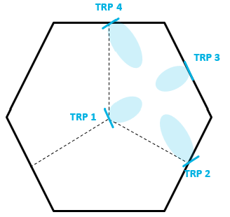 | 3 TRPs per cooperative set  Layout:  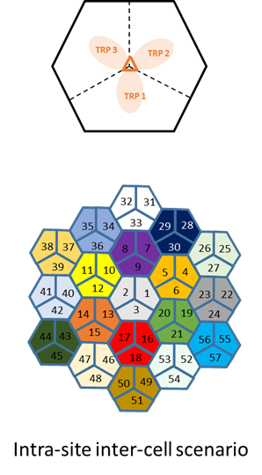

Proposal 2.1-1
Adopt the table 2.1A and Table 2.1B as the basic assumption of SLS for evaluation of DL-based CSI acquisition.
Company | Item | Input
Mod v0 | # x | Please provide comments for each item(proposals are in the first columns), by indicating the number.  Or if anything missing, please put # X, #Y, #Z and your corresponding comment
Samsung | #6  Layout  /deployment. | This row is whether we use 1-ring or 2-ring in the layout. Rather than using only 7*3, we suggest to replace it by 1-ring (7*3), 2-ring.(19*3) layout.  In our view, 1-ring can be useful and relaxed to simulation time for AI-scheme SLS, and 2-ring can be used for non-AI-scheme SLS as we have used it as baseline in LTE/NR.
Samsung | #10 | Although we are OK to study up to 256 ports, it hasn’t been supported so far and we are in study stage (meaning it may not be supported in the end), we suggest the corresponding configuration (256TXRU..) as optional.  For the configuration of 512TXRU, suggest it to remove.
MediaTek | #1,  #3,  #4,  #22 | #1 and #4:  We would like to first check with FL whether each company need to provide the evaluation result for all the scenarios/frequencies listed in the proposal? Or it is up to company to prioritize some case(s) according to its own interest? If all the cases are required, we prefer to narrow down the candidates. Otherwise, that will cause huge simulation effort.  #3:  We suggest first discussing the possible value of the CSI subband size. For 20MHz, the legacy size (i.e., 4, 8, 16) can be a good starting point. For large BW case (i.e., 100MH), the extended CSI subband size (e.g., 32 RBs) can be considered/studied in the joint consideration of the reasonable amount of reporting overhead.  #22:  We fully agree to utilize actual feedback overhead statistics in the simulation as the metric, which can better reflect the overhead according to rank adaption. Furthermore, we would like to suggest considering the average feedback overhead per each CSI report as the KPI of overhead assessment.

LLS assumption
The following proposal is derived based on companies’ contributions to this meeting.

Proposal 2.2-1
Adopt the following table as the assumptions for LLS for DL based CSI acquisition.
Parameters | Value
#1 Carrier frequency | Around 700MHz (FDD)  Around 2 GHz (FDD)  Around 4 GHz (TDD)  Around 7 GHz (TDD)
#2 Simulation bandwidth | 24RB, 48RB, others are not precluded
#3 Waveform and numerology | CP-OFDM, 15 kHz for FDD, 30 kHz for others
#4 Channel model | CDL-A/B/C/E in TR 38.901  - Possible DS values = {10, 30, 100, 300, 1000} ns.  - ASA, ASD, ZSA, ZSD follow the values in sec 7.7.1 in 38.901
#5 UE speed | 3 km/h, 30 km/h, 120km/h
#6 PRG | 2 RBs, 4 RBs
#7 BS antenna configuration | Align with SLS  Configuration for around 700MHz:  For non-CJT:  4TXRU 32AEs  (M, N, P, Mg, Ng; Mp, Np) = (8, 2, 2, 1, 1, 1, 2). (dH, dV) = (0.5, 0.5)λ  For CJT:  8TXRU 8AEs  (M, N, P, Mg, Ng; Mp, Np) = (2, 2,2,1,1,2,2). (dH, dV) = (0.5, 0.5)λ  Configuration for around 2GHz:  64TXRU 192AEs  (M, N, P, Mg, Ng; Mp, Np) = (12, 8, 2, 1, 1, 4, 8). (dH, dV) = (0.5, 0.5)λ  Configuration for around 4GHz:  64TXRU 192AEs (outdoor combination 2)  (M, N, P, Mg, Ng; Mp, Np) = (12, 8, 2, 1, 1, 4, 8). (dH, dV) = (0.5, 0.8)λ  Configuration for around 7GHz:  128TXRU 768AEs (outdoor combination 1)  (M, N, P, Mg, Ng, Mp, Np) = (24,16,2, 1, 1, 4,16). (dH,dV) = (0.5,0.8)λ  256TXRU 1024AEs (Outdoor Combination 2):  (M, N, P, Mg, Ng; Mp, Np) = (32, 16, 2, 1, 1, 8, 16). (dH, dV) = (0.5, 0.8)λ  512TXRU 2048AEs (Outdoor Combination 5): if supported  (M, N, P, Mg, Ng; Mp, Np) = (32, 16, 2, 1, 1; 8, 16). (dH, dV )= (0.5, 0.8) λ  Other BS antenna configurations are not precluded
#8 UE antenna configuration | Align with SLS  4Rx/8Rx  Follow agreements in agenda 10.1
#9 SU-MIMO rank | Option1: up to 2 layers  Option2: up to 4 layers  Option3: up to 8 layers
#10 Receiver type | MMSE-IRC
#11 CW to layer mapping | NR CW to layer mapping (baseline)
#12 Channel coding | LDPC
#13 MCS | QPSK (1/5, 1/3), 16QAM (1/2, 3/4), 64QAM (2/3, 5/6), 256QAM (3/4, 5/6),
#14 Channel estimation | Realistic as baseline  For lower frequency density CSI-RS, sample and hold is assumed as baseline for RBs without CSI-RS. Companies to report if other assumptions are used.
#15 Link adaptation | AMC/fixed MCS
#16 KPIs | Intermediate KPIs: SGCS/NMSE  BLER, SE/throughput
#17 Other CSI-RS parameters | Specified by proponent, e.g., CDM-group sizes, CDM group layout, PDSCH/CSI-RS multiplexing, etc.
#18 Maximum CSI-RS power boosting | 6dB (FFS other values pending RAN4 feedback)
#19 CSI-RS periodicity | 10, 20 ms

Company | Item | Input
Mod v0 | # x | Please provide comments for each item, by indicating the number.  Or if anything missing, please put # X, #Y, #Z and your corresponding comment
Samsung | # 7 | Same comment as we did above for SLS. Optional for 256TXRU configuration, and remove 512TXRU configuration

AI-based CSI compression
This part can be discussed if no big concern on study of JSCC/JSCM.

KPI and basic assumption for AI-based CSI compression
Agreement (RAN 1 #123)
For study/evaluation of the performance and feasibility of AI/ML use cases in 6GR, at least the following may be considered
  - Intermediate performance KPIs (e.g., SGCS), link level KPIs (e.g., BLER) and system level KPIs (e.g., throughput vs overhead), etc
  - Computation complexity/latency (inference/monitoring)
  - Power consumption, if feasible to evaluate
  - Model size
  - Data collection impact
  - Scalability (refer to the examples in TR 38.843)
  - Generalization performance
    - FFS on whether and how to consider realistic deployment scenarios
  - Overhead/complexity associated with data collection, inferencing, performance monitoring, online/site specific fine-tuning, inter-vendor collaboration (if applicable)
  - Online training/fine-tuning training latency, if feasible to evaluate
  - Inter-vendor collaboration impact, if applicable
Note: Details to be discussed per use case.
Note: above aspects may be considered for both AI/ML and non-AI counter part

Proposal 2.3.1-1
For the study on AI-based CSI compression, the following is considered:
- Intermediate KPI: SGCS
- System KPI: throughput vs CSI feedback overhead
  - The number of UL resource elements:
    - E.g., 32, 72, 144 for at least for rank 1 64 Tx ports, 13 SBs
    - Other values are not precluded
    - Values can be scaled according to the number of ports, SBs, number of layers/Rx ports
  - Note: the overhead of DMRS is reported by company
- Model/computation complexity at UE side: FLOPs/M
- Model/computation complexity at NW side: FLOPs/M
- Model size: Number of parameters/M
- Matrix size (when applicable): Mbytes
- Overhead of downloadable parameters for inference (when applicable): Mbytes
- [Overhead/complexity/impact of inter-vendor collaboration (when applicable)]: FFS
- Benchmark: NR SSCC approach with 2-sided model and NR eType II feedback
Support/fine
Not support

Table 2.3.1A Additional inputs
Company | Input
Mod v0 | The above proposal is based on the agreement of RAN 1 #123, with details for AI-compression.  Scalability and generalization to be discussed separately in next proposal.  If any comment,
MediaTek | - The type of CSI feedback considered should also be stated (implicit/explicit/both)  - The model/computation complexity should not be considered in isolation for each use case. It should be considered comprehensively for all use cases. E.g., if AI-based CSI prediction and CSI compression are both performed at the UE, the model/computation complexity need not necessarily be the sum of the two individual complexities.  - We believe the 2-sided model should also be studied, so the overhead/complexity/impact of inter-vendor collaboration should not be FFS.

Generalizations/Scalability for JSCCJSCM
Several companies provided generalization results for different uplink channels, e.g., AWGN, fading channel, different SNRs, different DL channel. Good generalization performance is observed for JSCM.
Table 2.3.2A: Preliminary Observations
Scenarios | Observations
#1  Uplink fading vs AWGN | 6 companies showed the good generalization performance for the case training over AWGN and testing over fading channel.
#2  Different uplink SNR | Most companies (Table 4.1-1B) reported good generalization performance with trained by mix UL SNR and testing by certain UL SNR.  3 companies showed the better performance with SNR specific models.
#3  Different DL channels | 1 company reported results, for testing over UMi  Case 2a: Model trained with UMi, for a given matrix trained with UMa  Case 2b: Model and matrix trained with Uma  It showed 0.09 SGCS loss for Case 2b; and 0.03 SGCS loss for Case 2a in high SNR only

In addition, some proposal can be found in Table 2.3.2D

Proposal 2.3.2-1
For the evaluation of scalability/generalization for AI-based CSI compression, the evaluation methodology in NR (as in TR 38.843) can be considered as the starting point. The set of configurations are considered focusing on one or more of the following aspects:
- Various DL channels for compression, for example, deployment scenarios (e.g., UMa, UMi, InH), outdoor/indoor UE distributions (e.g., 10:0, 8:2, 5:5, 2:8, 0:10), antenna virtualization (TxRU mapping)
- Various uplink channel for uplink transmission (e.g., AWGN, CDL, TDL, different uplink SNR range)
- Various UL resource size, e.g., size, for CSI feedback (for JSCM)
- [Various gNB (Rx chain, channel estimation, equalization) implementations for two-sided model]
- Various number of Tx/Rx ports, if applicable
Companies report the training and testing assumptions.
Support/fine | Nokia, Samsung, CATT
Not support

Table 2.3.2B Additional inputs
Company | Input
Mod v0 | I have checked the evaluations in R19 on generalization. For some aspects, we know it should be fine without re-evaluation. Therefore, I tried to combine those into “DL channels for compression”.  The extra part is UL channel, and UL resource for scalability.  Rx port may only apply for explicit H.  Please share some comments
MediaTek | The brackets can be removed for two-sided model

Table 2.3.2C: Preliminary results
Company | Scenarios | Key observation and results
CMCC | #1 | 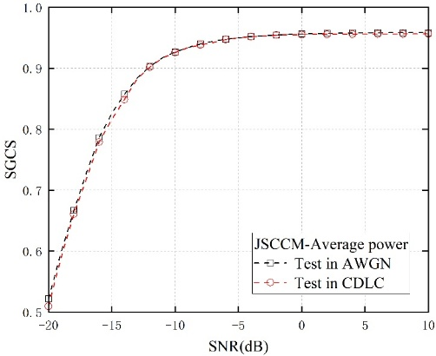  Figure 21. SGCS performance of JSCCM under different testing channels, where the training channel is AWGN and training SNR is 10dB.  Observation 20: The SGCS performance of JSCCM under AWGN and CDL-C channels is similar.  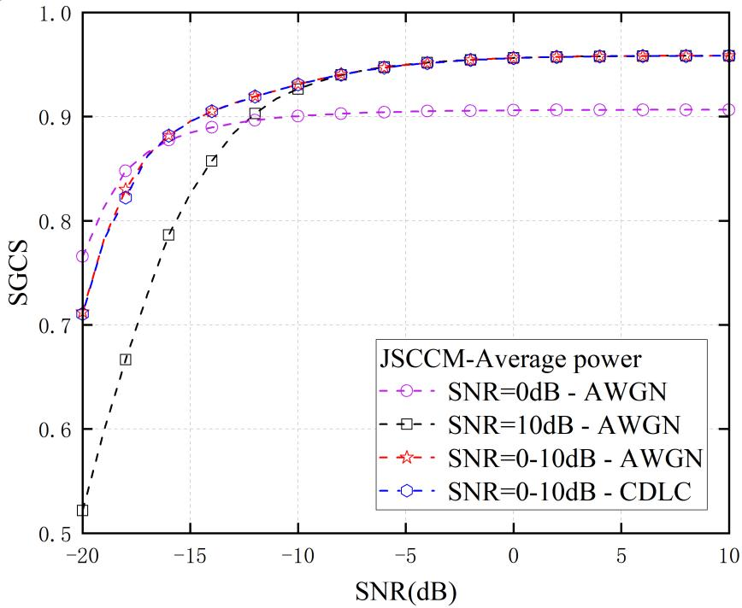  Figure 22. SGCS performance of JSCCM with mixed-SNR training, where the training channel is AWGN.  Observation 21: Compared to models trained at any fixed SNR level, the mixed-SNR-trained JSCC model is more robust and generalizable across diverse SNRs.
Samsung | #1, #2, #3 | 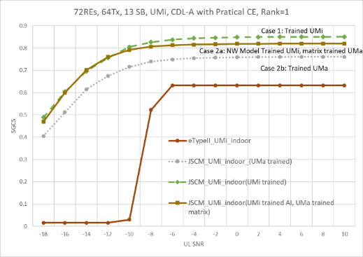  Figure 13. Generalization performance over CDL-A channel with PAPR restriction
MediaTek | #1, #2, | 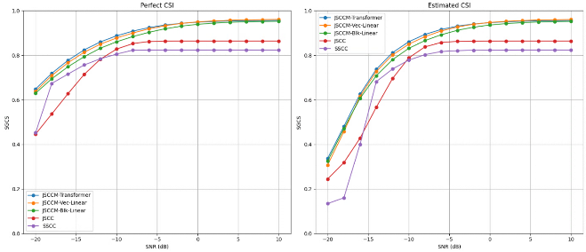  Figure-2.4.1.2.1 SGCS versus UL SNR for SSCC, JSCC and JSCCM.  Observation 2.4.1.2.1: JSCCM shows better performance than JSCC and SSCC in UL fading channels under conventional channel estimation (e.g., LS-CE with LMMSE interpolation) and equalization (e.g., LMMSE),
vivo | #1, #2, | 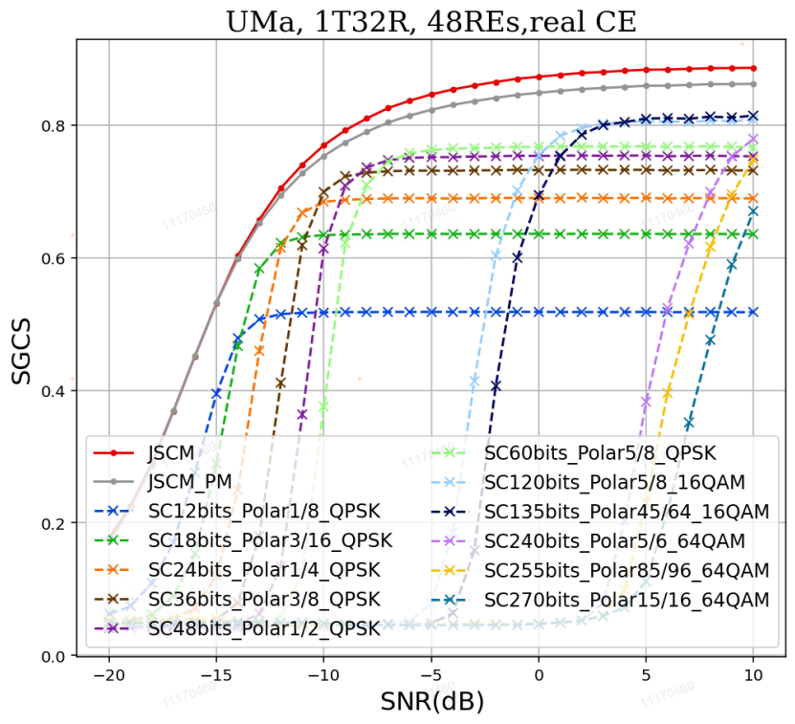  The comparison between the JSCM-based CSI feedback and the SSCC-based CSI feedback under UMa channel with ideal/real channel estimation
Lenovo | #1, #2, | 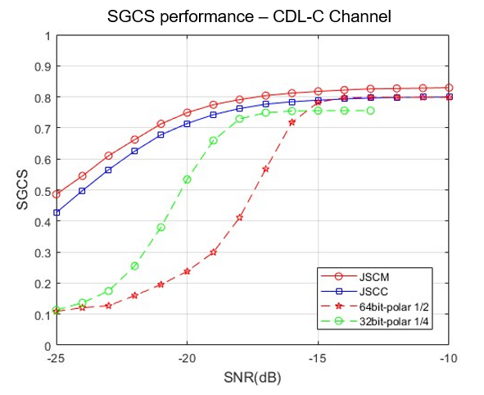  Figure 7. Performance of JSCC/JSCM for CSI feedback
BUPT | #1, #2, | 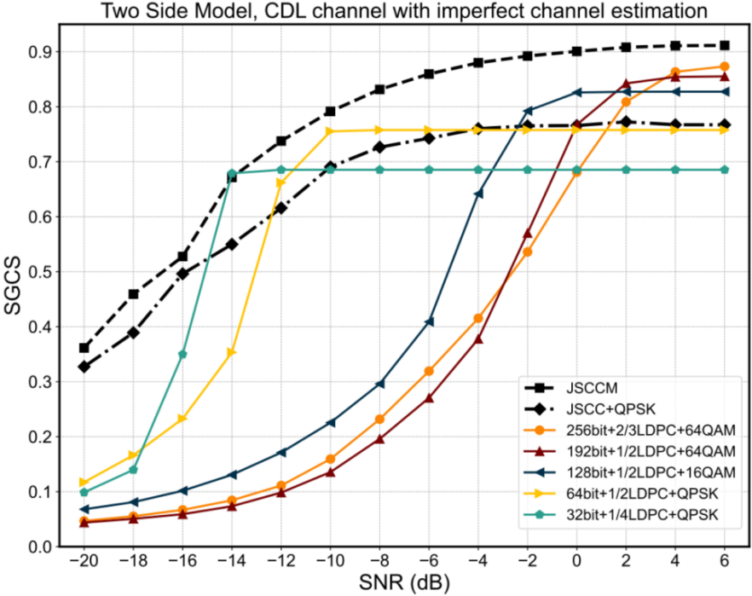  Fig. 5 Squared generalized cosine similarity (SGCS) vs. SNR under various schemes
Apple | #2, | 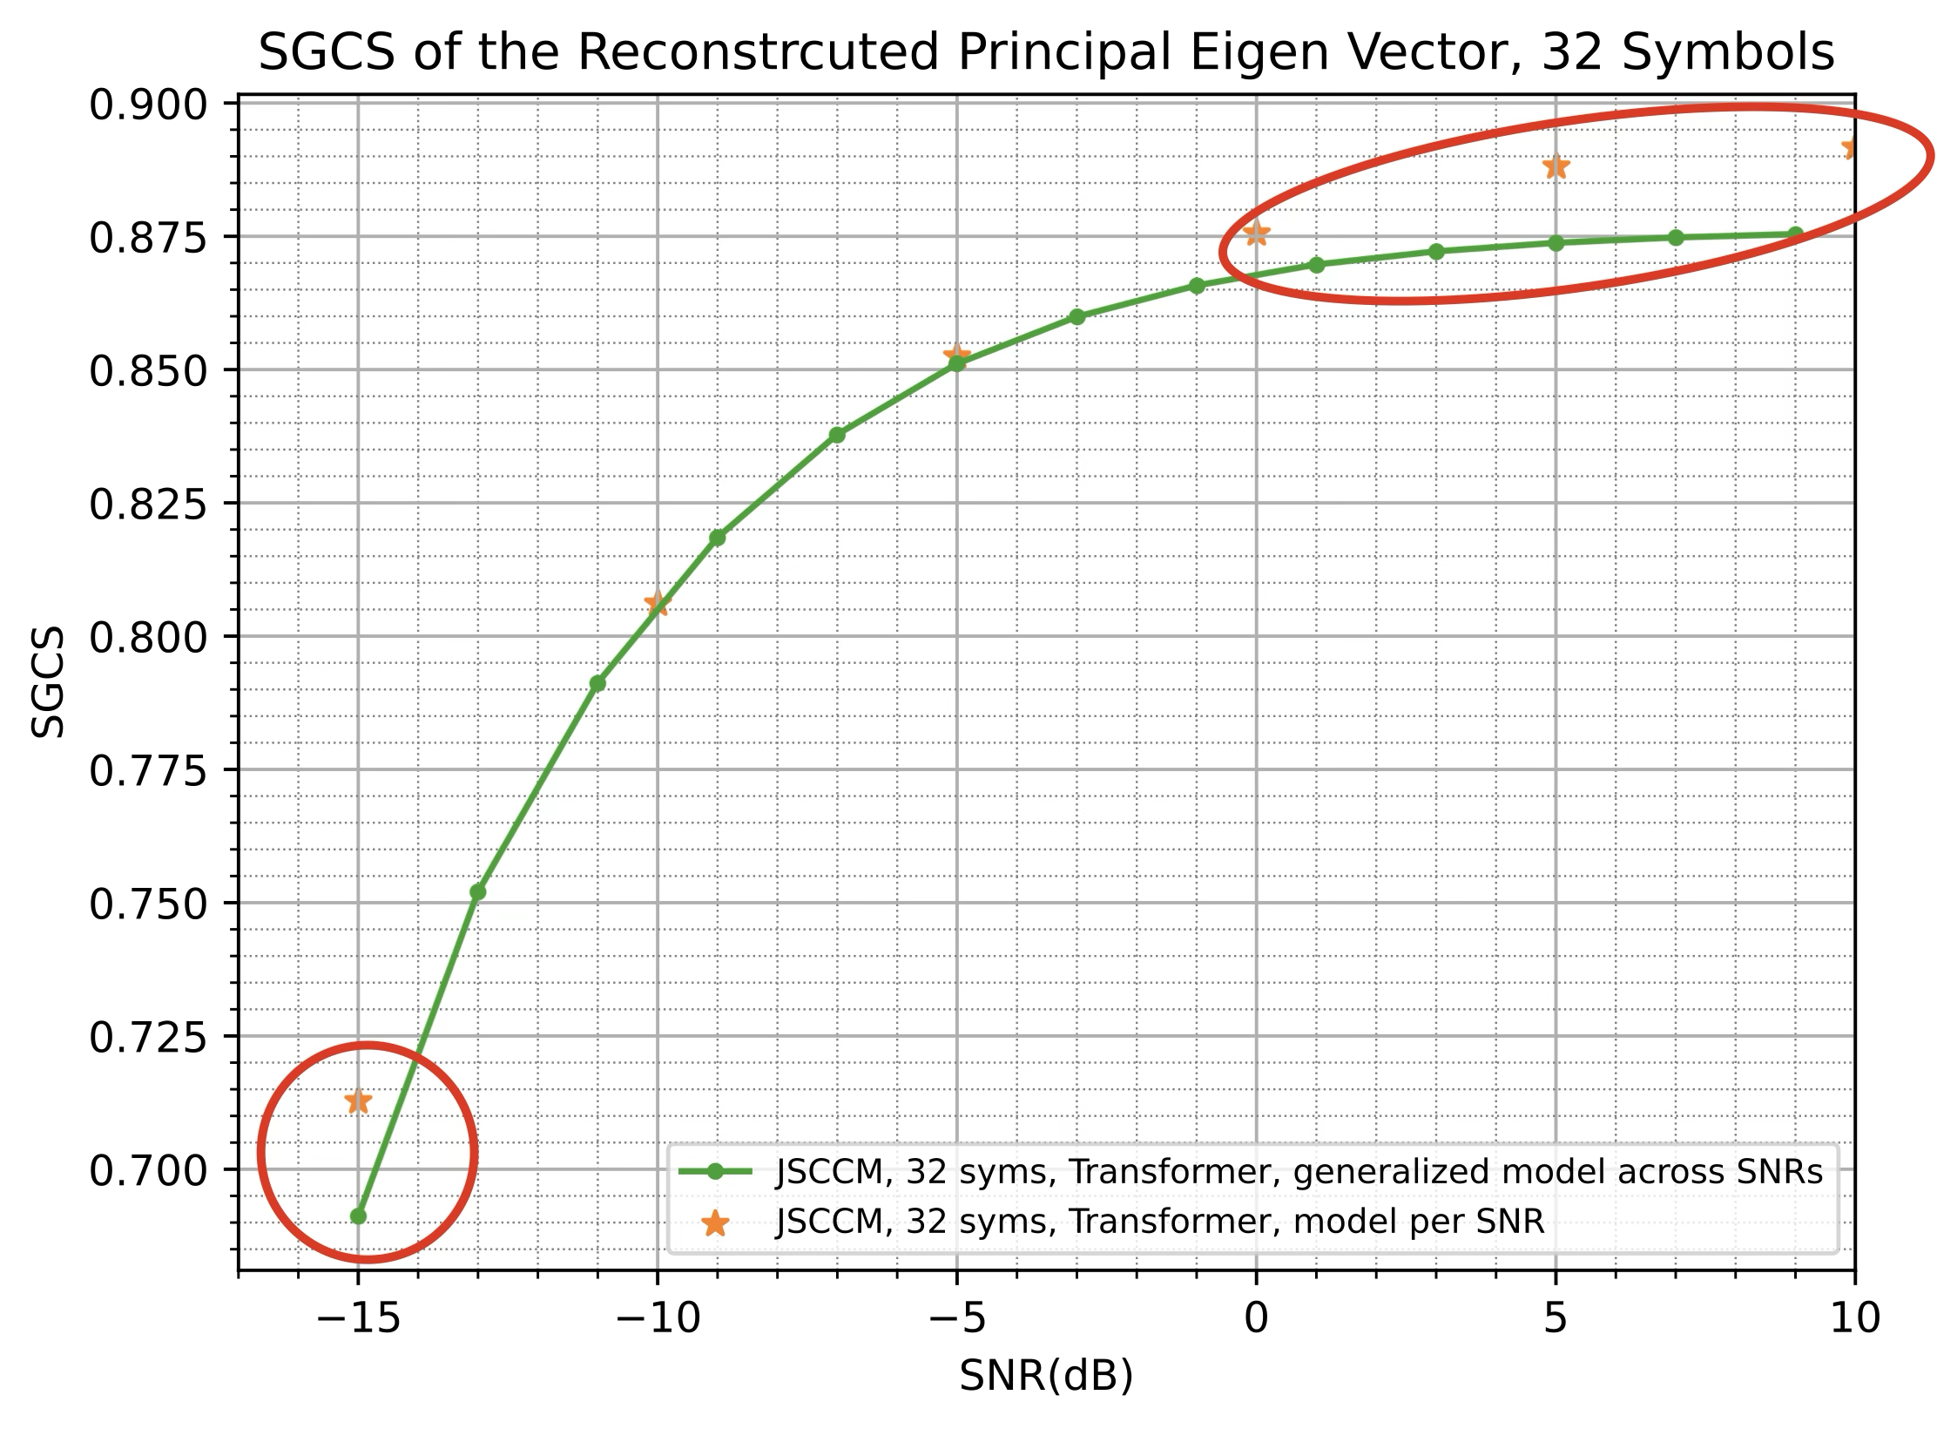  Fig. 3.2-2. Performance of JSCM with additional SNR information  Proposal 3-2-1: Study of AI based CSI compression using JSCM focus on enabling a simplified encoder at the UE side.  - Consider SNR signaling to enable UE side model input
Ericsson | #2, | 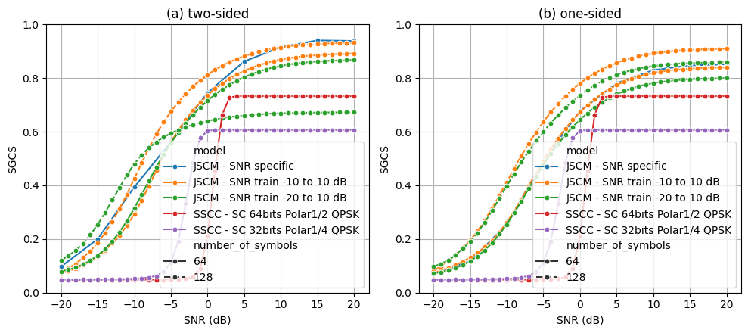  Figure 14: Performance of JSCM model for different payload sizes (number of TX symbols) trained for different SNR ranges. (a) two-sided. (b) one-sided.  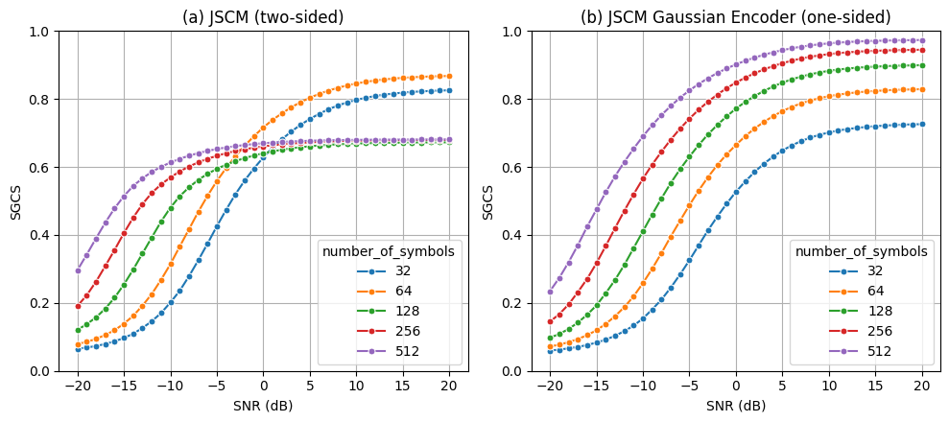  Figure 15: Performance of JSCM for different payload sizes (number of TX symbols) trained over SNR between -20 and 10 dB. (a) two-sided. (b) one-sided
Pengcheng | #1, #2, | 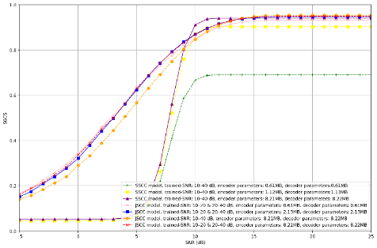  (a)SGCS versus SNR under multiple trainable-parameter budgets (reported as encoder/decoder parameter sizes).  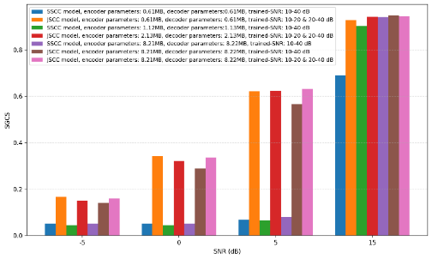  (b)SGCS at selected SNR points (e.g., −5/0/5/15 dB) to highlight the low-SNR region.  Figure 5: Complexity–performance trade-off between SSCC and JSCC.

CSI prediction
The following proposals are derived based on companies’ contributions.

Proposal 2.4-1
To evaluate the performance of non-AI/AI based CSI-RS prediction at UE side, consider
- Intermediate metric: Subband-level eigenvector SGCS calculated between predicted channel and ground-truth channel
- System-level metric: UPT (mean, 5%tile)
- Link-level metric: BLER/SE/throughput;
- Complexity metrics: FLOPs/MACs or number of parameters
- Baseline: Baseline#1: sample & hold, Baseline#2: full-dimension CSI measurement
- Companies to report sampling pattern
- Companies to report the considered non-ideal factors, if assumed, e.g., BS RF and array impairments
Support/fine
Not support

Company | Input

Proposal 2.4-2
For AI based CSI prediction, evaluate generalization/scalability performances of prediction models at least across the following scenarios/configurations
- Various deployment scenarios, e.g., UMa, InH
- Various carrier frequencies
- Various indoor/outdoor distributions
- Various BS antenna configurations, e.g., antenna spacing, antenna virtualization, antenna port layouts, antenna port numbers
- Various sampling ratios and/or sampling patterns
Support/fine
Not support

Company | Input

CSI framework

Unified CSI signaling framework

Brief summary on design principle
Design a CSI acquisition framework at least the following guiding design principles:
- Common framework for supporting multiple scenarios, for the serving cell CSI, LTM CSI, and CSI for SCell activation. E.g., based on the LTM CSI measurement and reporting configuration framework.
- A unified framework for both AI and non-AI.
- Managing the increase in RS overhead, CSI feedback overhead, and UE complexity.
- Support UEs with different capabilities
- Minimized RRC configuration overhead

FL: No intention to spend time to discuss this proposal. Just want to acknowledge the above design principle, and we will keep that in mind for the discussion in the future.

CSI reporting framework design
Several companies proposed simplification on CSI-RS triggering and report framework. Following directions/justifications have been proposed by companies:
Table 3.2A: Summary for directions for CSI framework simplification
Directions | Summary of observations | Summary of companies’ views
#1  Decoupling of CSI measurement triggering and reporting Triggering. | Motivation  1. Relax UE processing timeline  2. Avoid out of order issue  3. Reduce UE complexity and power  4. Relax scheduling restriction, mitigate scheduling latency.  FL assessment: Wide supported | Supported by (15): Nokia, Interdigital, ZTE, MediaTek, CMCC, xiaomi, Ericsson, NEC (Unified for UEI-/NWI-), China Telecom, Sony, DOCOMO, Qualcomm, Samsung. Apple
#2  Restriction of uplink channel for CSI report | Motivation of olution #2-1: CSI report only in PUSCH  1. PUSCH-only can result in simplifying UCI handling (multiplexing/prioritization) rules and procedures  2. Avoid complicated PUCCH resource determination  3. Easy to handle large payload.  4. Avoid duplicated function  Motivation of solution #2-2: AP-CSI report on PUSCH and P-CSI report on PUCCH.  1. Has been commercially deployed in 5G  FL assessment: can be discussed together with #3 | Solution #2-1: CSI report only in PUSCH  - Supported by (11): Nokia, Spreadtrum, InterDigital, OPPO, Lenovo, Fujistu (FFS on PUCCH), HONOR, Panasoic (FFS), Qualcomm, DOCOMO, Samsung  Solution #2-2: AP-CSI report on PUSCH and P-CSI report on PUCCH.  - Supported by (6): OPPO (low payload on PUCCH), CMCC, Huawei, Panasonic (FFS AP/SP on PUSCH, P on PUCCH), ZTE, Xiaomi
#3  Reduction of CSI reporting type | Issues for P-CSI  1. P-CSI is not needed on top of SP CSI.  2. Large overhead of P-CSI  Benefit of P-CSI  1.No PDCCH trigger  2. Wideband P-CSI on PUCCH widely used, especially for TDD  Issues for SP-CSI  1. SP-CSI can be treated as AP with multiple UL grant.  2. SP-CSI is not widely commercialized.  FL assessment: can be discussed together with #2 | Solution #3-1: Support P/AP CSI reporting, FFS on SP CSI reporting  - Supported by (4): Nokia, MediaTek, OPPO, Huawei, CMCC  Solution #3-2: Support AP CSI reporting, FFS on P/SP reporting  - Supported by (3): [CATT], Samsung (AP only, SP as a special case of AP), Fujitsu  no change from NR: Support P/SP/AP CSI reporting  - Supported by (3): InterDigital, ETRI, DOCOMO
#4  CSI report container/medium (L1 v.s. L2) | Concerns on CSI 1 L1:  Scheduling restriction, complex timelines and multiplexing rule  (expect to be resolved by #1 decoupling of triggering measurement and report)  Concerns on CSI in L2:  Significant delay, unnecessary overhead, significant UPT performance degradation, CSI reliability&robustness, issues for CSI retransmission, complexity of interworking of L1/L2  FL assessment:  Based on companies’ inputs and discussions:  - L1 for CSI reporting represents vast majority views with 18 companies supporting (v.s. 3 companies supporting L2 for CSI reporting)  - Some companies propose to further study this issue (e.g., for event-based reporting, whether PUSCH is used for UCI reporting etc.), and some companies point out that deciding between L1 and L2 for CSI reporting could depend on 6GR CSI payload range determination.  The vast majority companies support L1 for CSI reporting. Whether L2 can also be supported can still be studied after RAN1 has some initial discussions on the CSI payload range (probably after a few meetings). | Support of L1 (16): Huawei/HiSilicon (PUCCH/PUSCH), InterDigital (PUCCH/PUSCH), OPPO (PUCCH/PUSCH), CATT, ZTE, Xiaomi, Ofinno, NEC, Samsung, Apple (PUCCH/PUSCH), Lenovo, Docomo (PUSCH only), Qualcomm (PUSCH only), Honor (PUSCH only), TCL, LGE  Support of L2 (3): MediaTek (as one option to simplify UCI), Ericsson, Intel (for non-latency-critical CSI)  Further study is needed (3): Nokia (study L2 for event-based reporting), ETRI, Panasonic (study CSI as L2 data when PUSCH is used for UCI reporting)

Table 3.2B: Preliminary simulation result
Company | SLS results
Company | Direction # | Metric | Observation
Samsung | #4 | UPT | Observation #23: in terms of average UPT, SLS results show that using L2 MAC CE for CSI reporting would result in significant performance degradation (~10% loss) relative to using L1 UCI for CSI reporting with a variety of codebook assumptions.  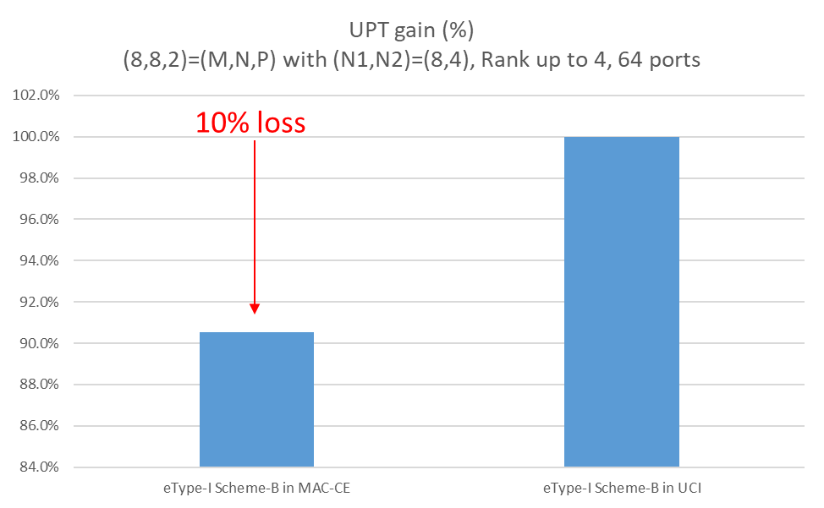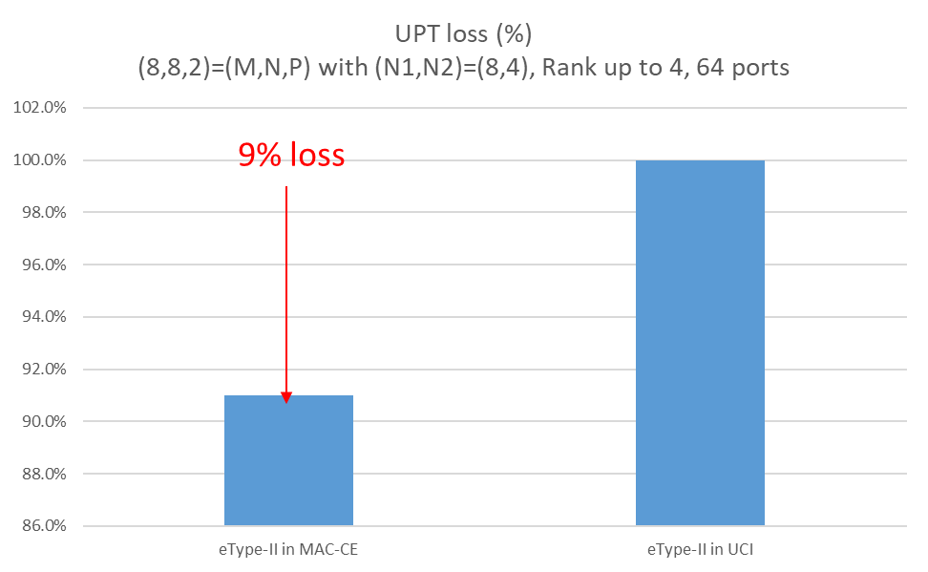
Ericsson | #1 | UL object tail latency

Based on the above summary, we have the following proposals:

Proposal 3.2-1
For simplification of CSI reporting framework, study at least following:
- Decoupling of CSI measurement triggering and CSI reporting triggering
- In addition to AP-CSI report, whether/how to also support P- and/or SP-CSI report
- In addition to PUSCH, whether/how to also report CSI on PUCCH
Support/fine | Nokia, Interdigital, ZTE, MediaTek, CMCC, xiaomi, Ericsson, NEC, China Telecom, Sony, DOCOMO, Qualcomm, Samsung. Apple, …
Not support

Proposal 3.2-2
Support CSI report in L1 as the basis for CSI container design. Study whether to also support CSI report in L2.
Support/fine | Huawei/HiSilicon, InterDigital, OPPO, CATT, ZTE, Xiaomi, Ofinno, NEC, Samsung, Apple, Lenovo, Docomo, Qualcomm, Honor, TCL, LGE, ….
Not support | MediaTek

Table 3.2C Additional inputs
Company | Input
Mod v0 | There were some other directions mentioned by some companies, e.g., CSI omission, which can be discussed later.  Based on my understanding of Tdoc view, I put some potential support companies’ name, pls check
Samsung | Proposal 3.2-1  Support. We think the proposal would be a good starting point. P and SP CSI are duplicated operation in our view, and P-CSI on PUCCH created complex UCI mux and priority rules in NR, which we don’t think it’s essentially needed. Supporting SP/AP-CSI only on PUSCH can streamline 6GR CSI framework while providing the same functionality.  Proposal 3.2-2  Support. As described in our tdoc, it’s unclear the benefit of reporting CSI in L2, given that it incurs large latency, overhead, UPT loss, and additional delay from frequent retransmissions.
MediaTek | Proposal 3.2-1:  - We would like to clarify decoupling “CSI-RS triggering” from CSI reporting triggering cannot shorten the preparation delay for an PUSCH with CSI request. The Longer preparation delay is mainly because UE takes the time for “computing the CSI”, such that we have Z/Z’ requirement defined in NR. Even the CSI-RS measurement is separately triggered, but UE still preform joint CSI computation and reporting once triggered, the long PUSCH preparation delay due to CSI computation is still observed. Hence, to literally loose UL scheduling restriction due to in-order scheduling requirement, we should study “ Decoupling of CSI measurement/generation triggering and CSI reporting triggering”.  - If “decoupling of CSI measurement/generation triggering and CSI reporting triggering” is agreed to be one study direction, then we may not need to define the CSI reporting type(s). Instead, only “CSI computation type” should be defined. For example, “CSI computation type” defines the time-domain behaviour when the UE should complete CSI computation and make the generated CSI be ready for transmission (i.e., periodic/aperiodic/even-triggered CSI computation), and when to transmit the generated CSI is according to NW allocation on the corresponding UL resource. Note that the above comment applies to either L1-based or L2-based CSI container we assume. Hence, we suggest revising “report” as “computation” if the first bullet is agreed.  Proposal 3.3-2:  It is too early to decide the baseline or prioritize any solution at the first meeting of the study item. Moreover, supporting both L1 and L2 at the end is NOT a good direction to go. That has no clear benefit. We are okay to study those two options but not okay to prioritize anyone for now.

Early/Fast CSI acquisition
Many companies propose to support/study early/fast CSI acquisition in the initial access procedure (e.g., Msg3) to avoid conservative link adaptation, as well as for Scell activation, lower layer mobility, and M-TRP CJT scenarios. In addition, some companies (Fujitsu, AT&T) suggested to defer the study until rel-20 work becomes stabilized.
Table 3.3A: Summary for scenarios for early/fast CSI acquisition
Directions | Summary of observations | Summary of companies’ views
#1  UE transition from IDLE/INACTIVE to CONNECTED mode, | Justification:  Early/fast CSI acquisition during initial access (e.g., CSI reporting via Msg3) can ensure timely link adaptation hence avoiding sudden throughput drop when the UE starts entering the CONNECTED mode.  This issue is being discussed in Rel-20 NR MIMO as one of the design objectives.  FL assessment: A number of companies showed interests and provide analysis/justification. | Supported by (12): Nokia, OPPO, ZTE, CMCC, Ofinno, xiaomi, Apple, ETRI, Ericsson, Panasonic, Sony, Qualcomm
#2  Early CSI for lower layer mobility | A number of companies have shown interests in and also performance benefits of early CSI acquisition during mobility, which may involve handover, cell switching and etc.  Rel-19 LTM has supported a form of early CSI acquisition. | Supported by (10): Interdigital, OPPO, TCL, ZTE, xiaomi，NEC, Apple, ETRI Sony, DOCOMO
#3  Scell deactivation to activation, and Scell dormancy state to active state | Similar observations as #1. | Supported by (7): Nokia, vivo, Apple, ETRI, Ericsson, Sony, DOCOMO
#4  M-TRP CJT scenarios | According to companies’ inputs, it is FL’s understanding that early CSI acquisition is important/beneficial for M-TRP CJT scenario. This should apply to both  (1) initial access (i.e., for the UE transitioning from IDLE/INACTIVE to CONNECTED) and  (2) lower layer mobility  FL assessment: According to discussions from companies and FL’s understandings of #1 and #2 above, FL proposes to include M-TRP CJT in the discussions of #1 and #2. | Supported by (3): TCL, ZTE, CMCC

Table 3.3B: Preliminary simulation result
Company | SLS results
Company | Direction # | Metric | Observation
ZTE | #4 | UPT,  # of XR packet | 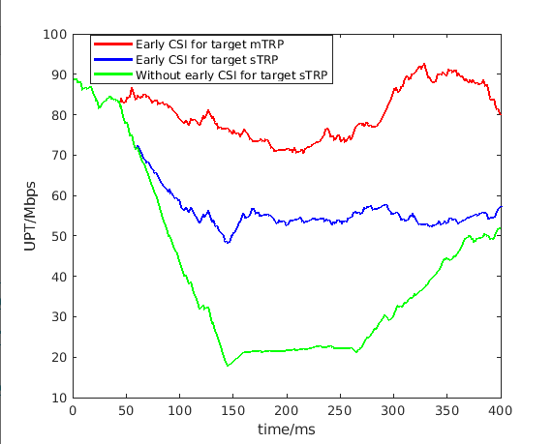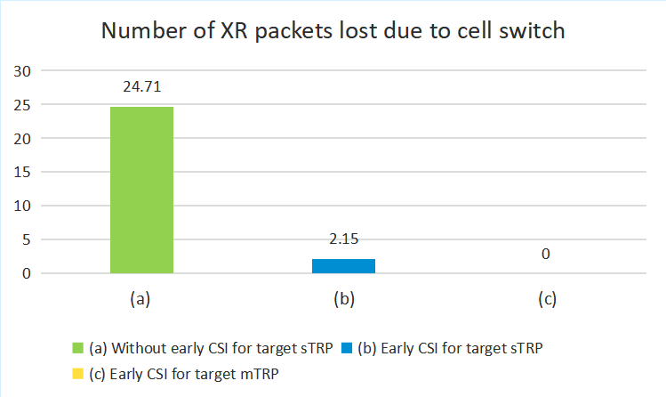  (a) (b)  Figure 15 Performance comparison of different early CSI acquisition schemes for (a) normal traffic model and (b) XR service model

Proposal 3.3-1
Study on how to support early CSI triggering/reporting, at least including the following scenarios:
- UE transition from IDLE/INACTIVE to CONNECTED mode including sTRP and M-TRP CJT,
- Scell deactivation to activation, and Scell dormancy state to active state
- Early CSI for lower layer mobility including sTRP and M-TRP CJT
- Use Rel-20 early CSI as a starting point
- Note: Early beam report is to be discussed separately in the Beam Management agenda
Support/fine | Nokia, OPPO, ZTE, CMCC, Ofinno, xiaomi, Apple, ETRI, Ericsson, Panasonic, Sony, Qualcomm, Interdigital, TCL, NEC, DOCOMO, vivo…
Not support

Table 3.3C Additional inputs
Company | Input
Mod v0 | I suppose all companies should be ok with the above proposal.  If additional input,
MediaTek | Even we are supportive to all these use cases, we are not sure whether this is the right agenda item to discuss them:  - Procedure of UE transition from IDLE/INACTIVE to CONNECTED mode is unclear and is to be discussed in AI 10.5.1.1 or AI 10.5.1.2. Based our understanding from Rel-20 MIMO early CSI, more discussion focused on the procedure/signaling. W/o common understanding on the initial access and RACH procedure, it is difficult to agree on how to support early CSI/CSI-RS.  - Same question on Scell deactivation to activation and lower layer mobility, if the procedure is discussed in another agenda items, early CSI should be considered when we design the corresponding procedure. Meanwhile, it is also unclear whether 6G will support SCell dormancy state.

UE-Initiated / Event-Triggered CSI
Many companies support to extend the Rel-19 UE-initiated beam reporting (UEIBR) to a more generic UE-initiated/event-triggered CSI reporting in 6GR, motivated by
- latency/overhead reduction for CSI reporting
- more efficient UL resource allocation for CSI reporting
- more adapting to channel dynamics.
It is also worth noting here that in the Beam Management agenda (10.5.2.4), UE-initiated/event-driven beam management will be separately discussed targeting different use cases. It may be better to have a unified design between the two (e.g., UL report medium), but the FL also acknowledges that there would be some differences – for instance, CSI reporting may have different event definitions and/or triggering conditions from beam reporting. Based on the above, the following FL proposal is provided.
- Supported by (15): Nokia, InterDigital, Spreadtrum, TCL, CMCC, CATT, OPPO, xiaomi, NEC, Samsung, LG, Intel, Fujitsu, ETRI, Sony
- AT&T: Study is needed
- Evidence: Nokia field data (TDD FR1, 100MHz) shows ~41% of periodic CSI reports are redundant (unchanged content) even with 160ms periodicity. UE-initiated reporting could skip these, saving energy/overhead.

Proposal 3.4-1
Support NW triggered CSI reporting as baseline. Study whether/how to support UE-initiated or event-triggered CSI reporting.
- Note: UE-initiated (event-triggered) beam management is to be discussed separately in the Beam Management agenda
Support/fine | Nokia, InterDigital, Spreadtrum, TCL, CMCC, CATT, OPPO, xiaomi, NEC, Samsung, LG, Intel, Fujitsu, ETRI, Sony, …
Not support

Table 3.4A Additional inputs
Company | Input
Mod v0 | I suppose all companies should be ok with the above proposal.  If additional input,
MediaTek | We are generally supportive to periodic/aperiodic/event-triggered manner for CSI acquisition/computation. But we have some suggestions on proposals:  - As commented in proposal 3.2-1, in the concept of decoupling CSI measurement/computation triggering from CSI reporting triggering, studying/defining "CSI computation type" is more important, instead of “CSI reporting type”. But it should be discussed after RAN1 has agreed on decoupling triggering between CSI measurement/computation and CSI reporting  - Periodic CSI acquisition is very essential and widely used in real-field deployment. It is worthy to support that in 6GR. Whether to assume aperiodic CSI acquisition as FL recommended needs more discussion.  We are fine with discussing UE-initiated (event-triggered) BM in the other agenda, but it may turn out different solutions supported for BM and CSI, when handled by two groups of people, like event-trigger reporting for LTM and BM in NR. That makes implementation inconsistency and has no benefit. Hence, it will be better to strive to have a unified solution to support UE-initiated (event-triggered) framework for different use cases.

CSI Framework design for spatial domain adaption (NES)
11 companies proposed to study on the support of NES for 6G.

Proposal 3.5-1
Study whether/how to accommodate spatial-domain adaptation for NES in CSI Framework design in relation to CSI-RS design.
Support/fine | Nokia, vivo, Samsung, Lenovo, Fujitsu, LG, Sony, DOCOMO, AT&T, KDDI, InterDigital, MediaTek
Not support

Table 3.4A Additional inputs
Company | Input
Mod v0 | I may miss some supporting companies, pls feel free to add your name in above table.  And if you have any additional view, pls comment below
InterDigital | We support proposal 3.5-1
MediaTek | We support this proposal in principle.

CPU/APU/Processing timeline
Several companies pointed out that the CPU/APU calculation and CPU processing timeline is too complicated. The rigid coupling of measurement, calculation, and reporting creates significant bookkeeping burdens for both the Network (NW) and User Equipment (UE).
FL assessment: Consider to open this discussion later, e.g., after decoupling of trigger and report.

CSI reporting

Unified fixed codebook design
Almost all companies explicitly mentioned to support unified fixed codebook design for different scenarios.
Table 4.1A: Summary for directions for CSI framework simplification
Issues | Summary of observations | Summary of companies’ views
#1:  Baseline structure for the Unified Fixed Codebook. | Option 1: eType II structure as the baseline.  - Two companies showed their unified scheme (L=1) outperforms Rel-19 Type-I Scheme B (as in Table 4.1B).  Option 2: Type I structure as the baseline.  - eType-II is sensitive channel aging and performs worse than Type I in Line-of-Sight (LoS) conditions.  Option 3: Type-I and/or eType-II as the baseline (E.g., Type I for low resolution and eType II for Hi-resolution) | Option 1: eType II structure as the baseline.  - Supported by (16): ZTE, Samsung, Lenovo, KT, Honor, Ericsson, AT&T, CEWiT, NEC, MediaTek (explicit channel FB), Huawei, Nokia, Apple, Intel, CATT, CMCC  Option 2: Type I structure as the baseline.  - Supported by(2): Qualcomm, Tejas  Option 3: Type-I and/or eType-II as the baseline (E.g., Type I for low resolution and eType II for Hi-resolution)  - Supported by (8): InterDigital, OPPO, TCL (Type I or eType II), vivo (Type-I SP CB, the eType-II CB and the eType-II CB for CJT), Xiaomi, Fujitsu, LGE, DCM
#2  Use cases supported by unified codebook | #1: Coherent Joint Transmission (CJT)  #2: High Doppler / High Speed (HST)  #3: Near-Field Propagation  Several companies mention the support near-field propagation for FR3. Some expect to use UFC to support NF, however, some companies believed it requires some modification. In addition, some companies are skeptical on the need. | #1: Coherent Joint Transmission (CJT)  - Supported by (18): CMCC, CATT, Fujitsu, Samsung, ZTE, DOCOMO, LG, Panasonic, KDDI, CATT, vivo, Ericsson, Interdigital, Nokia, Huawei, OPPO, NEC, Lenovo  #2: High Doppler / High Speed (HST)  - Supported by (3): ZTE, CMCC, Fraunhofer  #3: Near-Field Propagation (NF)  - Supported by (11): Huawei, ZTE. vivo, xiaomi, Apple, Lenovo, LG, Honor, Panasonic, CEWiT, Google,  - Skeptical (2): NEC, OPPO

Table 4.1B: Preliminary simulation result
Company | SLS results
Company | Issue # | Metric | Observation
ZTE | #1 | UPT | 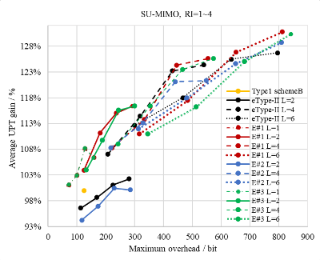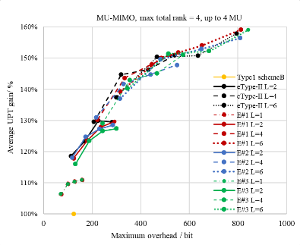  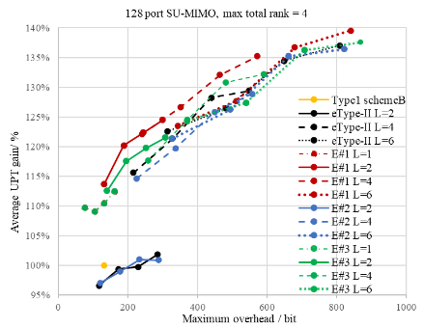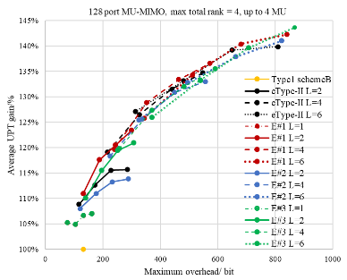  Figure 3 SLS results for unified fixed codebook in SU/MU-MIMO with 32/128 ports
Samsung | #1 | UPT | Observation #6: L ayer-specific SD vector selection with the following parameter combinations outperform the other schemes in a given overhead:  - For L=1,  - p_{v}={1/8,1/16};  - For L>1,  - L=2 and p_{v} ={1/8,1/16};  - L=3 and p_{v} ={1/8,1/16}; and  - L=3 and p_{v} ={1/4,1/8}.  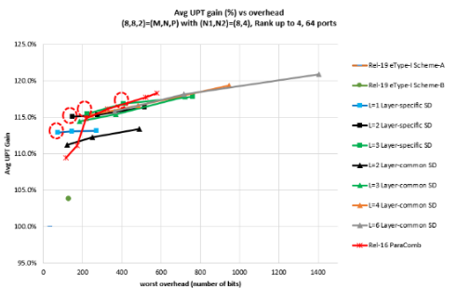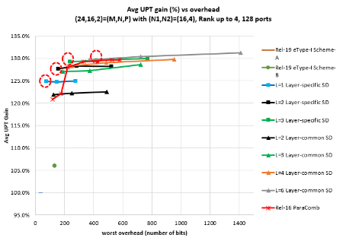  Figure 2. The case of 64 ports, RI_{MAX}=4, SU-MIMO, SB scenario  Figure 3. The case of 128 ports, RI_{MAX}=4, SU-MIMO, SB scenario  Observation #7: From the initial SLS results,  - replace layer-common SD basis selection with layer-specific SD basis vector selection in eType-II;  - remove high values of L (e.g., 4,6), since their performance isn’t improved much while incurring much overhead; and  - remove the b value; since it doesn’t improve UPT-vs-overhead tradeoff overall.  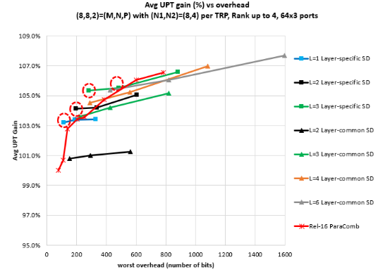  Observation #8: Similar to sTRP scenario, CJT with layer-specific SD vector selection (the proposed UFC method) with the following parameter combinations outperform the other schemes in a given overhead:  - For L=1,  - p_{v}={1/8,1/16};  - For L>1,  - L=2 and p_{v} ={1/8,1/16};  - L=3 and p_{v} ={1/8,1/16}; and  - L=3 and p_{v} ={1/4,1/8}.  Observation #9:  - A linear trend of UPT performance w.r.t. overhead is shown, i.e., eType-II with L=1 (up to 11% gain) > Rel-19 eType-I Scheme-B (up to 5% gain) > eType-I Scheme-A.  - eType-I Scheme-A (a.k.a Rel-15 Type-I) performs the worst.  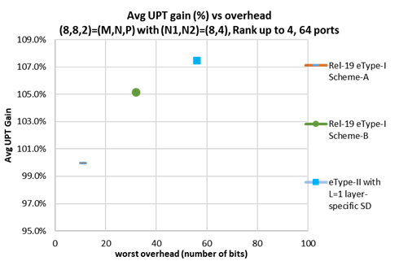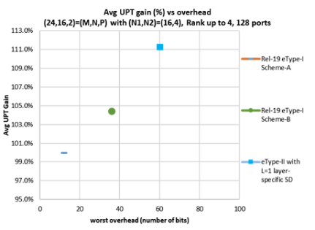
Qualcomm | #1 | UPT | 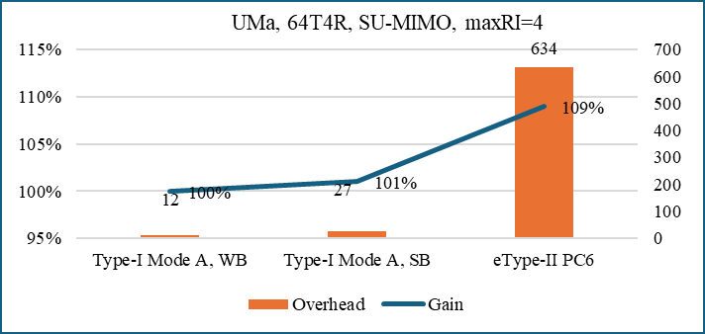  Figure 3-2: Performance gain and overhead comparison of Type‑I CB and eType‑II CB  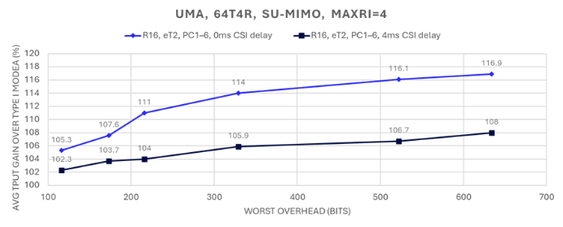  Figure 3-3: R16 eType II SU-MIMO Gain over Rel-19 Type I Mode A  Observation 14: Type II PMI is very sensitive to channel/interference aging. Evaluations show 2.3% - 8% performance loss when CSI feedback delay is considered.
Fraunhofer | #2  HST | UPT | 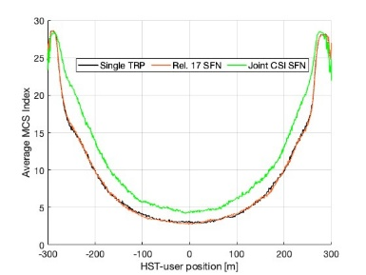  Figure 1: Selected Average MCS index by the HST-user at each transmission occasion along the track  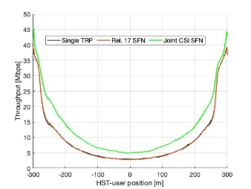  Figure 2: Achieved throughput [Mbps] at each transmission occasion along the track  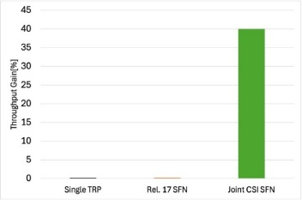  Figure 3: Throughput gain of single TRP, Rel. 17 SFN and Joint CSI SFN schemes with respect to the single TRP scheme.
vivo | #2 NF | SE | 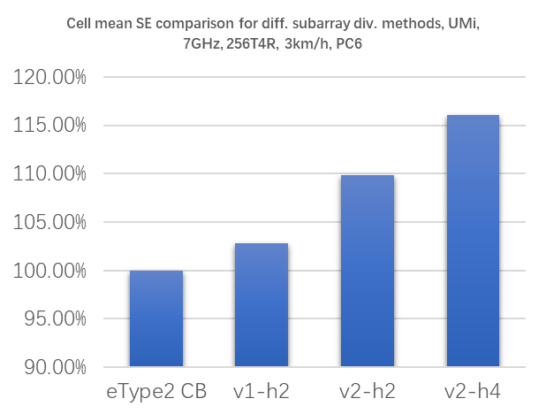  - Cell mean SE comparison for different sub-panel divisions  Observation: Subarray processing based on CJT CB can yield ~15% gains over eType2 CB at PC6.
Google | #2 NF | distribution | 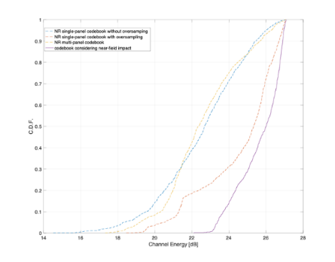  Figure 2: Simulation results for the codebook based on the near-field impact

Proposal 4.1-1
Strive to provide a unified fixed codebook design, including low- and high-resolution, at least for the following use cases
- SU-MIMO and MU-MIMO
- Single TRP and CJT
- FFS on whether to consider other use cases at least including High Doppler / High Speed Train (HST), Near-Field Propagation
  - For these use cases, FFS on whether/how to provide unified codebook design or necessary design/enhancement
Support/fine | CMCC, CATT, Fujitsu, Samsung, ZTE, DOCOMO, LG, Panasonic, KDDI, CATT, vivo, Ericsson, Interdigital, Nokia, Huawei, OPPO, NEC, Lenovo, …
Not support

Proposal 4.1-2
For the unified fixed codebook design,
- For high-resolution, use eTypeII (analogous to Rel-16 NR eType-II with L>1) structure as the basis for the design
- For low-resolution, as the basis for the design,
  - FFS: use either eType-II (analogous to Rel-16 NR eType-II with L=1) structure or Type-I (e.g. analogous to Rel-19 NR scheme A or Rel-19 NR scheme B)
- NR DFT basis can be assumed
Support/fine | ZTE, Samsung, Lenovo, KT, Honor, Ericsson, AT&T, CEWiT, NEC, Huawei, Nokia, Apple, Intel, CATT, CMCC, InterDigital……
Not support

Table 3.4A Additional inputs
Company | Input
Mod v0 | I suppose the proposals can be supported by the companies listed above. Please update if there is missing or if you have any additional comment
InterDigital | We support Proposal 4.1-2
Samsung | OK with Proposal 4.1-1.  OK with Proposal 4.1-2. As analysed/described in our tdoc, eType-II with the following simple modification offers good UPT-vs-overhead trade-off:  - Layer-specific SD basis selection with L=1 (low-resol) and L>1 (high-resol)  - FD compression same as eType-II  - Removing beta from the codebook parameters  This ensures a common UE implementation while offering sufficient UPT gain over the other legacy schemes and variants in a given overhead of wide range. The same principle can be applied to mTRP CJT and a similar performance trend is shown.
MediaTek | Proposal 4.1-1/ Proposal 4.1-2:  Unifying the codebook design is a good direction, but it is not must-have to us if it cannot ensure the consistent UE implementation in high-resolution and low-resolution CSI in term of precoder feedback. That should be carefully assessed by UE venders. For now, it is too early to take that. Our intention on unified CSI approach is to report the explicit channel for supporting various use cases. However, there is no doubt among companies to have some simplification on NR codebooks. Hence, we suggest refining the wording "Stive to provide the unified codebook design" as "Strive to simplify the codebook design" and identify the use cases which RAN1 should focus on.

AI-based CSI compression
Four AI-based CSI compression use cases have been proposed, with following summary.
Table 4.2A Summary for AI-CSI use cases
Sub-use cases | Summary of observations | Summary of companies’ views
JSCC/JSCM | 17 Companies provided evaluation on JSCC/JSCM against Rel-19 eType-II or Rel-20 SSCC baselines.  - Most companies showed SGCS or NMSE results for JSCC/JSCM  - Two companies provide UPT vs payload for JSCM  - Promising gain can be observed for UPT, and overhead reduction.  wherein  16 companies showed results of JSCM  10 companies showed results of JSCC | Supported by (22): Nokia, Spreadtrum, OPPO, ZTE, MediaTek, CMCC, vivo, BJTU, China Telecom, Samsung, Apple, Lenovo, Fujitsu, Ericsson, DOCOMO, BUPT, Pengcheng, LG, Qualcomm, TCL, CATT, NEC,
DLable codebook/Basis | 2 companies showed the SLS results for DLable codebook, wherein one showed gain in UPT another showed no gain in SGCS  1 company showed results for DLable basis, large gain for Type I WB/SB, marginal gain for eTypeII  FL assessment: There is contradictory observations from different companies. More justification is needed, as well as the clarification on DLable codebook or DLable basis. In addition, this may not able to study if expect to leverage UFC design of non-AI codebook. | Supported by (9): Futurewei, Interdigital, ZTE, OPPO, NEC, Apple， DOCOMO, LG, Qualcomm
SRS fusion | FL assessment:  No additional results or justification showed in this agenda.  Suggest to consider in agenda 10.5.3.3 | Supported by (4): Interdigital, OPPO, NVIDIA, Lenovo

Based on the above summary, we have the following proposal:

Proposal 4.2-1
For AI-based CSI compression,
- At least support the study on JSCC and JSCM.
  - Both raw channel matrix and eigenvector(s) of the raw channel matrix is considered as target CSI for study. Other format is not precluded
- FFS on DLable codebook/basis for target use cases, codebooks and corresponding assumptions
- Note: CSI and SRS fusion is expected to be discussed in 10.5.3.3
Support/fine | Nokia, Spreadtrum, OPPO, ZTE, MediaTek, CMCC, vivo, BJTU, China Telecom, Samsung, Apple, Lenovo, Fujitsu, Ericsson, DOCOMO, BUPT, Pengcheng, LG, Qualcomm. TCL, CATT, NEC, …
Not support

Table 4.2B Additional inputs
Company | Input
Mod v0 | Note: NW-sided vs 2-sided to be discussed separately.  DLable basis/codebook may need more evaluation and justification. It is premature to conclude it now without suffer aligned results.  In addition,  Q: Do we need to prioritize one of JSCC or JSCM?

Table 4.2C Summary for AI-CSI use cases of evaluation results
Company | Use case | Metric | Key observation
Nokia | JSCC/JSCM | SGCS vs UL SNR | JSCC/JSCM for CSI compression and feedback primarily improves low‑SNR performance (mitigating the cliff effect). Furthermore, one‑sided JSCM performs close to two‑sided.  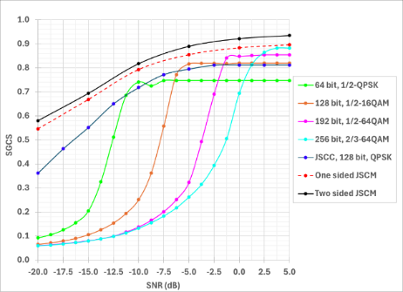
Spreadtrum | JSCC/JSCM | SGCS vs UL SNR | JSCC/JSCM leads to significant performance gain compared to the SSCC, especially at low SNR range.  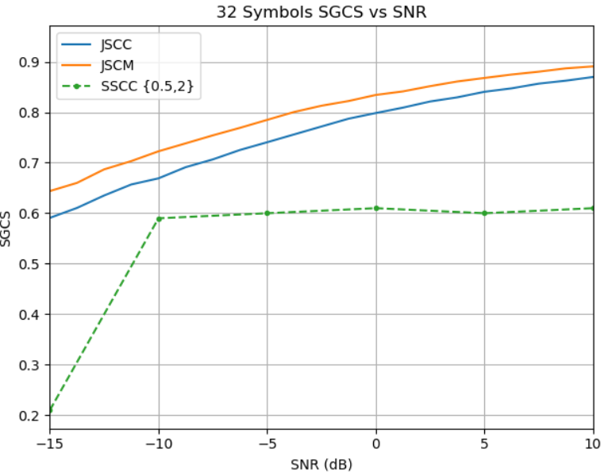
OPPO | JSCM | SGCS vs UL SNR | 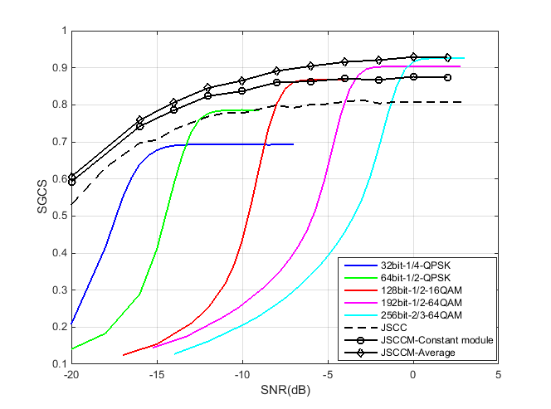  SGCS comparison among JSCC, JSCM and baseline; SGCS and CSI feedback payload comparison  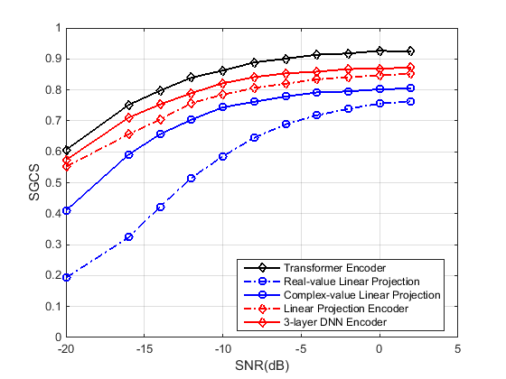  SGCS performance comparison for JSCM with two-side and NW-side model
ZTE | JSCM | SGCS vs UL SNR | 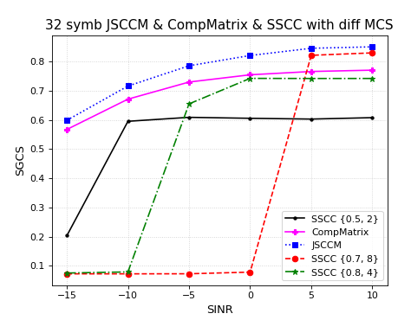  Figure 9 Simulation results of JSCCM (Note: SSCC {x, y} represents SSCC with a code rate of x and a modulation order of y)
MediaTek | JSCC/JSCM | SGCS vs UL SNR | Figure-2.4.1.2.1 SGCS versus UL SNR for SSCC, JSCC and JSCCM.  Observation 2.4.1.2.1: JSCCM shows better performance than JSCC and SSCC in UL fading channels under conventional channel estimation (e.g., LS-CE with LMMSE interpolation) and equalization (e.g., LMMSE),  Observation 2.4.1.2.2: A block-wise per-subband linear encoder for JSCCM (with shared weights across subbands) provides significant UE-side complexity reduction in terms of number of parameters and FLOPs compared to a vectorized full-band linear encoder and transformer-based encoders, with limited performance loss.  Proposal 2.4.1.2.1: Prioritize study of CSI compression and feedback with JSCCM over other CSI compression sub-cases, focusing on UE-side complexity reduction while retaining performance guarantees.
CMCC | JSCC/JSCM | SGCS vs UL SNR | 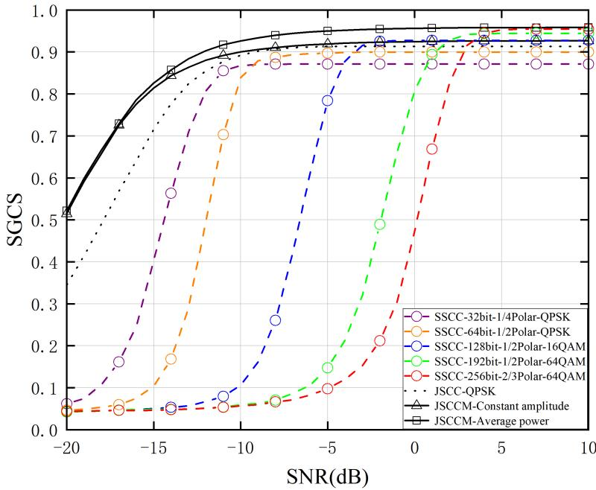  Figure 19. SGCS performance of SSCC, JSCC, and JSCCM.  Observation 17: For both constant amplitude and average power constraints, the JSCCM achieves an SGCS score around 0.9 when the SNR exceeds -10dB, and models trained at different SNRs have different SGCS performance.  Observation 18: At a given training SNR, the JSCCM with average power constraint maintains a performance advantage over the JSCCM with constant amplitude constraint throughout the inference SNR range.  Observation 19: For a given number of resource elements, JSCCM outperforms JSCC, and JSCC with QPSK exceeds SSCC. The resulting SGCS gain is particularly significant in low-SNR regimes.
vivo | JSCM | SGCS  UPT | 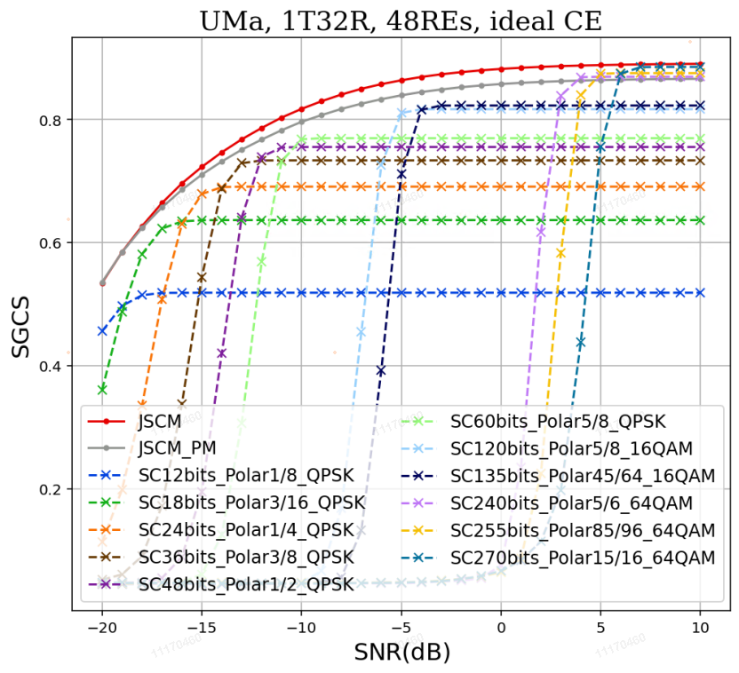  - The comparison between the JSCM-based CSI feedback and the SSCC-based CSI feedback under UMa channel with ideal/real channel estimation  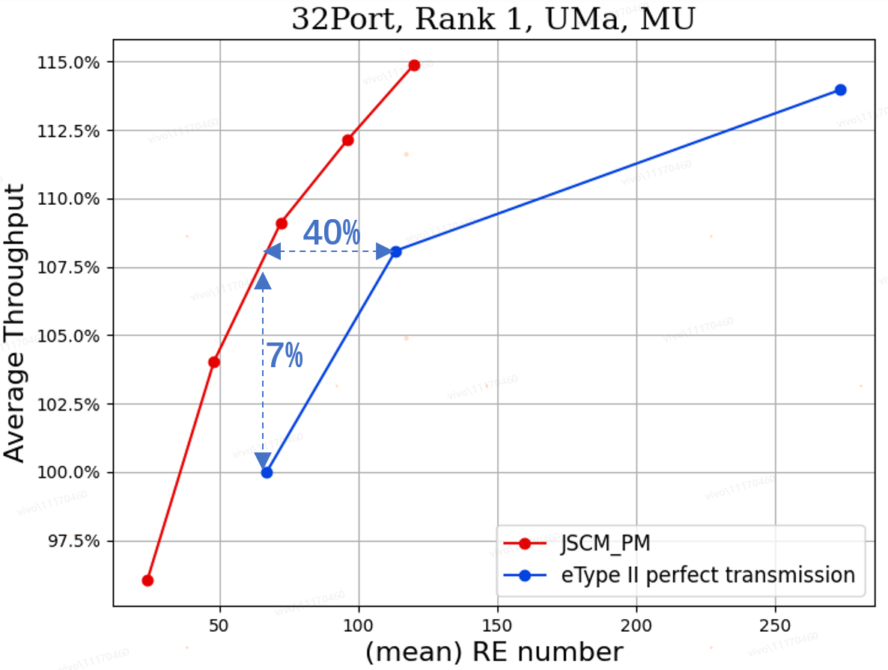  - The SLS comparison between the JSCM-based CSI feedback and the eType II with perfect transmission for CSI feedback  Observation 9: JSCM with PM as encoder addresses inter-vendor collaboration issue.  Observation 10: Compared with SSCC, JSCM could achieve 1~3 dB performance gain under UMa channel.  Observation 11: JSCM with PM could achieve acceptable performance with reduced parameter size and computational complexity.  Observation 12: Larger performance gain of JSCM under real CE can be observed compared with that under ideal CE.  Observation 13: Compared with eType II scheme, JSCM can achieve 7% throughput gain or 40% overhead reduction.
BJTU | JSCC/JSCM | NMSE | 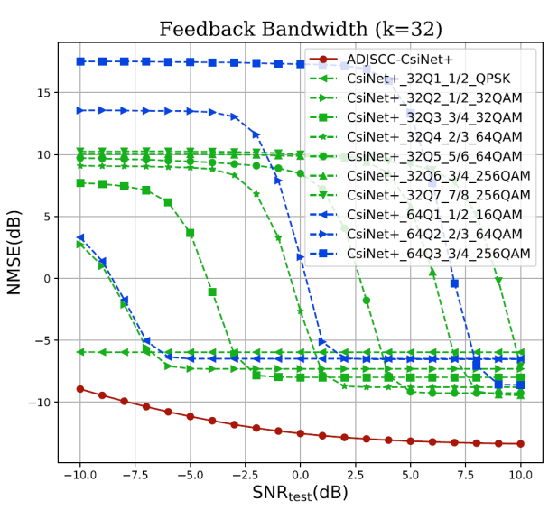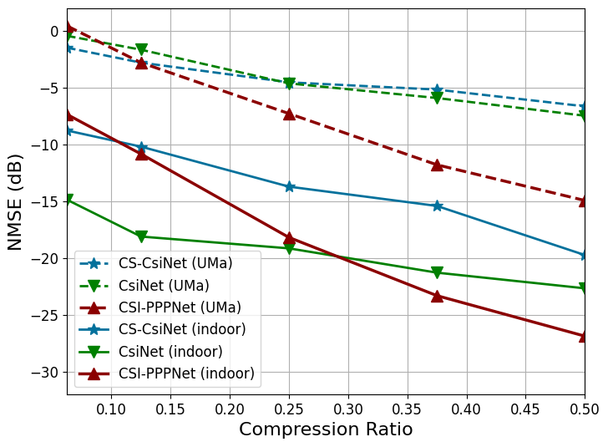  Fig. 4. Performance comparison of ADJSCC-based CSI feedback with SSCC-based CSI feedback.  Fig. 16. Performance comparison between one-sided and two-sided models [3].  Observation 1: Without introducing additional AI/ML model complexity, CSI feedback based on joint source channel coding (JSCC) is observed to improve the performance of CSI reconstruction accuracy.  One-sided CSI feedback frameworks based on JSCM (e.g., CSI-PPPNet) achieve competitive accuracy with far fewer parameters, reducing training and deployment overhead compared to two-sided models.
China Telecom | JSCC |  | Observation 1: For AI-based CSI enhancement, CNN-based JSCC achieves a SGCS of 0.86.
Samsung | JSCM | SGCS,  UPT  SE | 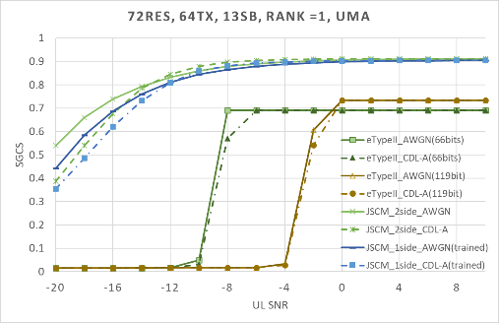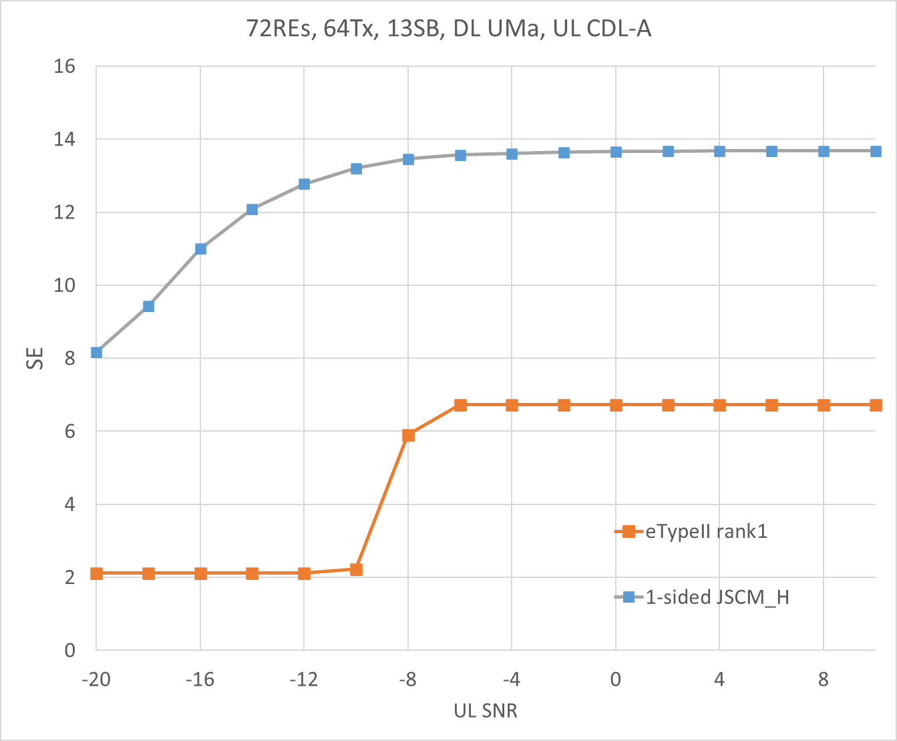  Figure 9. SGCS performance over Uplink AWGN channel and CDL-A channel (eigenvector)  Figure 10. Spectrum efficiency with eTypeII Rank 1 and explicit H (CDL-A channel for uplink)  Observation #16: JSCM provides signification overhead reduction (up to 70%) with UPT gain (up to 14% for SU and up to 7% for MU).  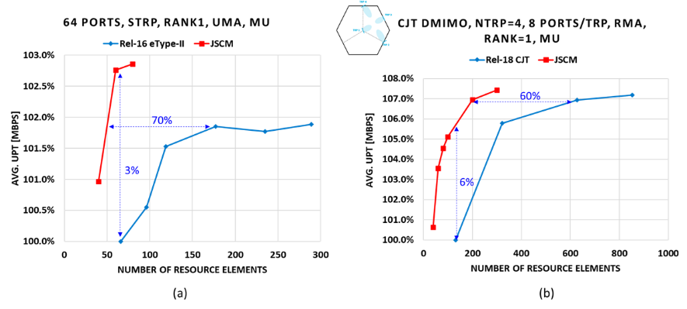  Figure 14. MU-MIMO: User perceived throughput (UPT) vs Rank 1 overhead (number of REs) (a) sTRP and (b) mTRP CJT scenarios  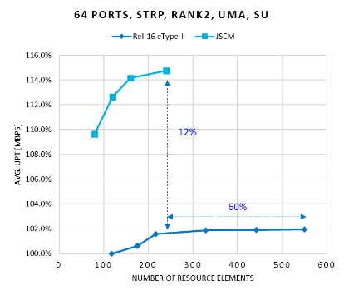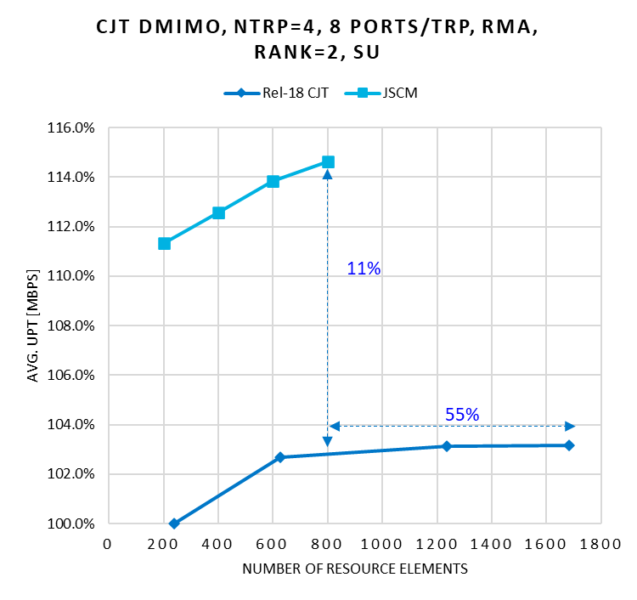  Figure 15. SU-MIMO: User perceived throughput (UPT) vs Rank 2 overhead (number of REs)
Apple | JSCM | SGCS | Fig. 3.2-1. Comparison of JSCCM with different encoder complexity with e-type 2 codebook
Lenovo | JSCC/JSCM |  | 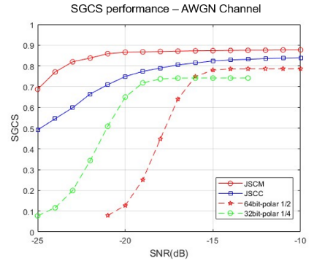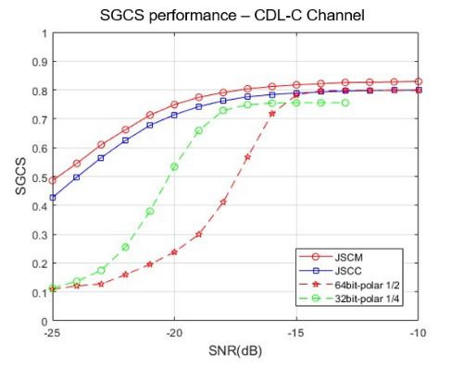  Figure 7. Performance of JSCC/JSCM for CSI feedback  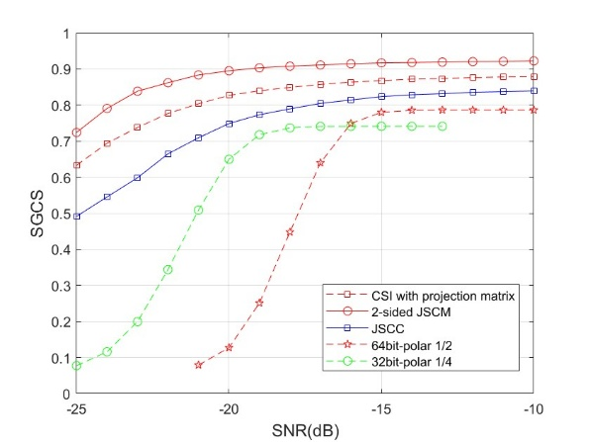  Figure 9. Performance of explicit CSl feedback based on projection matrix.
Fujitsu | JSCC/JSCM |  | - For CSI feedback, AI/ML based JSCC with two-sided model could achieve a better SGCS performance over SSCC (AI compression & polar codes) except for some SNR.  - For CSI feedback, AI/ML based JSCCM with one/two-sided model could achieve a better SGCS performance over SSCC (AI compression & polar codes) in the whole SNR region.  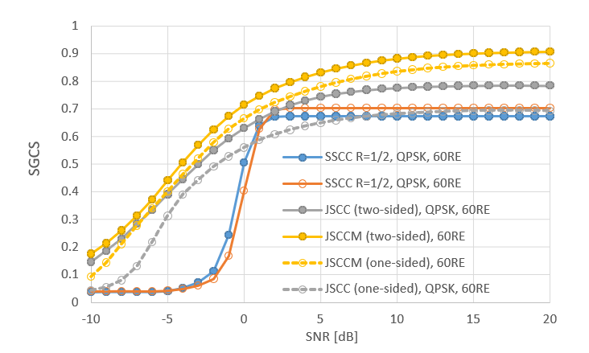  Figure 7 SGCS performances of JSCC, JSCCM and SSCC for DL CSI feedback.
Ericsson | JSCM |  | 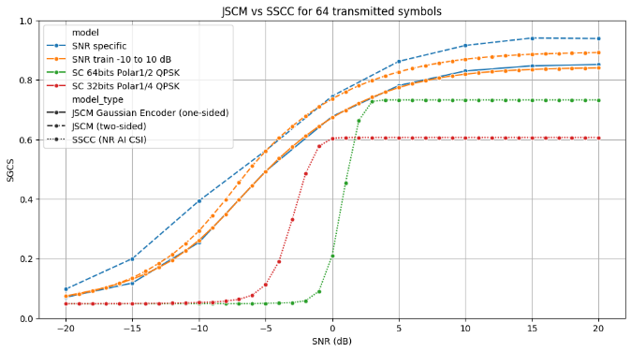  Figure 13: Performance of one-sided JSCM, two-sided JSCM and SSCC based CSI feedback schemes.
DOCOMO | JSCM | NMSE | 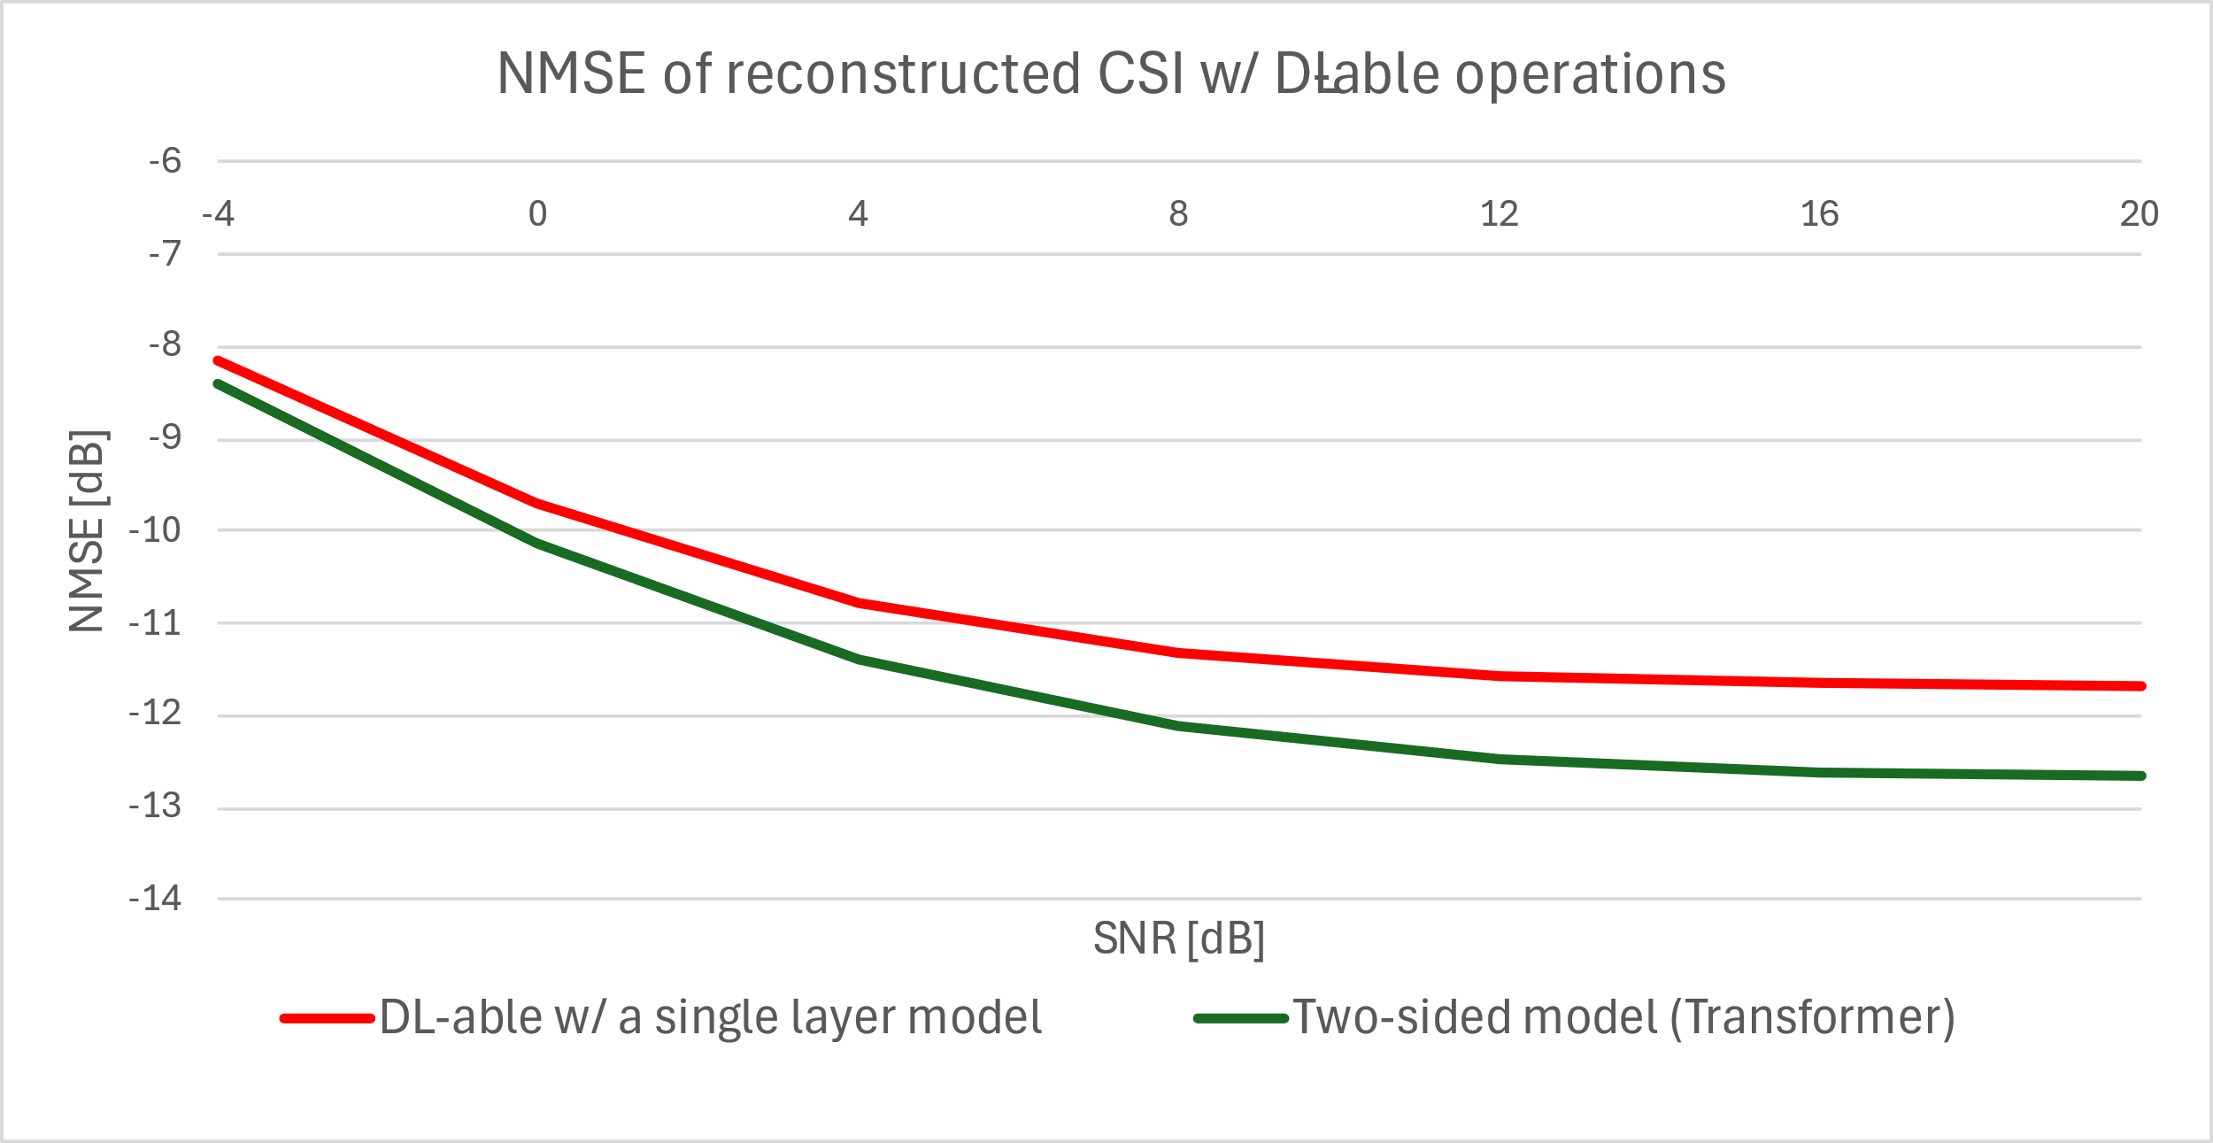  Figure 4-4: NMSE of the CSI compression schemes with DL-able operations
BUPT | JSCC/JSCM | SGCS | Fig. 5 Squared generalized cosine similarity (SGCS) vs. SNR under various schemes  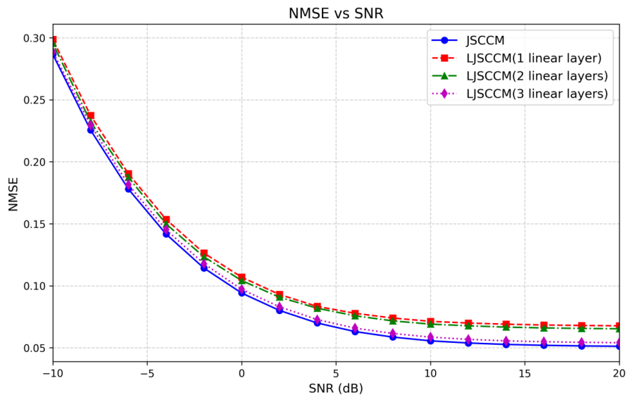  Fig. 6 NMSE vs. SNR under JSCCM-based and LJSCCM methods
Pengcheng | JSCC/JSCM | SGCS | 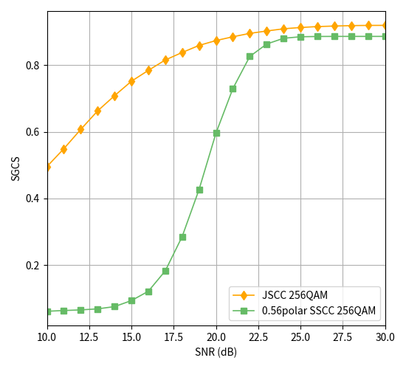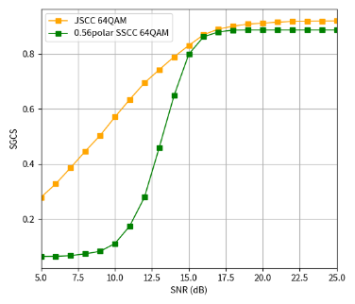  256QAM JSCC vs SSCC 64QAM JSCC vs SSCC  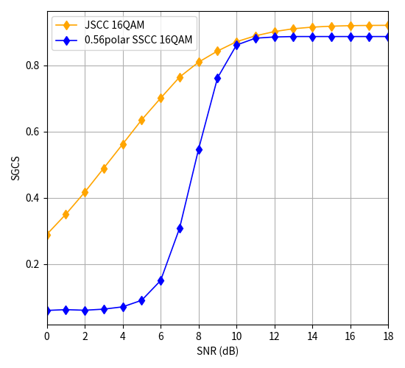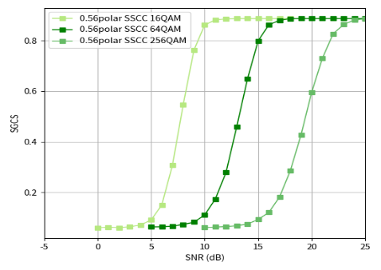  16QAM JSCC vs SSCC various QAM-Modulation SSCC CSI feedback  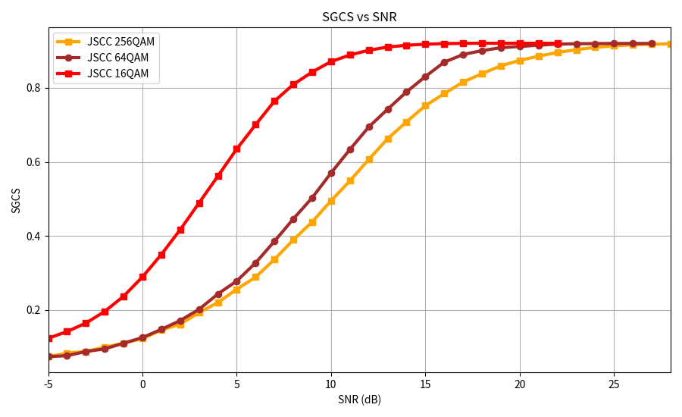  multiple QAM-Modulation JSCC CSI feedback  - SGCS performance of multiple QAM-Modulation JSCC-based CSI feedback and the AI/ML-based conventional CSI feedback  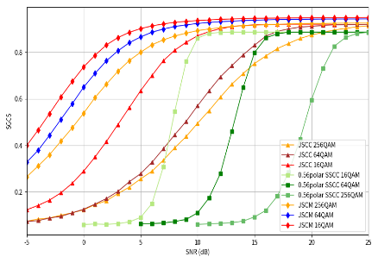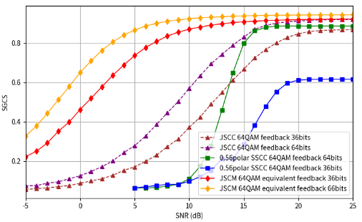  Figure 6 SGCS performance of various CSI feedback methods  Figure 7 Performance Comparison of SSCC, JSCC, and JSCM in SGCS: Impact of Feedback Bit Quantity and Signal-to-Noise Ratio
ZTE | DLable codebook | UPT | Observation 4: Type-I-like downloadable codebook (solution-1) can bring ~20% average UPT gain with same codebook size, or reduce 3/4 codebook size with same UPT performance, compared with legacy Type-I codebook.  Observation 5: Type-II-like downloadable codebook (solution-2) can bring 5~20% average UPT gain (much more in cell-edge), compared with eType-II (cell-specific CSI-RS) and FeType-II (UE-specific CSI-RS).  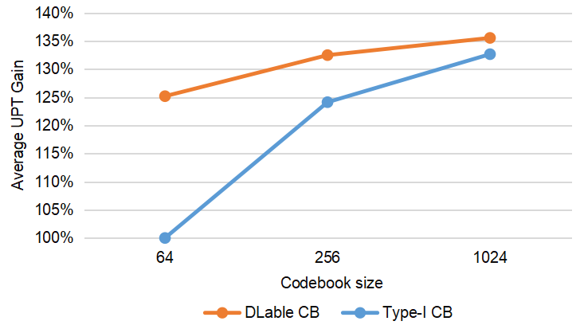  (a)  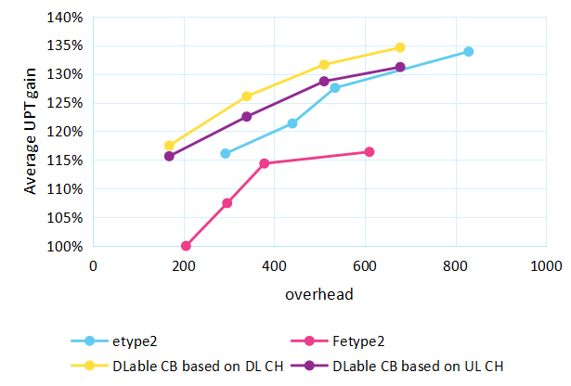  (b)  Figure 5 SLS results for (a) Type-I-like and (b) Type-II-like downloadable codebook
Lenovo | DLable codebook | SGCS | 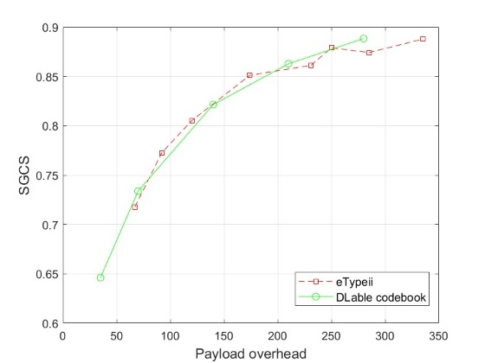  Figure 8. Performance of DLable codebook for CSI feedback.
Qualcomm | DLable basis | UPT | 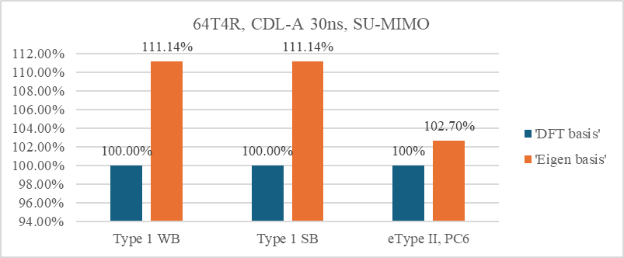  Figure 3-7: Gain of eigen basis over DFT with R19 Type I Mode A and eType II PMI

NW-side vs 2-sided
Some companies proposed to focus on NW-sided model for JSCM and/or DLable codebook/basis, while some companies
Table 4.2.1A: Summary on the view
Directions | Summary of observations | Summary of companies’ views
#1  Prioritized NW-sided model | 1. NW-sided model based JSCM can significantly reduce UE complexity by replacing the UE-side Neural Network with a Linear Projection (as in Table 4.2.1B)  2. NW-sided model can significantly reduce inter-vendor calibration effort.  3. Avoid overlap with NR standardization work  4. One-sided models generalize well and are easier to train than two-sided models. | Supported by (7): Spreadtrum, Interdigital, Huawei, OPPO, MediaTek, Xiaomi, DOCOMO
#2  Study both NW-sided and 2-sided model | 1. The study outcome of NR can be leveraged.  2. Focusing on complexity reduction.  FL assessment:  No need to repeat the discussion for 2-sided model intervenor collaboration, but focus on the delta part. | Supported by (3): Apple, Qualcomm, BUPT

Table 4.2.1B: Summary on UE complexity
Company | Observations
OPPO | - Complexity of UE-side encoder for JSCC/JSCM  - FLOPs comparison
  Model | FLOPs | Trainable parameters | Model Size
  Encoder | 93.95M | 10.70M | 48.43M Byte
  UE-side solution | FLOPs
  Transformer encoder | 93.95M
  Real-value linear projection | 0.21M
  Complex-value linear projection | 0.21M
  Linear projection encoder | 0.21M
  3-layer DNN encoder | 1.18M
MTK
  CSI compression scheme | Encoder  model | Decoder model | Encoder output dimension | Encoder parameter count | Encoder FLOPs
  SSCC | 2-layer transformer | 2-layer transformer | 11-58 (dynamic) | 1661k | 28.27m-28.35m
  JSCC | 2-layer transformer | 2-layer transformer | 72 | 1673k | 28.37m
  JSCCM | 2-layer transformer | 2-layer transformer | 144 | 1733k | 28.49m
  JSCCM | Vectorized linear encoder | 4-layer transformer | 144 | 120k | 239.62k
  JSCCM | Block-wise linear encoder | 4-layer transformer | 144 | 704 | 18.3k
CMCC | Table 11. UE complexity between low-complexity design and 2-side transformer
  UE complexity | Trainable parameters | FLOPs
  fixed random Gaussian matrix | / | 163840
  learnable Gaussian matrix | 82048 | 163840
  2-layer dense network | 196992 | 393216
  2-side transformer JSCCM | $$2.5×{10}^{6}$$ | $$7.135×{10}^{7}$$
vivo | - Parameter and Flops comparison of JSCCM_PM Encoder, JSCCM Encoder, and SC Encoder
  Scheme | Parameter | Flops
  JSCM_PM Encoder | 80 K | 160 K
  JSCM Encoder | 3 M | 9 M
  SC Encoder | 3 M ~ 6 M | 9 M ~ 21 M
Samsung | Table 4 Complexity for Rank =1 (SVD is not considered)
   | NW complexity  (Mflops) | UE Complexity  (Mflops)
  2-sided model | 86.19 | 86.19
  1-sided model | 86.19 | 1.92
BUPT | Table 2 Configurations of JSCCM and LJSCCM methods
  Related parameters | JSCCM | LJSCCM
  Total number of parameters/trainable parameters | 37,075,200 | 25,367,296/25,629,952/26,417,408
  Parameter size (float32) | 141.43 MB | 96.77/97.77/100.77 MB
  Number of Flops | 0.442G | 0.275/0.276/0.277G
  Encoder | 3-layer Transformer | 1/2/3 linear layers
  Decoder | 3-layer Transformer | 3-layer Transformer

Proposal 4.2.1-1
For the study on AI-based CSI compression, the study on inter-vendor collaboration aspects for 2-sided model to be discussed later after performance study for 2-sided model.
Support/fine
Not support

Table 4.2.1C Additional inputs
Company | Input
Mod v0 | I don’t think we need to rule out the performance study for 2-sided model. But no need to spend time to resolve inter-vendor collaboration issue. However, we can revisit it if the performance can be justified.  I cannot guess the view from two side about the above proposal. Therefore, I didn’t put any names in the above table. Please show you view in above table and additional view below, if any.
MediaTek | We think 2-sided model should not be precluded at this stage. It is not so clear why there should be an agreement to postpone discussion on inter-vendor collaboration aspects.

Physical Layer Integration of JSCM/JSCC
While performance is promising, integrating "analog-like" JSCM symbols into the digital 6G PHY creates unique challenges identified by multiple companies.
Table 4.2.2A: Key challenge for JSCC/JSCM
Issues | Observations (according to Table 4.2.2D)
#1  PAPR (JSCM) | 3 Companies pointed out higher PAPR caused by JSCM for DFT-s-OFDM.  1 company provided solution and result to reduce PAPR caused by JSCM with minor or without performance loss in SGCS. (Table 2.3.2B)
#2  Reliability & Lack of CRC (JSCM/JSCC) | 3 companies pointed out JSCM/JSCC is lack of CRC and sNB may not able to validate received CSI.
#3  UCI Multiplexing/  interleaving issues  (JSCM/JSCC) | 3 companies pointed out UCI multiplexing issue and interleaving issue with other UCI.

Table 4.2.2B: Preliminary results
Company | Scenarios | Key observation and results
Samsung | #1 | 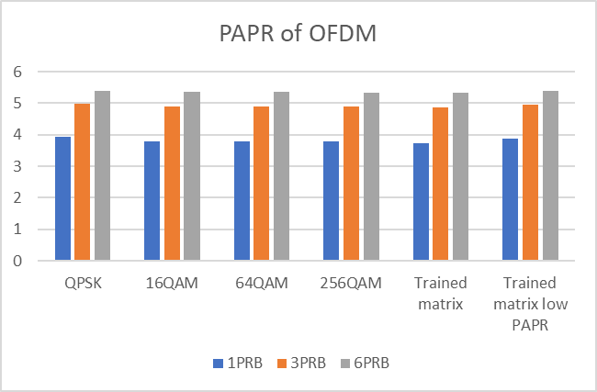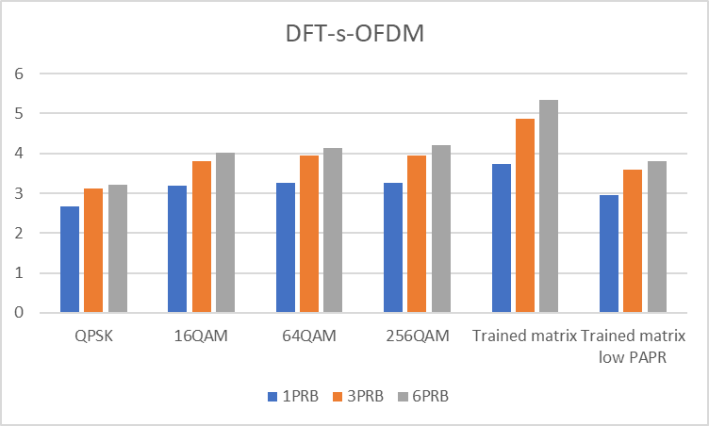  Figure 11. PAPR comparison.  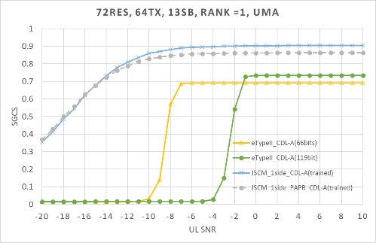  Figure 12. SGCS performance over CDL-A channel with PAPR restriction  Observation #14: it is observed that PAPR can be reduced for JSCM scheme with sufficiently small SGSC loss only in high SNR, where the PAPR is similar to the one of SSCC.

Based on discussion in Tdocs, the following is proposed:

Proposal 4.2.2-1
For the study on JSCC/JSCM, study at least the following issues:
- How to reduce/restrict PAPR for JSCM
- Whether/how to support error detection/assessment by NW on reported JSCC/JSCM-based CSI, e.g., CRC-like scheme
- Whether/how to multiplex JSCC/JSCM-based CSI with other UCI (e.g., non-JSCC/JSCM-based)
Support/fine | Nokia, TCL, CATT, NEC, Samsung, LG, Ericsson, Qualcomm, MediaTek
Not support

Table 4.2.2C Additional inputs
Company | Input
Mod v0
MediaTek | It is necessary to study how the UE transmit chain can handle transmission of arbitrary constellation points instead of selecting from a given set of constellation points.

Table 2.3.3D Observations
Company | Observation/proposal
Nokia | The study should focus on evaluating JSCC/M (including single‑sided JSCM) under practical constraints, such as constrained modulation symbols (QAM or NUC in line with 6GR modulation assumptions), robustness and recovery behavior under bursty channel errors due to the absence of channel coding in JSCC/M, and other relevant non‑idealities, in order to assess the overall potential of this use case.
TCL | Proposal 17 : Different HARQ mechanisms for CSI compression with JSCC, e.g., CRC-free and CRC-attached, should be evaluated.
CATT | Interleaving Mismatch: Unlike JSCC which outputs bits compatible with legacy bit-level interleaving, JSCM outputs modulated symbols, requiring a redesign of interleaving mechanisms.  UCI Multiplexing: JSCM disrupts the existing framework where CSI and other UCI (e.g., HARQ-ACK) share the same coding/modulation chain, raising unresolved issues on resource mapping and multiplexing. Proposal: CATT urges RAN1 to select only one ultimate AI scheme (choosing among SSCC, JSCC, and JSCM) to avoid fragmentation, and mandates that evaluation must account for impacts on legacy UCI processing.
NEC | Proposal 18: Study the impacts of lack of CRC and scrambling for JSCCM CSI reporting and methods to transmit/multiplex JSCCM CSI report via PUSCH.
Samsung | Observation #14: it is observed that PAPR can be reduced for JSCM scheme with sufficiently small SGSC loss only in high SNR, where the PAPR is similar to the one of SSCC.
LG | Observation #5: JSCM-based modulated symbols may exhibit unconstrained modulation characteristics different from QAM/NU-QAM, leading to different PAPR and RF/PA processing behaviour; mixing JSCM-modulated symbols with QAM-modulated symbols within the same OFDM symbol should be avoided.  Proposal #25: For study of JSCM for CSI compression (Sub-use case B), the following two aspects shall be considered:  - method for parallel transmission of bit-wise essential CSI information  - method for multiplexing/separation with QAM/NU-QAM signals considering PAPR and RF/PA differences
Ericsson | RAN4 PAPR/EVM requirements and performance impacts
Qualcomm | Proposal 21: For the study of CSI compression and feedback with AI/ML-based JSCM,  Performance, robustness, and feasibility of analog feedback should be carefully studied.  Performance, generalization aspects, and feasibility should be studied to determine the merit and feasibility of downloadable models.  Study should consider rigorous link-level and system-level evaluations with careful modeling of UL MIMO fading channels, interference, and UE/gNB implementation artifacts

DMRS-based CSI Reporting
DMRS-based CSI reporting was proposed by several companies with following summary

Table 4.3A: Summary on the views
Proposals | Summary of observations | Summary of companies’ views
#1  Utilizing DMRS for CSI updates (CQI/L1-SINR/Delta-MCS). | Justification  1. Fast link adaptation (Delta CQI) to track interference/aging without extra CSI-RS overhead.  2. CSI-RS based feedback may not inline with actual scheduled transmission  3. reduce overhead  4, better UPT/L1-RSRP (Table 4.3B)  Design  DMRS for on-demand CSI report  Skeptical  DMRS-based report should be considered later. | Support (10): Nokia (FFS), Huawei, ZTE, Tejas, MediaTek, GOOGLE, xiaomi, Samsung. Apple, Ericsson  Skeptical (2)  Spreadtrum (low priority in 6G day-1) Fujitsu (later)
#2  PDCCH CSI feedback | PDCCH link adaptation using CSI feedback from reference signals in data region is suboptimal | Support (1): Ericsson

Table 4.3B: Summary on evaluation results
Company | Proposal/  Metric | Key observation and results
MediaTek | #1  UPT | 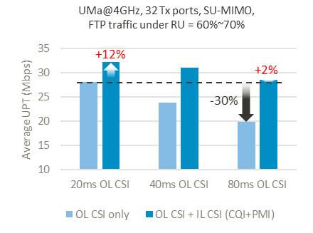  Figure-2.1.1 Average UPT performance of outer-loop CSI acquisition standalone vs. dual-loop CSI acquisition under different outer-loop CSI periodicities  Observation 2.1.1: A dual-loop CSI acquisition framework is motivated by the critical need to efficiently balance the trade-off between CSI update periodicity, resource consumption, and sustained high performance.  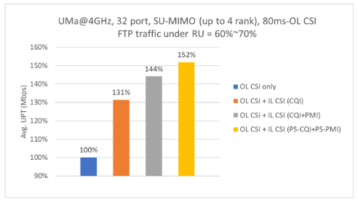  Figure-2.1.2.1 Average UPT performance of (1) Outer-loop CSI only, (2) dual-loop CSI with DMRS-based CQI tracking, (3) dual-loop CSI with DMRS-based CQI and PMI tracking and (4) dual-loop CSI with DMRS-based CQI and PMI tracking with DMRS port selection
Samsung | #1  CDF of L1-RSRP | 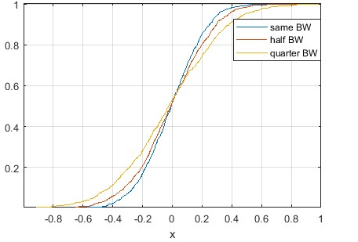  Figure 17: The CDF of L1-RSRP difference (x) between CSI-RS measurement and DM-RS measurement
Ericsson | #1  UPT | 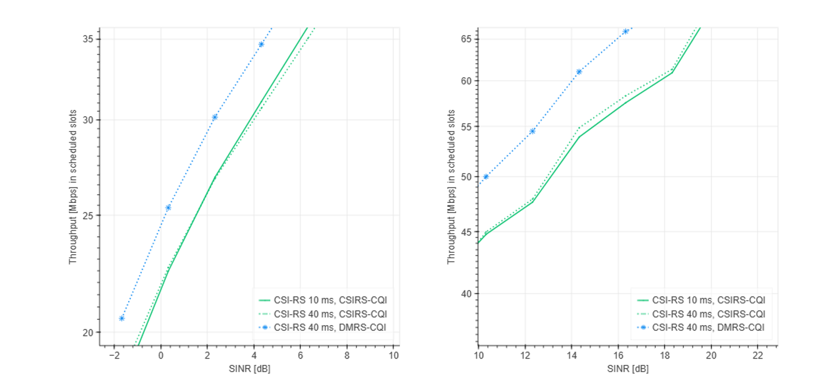  Figure 16: Throughput vs. SINR for CSI-RS-based CQI and PDSCH DMRS-based CQI in UMa scenario.  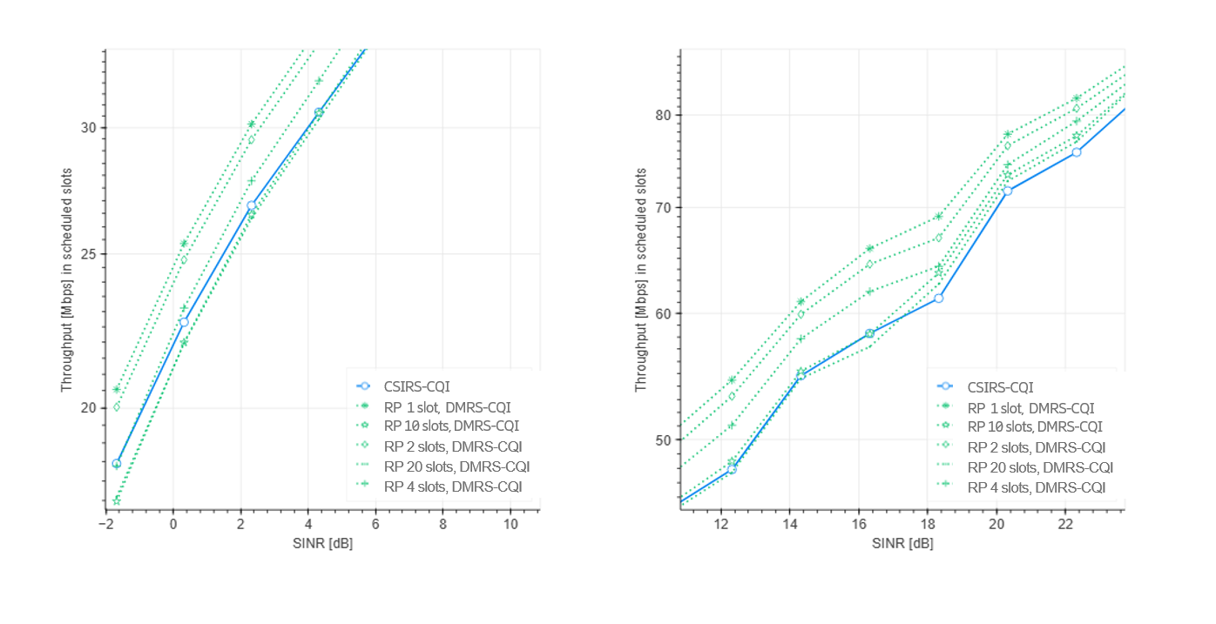  Figure 17: Throughput vs. SINR comparing CSI-RS-based CQI with DMRS-based CQI for different reporting periodicities (RP)

Proposal 4.3-1
Study on whether/how to support DMRS-based CSI reporting.

Support/fine | Nokia, Huawei, ZTE, Tejas, MediaTek, GOOGLE, xiaomi, Samsung. Apple, Ericsson, InterDigital
Not support

Table 4.3C Additional inputs
Company | Input
Mod v0 | Hope spredtrum/Fujitsu is fine with the above proposal. I didn’t put your name in “not support”. But if you have strong concern, please update the above table.
Samsung | OK with proposal. DMRS-based CSI acquisition is for fast link adaptation in both of FR1/FR2. CQI/RSRP should be baseline to study for report quantity, while PMI relies on the legacy CSI reporting based on CSI-RS.
MediaTek | Support. We are interested in DMRS-based CQI/RI/PMI tracking.

UE-assisted report
UE-assisted report was proposed for several cases as the summary:
Table 4.3A: Summary on the view
Proposals | Summary of observations | Summary of companies’ views
#1  CJT calibration (delay offset, frequency offset, DL/UL phase offset), | 1. Essential feature to enable CJT across non-collocated mTRPs via UE-assisted reporting for NW in calibrating any freq/time/phase mismatch among TRPs  2. Many companies suggest Rel-19 CJTC Dd/FO/PO as a starting point. | Supported by (10): ZTE, NEC, Samsung, Apple, Lenovo, Ericsson, vivo, OPPO, CMCC, CATT, InterDigital
#2  Long-Term Channel Property information report (e.g. TDCP and/or SDCP and/or FDCP) | Long-term channel property can facilitate efficient MIMO transmission operations (e.g., CSI acquisition with reduced overhead/feedback, aid proper codebook parameter selection L, pv, etc) | Supported by (9): OPPO, ZTE, CATT, vivo, ETRI (SDCP), Ericsson, DCM(FFS), Google (TDCP), Huawei (long-term channel information), InterDigital
#3  Interference plus noise (IPN) feedback | For SRS-based DL CSI acquisition, DL interference info is still needed for NW to calculate proper SINR/spectral efficiency. The legacy CQI could be coarse info than IpN FB. | Support (2): Ericsson, Futurewei (study)
#4  CJT interference mitigation | For mitigating CJT interference, UE reports the inferference from other CJT coordination set. | Supported by(1): ZTE

Table 4.3B: Summary on evaluation results
Company | Proposal/  Metric | Key observation and results
ZTE | #2  UPT | Observation 7: The UE-reported compressed long-term channel covariance delivers an average UPT gain of 7% and a cell-edge UPT gain of 36% for mTRP CJT
Ericsson | #3  UPT | Table 6: UPT gain of IPN-based reciprocity DL over baseline (reciprocity DL based on adjusting CQI) at 20% and 50% resource utilization in Dense Urban scenario at 4 GHz with 20MHz bandwidth, 256 antenna elements/64 TXRU., RS periodicity = 10 slots.
   | RU=20% |  | RU=50%
   | Mean UPT | 5th percentile UPT | Mean UPT | 5th percentile UPT
  Reciprocity based on IPN report | 19% | 10% | 14% | 3%
Huawei | #2  Average SE/Cell-edge SE vs overhead | 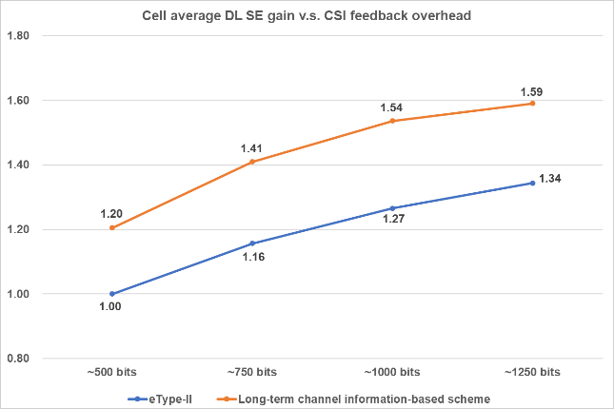  Figure 22. Cell average DL SE of long-term channel information-based explicit CSI feedback scheme  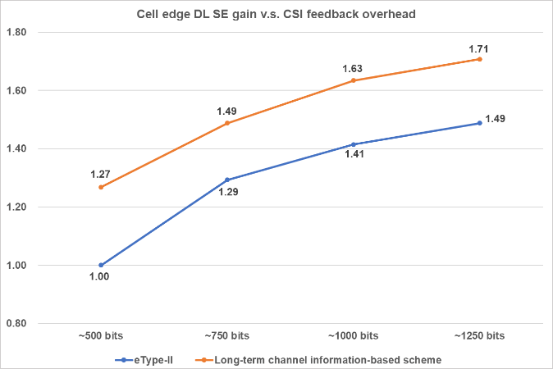  Figure 23. Cell edge DL SE of long-term channel information-based explicit CSI feedback scheme  Observation 14: For the same feedback overhead, long-term channel information-based explicit CSI feedback can improve cell average DL SE by +18% to +22% compared with eType-II scheme.  Observation 15: For the same feedback overhead, long-term channel information-based explicit CSI feedback can improve cell edge DL SE by +15% to +27% compared with eType-II scheme.
vivo | #1  Cell mean SE | 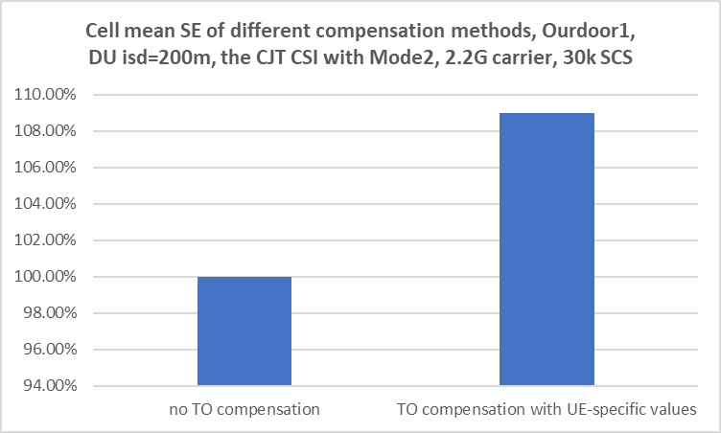  The comparison of SE performance for different approaches  UE compensation achieves larger performance gains of more than 8% compared to the baseline of no DO compensation.

Proposal 4.4-1
Study on UE-assisted report, at least including
- CJT calibration (delay offset, frequency offset, DL/UL phase offset)
- Channel Property Information report (e.g. Time-domain, Spatial-domain, and/or Frequency-domain) including long term and short term
- FFS: CJT interference mitigation, Interference plus noise (IPN) feedback.

Support/fine | ZTE, NEC, Samsung, Apple, Lenovo, Ericsson, vivo, OPPO, CMCC, CATT，ETRI, DOCOMO, Google, Huawei, Futurewei, InterDigital
Not support

Table 4.3C Additional inputs
Company | Input
Mod v0 | Consider the number of supporting companies, current put FFS for #3 and #4. Hope the proponent is ok with it.  If any addition comment,
InterDigital | We support proposal 4.4-1
Samsung | OK with the proposal. For CJT calibration reporting, considering to reuse Rel-19 CJTC would be a good start.  Suggest to remove ”…including long term and short term” in the second bullet, since it is especially not clear on what the short-term means (given that there are instantaneous CSI report quantities specified, CQI/PMI, etc)
MediaTek | It is unclear to us about what "Long term" or "Short term" channel property is and how to define those. Those need more study and discussion on the definition. For now, we think the proposal can be more general by removing the wording of "including long term and short term".

Explicit CSI Feedback
Explicit CSI feedback was proposed for by some companies as the summary:

Table 4.5A: Summary on the view
Issue | Summary of observations | Summary of companies’ views
#1  Whether to support explicit Feedback (Channel Matrix/Covariance/  Eigenvectors). | Rationale  Decouples UE from sNB precoding algorithms. Offer more freedom to sNB to utilize it for any MIMO transmission scheme (including MU-MIMO) , AI-based air interface (JSCM training), and SRS-free UEs.  Evidence  As in Table 4.5 B  Skeptical:  prefer implicit feedback as baseline due to overhead concerns. | Support/Study (11): Spreadtrum, Huawei, Samsung, MediaTek, CATT (implicit as baseline), LG, Intel, Qualcomm, TCL, ZTE, vivo  Skeptical (2): Ericsson, CMCC
#2  Definition and format of explicit CSI | Cat-H: Full Channel Matrix (Huawei, Samsung, Qualcomm, MediaTek).  Cat-R: Covariance Matrix (Samsung, Intel).  Projection: Y=AH, where A is a projection matrix (ZTE, vivo). | Cat-H(4): Huawei, Samsung, Qualcomm, MediaTek  Cat-R(2): Samsung, Intel  Projection(2): ZTE, vivo

Proposal 4.5-1
Support implicit CSI feedback (i.e. based on RI/PMI/CQI as defined in LTE and NR) as baseline. Study on whether/how to support explicit CSI feedback, including the definition and format of explicit CSI.
Support/fine | Spreadtrum, Huawei, Samsung, CATT (implicit as baseline), LG, Intel, Qualcomm, TCL, ZTE, vivo, InterDigital
Not support | MediaTek

Table 4.5 B Additional inputs
Company | Input
Mod v0 | I didn’t put Ericsson and CMCC in “not support” and hope the study outcome can address their concern on reporting overhead.  If any comment,
InterDigital | We support Proposal 4.5-1
Samsung | Ok with proposal. We see the need of explicit FB especially for AI-based CSI compression, JSCM, as the artificial quantization for CQI would limit the efficiency of the compression for both of training and inference.
MediaTek | We understand people are more familiar with implicit CSI feedback, as it has been studied in LTE and NR. To us, both explicit and implicit channel feedback are essential to study, and we don't prioritize anyone at the beginning of SI.  We also understand people may be afraid of high overhead always for explicit channel feedback, but explicit channel feedback does not always require the extreme high feedback overhead. Observed from Huawei’s and our evaluation results, when we control/limit the feedback overhead to a certain level, explicit channel feedback outperforms Type-I based PMI and eType-II based PMI feedback. Furthermore, we expect that the feedback overhead of explicit channel feedback can be further optimized if applying Rx-side compression which is not yet enabled in our evaluation result.

Table 4.5 B: Preliminary results
Company | Metric | Key observation and results
MediaTek | UPT | 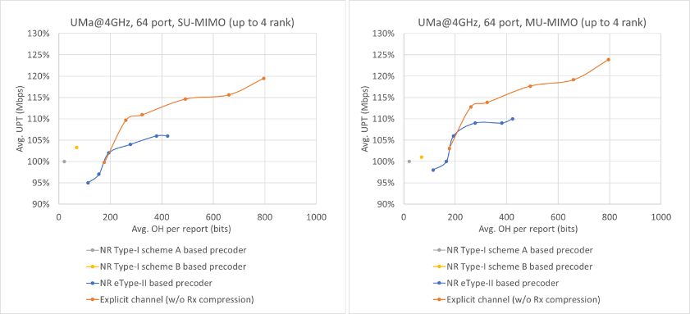  Figure-2.1.1.2 Average UPT performance of NR Type-I Scheme A precoder, NR Type-I Scheme B precoder, NR eType-II precoder vs. explicit channel feedback  Observation 2.1.1.3: Compared to NR eType-II codebook based SVD precoder feedback, explicit channel feedback offers lower UE implementation complexity and achieves better performance for the same level of feedback overhead.
Huawei | SE | Observation 14: For the same feedback overhead, long-term channel information-based explicit CSI feedback can improve cell average DL SE by +18% to +22% compared with eType-II scheme.  Observation 15: For the same feedback overhead, long-term channel information-based explicit CSI feedback can improve cell edge DL SE by +15% to +27% compared with eType-II scheme.
Samsung | SE | SE gain with AI-based JSCM for explicit H
Qualcomm | Sparsity level | 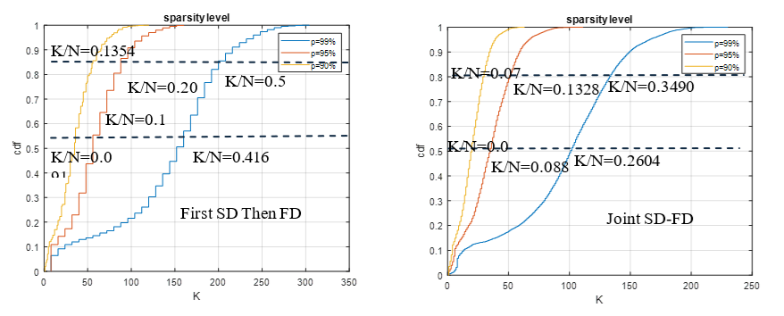  Figure 3-14: Sparsity level of the FD channel and the joint SD-FD channel  Observation 19: Channel compression using the joint SD-FD basis could improve the sparsity level by 100% compared to the compression with first SD then FD as Rel-16 eType II approach.

Others
Other proposals for CSI reporting design, including precoded CSI-RS, SRS free, some CQI related enhancement, NTN, etc.
More views are needed to trigger discussion in RAN1, or some dependency to other fundamental aspects.

CSI measurement

Channel measurement
Regarding channel measurement, we summarized the views as the table below
View summary |  | Companies
NZP CSI-RS as the channel measurement resource |  | Nokia, Futurewei, Spreadtrum, InterDigital, Huawei/HiSilicon, OPPO, TCL, ZTE, CATT, Tejas, MTK, CMCC, Xiaomi, vivo, IMU, Google, NEC, China Telecom, Samsung, Beammwave, Apple, Lenovo, Fujitsu, LG, Sharp, Honor, ETRI, Ericsson, Sony, NTT DCM, Qualcomm, ATT, KDDI, Rakuten, ASUSTek, China Unicom
Study DMRS as CSI measurement RS | For CQI/MCS reporting | Nokia, ZTE, Qualcomm(delta CQI), Ericsson, MTK, Apple(CQI/ Delta CQI), Google, Tejas
Study DMRS as CSI measurement RS | For RI reporting | Nokia, ZTE, MTK
Study DMRS as CSI measurement RS | For PMI reporting | MTK
Study DMRS as CSI measurement RS | For RSRP/SINR reporting | ZTE
Study DMRS as CSI measurement RS | For DMRS port selection | ZTE
Study DMRS as CSI measurement RS | Low priority for study | Spreadtrum
Almost all companies discuss CSI-RS for CSI measurement in this agenda. Multiple companies propose to study DMRS as the channel measurement RS for CSI, although 1 company propose to deprioritize this study.

Proposal 5.1-1:
6GR supports NZP CSI-RS as the channel measurement RS for CSI
- FFS other reference signals, e.g., DMRS
Support/fine | Nokia, Futurewei, Spreadtrum, InterDigital, Huawei/HiSilicon, OPPO, TCL, ZTE, CATT, Tejas, MTK, CMCC, Xiaomi, vivo, IMU, Google, NEC, China Telecom, Samsung, Beammwave, Apple, Lenovo, Fujitsu, LG, Sharp, Honor, ETRI, Ericsson, Sony, NTT DCM, Qualcomm, ATT, KDDI, Rakuten, ASUSTek, China Unicom
Not support

Company | Comment
MediaTek | Fine with the proposal. We are supportive to using DM-RS as the CSI reference signal.
Samsung | Support

Key observations
Company | Observation
Ericsson | Observation 13 PDCCH link adaptation using CSI feedback from reference signals in data region (e.g., CQI or L1-SINR based on CSI-RS) is suboptimal as the SINR experienced in data region and control region can be very different due to different loading experienced in these two regions.
Samsung | Observation #18: The measurement accuracy using PDSCH DM-RS has similar performance as the measurement accuracy using CSI-RS.

Interference measurement
Regarding channel measurement, we summarized the views as the table below
View summary |  | Companies
Resources | CSI-IM or ZP CSI-RS | Spreadtrum, vivo, Google, Samsung, LG
Resources | NZP CSI-RS | Futurewei, Spreadtrum, Google
Resources | 5G SSB | Google
Resources | DMRS | Qualcomm (for CSI prediction)
Other enhancements | Report interference statistics | Futurewei
Other enhancements | Inter-cell interference coordination among multiple cells | MTK, Huawei/HiSilicon, CMCC
Other enhancements | Advanced UE-side interference suppression | MTK

Limited number of companies discuss interference measurement in contributions. Hence FL will wait for more input to derive proposal 3.3. Companies are encouraged to share their views on interference measurement for CSI in 6GR, esp. on the RS type.

Proposal 5.2-1

Support/fine
Not support

Company | Comment
Samsung | We don’t see clear use case in real deployment utilizing NZP CSI-RS for IM yet, so we prefer to use only CSI-IM or ZP CSI-RS for IM.

Key observations
Company | Observation
MTK | Observation 2.1.3.1: High proportion of interference impacted CPEs of ~35% or more are observed in FWA networks.  Observation 2.1.3.2: FWA scenarios provides quasi-static channel properties with extended coherence times (e.g., >100ms), which makes interference coordination feasible and highly practical in FWA deployments.  As depicted in Figure-2.1.3.1, this yielded significant throughput gains: approximately 42% to 48% in indoor and outdoor 3.5GHz deployments, and 24% to 31% in 7GHz evaluations.

CSI prediction
Regarding CSI prediction, we summarized the views as the table below
View summary |  | Companies
UE side prediction | Frequency domain CSI prediction | Nokia, Futurewei, Spreadtrum, InterDigital, Huawei/HiSilicon (AI and non-AI), OPPO (AI and non-AI), TCL, ZTE (AI and non-AI), CATT, Tejas (AI and non-AI), MTK (Prioritize non-AI), CMCC, Xiaomi (AI and non-AI), vivo (AI and non-AI), NEC, Samsung, Nvidia, Apple, Lenovo, Fujitsu, LG, Sharp, Honor, ETRI, Ericsson (AI and non-AI), Panasonic (AI and non-AI), Sony, ATT, ASUSTek, China Unicom
UE side prediction | Spatial domain CSI prediction | Nokia, Futurewei, Spreadtrum, InterDigital, Huawei/HiSilicon (AI and non-AI), OPPO (AI and non-AI), TCL, ZTE (AI and non-AI), CATT, Tejas (AI and non-AI), MTK (Prioritize non-AI), CMCC, Xiaomi (AI and non-AI), vivo (AI and non-AI), NEC, Samsung, Nvidia, Apple, Lenovo, Fujitsu, LG, Sharp, Honor, ETRI, Ericsson (AI and non-AI), Panasonic (AI and non-AI), Sony, NTT DCM, ATT, ASUSTek, China Unicom
UE side prediction | Time domain prediction | Nokia (Rel-19 as start point, considering enhancement using multiple resource types), TCL (Joint prediction and compression), CATT, MTK (Prioritize non-AI, considering enhancement using multiple resource types for AI), vivo (AI and non-AI, NR with $N_{4}$=1 only as a starting point), IMU, BJTU, Samsung, Nvidia, Apple, Sharp, ETRI, Ericsson, Sony, Qualcomm (with interference prediction), Rakuten
UE side prediction | Cross beam/virtualization CSI prediction | Vivo, Apple, Sony, CATT
UE side prediction | Cross frequency unit (e.g., BWP, CC) CSI prediction | Samsung, Apple, LG, ETRI, Sony, NTT DCM
NW side prediction | Frequency domain CSI prediction | Futurewei, Huawei/HiSilicon (AI and non-AI), OPPO (AI and non-AI), NEC, Ericsson (AI and non-AI), NTT DCM, ATT, China Unicom
NW side prediction | Spatial domain CSI prediction | Futurewei, Huawei/HiSilicon (AI and non-AI), OPPO (AI and non-AI), NEC, Ericsson (AI and non-AI), NTT DCM, ATT, KDDI, vivo (for NES) , China Unicom
NW side prediction | Time domain prediction | Nvidia
NW side prediction | Cross frequency unit (e.g., BWP, CC) CSI prediction | NTT DCM
Assistance information | Full-dimension long term channel information | Huawei/HiSilicon (for AI and non-AI), vivo (for non-AI, Derived from full-dimension CSI-RS with longer periodicity), ZTE (Derived from full-dimension CSI-RS with longer periodicity), Tejas (Derived from full-dimension CSI-RS with longer periodicity), Xiaomi (Statistical power distribution in angular/frequency domain), ETRI (Derived from full-dimension CSI-RS with longer periodicity), Ericsson (Derived from full-dimension CSI-RS with longer periodicity), ATT (Long-term frequency domain or spatial domain correlation) , China Unicom
Assistance information | Compression/precoding matrix applied on CSI-RS | OPPO, MTK, Ericsson

It seems there is consensus to study non-AI or AI based CSI prediction among numerous domains. A large number of companies show attractive gain. The following proposals are derived based on companies’ contributions.

Proposal 5.3-1:
For 6GR, study the following non-AI and AI based low overhead CSI-RS or CSI prediction at UE or NW side
- Non-AI and AI based time domain CSI prediction
  - NR Rel-18/Rel-19 UE side CSI prediction with potential simplification is the start point
- Non-AI and AI based frequency/spatial domain prediction
  - At least for non-AI, consider the following information options used to reconstruct the reduced-dimension measurement into full-dimension channel
    - Option 1: Full-dimension long term channel information, either derived from full-dimension CSI-RS measurement or NW/UE signalling
    - Option 2: Compression/precoding matrix applied on CSI-RS
- AI based cross beam/virtualization CSI prediction
- AI based cross frequency unit (e.g., BWP, CC) CSI prediction
Support/fine | Nokia, Futurewei, Spreadtrum, InterDigital, Huawei/HiSilicon, OPPO, TCL, ZTE, CATT, Tejas, MTK, CMCC, Xiaomi, vivo, NEC, Samsung, Nvidia, Apple, Lenovo, Fujitsu, LG, Sharp, Honor, ETRI, Ericsson, Panasonic, Sony, NTT DCM, ATT, ASUSTek, Rakuten, China Unicom
Not support

Company | Comment
MediaTek | Supportive to this proposal. However, it a bit unclear to us what “cross virtualization” means?

Proposal 5.3-2
For non-AI and AI based time domain CSI prediction, with NR Rel-18/Rel-19 UE side CSI prediction with potential simplification as the start point, FFS
- Whether to support both N4=1 and N4>1
- Combined configuration of P/SP and AP RS for data collection and inference
- Large number of ports (>32 ports)
- CSI prediction with longer CSI-RS periodicities
- Use of DMRS for interference prediction
Support/fine | Nokia, TCL, CATT, MTK, vivo, IMU, BJTU, Samsung, Nvidia, Apple, Sharp, ETRI, Ericsson, Sony, Qualcomm, Rakuten, InterDigital
Not support

Company | Comment
InterDigital | We support Proposal 5.3-2

Proposal 5.3-3
For NW-side CSI prediction use cases, study the following input for NW-sided model
- Sparse channel matrix
- Precoding matrix indicated by PMI
- Full-dimension long term channel information
Support/fine | Futurewei, Huawei/HiSilicon, OPPO, NEC, Ericsson, NTT DCM, ATT, KDDI, vivo, Nvidia, China Unicom
Not support

Company | Comment

Key observations
Company | Observation
Nokia | UE side  Model 1 uses fewer transformer layers, with approximately 0.95 million trainable parameters and 54.54 million FLOPs, while Model 2 employs more layers, resulting in about 2.14 million parameters and 122.96 million FLOPs. Both models were trained over overall CSI-RS densities from ½ to 1/13, with a fixed SD = ½ and FD varies correspondingly and the corresponding NMSE improvements relative to linear interpolation are shown in Figure 4.  Due to its higher complexity, Model 2 consistently achieves about a 1 dB NMSE gain over Model 1, indicating that improved channel reconstruction from sparse CSI-RS can be obtained by increasing model complexity, with a clear performance–complexity tradeoff to be explored in future studies.  NW side  The main challenges of NW-sided frequency and/or spatial domain CSI prediction are high CSI feedback overhead and obtaining high quality labels.  Observation 15. For the frequency and/or spatial domain CSI prediction, it is beneficial to maintain conventional rectangular/square patterns as the baseline and consider support for additional patterns only when clear, generalizable gains are demonstrated, with appropriate capability handling to protect legacy operation.
Spreadtrum | Observation 5: For frequency domain low CSI-RS overhead, the loss of SGCS is less than 5% with 87% RS overhead reduction in frequency domain.  Observation 6: For spatial domain low CSI-RS overhead, the loss of SGCS is less than 5% with 75% RS overhead reduction in spatial domain.  Observation 7：AI/ML model can achieve good generalization performance in frequency domain reduction for the case that the training dataset and testing dataset are generated with various deployment scenarios.  Observation 8：AI/ML model can achieve good generalization performance in frequency domain reduction for the case that the training dataset and testing dataset are generated with various carrier frequencies.  Observation 9：AI/ML model can achieve good generalization performance in frequency domain reduction for the case that the training dataset and testing dataset are generated with various UE speeds.  Observation 10: For spatial domain reduction, the loss SGCS is approximately 28% compared to non- generalization with various scenarios.  Observation 11：AI/ML model can achieve good generalization performance in spatial domain reduction for the case that the training dataset and testing dataset are generated with various carrier frequencies.  Observation 12: AI/ML model can achieve good generalization performance in spatial domain reduction for the case that the training dataset and testing dataset are generated with various UE speeds.
InterDigital | Observation 18: According to presented results, for AI/ML-based CSI-RS overhead reduction,  - FDR-based results in very good SGCS performance (≥0.9) for the entire range of reduction factors of 2×, 4× and 8×. Also, the performance is maintained across different sizes of gNB antenna ports.  - SDR-based results in a reasonable SGCS performance (≥0.88) for the reduction factors of 2× and 4×. Compared to the FDR case, it appears that the SGCS performance is more sensitive to spatial domain reduction.  - It is feasible to use UE-side AI/ML prediction for CSI-RS overhead reduction in frequency and/or spatial domain (Sub-Case A).
Huawei/HiSilicon | See section 6.5 for Non-AI observations  Observation 12: Taking long-term channel information as additional information for CSI prediction can achieve SGCS gain especially for ultra-sparse CSI-RS in spatial domain.  Observation 13: The model size and training data size of AI/ML-based solutions with long-term channel information can be reduced by 75% and 55% respectively to achieve similar SGCS compared to AI/ML-based solutions without long-term channel information.
OPPO | Observation 5: With sparse CSI-RS density in frequency and/or spatial domain, high SGCS values can be achieved by UE-side model with FLOPs < 1M.
ZTE | Observation 8: Wiener-filtering-based CSI prediction (UE-side implementation) with SD low-overhead CSI-RS delivers 5.35% average UPT gain and 4.56% 5%-like UPT gain.  Observation 9: AI-based CSI prediction (UE-side model) with SD low-density CSI-RS delivers 5.61% average UPT gain and 7.31% 5%-like UPT gain.
CATT | Observation 1: For SDR, when the spatial compression rate is 1/4, the AI/ML output channel matrix can achieve SGCS of 0.971/0.963 (128 /256ports).  Observation 2: For FDR, when the frequency compression rate is 1/4, the AI/ML output channel matrix can achieve SGCS of 0.966/0.968 (128 /256ports).  Observation 3: For SFDR, when the spatial and frequency compression rates are both 1/4, the AI/ML output channel matrix can achieve SGCS of 0.953/0.944 (128 /256ports).  Observation 4: In SFDR, the equivalent compression rate can be 1/16 (i.e., the CSI-RS overhead can be reduced by 93%), while the SGCS performance is still satisfactory (nearly 0.95, only 0.01~0.02 performance degradation as compared with SDR/FDR).
Tejas | Observation 8 A 5.3% throughput gain with the flexible sounding approach is observed as compared to the baseline where all the CSI-RS ports are contiguously sounded.
MTK | Observation 2.4.2.1.1: For spatial domain CSI-RS reduction, the trained pattern achieves the best or near-best NMSE at all densities, showing the advantage of AI/ML-based joint CSI-RS pattern generation and CSI prediction, especially for high reduction ratio cases.  Observation 2.4.2.1.2: For frequency domain CSI-RS reduction, the trained pattern also achieves the best NMSE at all densities, showing the advantage of AI/ML-based joint CSI-RS pattern generation and CSI prediction, especially for high reduction ratio cases.  Observation 2.4.2.2.1: Over all time slots in prediction windows, Scheme#1(P/SP+AP RS) shows 8%, 187%, 271%, and 267% SGCS performance gain compared to the baseline for 3, 10, 20, and 30 km/h UE speed, respectively. Scheme#2 (P/SP RS) also shows 4%, 117%, 92%, 100% SGCS performance gain compared to baseline for 3, 10, 20, and 30 km/h UE speed, respectively.  Observation 2.4.2.2.2: Over all time slots in prediction windows, Scheme#1(P/SP+AP RS) shows 1%, 5%, 65%, 73% SGCS performance gain compared to Scheme#2 (P/SP RS) for 3, 10, 20, and 30 km/h UE speed, respectively.  Observation 2.4.2.2.3: Over all time slots in the prediction window, Scheme#1(P/SP+AP RS) shows 6.3dB, 14.0dB, 15.0dB, 11.8dB NMSE performance gain compared to the baseline for 3, 10, 20, and 30 km/h UE speed, respectively. Scheme#2 (P/SP RS) also shows -1.1dB, 6.2dB, 3.0dB, 3.1dB NMSE performance gain compared to baseline for 3, 10, 20, and 30 km/h UE speed, respectively.  Observation 2.4.2.2.4: Over all time slots in prediction window, Scheme#1(P/SP+AP RS) shows 3.8dB, 5.1dB, 10.6dB, 7.7dB NMSE performance gain compared to Scheme#2 (P/SP RS) for 3, 10, 20, and 30 km/h UE speed, respectively.  Observation 2.4.2.2.5: NMSE and SGCS gain of scheme#1 compared to scheme#2 comes with larger overhead for AP RS transmission and significantly shorter observation window (32% in our evaluations).  Observation 2.4.2.2.6: On Average over all slots in prediction window of each scheme, Sheme#1(P/SP+AP RS) shows 4%, 69%, 128%, and 155% SGCS gain over the baseline for 3, 10, 20, 30 km/h UE speed, respectively. Also, Scheme#2 (P/SP RS) shows 3%, 63%, 59%, and 71% SGCS gain over the baseline for 3, 10, 20, 30 km/h UE speed, respectively.  Observation 2.4.2.2.7: On Average over all slots in prediction window of each scheme, Sheme#1(P/SP+AP RS) shows 0.6dB, 8.6dB, 10.4dB, and 6.4dB NMSE gain over the baseline for 3, 10, 20, 30 km/h UE speed, respectively. Also, Scheme#2 (P/SP RS) shows -1.6dB, 5.4dB, 2.2dB, and 1dB NMSE gain over the baseline for 3, 10, 20, 30 km/h UE speed, respectively.
CMCC | Observation 10: Compared to benchmark methods like sample-and-hold or traditional interpolation, the AI model improves spatial domain CSI prediction performance (in terms of SGCS) by up to 18%, 45%, and 152% when the ratio of measured ports to total ports is 1/2, 1/4, and 1/8, respectively.  Observation 11: A good prediction performance (>0.94 in terms of SGCS) for AI/ML based spatial domain CSI prediction can be achieved with CSI-RS overhead reduced to 1/2, 1/4, and 1/8, respectively.  Observation 12: Compared to spatial domain CSI prediction under fixed port pattern, spatial domain CSI prediction under AI optimized port pattern has 0.1%, 1.2%, 1.6% loss in terms of SGCS when the ratio of measured ports to total ports is 1/2, 1/4, and 1/8, respectively.  Observation 13: Compared to benchmark methods like sample-and-hold or traditional interpolation, the AI model improves frequency domain CSI prediction performance (in terms of SGCS) by up to 5%, 7%, and 9%, when the frequency density for measurement is 1/2, 1/4, 1/8, respectively.  Observation 14: A good prediction performance (>0.98 in terms of SGCS) for AI/ML based frequency domain CSI prediction can be achieved with CSI-RS overhead reduced to 1/2, 1/4, 1/8, respectively.  Observation 15: A good prediction performance (>0.94 in terms of SGCS) for AI/ML based joint spatial and frequency domain CSI prediction can be achieved with CSI-RS overhead reduced to 1/32.  Observation 16: For the use case of Frequency and/or spatial domain CSI prediction, the following performance gain and model complexity are observed
Xiaomi | Observation 1: AI/ML based CSI prediction in frequency domains has better performance than baseline scheme in different channel qualities and different frequency densities.  Observation 2: When the frequency density is 1/8, the SGCS of AI/ML based CSI prediction is around 0.948, 0.872, 0.857 for SNR =10dB, 0dB, -10dB, respectively.  Observation 3: When the channel quality is good, AI/ML based CSI prediction can maintain good performance even when frequency density decreases to 1/16, which achieves around 50% SGCS gain than baseline scheme.  Observation 4: Compared with density reduction in frequency domain, the SGCS performance is more sensitive to the density reduction in spatial domain.  Observation 5: When the spatial density is 1/2, the SGCS of AI based CSI prediction is around 0.957, 0.866, 0.648 for SNR =10dB, 0dB, -10dB, respectively.  Observation 6: CSI-RS Tx port pattern for measurement as model input should be carefully designed as it impacts the prediction performance a lot.  Observation 7: Joint frequency domain and spatial domain CSI-RS OH reduction has the best performance among these three cases.  Observation 8: AI model for frequency domain and/or spatial domain CSI prediction has good scalability performance in input dimension.  Observation 9: AI model for frequency domain and/or spatial domain CSI prediction has good generalization performance in different channel qualities.  Observation 10: It is feasible to collect data samples for training for AI based CSI prediction in frequency and/or spatial domain by measurement on CSI-RS with RS density=1 and all ports.
vivo | Observation 2: For spatial domain CSI prediction, the AI/ML-based scheme can achieve a significant performance gain compared with the sample & hold baseline. For instance, the performance gain is more than 20% when density=1/2 with uniform port selection.  Observation 3: For AI-based spatial domain CSI prediction, non-uniform pattern can achieve better performance than uniform pattern.  Observation 4: For frequency domain CSI prediction, the AI/ML-based scheme can achieve 9% ~47% performance gain compared with the non-AI baseline.  Observation 5: For frequency/spatial domain CSI prediction, the non-AI-based scheme can yield significant performance gain compared with sample & hold baseline and achieve similar performance as AI-based scheme.  Observation 6: Compared with regular CSI-RS, the throughput loss of sparse CSI-RS with non-AI-based scheme is marginal when CSI-RS estimation error is considered.  Observation 7: Compared with the sample & hold scheme, the SGCS gains of the AI-based scheme on beam #2 at layer 1, layer 2, layer 3, and layer 4 are ~39%, ~60%, ~79% and ~82%, respectively.
BJTU | Observation 3: AI/ML based CSI prediction can achieve very high prediction accuracy compared with baseline non-prediction in terms of both NMSE and SGCS.
Samsung | Observation #26: Even under aggressive subsampling, e.g., SD density set to 1/8, the spatial domain CSI-RS prediction achieves high reconstruction performance e.g., layer-1 SGCS around 0.9.  Observation #27: For the same overhead, frequency-and-spatial-domain prediction outperforms frequency-domain-only prediction and spatial-domain-only prediction.  Observation #28: For full-buffer traffic, the proposed AI-based spatial-domain CSI prediction achieves considerable UPT gain over the baseline system with no CSI-RS OH reduction, e.g., N=256 ports, SD=1/4 with 5ms CSI-RS periodicity archives 20.8% UPT gain.  Observation #29: The proposed AI-based spatial-domain CSI prediction achieves a generalization on various port transformation patterns by using the mixed dataset.  Observation #30: From performance point of view, UE-side model-based cross-frequency CSI-RS prediction is feasible with near-perfect SGCS performance (>0.9) between RB-level layer-1 eigenvectors from predicted channel and ‘ground-truth’ channel.  Observation #31: NR’s study on CSI prediction observed considerable mean and cell-edge UPT gain as well as robustness against impairments such as channel estimation error and phase discontinuity over non-AI/ML-based prediction.
Lenovo | Observation 5: A CSI-RS overhead reduction of 98% in both FD and SD achieves a SGCS of at least 0.75.
Fujitsu | Observation 1 AI/ML-based CSI reconstruction can achieve 75% CSI-RS overhead reduction without obvious SGCS degradation.  Observation 2 Different TX port down-sampling pattern may have big performance differences.
LG | Observation #1: AI/ML-based spatial and/or frequency domain prediction demonstrates the capability to significantly reduce CSI-RS overhead while maintaining prediction accuracy (SGCS).  Observation #2: Cross-frequency CSI prediction achieves sufficiently high accuracy at the FB level, demonstrating its feasibility.  Observation #3: Performance degrades noticeably in inter-FR scenarios (e.g., FR1 FR3), especially when the frequency gap is large. These results indicate that effective cross-frequency CSI prediction at the FR level requires more refined active FR band selection and advanced AI/ML model design.
Qualcomm | From the above evaluation results and complexity, it is seen that  • Reducing CSI-RS density worsens channel estimation performance. This is due to (1) lower effective power allocated to CSI-RS, and (2) aliasing if the CSI-RS density is too low compared to the delay spread of the channel.  • Advanced receiver (OMP, NN) can mitigate the performance loss due to lower density CSI-RS, but the performance gain comes at the cost of very high UE complexity.
Ericsson | Observation 2 For UE-sided spatial CSI prediction for CSI-RS overhead reduction, considering the fixed random CSI-RS port muting pattern, AI/ML-based method outperform non-AI/ML approaches when inferring the channel for all CSI-RS ports based on measurements of a subset of ports.  Observation 3 For UE-sided spatial CSI prediction for CSI-RS overhead reduction, at least for AI based approaches, the partial port sounding pattern can impact the CSI prediction performance.  Observation 8 CSI acquisition based on NW-assisted beamformed CSI-RS is able to effectively reduce straddling loss compared to legacy beamformed CSI-RS, and improve the overall system level performance.

LCM for CSI prediction
Regarding LCM aspects for CSI prediction, we summarized the views as the table below
LCM components | Companies
Finetuning/Continuous learning | Nokia, Huawei/HiSilicon, China Unicom
Data collection with full-dimension CSI-RS | Huawei/HiSilicon, vivo, CATT, MTK, Offino, Sony, Rakuten, China Unicom
Monitoring, e.g., metric report for UE sided model, or label report for NW-sided model | Huawei/HiSilicon, vivo, MTK, BJTU, Honor, China Unicom
Associated ID | NEC

Proposal 5.3.1-1
To facilitate AI based CSI prediction in 6GR, study the following LCM aspects
- Finetuning/Continuous learning
- Data collection with full-dimension CSI-RS
- Monitoring
- Associated ID
Support/fine | Nokia, Huawei/HiSilicon, vivo, CATT, MTK, Offino, Sony, Rakuten, BJTU, Honor, China Unicom
Not support

Company | Comment

CSI-RS design

Port number of CSI-RS
Regarding the port number of CSI-RS, we summarized the views as the table below
View summary |  | Companies
Follow 5G with up to 128 ports |  | Spreadtrum, Qualcomm
Study extension of 5G port number | Up to 256 | Futurewei, InterDigital, OPPO, TCL, ZTE, CATT, Tejas, MTK, Xiaomi, vivo, Google, NEC, China Telecom, Samsung, Apple, Lenovo, Fujitsu, LG, Sharp, Honor, ETRI, Ericsson, Panasonic, Sony, NTT DCM
Study extension of 5G port number | Up to 512 | Huawei/HiSilicon, MTK, vivo, LG, Sharp, Sony, ATT, China Unicom

More than 25 companies propose to study extending the maximum number of CSI-RS ports to 256 or 512, considering providing enough performance gap compared to 5G and meeting IMT-2030 requirement. Among them, several companies provide simulation results to justify the gain of 256 or 512 ports. 2 companies indicate their preference to keep NR maximum number, i.e., 128 ports, for 6GR.

Proposal 6.1-1
For CSI-RS for CSI acquisition in 6GR, study the extension of maximum number of ports to 256 or 512, including the performance gain compared with 128 ports supported by NR.
Support/fine | Futurewei, InterDigital, OPPO, TCL, ZTE, CATT, Tejas, MTK, Xiaomi, vivo, Google, NEC, China Telecom, Samsung, Apple, Lenovo, Fujitsu, LG, Sharp, Honor, ETRI, Ericsson, Panasonic, Sony, NTT DCM, Huawei/HiSilicon, ATT, China Unicom
Not support

Company | Comment
MediaTek | Support

Key observations
Company | Observation
Huawei, HiSilicon | Observation 4: 7GHz MIMO configured with 512 CSI-RS ports for 512 TXRUs improves cell average DL SE by +26% compared to the 256 CSI-RS ports for 512 TXRUs.  Observation 5: For a 7GHz MIMO system with 512 TXRUs, the SRS-based CSI acquisition approach leads to a 26.2% loss in cell average DL SE and a significant 72.8% loss in cell-edge DL SE, compared to the CSI-RS-based approach.
OPPO | Observation 2: With the same number of antenna elements, 256 ports can provide some gain over 128 ports, however 512 ports cannot provide additional performance gain.
MTK | Observation 2.2.1.1: To meet the requirements of IMT-2030, it is necessary for BS to support up to 256 or 512 TxRUs.
vivo | Observation 1: For an antenna array of 1024 AEs, the performance gain of the 256-port is 2.7 times that of the 128-port.
CATT | Figure 6 shows performance comparison of different number of ports for PDSCH transmission in 7GHz. In the simulation, the number of antenna elements and TxRUs are 1024 and 128, respectively. Simulation results show that increasing the number of CSI-RS ports from 32 to 256 yields an approximate 116% improvement in the average SE and a 150% improvement in the cell-edge SE. Moreover, increasing the number of CSI-RS ports from 128 to 256 yields 30% enhancement in average SE and 47% enhancement in cell-edge SE.

Basic methodology to support CSI-RS ports larger than 32
Regarding the basic methodology to support CSI-RS ports larger than 32, we summarized the views as the table below
View summary | Companies
Aggregating multiple resources based on <=32 ports | InterDigital (both homogenous and heterogenous), Tejas, Google
One resource to support >32 ports | Futurewei, Spreadtrum, Huawei/HiSilicon, OPPO, ZTE, Xiaomi, vivo, NEC, Samsung, BeammWave, Apple, LG, Honor, Ericsson, NTT DCM, China Unicom

16 companies support using one CSI-RS resource to support >32 ports, for achieving unified design for <=32 ports and > 32 ports. 3 companies propose to reuse the NR Rel-19 methodology, i.e., aggregating multiple resources to form >32 ports.

Proposal 6.2-1
For either X<=32-port or X>32-port CSI-RS in 6GR, support using one CSI-RS resource to contain the X ports.
Support/fine | Futurewei, Spreadtrum, Huawei/HiSilicon, OPPO, ZTE, Xiaomi, vivo, NEC, Samsung, BeammWave, Apple, LG, Honor, Ericsson, NTT DCM, China Unicom
Not support

Company | Comment
MediaTek | Support

CSI-RS pattern
Regarding the pattern of CSI-RS, we summarized the views as the table below
View summary |  | Companies
CSI-RS pattern for larger number of ports is defined on multiple RBs in time or frequency domain |  | OPPO, vivo, ZTE, Xiaomi, Samsung, Apple, Fujitsu, Ericsson, NTT DCM, ATT
CSI-RS pattern is defined as aggregation of CDM blocks |  | OPPO, vivo, ZTE, Xiaomi, Samsung, Apple, Fujitsu, Ericsson, NTT DCM
CDM design | Reuse NR, i.e., CDM 2, 4, 8, with potential reduction of candidates | Vivo, Xiaomi, NEC
CDM design | Consider larger CDM size, e.g., CDM 16 | Apple, Ericsson, NTT DCM
CDM design | New CDM type for NR CDM size | ZTE
Aspects to determine CSI-RS pattern, e.g., CDM block size, OCC | CSI-RS power considering power boosting limit | Samsung, Ericsson
 | CSI-RS sharing | Vivo, Samsung
 | MRSS | Ericsson

A number of companies discuss critical issues related with CSI-RS pattern design, which are summarized in the following proposal.

Proposal 6.3-1
6GR CSI-RS pattern is defined as aggregation of CDM blocks, for which study the following aspects
- Whether CSI-RS pattern is defined on single or multiple RBs in time/frequency domain
- For CDM design, consider the following options
  - Option 1: Reuse NR, i.e., CDM 2, 4, 8 with potential reduction of candidates
  - Option 2: Larger CDM size, e.g., CDM 16
  - Option 3: New CDM type for NR CDM size (e.g., fd-CDM4 or cdm8-FD4-TD2)
- Aspects to be considered for designing CSI-RS pattern
  - CSI-RS power considering power boosting limit
  - CSI-RS sharing among multiple resources
  - MRSS
Support/fine | OPPO, vivo, ZTE, Xiaomi, Samsung, Apple, Fujitsu, Ericsson, NTT DCM, ATT, NEC
Not support

Company | Comment
MediaTek | Support. On CDM, one potential direction could be simplying NR CDM type (not just reusing).

Key observations
Company | Observation
Apple | Observation 2-1-2: For 128-ports CSI-RS, at higher Doppler, we observe performance degradation of options (option 1, 3) with TD-OCC=4, compared to options with TD-OCC=2 (options 2, 4)  Observation 2-1-3: For 256-ports CSI-RS, at medium delay spread and higher Doppler, we observe performance degradation of options (option 1) with TD-OCC=4, compared to options with TD-OCC=2 (option 2), but overall degradation compared to lower delay spread

CSI-RS sharing
Regarding the CSI-RS sharing, we summarized the views as the table below
Use cases | Companies
Sharing among different numbers of ports | Nokia, Spreadtrum, MTK, vivo, Google, Samsung, Ericsson, NTT DCM, KDDI
Sharing among different densities | Vivo, InterDigital
Sharing among 5G and 6G UEs | Google

A number of companies propose to study CSI-RS RE sharing among multiple resources for different use cases, in order to save CSI-RS overhead from system-level perspective.

Proposal 6.4-1
For 6GR CSI-RS, study CSI-RS RE sharing among multiple resources considering the following use cases.
- Use case 1: Sharing among different number of ports
- Use case 2: Sharing among different densities
- Use case 3: Sharing among 5G and 6G UEs
Support/fine | Nokia, Spreadtrum, MTK, vivo, Google, Samsung, Ericsson, NTT DCM, KDDI
Not support

Company | Comment
InterDigital | We propose another use case, i.e., use case 4: sharing based on powerControlOffset.  In our understanding, powerControlOffset is an assumption made by the UE for CSI determination. NR CSI-RS resources with different powerControlOffset cannot be shared between UEs, at least for Rel-19 and Rel-20 UE supporting more than 32 ports. Allowing sharing based on powerControlOffset can reduce CSI-RS overhead.
MediaTek | Support

CSI-RS overhead reduction
Regarding CSI- RS overhead reduction, we summarized the views as the table below
View summary |  |  | Companies
Sparse CSI-RS in frequency/spatial domain | Lower frequency density |  | Nokia (1/16, 1/32), InterDigital, Huawei/HiSilicon, OPPO, TCL, ZTE, CATT, Tejas (with RB level hopping), MTK (1/8 as lowest), Xiaomi, vivo, NEC, Samsung, Nvidia, Apple, Fujitsu, LG, Sharp, Honor, ETRI, Ericsson, Panasonic, Sony, NTT DCM, ATT, Rakuten, ASUSTek
Sparse CSI-RS in frequency/spatial domain | Sparse CSI-RS in spatial domain |  | Nokia, InterDigital, Huawei/HiSilicon, OPPO, TCL, ZTE, CATT, Tejas, MTK, Xiaomi, vivo, NEC, Samsung, Nvidia, Apple, Fujitsu, LG, Sharp, Honor, ETRI, Ericsson, Panasonic, NTT DCM, ATT, KDDI, Rakuten, ASUSTek
Sparse CSI-RS in frequency/spatial domain | Sparse pattern in frequency domain | Uniform pattern only | NEC
Sparse CSI-RS in frequency/spatial domain | Sparse pattern in frequency domain | Uniform and non-uniform pattern | TCL, Honor, ATT
Sparse CSI-RS in frequency/spatial domain | Sparse pattern in frequency domain | Random pattern | NEC
Sparse CSI-RS in frequency/spatial domain | Sparse pattern in frequency domain | With frequency hopping | Tejas
Sparse CSI-RS in frequency/spatial domain | Sparse pattern in spatial domain | Uniform pattern only | NEC, Apple
Sparse CSI-RS in frequency/spatial domain | Sparse pattern in spatial domain | Uniform and non-uniform pattern | TCL, Honor, Ericsson, vivo, ATT
Sparse CSI-RS in frequency/spatial domain | Sparse pattern in spatial domain | Random pattern | NEC
Dynamically adapt the number of CSI-RS ports |  |  | Nokia, Spreadtrum, NTT DCM
Dynamically adapt the CSI-RS density |  |  | Sony, Rakuten
Dynamically adapt the CSI-RS periodicity |  |  | Lenovo, Sony, Rakuten
Using non-orthogonal CSI-RS ports for channel measurement |  |  | Lenovo

It seems we have more or less consensus to study CSI-RS overhead reduction.

Proposal 6.5-1
For 6GR CSI-RS, study CSI-RS design to achieve CSI-RS overhead reduction considering the following directions
- Direction 1: Sparse CSI-RS in frequency/spatial domain
  - Consider AI or non-AI prediction to reconstruct the full-dimension channel
  - Study uniform or non-uniform pattern, random pattern, etc., as sparse pattern in frequency and/or spatial domain, including its impact on performance
- Direction 2: Dynamically adapt the CSI-RS parameters, e.g, the number of ports, periodicity, density
- Direction 3: Use non-orthogonal CSI-RS ports
Support/fine | Nokia, InterDigital, Huawei/HiSilicon, OPPO, TCL, ZTE, CATT, Tejas, MTK, Xiaomi, vivo, NEC, Samsung, Nvidia, Apple, Fujitsu, LG, Sharp, Honor, ETRI, Ericsson, Panasonic, NTT DCM, ATT, KDDI, Rakuten, ASUSTek, Sony, Lenovo, China Unicom
Not support

Company | Comment
MediaTek | Support in principle. However, it seems this proposal is highly overlapped with Issue 5.3 CSI prediction. Maybe we could focus on basic CSI-RS design in this section.

Key observations in addition to section 5.3
Company | Observation
Huawei, HiSilicon | Observation 6: By exploiting long-term channel information at UE side, the SGCS under 1RE/1RB/1port CSI-RS density is significantly better than that achieved by estimation without long-term channel information under 1RE/1RB/1port CSI-RS density, for SNR=0/10dB.  Observation 7: By exploiting long-term channel information, MU-MIMO SE can be improved by +5% to +28% under the same CSI-RS overhead as 1RE/1RB/1port across varying SNRs.  Observation 8: By exploiting long-term channel information at UE side, the SGCS under 1RE/16RB/Port CSI-RS density is significantly better than that achieved by estimation without long-term channel information under 1 RE/RB/1port CSI-RS density, for SNR=0/10dB.  Observation 9: By exploiting long-term channel information at UE side, CSI-RS channel estimation accuracy in SGCS can be potentially improved by+45% to +78% under 1 RE/16 RB/1port CSI-RS density.  Observation 10: By exploiting long-term channel information at UE side, MU-MIMO SE can be improved by +15% to +51% compared to high-density CSI-RS in NR while reducing pilot overhead by 16X, due to following reasons.  - Increased PDSCH resources due to a reduction in CSI-RS overhead.  - Stabilized and improved channel estimation accuracy across all SNR ranges.  Observation 11: By exploiting long-term channel information at UE side, MU-MIMO SE can be improved by +50% to +120% under the same CSI-RS sparse density (e.g., 1RE/16RB/1port) across varying SNRs.
MTK | Observation 2.2.1.3: The existing low-density CSI-RS configurations in 5G NR Rel-20 (i.e., 1/4, 1/6, 1/8) represent a carefully balanced trade-off between overhead reduction and channel estimation accuracy. Any further decrease in density would severely compromise performance, making it an unviable option at least for non-AI based case.
Qualcomm | Observation 4: A fixed, sparse CSI‑RS pattern used across different UE categories (e.g., cell‑center and cell‑edge) in a broadcast configuration may be insufficient, as each group experiences different channel conditions, e.g. different SINR, delay spread, etc.  Observation 5: Configuring a lower‑density CSI‑RS pattern in the frequency domain may enforce the network to deploy UE‑specific CSI‑RS configurations, which in turn increases overall overhead compared with a dense broadcast‑type CSI‑RS approach.  Observation 6: Reducing the CSI‑RS density may introduce aliasing effects, which can degrade the quality of channel estimation, and, consequently, negatively impact the accuracy of CSI feedback.  Observation 7: For cell‑edge UEs, reducing the CSI‑RS density not only worsens channel estimation due to increased aliasing but also lowers the effective energy allocated to CSI‑RS, resulting in an even lower SNR. Both effects compound the degradation of channel estimation accuracy for these UEs.  Observation 8: Port muting can be sensitive to gNB RF and array impairments.

CSI-RS sequence
Regarding the sequence of CSI-RS, we summarized the views as the table below
View summary |  | Companies
NR Sequence is a start point |  | OPPO
Low-PAPR sequence for CSI-RS |  | Lenovo, Ericsson
Sequence type | PN | Spreadtrum
Initialization | UE specific | Spreadtrum

Limited number of companies discuss CSI-RS sequence in contributions. Hence FL will wait for more input to derive proposal 6.6. Companies are encouraged to share their views on CSI-RS sequence in 6GR.

Proposal 6.6-1:

Support/fine
Not support

Company | Comment
MediaTek | On sequence for CSI-RS, we’d like to add one candidate “new sequence (e.g., Z4 sequence)”.

CSI-RS time domain type
Regarding CSI-RS time domain types, we summarized the views as the table below
View summary |  | Companies
Time domain type of CSI-RS | Periodic | Spreadtrum, InterDigital, vivo, Lenovo, LG, ETRI, MTK  Concern: TCL
Time domain type of CSI-RS | Semi-persistent | Spreadtrum, InterDigital, TCL, LG, ETRI  Concern: MTK, vivo
Time domain type of CSI-RS | Aperiodic | Spreadtrum, InterDigital, TCL, vivo, Lenovo, LG, ETRI, MTK  Concern:
Time domain type of CSI-RS | Burst P/SP | LG
Time domain type of CSI-RS | UE triggered CSI-RS | Sony, InterDigital

Limited number of companies discuss CSI-RS time domain types in contributions. Hence FL will wait for more input to derive proposal 6.7. Companies are encouraged to share their views on CSI-RS time domain types in 6GR.

Proposal 6.7-1

Support/fine
Not support

Company | Comment

Key observations
Company | Observation
MTK | Observation 2.3.2: Semi-persistent CSI reporting/generation is actually rarely enabled in real-field deployment. Aperiodic CSI reporting with periodic CSI measurement has no clear use case but leads to unnecessary measurement as one of UE pain points that we identified. It is important to simplify the 6GR CSI framework which focuses on practical use cases with clear motivation or usage.

Proposals for online

Contact information
Company | Delegate(s) | Email address
Moderator | Feifei Sun (CSI framework, CSI reporting)  Hao Wu (CSI measurement, CSI-RS design) | Feifei.sun@samsung.com  hao.wu@vivo.com

Reference
- R1-2600039 On downlink-based CSI acquisition in 6GR Nokia
- R1-2600057 Discussion on aspects of downlink-based CSI acquisition for 6GR air interface FUTUREWEI
- R1-2600119 Discussion on aspects of downlink-based CSI acquisition for 6GR Spreadtrum, UNISOC
- R1-2600133 6GR CSI: Aspects of Downlink-based CSI Acquisition InterDigital, Inc.
- R1- 2601467 Aspects of downlink-based CSI acquisition Huawei, HiSilicon
- R1-2600194 Discussion on downlink based CSI acquisition OPPO
- R1-2600222 Aspects of downlink-based CSI acquisition TCL
- R1-2600231 Discussion on aspects of downlink-based CSI acquisition ZTE Corporation, Sanechips
- R1-2600306 Discussion on downlink-based CSI acquisition for 6GR CATT
- R1-2600339 Aspects of downlink-based CSI acquisition Tejas Network Limited
- R1-2600348 Aspects of downlink-based CSI acquisition MediaTek Inc.
- R1-2600396 Discussion on downlink-based CSI acquisition CMCC
- R1-2600436 Discussion on DL CSI acquisition for 6GR Xiaomi
- R1-2600511 Discussion on aspects of downlink-based CSI acquisition for 6GR vivo
- R1-2600559 IMU Views on Downlink-based CSI Acquisition IMU
- R1-2600571 Discussion on downlink based CSI acquisition BJTU
- R1-2600607 Views on Aspects of downlink-based CSI acquisition Ofinno
- R1-2600632 Aspects of Downlink Based CSI Acquisition Google
- R1-2600672 Discussion on downlink-based CSI acquisition NEC
- R1-2600700 Discussion on aspects of downlink-based CSI acquisition China Telecom
- R1- R1-2601516 Discussion on DL-based CSI acquisition and CSI-RS design Samsung
- R1-2600797 Discussion on aspects of downlink-based CSI acquisition BeammWave AB
- R1-2600805 Downlink-based CSI acquisition for 6GR air interface NVIDIA
- R1-2600835 Views on downlink-based CSI acquisition Apple
- R1-2600848 Aspects of downlink-based CSI acquisition Lenovo
- R1-2600875 Discussion on downlink-based CSI acquisition Fujitsu
- R1-2600880 Discussion on aspects of downlink-based CSI acquisition KT Corp.
- R1-2600890 Discussion on aspects of downlink-based CSI acquisition LG Electronics
- R1-2600911 Aspects of downlink-based CSI acquisition for 6GR study Intel Corporation
- R1-2600923 Aspects of downlink-based CSI acquisiton Sharp
- R1-2600948 Discussion on downlink-based CSI acquisition HONOR
- R1-2600980 Downlink CSI acquisition aspects for 6G Fraunhofer IIS, Fraunhofer HHI
- R1-2601010 Discussion on downlink-based CSI acquisition for 6GR ETRI
- R1- R1-2601451 Views on aspects of downlink-based CSI Acquisition Ericsson
- R1-2601051 Discussion on downlink based CSI acquisition Shanghai Jiao Tong University, NERC-DTV
- R1-2601068 Discussion on DL-based CSI Acquisition for 6G Panasonic
- R1-2601136 Discussion of aspects of downlink-based CSI acquisition Sony
- R1-2601189 Discussion on Aspects of downlink-based CSI acquisition NTT DOCOMO, INC.
- R1-2601225 Aspects of DL-based 6GR Channel Acquisition AT&T
- R1-2601280 Aspects of downlink-based CSI acquisition Qualcomm Incorporated
- R1-2601333 Discussion on downlink-based CSI acquisition KDDI Corporation
- R1-2601342 Discussion on Aspects of Downlink-Based CSI Acquisition Rakuten Mobile, Inc
- R1-2601352 Discussion on CSI acquisition ASUSTeK
- R1-2601399 Views on DL CSI acquisition in 6G CEWiT
- R1-2601425 Discussion on downlink-based CSI acquisition BUPT, X-NET
- R1-2601435 Discussion on aspects of downlink-based CSI acquisition for 6GR Pengcheng Laboratory, ZGC Institute of Ubiquitous-X Innovation and Application

