6GR Random Access Discussion Group Contact Information

Name | Company | Contact Info
Daewon Lee | Interdigital | daewon.lee@interdigital.com
Fumihiro Hasegawa | Interdigital | Fumihiro.Hasegawa@interdigital.com

Agenda 10.5.1.2 Feature Lead Chat Contact information
- Please add me in Wechat if you want. When you add me, please be sure to let me know your preferred name in English and Company name.
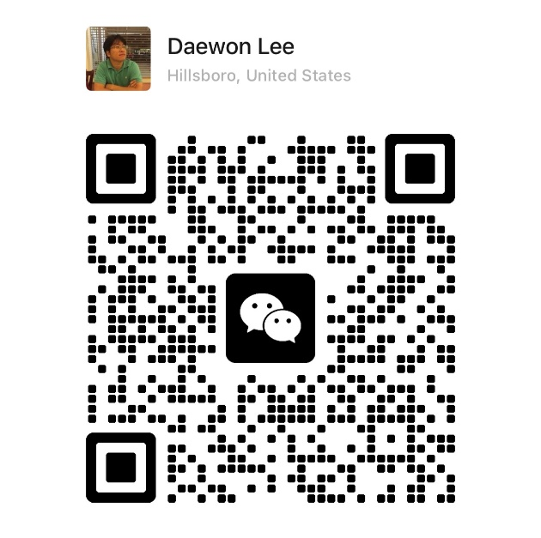
- Please add me in Whatsapp if you want. When you add me, please let me know your preferred name in English and Company name.
