3GPP TSG SA WG3 (Security) Meeting #94 ad-hoc S3-191027

11 – 15 March, 2019, Stockholm revision of S3-190603

Source: Philips

Title: Solution proposal for FS_CIoT_sec_5G key issue #1 and #2

Document for: Approval, Information, Discussion
Agenda Item: 5.6

1 Decision/action requested
This pCR proposes a solution for key issue #1 “Efficient frequent small data transmissions” and key issue #2 "integrity protection of small data" for study item on evolution of Cellular IoT security for the 5G System.

2 References
[1] 3GPP TR 33.861, Study on evolution of Cellular IoT security for the 5G System

Rationale
In TS 33.861 [1], key issue #1 discusses efficient frequent small data transmissions, and key issue #2 discusses integrity protection of small data. This pCR proposes a solution to reduce the integrity protection overhead if the integrity protection is applied to the UP. This solution is relevant when the size of the payload data is small.

4 Detailed proposal
It is proposed to approve the changes below for inclusion in TR 33.861 [1].

***** Start of Change *****

6.z Solution #z: Efficient integrity protection for small data transmissions with immediate result

6.z.1 Introduction
This solution addresses the key issue #1 "Efficient frequent small data transmissions" and the key issue #2 "Integrity protection of small data". This solution reduces the overhead of MAC-I (Message Authentication Code-Integrity) included in the small data when integrity protection is applied in the UP. The relative overhead of MAC-I is high as the payload size is small, and thus it decreases the effective user data throughput. The proposed solution decreases the overhead of transmitting one MAC-I from 4 octets to 1.

6.z.2 Solution details
The MAC-I is truncated to 8 bits (or any other suitable value).
The MAC-I for a message marked as 'first message' is computed in the traditional way. However, only the first 8 bits of the MAC-I are appended instead of the 4 octets of the full MAC-I.
The MAC-I for a next message between the same two entities uses the bits to be integrity protected from that next message as input for the MAC computation, prepended with
- the bits to be integrity protected from the three previous messages if none of these has been marked as a 'first message', or
- the bits to be integrity protected from the previous messages up to and including the last message marked as 'first message' if the last message marked as a 'first message' is at most the third previously sent message.

Figure 6.z.2-2 illustrates this solution. Data 1 through N-1 are sent without MAC-I, and MAC-I is inserted in the last data unit (i.e. data N) only. This MAC-I represents the integrity of the entire series of data 1 through N instead of individual data having its own MAC-I.
In order to indicate whether the transmitted data is the 'first message' or not, one of the reserved bits in PDCP header is used. The value of 1 is set when the message is a 'first message', and the value of 0 is set when the message is a 'next message' i.e. not a 'first message'. The transmitter and receiver store the last three message for use in the truncated MAC-I computation.
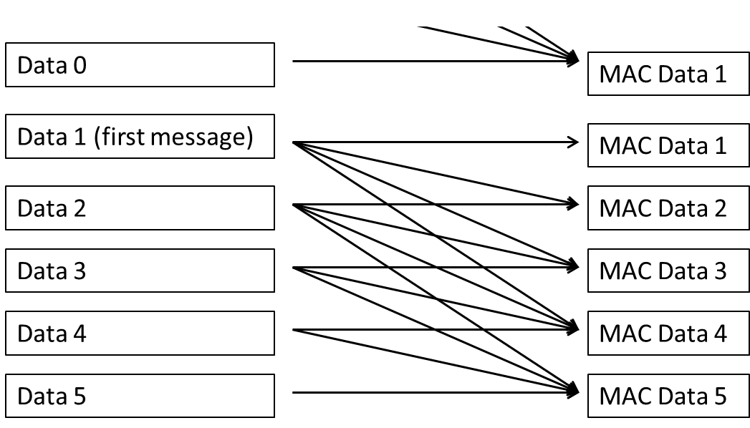
Figure 6.z.2-1 Efficient integrity protection for small data transmission
Editor's Note: The receiver behavior when a MAC fails is FFS.
Editor's Note: The transmitter behavior and storage requirements are FFS.

6.z.3 Evaluation
Editor's Note: The evaluation is FFS.
Editor's Note: The cryptographic analysis of this solution is FFS.
Editor's Note: The efficiency on the receiver side is FFS.

***** End of Change *****

