3GPP TSG-SA WG3 Meeting #94Ad-Hoc S3-190951
Stockholm (Sweden), 11-15 March 2019 revision of S3-190757

Source: China Mobile, ZTE Corporation, Nokia, Nokia Shanghai Bell

Title: Considerations on network product class when using NFV technology

Document for: Approval
Agenda Item: 5.14

1 Decision/action requested
It is suggested to discuss and approve the proposed considerations on network product class when using NFV technology in to the TR 33.818, as well as the definitions for virtualized network product class and virtualized network product.

2 References
[1] 3GPP TR 33.916: “Security Assurance Methodology (SCAS) for 3GPP network products”
[2] 3GPP TR 33.805: “Study on security assurance methodology for 3GPP network products (Release 12)”
[3] 3GPP TS28.500: Management concept, architecture and requirements for mobile networks that include virtualized network functions (Release 14)
[4] ETSI GS NFV-SEC 001: “Network Functions Virtualisation (NFV); NFV Security; Problem Statement”.

3 Rationale
The following definitions of network product class and network product were proposed in the TR 33.805/33.916:
Network product class: A network product class, in the context of SECAM, is the class of products that all implement a common set of 3GPP defined functionalities.
Network product: A network product is the instantiation of one or more network product class(es).
These definitions are not suitable for virtualized enviornment, new definition is needed. In addition, considering decoupled ways and deployment scenarios (ref. ETSI GS NFV-SEC 001 [1]) in virtualized environment, there may be multiple type of a virtualized network product class.

4 Detailed proposal
****************** Start of the first change ******************

2 References
Editor’s Note: This clause will outline that the present document contains references.
The following documents contain provisions which, through reference in this text, constitute provisions of the present document.
- References are either specific (identified by date of publication, edition number, version number, etc.) or non-specific.
- For a specific reference, subsequent revisions do not apply.
- For a non-specific reference, the latest version applies. In the case of a reference to a 3GPP document (including a GSM document), a non-specific reference implicitly refers to the latest version of that document in the same Release as the present document.
[1] 3GPP TR 33.916: “Security Assurance Methodology (SCAS) for 3GPP network products”
[2] 3GPP TR 33.926: “Security Assurance Specification (SCAS) threats and critical assets in 3GPP network product classes”
[3] 3GPP TR 33.117: “Catalogue of general security assurance requirements”
[x] 3GPP TS 28.500: "Management concept, architecture and requirements for mobile networks that include virtualized network functions"
[y] ETSI GS NFV-SEC 001: "Network Functions Virtualisation (NFV); NFV Security; Problem Statement".

****************** End of the first change *********************

****************** Start of the second change ******************

3 Definitions and abbreviations

3.1 Definitions
For the purposes of the present document, the terms and definitions given in 3GPP TR 21.905 [1] and the following apply. A term defined in the present document takes precedence over the definition of the same term, if any, in 3GPP TR 21.905 [1].

Virtualized network product class: A virtualized network product class, in the context of SECAM, is the class of products that implement 3GPP defined network functionalities running on Network Function Virtualization Infrastructure (NFVI). Depending on different deployment scenarios of network operators, there are three types of the class:
- Type 1: implement 3GPP defined functionalities only
- Type 2: implement 3GPP defined functionalities and virtualization layer
- Type 3: implement 3GPP defined functionalities, virtualization layer, and hardware layer
Virtualized network product: A virtualized network product is the instantiation of one or more virtualized network product class(es).

3.2 Abbreviations
For the purposes of the present document, the abbreviations given in 3GPP TR 21.905 [1] and the following apply. An abbreviation defined in the present document takes precedence over the definition of the same abbreviation, if any, in 3GPP TR 21.905 [1].

VNF Virtualized Network Function

****************** End of the Second change *********************
****************** Start of the third change ******************

4 Overview

4.0 Introduction

4.0.1 Considerations on network product class when using NFV technology
The definitions of network product class and network product were documented in the TR 33.916 [1]. For implementing 3GPP defined functionalities in network products, some functionalities that relate to the supporting platform (e.g. hardware components, operating system, etc.) also need to be implemented. The platform provides execution environment for 3GPP defined functionalities. For physical network products, the platform and the 3GPP defined functionalities are tightly coupled, while for virtualized network products, the platform and the 3GPP defined functionalities are decoupled. The platform of virtualized network products composes of a hardware layer and a virtualization layer, and is common for 3GPP defined functionalities. Concept of 3GPP VNF is defined in TS 28.500 [x]. According to the concept in [x], a 3GPP VNF is 3GPP network function(s) that runs on a Network Function Virtualization Infrastructure (NFVI), which is the platform of virtualized network products described above.
The realistic deployment scenarios are summarized in ETSI NFV-SEC 001 [y], based on which a 3GPP network operator can deploy 3GPP defined functionalities in three modes:
- Mode 1. A network operator purchases 3GPP VNFs from its vendors and deploys it on a third partyNFVI.
- Mode 2. A network operator purchases 3GPP VNFs and the virtualization layer (e.g. hypervisor) from its vendors, and deploys them on a third party hardware layer.
- Mode 3. A network operator purchases and deploys 3GPP VNFs, the virtualization layer and the hardware layer from its vendors.
Each deployment mode requires the different composition of virtualized network products purchased and deployed by a network operator, which are subject to the testing and evaluation in SECAM scheme. Accordingly, the different compistion of virtualized network products maps to three types of virtualized network product class as depicted in Figure 1:
- Type 1: implement 3GPP defined functionalities only
- Type 2: implement 3GPP defined functionalities and virtualization layer
- Type 3: implement 3GPP defined functionalities, virtualization layer, and hardware layer

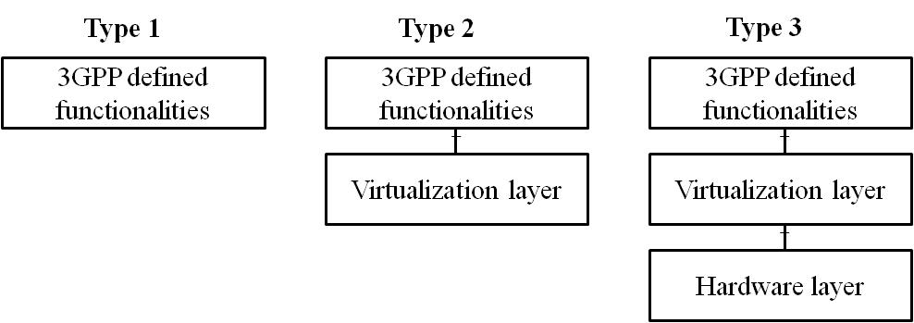
Figure 4.0.1-1: Three types of virtualized network product class
For type 2 and type 3, the 3GPP defined functionalities, the virtualization layer, and the hardware layer can be decoupled from each other and can be provided by different vendors. It implies that the targets of security assurance evaluation could be the decoupled components of a virtualized network product and the security assurance requirements on the interface(s) between components of type 2 and type 3 need to be considered in decoupling scenarios.
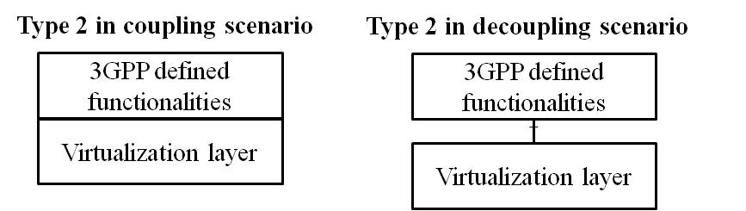
Figure 4.0.1-2: Type2 in coupling and decoupling scenarios
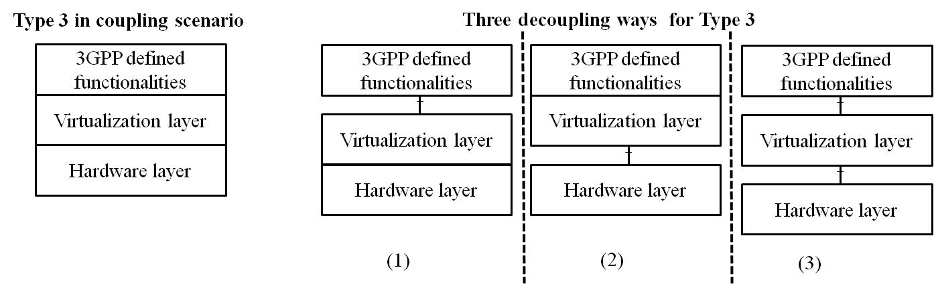
Figure 4.0.1-3: Type3 in coupling and decoupling scenarios
For type 2 in the decoupling scenarion as depicted in Figure 2, a network operator can purchase the 3GPP defined functionalities and the virtualization layer from the same or different vendors. So, it is required to assure the security of the decoupled 3GPP defined functionalities and the virtualization layer separately.
For type 3 in the decoupling scenarion as depicted in Figure 3, there are three decoupling ways. Like type 2 in the decoupling scenarion, the security assurance requirements of the decoupled components need to be considered respectively.
To cover all possible decoupling scenarios, this document suggests that the targets of security assurance evaluation (ToEs) in this study be 3GPP defined functionalities, virtualization layer and hardware layer respectively. The security assurance requirements on the interfaces between componentsof type 2 and type 3 are applied in decoupling scenarios.

****************** End of the changes ******************

